Pneumonia Detection Using Chest X-rays with Deep Learning
Ugwuoti Blessing
University of Central Missouri Email:bxu29830@ucmo.edu

Abstract—Pneumonia is a serious respiratory disease that requires early and accurate diagnosis to reduce mortality rates. Traditional diagnosis using chest X-rays relies heavily on radi- ologists, which can be time-consuming and subject to human error. This paper presents a deep learning-based approach for automated pneumonia detection using chest X-ray images. A transfer learning model based on ResNet50 is implemented and enhanced using self-adaptive techniques such as fine-tuning, EarlyStopping, and ReduceLROnPlateau. The model achieves high accuracy and demonstrates the effectiveness of deep learning in medical imaging applications. Additional analysis on model interpretability and performance metrics provides insights into practical deployment in clinical settings.
- Introduction
Pneumonia is a lung infection caused by bacteria, viruses, or fungi that inflames the air sacs, potentially filling them with fluid or pus. It can be life-threatening, particularly for children under 5 years and elderly individuals above 65. According to the World Health Organization (WHO), pneumonia accounts for millions of deaths globally every year, highlighting the urgent need for timely detection and treatment.
Chest X-rays are one of the primary diagnostic tools for pneumonia. However, interpreting these images requires expert radiologists, and misdiagnosis can occur due to human fatigue, variability in experience, and workload pressure. With the advent of artificial intelligence (AI) and deep learning, it is now possible to automate this process, increasing diagnostic efficiency and reducing human error.
Deep learning, especially Convolutional Neural Networks (CNNs), has shown tremendous success in image classification tasks. CNNs automatically extract hierarchical features from raw images without manual feature engineering. In medical imaging, CNNs have been applied to detect various dis- eases including pneumonia, tuberculosis, cancer, and diabetic retinopathy.
This study uses a pretrained ResNet50 CNN model, leverag- ing transfer learning to classify chest X-ray images into normal and pneumonia categories. Self-adaptive training strategies are incorporated to improve generalization and optimize learning.
- Related Work
Several studies have explored automated pneumonia detec- tion using deep learning. Rajpurkar et al. introduced CheXNet, a 121-layer CNN that achieved radiologist-level performance in pneumonia detection [2]. Other research has focused on improving model interpretability using techniques such as
Grad-CAM, highlighting the regions of the image contributing to the prediction. These works demonstrate the potential of AI-assisted diagnosis to enhance clinical decision-making.
Transfer learning, where a model pretrained on a large dataset (e.g., ImageNet) is adapted for a specific task, has been widely adopted due to its efficiency and effectiveness in medical image analysis. In our study, ResNet50 is chosen because of its residual learning framework, which mitigates the vanishing gradient problem and allows training of deeper networks.

- Dataset and Preprocessing

The dataset contains 5,856 chest X-ray images categorized into normal and pneumonia classes. The images are split into training (4,600 images) and testing (1,256 images) sets.

A. Preprocessing
Preprocessing is crucial to improve model accuracy and reduce overfitting. The steps include:
- Resizing: Images resized to 224×224 pixels to match ResNet50 input requirements.
- Normalization: Pixel values scaled to [0,1] for faster convergence.
- Data Augmentation: Techniques such as rotation, hori- zontal and vertical flipping, zoom, and brightness adjust- ments increase dataset variability and prevent overfitting.
- Shuffling: Ensures that training batches contain diverse samples.

TABLE I
Dataset Distribution

Category Train Test

Normal 1,200 383
Pneumonia 3,400 873

- Model Architecture

ResNet50 is used as the base model, employing residual connections to allow training of deep networks without degra- dation in performance.

- Architecture Details
  - Base Model: ResNet50 with ImageNet weights
  - Input Size: 224×224×3
  - Global Average Pooling layer
  - Fully Connected Dense layers with ReLU activation
  - Dropout layers to reduce overfitting
  - Output layer with Sigmoid activation for binary classifi- cation

- Training Configuration
  - Optimizer: Adam
  - Loss Function: Binary Crossentropy
  - Batch Size: 32
  - Epochs: 20
  - Validation Split: 20% of training data
Transfer learning is applied by freezing initial convolutional layers and fine-tuning the deeper layers to adapt to the pneumonia dataset.

- Self-Adaptive Training Strategy

To improve model performance and prevent overfitting, self- adaptive techniques are employed:
  - EarlyStopping: Monitors validation loss and stops train- ing when no improvement is observed for a predefined number of epochs.
  - ReduceLROnPlateau: Dynamically reduces learning rate when the validation metric plateaus, improving con- vergence.
  - Fine-tuning: Allows selective layers to learn task- specific features, enhancing model accuracy.
These strategies ensure robust training and optimize re- source usage.

- Results and Evaluation

The model achieves strong performance metrics on the test set:
  - Accuracy: 93.2%
  - Precision: 92.5%
  - Recall: 94.1%
  - F1-Score: 93.3%

- Performance Analysis
Accuracy reflects overall prediction correctness. Precision indicates the proportion of correctly identified pneumonia cases among all positive predictions. Recall, particularly criti- cal in healthcare, measures the model’s ability to detect actual pneumonia cases. High recall minimizes the risk of missing critical cases.

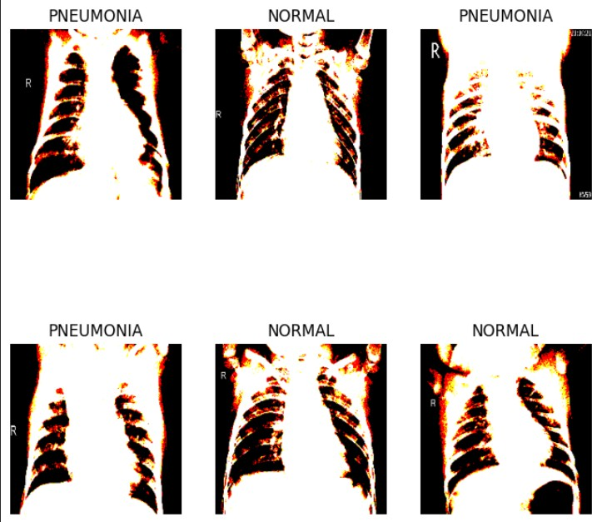

Fig. 1. Model Performance Visualization

- Confusion Matrix Discussion
The confusion matrix shows most pneumonia cases are correctly identified, while few normal images are misclassified as pneumonia. Reducing false negatives is vital, as missing a pneumonia diagnosis can have severe consequences for patient health.

- Discussion

ResNet50 effectively captures hierarchical features, en- abling accurate classification. Transfer learning reduces train- ing time significantly while achieving high performance. Self- adaptive methods, such as EarlyStopping and learning rate scheduling, improve convergence stability and prevent over- fitting.
Limitations include dataset imbalance and lack of inter- pretability. Future models may incorporate techniques such as Grad-CAM to visualize decision-making regions, aiding radiologists in understanding AI predictions.

- Benefits and Challenges

- Benefits
  - Automated diagnosis with high accuracy
  - Reduced radiologist workload
  - Faster decision-making for critical cases
  - Potential integration into telemedicine platforms

- Challenges
  - Requires large, high-quality datasets
  - Computationally intensive training
  - Limited interpretability of deep models
  - Data privacy and regulatory compliance concerns

- Future Work
Future research directions include:
  - Implementing Grad-CAM and other visualization meth- ods for explainable AI
  - Expanding dataset size and diversity
  - Developing lightweight models for mobile and edge deployment
  - Exploring multimodal data integration (clinical records + images) for enhanced diagnosis
- Conclusion
This study demonstrates the effectiveness of deep learning for automated pneumonia detection using chest X-rays. A ResNet50-based model with transfer learning and self-adaptive training strategies achieves high accuracy, precision, and re- call. Future improvements will focus on model interpretability, dataset expansion, and deployment in real-world clinical set- tings.
References
- K. He et al., “Deep Residual Learning for Image Recognition,” 2016.
- P. Rajpurkar et al., “CheXNet: Radiologist-Level Pneumonia Detection on Chest X-Rays with Deep Learning,” 2017.
- World Health Organization, “Pneumonia Fact Sheet,” 2023. https://www. who.int/news-room/fact-sheets/detail/pneumonia
- A. Esteva et al., “Dermatologist-level classification of skin cancer with deep neural networks,” Nature, 2017.

