STUDY TITLE:
EFFICACY OF LAPAROSCOPICALLY ADMINISTERED VERSUS ULTRASOUND GUIDED TRANSVERSE ABDOMINAL PLANE (TAP) BLOCKS IN ADULT PATIENTS UNDERGOING LAPAROSCOPIC APPENDICECTOMY TO CONTROL POST-OPERATIVE PAIN

INTRODUCTION AND EXISTING KNOWLEDGE:

Appendicectomy is considered a minor operation by many surgeons and anaesthetists. However, laparoscopic appendicectomy can cause moderate to severe pain, despite multimodal analgesia with local anaesthetic wound inﬁltration, paracetamol and opioids (with associated side-effects).¹ Pain after laparoscopic appendicectomy has more causes than pain after open appendicectomy. Pain is caused by the surgical incisions, intra-abdominal surgery and abdominal distension, which causes traction of the blood vessels and nerves, phrenic nerve irritation and referred shoulder pain.²
Transverse abdominal plane (TAP) block was first described by Rafi in 2001 as a traditional blind landmark technique using the lumbar triangle of petit.³ This triangle is located between the lower costal margin and iliac crest and is bounded by external oblique , latismus dorsii and iliac crest.³ A meta-analysis by Siddiqui MR in 2011 found that TAP block not only reduces the need for postoperative opioid use thus reduces the drug related side-effects but also provides more effective pain relief.⁴
TAP blocks were usually administered blindly by a double pop technique or alternatively under Ultrasound guidance (lateral, posterior, subcostal TAP blocks) with improved precision.⁵ A few years later, in 2011, laparoscopic assisted TAP block performed by the surgeon intraoperatively during elective laparoscopic cholecystectomy was reported as a new technique.⁶
TAP blocks are also gaining popularity among gynaecological surgeons for lower abdominal procedures as hysterectomies and caesarian sections, and certain studies have found them superior to port site infiltration in controlling post-op pain.^{1,7} Another technique Rectus sheath block is used for post-operative analgesia in midline incisions such as laparotomy and has shown to significantly reduce use of morphine⁸ and pain scores when compared with placebo.⁹ Rectus sheath block has also been used in combination with TAP block with good results.^{10,11}
TAP blocks not only anaesthetise the anterolateral abdominal wall but also has effect on the parietal peritoneum⁵ thus theoretically speaking would be more effective in acute appendicitis where localised pain in right iliac fossa is caused by involvement of the parietal peritoneum after progression of the inflammatory process.¹²
The most commonly practiced technique after a laparoscopic appendicectomy is port site infiltration with local anesthetic agent.¹³ TAP blocks though have proven to be much more effective than port site infiltration in controlling post-operative pain,¹⁴ are still not widely practiced due to the time constraint in emergency setting as they are mostly performed by the anesthetists with ultrasound guidance before the operation is started and significantly increase the total theatre time consumed. Whereas time taken to administer laparoscopic assisted TAP blocks in experienced hands is negligible as compared to ultrasound guided technique, thus is very practical even in emergency operations.
The efficacy of TAP blocks has been mostly evaluated in elective surgeries as laparoscopic cholecystectomies, diagnostic laparoscopies and elective gynecological operations etc. but in this study we are going to compare the efficacy of TAP blocks administered by two different techniques in emergency setting i.e laparoscopic appendicectomy.

HYPOTHESIS/AIM OF STUDY:
Aim of the study is to compare the efficacy of laparoscopically administered versus ultrasound guided TAP blocks in adult patients undergoing laparoscopic appendicectomy to control post-operative pain. As if laparoscopic assisted TAP blocks are found to be equally effective as ultrasound guided ones, the need of additional time, expertise and equipment required to perform ultrasound guided blocks could be eliminated.
Hypothesis of the study is that TAP blocks administered by Laparoscopic technique will be equally effective in controlling post-op pain and reducing opioid analgesia requirement as those given with ultrasound guidance in the patients undergoing laparoscopic appendicectomy.

METHODOLOGY:
STUDY DESIGN:
Interventional, single centre, double blinded Randomized controlled trial.
SAMPLE SELECTION:
INCLUSION CRITERIA:
- Patients aged 16 years or above.
- Both males and females.
- Those undergoing laparoscopic appendicectomy for uncomplicated appendicitis.

EXCLUSION CRITERIA:
- Allergic to local anaesthetic / Bupivacaine
- Body Mass Index (BMI) >35 kg/m²
- Past history of major abdominal surgery
- Complicated appendicitis i.e, appendicular mass, appendicular abscess, perforated / gangrenous appendicitis.
- Those converted to open procedure
- Where more than 3 ports are used.
- American Society of Anaesthetists grade (ASA) > 2

INTERVENTIONS:
Laparoscopically administered TAP blocks:
The TAP block is performed bilaterally by infiltrating 0.25% Bupivacaine at four points (10 cc at each site):
- Bilaterally 2 cm below costal margin in anterior axillary line.
- Bilaterally 2 cm above iliac crest in mid-axillary line.
- After creation of pneumoperitoneum the laparoscopic camera is positioned to view the region of the lateral abdominal wall where the TAP block will be infiltrated.
- The blunt needle is introduced externally through the skin as per a standard blind 2-pop technique, but direct vision ensures that the second pop is not intra-peritoneal.
- On injection of local anesthetic, ‘Doyle’s internal bulge sign’ can be seen as the TA muscle with peritoneum is pushed internally. (FIG 1) If the needle is accidentally passed beyond the correct plane, a transparent bulge is formed due to deposition of drug directly beneath the peritoneal layer.
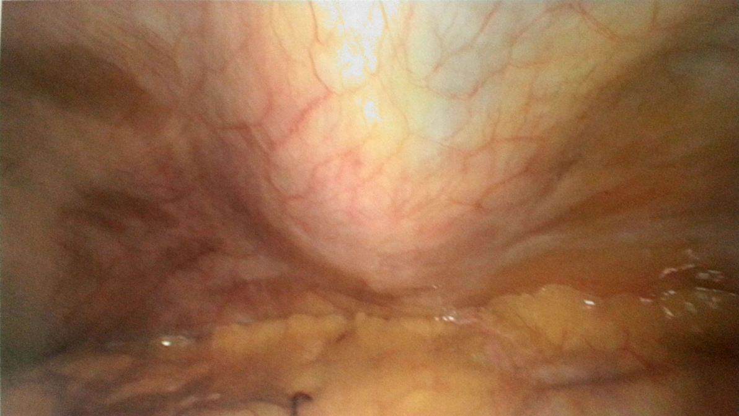
FIG 1: Doyle’s internal bulge sign
Ultrasound guided TAP blocks:
With the help of a liner ultrasound probe different layers of anterior abdominal wall are identified. A needle is then proceeded carefully keeping the track of its tip with ultrasound and stopped when the tip reaches the transverse abdominal plane. 10 cc of 0.25% Bupivacaine is the injected slowly in this plane.
As in case of laparoscopic assisted, the ultrasound guided TAP block will also be performed bilaterally by infiltrating 0.25% Bupivacaine at four points (10 cc at each site):
- Bilaterally 2 cm below costal margin in anterior axillary line.
- Bilaterally 2 cm above iliac crest in mid-axillary line.
Laparoscopic appenicectomy:
A standard 3 port technique laparoscopic appendicectomy is done in all cases using 2 X 10 mm ports and 1 X 5 mm port. Port placement could slightly vary according to the surgeon’s preference.

DATA COLLECTION METHOD:

120 total patients were enrolled with 60 in each group. Sample size calculation was based on primary outcome variable i.e post-operative pain. Alpha value of 0.05, power of 80% and standard deviation of 1.96 (Confidence Interval 95%) were utilized to calculate the sample size. GROUP A comprised of patients receiving laparoscopically administered TAP blocks and GROUP B included those having ultrasound guided TAP blocks.
Block randomization technique was used and both the patients and outcome assessors were not aware of the randomization arm (Double blinded). The patients fulfilling the inclusion and exclusion criteria, were enrolled after informed consent.
All patients underwent laparoscopic appendicectomy by a standard 3 port technique. All procedures were done by skilled post graduate residents or consultants. Laparoscopic or ultrasound guided TAP blocks were infiltrated after giving general anesthesia and before proceeding with appendicectomy according to randomization and study protocol.
Post-operative pain was assessed on visual analog scale 1-10, and was measured at 1, 4 and 6 hours postoperatively to assess pain severity at these intervals, and post-operative opioid analgesia (Nalbuphine Intravenous) requirement was measured. Duration of post-operation hospital stay in hours was calculated from time of completion of surgery to the time of discharge. Data was collected on study-specific proforma (see specimen after references).

DATA ANALYSIS:
(Please write down this part that how the data was analysed)
Methodology: 120 total patients were enrolled with 60 in each group. Sample size calculation was based on primary outcome variable i.e post-operative pain. GROUP A comprised of patients receiving laparoscopically administered TAP blocks and GROUP B included those having ultrasound guided TAP blocks. All data were entered and analyzed by using SPSS version 20, and our confidence level was 95%, meaning that p-value < 0.05 will be considered as significant. For this analysis we would be using the independent sample t test. This is because we have 2 groups, and we want to test if there is any difference in their means. (ANOVA would have been the second option, if we had 3 or more groups). The descriptive statistics of the demographic variables (gender and ages) would be given as well as the ANOVA tables for each hypothesis as well as a detailed interpretations.

Results and Interpretations
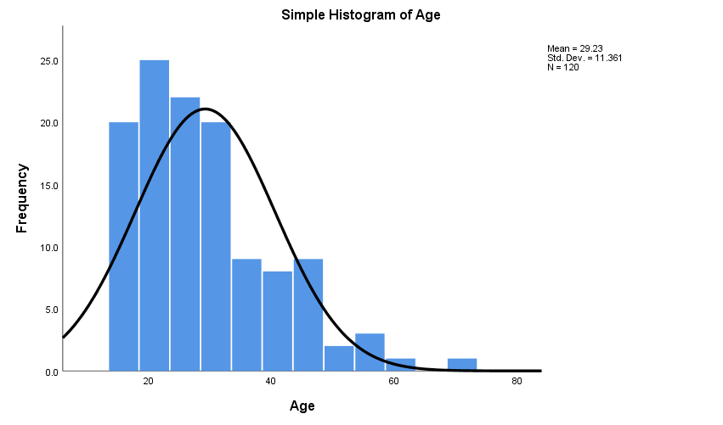
Figure 1: Showing age distribution of respondents. From the graph, we can deduce that magority of the respondents were 20 years old.
Table 1
Gender
 |  | Frequency | Percent | Valid Percent | Cumulative Percent
Valid | M | 73 | 60.8 | 60.8 | 60.8
Valid | F | 47 | 39.2 | 39.2 | 100.0
Valid | Total | 120 | 100.0 | 100.0

Table 1 shows the frequency distribution of respondents gender, from the table, it is noticeable that most of the respondents where male (60.8%) while 39.2% claimed to be female.
Next, is to carry out an alalysis to check if there is any mean difference between the two groups in terms of pain score ( 1, 4, ang 6), total Nalbuphine used by each groups as well as the hospital stay for each groups .
Table 2
Independent Samples Test
 |  | Levene's Test for Equality of Variances |  | t-test for Equality of Means
 |  | F | Sig. | t | df | Sig. (2-tailed) | Mean Difference | Std. Error Difference | 95% Confidence Interval of the Difference
 |  |  |  |  |  |  |  |  | Lower | Upper
Nalbuphine | Equal variances assumed | .024 | .876 | .576 | 118 | .566 | 1.750 | 3.041 | -4.271 | 7.771
Nalbuphine | Equal variances not assumed |  |  | .576 | 118.000 | .566 | 1.750 | 3.041 | -4.271 | 7.771

Table 2 is the first hypothesis (H1), tested with an independent samples t-test, showing a non statistically significant difference between the two groups A = (n = 60, M = 20.75 SD = 16.668) and B = (n = 60, M =19.00, SD = 16.642) in comparison to the total Nalbuphine used t(118) = 0.566, p > 0.05. Levene’s test indicated equal variances (F = 0.024, p = 0.876), This showed that there is no statistically significant difference between the total Nalbuphine used between the two groups, hence, the null hypothesis for H1 is not rejected since p > 0.05.

Table 3
Independent Samples Test
 |  | Levene's Test for Equality of Variances |  | t-test for Equality of Means
 |  | F | Sig. | t | df | Sig. (2-tailed) | Mean Difference | Std. Error Difference | 95% Confidence Interval of the Difference
 |  |  |  |  |  |  |  |  | Lower | Upper
Duration | Equal variances assumed | .150 | .699 | -.183 | 118 | .855 | -.667 | 3.653 | -7.900 | 6.567
Duration | Equal variances not assumed |  |  | -.183 | 117.905 | .855 | -.667 | 3.653 | -7.900 | 6.567

Table 3 the independent t test, it shows a non statistically significant difference between the two groups A = (n = 60, M = 36.52, SD = 19.720) and B = (n = 60, M =37.18, SD = 20.289) in comparison to the total duration spent in the hospital, we can see that ther was no statistically significant, t(118) = 0.855, p > 0.05. Levene’s test indicated equal variances (F = 0.150, p = 0.699), This showed that there is no statistically significant difference between the total duration spent in the hospital between the two groups, hence, the null hypothesis for H2 is not rejected since p > 0.05.

Table 4
Independent Samples Test
 |  | Levene's Test for Equality of Variances |  | t-test for Equality of Means
 |  | F | Sig. | t | df | Sig. (2-tailed) | Mean Difference | Std. Error Difference | 95% Confidence Interval of the Difference
 |  |  |  |  |  |  |  |  | Lower | Upper
Pain Score @ 1h | Equal variances assumed | .397 | .530 | .209 | 118 | .834 | .067 | .318 | -.564 | .697
Pain Score @ 1h | Equal variances not assumed |  |  | .209 | 116.197 | .834 | .067 | .318 | -.564 | .697

Table 4 shows a non statistically significant difference between the two groups A = (n = 60, M = 1.87, SD = 1.631) and B = (n = 60, M =1.80, SD = 1.848) in comparison to the Pain Score @ 1h, we can see that there was no statistically significant, t(118) = 0.855, p > 0.05. Levene’s test indicated equal variances (F = 0.209 p = 0.834), This showed that there is no statistically significant difference between the Pain Score @ 1h between the two groups, hence, the null hypothesis for H3 is not rejected since p > 0.05.

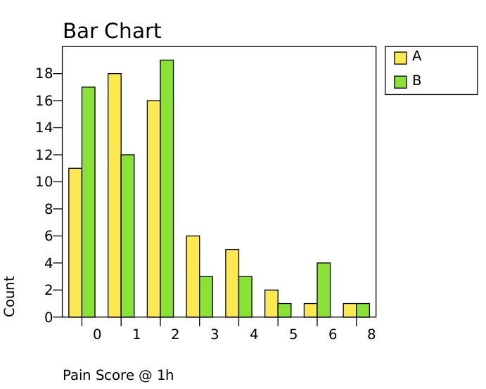

Table 5
Independent Samples Test
 |  | Levene's Test for Equality of Variances |  | t-test for Equality of Means
 |  | F | Sig. | t | df | Sig. (2-tailed) | Mean Difference | Std. Error Difference | 95% Confidence Interval of the Difference
 |  |  |  |  |  |  |  |  | Lower | Upper
Pain Score @ 4h | Equal variances assumed | 4.830 | .030 | .446 | 118 | .657 | .150 | .337 | -.517 | .817
Pain Score @ 4h | Equal variances not assumed |  |  | .446 | 105.222 | .657 | .150 | .337 | -.518 | .818
Table 5 is the forth hypothesis (H4), tested with an independent samples t-test, it shows a non statistically significant difference between the two groups A = (n = 60, M = 2.58, SD = 2.142) and B = (n = 60, M =2.43, SD = 1.489) in comparison to the Pain Score @ 4h, we can see that there was no statistically significant, t(118) = 0.657, p > 0.05. Levene’s test indicated unequal variances (F = 4.830, p = 0.030), This showed that there is no statistically significant difference between the Pain Score @ 4h between the two groups, hence, the null hypothesis for H4 is not rejected since p > 0.05.

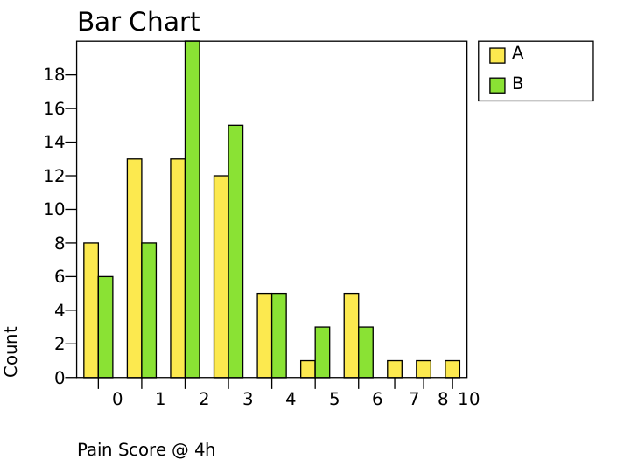

Table 6
Independent Samples Test
 |  | Levene's Test for Equality of Variances |  | t-test for Equality of Means
 |  | F | Sig. | t | df | Sig. (2-tailed) | Mean Difference | Std. Error Difference | 95% Confidence Interval of the Difference
 |  |  |  |  |  |  |  |  | Lower | Upper
Pain Score @ 6h | Equal variances assumed | .536 | .465 | -.636 | 118 | .526 | -.267 | .419 | -1.097 | .564
Pain Score @ 6h | Equal variances not assumed |  |  | -.636 | 117.420 | .526 | -.267 | .419 | -1.097 | .564
Table 6 is the fifth hypothesis (H5), tested with an independent samples t-test, it shows a non statistically significant difference between the two groups A = (n = 60, M = 3.25, SD = 2.214) and B = (n = 60, M =3.52, SD = 2.376) in comparison to the Pain Score @ 6h, we can see that there was no statistically significant, t(118) = 0.526, p > 0.05. Levene’s test indicated equal variances (F = 0.536, p = 0.465), This showed that there is no statistically significant difference between the Pain Score @ 6h between the two groups, hence, the null hypothesis for H5 is not rejected since p > 0.05.

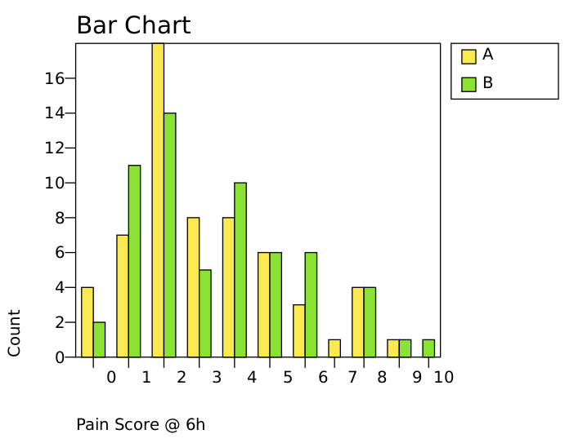

Table 7: Summary table for the five hypothesis test
 | Means of each Groups |  | P-value
Variables | A | B
Nalbuphine used | 20.75 | 19.00 | 0.566
Duration in the hospital | 36.52 | 37.18 | 0.855
Pain Score @ 1h | 1.87 | 1.80 | 0.855
Pain Score @ 4h | 2.58 | 2.43 | 0.657
Pain Score @ 6h | 3.25 | 3.52 | 0.526

As seen above, the p-values are > 0.05, hence, the means of the two groups are not significant different from each other.

CONCLUSION:
The aim of this study was to compare the efficacy of laparoscopically administered versus ultrasound guided TAP blocks in adult patients undergoing laparoscopic appendicectomy to control post-operative pain. To check if laparoscopic assisted TAP blocks are found to be equally effective as ultrasound guided ones, the need of additional time, expertise and equipment required to perform ultrasound guided blocks could be eliminated. The survey was carried out and data collected was analyzed using SPSS. From the analysis conducted, it was observed that majority of the respondents were 20 years old, with 60.8% of male and 39.2% female. Five different hypothesis test was carried out for the two groups on the total Nalbuphine used, Duration spent in the hospital, Pain Score @ 1h, Pain Score @ 4h and Pain Score @ 6h. From the ANOVA, The F-test is used for determining whether the variances of two samples (or groups) differ from each other. And Sig means significant value. And from the results, we could see that there was no statistical significant relationship between the two groups for all these variables. (at 95% confidence level). Therefore, we can conclude that TAP blocks administered by Laparoscopic technique will be equally effective in controlling post-op pain and reducing opioid analgesia requirement as those given with ultrasound guidance in the patients undergoing laparoscopic appendectomy.

REFERENCES:
- Sauerland S, Jaschinski T, Neugebauer EA. Laparoscopic versus open surgery for suspected appendicitis. Cochrane Database Systematic Review 2010; 10: CD001546.
- Crozier TA. Post-laparoscopy pain and pain relief. In: Croizer TA, ed. Anaesthesia for Minimally Invasive Surgery. Cambridge, PA: Cambridge University Press, 2004: 93–8.
- Rafi AN. Abdominal field block:A new approach via the lumbar triangle. Anaesthesia. 2001;56(10):1024–6.
- Siddiqui MR, Sajid MS, Uncles DR, Cheek L, Baig MK. A meta-analysis on the clinical effectiveness of transversus abdominis plane block. J Clin Anesth. 2011;23(1):7–14.
- Uppal, V., Sancheti, S. & Kalagara, H. Transversus Abdominis Plane (TAP) and Rectus Sheath Blocks: a Technical Description and Evidence Review. Curr Anesthesiol Rep 9, 479–487
- Magee C, Clarke C, Lewis A. Laparoscopic TAP block for laparoscopic cholecystectomy:Description of a novel technique. Surgeon. 2011;9(6):352–3.
- Rajanbabu A, Puthenveettil N, Appukuttan A, Asok A. Efficacy of laparoscopic-guided transversus abdominis plane block for patients undergoing robotic-assisted gynaecologic surgery: A randomised control trial. Indian J Anaesth 2019;63:841-6
- Bashandy GM, Elkholy AH. Reducing postoperative opioid consumption by adding an ultrasound-guided rectus sheath block to multimodal analgesia for abdominal cancer surgery with midline incision. Anesthesiology and Pain Medicine. 2014;4:e18263.
- Elbahrawy K, El-Deeb A. Rectus sheath block for postoperative analgesia in patients with mesenteric vascular occlusion undergoing laparotomy: a randomized single-blinded study. Anesthesia, Essays and Researches. 2016;10:516–20.
- Abdelsalam K, Mohamdin OW. Ultrasound-guided rectus sheath and transversus abdominis plane blocks for perioperative analgesia in upper abdominal surgery: a randomized controlled study. Saudi Journal of Anaesthesia. 2016;10:25–8.
- Yassen K, Lotfy M, Miligi A, Sallam A, Hegazi EAR, Afifi M. Patient-controlled analgesia with and without transverse abdominis plane and rectus sheath space block in cirrhotic patients undergoing liver resection. Journal of Anaesthesiology, Clinical Pharmacology. 2019;35:58–64.
- Humes DJ, Simpson J. Acute appendicitis. BMJ. 2006;333(7567):530–534.
- Ahn SR, Kang DB, Lee C, Park WC, Lee JK. Postoperative pain relief using wound infiltration with 0.5% bupivacaine in single-incision laparoscopic surgery for an appendectomy. Ann Coloproctol. 2013;29(6):238–242.
- Elamin G., Waters P.S., Hamid H., O'Keeffe H.M., Waldron R.M., Duggan M., Khan W. Efficacy of a Laparoscopically Delivered Transversus Abdominis Plane Block Technique during Elective Laparoscopic Cholecystectomy: A Prospective, Double-Blind Randomized Trial . Journal of the American College of Surgeons. 2015; 221 (2) , pp. 335-344.

EFFICACY OF LAPAROSCOPICALLY ADMINISTERED VERSUS ULTRASOUND GUIDED TRANSVERSE ABDOMINAL PLANE (TAP) BLOCKS IN ADULT PATIENTS UNDERGOING LAPAROSCOPIC APPENDICECTOMY TO CONTROL POST-OPERATIVE PAIN
DATA COLLECTION PROFORMA
GROUP : A / B
HOSPITAL REGISTRATION No. /MRN:_________________
AGE: __________________ SEX: M / F
DATE OF ADMISSION: _______________________________________
DATE & TIME OF COMPLETION OF SURGERY: __________________________________
DATE & TIME OF DISCHARGE: _______________________________________
DURATION OF HOSPITAL STAY: _________________ Hours
TOTAL OPIOID ANALGESIA (NALBUPHINE) GIVEN IN POST-OP PERIOD: __________ mgs
PAIN SCORE ON VISUAL ANALOGUE SCALE:

POST-OP HOUR | PAIN SCORE (as told by patient)
1
4
6

