Research and Evidence (RE) Module – Vertical Module

Introduction
People of all ages, until the middle of the last century, died from diseases that nowadays can be prevented by vaccines. A Vaccine-preventable disease is the best synonym that can accompany the names of each of those diseases(1). Infants, in particular, were contributing the highest mortality as for their undeveloped immune system in the United States, for example, deaths from polio infection reached 1904 cases in 1950(1). Diseases such as measles, diphtheria, smallpox, and pertussis topped the list of childhood killers. Nevertheless, since the discovery of vaccination, many of those diseases were contained. Smallpox infection, for example, has been eradicated (1). Immunization is the process whereby a person is made immune or resistant to an infectious disease, typically by the administration of a vaccine(2). immunity to a disease is achieved when the body synthesizes specific proteins called antibodies, which act against a particular disease. Antibodies are disease-specific. For example, the measles antibody will protect a person who is exposed to measles disease but will not other diseases. Immunity is two types, active immunity and passive immunity. Active immunity is what vaccines act through. Vaccines will trick the body into believing it has a real disease so that the body will synthesize antibodies, synthesis of the body's own antibodies rather than receiving it readily from the outside as in the passive immunity is why it is called active immunity Active immunity lasts long, and sometimes it lasts for life (2, 3)

Objectives:
1. To assess the knowledge and attitude and practice regarding nonobligatory vaccines.
2. To identify barriers and factors influencing uptake decision.
The research question is ; What is the prevalence of vaccine hesitancy among Makkah population, Saudi Arabia, 2020.

Hypothesis:
Vaccine hesitancy is more prevalent recently than in the previous findings.
Vaccine hesitancy is more prevalent in adult rather than in children.

Methodology:
A cross-sectional study will be conducted among adult (18 to 60 year old) residents population in Makkah city, who attend a two randomly selected hospitals (Maternity and Children Hospital, Hera'a General Hospital) as care givers during March, 2020. Participants will be subjected to a well-structured, Arabic- based, valid and reliable questionnaire. The questionnaire aims to evaluate vaccine hesitancy. It is an internet-based tool that consists of five sections. Statistical Package for the Social Sciences (SPSS), version 21.0. was used to analyses the questionnaire. Section one is concerned with demographic information such as age, sex, educational level, economic status, chronic illnesses, and nationality, it would be analyses using the descriptive statistics, this would enable us see the frequency distribution of the data. Section two is concerned with the knowledge of participants’ perception regarding vaccinations, and their source of knowledge. Sections three is where participants are asked to state their attitudes towards vaccination. Section four is focused on the compliance of vaccination. And the last section concentrates on reasons of hesitancy if present. The remaining sections would be analyzed using the Cross Tabulations and the ANOVA test, so that we can see the interactions between the participants perception regarding vaccinations and their hesitancy if present.

Analysis and Results:

Socio-Demographic data analysis

Table 1
Participant
 |  |  | Frequency |  | Percent |  | Valid Percent |  | Cumulative Percent
Valid | Adult | 199 |  | 76.0 |  | 76.0 |  | 76.0
Valid | Parent | 63 |  | 24.0 |  | 24.0 |  | 100.0
Valid | Total | 262 |  | 100.0 |  | 100.0

Table 1, is the frequency distribution of participants in the survey, form the table, it is observed that 76% of the participants were adults, and 24% were parents. The visualization is seen below.

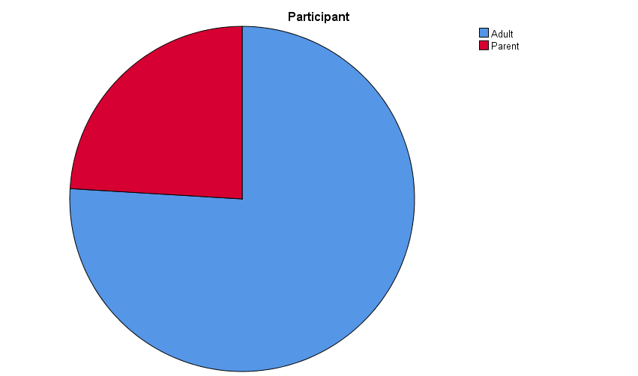

Table 2
Gender
 |  | Frequency | Percent | Valid Percent | Cumulative Percent
Valid | Male | 51 | 19.5 | 19.5 | 19.5
Valid | Female | 211 | 80.5 | 80.5 | 100.0
Valid | Total | 262 | 100.0 | 100.0

Table 2, is the frequency distribution of participants Gender, form the table, it is observed that 19.5% of the participants were Male, and 80.5% were Females. The visualization is seen below.

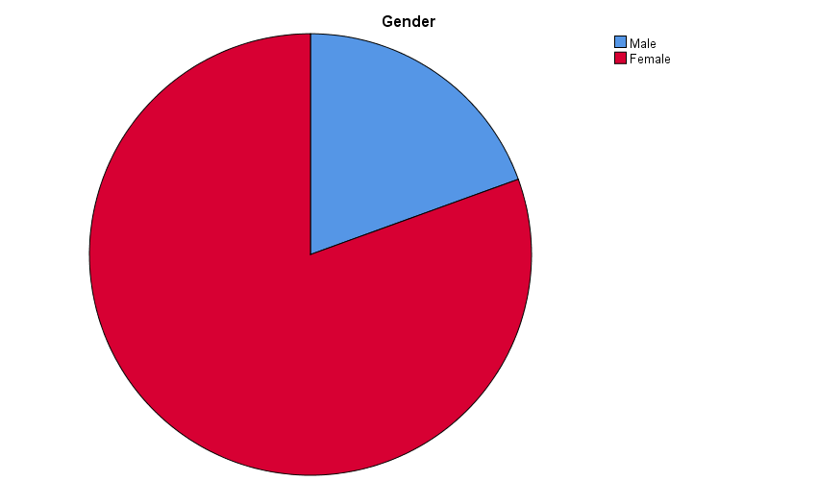

Table 3
Nationality
 |  | Frequency | Percent | Valid Percent | Cumulative Percent
Valid | Saudi | 253 | 96.6 | 96.6 | 96.6
Valid | Non-Saudi | 9 | 3.4 | 3.4 | 100.0
Valid | Total | 262 | 100.0 | 100.0

Table 3, is the frequency distribution of participants Nationality, form the table, it is observed that 96.6% of the participants were from Saudi, and 3.4% were none Saudi’s. The visualization is seen below.

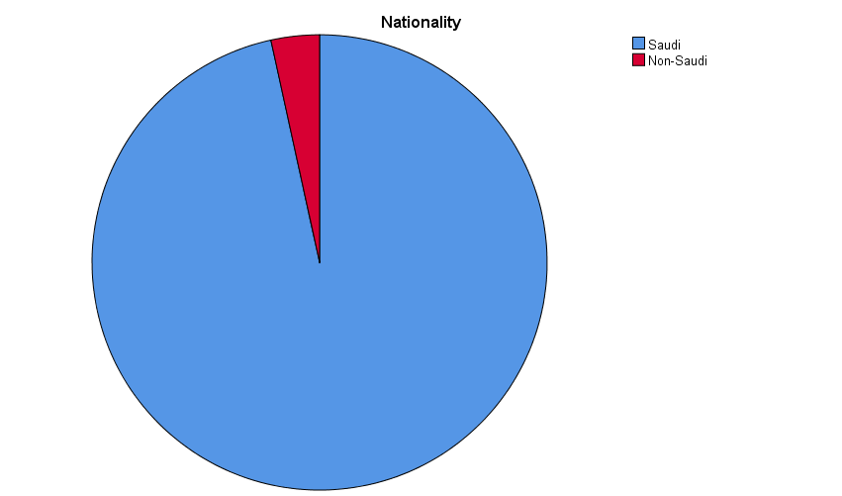

Table 4
Educational Level
 |  | Frequency | Percent | Valid Percent | Cumulative Percent
Valid | Secondary | 49 | 18.7 | 18.7 | 18.7
Valid | intermediate | 3 | 1.1 | 1.1 | 19.8
Valid | Bachelor | 198 | 75.6 | 75.6 | 95.4
Valid | Higher education studies | 12 | 4.6 | 4.6 | 100.0
Valid | Total | 262 | 100.0 | 100.0

Table 4, is the frequency distribution of participants Education Level, form the table, it is observed that 75.6% of the participants were Bachelor’s, and 1.1% were Intermediates. The visualization is seen below.
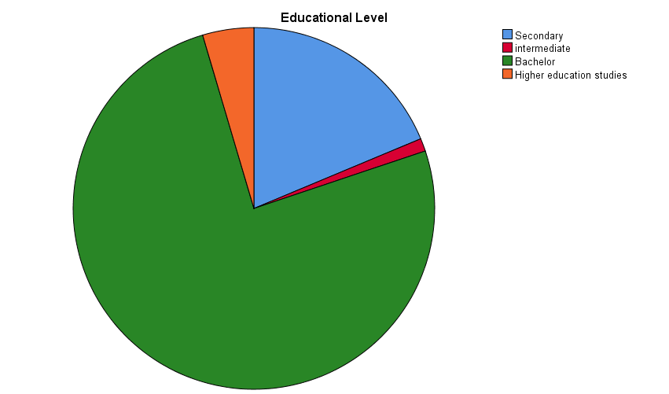

Table 5
Marital Status
 |  | Frequency | Percent | Valid Percent | Cumulative Percent
Valid | Single | 162 | 61.8 | 61.8 | 61.8
Valid | Married | 100 | 38.2 | 38.2 | 100.0
Valid | Total | 262 | 100.0 | 100.0

Table 4, is the frequency distribution of participants Marital Status, form the table, it is observed that 61.8% of the participants were Single, and 3.2% were Married. The visualization is seen below.

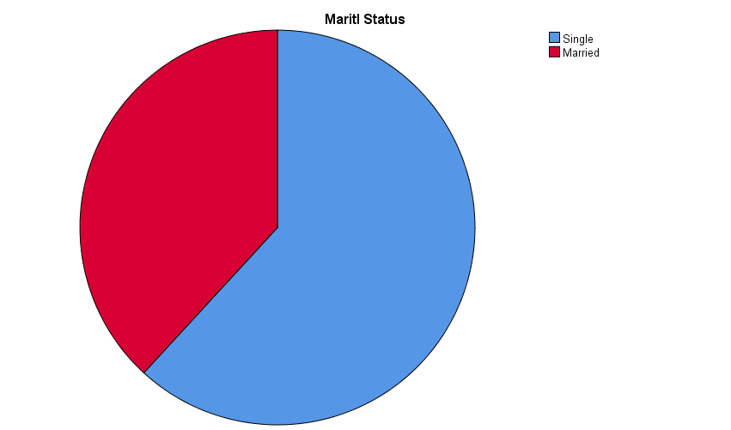

The table below assess the knowledge and attitude and practice regarding nonobligatory
vaccines.
S/N | Variables | Yes | No
1 | Do you think Vaccination are safe? | 254 (96.95) | 8 (3.05)
2 | Have you ever heard of seasonal influenza vaccine? | 241 (91.98) | 21 (8.02)
3 | Do you support vaccination against seasonal flu? | 229 (87.40) | 33 (12.60)
5 | Is there a possibility that you will take the seasonal flue vaccination after outbreak of Corona Virus (COVID 19) | 175 (66.79) | 87 (33.21)
6 | If there a new vaccine against the new Corona virus (COVID 19) , will you take it? | 227 (86.64) | 35 (13.36)

The table above shows the knowledge and attitude and practice regarding nonobligatory vaccines, from the table, we can see that 96% of the respondents thinks that vaccination are safe. Majority of the respondents, (91.98%) have never heard of seasonal influenza vaccine. 66.79 % said that there is possibility that they will take the seasonal flue vaccination after outbreak of Corona Virus (COVID 19)

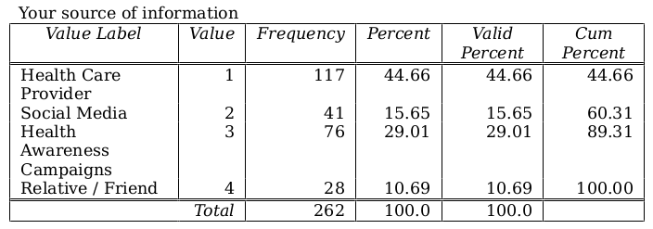
The table above shows the various sources of information about the seasonal influenza vaccine. Most of the respondents got the information from health care centers, and also via the social media.

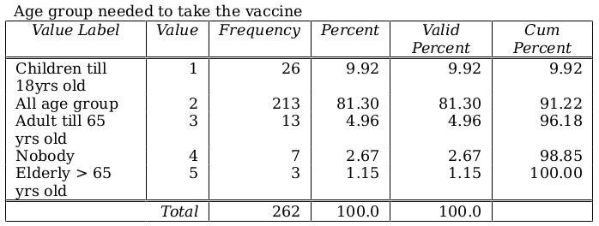
The table above shows the frequency distribution of age groups the participants thinks would need the seasonal influenza vaccine. Almost all the respondents (81.30%) believes that the seasonal influenza vaccine was meant for all age group. Only few of them thinks the seasonal influenza vaccine was for elderly ones of age 65 and above.

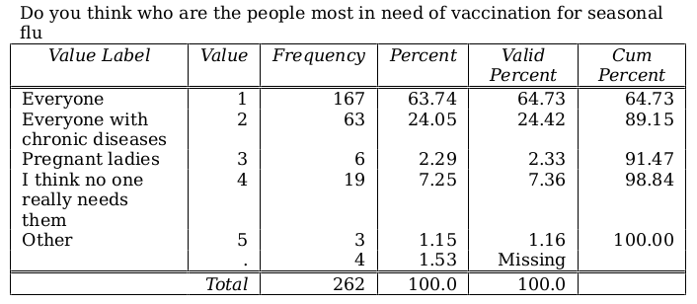
The table above shows the frequency distribution of different groups the people who needs the seasonal influenza vaccine. most all the respondents (63.74%) believes that the seasonal influenza vaccine was meant for everyone. 24.05% believes that the vaccine was meant for everyone with chronic diseases. 7.55% thinks no one really needs the vaccine.

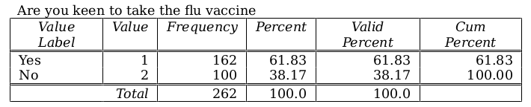
The table above shows the attitude and practice regarding the vaccines. 61.83% are keen to taking the flu vaccine while 38.17% were not.

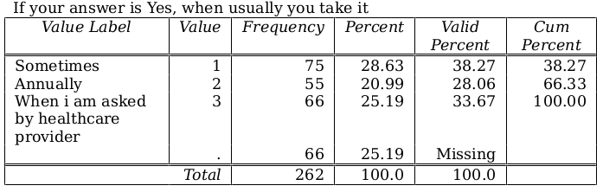
This table above is a consequence of the question asked before, for those who said yes to the previous question, we want to know how often they take the vaccines, from this table, we can see that 28.63% says that they take it sometimes, 20.99% says that they take it annually, 25.19% says that they take it when they are asked by an healthcare provider.

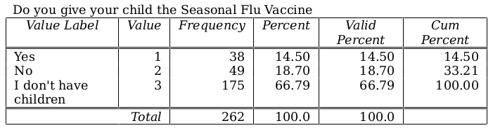
The table above shows the responds of respondents behaviors as regards giving their children the vaccines. Although 66.79% said they don’t have children, however, 18.70% said no to the question. And 14.50 said they do give their children the seasonal flu vaccine.

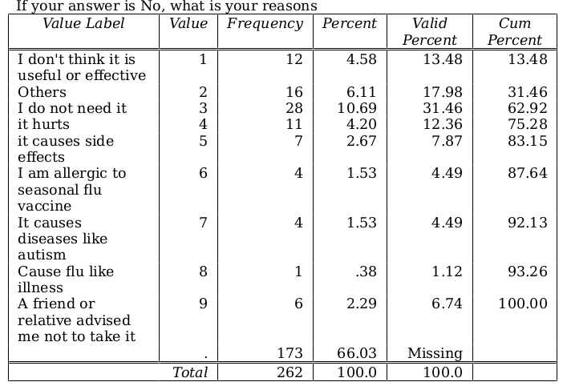

This table above is a consequence of the question asked before, for those who said no to the previous question, we want to know the reasons for their actions, from this table, we can see that 10.69% thinks they do not need it, 4.59% don’t think it is not useful or effective. 1.53% said they were allergic to seasonal flu vaccine, the same percentage of person also said that the vaccine causes diseases like autism.

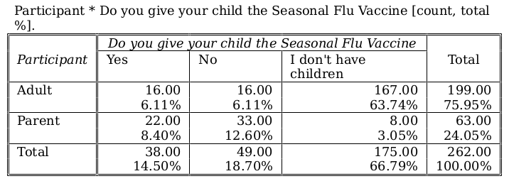

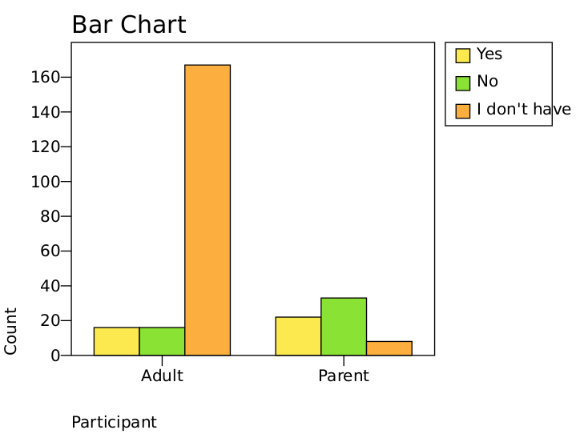

The table and graph above shows the cross tabulation of participants, some where adults while some where parents. Out of 66 parents, only 22 of them gives their children the seasonal flu vaccine, hence we can say that only 22 respondents had children. And out of 199 respondents who are adults, only 16 of them gave their children the vaccine. Most of the adults don’t have children.

Hypothesis 1:
H0: There is no significant interaction between participants different age groups and their willingness to accepts the introduction of a new vaccine against corona.
H1: There is a significant interaction between participants different age groups and their willingness to accepts the introduction of a new vaccine against corona.

Decision Rule: Reject H0 if p-value is < 0.05

Age group needed to take the vaccine * If there is a new vaccine against the new Corona Virus (COVID19), will you take it Cross-tabulation
 |  |  | If there is a new vaccine against the new Corona Virus (COVID19), will you take it |  | Total
 |  |  | Yes | No | Total
Age group needed to take the vaccine | Children till 18yrs old | Count | 24 | 2 | 26
Age group needed to take the vaccine | Children till 18yrs old | Expected Count | 22.5 | 3.5 | 26.0
Age group needed to take the vaccine | All age group | Count | 188 | 25 | 213
Age group needed to take the vaccine | All age group | Expected Count | 184.5 | 28.5 | 213.0
Age group needed to take the vaccine | Adult till 65 yrs old | Count | 10 | 3 | 13
Age group needed to take the vaccine | Adult till 65 yrs old | Expected Count | 11.3 | 1.7 | 13.0
Age group needed to take the vaccine | Nobody | Count | 2 | 5 | 7
Age group needed to take the vaccine | Nobody | Expected Count | 6.1 | .9 | 7.0
Age group needed to take the vaccine | Elderly > 65 yrs old | Count | 3 | 0 | 3
Age group needed to take the vaccine | Elderly > 65 yrs old | Expected Count | 2.6 | .4 | 3.0
Total |  | Count | 227 | 35 | 262
 |  | Expected Count | 227.0 | 35.0 | 262.0

The Cross Tabulation table above, shows the interaction between participants different age groups and their willingness to accepts the introduction of a new vaccine against corona. From the table, giving the distribution of age groups, we would have expected 22.5 of the respondents of the children till 18 years old to say yes, to taking a new vaccine against corona virus if introduced, however, from the survey, the count we had was 24, which is more than than what we expected, (this is a good one). Also we would have expected that 6.1 individuals would not take the new vaccine against the new Corona Virus (COVID19), but surprisingly only 2 was counted. However, we expected that people in age group of 65 who says no to a new vaccine should be 1.7, but we rather counted 3 persons. to further show the significant of this claim, we have the Chi Squared test below.

Chi-Square Tests
 | Value | df | Asymptotic Significance (2-sided)
Pearson Chi-Square | 23.123ª | 4 | .000
Likelihood Ratio | 15.423 | 4 | .004
Linear-by-Linear Association | 8.586 | 1 | .003
N of Valid Cases | 262
a. 5 cells (50.0%) have expected count less than 5. The minimum expected count is .40.

conclusion: The table above is the Chi square test for the Cross tabulation, from the table, we can deduce that the p-value is 0.00 which is < 0.05, hence we conclude that there is a significant interaction between participants different age groups and their willingness to accepts the introduction of a new vaccine against corona.

Hypothesis 2:
H0: There is no significant interaction between parents giving their child seasonal flue vaccine or not and their motivation behind their choice.
H1: There is a significant interaction between parents giving their child seasonal flue vaccine or not and their motivation behind their choice.

Decision Rule: Reject H0 if p-value is < 0.05

Do you give your child the Seasonal Flu Vaccine Cross-tabulation * If your answer is No, what is your reasons
 |  |  | Do you give your child the Seasonal Flu Vaccine |  |  | Total
 |  |  | Yes | No | I don't have children | Total
If your answer is No, what is your reasons | I don't think it is useful or effective | Count | 0 | 8 | 4 | 12
If your answer is No, what is your reasons | I don't think it is useful or effective | Expected Count | .7 | 6.1 | 5.3 | 12.0
If your answer is No, what is your reasons | Others | Count | 0 | 7 | 9 | 16
If your answer is No, what is your reasons | Others | Expected Count | .9 | 8.1 | 7.0 | 16.0
If your answer is No, what is your reasons | I do not need it | Count | 0 | 16 | 12 | 28
If your answer is No, what is your reasons | I do not need it | Expected Count | 1.6 | 14.2 | 12.3 | 28.0
If your answer is No, what is your reasons | it hurts | Count | 2 | 4 | 5 | 11
If your answer is No, what is your reasons | it hurts | Expected Count | .6 | 5.6 | 4.8 | 11.0
If your answer is No, what is your reasons | it causes side effects | Count | 2 | 3 | 2 | 7
If your answer is No, what is your reasons | it causes side effects | Expected Count | .4 | 3.5 | 3.1 | 7.0
If your answer is No, what is your reasons | I am allergic to seasonal flu vaccine | Count | 1 | 1 | 2 | 4
If your answer is No, what is your reasons | I am allergic to seasonal flu vaccine | Expected Count | .2 | 2.0 | 1.8 | 4.0
If your answer is No, what is your reasons | It causes diseases like autism | Count | 0 | 2 | 2 | 4
If your answer is No, what is your reasons | It causes diseases like autism | Expected Count | .2 | 2.0 | 1.8 | 4.0
If your answer is No, what is your reasons | Cause flu like illness | Count | 0 | 0 | 1 | 1
If your answer is No, what is your reasons | Cause flu like illness | Expected Count | .1 | .5 | .4 | 1.0
If your answer is No, what is your reasons | A friend or relative advised me not to take it | Count | 0 | 4 | 2 | 6
If your answer is No, what is your reasons | A friend or relative advised me not to take it | Expected Count | .3 | 3.0 | 2.6 | 6.0
Total |  | Count | 5 | 45 | 39 | 89
 |  | Expected Count | 5.0 | 45.0 | 39.0 | 89.0

The Cross Tabulation table above, shows the interaction between parents giving their child seasonal flue vaccine or not and their motivation behind their choice. From the table, giving the distribution of participants who do not give their child the Seasonal Flu Vaccine, we would have expected 6.1 of the respondents don't think it is useful or effective, however, from the survey, the count we had was 8, which is more than than what we expected, (this is not a good one). Also we would have expected that count of 3 individuals whose friend or relative advised them not to take it, but surprisingly 4 that was counted. This shows the perception of participants regarding vaccinations and their hesitancy, to further show the significant of this claim, we have the Chi Squared test below.

Chi-Square Tests
 | Value | df | Asymptotic Significance (2-sided)
Pearson Chi-Square | 21.138ª | 16 | .173
Likelihood Ratio | 19.673 | 16 | .235
Linear-by-Linear Association | .303 | 1 | .582
N of Valid Cases | 89
a. 20 cells (74.1%) have expected count less than 5. The minimum expected count is .06.

conclusion: The table above is the Chi square test for the Cross tabulation, from the table, we can deduce that the p-value is 0.173 which is > 0.05, hence we do not reject H0, and the conclude that there is no significant significant interaction between parents giving their child seasonal flue vaccine or not and their motivation behind their choice.

Conclusion
A vaccine is a biological preparation that provides active acquired immunity to a particular infectious disease. From the research made we observed that majority of the respondents, (91.98%) have never heard of seasonal influenza vaccine, hence, we recommend that drastic measures should be taking in creating more awareness by increasing the campaigns among relatives and friends. Also, the research pointed to the fact that out of 262 respondents, only 162 persons were keen to taking the flu vaccine, hence, the need and importance of the vaccine must be made known to more people. When we looked at the age group who needed this vaccine more, most of the respondents (81.30%) believes that the seasonal influenza vaccine was meant for all age group. Only few of them thinks the seasonal influenza vaccine was for elderly ones of age 65 and above. Therefore we can say that Vaccine hesitancy is not more prevalent recently than in the previous findings. Also, most parents didn’t see the need to give their children the seasonal flu vaccine, from the analysis we could see that Out of 66 parents, only 22 of them gives their children the seasonal flu vaccine. We recommend more awareness to be made, so parents can see the health benefit of the seasonal flu vaccine.

Discussion
Following the objectives of the study, The questionnaire aims to evaluate vaccine hesitancy. Section one was concerned with demographic information such as age, sex, educational level, economic status, chronic illnesses, and nationality, and it was analyzed using the descriptive statistics, this enable us see the frequency distribution of the data. From the analysis, out of a total participants of 262, it was recorded that 76% of the participants were adults, and 24% were parents. We had 19.5% of the participants Male, and 80.5% Females. On the nationality level, 96.6% of the participants were from Saudi, and 3.4% were none Saudi’s. On the education level, 4.8% were higher school students, 75.6% of the participants were Bachelor’s, and 1.1% were Intermediates. Few of the respondents were Married, as we had 61.8% of the participants that were Single. Section two was concerned with the knowledge of participants’ perception regarding vaccinations, and their source of knowledge. Sections three was where participants were asked to state their attitudes towards vaccination. Section four is focused on the compliance of vaccination. And the last section concentrates on reasons of hesitancy if present. The remaining sections were analyzed using the Cross Tabulations and the ANOVA test, so that we could see the interactions between the participants perception regarding vaccinations and their hesitancy if present. The first hypothesis was to check if there was a significant interaction between participants different age groups and their willingness to accepts the introduction of a new vaccine against corona. From the Cross tabulation table, giving the distribution of age groups, we would have expected 22.5 of the respondents of the children till 18 years old to say yes, to taking a new vaccine against corona virus if introduced, however, from the survey, the count we had was 24, which is more than than what we expected, Also we would have expected that 6.1 individuals would not take the new vaccine against the new Corona Virus (COVID19), but surprisingly only 2 was counted. This shows that many people are not hesitating to take the new vaccine when introduced, to further show the significant of this claim, we had the Chi Squared test p-value of 0.00 which is < 0.05, that gave us enough evidence to conclude that the prevalence of vaccine hesitancy among Makkah population is low. This is also confirmed by a study made by Manika Suryadevara and Joseph B Domachowske on the Department of Pediatrics on the Influenza vaccine hesitancy in a low-income community in central New York State (10). From their study, it was stared that At the time of study enrollment, 386 (37%) participants had already received 2012–13 IV. Of the 655 unimmunized participants, 299 (46%) stated intent to receive 2012–13 IV, 312 (30%) stated they had no intent to receive IV, and 44 (4%) were unsure about their intent. There was even distribution of IV hesitancy among the different age groups, genders, and ethnicity Of the 299 participants who intended to receive vaccine but had not yet done so, 284 (95%) stated the reason for delay was difficult access to vaccine (cost, lack of insurance, no doctor, or no time). Of the 128/299 participants who provided reasons for having intent to receive vaccine, the majority (94,) did so for protection of self and/or family. In general, the younger age groups were more likely than the elders (P < 0.01). This is similar to our result gotten from the first hypothesis, we observed that there was a significant interaction between participants different age groups and their willingness to accepts the introduction of a new vaccine against corona. From the test carried out, we could see that the younger age groups were more likely than the elders with (P = 0.00). The second hypothesis was to test whether there was is a significant interaction between parents giving their child seasonal flue vaccine or not and their motivation behind their choice. From the Cross tabulation table, giving the distribution of participants who do not give their child the Seasonal Flu Vaccine, we would have expected 6.1 of the respondents don't think it is useful or effective, however, from the survey, the count we had was 8, which is more than than what we expected, (this is not a good one). Also we would have expected that count of 3 individuals whose friend or relative advised them not to take it, but surprisingly 4 that was counted. Furthermore, the Chi square test gave a p-value of 0.173 which is > 0.05, hence hull hypothesis was nut rejected, and we conclude that there is no significant significant interaction between parents giving their child seasonal flue vaccine or not and their motivation behind their choice. We can buttress this with a study from Abdullah A. Alabbad abd Abdulaziz K. Alsaad on the Prevalence of influenza vaccine hesitancy at a tertiary care hospital in Riyadh, Saudi Arabia (11) (12), their study reveals that Overall, 17% (n = 51) of participants completely refused influenza vaccination and were thus deemed vaccine-hesitant and this percentage is considered not significant, while 83% (n = 249) had been vaccinated in prior seasons or were planning to be vaccinated in the future Among the 51 participants who completely refused vaccination, the most common reasons for refusal were: “It doesn’t have any positive effect or benefit” (n = 11 [21.5%]), “I don’t need it because I’m healthy” (n = 9 [17.6%]), and “I think it causes serious side effects” (n = 7 [13.7%]). The also tallies with out the findings as we accessed the knowledge and attitude and practice regarding nonobligatory vaccines. From the table, we saw that 87% supported the use of vaccination against seasonal flu. While only 12.60% did not.

References:

1. Gangarosa EJ, Galazka AM, Wolfe CR, Phillips LM, Miller E, Chen RT, et al. Impact of anti-vaccine movements on pertussis control: the untold story. The Lancet. 1998;351(9099):356-61.
2. Anderson RM, May RM. Vaccination and herd immunity to infectious diseases. Nature. 1985;318(6044):323-9.
3. Lorini C, Santomauro F, Donzellini M, Capecchi L, Bechini A, Boccalini S, et al. Health literacy and vaccination: A systematic review. Human vaccines & immunotherapeutics. 2018;14(2):478-88.
4. Abalkhail MS, Alzahrany MS, Alghamdi KA, Alsoliman MA, Alzahrani MA, Almosned BS, et al. Uptake of influenza vaccination, awareness and its associated barriers among medical students of a University Hospital in Central Saudi Arabia. Journal of Infection and Public Health. 2017;10(5):644-8.
5. Fournet N, Mollema L, Ruijs WL, Harmsen IA, Keck F, Durand JY, et al. Under-vaccinated groups in Europe and their beliefs, attitudes and reasons for non-vaccination; two systematic reviews. BMC Public Health. 2018;18(1):196.
6. Drăgănescu A, Săndulescu O, Florea D, Vlaicu O, Streinu-Cercel A, Oțelea D, et al. The 2017–2018 influenza season in Bucharest, Romania: epidemiology and characteristics of hospital admissions for influenza-like illness. BMC Infectious Diseases. 2019;19(1):967.
7. MOH S. Statistical Yearbook. MOH website2018.
8. Alabbad AA, Alsaad AK, Al Shaalan MA, Alola S, Albanyan EA. Prevalence of influenza vaccine hesitancy at a tertiary care hospital in Riyadh, Saudi Arabia. Journal of Infection and Public Health. 2018;11(4):491- 9.
9. Mantel C, Chu SY, Hyde TB, Lambach P. Seasonal influenza vaccination in middle-income countries: Assessment of immunization practices in Belarus, Morocco, and Thailand. Vaccine. 2020;38(2):212-9.
10. Manika Suryadevara and Joseph B Domachowske on the Department of Pediatrics on the Influenza vaccine hesitancy in a low-income community in central New York State
11. Abdullah A. Alabbad abd Abdulaziz K. Alsaad on the Prevalence of influenza vaccine hesitancy at a tertiary care hospital in Riyadh, Saudi Arabia. Journal of Infection and Public Health.
12. Mohammed S. Abalkhail and Mohannad S. Alzahrany on the Uptake of influenza vaccination, awareness and its associated barriers among medical students of a University Hospital in Central Saudi Arabia. Journal of Infection and Public Health.

