Impact of Knowledge, attitude, and practice of Osteoporosis among adult population in Majmaah City, Saudi Arabia
INTRODUCTION
Osteoporosis is one of the major health concerns among the healthcare providers and relevant stakeholders. The disease has been on the rise in various countries across the globe. Osteoporosis is one of the most common metabolic infections affecting millions of people worldwide including the Kingdom of Saudi Arabia (ElTohami, Sami, Eidan, Mubarak, & Alotaibi, 2015). Improving awareness among the healthcare providers, such as physicians, is critical in the identification and provision of timely medical intervention to the affected individuals.
OBJECTIVE OF STUDY
The aim of this study is to evaluate the Impact of Knowledge, attitude, and practice of Osteoporosis among adult population in Majmaah City, Saudi Arabia.

RESEARCH METHODOLOGY
The study will leverage the community-based cross-sectional survey. The approach will be critical in determining the impact of beliefs, practice and attitude of the general population within the selected study area. The analysis part presents the demographic and inferential analysis techniques applied in estimating the impact of knowledge, attitude and practice of Osteoporosis among adult population in Majmaah city, Saudi Arabia. The analysis outputs are in the form of frequency tables, percentages, charts and T-test for difference of means, Mann-Whitney and Cronbach’s Alpha.

DEMOGRAPHIC CHARACTERISTICS OF THE RESPONDENTS
Table 1

Age
 |  | Frequency | Percent | Valid Percent | Cumulative Percent
Valid | 15-25 | 49 | 15.6 | 15.6 | 15.6
Valid | 26-35 | 91 | 28.9 | 28.9 | 44.4
Valid | 36-45 | 91 | 28.9 | 28.9 | 73.3
Valid | 46-55 | 53 | 16.8 | 16.8 | 90.2
Valid | More than 55 | 31 | 9.8 | 9.8 | 100.0
Valid | Total | 315 | 100.0 | 100.0

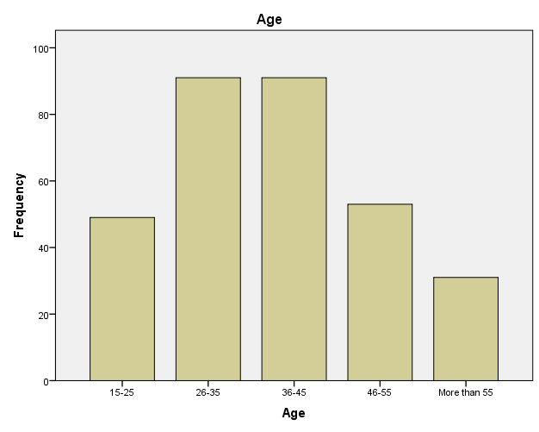
The above table 1 shows the distribution of age range of the respondents that participated in the study where 49(15.6%) of the respondents claimed to fall within the age range of 15-25years; 91(28.9%) each which also takes the largest percentage of the study population fall within the age range of 26-35years and 36-45years respectively while 53(16.8%) of these respondents claimed to fall within the age range of 46-55years and 31(9.8%) claimed to be more than 55years as at the time of this study.

Table 2

Gender
 |  | Frequency | Percent | Valid Percent | Cumulative Percent
Valid | Female | 105 | 33.3 | 33.3 | 33.3
Valid | Male | 210 | 66.7 | 66.7 | 100.0
Valid | Total | 315 | 100.0 | 100.0

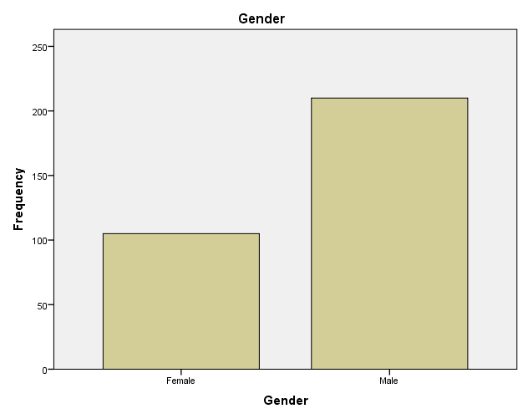
Table 2 above shows the distribution on the gender of the respondents that participated in the study where majority of the respondent which takes 210(66.7%) claimed to be male while 105(33.3%) claimed to be female. This ascertains the findings by Chan, et al., 2019; Amani, 2015 which shows that men tend to be more physically active as compared to their female counterpart.

Table 3
Nationality
 |  | Frequency | Percent | Valid Percent | Cumulative Percent
Valid | Non- Saudi | 89 | 28.3 | 28.3 | 28.3
Valid | Saudi | 226 | 71.7 | 71.7 | 100.0
Valid | Total | 315 | 100.0 | 100.0

Table 3 shows the distribution on nationality of the respondents and it was revealed that larger percentage of the respondents which account for 226(71.7%) of them claimed to be from Saudi while 89(28.3%) claimed to be Non-Saudi.

Table 4
Marital Status
 |  |  | Frequency |  | Percent |  | Valid Percent |  | Cumulative Percent
Valid | Divorced | 11 |  | 3.5 |  | 3.5 |  | 3.5
Valid | Married | 227 |  | 72.1 |  | 72.1 |  | 75.6
Valid | Single | 47 |  | 14.9 |  | 14.9 |  | 90.5
Valid | Widowed | 30 |  | 9.5 |  | 9.5 |  | 100.0
Valid | Total | 315 |  | 100.0 |  | 100.0

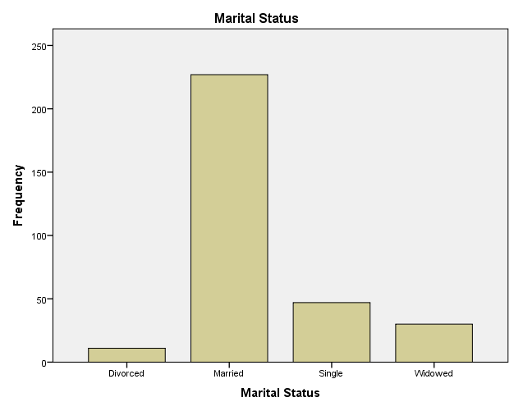

The above table 4 and chart shows that majority of the respondents that participated in the study which account for 227(72.1%) of them claimed to be married as at the time of this study; 47(14.9%) claimed to be single while 30(9.5%) claimed to be widowed and 11(3.5%) of these respondents claimed to be divorced.

Table 5

Level of Education
 |  | Frequency | Percent | Valid Percent | Cumulative Percent
Valid | Bachelor | 128 | 40.6 | 40.6 | 40.6
Valid | Intermediate | 47 | 14.9 | 14.9 | 55.6
Valid | Other | 78 | 24.8 | 24.8 | 80.3
Valid | Primary | 13 | 4.1 | 4.1 | 84.4
Valid | Secondary | 49 | 15.6 | 15.6 | 100.0
Valid | Total | 315 | 100.0 | 100.0

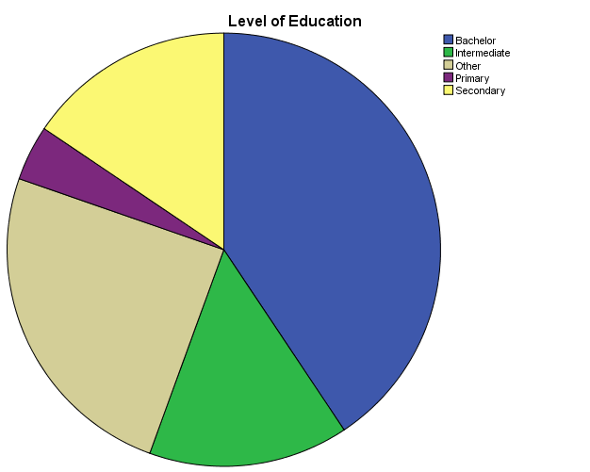

The above table 5 shows the distribution on the respondents level of education where it was revealed that largest percentage of 128(40.6%) of these total respondents claimed to have up to bachelors degree; 47(14.9%) claimed to be intermediate; 49(15.6%) of them claimed to have up to secondary school level while 13(4.1%) claimed to have only primary certificate and 78(24.8%) of these total respondents claimed to have other certificate aside from those mentioned above.

Table 6

Occupation
 |  | Frequency |  | Percent |  | Valid Percent |  | Cumulative Percent
Valid | Employed |  | 219 |  | 69.5 |  | 69.5 |  | 69.5
Valid | Unemployed |  | 96 |  | 30.5 |  | 30.5 |  | 100.0
Valid | Total |  | 315 |  | 100.0 |  | 100.0

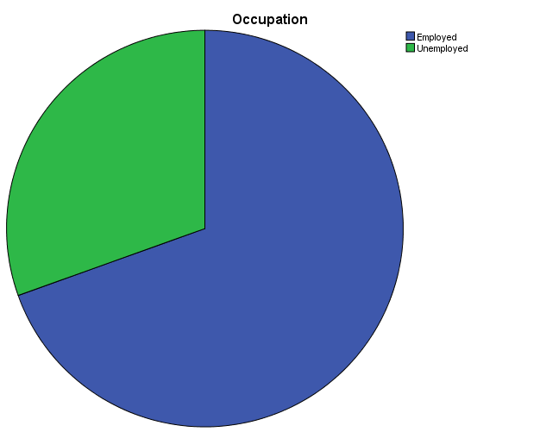

The above table 6 shows the responses of the respondents on if they are employed or not and it was revealed that majority of the respondents which account for 219(69.5%) of the respondents claimed they are employed while 96(30.5%) claimed to be unemployed as at the time of this study.
Table 7

Income Level
 |  | Frequency | Percent | Valid Percent | Cumulative Percent
Valid | 10,000- 15,0000 | 56 | 17.8 | 17.8 | 17.8
Valid | 3000- 5000 | 82 | 26.0 | 26.0 | 43.8
Valid | 5000- 10000 | 132 | 41.9 | 41.9 | 85.7
Valid | Above 15,000 | 24 | 7.6 | 7.6 | 93.3
Valid | Less than 3000 | 21 | 6.7 | 6.7 | 100.0
Valid | Total | 315 | 100.0 | 100.0

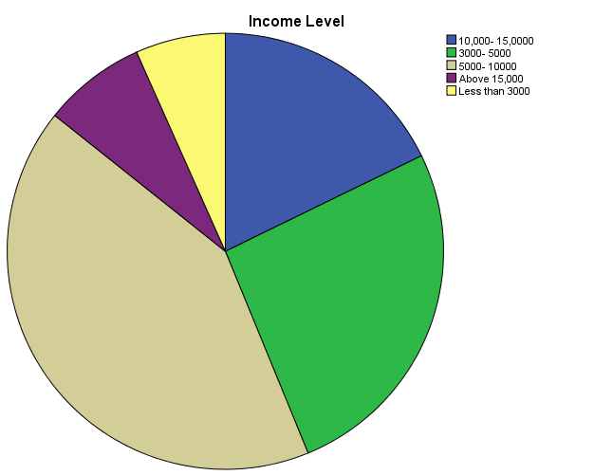

The above table 7 shows the income level of the respondents and it was revealed that 56(17.8%) of these respondents claimed to be earning between 10,000 – 15,000; 82(26.0%) claimed they earn between 3,000 – 5,000; 132(41.9%) which takes the largest percentage of the respondents claimed they earn between 5,000 – 10,000 while 24(7.6%) of these respondents claimed to be earning above 15,000 and 21(6.7%) also claimed they earn less than 3,000.

OBJECTIVE QUESTIONS
Table 8
S/N | ITEMS | Yes | No | I don’t know
1 | Have you ever heard about Osteoporosis? | 241(76.5%) | 65(20.6%) | 9(2.9%)
2 | Family history play no role in the development of osteoporosis | 159(50.5%) | 140(44.4%) | 16(51%)
3 | Old age is one of the risk factor for the development of osteoporosis | 210(66.7%) | 81(25.7%) | 24(7.6%)
4 | Sunlight is important for absorption of calcium in the body | 227(72.1%) | 71(22.5%) | 17(5.4%)
5 | Calcium supplementation is a critical aspect of dietary modification | 239(75.9%) | 57(18.1%) | 19(6.0%)
6 | Routine radiological investigations are not important in the management of osteoporosis. | 123(39.0%) | 163(51.7%) | 29(9.2%)
7 | Regular physical activity can help in strengthening bone and prevent osteoporosis. | 196(62.2%) | 79(25.1%) | 40(12.7%)
8 | Having three days of exercise per week can help in improving the health bones | 201(63.8%) | 74(23.5%) | 40(12.7%)
9 | Low dairy product-based food can prevent osteoporosis. | 154(48.9%) | 142(45.1%) | 19(6.0%)
10 | Drinking Milk can help in prevention of Osteoporosis? | 240(76.2%) | 58(18.4%) | 17(5.4%)
11 | Osteoporosis has no significant sign and symptoms during the early phases of the health condition | 193(61.3%) | 91(28.9%) | 31(9.8%)
12 | Osteoporosis can lead to loss of Height | 165(52.4%) | 122(38.7%) | 28(8.9%)
13 | Lifestyle and diet contributes to the development of osteoporosis | 199(63.2%) | 85(27.0%) | 31(9.8%)
14 | There is a screening test for Osteoporosis? | 188(59.7%) | 85(27.0%) | 42(13.3%)

Table 8 above shows the distribution on the objective questions on Osteoporosis where it was revealed that majority which account for 241(76.5%) claimed they have heard about the subject topic of Osteoporosis while 65(20.6%) still claimed they do not even know anything nor heard about Osteoporosis before; larger percentage of 159(50.5%) which took more than average of the total respondents that participated in the study also claimed that family history play no role in the development of osteoporosis, though relatively high percentage of the total respondents which account for 140(44.4%) disagree with the claim and said family history has no role to play in the development of osteoporosis. Majority of the respondents which takes 210(66.7%) of these total respondents that participated in the study claimed old age is one of the risk factor for the development of osteoporosis while 81(25.7%) of the respondents do not agree with this claim; 227(72.1%) of the respondents claimed sunlight is important for absorption of calcium in the body while 71(22.5%) do not agree with the claim. Also, the table shows that 123(39.0%) of the respondents claimed that routine radiological investigations are not important in the management of osteoporosis while largest percentage of these total respondents disagree with this claim; majority of the respondents which account for 193(61.3%) claimed that Osteoporosis has no significant sign and symptoms during the early phases of the health condition and 91(28.9%) of the respondents disagree with this claim, and lastly, 188(59.7%) which also takes the largest percentage of the respondents that participated in the study claimed that there is a screening test for Osteoporosis while 85(27.0%) of them said there is no screening test for Osteoporosis; this means there is still need for more awareness on this subject area.

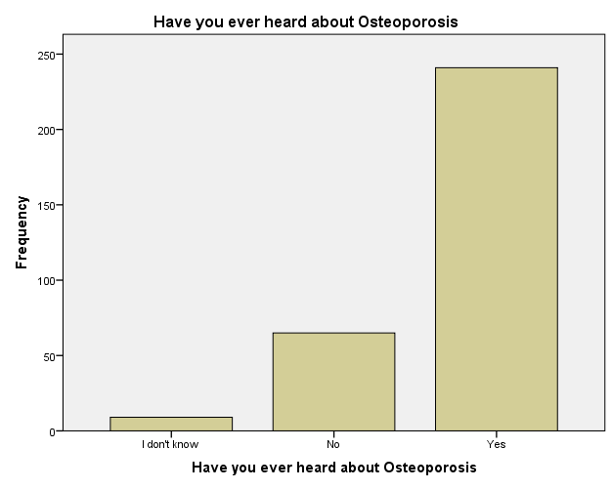

Fig 8

The chart above shows that 241(76.5%) of the respondents claimed they have heard about Osteoporosis while 65(20.6%) of the total respondents claimed they have never heard about Osteoporosis and 9(2.9%) said they don’t know

Fig 9
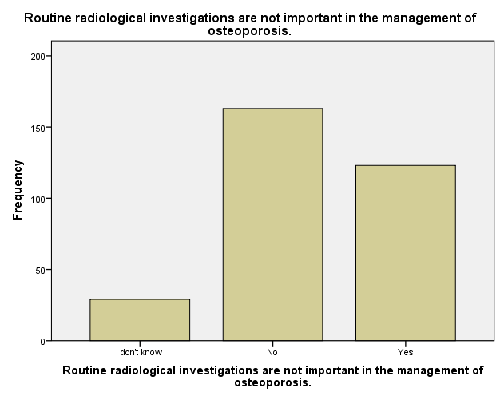

The above fig 9 shows the graphical representation on the distribution on if routine radiological investigations are not important in the management of Osteoporosis and it was revealed that 163(51.7%) which takes the largest percentage of the respondents claimed routine radiological investigations are important in the management of Osteoporosis while 123(39.0%) claimed routine radiological investigations are not important, and 29(9.2%) said they don’t know.

Fig 10
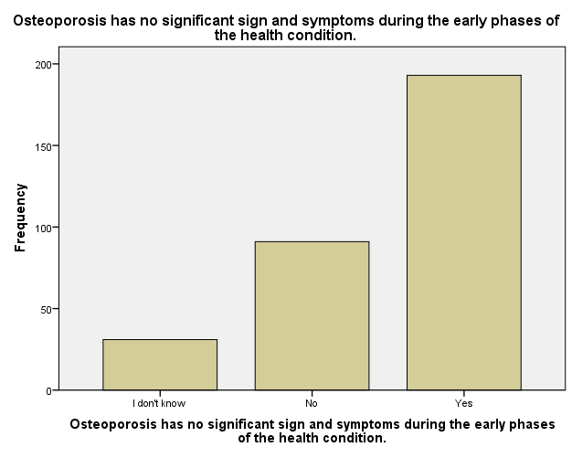

The above fig 10 chart shows the distribution on if Osteoporosis has no significant sign and symptoms during the early phases of the health condition and 193(61.3%) of the total respondents that participated in the study claimed this subject area “Osteoporosis” has no significant sign and symptoms during the early phases of the health condition while 91(28.9%) disagree with this claim and 31(9.8%) claimed they don’t know.

Fig 11
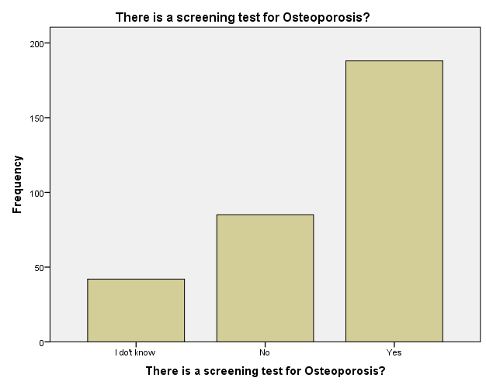

Fig 11 above shows the responses of the respondents on if there is a screening test for Osteoporosis and 188(59.7%) of these respondents claimed there is a screening test for Osteoporosis while 85(27.0%) claimed there is no screening test for Osteoporosis and 42(13.3%) claimed they don’t know.

T- Test and Mann-Whitney to find out the difference between two independent groups (Gender)
Table 9.0: shows the average by Gender

Group Statistics
 | Gender | N | Mean | Std. Deviation | Std. Error Mean
Have you ever heard about Osteoporosis | FEMALE | 105 | .00 | .000 | .000
Have you ever heard about Osteoporosis | MALE | 210 | .40 | .571 | .039

Table9.1
Independent Samples Test
 |  | Levene's Test for Equality of Variances |  | t-test for Equality of Means
 |  | F | Sig. | t | df | Sig. (2-tailed) | Mean Difference | Std. Error Difference | 95% Confidence Interval of the Difference
 |  |  |  |  |  |  |  |  | Lower | Upper
Have you ever heard about Osteoporosis | Equal variances assumed | 436.298 | .000 | -7.084 | 313 | .000 | -.395 | .056 | -.505 | -.285
Have you ever heard about Osteoporosis | Equal variances not assumed |  |  | -10.027 | 209.000 | .000 | -.395 | .039 | -.473 | -.318

Table 9.2
Test Statisticsª
 | Have you ever heard about Osteoporosis
Mann-Whitney U | 7140.000
Wilcoxon W | 12705.000
Z | -6.917
Asymp. Sig. (2-tailed) | .000
a. Grouping Variable: Gender

The difference between the gender (males and females), we found that there was statistical significant (p<0.05) in their awareness of osteoporosis i.e. there is presence of statically significant between males and females in their awareness on the knowledge to prevent osteoporosis.

Fig 10: Awareness of osteoporosis knowledge according to the age groups
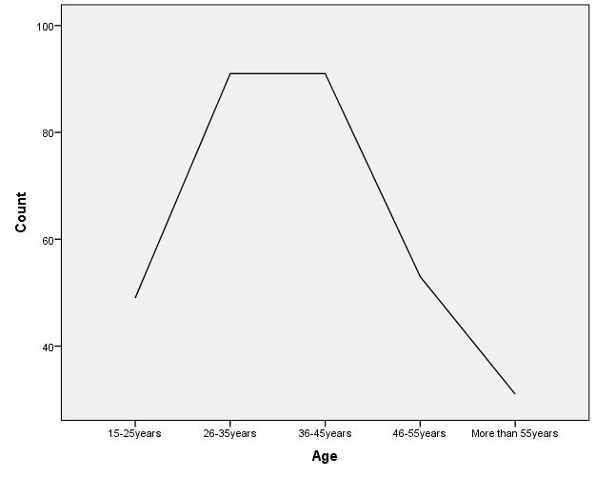

Younger participants (age groups 2 and 3) which means (26-35 years old and 36-45years old) had a greater awareness of osteoporosis than age rest of age groups, and the difference between the age groups was statistically significant (p<0.001). (Figure10)

Fig 11: Awareness of osteoporosis knowledge according to the educational level
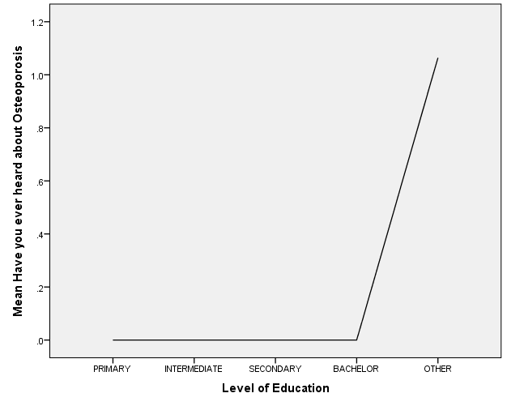

Awareness of osteoporosis was also significantly different between educational groups. It was lowest in the primary school group (p<0.001). Awareness of osteoporosis was positively correlated with education (p<0.001). (Figure 11)

The stability of the questionnaire analysis
We checked the stability of the questionnaire analysis by using Cronbach’s Alpha (Table 10)

Reliability Statistics
Cronbach's Alpha | Cronbach's Alpha Based on Standardized Items | N of Items
.985 | .986 | 14

We can see that Cronbach’s alpha is 0.985, which indicates a high level of internal consistency for the scale.
Discussion
This study assesses the impact of knowledge, attitude and practice of osteoporosis among adult population in Majmaah city, Saudi Arabia. In this study, osteoporosis questionnaire was administered to investigate the impact of knowledge and risk awareness of population about the osteoporosis management and age most affected and the gender group which are more involved.
We found that the male group was more aware of the knowledge and prevention methods against osteoporosis however the results of our study indicate that males showed better knowledge on osteoporosis than females. The data concerning the relationship between knowledge levels about osteoporosis and having osteoporosis are less consistent. Some studies found that family history play no role in the development of osteoporosis [1] and [2]which is in correlation with the findings of this study. In another study, having osteoporosis was found to be associated with increased knowledge [3]. In another study, 84.8% of all women related osteoporosis with aging, which is concordant with the findings of a study held in Norway, where 85% of women answered positively to this question [3]. In the same study by Magnus et al [3] surveyed a random sample of 1514 Norwegian women and men aged 16-79 years. This study demonstrated a relatively high level of the knowledge of osteoporosis and its consequences in the entire population.
A common negative attitude that was observed among study participants was the claim that routine radiological investigations are not important in the management of Osteoporosis. According to health belief model, the individual’s perception of a disease and likelihood of adoption of positive attitude and practices depend on four important parameters i.e. perceived seriousness of a disease perceived susceptibility of a disease, perceived benefits of positive attitude and practice and lastly perceived barriers that might restrain an individual to make positive changes [4]. Similar to findings of other studies, a majority of the participants in the present study have identified lack of calcium and dairy products to be a risk factor for osteoporosis; also, minority had identified family history as risk factor for osteoporosis [5]. Many also believe that regular physical activity can help in strengthening bone and prevent Osteoporosis while a recommendation for intake of milk was given in other to prevent Osteoporosis and low diary product-based can prevent Osteoporosis.

Conclusion
The majority of the participants were aware of some knowledge about osteoporosis but male respondents were more knowledgeable in some very important points in this manner, though this can be as a result of higher percentage of male participating in the study. Age was positively correlated (0.758) with the level of awareness and Awareness of osteoporosis was significantly different between educational groups. It was lowest in the primary school group. Awareness of osteoporosis was positively correlated with education (0.622). Therefore it is important to improve more on the awareness and knowledge of osteoporosis and its prevention measures as osteoporosis is a disease that can be prevented. Ministry of health need to determine the population’s knowledge of and attitudes towards osteoporosis to plan effective education programs to be able to avoid late complications and to safe highly cost methods of treating such a conditions; by doing this, Osteoporosis would be reduced in the organization.

REFERENCE

1. https://www.ncbi.nlm.nih.gov/pubmed/14735301
Drozdzowska B, Pluskiewicz W, Skiba M (2004) Knowledge about osteoporosis in a cohort of Polish females: the influence of age, level of education and personal experiences. Osteoporos Int 15:645–648.

2. https://www.ncbi.nlm.nih.gov/pubmed/16797149
Vytrisalova M, Kubena A, Vlcek J et al (2007) Knowledge of osteoporosis correlated with hormone therapy use and health status. Maturitas 56:21–29

3. https://link.springer.com/article/10.1007/BF02652555
Magnus JH, Joakimsen RM, Berntsen GK, et al. What do Norwegian women and men know about osteoporosis? Osteoporosis Int 1996;6:31-6.

4. https://journals.sagepub.com/doi/abs/10.1177/109019817400200403?journalCode=heba
Health belief model. Chapter 4. Theory Essence Sentence, Personnel beliefs influence health behaviors. Jones and Barlett Publishers. [Cited 2016 Aug 7]. Available at http://www.jblearning. com/samples/0763743836/chapter%204.pdf.

5. https://www.ncbi.nlm.nih.gov/pubmed/11569595
Curry LC, Hogstel MO. Risk status related to knowledge of osteoporosis in older women. J Women Aging 2001; 13(2).

