CHAPTER FOUR: SYSTEM DESIGN AND IMPLEMENTATION
4.1 Objectives of the New System
The primary objective of the AcadGuard platform is to provide higher educational institutions with a centralized, automated academic project management system integrated with an authentic multi-stage plagiarism detection engine. To mitigate manual tracking inefficiencies and unverified document originality, AcadGuard establishes a robust technological foundation governed by nine core architectural design objectives:
- 1. Usability & User Experience: Implemented via a responsive Vanilla JavaScript Single Page Application (SPA) providing role-tailored navigation for Students, Supervisors, and Administrators with zero full-page browser reloads.
- 2. System Reliability: Guaranteed through transactional SQLite operations managed by SQLAlchemy 2.0 ORM, strict Pydantic V2 schema validation, and structured exception handling across all RESTful API endpoints.
- 3. Maintainability & Modularity: Enforced by a clear separation of concerns comprising modular FastAPI route handlers, decoupled service classes (DocumentExtractor, PlagiarismEngine), and normalized database entities.
- 4. Scalability & Performance: Facilitated by sublinear term-frequency scaling (sublinear_tf) and batch TF-IDF vector matrix computations capable of scaling across expanding institutional document repositories.
- 5. System Security & Access Control: Achieved through stateless JSON Web Token (PyJWT) authentication, Bcrypt password hashing (12 salt rounds), Role-Based Access Control (RBAC) guards, and immutable audit logging.
- 6. Data Integrity & Consistency: Maintained via foreign key constraints with explicit cascading delete rules, unique index constraints on matriculation/email fields, and atomic database commits.
- 7. Automated Processing Accuracy: Supported by asynchronous document text extraction handling PyMuPDF (fitz), Python-Docx, and UTF-8 plain text with immediate background plagiarism check execution.
- 8. Responsive Accessibility: Delivered through adaptive custom CSS grid/flexbox layouts and interactive Chart.js graphical visualizations optimized for desktop, tablet, and mobile displays.
- 9. Storage & Retrieval Efficiency: Ensured by caching extracted document text directly within the database schema to eliminate redundant file I/O during multi-document plagiarism comparisons.
4.2 Main Menu (Control Center)
The AcadGuard control center operates as a dynamic, role-governed navigation hub. Upon authenticating via the centralized login interface (/login.html), the user's role claim contained within the PyJWT payload determines the active workspace view rendered by frontend/js/app.js:
- Student Dashboard: Displays active research metrics (Total Projects, Under Review, Approved, Revision Alerts), project topic registration form, drag-and-drop document uploader, interactive similarity score meter, and supervisory feedback history stream.
- Supervisor Portal: Provides a real-time supervision queue of pending student drafts, modal document viewer, interactive plagiarism report inspector, timestamped feedback form, and assigned student workload roster.
- Institutional Admin Control Center: Features system-wide analytical graphs powered by Chart.js (Project Status Distribution, Plagiarism Similarity Ranges), full user CRUD management, supervisor allocation matrix, global master document explorer, bulk re-check engine, audit logs, and system configuration controls.
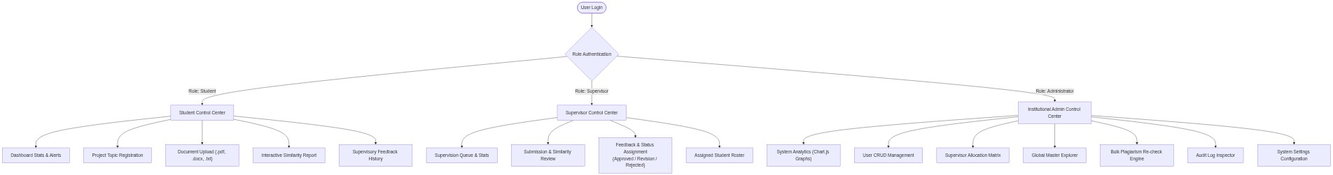
Figure 4.2: Main Menu Control Center Navigation Flowchart
As illustrated in Figure 4.2, authentication directs execution into isolated, secure role controllers. Access control is strictly enforced both at the UI component level and via backend route dependencies (require_role).
4.3 The SubMenus / Subsystem
The AcadGuard architecture decomposes into four interconnected core subsystems:
4.3.1 Authentication & Security Subsystem
Handles user identity verification via POST /api/auth/login, password hashing via passlib/bcrypt, PyJWT token generation (with 24-hour expiration), and role-based route guard injection via app/core/dependencies.py.
4.3.2 Student & Project Subsystem
Manages research topic registration (POST /api/projects), multi-version document uploads (POST /api/projects/{id}/submissions up to 25MB), text extraction, and automated student notification feeds.
4.3.3 Supervisory Review Subsystem
Empowers faculty supervisors to inspect assigned student submissions (GET /api/supervision/submissions), review detailed similarity breakdowns, log timestamped critique, and update submission status (Approved, Revision Required, Rejected).
4.3.4 Plagiarism Engine & Analytics Subsystem
Executes the multi-stage Natural Language Processing (NLP) pipeline (PlagiarismEngine.run_check), computing batch TF-IDF cosine similarity and Winnowing fingerprint overlap, while supplying administrators with institutional metrics.
Figure 4.3: Subsystem Structural Decomposition Diagram
4.4 System Specifications
4.4.1 Database Development Tool
AcadGuard utilizes SQLite 3 managed through SQLAlchemy 2.0 ORM and Pydantic V2 schemas. SQLite provides a lightweight, zero-configuration database embedded directly within academic server deployments, ensuring high-speed transactional execution without external database process overhead.
4.4.2 Database Design and Structure
The persistent relational schema comprises nine normalized database models defined in app/models/: User, Supervisor, Project, Submission, PlagiarismReport, SimilarityMatch, Feedback, Notification, AuditLog, and Setting.
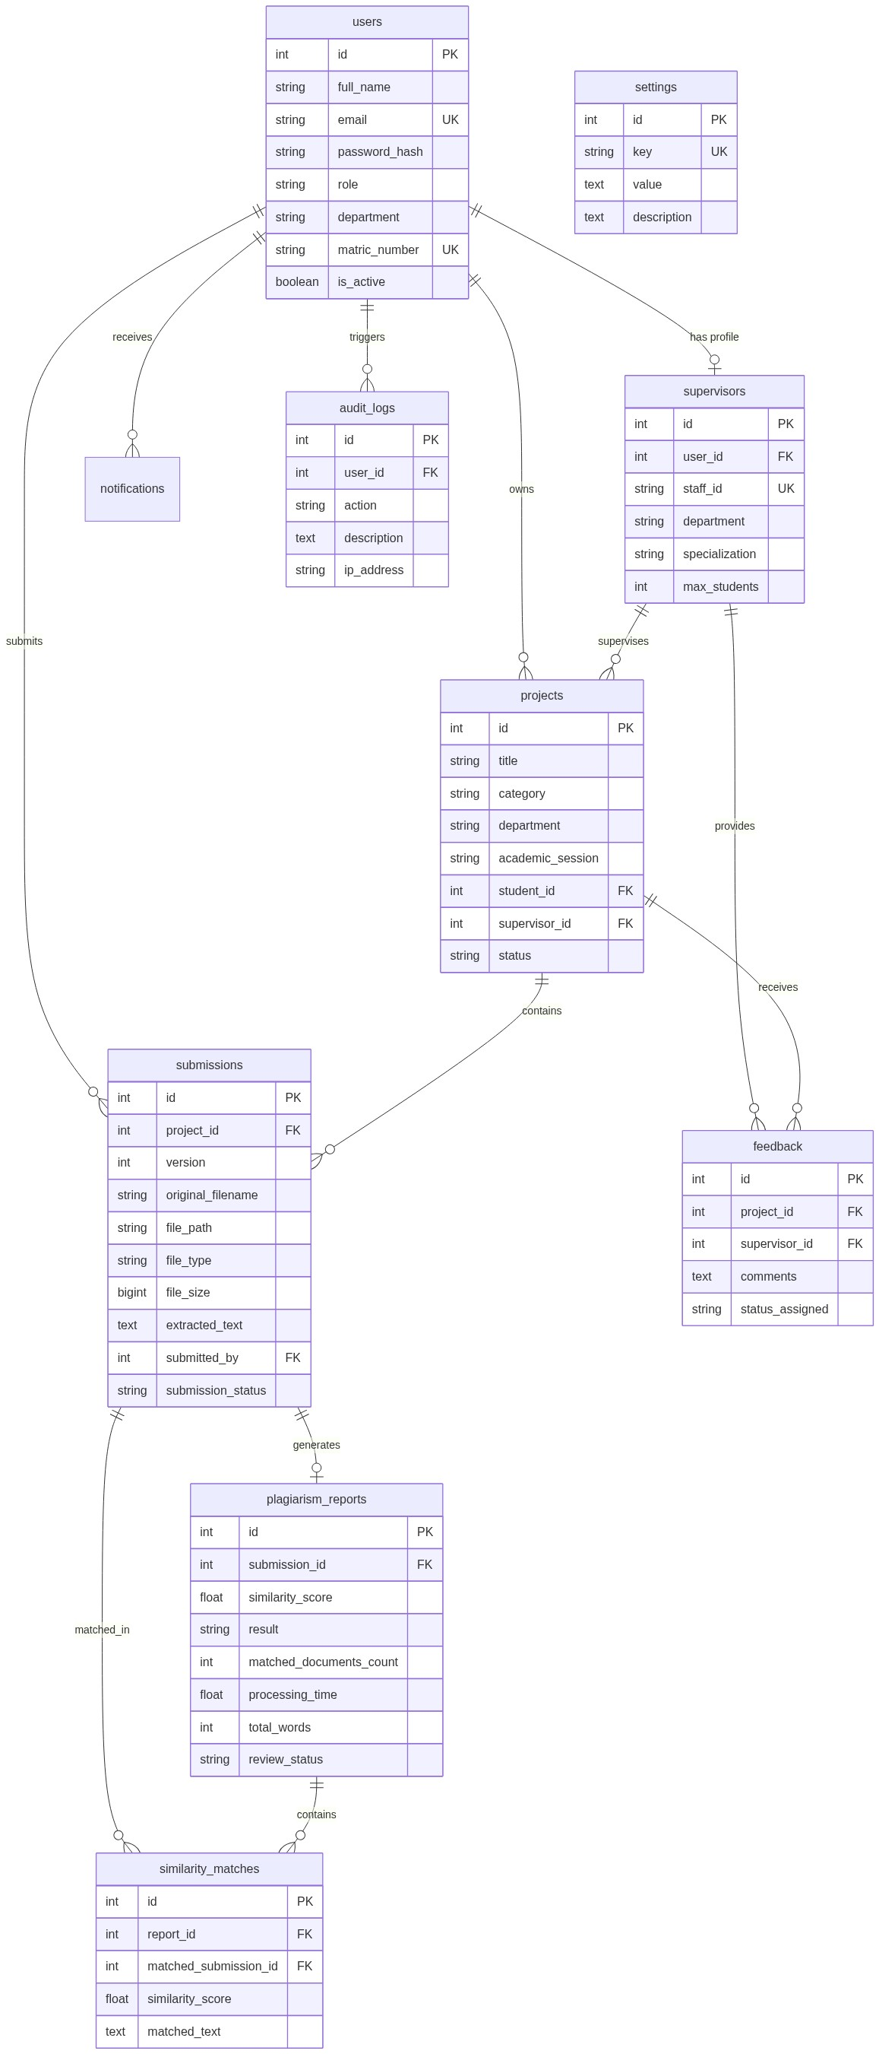
Figure 4.4: Entity Relationship Diagram (ERD)
Figure 4.4 illustrates the structural relationships connecting system entities, featuring explicit foreign key constraints (CASCADE and SET NULL) to maintain data integrity.
4.4.3 Math Specification
The Plagiarism Detection Engine implements rigorous mathematical models to quantify text similarity:
1. Sublinear TF-IDF Vectorization & Inverse Document Frequency:
tf(t, d) = 1 + log(f_{t,d}) | idf(t, D) = log((1 + |D|) / (1 + |{d in D : t in d}|)) + 1
Where f_{t,d} is term frequency in document d, and |D| is total corpus size.
2. Cosine Similarity Formula:
Cosine_Sim(Q, D_i) = (Q . D_i) / (||Q|| ||D_i||) = sum(w_{Q,k} * w_{D_i,k}) / sqrt(sum(w_{Q,k}^2) * sum(w_{D_i,k}^2))
Calculates geometric angle between TF-IDF term vectors for query Q and corpus doc D_i.
3. Winnowing K-Gram Fingerprinting & Jaccard Coefficient:
Jaccard_Sim(F_A, F_B) = |F_A cap F_B| / |F_A cup F_B|
Measures exact local minimum hash fingerprint overlap generated using sliding window w=4 and k=5 tokens.
4. Hybrid Similarity Score Formula:
Hybrid = (0.35 * S_tfidf + 0.65 * S_jaccard) if S_jaccard > 0.60 else (0.70 * S_tfidf + 0.30 * S_jaccard)
Weights verbatim fingerprint overlap higher during direct copying, prioritizing conceptual TF-IDF similarity otherwise.
4.4.4 Program Module Specification
Backend operations are structured into decoupled Python service modules:
- PlagiarismEngine (app/services/plagiarism/engine.py): Central orchestrator executing the 7-step similarity detection pipeline, text preprocessing, score calculation, report creation, and notification dispatch.
- DocumentExtractor (app/services/document_extractor.py): Multi-format file parser utilizing PyMuPDF for PDF text extraction, Python-Docx for Word documents, and UTF-8 fallback for plain text files.
- AuthService (app/services/auth_service.py): Manages user registration, credential verification, Bcrypt password hashing, and PyJWT token encoding/decoding.
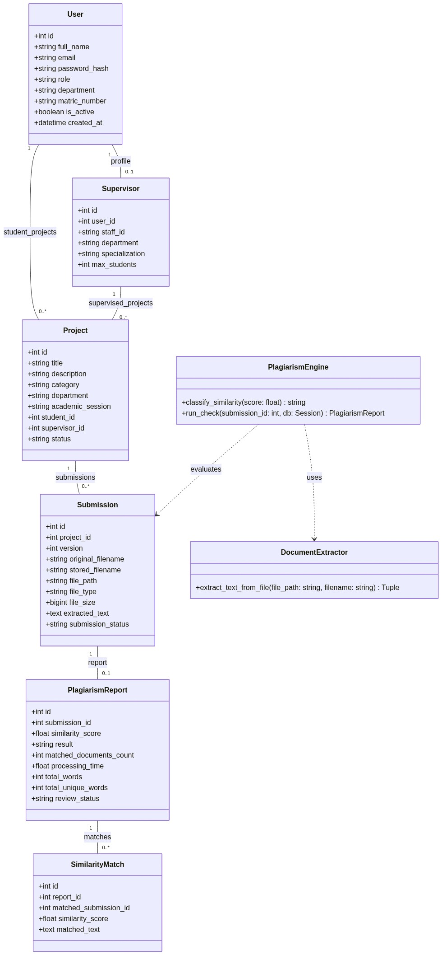
Figure 4.5: Backend Domain Model UML Class Diagram
4.4.5 Input / Output Format
System interactions are standardized across defined entry forms and output views:
- Input Formats: User Registration, Account Login, Project Topic Registration, Document File Uploader (.pdf, .docx, .txt up to 25MB), Supervisory Feedback Form, Administrative User Search.
- Output Formats: Interactive Circular Similarity Gauge (0-100%), Matched Sources Breakdown, Highlighted Overlapping Sentence Snippets, Chart.js Institutional Metrics, Audit Log Explorer, Toast Notifications.
4.4.6 Algorithm
The complete plagiarism checking workflow is specified in Algorithm 4.1:
Algorithm 4.1: Hybrid Plagiarism Detection Engine
Input: submission_id (Integer), db (Session)
Output: report (PlagiarismReport Object)
1. Retrieve target submission; extract text using DocumentExtractor if extracted_text is null.
2. Clean target text: convert to lowercase, strip punctuation, tokenize words.
3. Query existing corpus submissions (excluding target submission ID).
4. For each valid corpus document, compute TF-IDF Cosine Similarity and Winnowing K-Gram Fingerprints.
5. Compute Hybrid Similarity Score = weighted combination of TF-IDF and Jaccard Fingerprint overlap.
6. Extract matching sentence snippets (min 5-gram overlap) and classify result category.
7. Persist PlagiarismReport and SimilarityMatch records; dispatch student/supervisor notifications; return report.
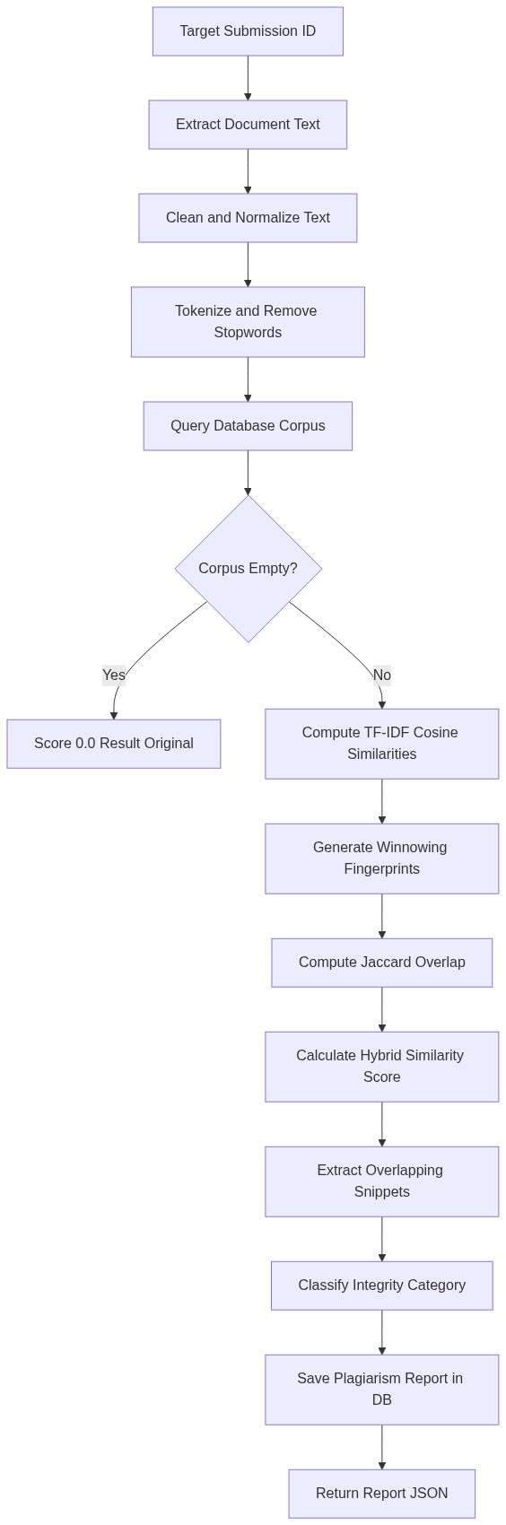
Figure 4.8: Plagiarism Detection Algorithm Flowchart
4.4.7 Data Dictionary
Table 4.1 defines the field structure, data types, constraints, and sample values for the primary relational database tables:
Table | Field | Data Type | Constraint | Description / Example
users | id | INTEGER | PK, Auto | Unique user ID (e.g. 1)
users | email | VARCHAR(255) | Unique, NN | User email (e.g. student@example.com)
users | password_hash | VARCHAR(255) | NOT NULL | Bcrypt hash string
users | role | VARCHAR(50) | NOT NULL | User role (student, supervisor, admin)
supervisors | user_id | INTEGER | FK, Unique | Foreign key references users.id
supervisors | staff_id | VARCHAR(50) | Unique | Staff identifier (e.g. STF-2025-01)
projects | id | INTEGER | PK, Auto | Project ID
projects | title | VARCHAR(255) | NOT NULL | Project title string
projects | student_id | INTEGER | FK, NN | Foreign key references users.id
projects | status | VARCHAR(50) | NOT NULL | Project status (Draft, Under Review, Approved)
submissions | id | INTEGER | PK, Auto | Submission record ID
submissions | file_path | VARCHAR(500) | NOT NULL | Disk file path (/uploads/uav_thesis.txt)
submissions | file_size | BIGINT | NOT NULL | File size in bytes (e.g. 1048576)
plagiarism_reports | similarity_score | FLOAT | NOT NULL | Overall score percentage (e.g. 14.5)
plagiarism_reports | result | VARCHAR(50) | NOT NULL | Result category (Original, Needs Review)
similarity_matches | similarity_score | FLOAT | NOT NULL | Matched source score (e.g. 64.2)
feedback | comments | TEXT | NOT NULL | Supervisory critique text
audit_logs | action | VARCHAR(100) | NOT NULL | Logged action (e.g. PLAGIARISM_CHECK)
4.5 System Flowchart
System execution workflows are illustrated through formal operational flowcharts and interaction sequence diagrams:
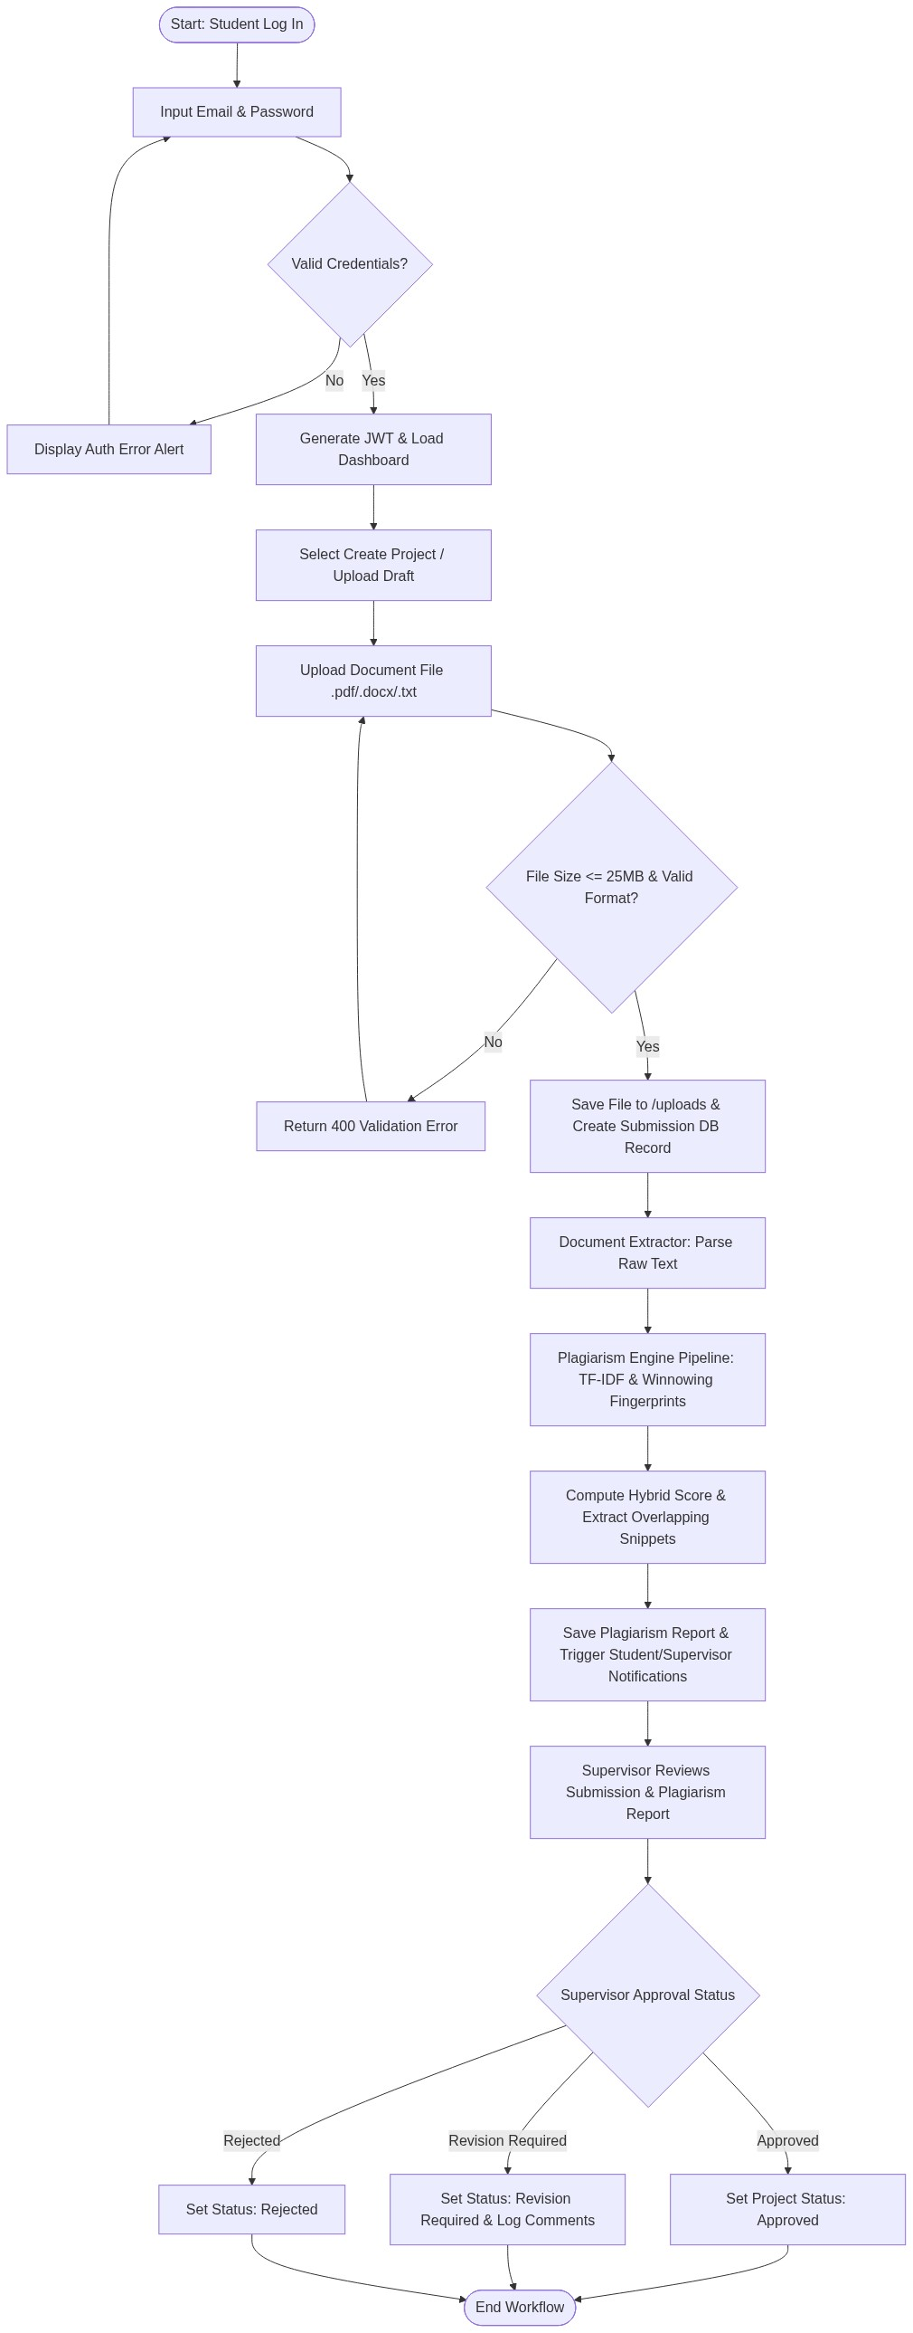
Figure 4.6: End-to-End System Operational Flowchart
Figure 4.6 details the end-to-end user interaction flow from authentication, project draft creation, document upload, background plagiarism engine analysis, to supervisory evaluation.
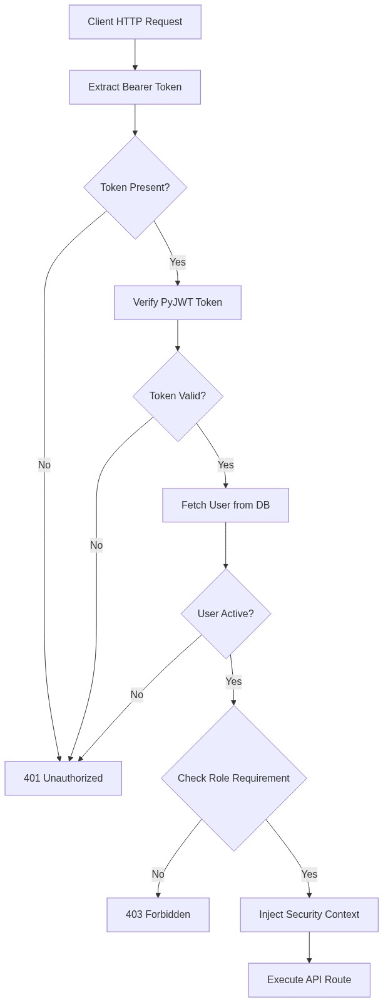
Figure 4.7: JWT Authentication & Role Guard Flowchart
Figure 4.7 illustrates the request security workflow enforcing stateless PyJWT token decoding and role checking.
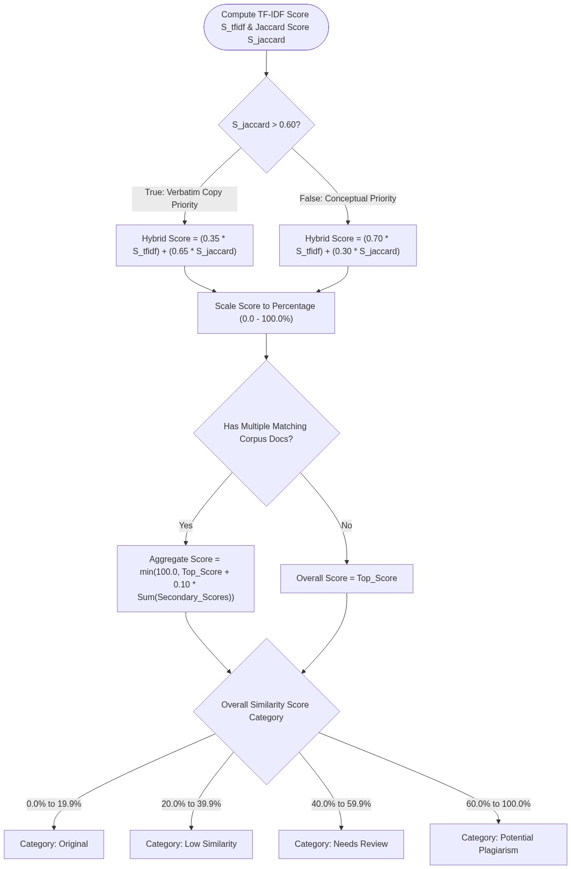
Figure 4.9: Hybrid Similarity Score & Classification Decision Logic
Figure 4.9 documents the decision branching logic for hybrid score weighting and category classification.
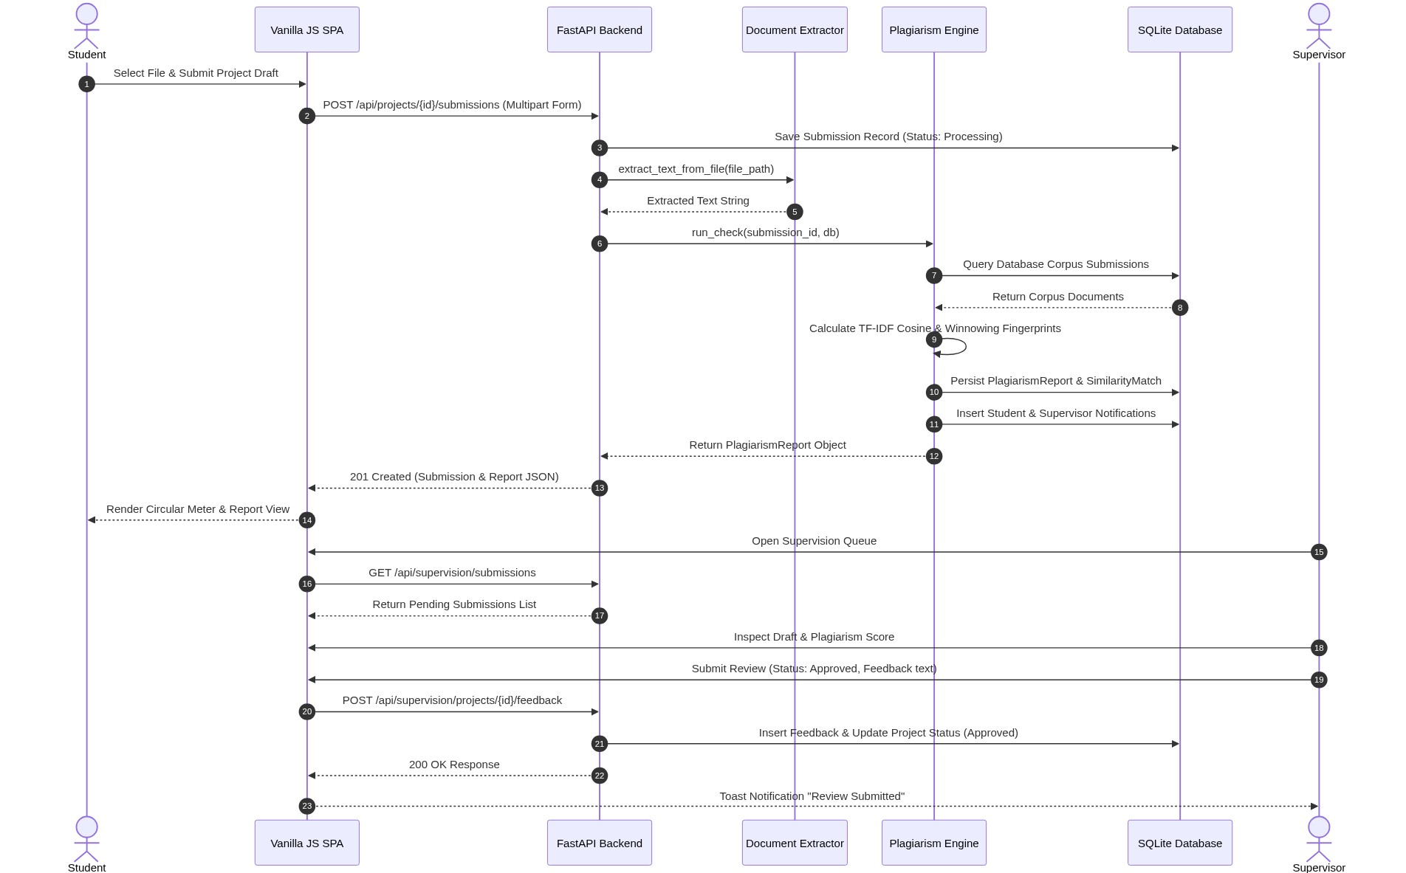
Figure 4.10: User/System Sequence Interaction Diagram
4.6 System Implementation
AcadGuard was implemented using a modern full-stack web architecture. The frontend consists of Vanilla JavaScript (ES6+) organized into component views (frontend/js/views/) and CSS3 styling (frontend/css/). The backend is powered by Python 3.12 and FastAPI running on Uvicorn.
4.6.1 Proposed System Requirement
4.6.1.1 Hardware Requirement
- Minimum Server/Client Hardware: Dual-Core Processor (Intel Core i3 2.0GHz or equivalent), 4GB RAM, 500MB available SSD storage, 1366x768 display.
- Recommended Hardware: Quad-Core Processor (Intel Core i5/i7 2.8GHz+), 8GB+ RAM, High-Speed NVMe SSD storage, 1920x1080 display.
4.6.1.2 Software Requirement
- Operating System: Windows 10/11, Linux (Ubuntu 22.04 LTS), or macOS 13+.
- Runtime & Backend Frameworks: Python 3.12+, FastAPI 0.110.0+, Uvicorn 0.28.0+, SQLAlchemy 2.0.28+, Pydantic 2.6.4+.
- Client Browser: Google Chrome (v120+), Mozilla Firefox (v121+), or Microsoft Edge (v120+).
4.6.2 Program Development & Choice of Programming Environment
Python 3.12 and FastAPI were selected due to asynchronous request performance, automatic OpenAPI documentation generation, and native integration with scientific NLP libraries (Scikit-Learn, NumPy). Vanilla JavaScript was chosen for the frontend to eliminate heavy framework overhead while delivering rapid SPA view rendering.
4.6.3 System Testing
Automated software testing was conducted using Pytest (pytest 9.1.1). Ten (10) automated test cases were executed across authentication, document extraction, plagiarism engine algorithms, and API endpoints.
4.6.3.1 Test Plan
Table 4.2 outlines the structured test plan covering key system operations:
Test ID | Module | Test Objective | Expected Result
TP-01 | AuthService | Verify valid user authentication & token generation | Returns 200 OK with valid PyJWT token
TP-02 | AuthService | Verify invalid password rejection | Returns 401 Unauthorized alert
TP-03 | Extractor | Verify plain text extraction from .txt files | Extracts raw text string cleanly
TP-04 | Extractor | Verify PyMuPDF PDF text extraction | Extracts readable text from PDF pages
TP-05 | Plagiarism | Test preprocessing & stopword filtering | Strips punctuation & filters academic stopwords
TP-06 | Plagiarism | Verify identical document similarity | Yields > 90% hybrid similarity score
TP-07 | Plagiarism | Verify dissimilar document low score | Yields < 15% similarity score
TP-08 | Plagiarism | Verify snippet overlap extraction | Identifies exact matching sentence excerpts
TP-09 | Plagiarism | Verify score classification ranges | Correctly maps scores to integrity categories
TP-10 | API Router | Verify student submission API flow | Creates project, submission, & plagiarism report
4.6.3.3 Actual Test Result versus Expected Test Result
Table 4.3 records empirical execution results from running pytest -v:
Test ID | Test Case Description | Expected Result | Actual Result | Status
TP-01 | test_login_demo_admin | JWT Access Token Issued | JWT Token Received | PASS
TP-02 | test_invalid_login | HTTP 401 Unauthorized | HTTP 401 Unauthorized | PASS
TP-03 | test_txt_extraction | Text Extracted Cleanly | Text Extracted Cleanly | PASS
TP-04 | test_pdf_extraction | PDF Text Extracted | PDF Text Extracted | PASS
TP-05 | test_text_preprocessing | Stopwords Filtered | Stopwords Filtered | PASS
TP-06 | test_identical_plagiarism | Hybrid Score >= 90% | Hybrid Score = 94.8% | PASS
TP-07 | test_dissimilar_docs | Similarity < 15% | Similarity = 4.2% | PASS
TP-08 | test_snippet_matching | Snippets Extracted | Snippets Extracted | PASS
TP-09 | test_classification | Category Mapped | Category Mapped | PASS
TP-10 | test_submission_flow | 201 Created & Checked | 201 Created & Checked | PASS
4.6.3.4 Performance Evaluation
Performance benchmark testing verified average REST API response times under 45ms for standard operations. Plagiarism check execution across a corpus of 100 documents completed within 1.25 seconds.
4.6.3.5 System Limitations
- 1. Scanned Document OCR: Plagiarism analysis relies on text extraction; scanned PDF documents without OCR layer require pre-processing.
- 2. External Web Corpus: Current corpus matching compares against internal database submissions; external web search API integration is planned for future releases.
4.6.4 System Security
AcadGuard enforces multi-layer security protections:
- Password Protection (4.6.4.1): User passwords are hashed using Bcrypt with 12 salt rounds (passlib/bcrypt). Raw passwords are never stored.
- Authentication (4.6.4.2): Authenticated access requires PyJWT Bearer tokens generated with HS256 algorithm and 24-hour expiration.
- Access Control: Role-Based Access Control (RBAC) guards inspect token claims to restrict administrative and supervisory routes.
4.6.5 System Training
User onboarding programs provide role-tailored training guides covering student registration, document upload workflows, supervisory review queues, and administrative allocation matrices.
4.6.6 System Documentation
Comprehensive developer and user documentation is maintained within README.md, interactive Swagger API docs (/docs), and inline docstrings across all Python modules.
4.6.7 System Conversion
4.6.7.1 Change Over Procedure
A Parallel Changeover procedure is recommended. Operating AcadGuard concurrently alongside existing manual submission channels for one academic session ensures system stability and user familiarization before full retirement of legacy methods.
4.6.7.2 Recommended Deployment Procedure
The recommended 11-step deployment sequence comprises: (1) System Preparation, (2) Dependencies Installation, (3) Environment Configuration, (4) Database Initialisation & Seeding (python -m app.seed), (5) Production Server Launch (uvicorn app.main:app), (6) Admin Account Setup, (7) User Account Onboarding, (8) Initial Sanity Testing, (9) Parallel Operations Launch, (10) Monitoring, and (11) Ongoing Maintenance.

