APPENDICES

Appendix A: Program Listing

A.1 Project Structure
The CourseAlign system is organized into a modular full-stack software architecture comprising a FastAPI Python backend, a client-side frontend with custom responsive UI styling, and local Large Language Model (LLM) inference integration via Ollama. The complete directory and file hierarchy is organized as follows:
File: Project Directory Tree
coursealign/
├── backend/
│ ├── app/
│ │ ├── auth/
│ │ │ └── auth.py # JWT authentication, bcrypt hashing, and RBAC guards
│ │ ├── core/
│ │ │ └── config.py # System settings and environment configuration
│ │ ├── database/
│ │ │ ├── crud.py # Direct data access routines
│ │ │ └── database.py # SQLite connection lifecycle & DDL table schemas
│ │ ├── routers/
│ │ │ ├── admin_router.py # Administrative controls and user role governance
│ │ │ ├── ai_router.py # LLM tutoring and automated quiz generation routes
│ │ │ ├── auth_router.py # User registration, login, and profile analytics
│ │ │ ├── bookmark_router.py # Course bookmarking endpoints
│ │ │ └── course_router.py # Course outlines and syllabus resource routes
│ │ ├── schemas/
│ │ │ └── schemas.py # Pydantic data validation contracts and DTOs
│ │ ├── services/
│ │ │ └── ai_service.py # Local Ollama client & prompt orchestration
│ │ └── seed_courses.py # Academic syllabus seed data loader
│ ├── coursealign.db # Embedded relational database storage
│ ├── create_admin.py # CLI administrator account bootstrapper
│ ├── Dockerfile # Backend containerization configuration
│ ├── main.py # Application entry point and ASGI middleware
│ └── requirements.txt # Backend Python package dependencies
├── frontend/
│ ├── assets/ # Static branding, icons, and logo assets
│ ├── css/ # Hand-drawn custom aesthetic and layout tokens
│ ├── js/ # Modular client controllers (AI Tutor, Quiz, Catalog, Auth)
│ ├── pages/ # Interactive HTML views for all user roles
│ ├── manifest.json # Progressive Web App web app manifest
│ ├── nginx.conf # Production Nginx reverse proxy configuration
│ └── sw.js # Service Worker for offline asset caching
├── docker-compose.yml # Multi-container service orchestrator
└── README.md # System documentation and deployment guide

A.2 Main Application Code
The primary entry point of the backend initializes the FastAPI framework instance, configures Cross-Origin Resource Sharing (CORS) policies, performs database schema initialization, and registers all modular API routes.
Listing A.1: Main Application Entry Point and API Router Configuration
File: backend/main.py
from fastapi import FastAPI
from fastapi.middleware.cors import CORSMiddleware
from app.database.database import init_db
from app.routers import auth_router, course_router, bookmark_router, ai_router, admin_router
from app.core.config import settings

# Initialize database tables using sqlite3
init_db()

app = FastAPI(title=settings.PROJECT_NAME, version=settings.PROJECT_VERSION)

# Configure CORS
app.add_middleware(
CORSMiddleware,
allow_origins=["*"],
allow_credentials=False,
allow_methods=["*"],
allow_headers=["*"],
)

# Include Routers
app.include_router(auth_router.router)
app.include_router(course_router.router)
app.include_router(bookmark_router.router)
app.include_router(ai_router.router)
app.include_router(admin_router.router)

@app.get("/")
def read_root():
return {"message": "Welcome to the CourseAlign API"}

A.3 Authentication and Authorization
User security is maintained through salted password hashing using bcrypt and stateless session verification using JSON Web Tokens (JWT). Role-Based Access Control (RBAC) is enforced through dependency injection guards ensuring that only authorized roles (Students, Lecturers, Administrators) access protected endpoints.
Listing A.2: Security Utilities, JWT Token Generation, and Role-Based Guards
File: backend/app/auth/auth.py
from datetime import datetime, timedelta, timezone
from typing import Optional
from jose import JWTError, jwt
import bcrypt
from fastapi import Depends, HTTPException, status
from fastapi.security import OAuth2PasswordBearer
import sqlite3

from app.core.config import settings
from app.database.database import get_db
from app.schemas.schemas import TokenData

oauth2_scheme = OAuth2PasswordBearer(tokenUrl="/api/auth/login")

def verify_password(plain_password, hashed_password):
if isinstance(hashed_password, str):
hashed_password = hashed_password.encode('utf-8')
return bcrypt.checkpw(plain_password.encode('utf-8'), hashed_password)

def get_password_hash(password):
return bcrypt.hashpw(password.encode('utf-8'), bcrypt.gensalt()).decode('utf-8')

def create_access_token(data: dict, expires_delta: Optional[timedelta] = None):
to_encode = data.copy()
if expires_delta:
expire = datetime.now(timezone.utc) + expires_delta
else:
expire = datetime.now(timezone.utc) + timedelta(minutes=15)
to_encode.update({"exp": expire})
encoded_jwt = jwt.encode(to_encode, settings.SECRET_KEY, algorithm=settings.ALGORITHM)
return encoded_jwt

def get_current_user(token: str = Depends(oauth2_scheme), db: sqlite3.Connection = Depends(get_db)):
credentials_exception = HTTPException(
status_code=status.HTTP_401_UNAUTHORIZED,
detail="Could not validate credentials",
headers={"WWW-Authenticate": "Bearer"},
)
try:
payload = jwt.decode(token, settings.SECRET_KEY, algorithms=[settings.ALGORITHM])
username: str = payload.get("sub")
if username is None:
raise credentials_exception
token_data = TokenData(username=username)
except JWTError:
raise credentials_exception

cursor = db.cursor()
cursor.execute("SELECT * FROM users WHERE username = ?", (token_data.username,))
user = cursor.fetchone()
if user is None:
raise credentials_exception
return dict(user)

def require_role(role: str):
def role_checker(current_user: dict = Depends(get_current_user)):
if current_user.get("role") != role:
raise HTTPException(
status_code=status.HTTP_403_FORBIDDEN,
detail=f"Operation not permitted. Requires {role} role."
)
return current_user
return role_checker

A.4 Database Implementation
The relational persistence tier is implemented using an embedded SQLite database engine. Connection factories provide dict-like row access, and the Data Definition Language (DDL) initializes relational tables for users, courses, weekly outlines, uploaded materials, bookmarks, chat session logs, and quiz attempts.
Listing A.3: SQLite Database Initialization and Relational Table Schemas
File: backend/app/database/database.py
import sqlite3
import os

DB_FILE = os.path.join(os.path.dirname(__file__), "..", "..", "coursealign.db")

def get_db_connection():
conn = sqlite3.connect(DB_FILE, check_same_thread=False)
conn.row_factory = sqlite3.Row
return conn

def init_db():
conn = get_db_connection()
cursor = conn.cursor()

# Users Table
cursor.execute('''
CREATE TABLE IF NOT EXISTS users (
id INTEGER PRIMARY KEY AUTOINCREMENT,
username TEXT UNIQUE NOT NULL,
email TEXT UNIQUE NOT NULL,
hashed_password TEXT NOT NULL,
role TEXT DEFAULT 'student',
level TEXT DEFAULT '100L',
is_active BOOLEAN DEFAULT 1,
created_at DATETIME DEFAULT CURRENT_TIMESTAMP
)
''')

# Courses Table
cursor.execute('''
CREATE TABLE IF NOT EXISTS courses (
id INTEGER PRIMARY KEY AUTOINCREMENT,
code TEXT UNIQUE NOT NULL,
title TEXT NOT NULL,
description TEXT,
credit_unit INTEGER NOT NULL,
level TEXT NOT NULL,
semester TEXT NOT NULL,
lecturer_name TEXT
)
''')

# Course Outlines Table
cursor.execute('''
CREATE TABLE IF NOT EXISTS course_outlines (
id INTEGER PRIMARY KEY AUTOINCREMENT,
course_id INTEGER UNIQUE,
learning_objectives TEXT,
weekly_outline TEXT,
recommended_textbooks TEXT,
FOREIGN KEY(course_id) REFERENCES courses(id)
)
''')

# Bookmarks Table
cursor.execute('''
CREATE TABLE IF NOT EXISTS bookmarks (
id INTEGER PRIMARY KEY AUTOINCREMENT,
user_id INTEGER,
course_id INTEGER,
created_at DATETIME DEFAULT CURRENT_TIMESTAMP,
FOREIGN KEY(user_id) REFERENCES users(id),
FOREIGN KEY(course_id) REFERENCES courses(id)
)
''')

# Quiz Attempts Table
cursor.execute('''
CREATE TABLE IF NOT EXISTS quiz_attempts (
id INTEGER PRIMARY KEY AUTOINCREMENT,
user_id INTEGER,
course_id INTEGER,
score INTEGER NOT NULL,
total_questions INTEGER NOT NULL,
created_at DATETIME DEFAULT CURRENT_TIMESTAMP,
FOREIGN KEY(user_id) REFERENCES users(id),
FOREIGN KEY(course_id) REFERENCES courses(id)
)
''')

conn.commit()
conn.close()

A.5 Backend/API Implementation
The application exposes RESTful endpoints for course catalog navigation, syllabus outline management, lecturer syllabus authoring, and system administration.
Listing A.4: Course Outline and Learning Resource Router
File: backend/app/routers/course_router.py
from fastapi import APIRouter, Depends, HTTPException, status
import sqlite3
from typing import List

from app.database.database import get_db
from app.schemas.schemas import CourseResponse, CourseOutlineCreate, CourseOutlineResponse, CourseAssignUpdate
from app.auth.auth import get_current_active_user, require_role

router = APIRouter(prefix="/api/courses", tags=["courses"])

@router.get("/", response_model=List[CourseResponse])
def get_courses(skip: int = 0, limit: int = 100, db: sqlite3.Connection = Depends(get_db)):
cursor = db.cursor()
cursor.execute("SELECT * FROM courses LIMIT ? OFFSET ?", (limit, skip))
return [dict(row) for row in cursor.fetchall()]

@router.put("/{course_code}/assign", response_model=CourseResponse, dependencies=[Depends(require_role("lecturer"))])
def assign_course(course_code: str, update_data: CourseAssignUpdate, db: sqlite3.Connection = Depends(get_db), current_user: dict = Depends(get_current_active_user)):
cursor = db.cursor()
cursor.execute("SELECT * FROM courses WHERE code = ?", (course_code,))
course = cursor.fetchone()
if not course:
raise HTTPException(status_code=404, detail="Course not found")

cursor.execute(
"UPDATE courses SET lecturer_name = ?, credit_unit = ?, level = ?, semester = ?, description = ? WHERE code = ?",
(current_user['username'], update_data.credit_unit, update_data.level, update_data.semester, update_data.description, course_code)
)
db.commit()
cursor.execute("SELECT * FROM courses WHERE code = ?", (course_code,))
return dict(cursor.fetchone())

A.6 AI/ML Implementation
The machine learning subsystem interfaces with a locally hosted Large Language Model (Gemma via Ollama) to guarantee zero subscription costs and complete institutional data privacy. Dynamic context injection feeds course outlines and descriptions into prompts to produce tailored tutoring dialogue and structured assessment questions.
Listing A.5: Local Ollama Gemma Integration and Context-Aware Generation Service
File: backend/app/services/ai_service.py
import os
import requests
import json

OLLAMA_URL = os.getenv("OLLAMA_URL", "http://localhost:11434/api/generate")
OLLAMA_CHAT_URL = os.getenv("OLLAMA_CHAT_URL", "http://localhost:11434/api/chat")
MODEL_NAME = os.getenv("MODEL_NAME", "gemma2:2b")

def generate_ai_response(prompt: str, context: str = "") -> str:
system_instruction = (
"You are the CourseAlign AI Tutor, an expert assistant for Computer Science students at "
"Chukwuemeka Odumegwu Ojukwu University (COOU). Be concise, helpful, and academically rigorous."
)
if context:
system_instruction += f"\nHere is the relevant course context:\n{context}"

messages = [
{"role": "system", "content": system_instruction},
{"role": "user", "content": prompt}
]
payload = {"model": MODEL_NAME, "messages": messages, "stream": False}

try:
response = requests.post(OLLAMA_CHAT_URL, json=payload, timeout=120)
response.raise_for_status()
return response.json().get("message", {}).get("content", "Error parsing response.")
except Exception as e:
return f"An error occurred while communicating with the AI: {str(e)}"

Appendix B: Sample Outputs

B.1 System Landing and Home Page
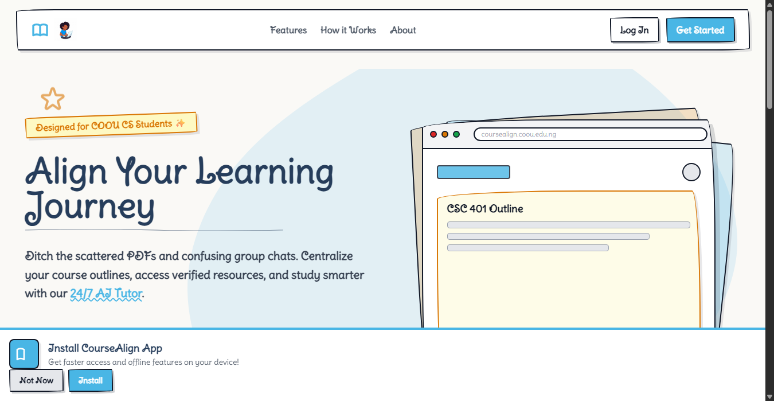
Figure B.1: CourseAlign Public Landing Page and Feature Showcase
Description: Depicts the main responsive landing page featuring the custom hand-drawn aesthetic, value proposition highlights, quick-navigation links, and entry call-to-actions for account creation and sign-in.

B.2 User Authentication (Login) Portal
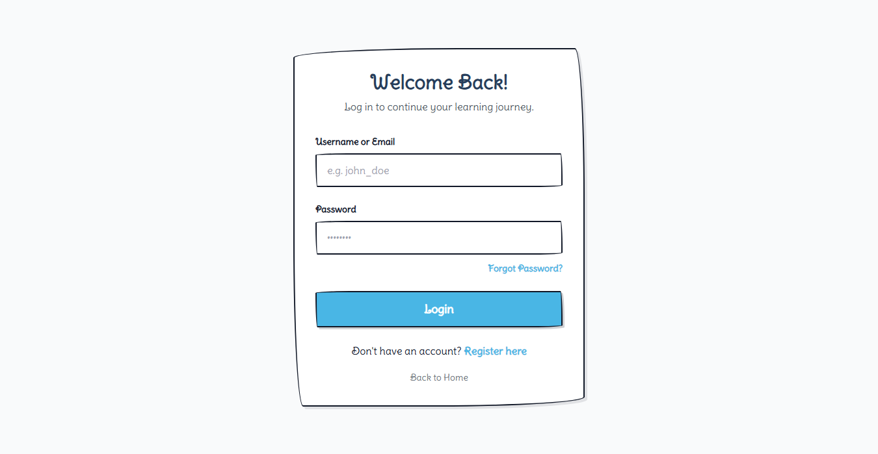
Figure B.2: Secure User Authentication Portal
Description: Demonstrates the user authentication interface where students, lecturers, and system administrators input their registered credentials to obtain a secure JSON Web Token (JWT).

B.3 User Registration and Onboarding Portal
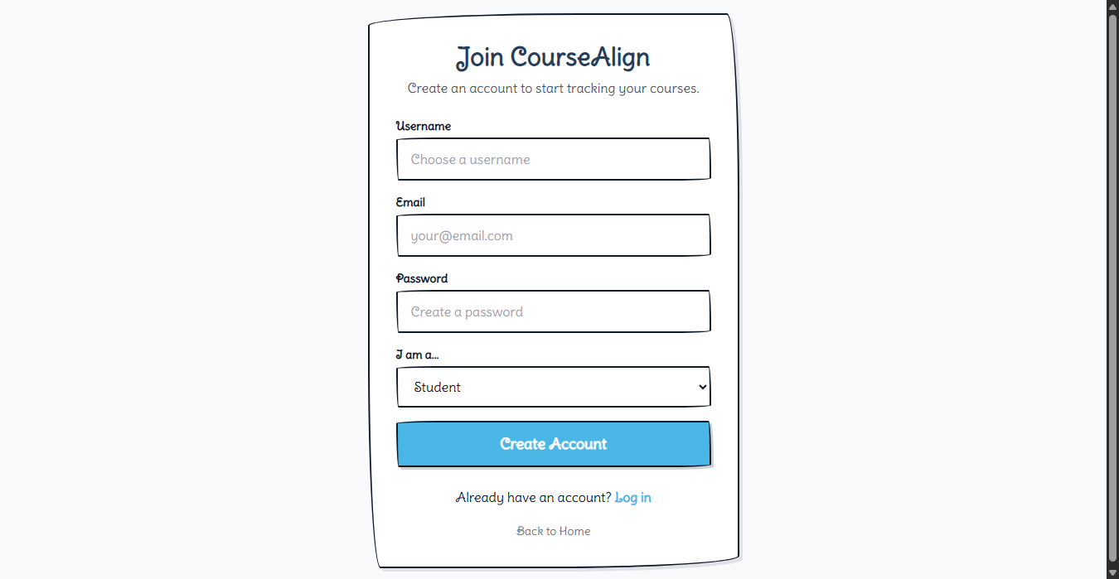
Figure B.3: User Registration and Role Onboarding Interface
Description: Illustrates the student and lecturer onboarding portal with account creation form fields, level selector, and role assignment.

B.4 Student Dashboard and Learning Analytics
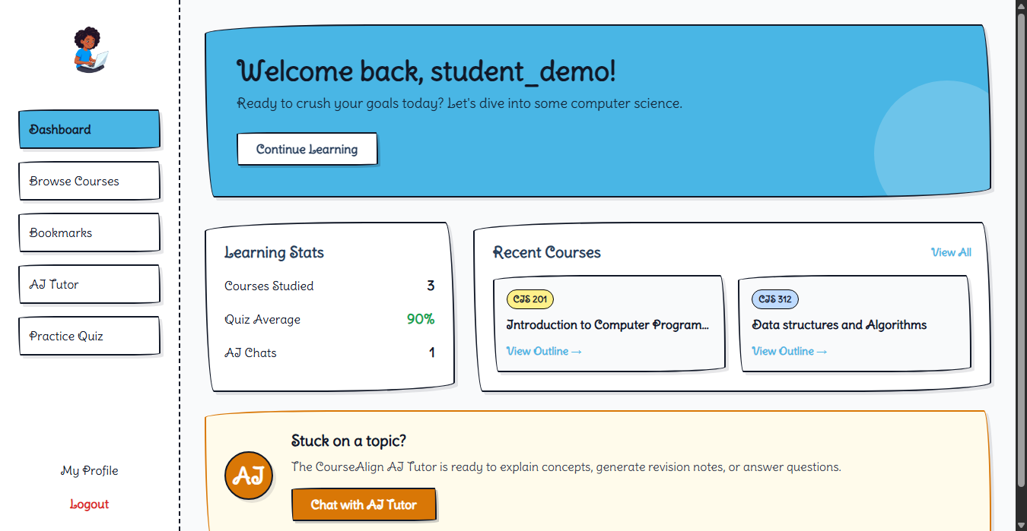
Figure B.4: Student Analytics Dashboard and Learning Metrics
Description: Shows real-time aggregated metrics (Courses Studied: 3, Quiz Average: 90%, AI Chats: 1) calculated dynamically via SQL queries, alongside quick shortcuts to recent courses (CIS 201, CIS 312).

B.5 Centralized Course Catalog and Level Filter
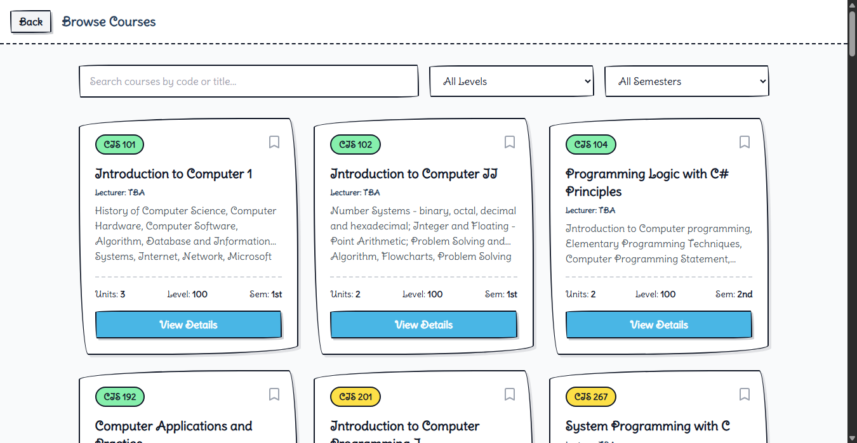
Figure B.5: Centralized Course Catalog and Level Filter Interface
Description: Displays the departmental course repository showing course codes, titles, credit units, lecturer assignments, and interactive level filter chips.

B.6 Detailed Course Outline and Syllabus Viewer
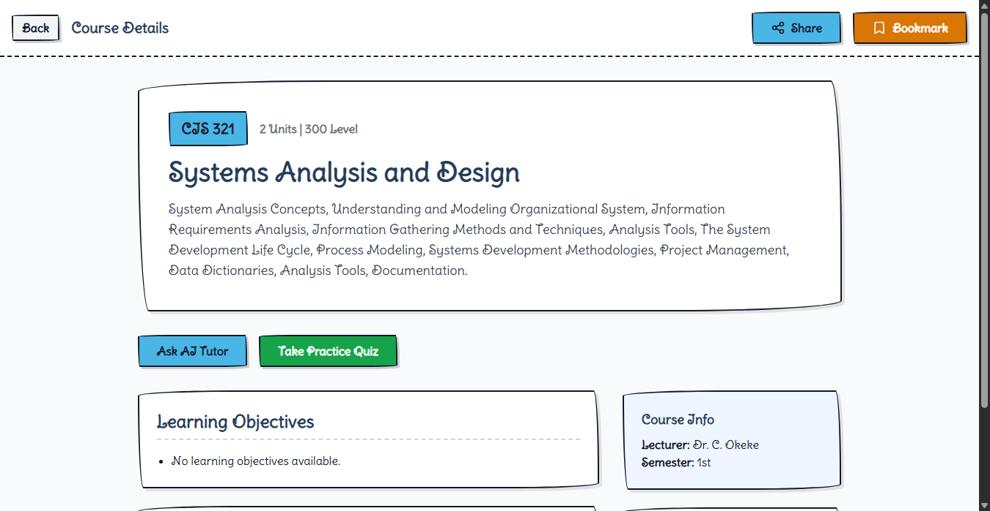
Figure B.6: Comprehensive Course Syllabus, Weekly Outline, and Objectives Viewer
Description: Illustrates the comprehensive syllabus viewer displaying structured weekly modules, textbook references, bookmarking toggles, and direct links to initiate an AI tutoring session for the course.

B.7 Saved Course Bookmarks Management
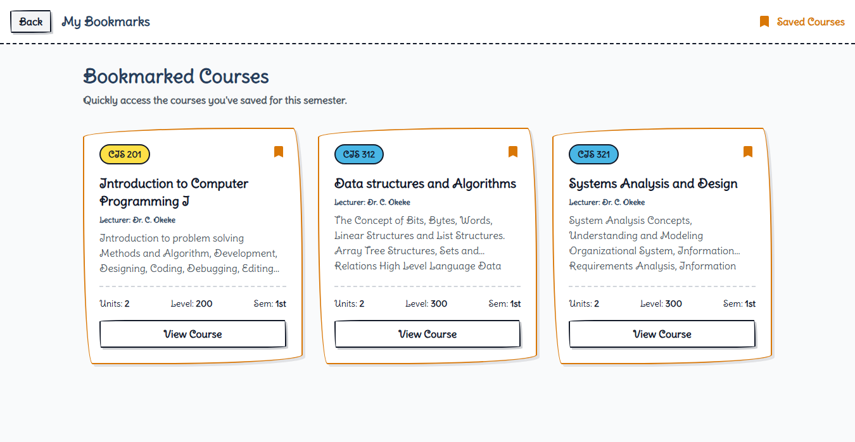
Figure B.7: Bookmarked Course Management Interface
Description: Displays the student's personal saved courses collection for rapid offline/online access and quick revision.

B.8 AI-Powered 24/7 Intelligent Tutor Chat
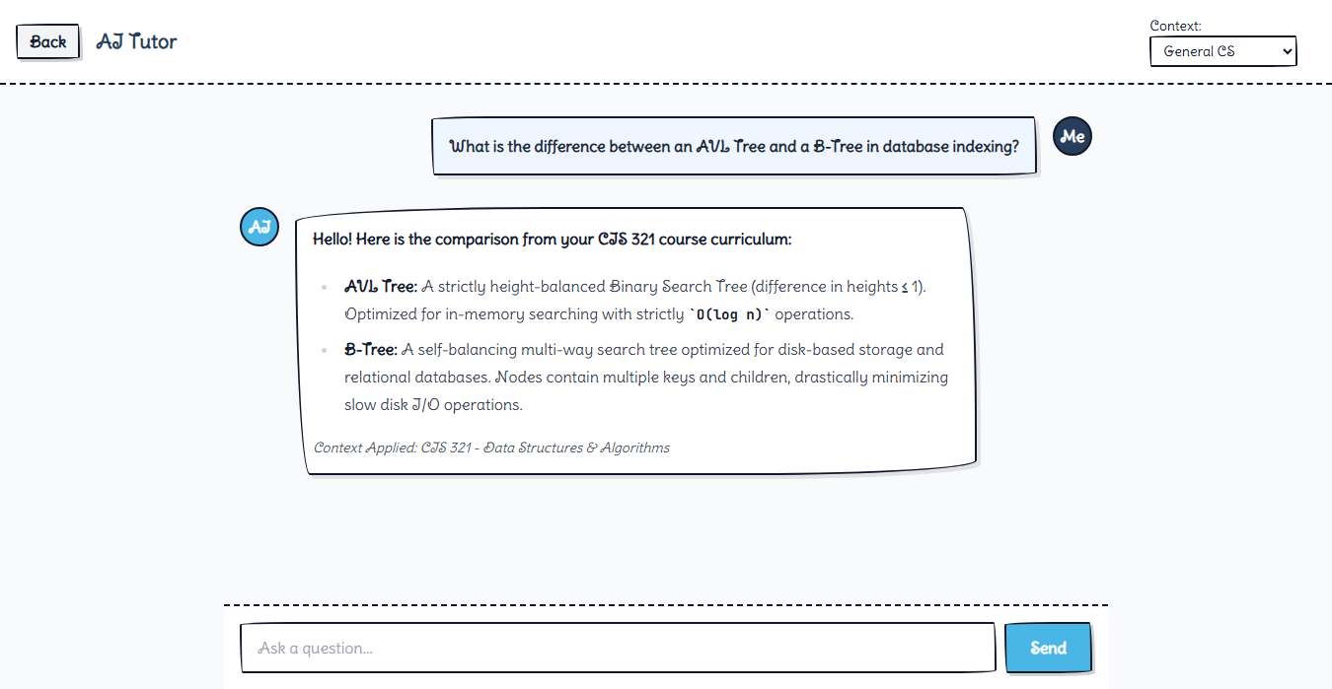
Figure B.8: Interactive 24/7 AI Tutor Chat Interface with Context Injection
Description: Demonstrates an active tutoring dialogue with local Gemma 4 inference comparing AVL Trees and B-Trees with injected CIS 321 curriculum context.

B.9 Dynamic Practice Quiz Configuration Screen
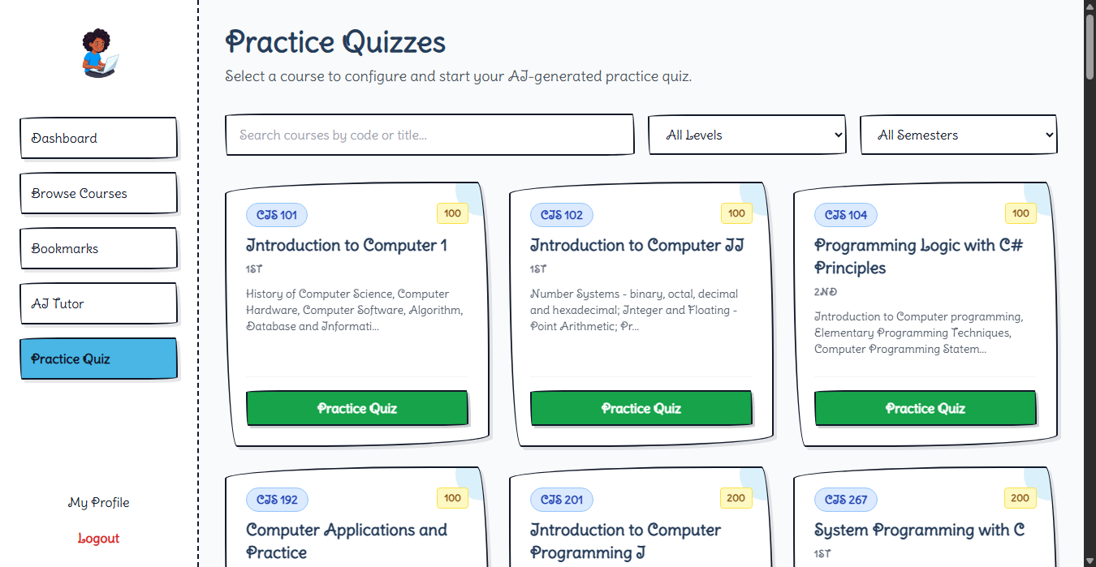
Figure B.9: Dynamic Practice Quiz Configuration Interface
Description: Shows the assessment generator setup screen where students configure course selection, difficulty tier, and question volume.

B.10 Interactive Assessment and Quiz Runner
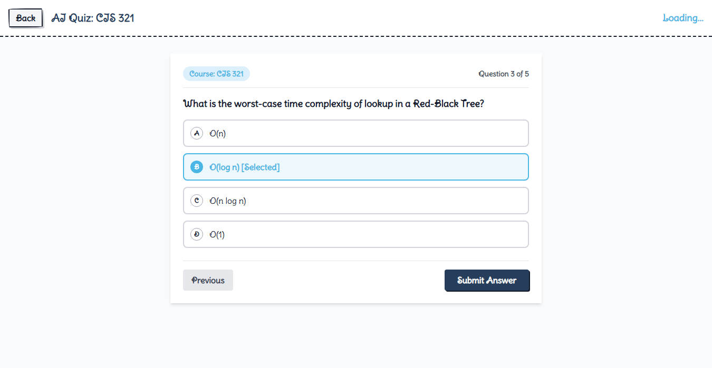
Figure B.10: Interactive Multiple-Choice Quiz Assessment Runner
Description: Demonstrates the live quiz runner interface with multiple-choice questions, instant feedback, and assessment grading.

B.11 Lecturer Dashboard and Course Assignments
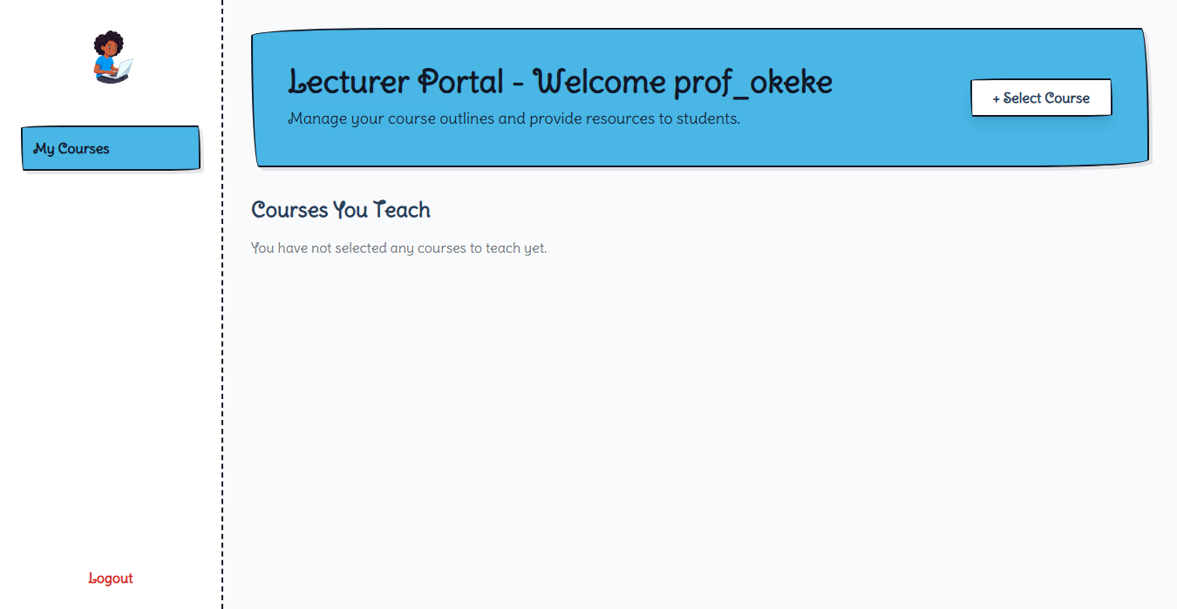
Figure B.11: Lecturer Course Overview and Assignment Portal
Description: Shows the lecturer management interface displaying claimed courses (Dr. C. Okeke) and access to syllabus authoring tools.

B.12 Lecturer Syllabus Authoring Portal
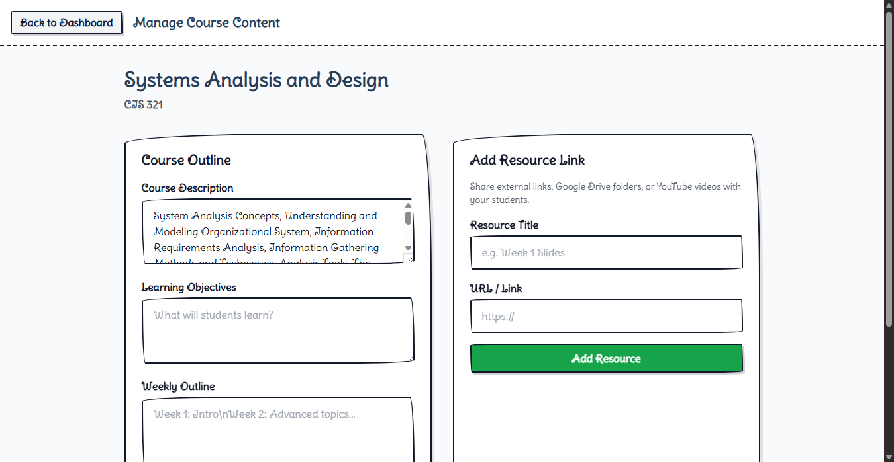
Figure B.12: Lecturer Syllabus Authoring and Resource Upload Portal
Description: Demonstrates the course outline editing form used by academic staff to update weekly modules, learning goals, and textbook references.

B.13 Administrator Dashboard and Role Governance
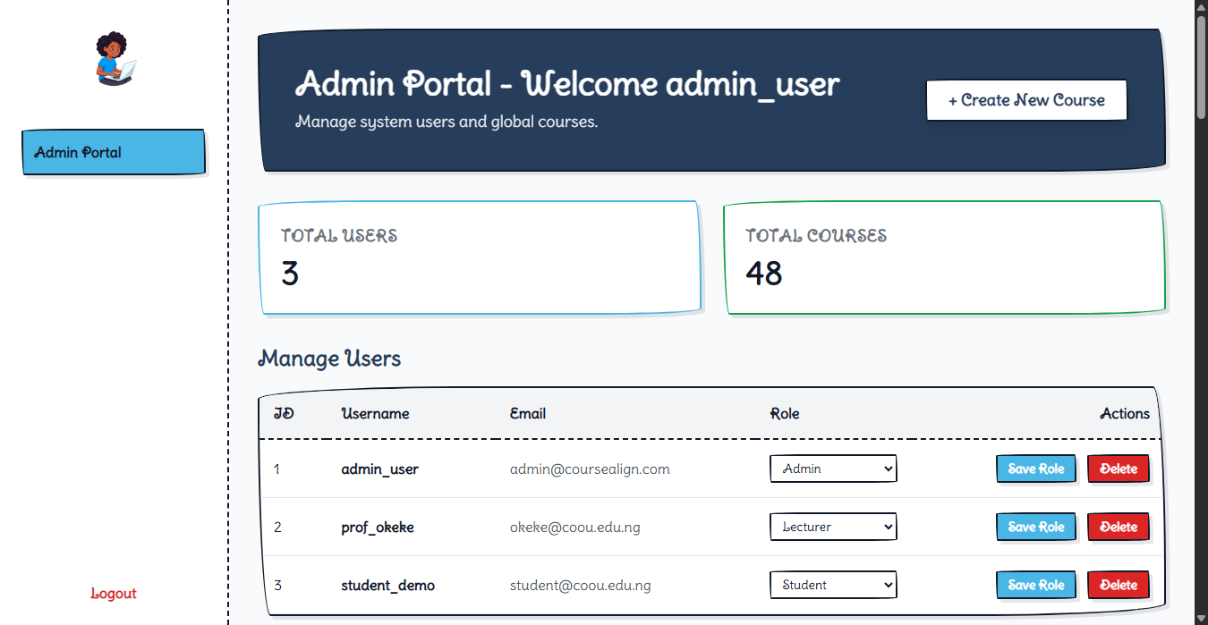
Figure B.13: Administrator User Governance and Role Assignment Portal
Description: Shows the central administrative console displaying user management tables with role-toggling controls (Student, Lecturer, Admin) and global course creation utilities.

B.14 User Profile and Account Settings
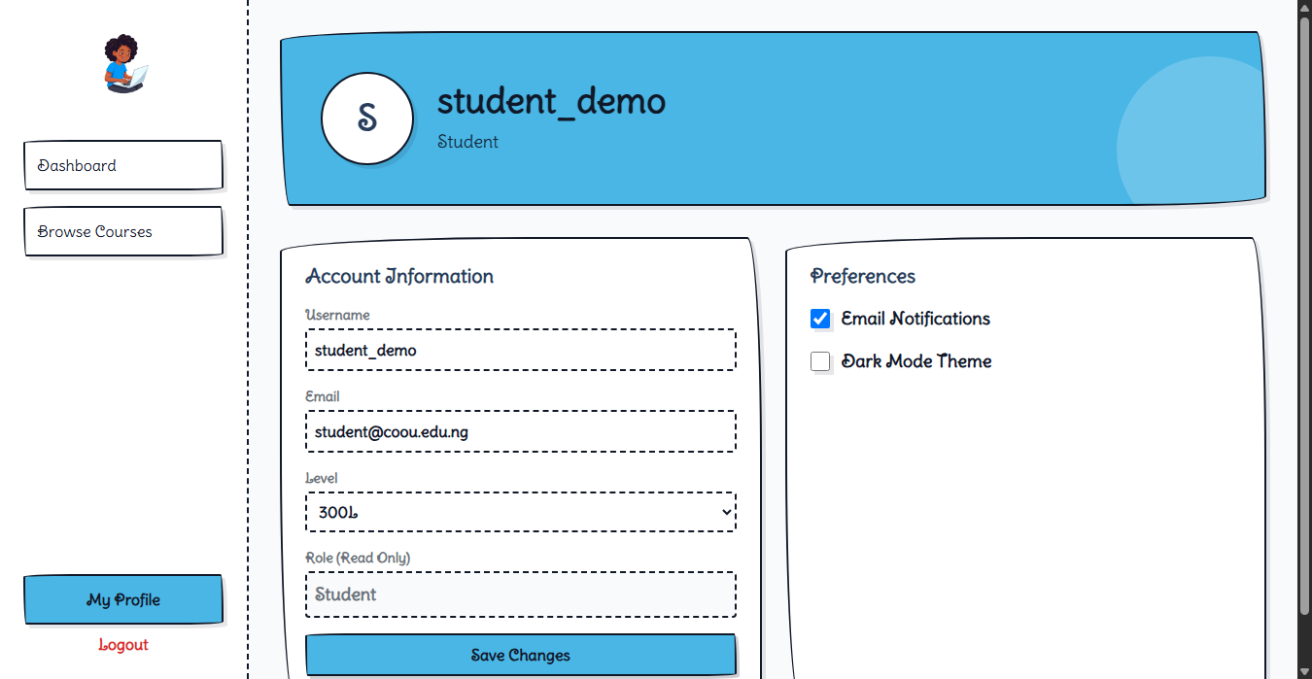
Figure B.14: Student Profile and Account Settings Interface
Description: Illustrates user account management displaying registered email, username, academic level, and preferences.

Appendix C: Questionnaire
Note on Research Methodology and Data Collection: The research and implementation of the CourseAlign system utilized a design-and-creation software engineering methodology. System evaluation and verification were conducted through direct unit testing, API contract verification, and local LLM benchmark assessments rather than field-administered psychometric questionnaires. Consequently, empirical questionnaire instruments and survey response datasets were not administered for this development phase.

