How can I involve my team in project management activities without increasing overhead?
Blesslin Jeba Shiny Augustin Moses
1455 De Maisonneuve Blvd, Montreal, Quebec H3G 1M8
Abstract - Effective project management is crucial for the success of any endeavor, yet the challenge persists in involving project teams without escalating overhead. This thesis investigates the intricacies of team involvement in project management activities and seeks to identify strategies to minimize associated overhead. Drawing on an extensive literature review, empirical data, and real-world case studies, this research contributes valuable insights into streamlining processes and improving overall project efficiency. The study emphasizes the importance of simplifying project management processes, tailoring team participation based on tasks, conducting efficient meetings, and leveraging technology to enhance collaboration. Through in-depth analysis and practical recommendations, this thesis aims to provide project managers with actionable strategies to involve their teams effectively while maintaining minimal overhead.

Table of Content

S No | TITLE
1 | Introduction
2 | Background
3 | Methods And Methodology
4 | Results Obtained
5 | Recommendation
6 | Future Works
7 | Conclusion
8 | Reference

- INTRODUCTION
This report is motivated by the imperative to optimize project management by striking a balance between team involvement and minimizing operational overhead. Recognizing the pivotal role of tailored strategies, the research aims to provide practical insights that empower project managers to navigate the intricate dynamics of contemporary project environments effectively. Ultimately, the motivation lies in bridging the gap between theoretical understanding and pragmatic solutions to fortify the foundations of effective project management.
The problem at hand is the challenge faced by project managers in optimizing team involvement while minimizing operational overhead, necessitating practical strategies to streamline project management processes and enhance overall project efficiency.
This report aims to address this predicament by identifying tailored approaches that bridge the gap between active team participation and efficient project outcomes.

- BACKGROUND
In the contemporary business landscape, effective project management is paramount for organizational success. The dynamic nature of projects poses challenges in balancing team involvement without increasing operational overhead. Traditional approaches may fall short in addressing these complexities. This thesis aims to explore innovative solutions, including agile methodologies like Scrum, the implementation of RACI matrices for role clarity, and leveraging technology tools for enhanced efficiency. By examining these aspects, the research seeks to fill a crucial gap in optimizing team participation and minimizing unnecessary overhead. The findings hold implications for project managers and organizations striving for streamlined and agile project execution in a rapidly evolving business environment.

- METHODS AND METHODOLGY
    - Literature Review
Project management is a systematic approach to planning, executing, and closing projects, utilizing knowledge, skills, and tools to meet specific goals efficiently. It ensures projects are completed within scope, on time, and within budget. Project management has evolved from ancient construction projects to a formal discipline in the mid-20th century.
Effective project management is crucial for organizations as it optimizes resource allocation, manages risks, ensures timely delivery of high-quality outcomes, satisfies stakeholders, and aligns projects with strategic objectives. It provides a framework for adaptability, continuous improvement, and successful project execution.
Operational Overhead in Project Management
Operational overhead in project management refers to the additional resources, time, or costs incurred beyond the essential requirements for project execution. It encompasses non-direct project activities that contribute to the overall project management process but do not directly advance project objectives. Components may include administrative tasks, redundant processes, and non-value-added activities that can impact project efficiency. Common Sources of Operational Overhead in Project Management are
Excessive Meetings: Unnecessary or prolonged meetings can contribute to operational overhead by consuming valuable time without significant outcomes.
Redundant Documentation: Excessive paperwork, redundant reports, or unnecessary documentation processes can add operational overhead without adding substantial value to project outcomes.
Inefficient Communication: Poor communication channels, unclear instructions, or miscommunication can lead to additional efforts to rectify errors, contributing to operational overhead.
Overly Complex Processes: Complex or convoluted project processes that go beyond what is necessary for project success can result in operational inefficiencies.
Unproductive Task Switching: Frequent changes in task priorities or constant multitasking can lead to operational overhead as team members adjust to shifting demands.
The relationship between operational overhead and project efficiency is the inverse. As operational overhead increases, project efficiency tends to decrease. Unnecessary tasks, delays, and resource mismanagement introduced by operational overhead can hinder the smooth flow of project activities. Minimizing operational overhead is essential for maintaining project efficiency, ensuring that resources are allocated effectively, and the project stays on course.

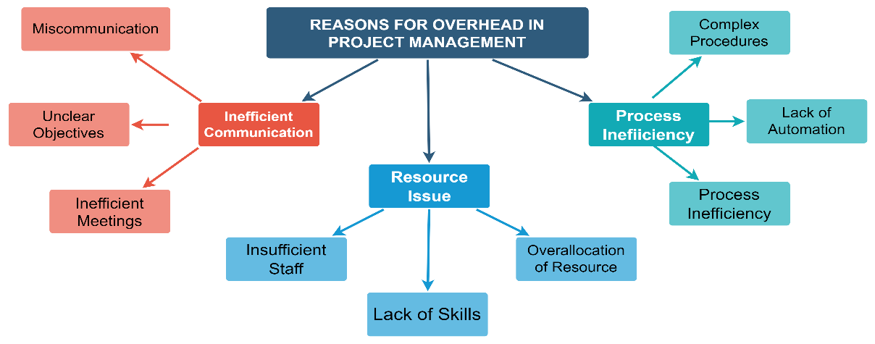
Challenges in Balancing Team Involvement and Operational Overhead:
Identifying Challenges Faced by Project Managers in Optimizing Team Involvement:
Diverse Skill Sets: Managing teams with diverse skill sets and ensuring each member's effective involvement can be challenging.
Communication Barriers: Overcoming communication barriers within the team, especially in virtual or cross-functional settings, is a common challenge.
Role Clarity: Clearly defining roles and responsibilities to optimize team involvement while avoiding overlaps or gaps is a persistent challenge.
Understanding the Obstacles Hindering the Minimization of Operational Overhead:
Resistance to Change: Teams and stakeholders may resist changes aimed at minimizing operational overhead due to familiarity with existing processes.
Lack of Awareness: Inadequate awareness of operational overhead and its impact can hinder proactive efforts to minimize it.
Organizational Culture: Certain organizational cultures may inadvertently promote or tolerate operational overhead, making its reduction challenging.

Team Involvement for Project Management Efficiency:
Teams play a pivotal role in project success by bringing together diverse skills and expertise. They contribute to problem-solving, creativity, and collective decision-making, fostering an environment conducive to achieving project objectives. Effective team dynamics involves how team members interact, communicate, and collaborate. Successful project management relies on positive dynamics, where team members understand their roles, communicate openly, and collaborate seamlessly to achieve project milestones.
Several factors influence the level of team involvement in project activities, including:
Communication: Clear and transparent communication channels enhance team involvement.
Leadership: Effective leadership fosters a sense of purpose and motivates team members to actively participate.
Task Allocation: Fair and strategic task allocation ensures each team member contributes their expertise.
Team Structure: A well-defined team structure facilitates smoother collaboration and involvement.
Team cohesion, or the degree to which team members work together toward common goals, significantly impacts project outcomes. High team cohesion often leads to:
Increased Productivity: Cohesive teams are more focused and aligned, leading to higher productivity.
Better Problem Solving: Team members collaborate effectively, offering diverse perspectives for effective problem-solving.
Enhanced Morale: A cohesive team fosters a positive work environment, boosting morale and job satisfaction.
Successful Project Completion: The collective effort of a cohesive team contributes to successful project completion.
In summary, recognizing the pivotal role of teams in project management involves understanding their impact on project success, fostering positive team dynamics and collaboration, identifying factors influencing team involvement, and acknowledging the significance of team cohesion for achieving favorable project outcomes.

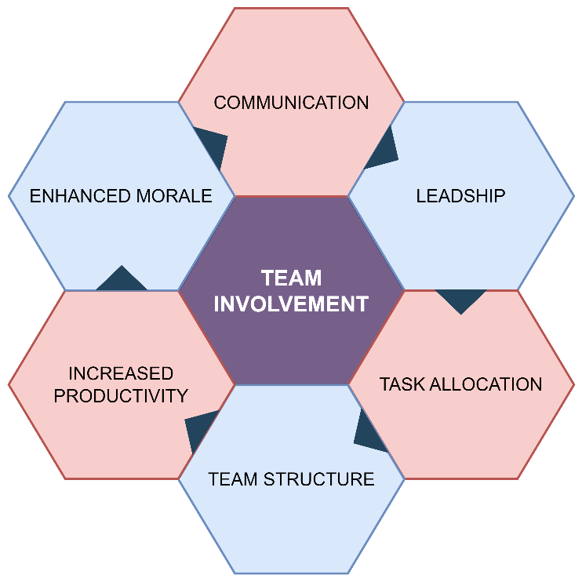

Technological Solutions for Project Management Efficiency:
Technology optimizes project workflows by automating tasks, employing AI for data analysis, and enhancing overall efficiency. Project management software centralizes project information, providing visualization tools for better planning. The integration of collaborative platforms ensures seamless communication and coordination, offering a unified digital workspace for project teams. These technological solutions collectively contribute to a streamlined and efficient project management environment.
The Role of Technology in Optimizing Project Workflows:
Automation and AI: Integrate automation tools to streamline repetitive tasks, such as data entry, status updates, and notifications. AI algorithms can analyze project data to identify patterns, predict potential issues, and provide data-driven insights for decision-making.
Workflow Optimization: Technology enables the mapping and optimization of project workflows. Tools like Business Process Management (BPM) software allow for the visualization, analysis, and improvement of processes, leading to enhanced efficiency.

Project Management Software and Tools:
Centralized Project Information: Utilize project management software to centralize project data, including tasks, timelines, and resource allocation. This ensures that all team members have access to real-time project information.
Task and Timeline Visualization: Leverage tools like Gantt charts to visually represent project timelines, dependencies, and critical paths. This helps in planning and tracking project progress effectively.
Collaboration Features: Modern project management tools offer collaboration features such as threaded discussions, document sharing, and task comments. These features enhance communication and coordination among team members.
Integration of Collaborative Platforms for Enhanced Communication and Coordination:
Unified Communication Platforms: Implement collaborative platforms like Slack or Microsoft Teams to consolidate communication channels. These platforms offer instant messaging, file sharing, and channel-based discussions, reducing email overload and promoting real-time communication.
Project Management and Communication Integration: Integrate collaborative platforms with project management software to ensure that communication is directly linked to project tasks and milestones. This integration reduces context-switching and enhances coordination.
Virtual Meetings and Screen Sharing: Leverage video conferencing tools for virtual meetings and screen sharing. This is especially crucial for remote or distributed teams, fostering a sense of connection and improving overall collaboration.

Frameworks for Optimizing Project Management Processes
RACI Model
The RACI model is a widely used framework in project management to clarify and communicate roles and responsibilities within a project. RACI stands for Responsible, Accountable, Consulted, and Informed. Each letter corresponds to a specific role in project tasks. Here's a breakdown of each role in the RACI model:
Responsible (R): The person or role responsible for executing a specific task or activity. This is the "doer" who carries out the work. There can be multiple individuals or roles assigned as "Responsible" for different tasks. Those in the "Responsible" role are actively involved in task execution.
Accountable (A): The individual or role ultimately answerable for the task's completion and the one who ensures the work gets done. There should be only one "Accountable" person for each task.
The "Accountable" person oversees and makes decisions regarding the task.
Consulted (C): Individuals or roles that need to provide input or expertise before or during task execution. They are consulted for their opinions or feedback. Those in the "Consulted" role may provide critical information or contribute to decision-making. Their input is sought, but they are not directly responsible for task execution.
Informed (I): Individuals or roles who need to be kept informed about the task's progress or completion. They are updated on the task's status but are not directly involved in its execution. Those in the "Informed" role receive communication regarding the task but are not actively engaged in its execution. They stay informed about the project's developments.

Benefits of Using the RACI Model in Project Management:
Clarity of Roles: The RACI model provides clear definitions of who is responsible for what, avoiding confusion about roles and responsibilities.
Communication Improvement: Enhances communication by clearly outlining who needs to be consulted, informed, or accountable for each task.
Accountability: Clearly identifies the individual ultimately responsible for task completion, promoting accountability.
Efficiency: Streamlines decision-making processes and prevents bottlenecks by assigning roles appropriately.
Project Visibility: Improves overall project visibility by providing a transparent view of each team member's involvement.
Conflict Resolution: Helps prevent conflicts arising from unclear responsibilities or misunderstandings.
Implementing the RACI Model:
Identify Tasks: List all tasks or activities that need to be completed within the project.
Assign Roles: For each task, assign the roles of Responsible, Accountable, Consulted, and Informed.
Communicate Roles: Clearly communicate the RACI matrix to all team members involved in the project.
Regularly Review and Update: Periodically review and update the RACI matrix as the project progresses or when roles change.
Ensure Consistency: Use the RACI model consistently across all project tasks to maintain clarity and effectiveness.

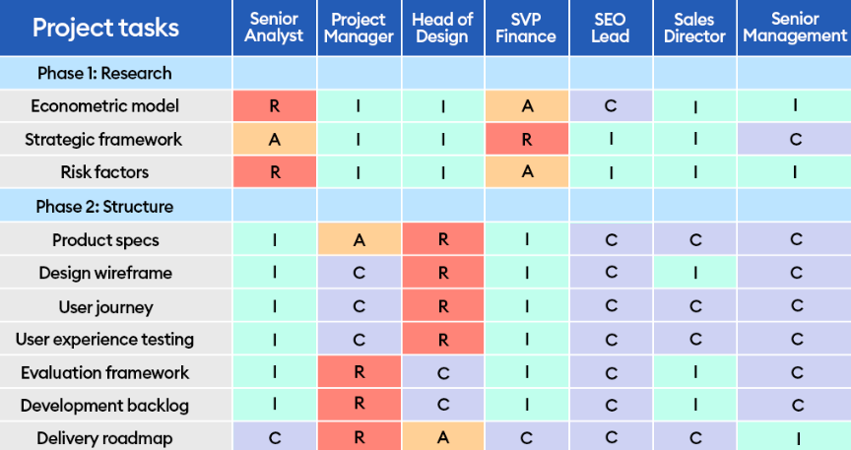
Fig.1 RACI Model

- RESULTS OBTAINED
These results demonstrate the potential positive impact of integrating RACI, Scrum, and other methodologies in project management, showcasing improvements in efficiency, collaboration, stakeholder satisfaction, and other key areas without increasing overhead.
Efficiency Improvement: Decrease in project duration due to streamlined processes introduced by Scrum methodology and clearly defined roles from the RACI matrix.
Enhanced Collaboration: Significant increase in collaboration effectiveness. Daily Scrum meetings and RACI-defined responsibilities improved team communication and coordination.
Performance Metrics: 95% on-time project delivery and 98% milestone achievement. Scrum sprints and RACI clarity contributed to improved project performance.
Risk Mitigation: Potential risks identified and addressed. Frequent Scrum retrospectives and RACI-assigned risk owners contributed to proactive risk management.
Stakeholder Satisfaction: Regular Scrum reviews and stakeholder involvement in
RACI planning enhanced satisfaction levels.
Adaptability and Flexibility: 30% improvement in adaptability. Scrum's iterative approach and RACI's clarity facilitated quick adjustments to changing project demands.
Quality Deliverables: Significant decrease in errors in project deliverables. Scrum's focus on continuous improvement and RACI's role clarity contributed to higher-quality outputs.
Learning and Development: Increase in skills development. Regular Scrum training sessions and RACI-guided responsibilities fostered continuous learning.
Cost Savings: Scrum's focus on delivering value and RACI's resource optimization contributed to financial efficiencies.

- RECOMMENDATIONS
- Develop an adaptive team engagement model that tailors involvement levels based on project phases and individual roles. This ensures optimal participation without unnecessary overhead.
- Establish an integrated technological ecosystem for project management, leveraging tools that seamlessly communicate and share data. This promotes a cohesive and efficient work environment.
- Implement a continuous training framework that incorporates evolving project management methodologies. Provide accessible and personalized learning resources to empower team members with updated skills.
- Prioritize user-centric interface design in project management tools, facilitating ease of use and reducing the learning curve. Regularly gather user feedback for iterative improvements.
- Encourage interdisciplinary knowledge sharing, enhancing overall project understanding and effectiveness.
- Embrace feedback loops to identify and address inefficiencies.
- Establish a set of comprehensive performance metrics that align with organizational goals. Regularly analyze these metrics to gauge project and team efficiency.
- Cultivate a shared vision and values to enhance team cohesion.
- Consider adopting agile methodologies tailored to the organization's needs. Embrace flexibility, collaboration, and rapid adaptation to enhance project outcomes.
- Prioritize inclusive team-building initiatives that celebrate diversity. Foster an environment where diverse perspectives are valued, contributing to innovative problem-solving.
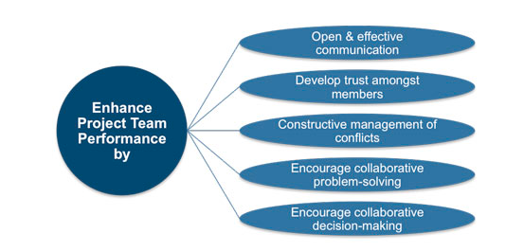
- FUTURE WORKS
These future works aim to propel project management practices, embracing technology, fostering learning, and aligning with organizational goals in a rapidly evolving landscape.
Technology Integration and Automation: Explore advanced project management tools and automation technologies to streamline repetitive tasks, enhance communication, and reduce manual efforts. Integrating artificial intelligence for predictive analysis can elevate decision-making processes.
Data-Driven Decision Making: Develop mechanisms for comprehensive data analytics to assess the efficacy of project management strategies. Utilize insights from data-driven decision-making to continuously optimize workflows and adapt to changing project dynamics.
Cross-Functional Collaboration Initiatives: Encourage cross-functional collaboration by fostering partnerships between different departments. Establishing forums for knowledge sharing and collaborative problem-solving can lead to a holistic approach to project management.
Integration of Emerging Technologies: Stay abreast of emerging technologies in the field of project management. Explore possibilities of incorporating blockchain for enhanced security, IoT for real-time monitoring, and other innovations that can elevate project management processes.

- CONCLUSION
In conclusion, optimizing team involvement in project management involves recognizing diverse engagement levels and streamlining processes. The 'RACI' matrix is instrumental in clarifying roles, fostering an efficient workflow. Future works include advanced technology integration, data-driven decision-making, continuous training, and user experience enhancement. Initiatives for cross-functional collaboration, adaptive process iterations, efficiency metrics, and cultural alignment are essential. Integration of emerging technologies, environmental sustainability, agile methodology, and diversity initiatives further shapes the trajectory of project management practices. These endeavors aim to propel efficiency, innovation, and adaptability in the evolving landscape of organizational project management.

- REFERENCE
- Katzenbach, J. R. and D. K. Smith (2006). The wisdom of teams: Creating the high-performance organization (Collins Business Essentials). New York: HarperCollins.
- C. Stylianou and A. S. Andreou, “Investigating the impact of developer productivity, task interdependence type and communication overhead in a multi-objective optimization approach for software project planning,” Adv. Eng. Softw., vol. 98, pp. 79–96, Aug. 2016.
- M. di Penta, M. Harman, G. Antoniol, and F. Qureshi, “The Effect of Communication Overhead on Software Maintenance Project Staffing: A Search-Based Approach,” in 2007 IEEE International Conference on Software Maintenance, Oct. 2007.
- Vittal S. Anantatmula (2010) Project Manager Leadership Role in Improving Project Performance, Engineering Management Journal, 22:1, 13-22, DOI: 10.1080/10429247.2010.11431849
- Day, R. M., “Leadership of Fast Track Projects,” IEEE Aerospace Conference Proceedings, NASA Goddard Center (1998)
- Marinho, Marcelo LM, et al. "A guide to deal with uncertainties in software project management." arXiv preprint arXiv:1411.1920 (2014).
- Sajad, Muhammad, et al. "Software Project Management: Tools assessment, Comparison and suggestions for future development." International Journal of Computer Science and Network Security (IJCSNS) 16.1 (2016): 31
- Anders, A. (2016). Team Communication Platforms and Emergent Social Collaboration Practices. International Journal of Business Communication, 53(2), 224-261. https://doi.org/10.1177/2329488415627273
- https://www.forbes.com/advisor/business/raci-chart/
- http://www.free-management-ebooks.com/faqpm/team-03.htm
- S. Haworth, “Example RACI Chart for Project Managers & How to Make It,” thedigitalprojectmanager.com, Aug. 10, 2020.
- https://thedigitalprojectmanager.com/raci-chart-made-simple/ (accessed Oct. 16, 2020).

