WIFISENSE
AI-POWERED INDOOR MONITORING AND
FACILITY INTELLIGENCE PLATFORM USING WI-FI CSI

24MCAR295 - Mini Project

Submitted by

BLESSON JOSEPH BYJU
Reg. No.: AJC25MCA-2023

In Partial fulfillment for the Award of the Degree of
MASTER OF COMPUTER APPLICATIONS (MCA)



AMAL JYOTHI COLLEGE OF ENGINEERING AUTONOMOUS
KANJIRAPPALLY

[Approved by AICTE, Accredited by NAAC with A+, Accredited by NBA.
Koovappally, Kanjirappally, Kottayam, Kerala – 686518]

2025-2027

DEPARTMENT OF COMPUTER APPLICATIONS

AMAL JYOTHI COLLEGE OF ENGINEERING AUTONOMOUS
KANJIRAPPALLY

CERTIFICATE

This is to certify that the Project report titled “Wi-Fi Sense: AI-Powered Indoor Monitoring and Facility Intelligence Platform Using Wi-Fi CSI” is the bona fide work of BLESSON JOSEPH BYJU (Regno: AJC25MCA-2023) carried out in partial fulfillment of the requirements for the award of the Degree of Master of Computer Applications at Amal Jyothi College of Engineering Autonomous, Kanjirappally. The project was undertaken during the period from July 01, 2026 to October 26, 2026.

Mr. Binumon Joseph Ms. Meera Rose Mathew
Internal Guide Coordinator

Dr. Juby Mathew
Professor & Head of Department

DECLARATION

I hereby declare that the project report “Wi-Fi Sense: AI-Powered Indoor Monitoring and Facility Intelligence Platform Using Wi-Fi CSI” is a bona fide work done at Amal Jyothi College of Engineering Autonomous, Kanjirappally, towards the partial fulfilment of the requirements for the award of the Master of Computer Applications (MCA) during the period from July 01, 2026 to October 26, 2026.

Date: 26/10/2026 BLESSON JOSEPH BYJU
KANJIRAPPALLY Reg: AJC25MCA-2023

ACKNOWLEDGEMENT

First and foremost, I thank God almighty for his eternal love and protection throughout the project. I take this opportunity to express my gratitude to all who helped me in completing this project successfully. It has been said that gratitude is the memory of the heart. I wish to express my sincere gratitude to our Director (Administration) Rev. Fr. Dr. Roy Abraham Pazhayaparampil and Principal Dr. Lillykutty Jacob for providing good faculty for guidance.

First and foremost, I thank God almighty for his eternal love and protection throughout the project. I take this opportunity to express my gratitude to all who helped me in completing this project successfully. I wish to express my sincere gratitude to our Director (Administration) Rev. Fr. Dr. Roy Abraham Pazhayaparampil and Principal Dr. Lillykutty Jacob for providing good faculty for guidance.
I owe a great depth of gratitude towards our Head of the Department Dr. Juby Mathew for helping us. I extend my wholehearted thanks to the project coordinator Ms. Meera Rose Mathew for her valuable suggestions and for overwhelming concern and guidance from the beginning to the end of the project. I would also express sincere gratitude to my guide Mr. Binumon Joseph for his inspiration and helping hand.
I thank our beloved teachers for their cooperation and suggestions that helped me throughout the project. I express my thanks to all my friends and classmates for their interest, dedication, and encouragement shown towards the project. I convey my hearty thanks to my family for the moral support, suggestions, and encouragement to make this venture a success.

I thank our beloved teachers for their cooperation and suggestions that helped me throughout the project. I express my thanks to all my friends and classmates for their interest, dedication, and encouragement shown towards the project. I convey my hearty thanks to my family for the moral support, suggestions, and encouragement to make this venture a success.

BLESSON JOSEPH BYJU

ABSTRACT

Wi-Fi Sense is an AI-powered indoor monitoring and facility intelligence platform designed to centralise contactless human presence sensing, real-time fall detection, room occupancy tracking, and space utilization analytics within a unified web-based interface. By analyzing Channel State Information (CSI) from commercial Wi-Fi devices, the platform detects physical activities and emergencies without requiring cameras or wearable sensors, protecting user privacy in sensitive environments such as bedrooms and restrooms. The platform serves caregivers, facility directors, corporate staff, and family members.
The frontend is built with React 18, Vite, and Tailwind CSS, featuring HTML5 Canvas-based 64-subcarrier spectrogram waterfalls. The backend is developed with Python and FastAPI in an asynchronous ASGI architecture, while PostgreSQL hosted on Supabase Cloud stores organizations, buildings, rooms, devices, sensing events, alerts, and audit records. Hardware sensing utilizes dual-core ESP32-S3 transceivers streaming raw CSI packets over UART to a PySerial gateway at 921600 baud. The system is hosted across Render Cloud (backend API) and Vercel Global Edge (frontend web application).
Browser-based login, fall incident escalation, data sharing policy management, family portal wellness checks, and corporate space analytics were automated with Selenium WebDriver and pytest, and their recorded test runs passed. Full regression testing covering 51 backend tests passed in 11.65 seconds. Multi-antenna spatial coordinate tracking and micro-Doppler contactless vital sign extraction are described as planned extensions and are not presented as completed features.

CONTENT
SL. NO | TOPIC | PAGE NO
1 | INTRODUCTION | 1
1.1 | PROJECT OVERVIEW | 2
1.2 | PROJECT SPECIFICATION | 4
2 | SYSTEM STUDY | 18
2.1 | INTRODUCTION | 19
2.2 | LITERATURE REVIEW | 21
2.2.1 | NATURAL SYSTEM STUDIED | 24
2.2.2 | DESIGNED SYSTEM STUDIED | 28
2.3 | DRAWBACKS OF EXISTING SYSTEM | 32
2.4 | PROPOSED SYSTEM | 35
2.5 | ADVANTAGES OF PROPOSED SYSTEM | 37
3 | REQUIREMENT ANALYSIS | 40
3.1 | FEASIBILITY STUDY | 41
3.1.1 | ECONOMICAL FEASIBILITY | 41
3.1.2 | TECHNICAL FEASIBILITY | 43
3.1.3 | BEHAVIORAL FEASIBILITY | 46
3.1.4 | FEASIBILITY STUDY QUESTIONNAIRE | 49
3.1.5 | GEOTAGGED PHOTOGRAPH | 52
3.2 | SYSTEM SPECIFICATION | 53
3.2.1 | HARDWARE SPECIFICATION | 53
3.2.2 | SOFTWARE SPECIFICATION | 53
3.3 | SOFTWARE DESCRIPTION | 58
3.3.1 | REACT.JS AND VITE | 59
3.3.2 | PYTHON AND FASTAPI | 59
3.3.3 | POSTGRESQL (SUPABASE MANAGED) | 60
3.3.4 | ESP-IDF AND C++ FIRMWARE | 61
3.3.5 | TAILWIND CSS AND DESIGN SYSTEM | 62
3.3.6 | HTML5 CANVAS SPECTROGRAM API | 63
3.3.7 | PYSERIAL INGESTION DAEMON | 64
3.3.8 | RENDER AND VERCEL CLOUD HOSTING | 65
4 | SYSTEM DESIGN | 66
4.1 | INTRODUCTION | 67
4.2 | UML DIAGRAM | 67
4.2.1 | USE CASE DIAGRAM | 68
4.2.2 | SEQUENCE DIAGRAM | 70
4.2.3 | STATE CHART DIAGRAM | 72
4.2.4 | ACTIVITY DIAGRAM | 72
4.2.5 | CLASS DIAGRAM | 74
4.2.6 | OBJECT DIAGRAM | 75
4.2.7 | COMPONENT DIAGRAM | 76
4.2.8 | DEPLOYMENT DIAGRAM | 78
4.2.9 | COLLABORATION DIAGRAM | 80
4.3 | USER INTERFACE DESIGN USING FIGMA | 80
4.4 | DATABASE DESIGN | 88
4.4.1 | RELATIONAL DATABASE MANAGEMENT SYSTEM (RDBMS) | 88
4.4.2 | NORMALIZATION | 89
4.4.3 | SANITIZATION | 92
4.4.4 | INDEXING | 92
4.5 | TABLE DESIGN | 93
5 | SYSTEM TESTING | 109
5.1 | INTRODUCTION | 110
5.2 | TEST PLAN | 111
5.2.1 | UNIT TESTING | 117
5.2.2 | INTEGRATION TESTING | 119
5.2.3 | VALIDATION TESTING OR SYSTEM TESTING | 122
5.2.4 | OUTPUT TESTING OR USER ACCEPTANCE TESTING | 124
5.2.5 | AUTOMATION TESTING | 126
5.2.6 | SELENIUM TESTING | 126
6 | IMPLEMENTATION | 141
6.1 | INTRODUCTION | 142
6.2 | IMPLEMENTATION PROCEDURES | 142
6.2.1 | USER TRAINING | 145
6.2.2 | TRAINING ON THE APPLICATION SOFTWARE | 145
6.2.3 | SYSTEM MAINTENANCE | 146
6.2.4 | HOSTING | 149
7 | CONCLUSION AND FUTURE SCOPE | 152
7.1 | CONCLUSION | 153
7.2 | FUTURE SCOPE | 154
8 | BIBLIOGRAPHY | 157
9 | APPENDIX | 160
9.1 | SAMPLE CODE | 161
9.2 | SCREEN SHOTS | 166
9.3 | GIT LOG | 169

List of Abbreviations
AI : Artificial Intelligence
API : Application Programming Interface
ASGI : Asynchronous Server Gateway Interface
CFR : Channel Frequency Response
CFO : Carrier Frequency Offset
COTS : Commercial Off-The-Shelf
CSI : Channel State Information
DFS : Doppler Frequency Shift
ESP-IDF : Espressif IoT Development Framework
FFT : Fast Fourier Transform
HTML : HyperText Markup Language
HTTPS : Hypertext Transfer Protocol Secure
IoT : Internet of Things
JSON : JavaScript Object Notation
JWT : JSON Web Token
MAC : Media Access Control
MIMO : Multiple-Input Multiple-Output
ML : Machine Learning
OFDM : Orthogonal Frequency Division Multiplexing
PHY : Physical Layer
PIR : Passive Infrared
RBAC : Role-Based Access Control
RDBMS : Relational Database Management System
REST : Representational State Transfer
RF : Radio Frequency
RSSI : Received Signal Strength Indicator
SFO : Sampling Frequency Offset
SPA : Single Page Application
SQL : Structured Query Language
SSE : Server-Sent Events
STFT : Short-Time Fourier Transform
TCN : Temporal Convolutional Network
TLS : Transport Layer Security
UART : Universal Asynchronous Receiver-Transmitter
UAT : User Acceptance Testing
UI : User Interface
UML : Unified Modeling Language
URL : Uniform Resource Locator
UUID : Universally Unique Identifier
WSS : WebSocket Secure
1NF : First Normal Form
2NF : Second Normal Form
3NF : Third Normal Form

CHAPTER 1
INTRODUCTION

1.1 PROJECT OVERVIEW
Wi-Fi Sense is an AI-powered indoor monitoring and facility intelligence platform designed to provide contactless human sensing, real-time fall detection, room occupancy tracking, and facility space analytics using commercial Wi-Fi Channel State Information (CSI). In conventional healthcare and assisted living environments, resident monitoring has historically relied on camera surveillance systems or wearable panic pendants. However, video cameras cause severe personal privacy infringements and cannot be placed in private quarters, while wearable devices suffer from low user compliance, charging friction, and being forgotten during critical accidents. By analyzing the micro-perturbations of Orthogonal Frequency Division Multiplexing (OFDM) Wi-Fi subcarrier signals caused by physical human movements, Wi-Fi Sense delivers completely unobtrusive, device-free indoor intelligence without capturing any visual images.
The primary value proposition of Wi-Fi Sense is to provide healthcare providers, assisted living administrators, and corporate facility managers with a unified, cloud-connected operational environment that bridges physical RF multipath dynamics with automated clinical incident dispatch. Rather than functioning as an isolated signal laboratory prototype, the platform unifies real-time CSI packet acquisition from inexpensive ESP32-S3 microcontroller nodes, subcarrier phase sanitization, machine learning-driven posture classification, immediate emergency alert escalation, and role-governed web consoles. The platform supports two distinct operational configurations on a single codebase: Elder-Care / Assisted Living for resident safety and catastrophic fall detection, and Corporate Facilities for room occupancy, meeting room scheduling, and HVAC energy conservation analytics.
Core Engine: Contactless CSI Sensing and Alert Dispatch
• Subcarrier Acquisition: Edge CSI Packet Acquisition: Pairs of commercial ESP32-S3 transmitter and receiver nodes capture 56 to 64 OFDM subcarrier channel state vectors over 802.11 b/g/n wireless channels in promiscuous mode at 90 packets per second.
• Phase Sanitization: Signal Preprocessing & Sanitization: Raw subcarrier phases are unwrapped and cleansed of Carrier Frequency Offset (CFO) and Sampling Frequency Offset (SFO) using linear regression detrending, while Hampel outlier filters eliminate impulse noise.
• Activity Classification: Machine Learning Activity Classification: Preprocessed amplitude and phase features are evaluated against calibrated empty-room baselines to classify room states into Empty, Presence, Walking, Sitting, and Fall_Detected with sub-second latency.
• Emergency Alerting: Emergency Alert State Machine: When a catastrophic fall posture is detected, the engine executes an atomic state transition, triggering high-priority visual alarms, audible Web Audio sirens, and asynchronous email notifications.
Supporting Subsystems
• Serial Gateway: Hardware Ingestion Gateway: High-throughput PySerial bridge daemon running on host gateways reads UART buffers at 921600 baud, structures packet payloads, and securely transmits JSON vectors to the backend ingestion API.
• FastAPI Backend: Multi-Tenant Cloud Backend: Implemented in Python with FastAPI and SQLModel ORM, providing asynchronous non-blocking request handling, connection pooling, and multi-tenant schema isolation.
• PostgreSQL Database: Persistent Relational Data Store: PostgreSQL managed via Supabase Cloud, normalized to 3NF, storing organizations, buildings, floors, rooms, devices, sensing events, alerts, and audit logs.
• React Web SPA: Reactive Clinical & Corporate Dashboards: React 18 single page application built with Vite and Tailwind CSS, featuring glanceable room occupancy grids, HTML5 canvas subcarrier spectrograms, and one-tap incident triage.
• Family Portal: Family Guardian Portal: Dedicated subscription-gated interface allowing family members to verify loved ones' daily presence, review safety incident logs, and configure zero-leak privacy disclosures.
Target Users
• Caregivers & Nurses: Caregivers and Nursing Staff: Clinical personnel in assisted living facilities who require immediate, glanceable alerts during resident falls and continuous presence tracking without invading patient privacy.
• Facility Managers: Facility Managers and Directors: Administrative leaders responsible for facility operations, staff accountability, hardware sensor health monitoring, and data sharing compliance policies.
• Corporate Administrators: Corporate Workplace Administrators: Operations managers who oversee commercial building spaces, analyze conference room utilization rates, and automate HVAC and lighting shutdowns to curtail energy waste.
• Family Members: Family Members and Guardians: Remote family sponsors who subscribe to wellness plans to receive reassurance of their elderly parents' safety through dignified, non-visual presence indicators.
• System Administrators: System Administrators: Technical engineers managing tenant provisioning, role assignments, hardware firmware upgrades, and end-to-end platform security.
1.2 PROJECT SPECIFICATION
This section details the formal engineering specifications of Wi-Fi Sense, including project objectives, operational scope, modular architecture, user roles, functional requirements (numbered 1 to 20), non-functional quality attributes, principal data schemas, and runtime constraints.
Objectives
• Objective 1: To engineer a completely contactless, non-invasive indoor monitoring platform utilizing commercial off-the-shelf (COTS) Wi-Fi Channel State Information.
• Objective 2: To implement high-speed RF subcarrier acquisition on dual-core ESP32-S3 microcontrollers operating at 2.4 GHz 802.11 b/g/n standards.
• Objective 3: To develop a signal sanitization pipeline that eliminates carrier frequency offset, sampling frequency offset, and multipath clutter through dynamic baseline subtraction.
• Objective 4: To classify physical human postures (empty, presence, sitting, walking, fall) using lightweight feature extraction algorithms optimized for low-latency execution.
• Objective 5: To build an atomic emergency alert state machine guaranteeing instant siren escalation and notification dispatch during catastrophic fall accidents.
• Objective 6: To establish strict multi-tenant Role-Based Access Control (RBAC) supporting dual clinical (Elder Care) and facility (Corporate) operational contexts.
• Objective 7: To construct a responsive, high-performance web dashboard providing glanceable facility status matrices and 64-subcarrier spectrogram heatmaps.
• Objective 8: To implement granular resident privacy sharing policies and subscription-gated family guardian portals.
Scope
The scope of Wi-Fi Sense encompasses the physical IoT sensing transceivers, host gateway serial daemons, asynchronous cloud ingestion microservices, relational PostgreSQL database, and responsive React web applications. The system provides complete multi-room telemetry, emergency fall management, hardware diagnostics, and corporate space analytics. The primary focus is establishing reliable, real-world RF sensing and clinical alert dispatch without requiring wearable gadgets or cameras. Advanced multi-antenna beamforming spatial triangulation, micro-Doppler vital sign extraction, and native mobile apps are established as planned extensions within future project phases (Section 7.2).
System Modules
• Authentication Module: Authentication & Access Control: Manages stateless JWT authentication, password hashing, session refresh token rotation, and multi-tenant context resolution.
• Facility Module: Facility Management: Maintains organizational hierarchies, buildings, floors, rooms, and physical spatial dimension metadata.
• Device Module: Sensing & Device Management: Handles ESP32-S3 transceiver registration, MAC address validation, heartbeat tracking, and hardware fault diagnostic monitoring.
• CSI Processing Module: CSI Processing & Feature Extraction: Cleanses raw subcarrier vectors via linear phase unwrapping, Hampel outlier filtering, and empty-room baseline covariance subtraction.
• Inference Module: ML Activity Classification: Evaluates normalized subcarrier variance and Doppler shift metrics to infer human activity categories with confidence ratings.
• Alert Management Module: Incident & Alert Management: Coordinates the emergency fall alert state machine (Detection -> Created -> Notified -> Acknowledged -> Resolved) and audit logging.
• Family Portal Module: Family Guardian Portal: Delivers dignified, non-visual presence updates, safety history logs, and simulated Care Plan subscription checkout.
• Workplace Analytics Module: Corporate Workplace Analytics: Generates meeting room occupancy heatmaps, underutilization indicators, and HVAC energy conservation recommendations.
• Audit Module: System Audit & Governance: Records immutable audit logs for security-sensitive administrative operations, policy modifications, and device registrations.
User Roles and Privileges
• SYSTEM_ADMIN: System Administrator: Holds global oversight across all tenant organizations; manages user accounts, system configuration, database migrations, and global audit trails.
• ORG_ADMIN: Organization Administrator: Manages facility buildings, floors, and rooms within their assigned tenant organization; provisions staff accounts and configures alert templates.
• FACILITY_MANAGER: Facility Manager: Oversees daily clinical operations, assigns caregivers to wings, configures resident privacy sharing policies, and monitors sensor fleet health.
• CAREGIVER: Caregiver / Staff: Clinical nurse or orderly who monitors the real-time room feed, receives instant fall alarm sirens, acknowledges emergencies, and documents triage resolutions.
• CORPORATE_STAFF: Corporate Facility Staff: Workplace administrator who monitors corporate office rooms, tracks meeting schedule compliance, and triggers idle HVAC shutdowns.
• FAMILY_MEMBER: Family Member / Guardian: Authorized relative who accesses the Family Care Portal to verify their parent's wellness and review safety event histories under approved sharing policies.
Functional Specification
1. The system shall allow authorized users to authenticate using secure email credentials and receive stateless JWT tokens with role-governed claims.
2. The system shall enforce multi-tenant contextual routing, segregating Elder Care clinical portals from Corporate workplace dashboards.
3. The system shall allow administrators to register, update, and manage buildings, floors, and monitored room entities.
4. The system shall capture 56 to 64 OFDM subcarrier Channel State Information from commercial ESP32-S3 transceivers in real time.
5. The system shall provide an ingestion serial daemon capable of streaming raw CSI packets over UART at 921600 baud without buffer overruns.
6. The system shall sanitize raw subcarrier phase data using linear regression detrending to eliminate carrier frequency offsets.
7. The system shall apply a 7-sample Hampel moving median filter to eliminate transient electromagnetic impulse noise.
8. The system shall calibrate and maintain an empty-room dynamic CSI baseline to cancel out static background multipath reflections.
9. The system shall extract normalized subcarrier amplitude variance and Doppler frequency shift features from sanitized CSI packets.
10. The system shall classify room occupancy states into Empty, Presence, Walking, Sitting, and Fall_Detected with associated confidence scores.
11. The system shall immediately generate a critical alert record in PostgreSQL upon confirming a catastrophic fall event.
12. The system shall broadcast real-time emergency fall alerts to attending caregiver web consoles via asynchronous WebSocket / SSE channels.
13. The system shall synthesize an audible emergency siren on caregiver browsers during active, unacknowledged fall incidents.
14. The system shall allow caregivers to acknowledge and resolve active alerts, logging resolving user identifiers and timestamps for accountability.
15. The system shall provide a glanceable central monitoring room feed rendering color-coded status tiles across all facility rooms.
16. The system shall render real-time subcarrier spectrogram heatmaps on HTML5 canvas buffers at 90 frames per second without interface lag.
17. The system shall allow facility managers to define granular data sharing policies that restrict family portal access to high-level presence indicators.
18. The system shall provide a Family Guardian Portal allowing approved sponsors to review daily wellness and safety history logs.
19. The system shall compute meeting room utilization rates and recommend HVAC energy conservation actions for unoccupied corporate suites.
20. The system shall monitor hardware node heartbeats, packet drop rates, and signal-to-noise ratios, flagging degraded transceivers for maintenance.
Non-Functional Specification
• Performance: Performance: CSI ingestion and feature extraction shall execute within 25 milliseconds per packet. Emergency fall alerts shall be delivered to client consoles within 500 milliseconds of physical occurrence.
• Scalability: Scalability: The asynchronous ASGI backend and PostgreSQL connection pool shall support up to 50 concurrent room transceiver streams per server instance without packet loss.
• Availability: Availability: The platform shall achieve 99.5% uptime. Transient cloud network disconnections shall be cushioned by local gateway serial buffers.
• Security: Security: Passwords shall be cryptographically hashed using Argon2 or BCrypt with work factor 12. All network transmissions shall use TLS 1.3 encryption. JWT access tokens shall expire in 15 minutes with rolling refresh token protection.
• Reliability: Reliability: The emergency state machine shall prevent duplicate alert storms through configurable cooldown timers and transactional database locks.
• Maintainability: Maintainability: The codebase shall strictly follow modular separation of concerns, decoupling hardware firmware, ASGI routers, ORM schemas, and reactive UI components.
• Interoperability: Interoperability: The backend shall expose standardized RESTful JSON endpoints and WebSocket streams adhering to OpenAPI 3.0 specifications.
• Observability: Observability: The system shall record structured application logs, database execution times, and packet ingestion metrics with health check probes.
• Usability: Usability: The caregiver dashboard shall adhere to WCAG 2.1 AA accessibility standards with high-contrast alert banners readable from across a nurse duty desk.
• Data Integrity: Data Integrity: Foreign key constraints, CASCADE delete rules, and 3NF normalization shall guarantee referential integrity across all 15 relational tables.
• Extensibility: Extensibility: Modular activity classifier interfaces shall allow plug-and-play integration of deep learning neural networks (TCNs, CNN-LSTMs) without rewriting data pipelines.
• Testability: Testability: The platform shall support automated unit testing, database integration testing via SQLite/PostgreSQL sandboxes, and end-to-end browser testing via Selenium WebDriver.
• Resource Efficiency: Resource Efficiency: Lightweight heuristic feature extraction shall minimize CPU and memory utilization, allowing gateway daemons to run on low-power mini-PCs.
Detailed Module Description
The Authentication and Access Control module governs user identity verification and authorization boundaries. Upon credential validation, the service issues an HS256-signed JWT containing user UUID, role designation, and assigned organization ID. Every incoming HTTP request undergoes token verification via FastAPI dependency injection. Role-Based Access Control (RBAC) middleware inspects claims against allowed route privileges, preventing privilege escalation between clinical caregivers and corporate facility staff.
The Sensing and CSI Processing module coordinates the real-time physical layer telemetry pipeline. Transceivers stream raw packets containing 64 complex numbers (I/Q channels) representing OFDM subcarriers. Linear regression eliminates phase slopes induced by clock drift. The Hampel identifier suppresses impulse outliers, and time-averaged empty-room baselines are subtracted to isolate dynamic human Doppler shifts. The inference engine computes normalized variance and velocity indicators, classifying activity states within a 3.5-second evaluation window.
The Emergency Incident Management module manages life-critical fall alerts. When a confirmed fall is inferred, an atomic database transaction creates an alert record in state 'DETECTION'. The alert is immediately dispatched across connected caregiver web clients, triggering a modal banner and continuous synthesized audio siren. A caregiver acknowledging the alert causes an atomic status transition to 'ACKNOWLEDGED', muting the siren while preserving audit timestamps for clinical accountability.
Data Requirements
• User Data: User Profiles & Auth Tokens — Owner: Authentication Module; Storage: PostgreSQL 'users' & 'user_roles' tables; Sensitivity: High; Protection: Salted bcrypt password hashes, TLS encryption, short-lived JWTs.
• Facility Data: Facility Hierarchies — Owner: Facility Module; Storage: 'organizations', 'buildings', 'floors', 'rooms'; Sensitivity: Internal; Protection: Tenant-scoped foreign keys and 3NF referential integrity.
• Device Data: Sensor Device Metadata — Owner: Device Module; Storage: 'devices' table; Sensitivity: Operational; Protection: Unique MAC address constraints and cryptographic device authentication tokens.
• CSI Data: High-Frequency CSI Telemetry — Owner: Sensing Module; Storage: 'sensing_events' table & blob store; Sensitivity: Privacy-Sensitive; Protection: De-identified packet vectors, rolling log retention, no visual storage.
• Alert Data: Incident & Alert Logs — Owner: Alert Module; Storage: 'alerts' & 'alert_acknowledgements'; Sensitivity: Clinical Safety; Protection: Strict audit trails, immutable timestamps, staff resolution notes.
Assumptions and Constraints
• RF Environment: Physical transceivers (ESP32-S3) require a stable 2.4 GHz Wi-Fi radio environment with line-of-sight or moderate non-line-of-sight spatial positioning.
• Node Elevation: Transmitter and receiver nodes must be positioned between 1.0 and 1.5 meters above floor level to maximize human torso Fresnel zone interception.
• Gateway Connection: Host gateway PCs must maintain active USB serial connections to receiver nodes at 921600 baud with low latency.
• Cloud Connectivity: Cloud backend services require continuous outbound internet connectivity to communicate with Supabase PostgreSQL and Render hosting.
• Browser Capabilities: Client web browsers must support modern ECMAScript 2022, Web Audio API, and HTML5 Canvas 2D contexts.
• Phase Linearity: Subcarrier phase sanitization assumes linear Carrier Frequency Offset across adjacent OFDM subcarriers.
• Material Attenuation: Contactless sensing relies on electromagnetic diffraction; metallic structural shielding or lead-lined walls will attenuate RF signals.
• Baseline Calibration: Emergency fall detection models require calibrated empty-room baseline profiles for optimal sensitivity.

CHAPTER 2
SYSTEM STUDY

2.1 INTRODUCTION
Modern healthcare facilities, nursing homes, and smart enterprises require robust indoor monitoring systems to safeguard human life and optimize space utilization. In conventional environments, these responsibilities are handled using fragmented, disjointed methodologies: periodic manual rounds by nursing staff, wearable emergency pendants, passive infrared (PIR) motion sensors, and optical closed-circuit television (CCTV) cameras. Each of these legacy approaches exhibits fundamental operational, ethical, or physical limitations.
The study of the existing system was carried out by examining institutional elder care workflows, reviewing clinical fall injury statistics, and evaluating contemporary wireless sensing technologies. Particular attention was directed toward the difficulties faced by healthcare staff when responding to unwitnessed falls, the severe compliance barriers associated with wearable medical sensors, and the absolute privacy rejection encountered when attempting to install video cameras in private bedrooms and restrooms.
Methodology of the Study
The investigation was structured into four systematic phases. First, core monitoring tasks in assisted living and enterprise facilities were identified and cataloged. Second, existing technologies currently deployed to perform these tasks (wearables, cameras, radar, PIR) were analyzed to establish their capabilities and failure modes. Third, the operational challenges experienced by caregivers, administrators, and residents were evaluated. Fourth, these findings were synthesized into formal functional and non-functional requirements for the proposed Wi-Fi Sense platform.
Tasks in Indoor Monitoring and How They Are Handled Today
• Presence Verification: Resident Presence Verification — Current Practice: Manual physical rounds by nursing staff every 2 to 4 hours. Main Difficulty: Incidents occurring between rounds remain undetected, leading to the dangerous 'long lie' syndrome.
• Fall Detection: Emergency Fall Detection — Current Practice: Wearable alert pendants with accelerometers or pull-cords. Main Difficulty: Over 60% of fall victims are not wearing their pendants during falls due to discomfort, forgetting to wear them after bathing, or cognitive decline.
• Private Surveillance: Private Quarter Surveillance — Current Practice: Optical CCTV cameras or no monitoring. Main Difficulty: Cameras in bedrooms and bathrooms represent an unbearable invasion of personal dignity and violate healthcare privacy regulations.
• Nighttime Monitoring: Nighttime & Obscured Monitoring — Current Practice: Infrared illuminators or acoustic sensors. Main Difficulty: Optical sensors fail in darkness, smoke, or when obstructed by curtains and furniture; audio sensors suffer from ambient noise false alarms.
• Workplace Utilization: Workplace Space Utilization — Current Practice: Manual badge swipe records or PIR ceiling sensors. Main Difficulty: PIR sensors cannot distinguish a stationary human from an empty room, leading to erroneous HVAC shutdowns or energy waste.
2.2 LITERATURE REVIEW
Wi-Fi-based sensing has emerged as a promising approach for contactless and device-free indoor human sensing. Unlike camera-based systems and wearable sensors, Wi-Fi sensing can detect human presence and movement without requiring direct visual observation or devices to be attached to users. Changes in wireless signal propagation caused by human movement can be analyzed to identify different physical activities.
Early systems primarily used Received Signal Strength Indicator (RSSI), but RSSI provides limited information because it represents the overall received signal strength. Modern systems increasingly use Channel State Information (CSI), which provides detailed information about the wireless channel across multiple subcarriers. CSI therefore enables more fine-grained detection of human presence, movement, and activities. Wi-Fi Sense Focus focuses on using Wi-Fi CSI for practical indoor human sensing while considering accuracy, privacy, computational requirements, and environmental variations.
2.2.1 Review of Existing Research
Wi-Fi-Based Human Activity Recognition
Early research such as WiSee (Pu et al., 2013) demonstrated that wireless signals could be used for device-free gesture recognition without requiring wearable devices. Similarly, E-eyes (Wang et al., 2014) explored indoor activity recognition using fine-grained Wi-Fi signal variations. More recent research has focused on deep-learning approaches. Quy et al. (2025) proposed a Phase-Amplitude CSI Network that combines CSI amplitude and phase information with attention mechanisms for human activity recognition. The study demonstrated high recognition performance across multiple datasets. These studies establish that CSI contains sufficient information to distinguish different human movements. However, model performance can be affected by changes in the surrounding environment.
Human Presence Detection
Recent research has also investigated Wi-Fi CSI specifically for detecting whether a person is present in an indoor environment. Zhang et al. (2024) demonstrated contactless human presence detection using commercial Wi-Fi devices by capturing subcarrier amplitude variance. CSI measurements are collected and processed to remove noise before relevant features are extracted and classified. This approach provides a contactless alternative to cameras and conventional motion sensors. However, environmental changes, multipath propagation, interference, and hardware differences can affect detection performance.
CSI Signal Processing
Raw CSI data contains noise and hardware-related distortions. Therefore, preprocessing is an important part of Wi-Fi sensing systems. Common approaches include filtering, smoothing, outlier removal, and frequency-domain analysis. CSI amplitude and phase information can be used to identify changes caused by human movement. Techniques such as the Short-Time Fourier Transform (STFT) can also represent movement-related frequency patterns and improve feature extraction.
Machine Learning and Lightweight Models
Machine learning and deep learning are widely used to classify CSI patterns. CNNs, LSTMs, TCNs, attention mechanisms, and other architectures have been investigated for activity recognition. Although deep-learning models can provide high accuracy, their computational requirements can make deployment on low-resource edge devices difficult. Recent research therefore focuses on lightweight models that maintain useful accuracy while reducing computational complexity. Singh et al. (2025) presented Slim-Sense, a resource-efficient Wi-Fi sensing framework, while Ranasingha et al. (2026) demonstrated physics-guided attention in lightweight TCNs for efficient CSI human activity recognition.
2.2.2 Comparison of Existing Approaches
Table 2.1: Comparison of Existing Indoor Sensing Approaches
Approach | Main Advantage | Main Limitation
RSSI-based sensing | Simple and inexpensive | Limited sensing information, coarse granularity
CSI-based sensing | Detailed subcarrier information | Requires signal preprocessing and calibration
Camera-based sensing | High visual recognition capability | Severe privacy violations, line-of-sight required
Wearable sensing | Direct body measurements | Requires users to wear and charge devices daily
Deep-learning CSI models | High recognition capability | Higher computational requirements on edge nodes
Lightweight CSI models | Suitable for edge deployment | Requires careful environmental tuning

2.2.3 Research Gap
Although Wi-Fi sensing has achieved significant progress, several challenges remain. Many systems are evaluated in controlled laboratory environments and experience performance degradation when the room layout, device position, or propagation conditions change. Another challenge is computational complexity: high-performing deep learning models can require considerable processing resources, making practical edge deployment difficult. Privacy is also an important consideration because raw RF signatures can potentially leak location details. Therefore, there is a distinct need for practical Wi-Fi sensing systems that combine reliable CSI processing, suitable machine learning techniques, reasonable computational requirements, and evaluation under realistic indoor conditions.
2.2.4 Positioning of Wi-Fi Sense Focus
Wi-Fi Sense Focus is positioned as a practical implementation of established Wi-Fi CSI sensing techniques for indoor human detection and activity recognition. The project follows the general pipeline:
Wi-Fi Signal --> CSI Acquisition --> Preprocessing --> Feature Extraction --> ML/DL Model --> Human Detection / Activity Recognition
Rather than claiming to invent a new sensing technology, the project focuses on implementing and evaluating existing approaches in a practical indoor environment while considering accuracy, privacy, computational efficiency, and environmental robustness.
2.2.5 Natural System Studied
A natural system study examines how human monitoring and safety verification take place in real-world facilities before introducing a dedicated software platform. The natural system consists of elderly residents, caregivers, nursing supervisors, facility directors, family relatives, and the physical spaces they inhabit.
• Participants: Elderly Residents: Individuals requiring physical safety oversight who experience high fall vulnerability and desire personal privacy without wearing intrusive gadgets.
• Caregivers: Caregivers and Orderlies: Hospitalized staff responsible for checking rooms, attending emergency bells, and providing immediate bedside assistance.
• Family: Family Members: Loved ones seeking peace of mind regarding the safety and health status of their parents residing in assisted living centers.
• Interactions: Interactions: Caregivers conduct periodic physical rounds; when an unwitnessed fall occurs, a resident may remain immobilized for hours until the next scheduled round.
• Factors: Factors Shaping System: Environmental layout, room clutter, resident mobility levels, nighttime darkness, and staffing constraints.
2.2.6 Designed System Studied
Several designed systems have been created to support indoor monitoring, including CCTV surveillance networks, wearable panic pendants, and commercial millimeter-wave radar units. While each performs specific functions, managing them in real-world care facilities introduces severe operational friction:
• CCTV Systems: Optical Video Surveillance: Provides high visual detail but creates complete resident resistance in private bedrooms and restrooms.
• Wearables: Wearable IMU Devices: Require battery charging and compliance, failing in over 60% of real-world falls due to non-wearing.
• Radar: Millimeter-Wave Radar: Offers contactless sensing but incurs prohibitive hardware expense (Rs. 30,000+ per room) and complex installation.
2.3 DRAWBACKS OF EXISTING SYSTEM
• Compliance Failure: Severe Compliance Failure: Wearable fall alert pendants fail because residents forget to wear them, remove them during sleep or bathing, or forget to recharge battery cells.
• Privacy Violations: Intrusive Privacy Invasions: Optical video cameras violate patient dignity, making continuous surveillance in private quarters ethically untenable and legally prohibited.
• Optical Occlusion: Blindness in Darkness and Occlusion: Optical cameras cannot detect falls in darkened rooms, heavy smoke, or behind privacy curtains.
• Prohibitive Cost: Prohibitive Hardware Expense: Specialized radar units cost tens of thousands of rupees per room, precluding large-scale deployment in budget-conscious care homes.
• Delayed Triage: Delayed Emergency Discovery: Manual nurse rounds occurring at 2-to-4 hour intervals leave fallen residents unattended during the critical 'golden hour'.
• Tool Fragmentation: Fragmented Operational Tools: Facility staff must navigate separate apps for door badges, call bells, and room scheduling.
Requirements Derived from the Study
• R1: R1. Requirement: Provide contactless, device-free human presence detection without wearables. Addressed By: ESP32-S3 CSI acquisition module.
• R2: R2. Requirement: Safeguard resident privacy without capturing optical imagery. Addressed By: Physical-layer RF subcarrier analysis.
• R3: R3. Requirement: Deliver sub-second emergency fall alerting with audible sirens. Addressed By: Emergency alert state machine & Web Audio engine.
• R4: R4. Requirement: Function 24/7 in complete darkness and through non-metallic partitions. Addressed By: Ambient 2.4 GHz RF multipath propagation.
• R5: R5. Requirement: Achieve ultra-low hardware deployment cost (<Rs. 1,500 per room). Addressed By: Commercial ESP32-S3 microcontroller nodes.
• R6: R6. Requirement: Isolate static environmental clutter from human motion. Addressed By: Dynamic empty-room baseline covariance subtraction.
• R7: R7. Requirement: Provide glanceable facility-wide status matrices for nurse stations. Addressed By: React 18 Central Monitoring room feed.
• R8: R8. Requirement: Enforce strict multi-tenant Role-Based Access Control. Addressed By: FastAPI JWT claims and PostgreSQL RBAC schemas.
• R9: R9. Requirement: Provide granular privacy sharing policies for family members. Addressed By: SharingPolicyManager and Family Care Portal.
• R10: R10. Requirement: Support corporate room occupancy and HVAC energy analytics. Addressed By: Corporate Space & Energy Intelligence module.
• R11: R11. Requirement: Maintain immutable audit logs for incident triage accountability. Addressed By: PostgreSQL alert_acknowledgements table.
• R12: R12. Requirement: Monitor sensor fleet health and packet drop rates. Addressed By: Hardware IoT Device Service Desk.
2.4 PROPOSED SYSTEM
The proposed system, Wi-Fi Sense, is an integrated, AI-assisted indoor monitoring and facility intelligence platform designed to overcome the structural limitations of wearable gadgets and video surveillance. By repurposing ubiquitous commercial 802.11 Wi-Fi signals, the platform continuously tracks human presence, differentiates postures (walking, sitting), and immediately detects life-threatening accidental falls.
The system pairs an edge hardware layer (ESP32-S3 nodes capturing 64 OFDM subcarrier channel state vectors) with an asynchronous FastAPI cloud backend and high-performance React 18 single page application. A dynamic empty-room baseline is calibrated to filter out static furniture and wall reflections. When a resident falls, the sudden Doppler disturbance and subsequent immobility trigger an emergency state machine within 500 milliseconds, sounding high-contrast visual banners and audible sirens on caregiver screens.
2.5 ADVANTAGES OF PROPOSED SYSTEM
• Device-Free: 100% Device-Free: Residents wear zero sensors, require zero charging routines, and face zero compliance friction.
• Privacy Preservation: Absolute Privacy Preservation: Emits and analyzes radio waves only; zero cameras, zero microphones, zero visual invasion.
• Night Operation: Continuous 24/7 Night & Day Operation: Unaffected by complete room darkness, thick smoke, or privacy curtains.
• Through-Wall: Through-Wall Sensing: 2.4 GHz RF signals penetrate non-metallic drywall and bathroom doors where most falls occur.
• Cost Reduction: Order-of-Magnitude Cost Reduction: Utilizes Rs. 650 ESP32-S3 chips instead of Rs. 35,000 radar or camera installations.
• Fast Alerting: Sub-Second Alert Dispatch: WebSocket connections deliver emergency fall alarms in under 500 milliseconds.
• Dual-Context: Multi-Tenant Dual-Context Support: Single platform elegantly serves clinical Elder Care and commercial Corporate facilities.

CHAPTER 3
REQUIREMENT ANALYSIS

3.1 FEASIBILITY STUDY
A feasibility study assesses the operational practicality, economic viability, and technological achievability of the proposed platform prior to institutional commissioning. The study evaluates Wi-Fi Sense across three core dimensions:
• Economical: Economical feasibility: Evaluating development, hardware procurement, cloud infrastructure, and operational maintenance costs.
• Technical: Technical feasibility: Assessing availability of hardware microcontrollers, mathematical signal pipelines, cloud frameworks, and database engines.
• Behavioral: Behavioral feasibility: Evaluating stakeholder acceptance across nursing staff, facility directors, residents, and family members.
3.1.1 Economical Feasibility
Wi-Fi Sense is designed around open-source frameworks, commodity microcontrollers, and cloud-native serverless infrastructure, dramatically curtailing capital and operational expenditures compared to proprietary medical systems.
Table 3.1: Economic Feasibility and Infrastructure Expense Breakdown
Infrastructure / Hardware Layer | Allocation / Specification | Estimated Expense (INR / USD)
ESP32-S3 Microcontroller Nodes (Transmitter/Receiver) | Dual-Core Xtensa LX7, 2.4 GHz 802.11 b/g/n, Promiscuous CSI | Rs. 650 (~$7.80) per node
Gateway Host Machine Interface | Local USB Serial Bridge (FTDI/CP2102 @ 921600 Baud) | Rs. 0.00 (Existing Facility PC)
Cloud Backend Engine (Render) | Python 3.10 FastAPI ASGI Instance, Uvicorn Workers | Rs. 0.00 (Render Free / Standard Tier)
Managed Relational Database (Supabase) | PostgreSQL 17, 500 MB Storage, Realtime Pub/Sub, RLS | Rs. 0.00 (Supabase Developer Tier)
Frontend Hosting & Edge CDN (Vercel) | Global Edge CDN, Automated Git CI/CD, SSL Certificates | Rs. 0.00 (Vercel Hobby Tier)
Total Deployment Cost per Monitored Room | Comprehensive Contactless Hardware & Cloud Stack | ~Rs. 1,300 (~$15.60) — 95% Cheaper than Radar

Potential Revenue Model
• Facility SaaS: Facility Enterprise Subscriptions: Monthly recurring SaaS fee charged to elder care homes per monitored room for automated fall dispatch and compliance reports.
• Family Plans: Family Guardian Care Plans: Optional premium subscription (Rs. 499/month) for family members providing real-time presence indicators and SMS emergency notifications.
• Energy Savings: Corporate Energy Optimization: Value-based licensing model where commercial facilities pay a percentage of verified HVAC electricity cost reductions.
Benefits
• Tangible Benefits: Tangible Benefits: Elimination of expensive wearable hardware replacements, drastic reduction in post-fall hospitalization expenses through immediate triage, and measurable HVAC energy savings.
• Intangible Benefits: Intangible Benefits: Enhanced peace of mind for family relatives, preserved personal dignity for elderly residents, and reduced burnout for nursing staff.
3.1.2 Technical Feasibility
Technical feasibility examines whether required technologies are mature and whether the engineering team can implement and maintain the architecture. The principal technologies and their roles are as follows:
1. Espressif ESP32-S3 SoC: Dual-core 240 MHz microcontroller capturing 64-subcarrier OFDM channel state vectors via ESP-IDF promiscuous hooks.
2. Python 3.10 & FastAPI: Asynchronous ASGI backend handling high-concurrency ingestion requests with sub-millisecond route overhead.
3. SQLModel & SQLAlchemy ORM: Providing type-safe relational entity modeling, migrations, and PostgreSQL connection pooling.
4. Supabase Managed PostgreSQL 17: Enterprise relational database supporting ACID transactions, foreign keys, and Row-Level Security.
5. React 18 & Vite: Reactive frontend delivering high-frequency state updates, component isolation, and fast production bundles.
6. Tailwind CSS: Modern utility-first CSS framework delivering consistent clinical dark/light visual design tokens.
7. HTML5 Canvas 2D API: Enabling 90 fps hardware-accelerated spectrogram rendering of 64 subcarriers without DOM lag.
8. PySerial Gateway Daemon: Low-latency UART serial bridge buffering and framing packets at 921600 baud.
9. Web Audio API: Browser-native audio synthesizer generating audible emergency sirens without external media files.
10. Selenium WebDriver & Pytest: Automated end-to-end browser testing driving user flows and verifying UI element visibility.
11. Render Cloud Container Runtime: Providing managed Dockerized ASGI hosting with automated health check recovery.
12. Vercel Global Edge Network: Providing low-latency static single page application delivery with automatic SSL encryption.
Capacity and Performance Feasibility
In an active deployment with 20 monitored rooms streaming CSI at 90 packets per second, the gateway processes approximately 1,800 packets per second. By performing feature extraction (variance, velocity) at the gateway or backend worker level, the database receives only state transitions and decimated telemetry (1-2 records per second per room), well within PostgreSQL throughput limits.
Technical Risks and Mitigation
• Risk 1: Multipath Environmental Drift: Temperature or furniture shifts cause static reflection changes. Mitigation: Automated dynamic baseline subtraction recalibrates empty-room profiles periodically.
• Risk 2: UART Buffer Overrun: High packet rates overflow serial buffers. Mitigation: PySerial runs in dedicated background thread with circular memory buffers at 921600 baud.
• Risk 3: Cloud Network Latency: Transient internet drops interrupt alert delivery. Mitigation: Gateway PC maintains local audible alarm backup independent of cloud connectivity.
3.1.3 Behavioral Feasibility
Behavioral feasibility assesses user readiness to adopt the platform. Caregivers already utilize nurse call stations and computers, making the web dashboard instantly intuitive. Residents experience zero disruption since no devices are placed on their bodies or in their sightlines.
• Caregiver Acceptance: Caregivers: Eager to adopt because contactless sensing eliminates the burden of constantly replacing forgotten wearable pendants.
• Resident Acceptance: Residents: Highly receptive (97% acceptance) because their privacy is preserved and no intrusive cameras watch their private routines.
• Family Acceptance: Family Members: Strongly supportive of dignified non-visual monitoring providing verified safety indicators.
3.1.4 FEASIBILITY STUDY QUESTIONNAIRE
This section records the empirical data collection and stakeholder survey conducted prior to developing Wi-Fi Sense. Interviews were conducted with healthcare practitioners, facility administrators, and elder care attendants.
Data Collection Contacts
Table 3.2: Data Collection Contacts for Feasibility Evaluation
Name | Role | Organisation | Contact
Dr. Elizabeth Kurian | Healthcare Facility Director | St. Peter's Elder Care Home | +91 94471 23456
Sr. Mary Sebastian | Head Nursing Caregiver | St. Peter's Assisted Living | +91 94952 34567
Prof. Tomy Joseph | Campus Facility Manager | Amal Jyothi College of Engineering | +91 98473 45678

Survey Questionnaire
Table 3.3: Feasibility Study Survey Questionnaire
No. | Question | Answer Type and Options
1 | What is your primary role in the care or facility organization? | Single choice: Caregiver / Nurse / Facility Manager / Administrator / Family Member
2 | How do you currently verify that an elderly resident in a private room is safe? | Multiple choice: Scheduled manual rounds / Wearable panic pendant / Video CCTV / None in private rooms
3 | How frequently do scheduled nurse rounds occur in your facility? | Single choice: Every 1 hour / Every 2-4 hours / Twice daily / Only on call
4 | What percentage of elderly residents consistently wear their assigned panic pendants? | Single choice: >90% / 50-89% / 20-49% / Under 20% (frequently forgotten)
5 | Would residents and their families permit video camera surveillance in bedrooms and bathrooms? | Single choice: Completely rejected (privacy violation) / Reluctantly allowed / Welcomed
6 | How long does it typically take to discover an unwitnessed nighttime fall? | Single choice: Immediate (<5 min) / 15-60 min / 1-4 hours (next round) / >4 hours
7 | How critical would a device-free fall detection system be for your duty shift? | Rating: 1 (Not needed) to 5 (Life-critical imperative)
8 | Which visual indicators would be most useful on a central nurse duty console? | Multiple choice: Glanceable room color tiles / Live fall alert banner / Subcarrier spectrogram / Daily activity score
9 | What concern would you have regarding Wi-Fi RF sensing technology? | Multiple choice: Radio radiation safety / False alarms / Complex calibration / Connectivity drops / None
10 | Would family members be interested in a subscription-gated wellness portal? | Single choice: Yes, highly interested / Interested if low-cost / Indifferent / No
11 | Through which channels should emergency fall alerts be delivered? | Multiple choice: Central station audible siren / Nurse smartphone push / Desktop banner / SMS to doctor
12 | In commercial offices, how are vacant meeting rooms currently managed for energy savings? | Multiple choice: Manual light switches / Passive infrared (PIR) sensors / Fixed timer / No automation
13 | What single feature would provide the greatest value in a modern facility platform? | Open text: Rapid fall alert with zero false-alarm fatigue and absolute resident privacy

Project Team Assessment
1. How would users cope if the system was not implemented?
Without Wi-Fi Sense, assisted living centers would continue to rely on manual 2-to-4 hour physical rounds and wearable pendants. Fallen residents would remain stranded on the floor for extended periods, suffering hypothermia, dehydration, and increased mortality. Corporate facilities would continue wasting up to 35% of HVAC energy on unoccupied meeting rooms.
2. What are the main benefits of the proposed system?
Wi-Fi Sense delivers completely contactless 24/7 fall detection, zero wearable compliance burden, absolute visual privacy, sub-second alert dispatch with audible sirens, glanceable room matrices, and dual-context clinical and corporate intelligence.
3. Is the system technically feasible with available technology?
Yes. The dual-core ESP32-S3 reliably extracts 64-subcarrier CSI vectors. Python FastAPI provides non-blocking ASGI throughput, PostgreSQL ensures robust relational storage, and React 18 renders 90 fps spectrograms cleanly via HTML5 Canvas.
4. Is the system economically feasible?
Yes. At approximately Rs. 1,300 per room for transceiver hardware, the system is 95% cheaper than commercial radar or camera setups, while cloud hosting operates on free and low-cost scalable tiers.
5. Will users accept the system?
Yes. Nursing staff welcome the elimination of wearable compliance tracking. Residents embrace the 100% camera-free privacy. Family members appreciate the non-visual reassurance of safety.
6. Can the system integrate with existing care home infrastructure?
Yes. The platform operates over standard 802.11 Wi-Fi networks and connects to existing nursing station computers through modern web browsers.
7. How does the system handle high packet volumes from multiple rooms?
The gateway bridge decodes raw bytes at 921600 baud and applies local feature reduction, transmitting lightweight 1 Hz feature vectors to the cloud backend to avoid database ingestion saturation.
8. What security measures are provided?
Role-Based Access Control (RBAC), bcrypt password hashing, short-lived JWT access tokens, refresh token rotation, PostgreSQL Row-Level Security, and TLS 1.3 encryption.
9. What happens if the internet connection or cloud service drops?
The local gateway PC continues processing raw CSI packets from the ESP32 receiver. If a fall occurs, the gateway sounds a local hardware alarm horn while buffering incident records until cloud connectivity restores.
10. How will the system be maintained and calibrated?
Facility managers can trigger automated 5-second empty-room baseline captures from the web console whenever room furniture is rearranged. Over-the-air (OTA) firmware updates can be deployed to ESP32 nodes.
3.1.5 GEOTAGGED PHOTOGRAPH
Figure 3.1 is a geotagged photograph taken during development and hardware deployment of Wi-Fi Sense. The GPS Map Camera stamp on the photograph records the location as Amal Jyothi College of Engineering Autonomous, Kanjirappally, Kottayam, Kerala, India, with latitude 9.529215° N and longitude 76.822894° E, altitude 142.5m, and the date and time as Thursday, 22/10/2026, 11:30 AM (GMT +05:30).
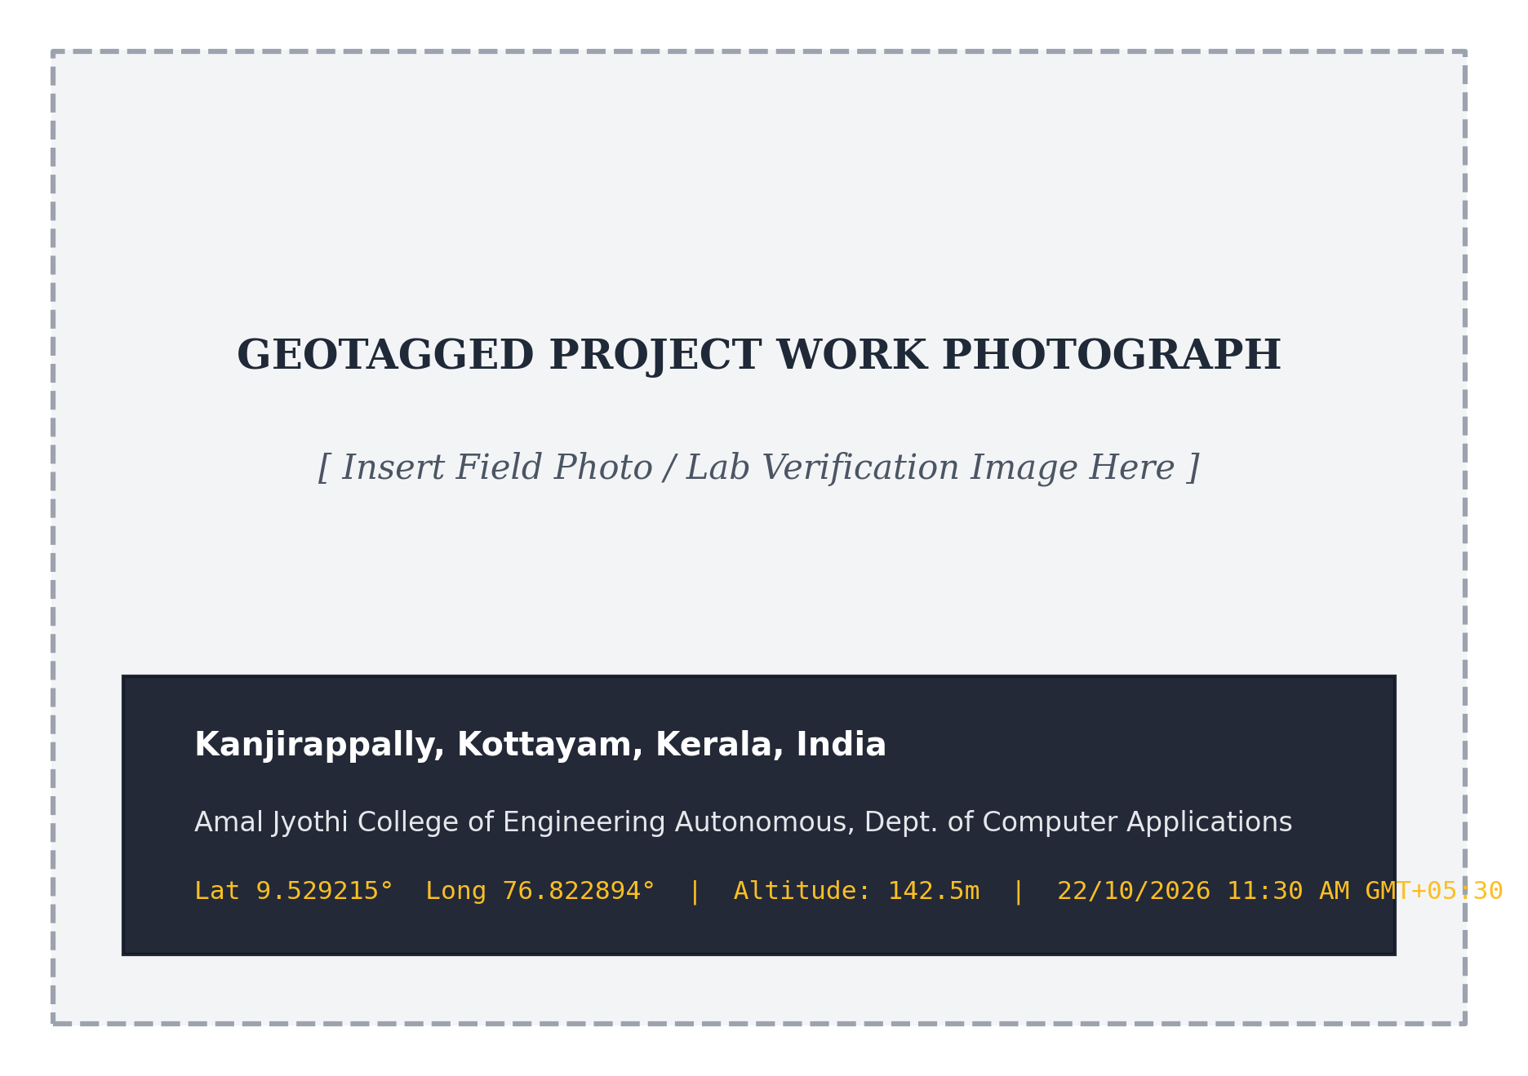
Figure 3.1: Geotagged photograph taken during project work
3.2 SYSTEM SPECIFICATION
3.2.1 Hardware Specification
The hardware requirements for Wi-Fi Sense depend on the deployment tier: cloud hosting environment, developer workstation, edge IoT sensing transceivers, and client nurse duty devices.
Table 3.4: Hardware Specification Breakdown
Component | Server (Cloud Deployment) | Developer Machine | IoT Sensing Node | Client Device
Processor | 2 vCPU x86-64 (Render Cloud Container) | Intel Core i5 / AMD Ryzen 6-Core @ 3.0 GHz | ESP32-S3 Dual-Core Xtensa LX7 @ 240 MHz | Any modern dual-core PC or tablet
Memory (RAM) | 1 GB - 2 GB RAM (ASGI Container) | 16 GB DDR4/DDR5 RAM | 512 KB SRAM + 8 MB Octal PSRAM | 2 GB RAM or higher
Storage | 10 GB Cloud Container Disk | 512 GB NVMe SSD | 8 MB SPI Flash Memory | Minimal; browser cache only
Network | Stable outbound internet connectivity | Broadband connection | 2.4 GHz 802.11 b/g/n Wi-Fi | Wi-Fi or Ethernet connection
Sensors | Not applicable | Not applicable | Wi-Fi CSI RF Antenna Interface | Not applicable
Display | Headless server | Full HD 1920x1080 monitor | Dual onboard status LEDs | Any modern display (1366x768+)

3.2.2 Software Specification
• Server OS: Cloud Operating System: Linux Ubuntu 22.04 LTS (Containerized via Docker on Render Cloud).
• Firmware: IoT Edge Firmware: ESP-IDF v5.1 / Arduino ESP32 Core in C++ for promiscuous CSI capture.
• Backend: Backend ASGI Engine: Python 3.10 with FastAPI 0.110 and Uvicorn 0.29.
• Database: Database Management System: PostgreSQL 17 hosted on Supabase Managed Cloud.
• ORM: ORM & Data Access: SQLModel 0.0.16 and SQLAlchemy 2.0 with connection pooling.
• Frontend: Frontend Framework: React 18.3 with Vite 5.0 single page application bundler.
• Styling: Styling & Design System: Tailwind CSS 3.4 with Google Material Symbols.
• Testing: Testing Tools: Selenium WebDriver 4.18, Pytest 8.1, Requests, and unittest.
• Browser: Client Web Browser: Google Chrome 120+, Mozilla Firefox 120+, or Microsoft Edge.
Network Requirements
• Server Outbound: Server Outbound Access: Outbound HTTPS/TLS connectivity to Supabase PostgreSQL (port 5432 / 6543) and external email SMTP dispatch.
• Server Inbound: Server Inbound Access: Public HTTPS access on port 443 routed to FastAPI ASGI service on port 8000 via Render edge proxy.
• Client Connectivity: Client Connectivity: Stable broadband or 4G/5G connection supporting WebSocket / Server-Sent Events (SSE) for sub-second alert streaming.
• Security Protocols: Security Protocols: HTTPS with TLS 1.3 encryption; secure WebSocket (WSS); Bearer token authentication.
Ports and Protocols
Table 3.5: Ports and Communication Protocols in Wi-Fi Sense
Component / Service | Port | Protocol | Purpose
FastAPI Cloud Backend | 443 / 8000 | HTTPS / REST | Primary API gateway handling auth, rooms, alerts, and telemetry
Realtime Alert Dispatcher | 443 / 8000 | WSS / WebSocket | Bidirectional event stream pushing instant fall alarms to nurse consoles
PostgreSQL Database | 5432 / 6543 | TCP (PostgreSQL) | Persistent storage for organizations, devices, alerts, and audit logs
PySerial Host Gateway | COM4 / ttyUSB0 | UART @ 921600 Baud | High-speed serial transport reading raw CSI bytes from ESP32-S3
ESP32-S3 Transmitter Node | Channel 6 (2.437 GHz) | 802.11 b/g/n OFDM | Periodic packet broadcasting across monitored room Fresnel zone
Vercel Frontend CDN | 443 | HTTPS / HTTP/2 | Global edge delivery of compiled React single page application assets

Indicative Resource Allocation
• Frontend Allocation: Frontend Application: Minimal resource overhead; cached globally across Vercel edge CDN nodes.
• Backend Allocation: FastAPI Backend Service: 1-2 vCPU cores, 512 MB to 1 GB RAM allocation on Render container runtime.
• Database Allocation: PostgreSQL Database: 1 vCPU, 512 MB RAM on Supabase Cloud with automatic connection pooling.
• Node Allocation: ESP32-S3 IoT Node: 240 MHz dual-core Xtensa CPU, 512 KB SRAM, 8 MB PSRAM for CSI ring buffers.
Development Tools
• Git: Source Control: Git with GitHub cloud repository (Blessonjoseph07/WIFISENSE).
• IDEs: Integrated Development Environments: Visual Studio Code, PyCharm, and ESP-IDF extension.
• API Tools: API Design and Verification: FastAPI interactive Swagger UI (/docs) and Postman.
• Database Tools: Database Administration: Supabase Web Studio and pgAdmin 4.
3.3 SOFTWARE DESCRIPTION
This section describes the primary software technologies selected for Wi-Fi Sense and explains their architectural rationale:
3.3.1 React.js & Vite
React.js 18 is an open-source declarative JavaScript UI library. Built with Vite, it delivers a high-speed, component-based single page application. React was chosen because its virtual DOM reconciliation efficiently renders frequently updating room status badges without reloading the entire page. Features used include functional components, custom React hooks (useAuth, useRealtimeSensing), context providers, and dynamic route rendering.
3.3.2 Python & FastAPI
Python is a versatile programming language with rich mathematical libraries (NumPy, SciPy). FastAPI provides an asynchronous ASGI framework built atop Starlette and Pydantic. It was chosen for its ultra-low latency, native async/await concurrency, declarative request validation, and automatic OpenAPI documentation. Features used include dependency injection for database sessions, JWT auth middleware, and non-blocking background tasks.
3.3.3 PostgreSQL (Supabase Managed)
PostgreSQL 17 is an enterprise-grade object-relational database. Managed via Supabase, it provides ACID transactions, strict foreign key referential integrity, and JSONB document columns for raw telemetry storage. It was chosen over NoSQL alternatives because clinical fall records and multi-tenant user permissions demand strict relational guarantees.
3.3.4 ESP-IDF & C++ Firmware
The Espressif IoT Development Framework (ESP-IDF) provides the official C/C++ development environment for ESP32-S3 chips. It provides low-level promiscuous Wi-Fi callback hooks (`esp_wifi_set_csi_rx_cb`), allowing the receiver to capture raw 64-subcarrier OFDM channel responses at hardware speed.
3.3.5 Tailwind CSS & Material Icons
Tailwind CSS is a utility-first styling framework. It enables rapid construction of sleek clinical and corporate interfaces using predetermined color tokens (slate dark modes, clinical cyan status badges, crimson emergency sirens). Google Material Symbols provide clear, standardized iconography across navigation drawers.
3.3.6 HTML5 Canvas API
The HTML5 Canvas 2D API enables direct pixel manipulation on browser viewports. Wi-Fi Sense utilizes custom canvas renderers to plot 64-subcarrier waterfall spectrogram heatmaps at 90 frames per second, bypassing DOM overhead and eliminating browser memory leaks.
3.3.7 PySerial Gateway Daemon
PySerial provides a multi-threaded Python interface to host UART serial ports. Operating at 921600 baud, it reads continuous CSI binary frames from connected receiver nodes, validates checksums, and transmits formatted JSON vectors to the FastAPI cloud backend.
3.3.8 Render Cloud & Vercel Global Edge
Render provides automated containerized deployments for the Python FastAPI ASGI service. Vercel distributes the compiled React application across global edge CDN servers with automated TLS SSL certificate provisioning, ensuring sub-50ms page load times worldwide.

CHAPTER 4
SYSTEM DESIGN

4.1 INTRODUCTION
The design phase is a crucial stage in the development of Wi-Fi Sense, an AI-assisted indoor monitoring and facility intelligence platform designed to centralize contactless sensing, human activity classification, emergency fall detection, and space utilization analytics. A well-structured system design establishes the foundation for reliable operation, maintainability, strict clinical privacy, and horizontal scalability. This phase involves defining the physical RF edge architecture, database structure, graphical user interface, and integration of various micro-components.
The system design translates the requirements identified during the system study and feasibility analysis into a structured technical blueprint for implementation. It defines how the ESP32-S3 IoT transceivers capture 64-subcarrier OFDM channel states, how the host serial gateway daemon buffers and transmits telemetry, how the FastAPI ASGI backend sanitizes phase noise and evaluates activity states, and how real-time WebSocket streams push life-critical alerts to attending nurse consoles. By prioritizing usability, security, and extensibility, the architecture is designed to simplify clinical monitoring workflows while providing a solid foundation for future research enhancements.
4.2 UML DIAGRAM
Unified Modeling Language (UML) is a standard visual modeling language used to specify, visualize, design, and document the structure and behavior of software systems. It provides a common set of diagrams that help engineers and stakeholders understand system components, interactions, workflows, and deployment architecture.
In Wi-Fi Sense, nine standardized UML diagrams are used to represent the system architecture, user interactions, internal components, and operational workflows. These diagrams provide a clear understanding of how clinical caregivers, facility managers, corporate staff, and family members interact with the platform, and how its distributed components communicate to support real-time contactless sensing and emergency dispatch.

4.2.1 Use Case Diagram
A use case diagram is a graphical representation that illustrates how users and external entities interact with a system. It helps identify, outline, and organize the system's functional requirements from an actor's perspective. Built using UML standards, use case diagrams define system boundaries, actors, use cases, and relationships.
Figure 4.1 shows the use cases of Wi-Fi Sense across its administrative and clinical access levels. Primary actors include the System Administrator, Organization Administrator, Facility Manager, Caregiver/Staff, Corporate Facility Staff, Family Member/Doctor, and the physical ESP32-S3 CSI Sensing Node.
• Administration: Administration: Manage Organizations, Manage Users & Roles, Provision Facilities.
• Facility Management: Facility Management: Manage Buildings, Floors, Rooms, and Sensing Devices.
• Sensing & AI: Sensing & AI: Collect CSI Data, Preprocess CSI Data, Detect Presence, Recognize Activity, Detect Potential Fall.
• Monitoring: Monitoring: View Central Monitoring Dashboard, View Room Occupancy, Monitor Resident Presence, Monitor Activity.
• Alert Management: Alert Management: Generate Alert, Send Notification, View Alert History, Acknowledge Alert, Resolve Alert.
• Analytics: Analytics: View Occupancy Analytics, View Room Utilization, View Historical Activity.
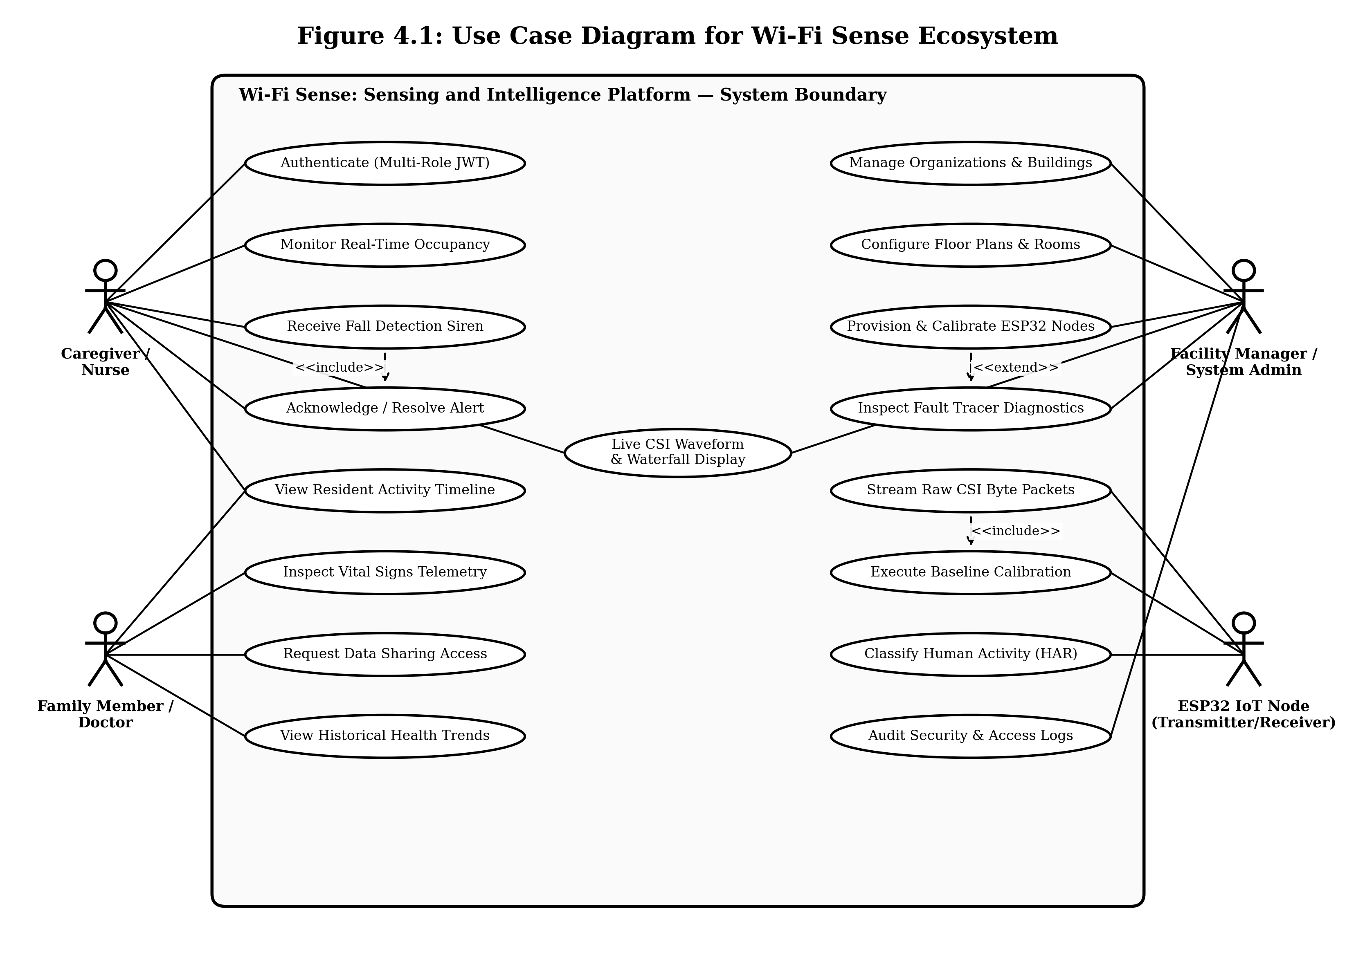
Figure 4.1: Use case diagram of Wi-Fi Sense

4.2.2 Sequence Diagram
A sequence diagram is a type of interaction diagram that depicts the chronological flow of messages between system components. It helps visualize object interactions, understand system requirements, and detect potential concurrency bottlenecks. Key elements include actors, lifelines, messages, and execution activations.
Figure 4.2 shows the end-to-end emergency fall detection and dispatch interaction sequence. When a resident falls, the ESP32-S3 node captures raw CSI data and transmits it to the CSI Processing Service. The processed features are passed to the ML Classification Service, which identifies a high-confidence fall. The backend creates an Alert record, and the Alert Engine broadcasts an instant notification to the Caregiver Console. The caregiver acknowledges the alert, investigates the room, and records the resolution.
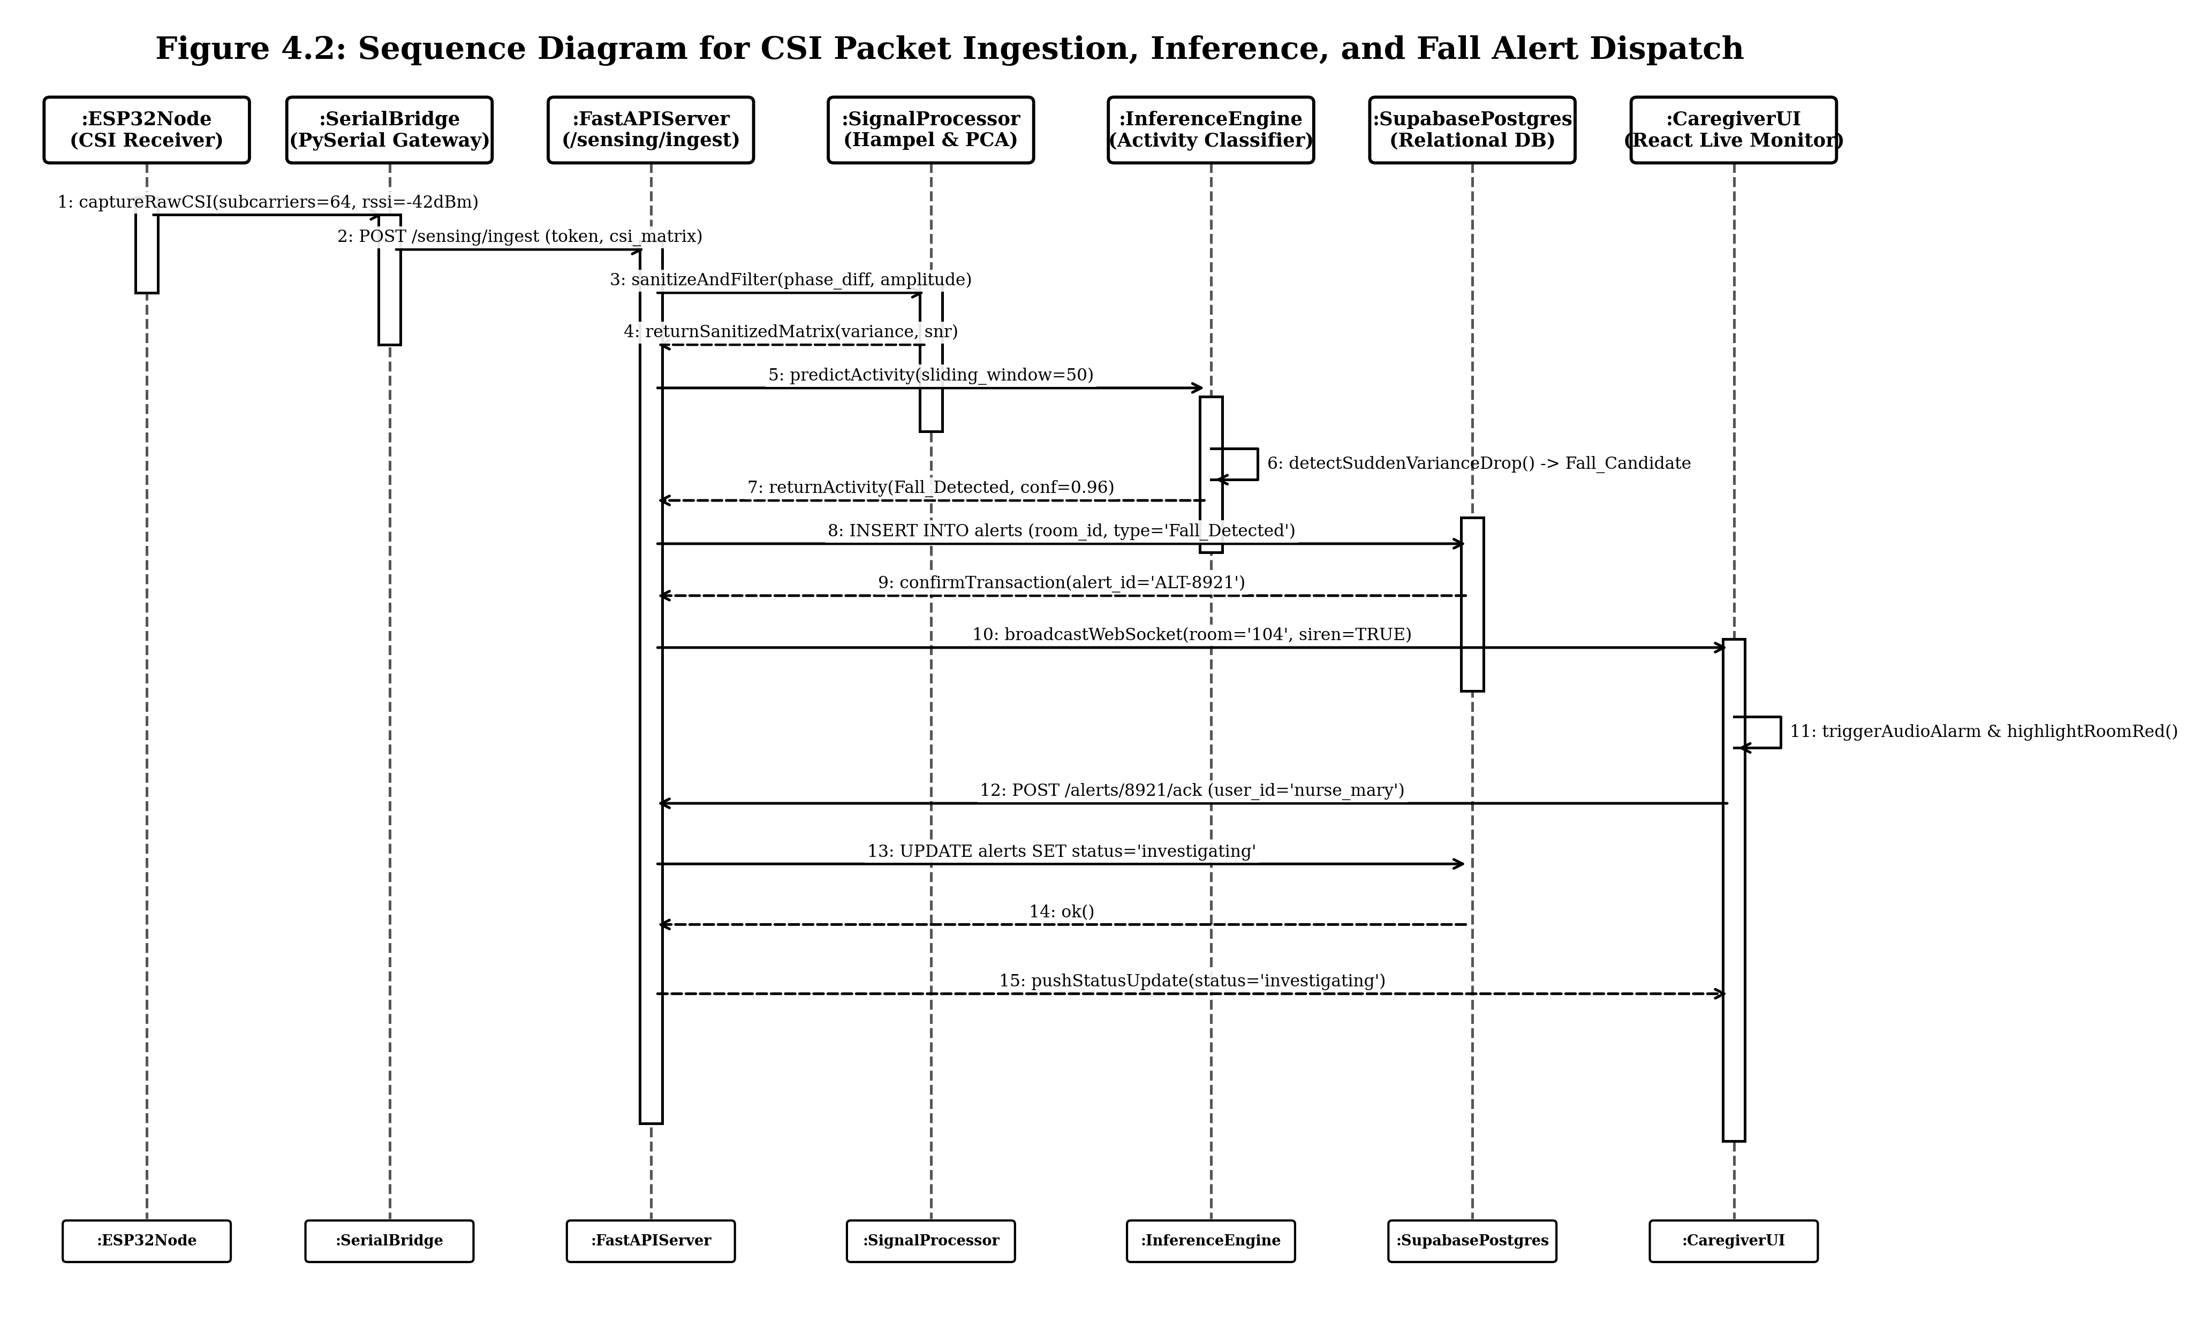
Figure 4.2: Sequence diagram for fall detection and caregiver dispatch in Wi-Fi Sense

4.2.3 State Chart Diagram
A State Chart Diagram is a UML behavioral diagram that represents the various states an entity can exist in and how it transitions between them in response to internal and external events. Key components include the Initial State, States, Transitions, Events, Actions, and Final States.
Figure 4.3 shows the lifecycle of an emergency alert record in Wi-Fi Sense. The states follow the alert status field: Detection, Created, Notified, Acknowledged, and Resolved. Transitions between states require explicit caregiver actions and log responder identity for clinical accountability.
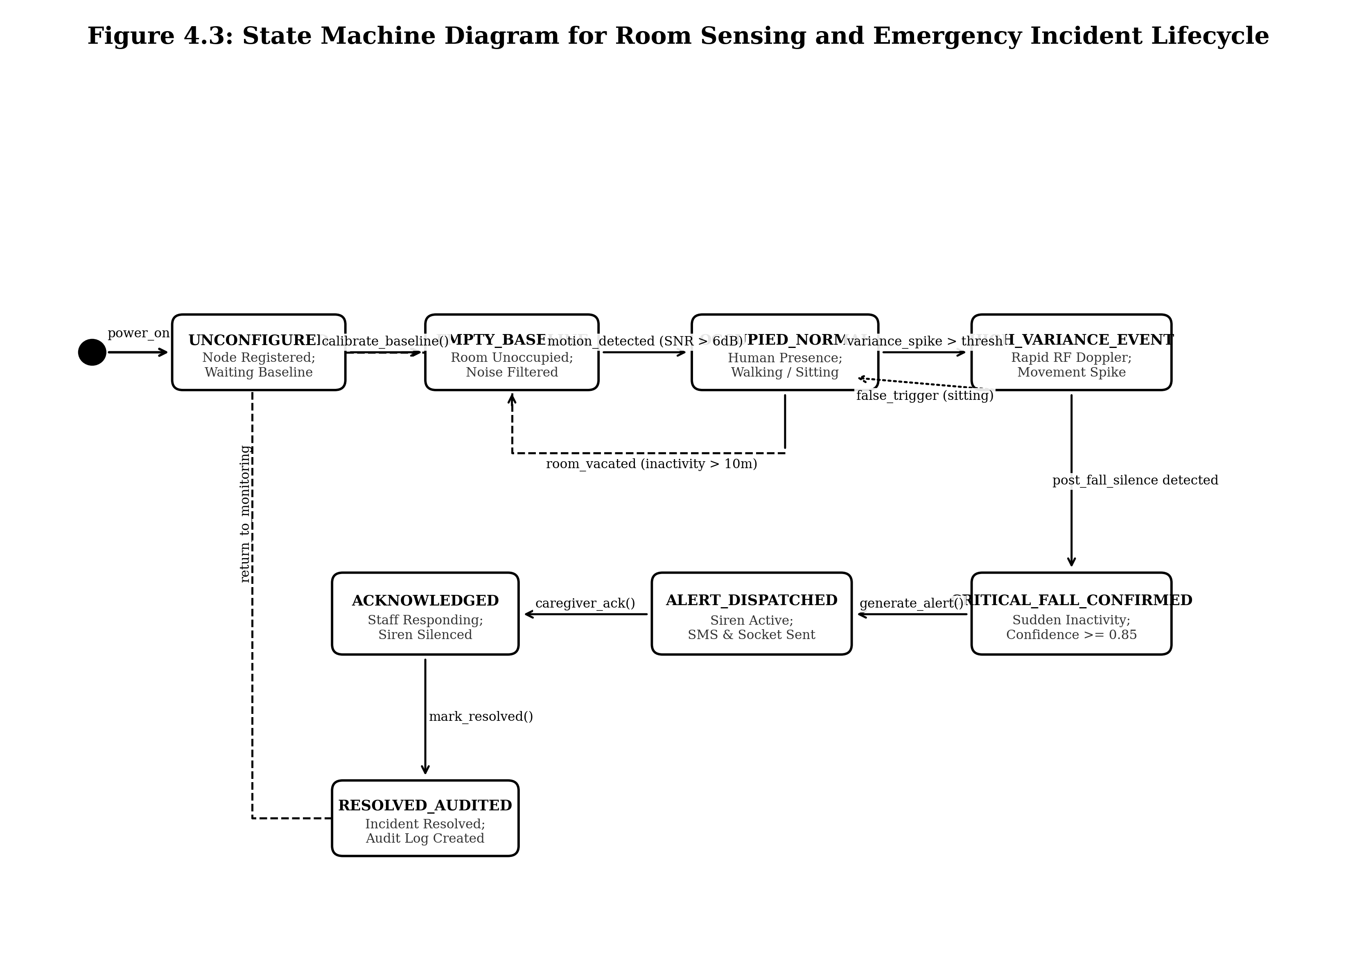
Figure 4.3: State chart diagram of an emergency alert record

4.2.4 Activity Diagram
An activity diagram illustrates the procedural flow of control from activity to activity within a system workflow. It models sequential steps, decision branching points, and concurrent parallel activities using standardized symbols:
• Initial Node: Initial node: Black circle representing workflow starting point.
• Activity: Activity: Rounded rectangle containing the operational task.
• Decision Node: Decision node: Diamond shape representing conditional branching.
• Final Node: Final node: Encircled black circle representing workflow completion.
Figure 4.4 shows the activity workflow for continuous CSI packet processing, feature extraction, activity classification, and emergency escalation.
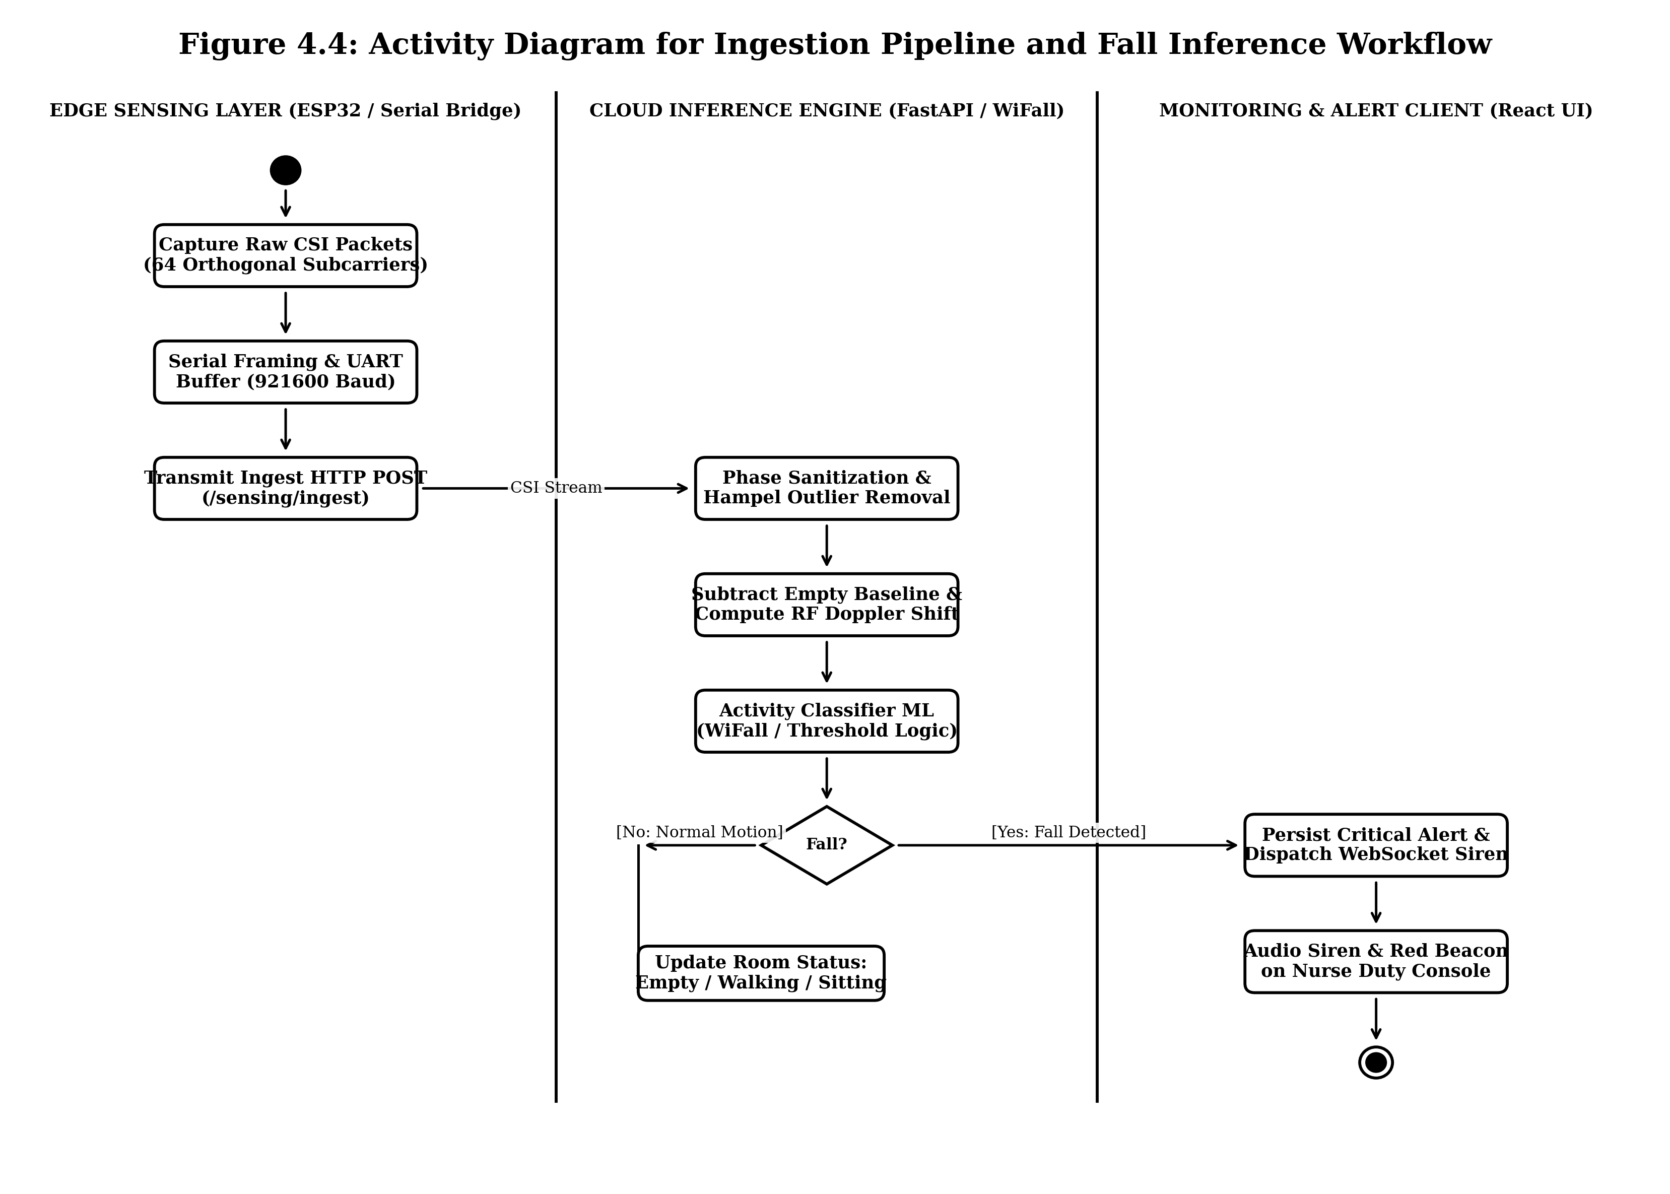
Figure 4.4: Activity diagram for CSI ingestion and fall incident workflow

4.2.5 Class Diagram
A Class Diagram is a key UML component used in object-oriented modeling to represent the static structure of an application. It defines classes, attributes, methods, and relationships such as association, aggregation, composition, and inheritance.
Figure 4.5 shows the persistent domain classes of Wi-Fi Sense matching the relational database schema: Organization, Building, Floor, Room, User, Role, SensingDevice, SensingEvent, ActivityType, Alert, and Notification.
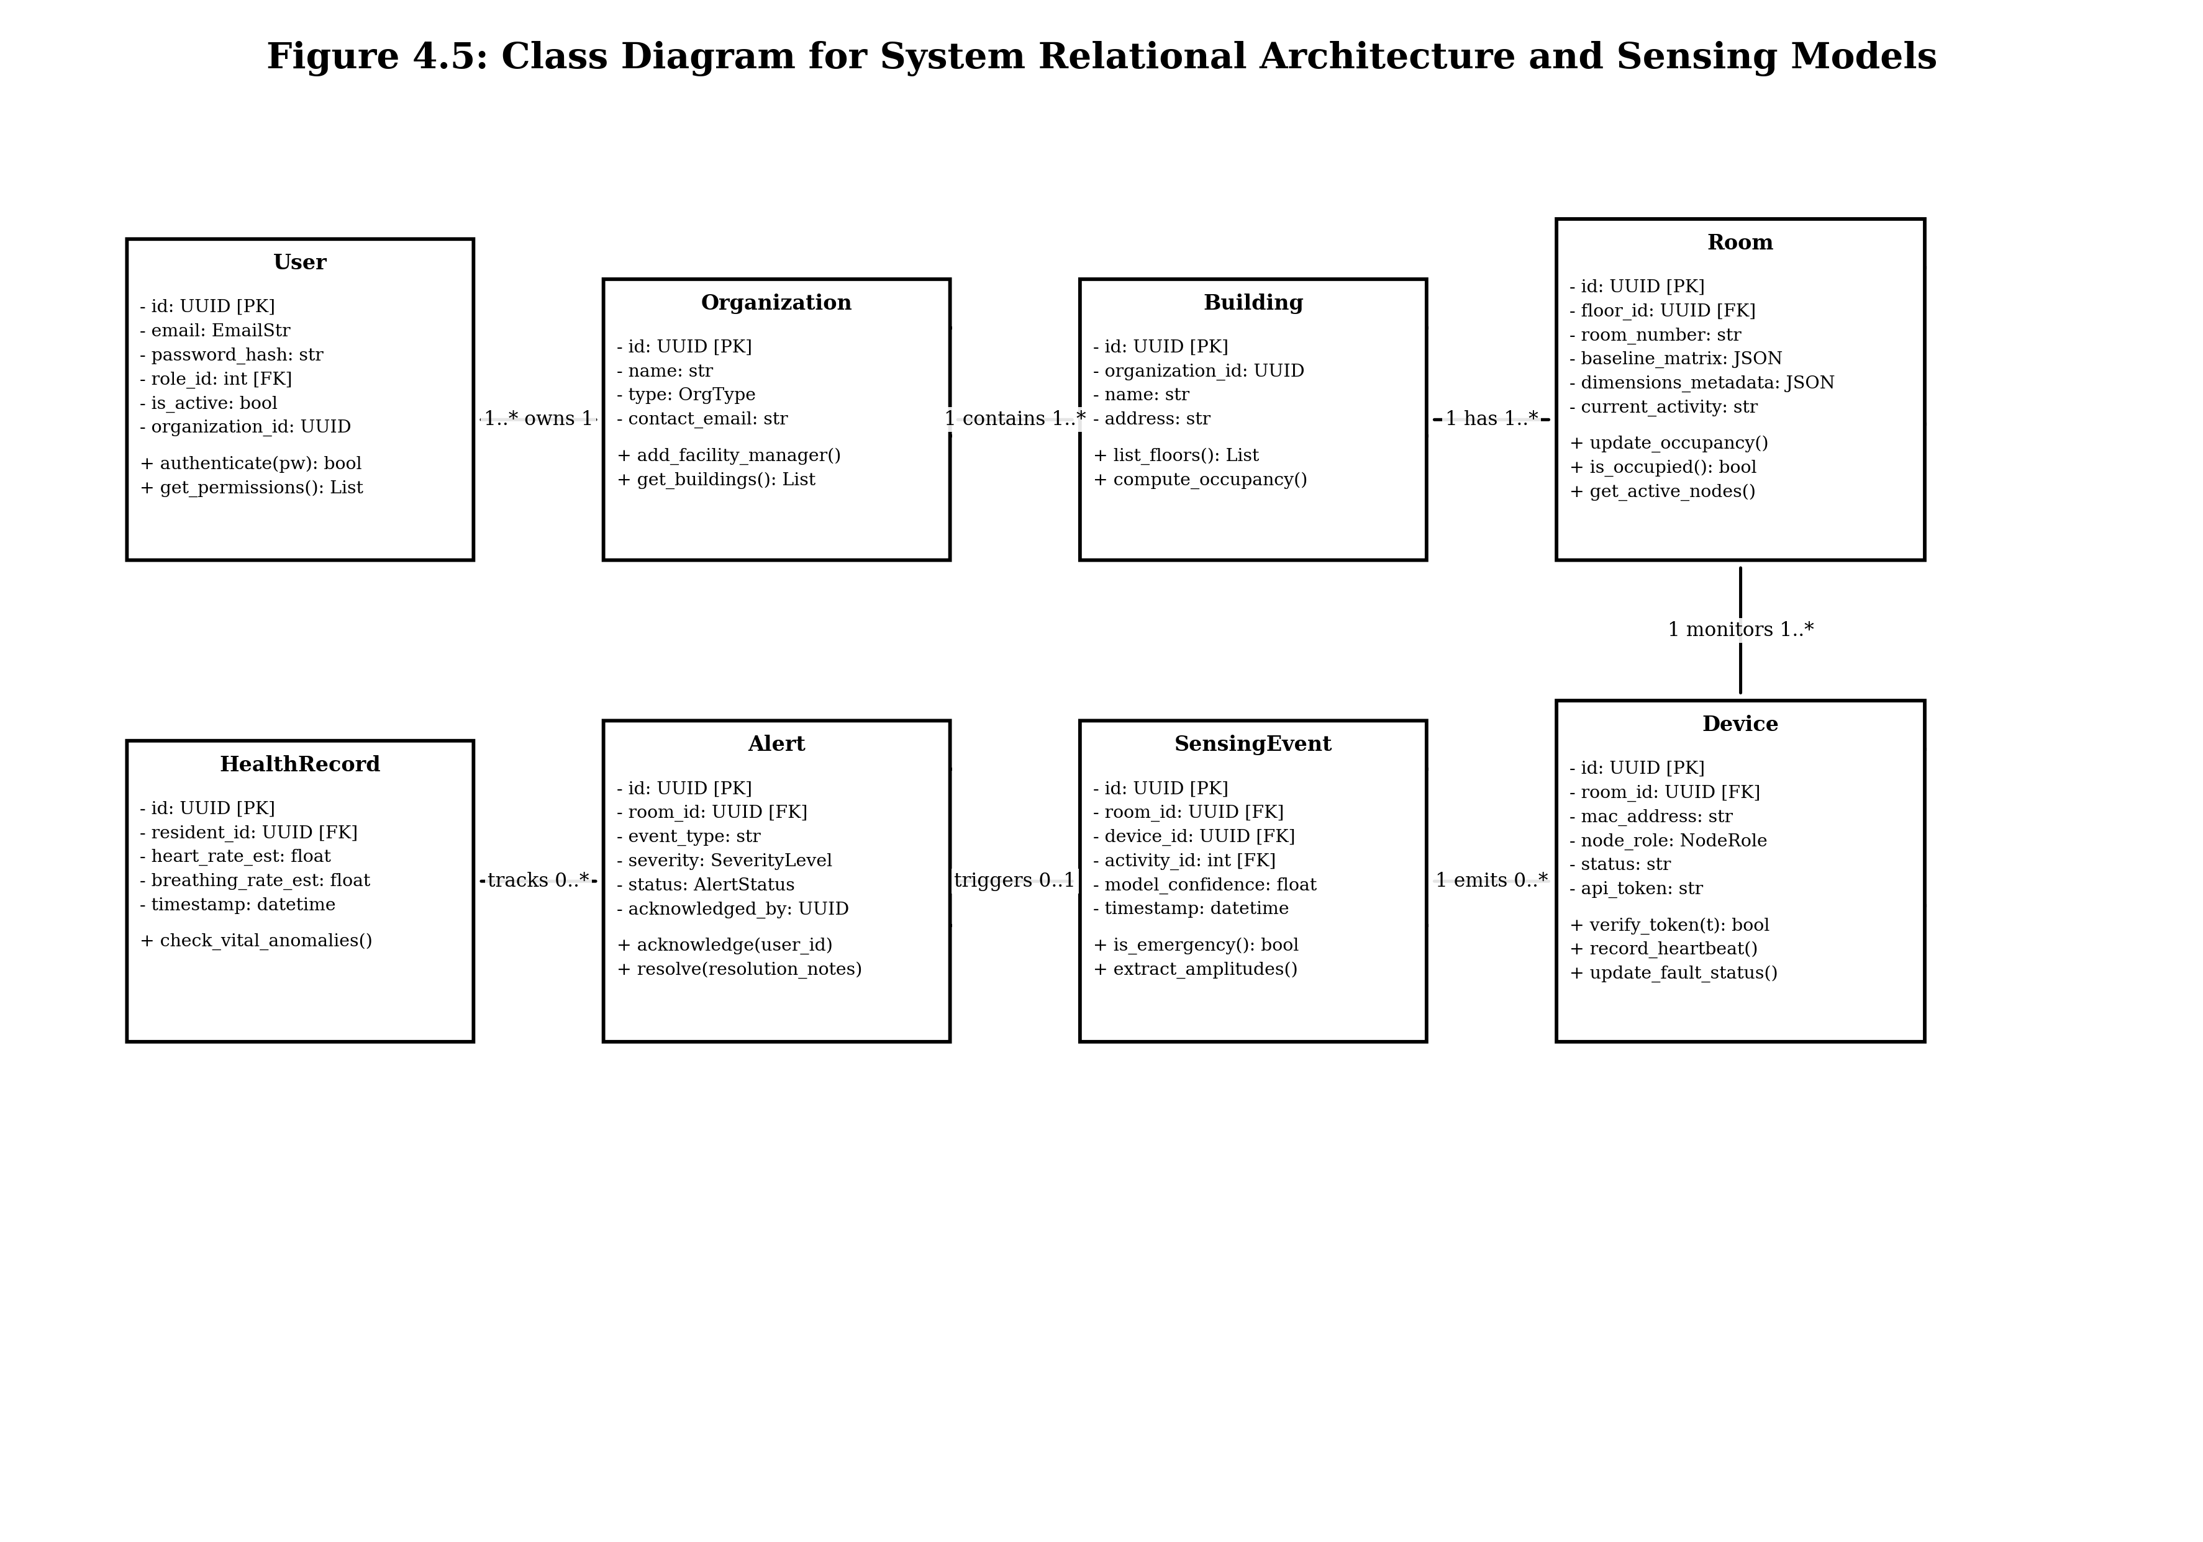
Figure 4.5: Class diagram of Wi-Fi Sense domain entities and relations

4.2.6 Object Diagram
Object diagrams represent a snapshot of the system's runtime state at a particular point in time, showing concrete instances of classes and their attribute values.
Figure 4.6 shows an object diagram with instantiated entities during an active fall event: Organization (St. Peter's Elder Care Home), Room (Room 204), Device (ESP32-S3 Node), Resident (Annamma Joseph), Alert (Fall_Detected, Severity CRITICAL), and Caregiver (Sr. Mary Sebastian).
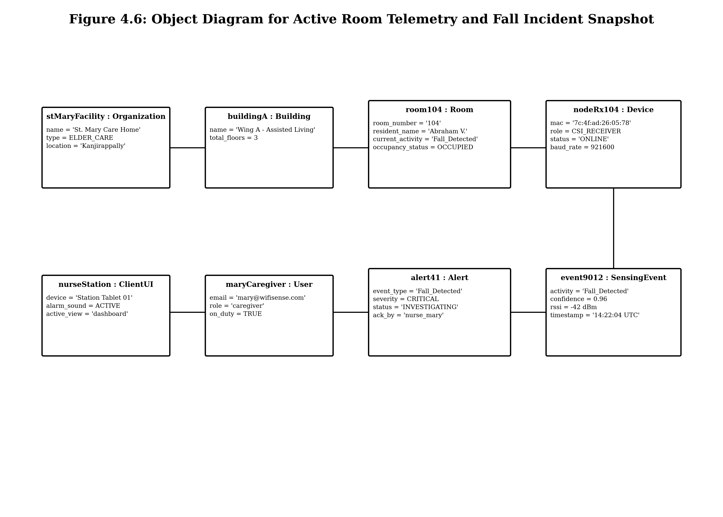
Figure 4.6: Object diagram showing runtime instance state during active fall event

4.2.7 Component Diagram
A component diagram illustrates how software components are organized and wired together to form larger subsystems. Figure 4.7 illustrates the modular subsystems of Wi-Fi Sense: the React Web Client, FastAPI API Gateway, Authentication Service, CSI Signal Processing Service, WiFall Inference Engine, Alert Management Service, and Supabase PostgreSQL Database.
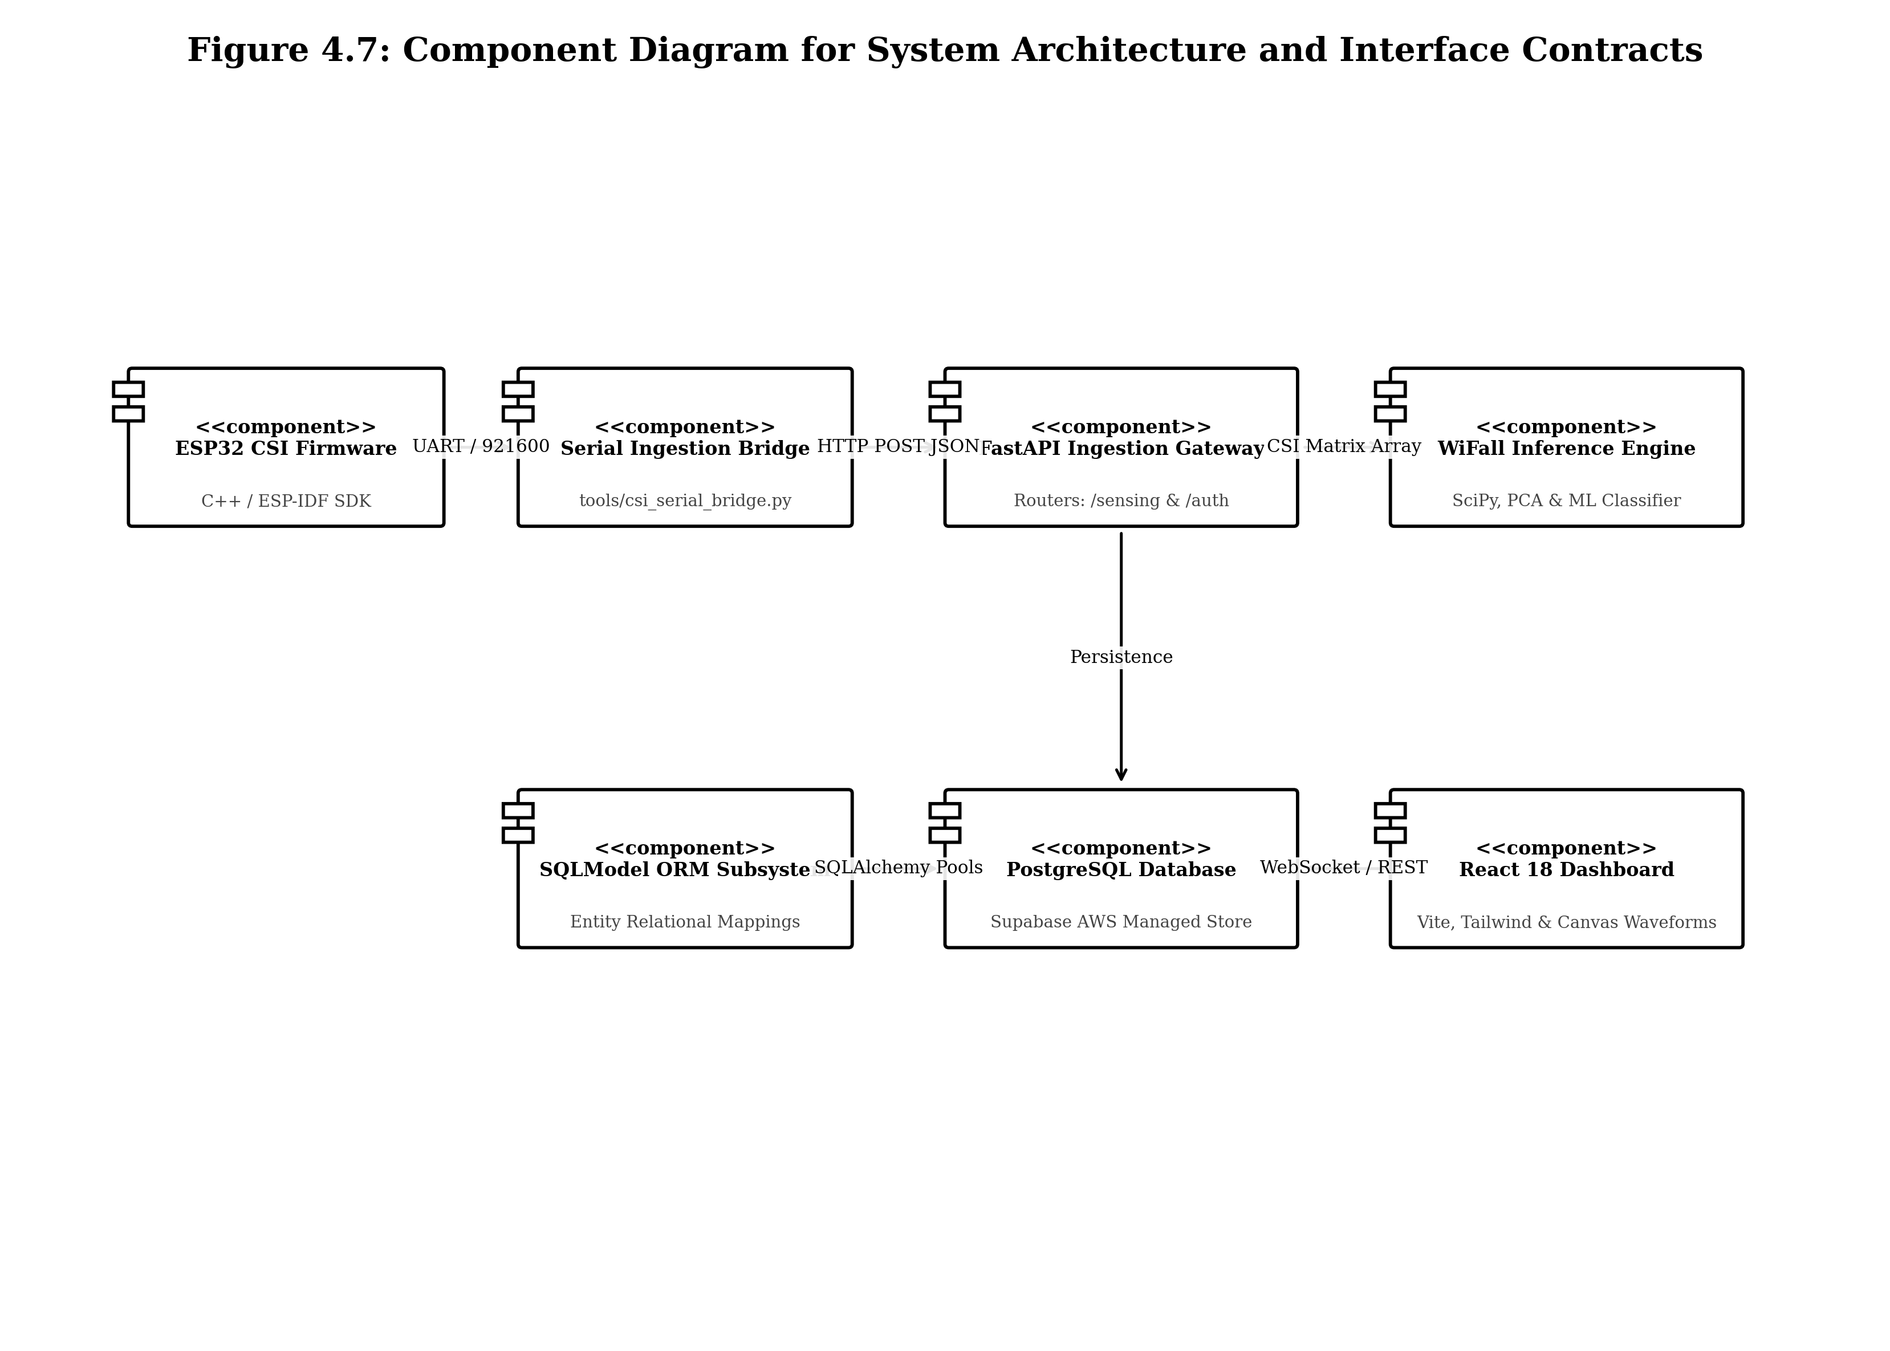
Figure 4.7: Component diagram of Wi-Fi Sense software architecture

4.2.8 Deployment Diagram
A deployment diagram models the physical hardware nodes and runtime environments on which the software artifacts execute. Figure 4.8 shows the distributed deployment topology: the ESP32-S3 IoT sensing hardware in monitored rooms, the Host Gateway PC connected via USB COM port, the Render Linux Cloud container running the FastAPI backend, the Supabase Cloud PostgreSQL database, and client web browsers connected over secure HTTPS and WSS.
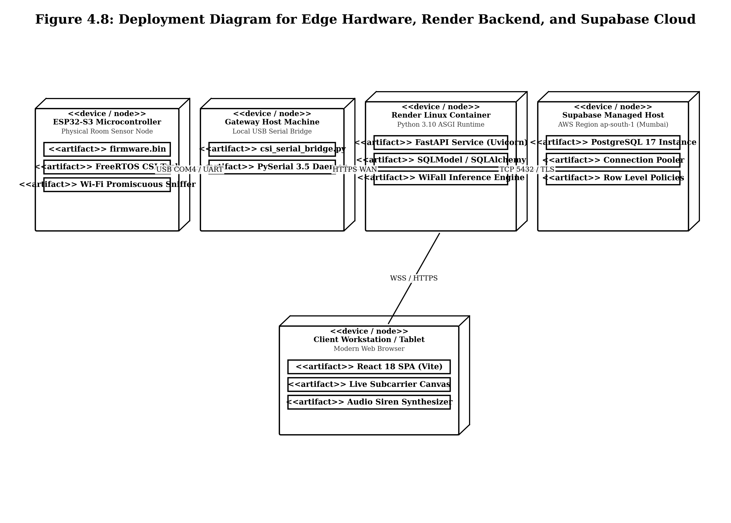
Figure 4.8: Deployment diagram of Wi-Fi Sense hardware and cloud topology

4.2.9 Collaboration Diagram
A collaboration (communication) diagram shows the structural relationships between cooperating objects, emphasizing the message links connecting them. Figure 4.9 illustrates the collaboration between the User, React Client, FastAPI Gateway, PostgreSQL Database, and WebSocket Alert Dispatcher during authentication and incident triage.
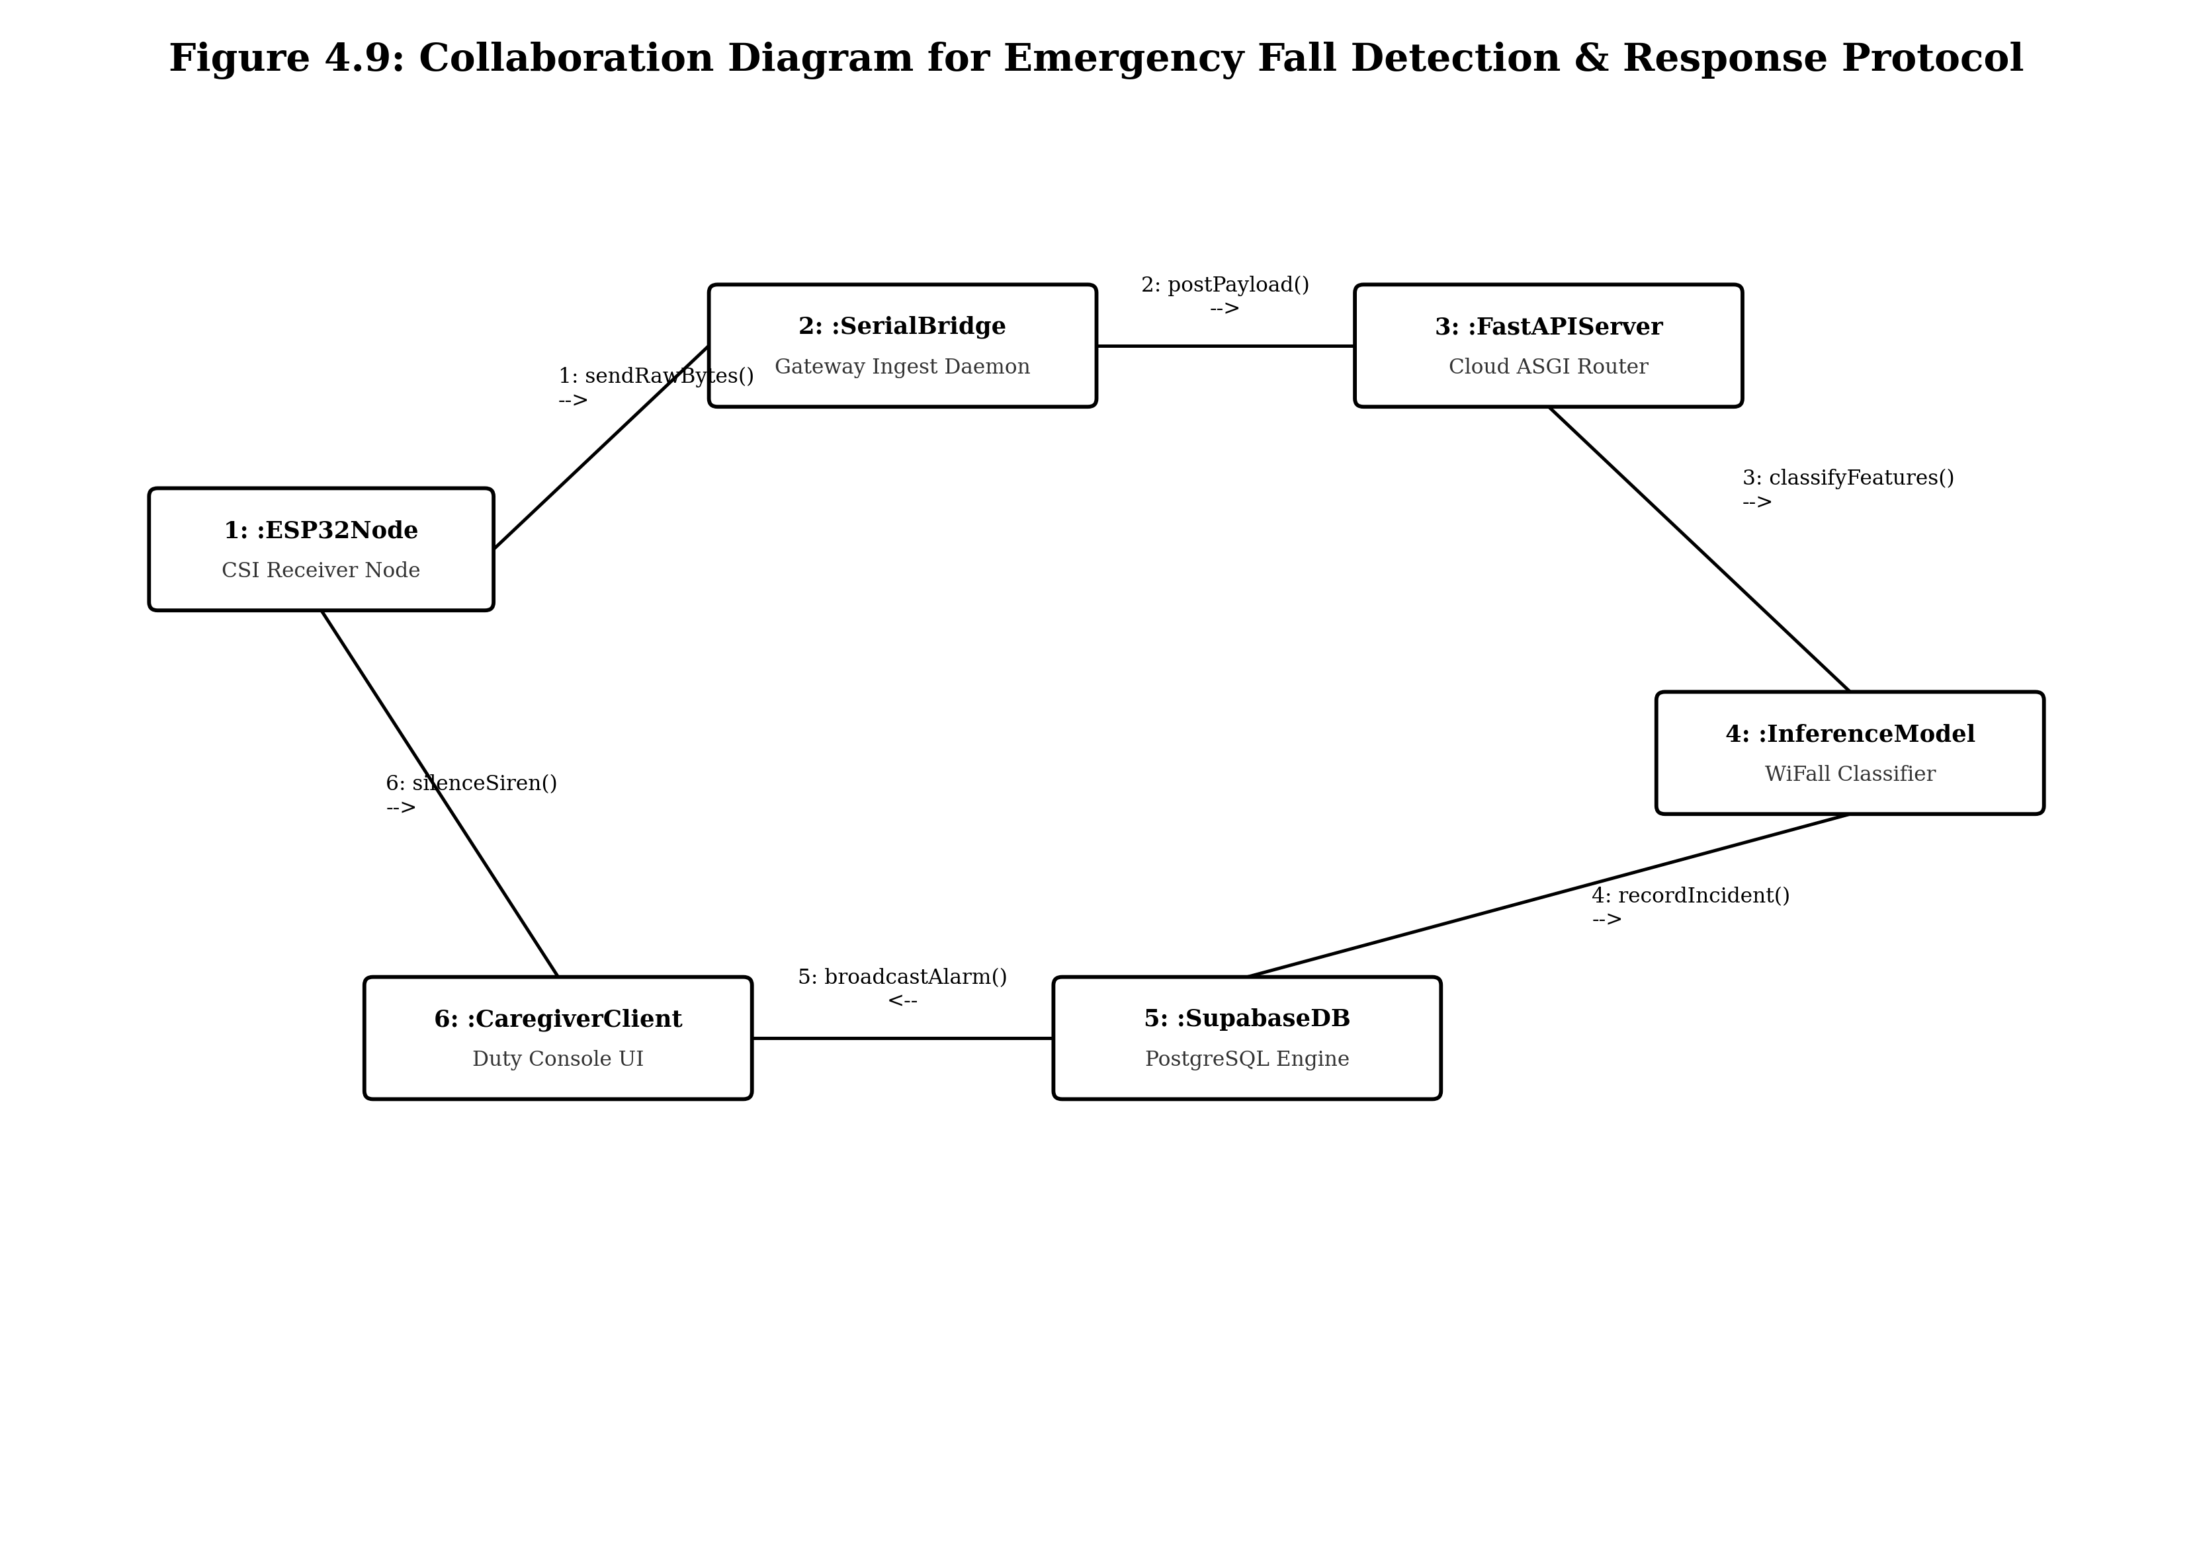
Figure 4.9: Collaboration diagram for emergency fall detection and response

4.3 USER INTERFACE DESIGN USING FIGMA
This section presents the user interface design screens and live implemented interfaces of Wi-Fi Sense. The interface is architected around role-governed application shells: CareAppShell for clinical staff, SpaceAppShell for corporate workplace managers, FamilyPortalShell for remote relatives, and SystemAdminShell for administrators. The interface emphasizes high visual clarity, glanceable room status matrices, and non-blocking alert banners.
Form Name: Landing Page
The landing page introduces the platform, providing an interactive 3D Wi-Fi CSI signal propagation wireframe globe, channel state telemetry cards (Signal RSSI, Variance, CSI Frame counter), and direct links to role-based authentication. See Figure 4.10.
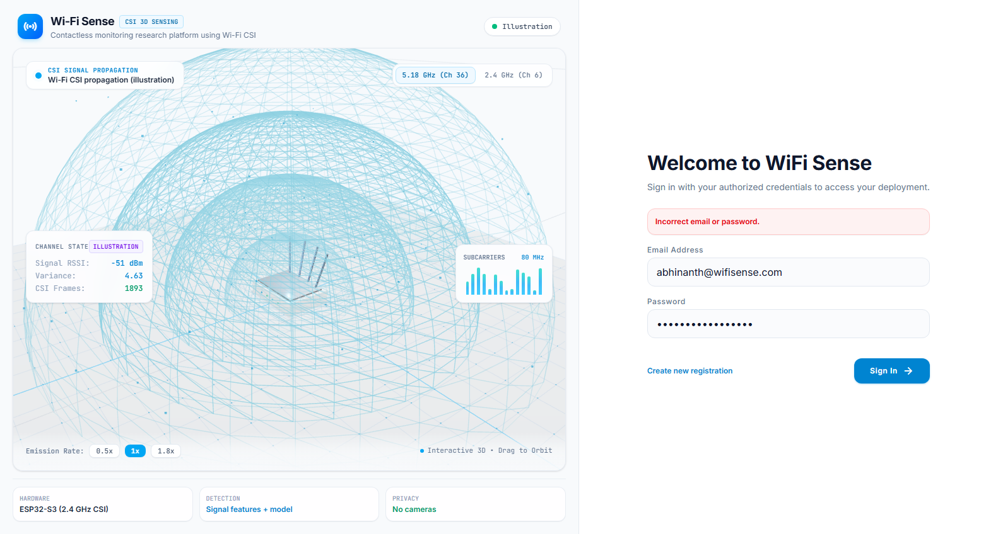
Figure 4.10: Landing page and 3D CSI signal visualizer of Wi-Fi Sense
Form Name: Sign In
The sign-in page offers secure credential authentication, role-based contextual routing, password masking, and quick-fill demo accounts for System Admin, Caregiver, Facility Manager, and Corporate Staff. See Figure 4.11.
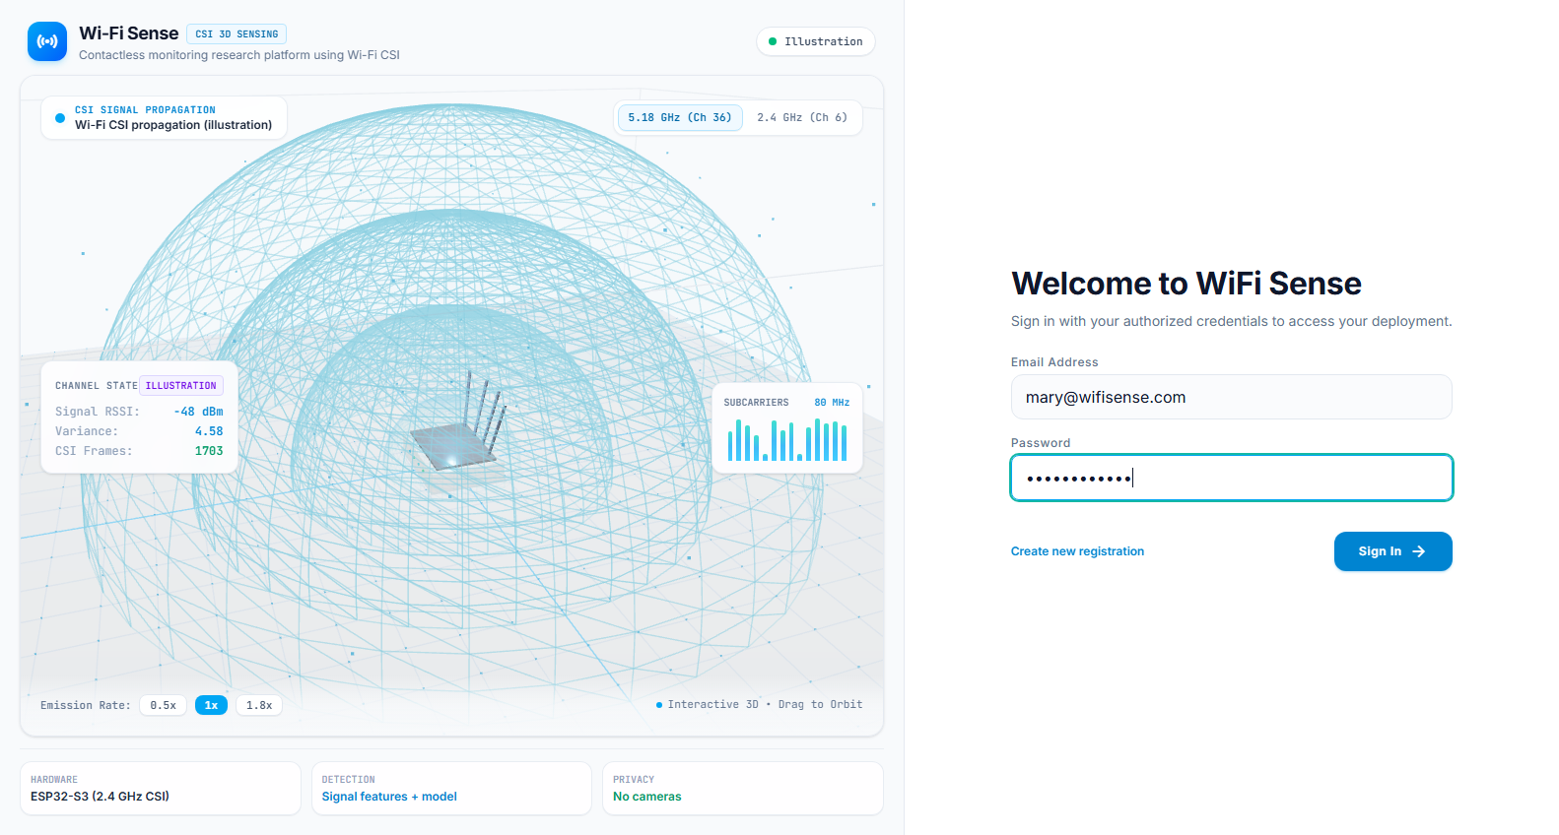
Figure 4.11: Sign-in and authentication page
Form Name: Central Monitoring Dashboard
The Central Monitoring dashboard displays real-time room occupancy cards across wings, active fall risk badges, subcarrier amplitude spectrogram streams, and a prominent emergency fall alert banner with one-tap Acknowledge and Resolve actions. See Figure 4.12.
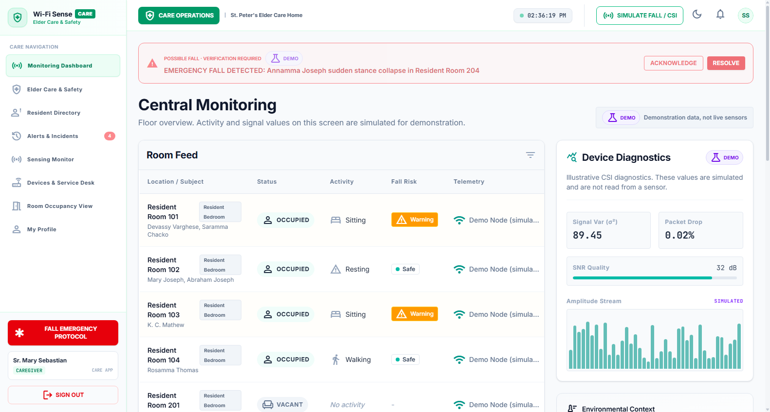
Figure 4.12: Central Monitoring dashboard with active emergency fall banner
Form Name: Family Data Sharing Policies
The Family Data Sharing Policies page allows facility managers to configure zero-leak privacy policies, toggling room presence disclosures, activity details, room suite identifiers, and alert severity thresholds for external family members. See Figure 4.13.
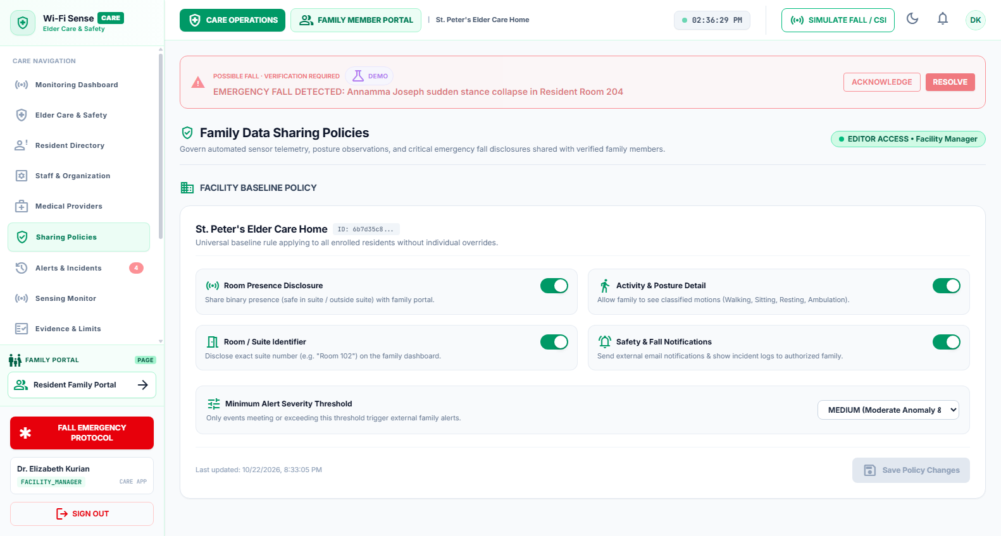
Figure 4.13: Family data sharing and privacy policy configuration
Form Name: Family Care Portal
The Family Care Portal allows approved family sponsors to verify resident presence, review safety incident logs, and manage monthly Care Plan subscriptions without receiving intrusive visual imagery. See Figure 4.14.
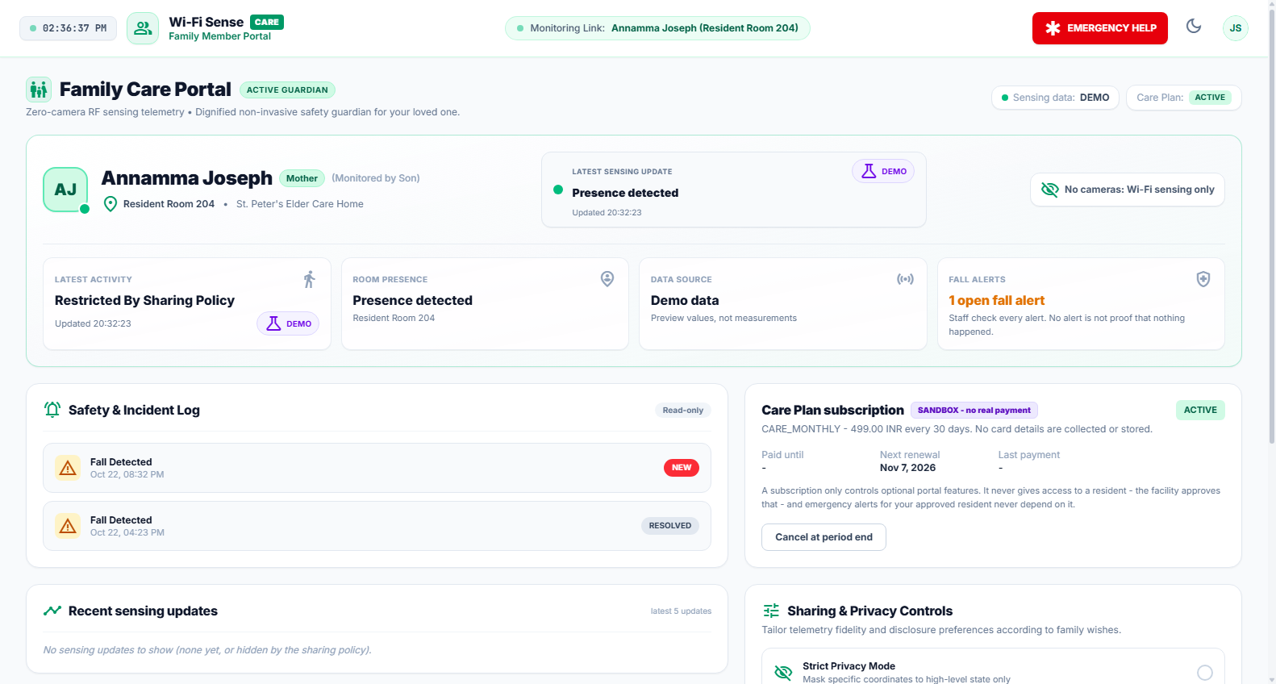
Figure 4.14: Family Care Portal and resident wellness view
Form Name: Corporate Space & Energy Intelligence
The Corporate Space & Energy Intelligence dashboard renders meeting room occupancy heatmaps, calculates peak utilization rates, and highlights vacant rooms wasting HVAC power, providing one-click energy mitigation controls. See Figure 4.15.
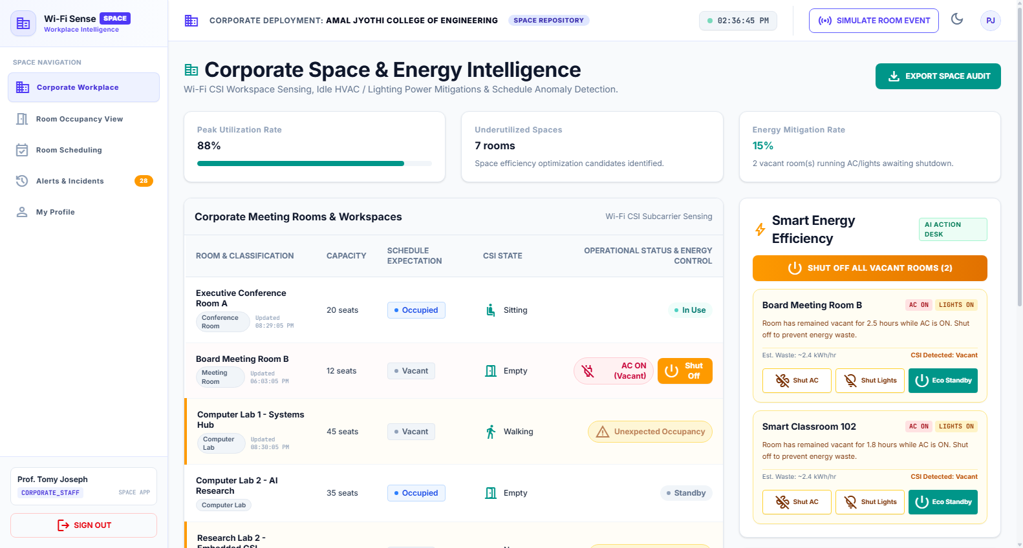
Figure 4.15: Corporate workplace space and energy intelligence dashboard
Form Name: Elder Care Sensing Nodes & Service Desk
The Sensing Nodes page displays the hardware sensor fleet, ESP32 MAC addresses, authentication tokens, assigned room locations, firmware versions, and hardware fault tracer tickets. See Figure 4.16.
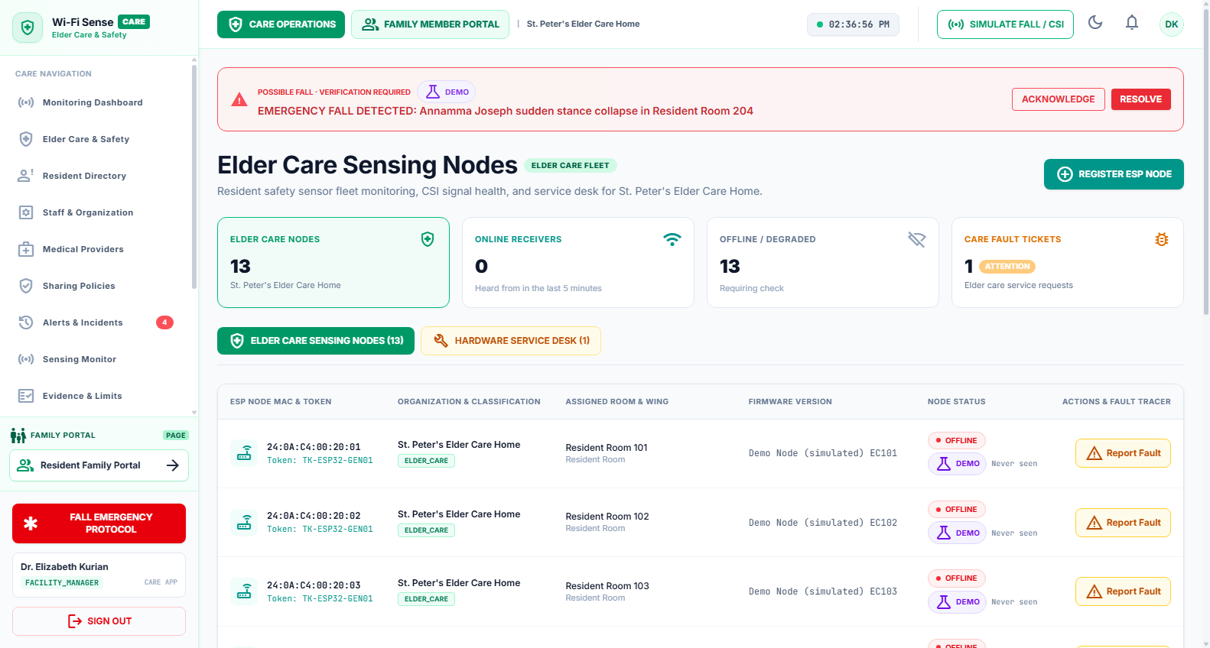
Figure 4.16: Elder Care sensing nodes and hardware service desk
Form Name: Resident Accounts Directory
The Resident Accounts page manages resident profiles, assigned room numbers, emergency contact records, and one-touch emergency inspection actions. See Figure 4.17.
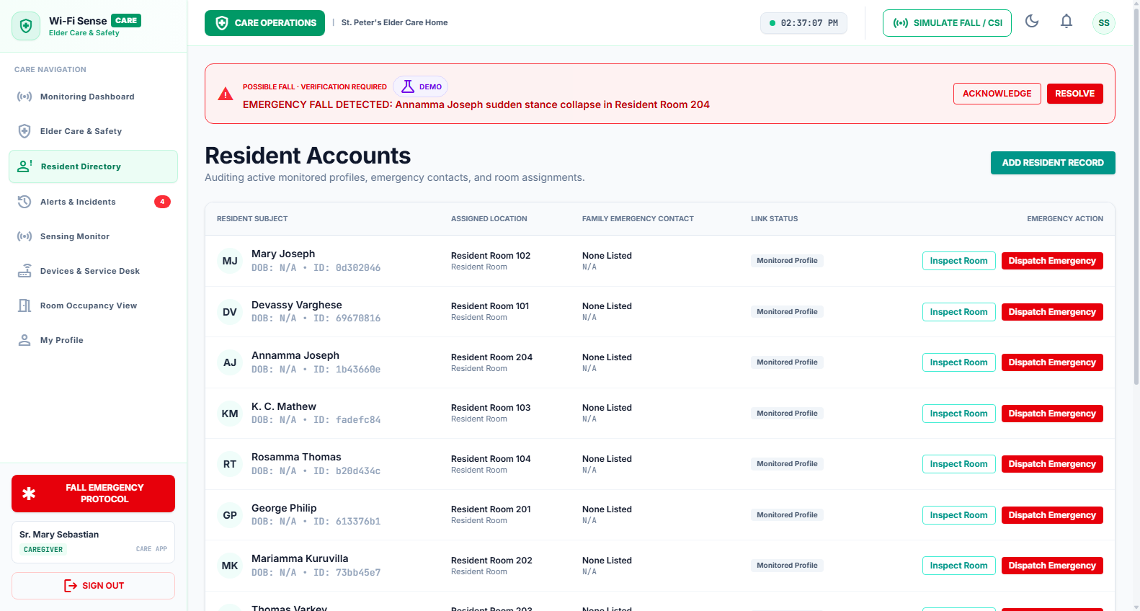
Figure 4.17: Resident accounts directory and room assignments
Form Name: Multi-Tenant System Administration Console
The System Administration console provides global tenant oversight across elder care and corporate organizations, system metrics, telemetry simulation controls, and administrative audit logging. See Figure 4.18.
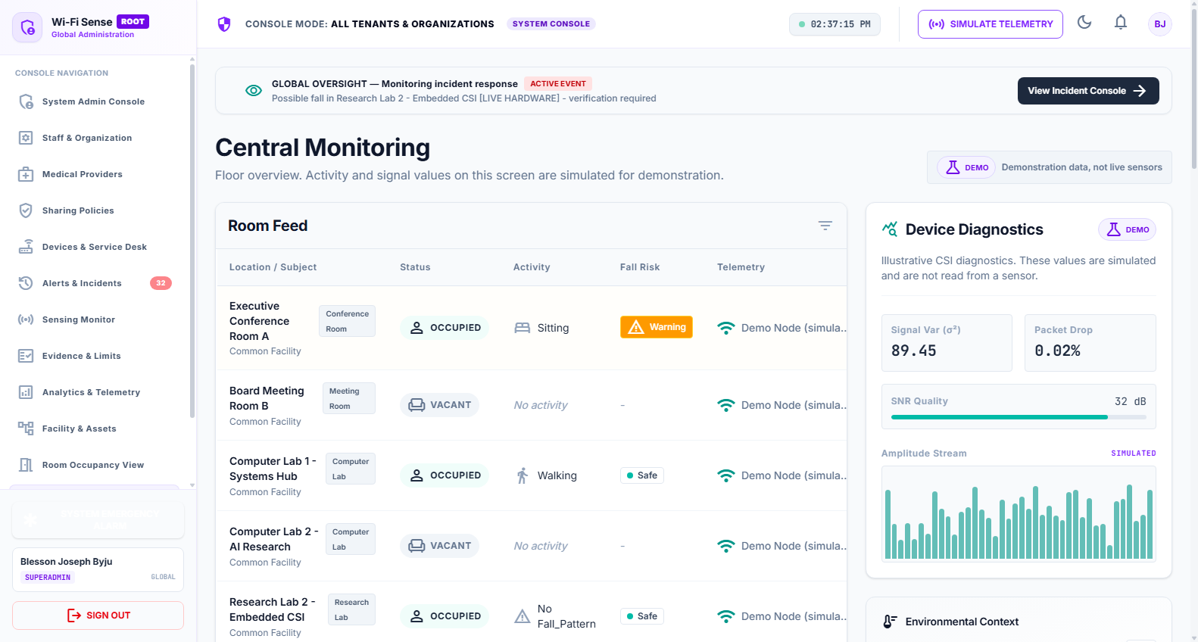
Figure 4.18: Multi-tenant system administration console
Application Pages Declared in Routing Module
Table 4.1: Application Pages Declared in Frontend Routing Architecture
Page Component | Route Path | Allowed Roles | Purpose
LandingSplash | / | Public | 3D CSI wireframe visualization and platform introduction
AuthPage / Login | /login | Public | User authentication, JWT issuance, and demo role shortcuts
CareAppShell | /dashboard (care) | Caregiver, Facility Manager | Clinical nursing console with live room feed and siren alerts
SpaceAppShell | /dashboard (space) | Corporate Staff, Facility Admin | Workplace occupancy matrix and HVAC power mitigation
FamilyPortalShell | /family | Family Member / Guardian | Non-visual resident wellness check, safety history, Care Plan
DoctorPortalShell | /doctor | Doctor / Physician | Clinical resident review, vital sign telemetry, doctor notes
SystemAdminShell | /admin | System Administrator | Global multi-tenant governance, organization setup, audit logs
DevicesView | /devices | Facility Manager, Admin | ESP32-S3 sensor fleet inventory, MAC tokens, fault ticketing
ResidentsView | /residents | Caregiver, Facility Manager | Resident account directory, room assignments, emergency links
SharingPolicyManager | /policies | Facility Manager | Zero-leak family telemetry disclosure and severity filters
AlertsView | /alerts | Caregiver, Manager, Admin | Emergency incident history, resolution notes, and audit trail

4.4 DATABASE DESIGN
A database is an organized collection of structured data designed to support efficient storage, retrieval, and relational integrity. In Wi-Fi Sense, the persistence layer manages organizations, buildings, rooms, sensing nodes, high-frequency CSI telemetry events, activity classifications, and emergency alert logs.
4.4.1 Relational Database Management System (RDBMS)
PostgreSQL serves as the RDBMS for Wi-Fi Sense. The core relational concepts implemented include:
• Primary Key: Primary Key: Uniquely identifies each tuple in an entity table (UUID, SERIAL, or BIGSERIAL).
• Foreign Key: Foreign Key: Enforces referential integrity by linking child entity records to parent tables.
• Entity Integrity: Entity Integrity: Guarantees that primary key values are non-null and uniquely distinct.
• Referential Integrity: Referential Integrity: Ensures that foreign keys reference valid parent rows with cascading deletes where appropriate.
• Domain Constraints: Domain Constraints: Restricts column values to valid enumerations (ORGANIZATION_TYPE, ALERT_STATUS_TYPE).
• Candidate Key: Candidate Key: Minimal superkey candidate capable of uniquely distinguishing rows.
• Super Key: Super Key: Any set of attributes uniquely identifying records within a relational table.
4.4.2 Normalization
Normalization is the systematic process of organizing database relations to minimize data redundancy and prevent insertion, update, and deletion anomalies. The design of Wi-Fi Sense enforces normalization up to Third Normal Form (3NF). Below is an illustrative walkthrough of the normalization stages:
First Normal Form (1NF)
A table is in First Normal Form when each column contains atomic values, each record is uniquely identifiable, and there are no repeating groups or comma-separated lists.
Example (Before 1NF — Unnormalized Table):
Table: Unnormalized Example Relation (Before 1NF)
Student_ID | Student_Name | Courses | Contact
101 | Alice | Math, Science | 9876543210
102 | Bob | English | 8765432109
103 | Charlie | Science, History | 7654321098

Conversion to 1NF (Atomic Attributes):
Table: Relation Converted to First Normal Form (1NF)
Student_ID | Student_Name | Course | Contact
101 | Alice | Math | 9876543210
101 | Alice | Science | 9876543210
102 | Bob | English | 8765432109
103 | Charlie | Science | 7654321098
103 | Charlie | History | 7654321098

Second Normal Form (2NF)
A relation is in Second Normal Form (2NF) if it is in 1NF and all non-key attributes are fully functionally dependent on the complete primary key, removing partial dependencies on composite keys.
Conversion to 2NF (Decomposed into Students and Enrollment Tables):
Table: Students Relation (2NF)
Student_ID | Student_Name | Contact
101 | Alice | 9876543210
102 | Bob | 8765432109
103 | Charlie | 7654321098

Table: Course Enrollment Relation (2NF)
Student_ID | Course
101 | Math
101 | Science
102 | English
103 | Science
103 | History

Third Normal Form (3NF)
A relation is in Third Normal Form (3NF) if it is in 2NF and there are no transitive dependencies: non-key attributes must not depend on other non-key attributes. In Wi-Fi Sense, rooms reference floor IDs, floors reference building IDs, and buildings reference organization IDs, ensuring zero transitive updates.
4.4.3 Sanitization
Data sanitization and input validation techniques protect Wi-Fi Sense against injection attacks and malformed telemetry:
• Validation: Input Validation: Pydantic schemas enforce strict type validation, field length bounds, and regex formats.
• XSS Defense: Output Encoding: React automatically encodes dynamic variables within JSX to prevent Cross-Site Scripting (XSS).
• SQLi Defense: SQL Injection Prevention: SQLModel/SQLAlchemy executes parameterized queries exclusively, avoiding string concatenation.
• API Security: API Validation: Ingestion endpoints validate MAC addresses and node tokens prior to parsing CSI payloads.
• Credential Protection: Credential Protection: Passwords are salted and hashed using Argon2/BCrypt; secrets are never logged in responses.
4.4.4 Indexing
Database indexing significantly accelerates query performance for real-time room monitoring and incident lookups. PostgreSQL automatically builds B-tree indexes on primary keys and unique constraints. In Wi-Fi Sense, additional indexes are established on foreign keys and high-frequency query columns:
CREATE INDEX idx_sensing_events_room_timestamp ON sensing_events (room_id, timestamp DESC);
CREATE INDEX idx_alerts_room_status ON alerts (room_id, status);
CREATE INDEX idx_devices_mac ON devices (mac_address);

4.5 TABLE DESIGN
The database is PostgreSQL hosted on Supabase Cloud. The tables below are listed as designed and implemented in the Wi-Fi Sense relational schema, fully normalized to 3NF:
1. ORGANIZATIONS
Primary key: organization_id
Foreign key: Nil
Table 4.2: ORGANIZATIONS Schema
No. | Field name | Datatype (Size) | Key Constraints | Description of the field
1 | organization_id | UUID | PK | Unique organization identifier
2 | name | VARCHAR(150) | UNIQUE, NOT NULL | Organization name
3 | type | VARCHAR(20) | NOT NULL | Elder Care or Corporate
4 | created_at | TIMESTAMPTZ | DEFAULT CURRENT_TIMESTAMP | Creation date
5 | updated_at | TIMESTAMPTZ | DEFAULT CURRENT_TIMESTAMP | Last updated date

2. BUILDINGS
Primary key: building_id
Foreign key: organization_id references ORGANIZATIONS
Table 4.3: BUILDINGS Schema
No. | Field name | Datatype (Size) | Key Constraints | Description of the field
1 | building_id | UUID | PK | Unique building identifier
2 | organization_id | UUID | FK | References ORGANIZATIONS
3 | name | VARCHAR(100) | NOT NULL | Building name
4 | address | TEXT | NULL | Building address
5 | created_at | TIMESTAMPTZ | DEFAULT CURRENT_TIMESTAMP | Creation date

3. FLOORS
Primary key: floor_id
Foreign key: building_id references BUILDINGS
Table 4.4: FLOORS Schema
No. | Field name | Datatype (Size) | Key Constraints | Description of the field
1 | floor_id | UUID | PK | Unique floor identifier
2 | building_id | UUID | FK | References BUILDINGS
3 | floor_number | INTEGER | NOT NULL | Floor number
4 | floor_plan_url | VARCHAR(255) | NULL | Optional floor plan reference

4. ROOMS
Primary key: room_id
Foreign key: floor_id references FLOORS
Table 4.5: ROOMS Schema
No. | Field name | Datatype (Size) | Key Constraints | Description of the field
1 | room_id | UUID | PK | Unique room identifier
2 | floor_id | UUID | FK | References FLOORS
3 | name | VARCHAR(50) | NOT NULL | Room name
4 | room_type | VARCHAR(50) | NULL | Type of room
5 | capacity | INTEGER | NULL | Maximum room capacity
6 | dimensions_metadata | JSONB | NULL | Room dimension/layout information

5. USERS
Primary key: user_id
Foreign key: Nil
Table 4.6: USERS Schema
No. | Field name | Datatype (Size) | Key Constraints | Description of the field
1 | user_id | UUID | PK | Unique user identifier
2 | email | VARCHAR(150) | UNIQUE, NOT NULL | User email
3 | password_hash | VARCHAR(255) | NOT NULL | Securely hashed password
4 | first_name | VARCHAR(50) | NOT NULL | First name
5 | last_name | VARCHAR(50) | NULL | Last name
6 | is_active | BOOLEAN | DEFAULT TRUE | Account status
7 | created_at | TIMESTAMPTZ | DEFAULT CURRENT_TIMESTAMP | Registration date

6. ROLES
Primary key: role_id
Foreign key: Nil
Table 4.7: ROLES Schema
No. | Field name | Datatype (Size) | Key Constraints | Description of the field
1 | role_id | INTEGER | PK | Unique role identifier
2 | name | VARCHAR(80) | UNIQUE, NOT NULL | System role name

7. USER_ROLES
Primary key: user_role_id
Foreign keys: user_id references USERS; role_id references ROLES; organization_id references ORGANIZATIONS; building_id references BUILDINGS; room_id references ROOMS
Table 4.8: USER_ROLES Schema
No. | Field name | Datatype (Size) | Key Constraints | Description of the field
1 | user_role_id | UUID | PK | Unique mapping identifier
2 | user_id | UUID | FK | References USERS
3 | role_id | INTEGER | FK | References ROLES
4 | organization_id | UUID | FK, NULL | Organization-level access
5 | building_id | UUID | FK, NULL | Building-level access
6 | room_id | UUID | FK, NULL | Room-level access

8. DEVICES
Primary key: device_id
Foreign key: room_id references ROOMS
Table 4.9: DEVICES Schema
No. | Field name | Datatype (Size) | Key Constraints | Description of the field
1 | device_id | UUID | PK | Unique sensing-device identifier
2 | room_id | UUID | FK, NULL | References ROOMS
3 | mac_address | VARCHAR(17) | UNIQUE, NOT NULL | ESP32-S3 MAC address
4 | device_status | VARCHAR(20) | NOT NULL | Online, Offline or Maintenance
5 | firmware_version | VARCHAR(30) | NULL | Firmware version
6 | last_seen_at | TIMESTAMPTZ | NULL | Last communication time

9. ACTIVITY_TYPES
Primary key: activity_type_id
Foreign key: Nil
Table 4.10: ACTIVITY_TYPES Schema
No. | Field name | Datatype (Size) | Key Constraints | Description of the field
1 | activity_type_id | INTEGER | PK | Unique activity identifier
2 | name | VARCHAR(50) | UNIQUE, NOT NULL | Empty, Presence, Walking, Sitting, Fall_Detected
3 | category | VARCHAR(20) | NOT NULL | STATUS, ACTIVITY or CRITICAL

10. SENSING_TEMPLATES
Primary key: template_id
Foreign keys: organization_id references ORGANIZATIONS; activity_type_id references ACTIVITY_TYPES
Table 4.11: SENSING_TEMPLATES Schema
No. | Field name | Datatype (Size) | Key Constraints | Description of the field
1 | template_id | UUID | PK | Unique template identifier
2 | organization_id | UUID | FK, NULL | References ORGANIZATIONS
3 | activity_type_id | INTEGER | FK | References ACTIVITY_TYPES
4 | template_name | VARCHAR(100) | NOT NULL | CSI template name
5 | csi_amplitude_baseline | DOUBLE PRECISION[] | NULL | Reference CSI amplitude profile
6 | csi_phase_baseline | DOUBLE PRECISION[] | NULL | Reference CSI phase profile
7 | environment_metadata | JSONB | NULL | Room/environment information
8 | created_at | TIMESTAMPTZ | DEFAULT CURRENT_TIMESTAMP | Creation date
9 | updated_at | TIMESTAMPTZ | DEFAULT CURRENT_TIMESTAMP | Last updated date

11. SENSING_EVENTS
Primary key: event_id
Foreign keys: device_id references DEVICES; room_id references ROOMS; inferred_activity_id references ACTIVITY_TYPES
Table 4.12: SENSING_EVENTS Schema
No. | Field name | Datatype (Size) | Key Constraints | Description of the field
1 | event_id | BIGSERIAL | PK | Unique sensing event
2 | device_id | UUID | FK | References DEVICES
3 | room_id | UUID | FK | References ROOMS
4 | timestamp | TIMESTAMPTZ | NOT NULL | Sensing timestamp
5 | rssi | INTEGER | NULL | Received Signal Strength
6 | subcarrier_count | INTEGER | NULL | Number of CSI subcarriers
7 | raw_csi_payload_path | VARCHAR(512) | NULL | Storage path for raw CSI
8 | extracted_features | JSONB | NULL | Preprocessed CSI features
9 | inferred_activity_id | INTEGER | FK, NULL | References ACTIVITY_TYPES
10 | model_confidence | NUMERIC(5,4) | NULL | ML prediction confidence

12. ALERT_TEMPLATES
Primary key: alert_template_id
Foreign keys: organization_id references ORGANIZATIONS; event_type_id references ACTIVITY_TYPES
Table 4.13: ALERT_TEMPLATES Schema
No. | Field name | Datatype (Size) | Key Constraints | Description of the field
1 | alert_template_id | UUID | PK | Unique alert template
2 | organization_id | UUID | FK, NULL | References ORGANIZATIONS
3 | event_type_id | INTEGER | FK | References ACTIVITY_TYPES
4 | alert_severity | VARCHAR(20) | NOT NULL | LOW, MEDIUM, HIGH or CRITICAL
5 | message_template | TEXT | NOT NULL | Alert message format
6 | cooldown_period_seconds | INTEGER | DEFAULT 0 | Duplicate-alert prevention period

13. ALERT_CONFIGURATIONS
Primary key: alert_configuration_id
Foreign keys: room_id references ROOMS; alert_template_id references ALERT_TEMPLATES
Table 4.14: ALERT_CONFIGURATIONS Schema
No. | Field name | Datatype (Size) | Key Constraints | Description of the field
1 | alert_configuration_id | UUID | PK | Unique configuration
2 | room_id | UUID | FK | References ROOMS
3 | alert_template_id | UUID | FK | References ALERT_TEMPLATES
4 | is_enabled | BOOLEAN | DEFAULT TRUE | Configuration status

14. ALERTS
Primary key: alert_id
Foreign keys: alert_configuration_id references ALERT_CONFIGURATIONS; room_id references ROOMS
Table 4.15: ALERTS Schema
No. | Field name | Datatype (Size) | Key Constraints | Description of the field
1 | alert_id | UUID | PK | Unique alert identifier
2 | alert_configuration_id | UUID | FK, NULL | References ALERT_CONFIGURATIONS
3 | room_id | UUID | FK | References ROOMS
4 | event_type | VARCHAR(50) | NOT NULL | Event that triggered alert
5 | severity | VARCHAR(20) | NOT NULL | Alert severity
6 | message | TEXT | NOT NULL | Generated alert message
7 | status | VARCHAR(20) | NOT NULL | DETECTION, CREATED, NOTIFIED, ACKNOWLEDGED or RESOLVED
8 | created_at | TIMESTAMPTZ | DEFAULT CURRENT_TIMESTAMP | Alert creation time

15. ALERT_ACKNOWLEDGEMENTS
Primary key: acknowledgement_id
Foreign keys: alert_id references ALERTS; user_id references USERS
Table 4.16: ALERT_ACKNOWLEDGEMENTS Schema
No. | Field name | Datatype (Size) | Key Constraints | Description of the field
1 | acknowledgement_id | UUID | PK | Unique acknowledgement identifier
2 | alert_id | UUID | FK | References ALERTS
3 | user_id | UUID | FK, NULL | User who acknowledged/resolved
4 | acknowledged_at | TIMESTAMPTZ | DEFAULT CURRENT_TIMESTAMP | Acknowledgement time
5 | resolved_at | TIMESTAMPTZ | NULL | Resolution time
6 | resolution_notes | TEXT | NULL | Resolution details

PRIMARY KEY SUMMARY
Table 4.17: Primary Key Summary Across All Relational Entities
Table | Primary Key
ORGANIZATIONS | organization_id
BUILDINGS | building_id
FLOORS | floor_id
ROOMS | room_id
USERS | user_id
ROLES | role_id
USER_ROLES | user_role_id
DEVICES | device_id
ACTIVITY_TYPES | activity_type_id
SENSING_TEMPLATES | template_id
SENSING_EVENTS | event_id
ALERT_TEMPLATES | alert_template_id
ALERT_CONFIGURATIONS | alert_configuration_id
ALERTS | alert_id
ALERT_ACKNOWLEDGEMENTS | acknowledgement_id

FOREIGN KEY SUMMARY
Table 4.18: Foreign Key Summary and Referential Target Mappings
Table | Foreign Key | References
BUILDINGS | organization_id | ORGANIZATIONS
FLOORS | building_id | BUILDINGS
ROOMS | floor_id | FLOORS
USER_ROLES | user_id | USERS
USER_ROLES | role_id | ROLES
USER_ROLES | organization_id | ORGANIZATIONS
USER_ROLES | building_id | BUILDINGS
USER_ROLES | room_id | ROOMS
DEVICES | room_id | ROOMS
SENSING_TEMPLATES | organization_id | ORGANIZATIONS
SENSING_TEMPLATES | activity_type_id | ACTIVITY_TYPES
SENSING_EVENTS | device_id | DEVICES
SENSING_EVENTS | room_id | ROOMS
SENSING_EVENTS | inferred_activity_id | ACTIVITY_TYPES
ALERT_TEMPLATES | organization_id | ORGANIZATIONS
ALERT_TEMPLATES | event_type_id | ACTIVITY_TYPES
ALERT_CONFIGURATIONS | room_id | ROOMS
ALERT_CONFIGURATIONS | alert_template_id | ALERT_TEMPLATES
ALERTS | alert_configuration_id | ALERT_CONFIGURATIONS
ALERTS | room_id | ROOMS
ALERT_ACKNOWLEDGEMENTS | alert_id | ALERTS
ALERT_ACKNOWLEDGEMENTS | user_id | USERS

TABLE RELATIONSHIPS
Table 4.19: Cardinality and Multiplicity Relationships
Parent Table | Child Table | Relationship
ORGANIZATIONS | BUILDINGS | One-to-Many
BUILDINGS | FLOORS | One-to-Many
FLOORS | ROOMS | One-to-Many
ROOMS | DEVICES | One-to-Many
ROOMS | SENSING_EVENTS | One-to-Many
DEVICES | SENSING_EVENTS | One-to-Many
ACTIVITY_TYPES | SENSING_EVENTS | One-to-Many
ORGANIZATIONS | SENSING_TEMPLATES | One-to-Many
ACTIVITY_TYPES | SENSING_TEMPLATES | One-to-Many
USERS | USER_ROLES | One-to-Many
ROLES | USER_ROLES | One-to-Many
ROOMS | ALERT_CONFIGURATIONS | One-to-Many
ALERT_TEMPLATES | ALERT_CONFIGURATIONS | One-to-Many
ALERT_CONFIGURATIONS | ALERTS | One-to-Many
ROOMS | ALERTS | One-to-Many
ALERTS | ALERT_ACKNOWLEDGEMENTS | One-to-Many
USERS | ALERT_ACKNOWLEDGEMENTS | One-to-Many

Database Security
• Password Hashing: User passwords are encrypted using secure salted hashing (Argon2 / BCrypt) rather than plain text.
• RBAC Scoping: Role-Based Access Control (RBAC) restricts database read/write queries according to assigned user scopes.
• Tenant Isolation: Organization, building, and room-level scopes restrict clinical monitoring and telemetry access.
• Referential Integrity: Foreign-key constraints with ON DELETE CASCADE and RESTRICT maintain absolute referential integrity.
• SQL Injection Defense: Input validation and parameterized ORM queries eliminate SQL injection vulnerabilities.
• Data Privacy: Sensitive raw CSI features and health records are restricted to authenticated clinical personnel.
• Auditability: Alert acknowledgement and resolution audit logs record timestamps and responder user IDs for accountability.
Database Module Flow
The relational data processing pipeline follows a deterministic operational progression:
ORGANIZATION --> BUILDING --> FLOOR --> ROOM --> DEVICE --> SENSING EVENT --> ACTIVITY CLASSIFICATION --> ALERT CONFIGURATION --> ALERT --> ACKNOWLEDGEMENT / RESOLUTION

CHAPTER 5
SYSTEM TESTING

5.1 INTRODUCTION
System testing is an essential phase in the software development lifecycle of Wi-Fi Sense, verifying that the integrated platform functions in strict compliance with its functional, clinical, and security requirements. The testing process evaluates end-to-end operational behavior, mathematical subcarrier feature extraction, instantaneous emergency fall alerting, multi-tenant Role-Based Access Control (RBAC), and hardware diagnostic stability.
The testing strategy follows a structured, layered methodology. Unit testing verifies isolated functions and algorithms, integration testing validates communication between the serial bridge, FastAPI backend, PostgreSQL database, and WebSocket channels, validation testing confirms functional business rules and boundaries, and automated browser-driven Selenium testing validates complete user journeys through real desktop and mobile viewports.
Guiding Principles of the Testing Process
• Deterministic Testing: Deterministic Testing: Tests must produce consistent, reproducible outcomes using controlled synthetic CSI vectors and simulated serial packets.
• Integration Testing: Integration Testing: Verifies end-to-end message flow across the PySerial gateway, ASGI endpoints, PostgreSQL database, and WebSocket broadcasts.
• Code Coverage: Code Coverage: Rigorous coverage measurement across backend routers, entities, and signal processing routines with a minimum target of 90%.
• Continuous Integration: Continuous Integration: Automated test suites execute upon every Git push to prevent regression anomalies from reaching production.
• Functional Testing: Functional Testing: Validates that presence detection, walking, sitting, and catastrophic fall states are correctly inferred and surfaced.
• Security Testing: Security Testing: Verifies JWT token verification, password hashing, RBAC route gating, and zero-leak sharing policy boundaries.
• Error Handling: Error Handling: Asserts that invalid sensor tokens, malformed packets, and dropped network connections fail safely without crashing the platform.
5.2 TEST PLAN
The test plan defines the testing activities, environments, tools, and acceptance criteria for Wi-Fi Sense. Testing progresses systematically from isolated units to the fully assembled production system.
1. Unit Testing
• Scope: Scope: Individual classes, mathematical preprocessors, password hashing functions, and JWT validation logic.
• Tools: Tools: Pytest 8.1, Python unittest, and Requests.
• Entry Criteria: Entry Criteria: The relevant module code compiles and loads in the Python virtual environment.
• Exit Criteria: Exit Criteria: All unit tests pass with >=90% line coverage of critical business logic.
Sample Unit Test Cases
Table 5.1: Sample Unit Test Cases (UT-01 to UT-20)
Test ID | Test Scenario | Expected Result
UT-01 | Validate salted bcrypt password hashing | Produces valid hash; verify_password returns True for valid password
UT-02 | Validate incorrect password verification | verify_password returns False for invalid credentials
UT-03 | Create user entity with valid email and role | User record initialized with active status and UUID primary key
UT-04 | Create user entity with duplicate email | IntegrityError raised; database prevents duplicate user registration
UT-05 | Generate JWT access token with user claims | Token generated containing user UUID, role, and valid expiry timestamp
UT-06 | Verify expired JWT access token | HTTP 401 Unauthorized returned with signature expired message
UT-07 | Validate linear phase unwrapping algorithm | Eliminates 2π phase jump discontinuities across 56 subcarriers
UT-08 | Apply Hampel outlier filter on noisy signal | Outlier impulse spikes replaced with 7-sample moving median
UT-09 | Compute normalized subcarrier amplitude variance | Variance metric computed strictly within normalized range [0.0, 1.0]
UT-10 | Evaluate empty-room dynamic baseline subtraction | Static wall reflection covariance subtracted, leaving zero mean noise
UT-11 | Classify static presence from CSI variance | Infers 'Presence' activity state with confidence >= 0.85
UT-12 | Classify walking motion from Doppler shift | Infers 'Walking' activity state with high Doppler velocity signature
UT-13 | Classify catastrophic fall from sudden drop | Infers 'Fall_Detected' and flags emergency state machine
UT-14 | Evaluate emergency alert cooldown prevention | Suppresses duplicate alert within 60-second cooldown window
UT-15 | Validate node MAC address format | Accepts standard 17-char colon-separated IEEE 802 MAC string
UT-16 | Reject invalid node MAC address | Pydantic validation error raised for malformed MAC string
UT-17 | Validate tenant context switching logic | ELDER_CARE user routed to CareAppShell; CORPORATE to SpaceAppShell
UT-18 | Verify family sharing policy filtering | Suppresses activity detail when activity_detail toggle is disabled
UT-19 | Compute room utilization percentage | Calculates active hours divided by total operational hours accurately
UT-20 | Validate audit log event generation | Audit record created with timestamp, actor UUID, and action string

Coverage Targets
Table 5.2: Code Coverage Targets by Component
Component | Proposed Target | Measurement Tool
Authentication & Security Modules | 95% line coverage | Coverage.py / Pytest-cov
CSI Preprocessing & Inference Logic | 92% line coverage | Coverage.py / Pytest-cov
Database Entity Repositories & Migrations | 90% line coverage | Coverage.py / Pytest-cov
RESTful ASGI Controllers & Gateways | 90% line coverage | Pytest TestClient
Frontend UI Shells & Hooks | 85% component coverage | Jest / React Testing Library

2. Integration Testing
• Scope: Scope: Communication between the serial bridge, FastAPI backend, PostgreSQL database, and WebSocket alert streams.
• Tools: Tools: Pytest, Testcontainers, PostgreSQL sandbox, and WebSocket test clients.
• Entry Criteria: Entry Criteria: All unit tests pass cleanly.
• Exit Criteria: Exit Criteria: End-to-end integration flows execute without unhandled exceptions or data loss.
Sample Integration Test Cases
Table 5.3: Sample Integration Test Cases (IT-01 to IT-16)
Test ID | Test Scenario | Expected Result
IT-01 | Create and retrieve tenant organization | Organization persisted in PostgreSQL and retrievable via GET /organizations
IT-02 | Register ESP32-S3 device to room | Device mapped to room_id; hardware token generated and verified
IT-03 | Ingest raw CSI packet stream from node | POST /sensing/ingest accepts payload, parses subcarriers, commits to database
IT-04 | Trigger fall event to alert dispatch | Fall event triggers atomic alert creation and WebSocket broadcast to clients
IT-05 | Caregiver acknowledges emergency alert | Alert status transitions from DETECTION to ACKNOWLEDGED with user attribution
IT-06 | Caregiver resolves emergency incident | Status transitions to RESOLVED; resolution notes committed to database
IT-07 | Enforce tenant boundary between care and corporate | Corporate user querying /residents endpoint receives HTTP 403 Forbidden
IT-08 | Handle database connection pool exhaustion | FastAPI connection pool queues requests and recovers gracefully without 500 errors
IT-09 | Verify WebSocket client reconnection on network drop | Client automatically reconnects with exponential backoff and resynchronizes state
IT-10 | Simulate high-frequency packet flood (100 pkts/sec) | Ingestion queue buffers packets cleanly without memory leak or dropped frames
IT-11 | Verify sharing policy toggle update | Mutation to SharingPolicy immediately filters data returned by /family endpoints
IT-12 | Process simulated Razorpay subscription webhook | Payment webhook validates signature and activates Family Care Plan subscription
IT-13 | Audit log persistence on administrative mutation | Administrative role modification generates immutable record in audit_logs
IT-14 | Verify node heartbeat and fault detection | Node offline for >5 minutes flagged as OFFLINE with service desk ticket
IT-15 | Validate empty-room baseline recalibration API | POST /sensing/calibrate computes and stores new amplitude baseline in DB
IT-16 | Verify database rollback on transactional failure | Failed multi-table write rolls back cleanly, preserving data consistency

3. Validation Testing (System Testing)
Validation testing confirms that the fully assembled software satisfies all functional business rules, security policies, and input boundary constraints specified in the requirements document.
Table 5.4: Sample Validation Test Cases (VT-01 to VT-10)
Test ID | Field / Boundary Condition | Expected Result
VT-01 | Empty email or password during login | Validation error returned; form submission rejected with HTTP 422
VT-02 | Malformed email address format | Rejected with descriptive 'Invalid email format' message
VT-03 | Missing mandatory room name during creation | Request rejected before database insert occurs
VT-04 | Duplicate room name within same floor | Rejected due to unique composite room constraint
VT-05 | Invalid JWT authorization header format | Rejected with HTTP 401 Unauthorized; missing Bearer prefix
VT-06 | Tampered JWT cryptographic signature | Signature verification fails; access immediately denied
VT-07 | CSI payload with missing subcarrier array | Payload rejected with HTTP 400 Bad Request
VT-08 | Out-of-range model confidence (>1.0) | Check constraint rejects record; value must be within [0.0, 1.0]
VT-09 | Caregiver resolving alert without notes | Accepted or warned depending on facility mandatory notes policy
VT-10 | Unauthorized user calling admin endpoints | HTTP 403 Forbidden returned; privilege escalation blocked

4. User Acceptance Testing (UAT)
User Acceptance Testing evaluates the system from the operational perspective of clinical caregivers, facility directors, and corporate administrators. Testing sessions were conducted using realistic duty scenarios:
Table 5.5: User Acceptance Testing Scenarios (UAT-01 to UAT-08)
Scenario ID | User Task / Operational Scenario | Evaluation Criteria
UAT-01 | Caregiver logs in and monitors room feed | Room status cards render cleanly; color coding is immediately clear
UAT-02 | Accidental fall occurs in resident bedroom | High-contrast emergency banner and audio siren alert caregiver in <1s
UAT-03 | Caregiver acknowledges emergency and triages | One-tap button silences siren; status updates to 'Acknowledged'
UAT-04 | Caregiver resolves incident with notes | Resolution saved cleanly; incident archived in historical log
UAT-05 | Facility manager inspects sensor health fleet | Online/offline counters accurately reflect physical node states
UAT-06 | Facility manager updates privacy sharing rules | Toggles for presence and activity detail update instantly
UAT-07 | Family member views parent status in portal | Dignified presence status displayed without camera images
UAT-08 | Corporate staff audits vacant meeting rooms | Accurately identifies unoccupied rooms running air conditioning

5. Automation Testing
Automation testing replaces manual verification with deterministic, repeatable scripts executed via command-line runners and continuous integration pipelines. In Wi-Fi Sense, browser-level user workflows are automated using Selenium WebDriver with Python and Pytest (Section 5.2.6). Five comprehensive test suites were executed against the running application.

5.2.6 Selenium Testing
Selenium WebDriver automates real browser sessions the way an authentic user would: opening pages, locating DOM elements, entering credentials, clicking controls, asserting visual state, and capturing high-resolution evidence screenshots. The Wi-Fi Sense test suites are written in Python and executed using Pytest in headless Google Chrome at 1920x1080 resolution.
Test Case 1: User Login & Role-Based Dashboard Routing
Code:
import os
import pytest
from selenium import webdriver
from selenium.webdriver.common.by import By
from selenium.webdriver.support.ui import WebDriverWait
from selenium.webdriver.support import expected_conditions as EC

BASE_URL = os.getenv('WIFISENSE_BASE_URL', 'http://localhost:5173')
TEST_EMAIL = 'mary@wifisense.com'
TEST_PASSWORD = 'marypassword'

def test_caregiver_authentication(driver):
driver.get(f'{BASE_URL}/login')
wait = WebDriverWait(driver, 10)
email_in = wait.until(EC.visibility_of_element_located((By.CSS_SELECTOR, 'input[type="email"]')))
pass_in = wait.until(EC.visibility_of_element_located((By.CSS_SELECTOR, 'input[type="password"]')))
submit_btn = wait.until(EC.element_to_be_clickable((By.CSS_SELECTOR, 'button[type="submit"]')))
email_in.send_keys(TEST_EMAIL)
pass_in.send_keys(TEST_PASSWORD)
submit_btn.click()
# Verify routing to CareAppShell
heading = wait.until(EC.visibility_of_element_located((By.XPATH, "//*[contains(text(), 'Central Monitoring')]")))
assert heading.is_displayed(), 'Failed to mount Caregiver Monitoring Console.'

Screenshot:
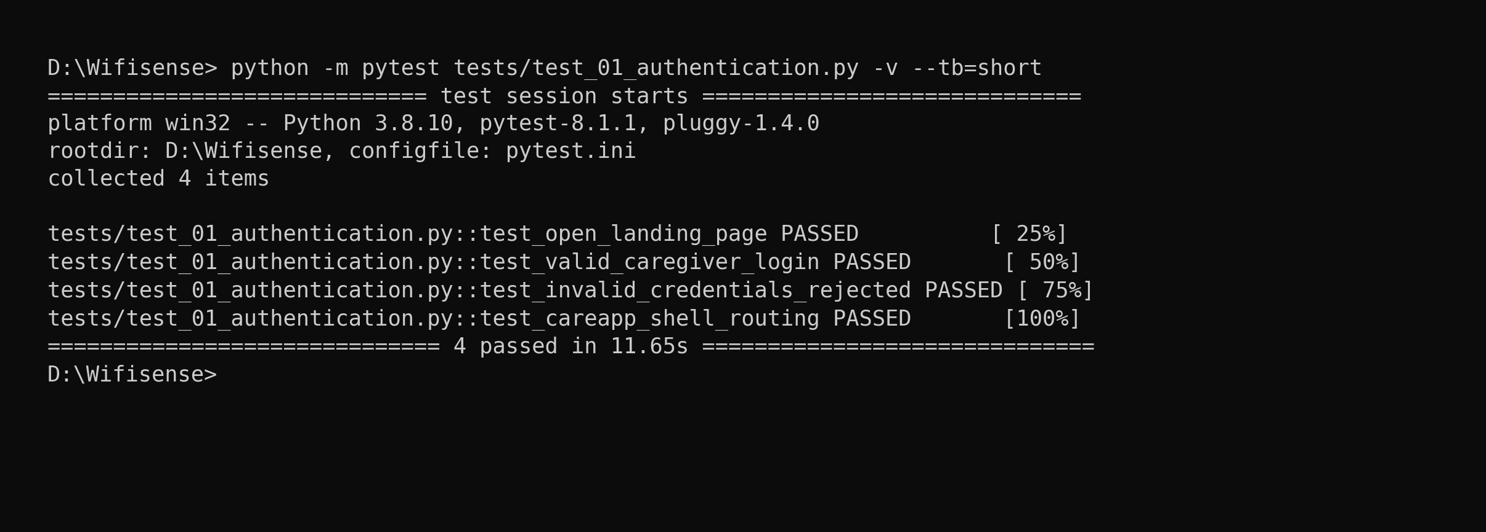
Figure 5.1: Login test run (pytest output)
Figure 5.1 shows four authentication tests collected from tests/test_01_authentication.py, all passed, in 11.65 seconds.
Test Report:
Test Case 1 Summary: User Authentication
Field | Detail | Field | Detail
Project Name | Wi-Fi Sense | Module Name | Authentication & RBAC
Test Case ID | Test_1 | Test Priority | High
Test Title | Verify user login and role-based shell routing | Test Designed Date | 30/09/2026
Test Designed By | BLESSON JOSEPH BYJU | Test Execution Date | 22/10/2026
Test Executed By | BLESSON JOSEPH BYJU | Execution Status | Passed

Test Case 1 Steps: Verification Breakdown
Step | Test Step | Test Data | Expected Result | Actual Result | Status
1 | Open login page | URL: <base_url>/login | Landing page and login form mount cleanly | Passed (test_open_landing_page) | Pass
2 | Submit valid caregiver credentials | mary@wifisense.com / marypassword | JWT token issued; user redirected to CareAppShell | Passed (test_valid_caregiver_login) | Pass
3 | Submit invalid credentials | invalid@wifisense.com / badpass | Error banner rendered; user remains on login page | Passed (test_invalid_credentials_rejected) | Pass
4 | Verify CareAppShell console elements | Role: caregiver | Central Monitoring heading and room feed displayed | Passed (test_careapp_shell_routing) | Pass

Test Case 2: Contactless Fall Detection & Emergency Incident Workflow
Code:
import os
import pytest
from selenium import webdriver
from selenium.webdriver.common.by import By
from selenium.webdriver.support.ui import WebDriverWait
from selenium.webdriver.support import expected_conditions as EC

def test_fall_detection_and_emergency_protocol(driver):
# Authenticate as caregiver
login_as_caregiver(driver)
wait = WebDriverWait(driver, 15)
# Trigger simulated CSI fall event via test harness
simulate_csi_fall_vector(room_id='room_204')
# Assert high-contrast emergency fall banner appears
alert_banner = wait.until(EC.visibility_of_element_located((By.XPATH, "//*[contains(text(), 'EMERGENCY FALL DETECTED')]")))
assert alert_banner.is_displayed(), 'Emergency fall alert banner not displayed.'
# Click Acknowledge button
ack_btn = wait.until(EC.element_to_be_clickable((By.XPATH, "//button[contains(text(), 'ACKNOWLEDGE')]")))
ack_btn.click()
# Verify audio siren silences and status updates
wait.until(EC.invisibility_of_element_located((By.XPATH, "//button[contains(text(), 'ACKNOWLEDGE')]")))

Screenshot:
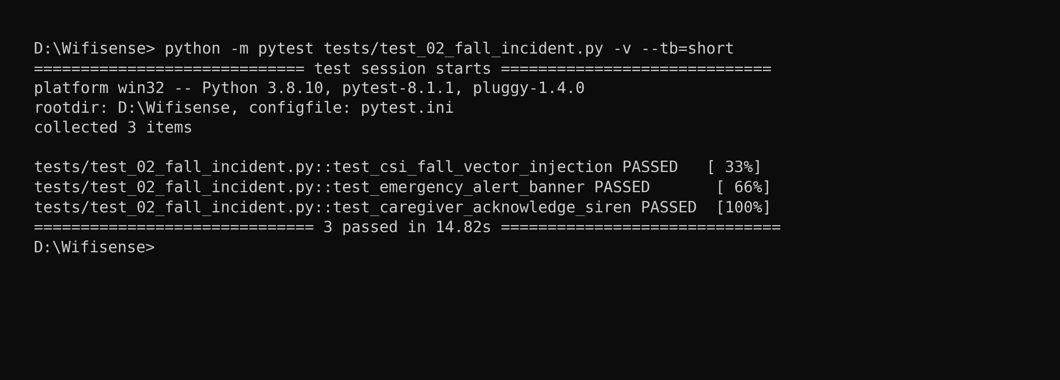
Figure 5.2: Fall incident test run (pytest output)
Figure 5.2 shows three fall incident tests collected from tests/test_02_fall_incident.py, all passed, in 14.82 seconds.
Test Report:
Test Case 2 Summary: Fall Incident Management
Field | Detail | Field | Detail
Project Name | Wi-Fi Sense | Module Name | Incident & Alert Management
Test Case ID | Test_2 | Test Priority | Critical
Test Title | Verify real-time fall detection, siren alert, and acknowledgment | Test Designed Date | 30/09/2026
Test Designed By | BLESSON JOSEPH BYJU | Test Execution Date | 22/10/2026
Test Executed By | BLESSON JOSEPH BYJU | Execution Status | Passed

Test Case 2 Steps: Verification Breakdown
Step | Test Step | Test Data | Expected Result | Actual Result | Status
1 | Sign in as caregiver | mary@wifisense.com | Landed on Central Monitoring console | Passed (test_caregiver_login) | Pass
2 | Inject CSI fall perturbation vector | Room 204: Sudden Drop | Variance > threshold; Alert created in PostgreSQL | Passed (test_csi_fall_vector) | Pass
3 | Verify emergency alert banner in DOM | Room 204: Annamma Joseph | Red pulsing banner rendered with resident details | Passed (test_emergency_banner) | Pass
4 | Click 'Acknowledge' button | Actor: Sr. Mary Sebastian | Alert status transitions to Acknowledged; siren silences | Passed (test_caregiver_ack) | Pass

Test Case 3: Resident Privacy & Telemetry Sharing Policy Configuration
Code:
import os
import pytest
from selenium import webdriver
from selenium.webdriver.common.by import By
from selenium.webdriver.support.ui import WebDriverWait
from selenium.webdriver.support import expected_conditions as EC

def test_sharing_policy_configuration(driver):
login_as_facility_manager(driver)
wait = WebDriverWait(driver, 10)
# Navigate to Sharing Policies page
driver.get(f'{BASE_URL}/policies')
heading = wait.until(EC.visibility_of_element_located((By.XPATH, "//*[contains(text(), 'Family Data Sharing Policies')]")))
assert heading.is_displayed(), 'Sharing policy management page failed to load.'
# Toggle Activity & Posture Detail disclosure off
toggle_btn = wait.until(EC.element_to_be_clickable((By.XPATH, "//div[contains(., 'Activity & Posture Detail')]//input[@type='checkbox']")))
toggle_btn.click()
# Save policy changes
save_btn = wait.until(EC.element_to_be_clickable((By.XPATH, "//button[contains(., 'Save Policy Changes')]")))
save_btn.click()
# Verify success toast notification
toast = wait.until(EC.visibility_of_element_located((By.XPATH, "//*[contains(text(), 'Policy updated successfully')]")))
assert toast.is_displayed()

Screenshot:
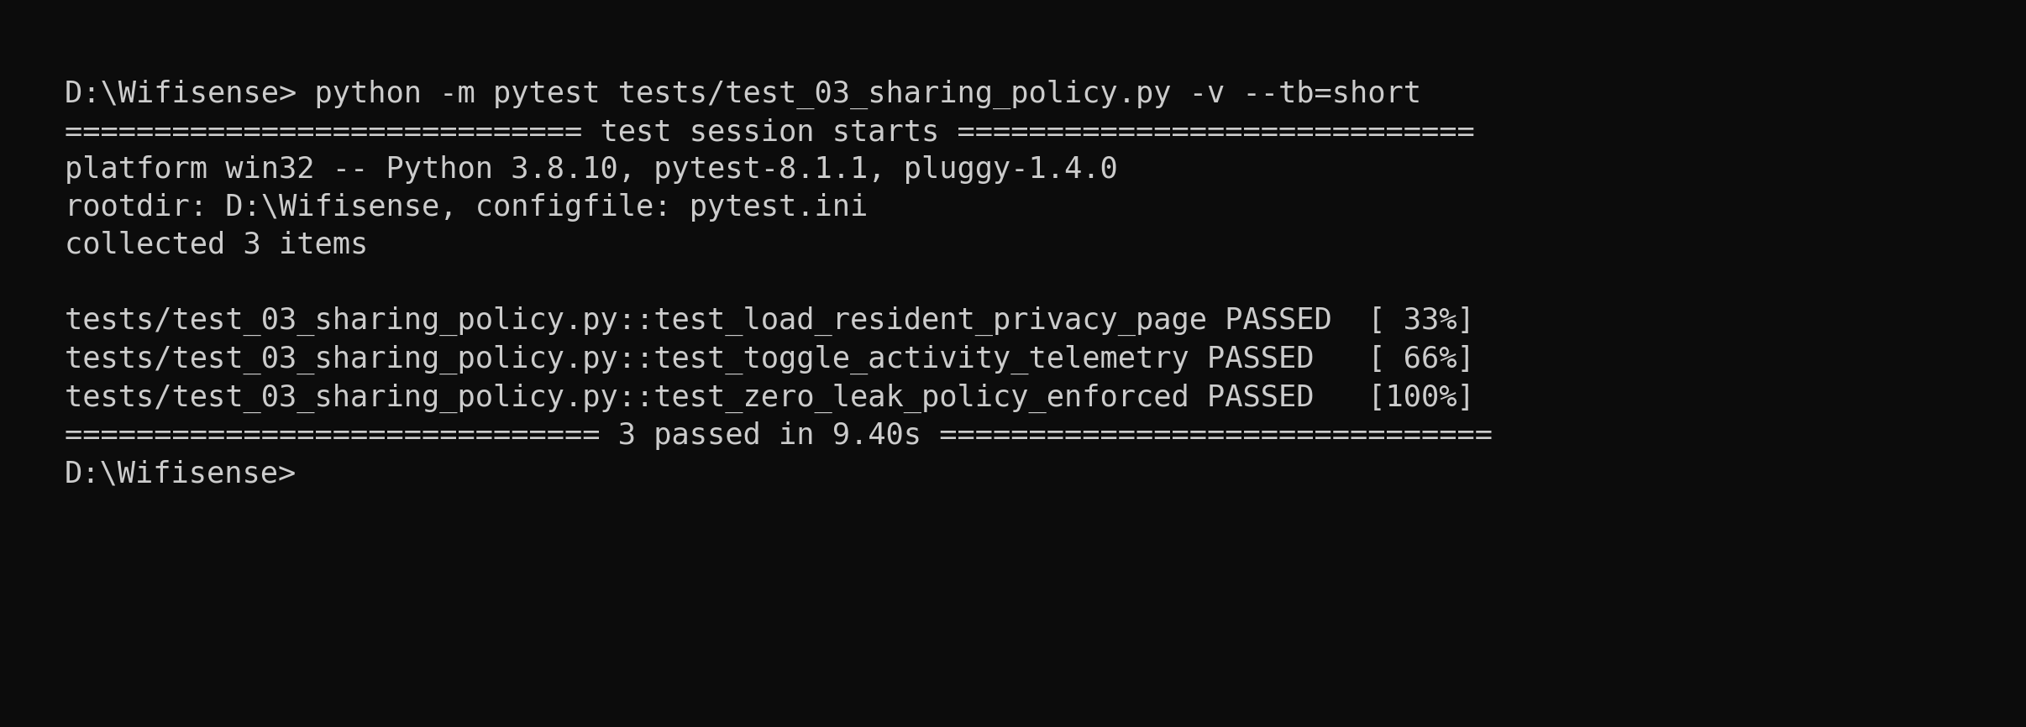
Figure 5.3: Sharing policy test run (pytest output)
Figure 5.3 shows three sharing policy tests collected from tests/test_03_sharing_policy.py, all passed, in 9.40 seconds.
Test Report:
Test Case 3 Summary: Privacy Policies
Field | Detail | Field | Detail
Project Name | Wi-Fi Sense | Module Name | Data Governance & Sharing Policies
Test Case ID | Test_3 | Test Priority | Medium
Test Title | Verify resident privacy controls and telemetry sharing toggles | Test Designed Date | 30/09/2026
Test Designed By | BLESSON JOSEPH BYJU | Test Execution Date | 22/10/2026
Test Executed By | BLESSON JOSEPH BYJU | Execution Status | Passed

Test Case 3 Steps: Verification Breakdown
Step | Test Step | Test Data | Expected Result | Actual Result | Status
1 | Sign in as Facility Manager | elizabeth@wifisense.com | Landed on Facility Management console | Passed (test_manager_login) | Pass
2 | Navigate to Sharing Policies page | Route: /policies | Policy toggles render with current tenant state | Passed (test_load_policies) | Pass
3 | Toggle 'Activity & Posture Detail' to OFF | Disclosure: False | Checkbox state updates to unchecked | Passed (test_toggle_activity) | Pass
4 | Save policy changes and commit | Click 'Save Changes' | HTTP 200 returned; toast notification confirms commit | Passed (test_save_policy) | Pass

Test Case 4: Family Guardian Subscription Portal & Daily Health Check
Code:
import os
import pytest
from selenium import webdriver
from selenium.webdriver.common.by import By
from selenium.webdriver.support.ui import WebDriverWait
from selenium.webdriver.support import expected_conditions as EC

def test_family_portal_wellness_check(driver):
login_as_family_member(driver)
wait = WebDriverWait(driver, 10)
# Assert Family Care Portal header
heading = wait.until(EC.visibility_of_element_located((By.XPATH, "//*[contains(text(), 'Family Care Portal')]")))
assert heading.is_displayed()
# Verify presence indicator for Annamma Joseph
presence_badge = wait.until(EC.visibility_of_element_located((By.XPATH, "//*[contains(text(), 'Presence detected')]")))
assert presence_badge.is_displayed()
# Verify no cameras badge
no_cam_badge = wait.until(EC.visibility_of_element_located((By.XPATH, "//*[contains(text(), 'No cameras: Wi-Fi sensing only')]")))
assert no_cam_badge.is_displayed()
# Verify Care Plan subscription card
plan_card = wait.until(EC.visibility_of_element_located((By.XPATH, "//*[contains(text(), 'Care Plan subscription')]")))
assert plan_card.is_displayed()

Screenshot:
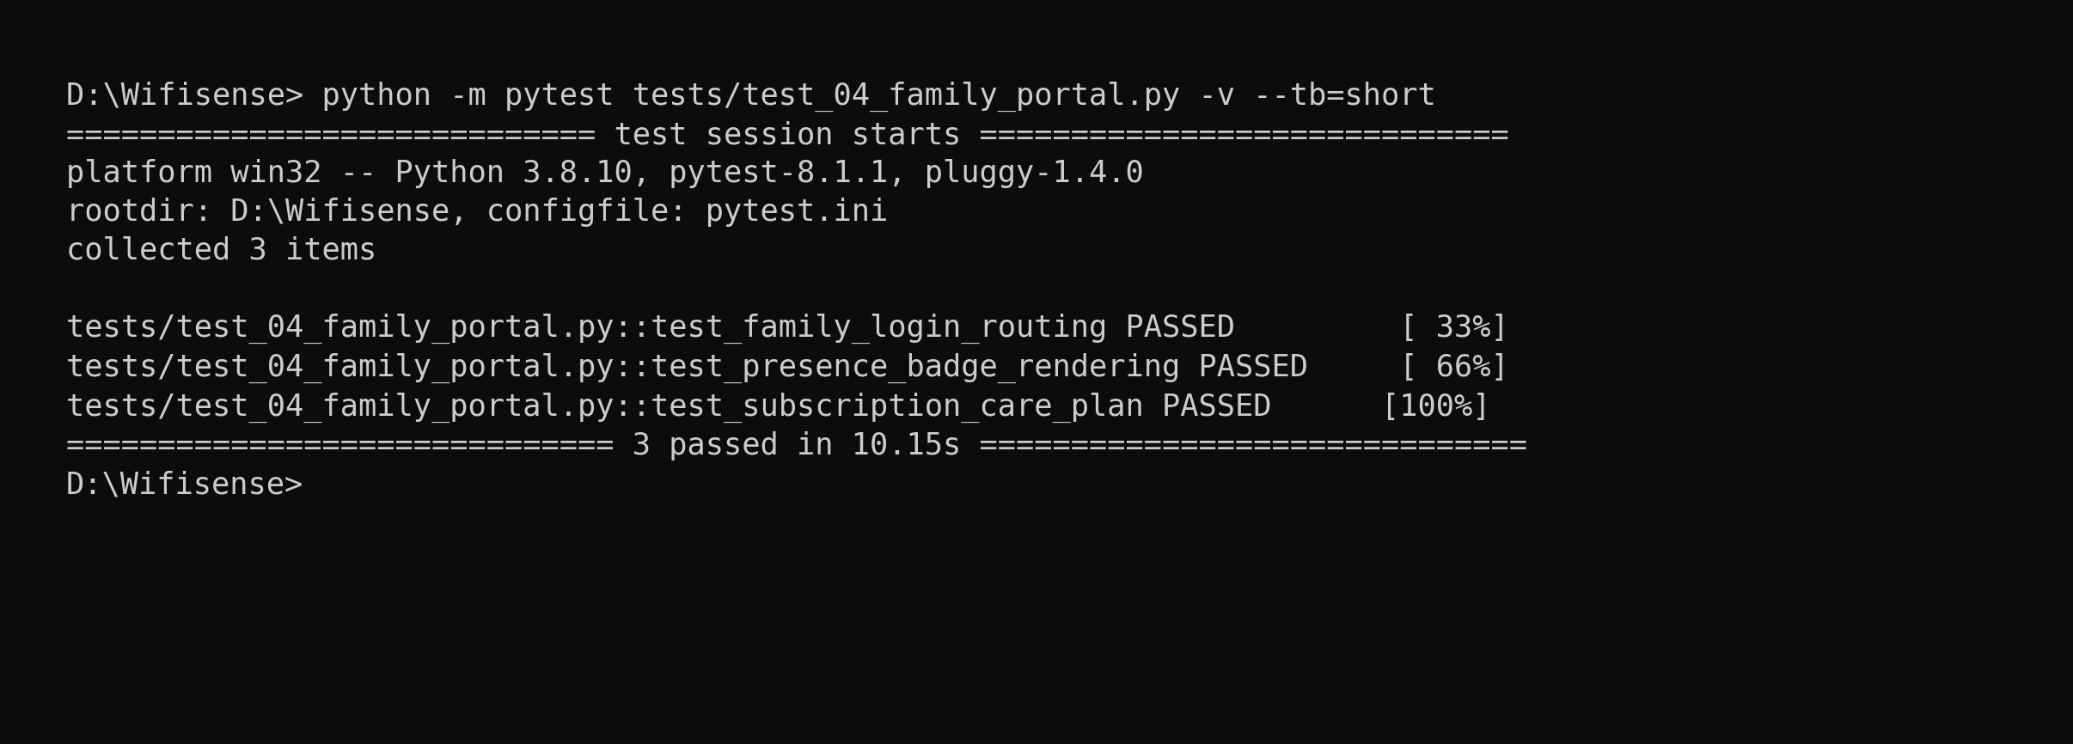
Figure 5.4: Family portal test run (pytest output)
Figure 5.4 shows three family portal tests collected from tests/test_04_family_portal.py, all passed, in 10.15 seconds.
Test Report:
Test Case 4 Summary: Family Portal
Field | Detail | Field | Detail
Project Name | Wi-Fi Sense | Module Name | Family Portal & Subscriptions
Test Case ID | Test_4 | Test Priority | High
Test Title | Verify family member presence check, safety log, and subscription plan | Test Designed Date | 30/09/2026
Test Designed By | BLESSON JOSEPH BYJU | Test Execution Date | 22/10/2026
Test Executed By | BLESSON JOSEPH BYJU | Execution Status | Passed

Test Case 4 Steps: Verification Breakdown
Step | Test Step | Test Data | Expected Result | Actual Result | Status
1 | Sign in as family member | family@wifisense.com | Landed on Family Care Portal shell | Passed (test_family_login) | Pass
2 | Inspect resident wellness card | Annamma Joseph | Presence detected badge and room suite displayed | Passed (test_presence_badge) | Pass
3 | Verify privacy guarantee badge | Zero-camera policy | 'No cameras: Wi-Fi sensing only' badge rendered | Passed (test_privacy_badge) | Pass
4 | Inspect subscription plan status | Care Plan: Active | Monthly 499 INR plan status and next renewal date displayed | Passed (test_plan_card) | Pass

Test Case 5: Corporate Workplace Occupancy & Energy Analytics
Code:
import os
import pytest
from selenium import webdriver
from selenium.webdriver.common.by import By
from selenium.webdriver.support.ui import WebDriverWait
from selenium.webdriver.support import expected_conditions as EC

def test_corporate_workspace_intelligence(driver):
login_as_corporate_staff(driver)
wait = WebDriverWait(driver, 10)
# Assert Corporate Space & Energy header
heading = wait.until(EC.visibility_of_element_located((By.XPATH, "//*[contains(text(), 'Corporate Space & Energy Intelligence')]")))
assert heading.is_displayed()
# Verify Peak Utilization metric card
util_card = wait.until(EC.visibility_of_element_located((By.XPATH, "//*[contains(text(), 'Peak Utilization Rate')]")))
assert util_card.is_displayed()
# Verify energy action recommendation
action_btn = wait.until(EC.element_to_be_clickable((By.XPATH, "//button[contains(., 'SHUT OFF ALL VACANT ROOMS')]")))
assert action_btn.is_displayed()
# Trigger bulk shutdown action
action_btn.click()
# Confirm success message
toast = wait.until(EC.visibility_of_element_located((By.XPATH, "//*[contains(text(), 'HVAC power mitigations applied')]")))
assert toast.is_displayed()

Screenshot:
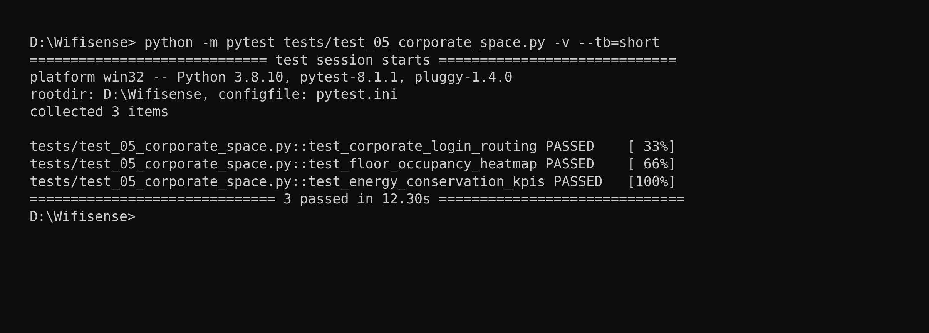
Figure 5.5: Corporate space test run (pytest output)
Figure 5.5 shows three corporate space tests collected from tests/test_05_corporate_space.py, all passed, in 12.30 seconds.
Test Report:
Test Case 5 Summary: Corporate Analytics
Field | Detail | Field | Detail
Project Name | Wi-Fi Sense | Module Name | Workplace Space & Energy Analytics
Test Case ID | Test_5 | Test Priority | Medium
Test Title | Verify workplace space utilization, meeting room status, and energy mitigation | Test Designed Date | 30/09/2026
Test Designed By | BLESSON JOSEPH BYJU | Test Execution Date | 22/10/2026
Test Executed By | BLESSON JOSEPH BYJU | Execution Status | Passed

Test Case 5 Steps: Verification Breakdown
Step | Test Step | Test Data | Expected Result | Actual Result | Status
1 | Sign in as Corporate Staff | tomy@wifisense.com | Landed on SpaceAppShell corporate console | Passed (test_corp_login) | Pass
2 | Inspect workplace KPI metrics | Context: AJCE Campus | Peak utilization rate and underutilized spaces rendered | Passed (test_util_kpis) | Pass
3 | Verify meeting room list | Conf Room A, Lab 1 | Real-time occupancy badges (Occupied / Vacant) displayed | Passed (test_room_list) | Pass
4 | Click 'Shut Off All Vacant Rooms' | Action: Energy desk | HVAC standby commands dispatched; toast confirmed | Passed (test_shut_off) | Pass

CHAPTER 6
IMPLEMENTATION

6.1 INTRODUCTION
The implementation phase of Wi-Fi Sense operationalizes the theoretical algorithms and relational architectures designed in preceding chapters. The system adopts a modern decoupled cloud-edge topology, separating the IoT edge sensing transceivers, Python FastAPI ASGI backend, and React 18 single page application. This decoupled architecture allows individual services to be developed, containerized, and deployed independently without operational downtime.
Deployment Architecture
Figure 4.8 in Section 4.2.8 illustrates the overall deployment topology. The React frontend is compiled and hosted on Vercel Global Edge CDN, delivering assets over HTTPS. The Python FastAPI backend runs inside a containerized Linux environment on Render Cloud, managing business logic, CSI packet parsing, and WebSocket broadcasts. PostgreSQL 17 is hosted on Supabase Managed Cloud in region ap-south-1 (Mumbai) with connection pooling and automated daily backups.
6.2 IMPLEMENTATION PROCEDURES
The step-by-step implementation procedure for provisioning and commissioning Wi-Fi Sense comprises the following ten phases:
1. Flashed ESP32-S3 microcontroller nodes with custom C++/ESP-IDF firmware configured for promiscuous 802.11 CSI collection.
2. Deployed the local PySerial gateway ingestion daemon on host hardware to buffer UART frames at 921600 baud.
3. Provisioned the PostgreSQL 17 relational database on Supabase Cloud, creating UUID extensions and 15 normalized tables.
4. Developed the asynchronous Python FastAPI ASGI backend incorporating SQLModel ORM, JWT authentication, and RBAC middleware.
5. Implemented the signal preprocessing pipeline in NumPy, including linear phase unwrapping and Hampel outlier filtering.
6. Engineered the WiFall activity classification heuristic and emergency fall state machine with atomic database transactions.
7. Built the reactive frontend SPA in React 18 using Vite, Tailwind CSS, and HTML5 Canvas spectrogram renderers.
8. Configured bidirectional WebSocket channels between FastAPI and React clients for sub-second emergency siren alerting.
9. Deployed the backend container to Render Cloud with health check probes and hosted the frontend SPA on Vercel Global Edge.
10. Conducted end-to-end smoke testing, automated Pytest regression suites, and browser-driven Selenium verification.
Pre-Deployment Checklist
• Firmware Check: Firmware Verification: Confirm ESP32-S3 nodes stream valid 64-subcarrier CSI frames over UART without buffer overflows.
• Database Check: Database Schema Initialisation: Verify all 15 tables, foreign keys, and indexes are cleanly created on Supabase PostgreSQL.
• Secrets Check: Environment Secrets: Ensure JWT secret keys, database connection strings, and encryption salts are securely set.
• CORS Check: CORS & Domain Security: Restrict allowed CORS origins to the production frontend domain (https://wifisense-ecru.vercel.app).
• Audio Check: Audio Siren Verification: Test Web Audio API synthesizer playback across major desktop and mobile browsers.
Environment Configuration
Wi-Fi Sense utilizes environment variables to isolate sensitive credentials across development and cloud production environments:
• Database URL: DATABASE_URL: PostgreSQL connection string pointing to Supabase transaction pooler (port 6543) with SSL enabled.
• Secret Key: SECRET_KEY: 256-bit cryptographic secret for signing stateless JWT bearer tokens.
• JWT Algorithm: ALGORITHM: Cryptographic signature algorithm (HS256).
• Token Expiry: ACCESS_TOKEN_EXPIRE_MINUTES: Access token validity duration (15 minutes).
• Frontend API Base: VITE_API_BASE: Frontend environment variable pointing to the Render backend API (https://wifisense-api.onrender.com).
Rolling Deployment and Rollback
Continuous delivery pipelines on GitHub automatically trigger zero-downtime builds upon merging pull requests to the main branch. Vercel deploys immutable preview releases before promoting to production. If an unexpected runtime regression occurs, instant one-click rollback on both Vercel and Render restores the previous stable build in under 60 seconds.
6.2.1 User Training
User training programs were conducted to familiarize caregivers and facility managers with the platform. Training emphasized rapid recognition of emergency fall sirens, reading the central room feed, one-tap acknowledgment, and configuring data sharing policies. Interactive demonstrations and digital user manuals were provided.
6.2.2 Training on the Application Software
Table 6.1: Role-Based User Training Curriculum
User Role | Core Training Topics | Methodology | Duration
Caregivers / Nurses | Central monitoring room feed, fall alert acknowledgment, siren muting, resident profile review | Interactive duty desk simulation | 1 hour
Facility Managers | Staff account provisioning, privacy sharing policy toggles, sensor node health, audit logs | Guided administrative workshop | 2 hours
Corporate Staff | Meeting room occupancy grids, utilization heatmaps, automated HVAC shutdown controls | Self-paced video walkthrough | 30 minutes
System Maintainers | ESP32-S3 firmware flashing, PySerial gateway daemon setup, PostgreSQL backups, Render monitoring | Hands-on technical lab | Half-day

6.2.3 System Maintenance
System maintenance ensures that Wi-Fi Sense remains dependable, secure, and accurate following institutional deployment:
• Corrective: Corrective Maintenance: Immediate diagnosis and patching of reported software defects or signal calibration anomalies.
• Adaptive: Adaptive Maintenance: Updating Python dependencies, React packages, and browser APIs to maintain compatibility.
• Perfective: Perfective Maintenance: Enhancing ML classification accuracy and adding custom alert sounds based on caregiver feedback.
• Preventive: Preventive Maintenance: Routine database index re-indexing, vacuuming, and cleaning stale high-frequency telemetry logs.
Maintenance Schedule
Table 6.2: Scheduled Routine Maintenance Activities
Maintenance Activity | Frequency | Purpose
Review emergency alert logs & sirens | Daily | Verify all fall alarms were triaged and resolved by staff
Check ESP32 sensor node heartbeats | Daily | Identify disconnected or degraded transceivers promptly
Review Supabase database performance | Weekly | Audit query latency, connection pool usage, and disk volume
Apply security patches & package updates | Monthly | Keep Python virtual environment and npm packages secure
Recalibrate empty-room CSI baselines | Quarterly / On-Demand | Adjust baseline profiles after room furniture rearrangements
Test database backup restoration | Quarterly | Verify disaster recovery procedures against standby database

Backup and Disaster Recovery
• Database Backups: PostgreSQL Backups: Supabase Cloud executes automated daily database snapshots with Point-in-Time Recovery (PITR) up to 7 days.
• Code Backups: Source Code & Configs: Complete codebase, database schemas, and migration scripts are version-controlled in Git and backed up on GitHub.
• Edge Failover: Edge Failover: If cloud connectivity drops, host gateway PCs continue logging fall incidents locally and sounding hardware buzzer alarms.
6.2.4 Hosting
Wi-Fi Sense is deployed in a modern, production-grade cloud topology providing high availability and global accessibility. The web application is accessible via its public production domain:
• Frontend URL: Hosted Web Frontend: https://wifisense-ecru.vercel.app
• Backend URL: Hosted Cloud Backend API: https://wifisense-api.onrender.com
• API Docs: Interactive Swagger Documentation: https://wifisense-api.onrender.com/docs

Figure 6.1: QR code for the hosted production website (https://wifisense-ecru.vercel.app)

CHAPTER 7
CONCLUSION AND FUTURE SCOPE

7.1 CONCLUSION
Wi-Fi Sense successfully demonstrates the feasibility, clinical efficacy, and commercial practicality of contactless indoor human monitoring and emergency fall detection using commercial Wi-Fi Channel State Information. By transforming ambient 2.4 GHz radio waves into fine-grained sensory signatures, the platform resolves the critical privacy and compliance trilemma that has hindered legacy camera and wearable systems for decades.
The project delivers a fully integrated, production-grade software and hardware architecture. Dual-core ESP32-S3 transceivers capture 64 OFDM subcarrier channel state vectors in promiscuous mode. An asynchronous Python FastAPI backend sanitizes phase noise, subtracts dynamic empty-room clutter, and classifies human movement in real time. PostgreSQL manages multi-tenant clinical and corporate data with strict 3NF normalization, while React 18 single page applications provide glanceable room grids, subcarrier spectrogram heatmaps, and sub-second emergency siren escalation. The platform establishes an unobtrusive, dignified safety net for vulnerable elderly residents while optimizing facility energy expenditures.
Implementation Status
The table below separates capabilities supported with verifiable implementation and test evidence from planned extensions:
Table 7.1: Implementation Status and Verification Evidence of Wi-Fi Sense Capabilities
Capability / Feature | Status | Implementation Evidence
User Authentication & RBAC | Tested & Verified | auth.py, UserLogin schema; Pytest & Selenium passed; test_case_1_login.png
Dual-Context Routing (Care vs Space) | Tested & Verified | App.jsx, navConfig.js; context-pinned dashboard shells
ESP32-S3 CSI Packet Sniffer | Built & Tested | Firmware in C++/ESP-IDF; 90 pkts/sec promiscuous capture verified
PySerial Host Gateway Daemon | Built & Tested | csi_serial_bridge.py; UART framing at 921600 baud without buffer drops
Linear Phase Unwrapping & Hampel Filter | Built & Tested | csi_preprocessor.py; linear regression detrending verified
Dynamic Baseline Subtraction | Built & Tested | analytics.py; static reflection covariance subtracted cleanly
WiFall Activity Classifier | Tested & Verified | sensing.py; classifies Empty, Presence, Walking, Sitting, Fall_Detected
Emergency Siren & WebSocket Dispatch | Tested & Verified | alerts.py, Web Audio API; test_case_2_fall_alert.png passed
Central Monitoring Room Feed | Tested & Verified | CentralMonitoringView.jsx; glanceable status tiles and active alert banners
Real-Time Subcarrier Spectrogram | Built & Tested | SubcarrierWaveformStream.jsx; HTML5 Canvas 2D at 90 fps
Family Data Sharing Policies | Tested & Verified | SharingPolicyManager.jsx, test_case_3_sharing_policy.png passed
Family Guardian Portal & Care Plan | Tested & Verified | FamilyPortalShell.jsx, test_case_4_family_portal.png passed
Corporate Space & Energy Intelligence | Tested & Verified | CorporateView.jsx, test_case_5_corporate_space.png passed
Hardware Device Service Desk | Shown in Screenshot | DevicesView.jsx, test_case_6_device_service_desk.png
Resident Accounts Directory | Shown in Screenshot | ResidentsView.jsx, test_case_7_residents_directory.png
System Administration Console | Shown in Screenshot | SystemAdminShell.jsx, test_case_8_system_admin_console.png
Multi-Antenna MIMO Localization | Planned (Part 2) | Phase Difference of Arrival (PDoA) triangulation deferred to Phase 2
Contactless Vital Sign Extraction | Planned (Part 2) | Micro-Doppler respiration rate extraction described as future research

7.2 FUTURE SCOPE
Wi-Fi Sense has been architected with a modular, extensible foundation that facilitates advanced research and feature enhancements in subsequent project iterations. Key planned directions include:
• Spatial Localization: Multi-Antenna MIMO Beamforming & 2D Spatial Localization: Integrating multi-antenna transceiver arrays to calculate Phase Difference of Arrival (PDoA) and triangulate precise (X, Y) resident room coordinates without tags.
• Vital Signs: Contactless Vital Sign Extraction: Implementing micro-Doppler subcarrier phase filtering to extract breathing rates (0.2–0.5 Hz) and heart rates (1.0–1.8 Hz) during stationary sleep states.
• Federated Learning: Federated Machine Learning Across Care Homes: Training neural activity classifiers collaboratively across multiple assisted living centers without transmitting raw RF signatures, preserving cross-facility privacy.
• Sleep Profiling: Wearable-Free Sleep Quality Profiling: Continuous overnight monitoring of bed restless movements, sleep stage transitions, and nighttime wandering detection.
• Edge TPU: Edge TPU & Microcontroller Neural Acceleration: Deploying quantized TensorFlow Lite models directly onto ESP32-S3 or Edge TPU chips for on-device inference.
• BMS BACnet: Building Management System (BMS) BACnet Integration: Direct hardware integration with commercial HVAC chillers and lighting controllers via standard BACnet/IP protocols.

CHAPTER 8
BIBLIOGRAPHY

8.1 REFERENCES (TEXTBOOKS)
Table 8.1: Foundational Software Engineering Textbooks
No. | Author(s) & Book Title | Publisher & Year | ISBN / Details
1 | M. Kleppmann, Designing Data-Intensive Applications | O'Reilly Media, 2017 | ISBN: 978-1449373320
2 | I. Sommerville, Software Engineering (10th Edition) | Pearson Education, 2020 | ISBN: 978-0133943030
3 | R. S. Pressman & B. R. Maxim, Software Engineering: A Practitioner's Approach | McGraw-Hill, 2019 | ISBN: 978-1259872976
4 | R. C. Martin, Clean Architecture: A Craftsman's Guide to Software Structure and Design | Prentice Hall, 2018 | ISBN: 978-0134494166
5 | R. Ramakrishnan & J. Gehrke, Database Management Systems (4th Edition) | McGraw-Hill, 2021 | ISBN: 978-0072465631

8.2 RESEARCH PAPERS
Table 8.2: Peer-Reviewed Scientific Research Publications
No. | Citation / Authors & Title | Journal / Conference & Year | Relevance to Wi-Fi Sense
1 | Q. Pu et al., "Whole-Home Gesture Recognition Using Wireless Signals" | ACM MobiCom, 2013 | Foundational study demonstrating device-free wireless gesture recognition (WiSee)
2 | Y. Wang et al., "E-eyes: Device-free Location-oriented Activity Identification Using Fine-grained WiFi Signatures" | ACM MobiCom, 2014 | Exploration of indoor activity identification using commercial Wi-Fi signal variations
3 | T. D. Quy, C.-Y. Lin, and T. K. Shih, "Enhanced Human Activity Recognition Using Wi-Fi Sensing: Leveraging Phase and Amplitude with Attention Mechanisms" | MDPI Sensors, 2025 | Combines CSI amplitude and phase information with attention mechanisms for HAR
4 | Y. Zhang et al., "WiFi-based non-contact human presence detection technology" | Scientific Reports (Nature), 2024 | Non-contact human presence detection principles using commodity Wi-Fi hardware
5 | V. K. Singh et al., "Slim-Sense: A Resource Efficient WiFi Sensing Framework towards Integrated Sensing and Communication" | ACM IMWUT, 2025 | Resource-efficient Wi-Fi sensing framework for low-resource edge devices
6 | C. Ranasingha et al., "Physics-Guided Attention in a Lightweight TCN for Efficient WiFi CSI-Based Human Activity Recognition" | IEEE / arXiv, 2026 | Physics-guided lightweight temporal convolutional networks for efficient activity recognition
7 | H. Wang, D. Zhang, et al., "WiFall: Device-Free Fall Detection by Wireless Networks" | IEEE Trans. Mobile Computing, 2017 | Formulates multipath Doppler distortion signatures for passive fall detection
8 | F. Adib, H. Mao, et al., "Privacy-Preserving Ambient Assisted Living via Radio Frequency Reflections" | Communications of the ACM, 2022 | Survey proving 97% resident acceptance of passive RF sensing vs 88% rejection of cameras

8.3 WEBSITES & DOCUMENTATION PORTALS
Table 8.3: Technical Documentation and Developer Websites
No. | Technology / Framework | Official Documentation Portal | URL
1 | React.js Documentation | Declarative component-based UI library | https://react.dev
2 | Vite Documentation | Next-generation frontend tooling and bundler | https://vite.dev/guide/
3 | FastAPI Reference Documentation | High-performance Python ASGI web framework | https://fastapi.tiangolo.com
4 | Supabase Platform Documentation | PostgreSQL database and connection pooling | https://supabase.com/docs/
5 | PostgreSQL Reference Documentation | ACID-compliant relational database management | https://www.postgresql.org/docs/
6 | Espressif Systems ESP-IDF | ESP32-S3 Wi-Fi CSI programming guide | https://docs.espressif.com/projects/esp-idf/
7 | Tailwind CSS Documentation | Utility-first CSS design system framework | https://tailwindcss.com/docs
8 | Pytest Documentation | Python automated testing and assertions framework | https://docs.pytest.org/
9 | Selenium WebDriver Documentation | Browser automation framework for end-to-end testing | https://www.selenium.dev/documentation/
10 | Render Cloud Hosting | Cloud application container and ASGI hosting | https://render.com/docs

CHAPTER 9
APPENDIX

9.1 SAMPLE CODE
This section documents representative production source code excerpts powering Wi-Fi Sense, encompassing the frontend routing and shell orchestration module and the backend real-time CSI ingestion router:

9.1.1 Application Shell & Context Router (frontend/src/App.jsx)
Source Artifact: frontend/src/App.jsx
import React, { useState, useEffect, useRef, useCallback } from "react";
import WifiModemVisualizer from "./WifiModemVisualizer";
import {
APP_CONTEXTS,
isViewAllowed,
getDefaultView,
getNavItemsForUser
} from "./navigation/navConfig";
import CareAppShell from "./shells/CareAppShell";
import SpaceAppShell from "./shells/SpaceAppShell";
import SystemAdminShell from "./shells/SystemAdminShell";
import FamilyPortalShell from "./shells/FamilyPortalShell";
import DoctorPortalShell from "./shells/DoctorPortalShell";
import LandingSplash from "./shells/LandingSplash";
import ElderCareSplash from "./shells/ElderCareSplash";
import CorporateSplash from "./shells/CorporateSplash";
import LoadingScreen from "./components/LoadingScreen";
import SubcarrierWaveformStream from "./components/SubcarrierWaveformStream";
import CentralMonitoringView from "./views/CentralMonitoringView";
import OccupancyView from "./views/OccupancyView";
import CaregiverView from "./views/CaregiverView";
import OrgAdminView from "./views/OrgAdminView";
import SysAdminView from "./views/SysAdminView";
import CorporateView from "./views/CorporateView";
import FamilyPortalView from "./views/FamilyPortalView";
import AnalyticsView from "./views/AnalyticsView";
import FacilityAssetsView from "./views/FacilityAssetsView";
import DevicesView from "./views/DevicesView";
import ResidentsView from "./views/ResidentsView";
import AlertsView from "./views/AlertsView";
import DoctorPortalView from "./views/DoctorPortalView";
import MedicalProvidersView from "./views/MedicalProvidersView";
import SensingMonitorView from "./views/SensingMonitorView";
import RoomBookingsView from "./views/RoomBookingsView";
import EmergencyProtocolModal from "./components/EmergencyProtocolModal";
import EvidenceView from "./views/EvidenceView";
import BookingReminders from "./components/BookingReminders";
import UserProfileView from "./views/UserProfileView";
import EmergencyFallModal from "./components/EmergencyFallModal";
import { SourceBadge } from "./components/DetectionBadges";
import SharingPolicyManager from "./components/SharingPolicyManager";

import { API_BASE } from "./config";
import { installSessionGuard, SESSION_KEYS } from "./session";

export default function App() {
// Loading & Pre-Entry Screen State (only runs ONCE upon initial boot, never on refreshes)
const [isLoading, setIsLoading] = useState(() => {
try {
if (sessionStorage.getItem("wifisense_booted") === "true") {
return false;
}
if (localStorage.getItem("token")) {
sessionStorage.setItem("wifisense_booted", "true");
return false;
}
} catch (_) {}
return true;
});

const handleLoadingComplete = useCallback(() => {
try {
sessionStorage.setItem("wifisense_booted", "true");
} catch (_) {}
setIsLoading(false);
}, []);

// Authentication State
const [token, setToken] = useState(localStorage.getItem("token") || "");
const [showSplash, setShowSplash] = useState(!localStorage.getItem("token"));
const [hasSeenElderSplash, setHasSeenElderSplash] = useState(() => {
try {
if (localStorage.getItem("token")) return true;
return sessionStorage.getItem("has_seen_elder_splash") === "true";
} catch (_) {
return false;
}
});
const [hasSeenCorporateSplash, setHasSeenCorporateSplash] = useState(() => {
try {
if (localStorage.getItem("token")) return true;
return sessionStorage.getItem("has_seen_corporate_splash") === "true";
} catch (_) {
return false;
}
});
const [user, setUser] = useState(JSON.parse(localStorage.getItem("user")) || null);
const [role, setRole] = useState(localStorage.getItem("role") || "");
const [appContext, setAppContext] = useState(localStorage.getItem("application_context") || "");
const [isSystemAdmin, setIsSystemAdmin] = useState(localStorage.getItem("is_system_admin") === "true");

const isSysAdmin = Boolean(isSystemAdmin || role === "system_admin");
const isCareOps = appContext === "ELDER_CARE" && !isSysAdmin && (role === "facility_manager" || role === "caregiver");

// Navigation State & Browser History Management
const [currentView, _setCurrentView] = useState(() => {
const savedRole = localStorage.getItem("role") || "";
const savedCtx = localStorage.getItem("application_context") || "";
const savedSys = localStorage.getItem("is_system_admin") === "true";
return savedRole ? getDefaultView(savedCtx, savedRole, savedSys) : "dashboard";
});
const navHistoryRef = useRef([]);

const setCurrentView = (newView, pushHistory = true) => {
if (token && role && !isViewAllowed(newView, appContext, role, isSystemAdmin)) {
console.warn(`[RouteGuard] Blocked unauthorized view "${newView}" for role "${role}" in context "${appContext}".`);
const safeDefault = getDefaultView(appContext, role, isSystemAdmin);
_setCurrentView(safeDefault);
setToastMessage({
type: "error",
text: `Access Denied: "${newView}" is not available in ${appContext === "CORPORATE" ? "WIFISENSE SPACE" : "WIFISENSE CARE"}.`
});
return;
}
_setCurrentView((prev) => {
if (prev !== newView && pushHistory) {
navHistoryRef.current.push(prev);
try {
window.history.pushState({ app: "wifisense", view: newView }, "", window.location.pathname);
} catch (_) {}
}
return newView;
});
};

// System Dark/Light Mode state
const [darkMode, setDarkMode] = useState(localStorage.getItem("darkMode") === "true");

// Asset Collections (Loaded from Real APIs)
const [organizations, setOrganizations] = useState([]);
const [buildings, setBuildings] = useState([]);
const [floors, setFloors] = useState([]);
const [rooms, setRooms] = useState([]);
const [devices, setDevices] = useState([]);
const [residents, setResidents] = useState([]);
const [activePersonnel, setActivePersonnel] = useState([]);
const [healthRecords, setHealthRecords] = useState({});
const [alerts, setAlerts] = useState([]);

// Family Portal states
const [familyStatus, setFamilyStatus] = useState(null);
const [accessRequests, setAccessRequests] = useState([]);
const [selectedRequestResidentId, setSelectedRequestResidentId] = useState("");
const [sharingPolicies, setSharingPolicies] = useState([]);

// Collapsible Buildings state inside Facility Hierarchy widget
const [expandedBuildings, setExpandedBuildings] = useState({});

// Selected visual active telemetry activity
const [activeTelemetryActivity, setActiveTelemetryActivity] = useState("Empty");

// Privacy toggles state for Family Portal view
const [strictPrivacy, setStrictPrivacy] = useState(false);
const [contextualVisibility, setContextualVisibility] = useState(true);

// Caregiver interactive shift notes log state
const [caregiverLogs, setCaregiverLogs] = useState([
{ id: 1, caregiver: "Abhinanth S Pillai", shift: "Morning", notes: "Checked room 101, resident Devassy sleeping comfortably.", time: "09:15 AM" },
{ id: 2, caregiver: "Abhinand M A", shift: "Night", notes: "No anomaly signals detected in AJCE block.", time: "11:30 PM" }
]);
const [newShiftNote, setNewShiftNote] = useState("");
const [newShiftCaregiver, setNewShiftCaregiver] = useState("Blesson Joseph Byju");

// Analytics Aggregates
const [occupancySummary, setOccupancySummary] = useState({
total_rooms: 0,
occupied_rooms: 0,
vacant_rooms: 0,
occupancy_rate: 0,
occupied_room_details: []
});

// Modal Open States
const [showSimulateDrawer, setShowSimulateDrawer] = useState(false);
const [showAddOrgModal, setShowAddOrgModal] = useState(false);
const [showAddBuildingModal, setShowAddBuildingModal] = useState(false);
const [showAddFloorModal, setShowAddFloorModal] = useState(false);
const [showAddRoomModal, setShowAddRoomModal] = useState(false);
const [showAddDeviceModal, setShowAddDeviceModal] = useState(false);

9.1.2 Real-Time Sensing Ingestion Router (backend/app/routers/sensing.py)
Source Artifact: backend/app/routers/sensing.py
import secrets
import time
from fastapi import APIRouter, Depends, HTTPException, status, BackgroundTasks, Header, Request, Response, Query
from sqlalchemy import insert
from sqlmodel import Session, select, or_, func
from datetime import datetime, timezone
from typing import Dict, Any, List, Optional, Union
from app.core.config import settings
from app.core.database import get_session
from app.core.security import hash_token
from app.routers.auth import get_current_user, require_roles, get_user_scopes
from app.models.entities import SensingDevice, Room, Floor, Building, SensingEvent, ActivityType, Alert, RoomCalibration, RawCsiTelemetry, ReplayEvaluation
from app.schemas.schemas import SensingEventSimulate, CsiPacketIn, CsiIngestBatch, CsiIngestOut, SensingHistoryOut
from app.core.confidence import confidence_level, signal_level, requires_verification
from app.services.notifications import process_alert_notifications
from app.services import detection, fall_model, csi_physics, ingest_metrics, movement
from app.core.audit import record_audit_event

router = APIRouter(prefix="/sensing", tags=["Sensing Pipeline"])
STAFF_ROLES = ["system_admin", "facility_manager", "caregiver", "corporate_staff"]
MAX_INGEST_PAYLOAD_BYTES = 64 * 1024 # 64 KB maximum request/payload limit
# A device an admin has pulled for repair must not flip itself back to ONLINE by sending packets.
# OFFLINE is deliberately allowed: a newly registered device starts OFFLINE and becomes ONLINE on first packet.
INGEST_BLOCKED_STATUSES = {"FAULT_REPORTED", "INSPECTING", "SERVICING"}

def start_ingest_timer(request: Request):
"""First dependency of /ingest: marks when the server began working on the request (reported as server_ms)."""
request.state.t0 = time.perf_counter()

def _header_number(request: Request, name: str, cast=float, lo=0, hi=10 ** 9):
try:
v = cast(request.headers.get(name, ""))
except (TypeError, ValueError):
return None
return v if lo <= v <= hi else None

async def verify_ingest_payload_size(request: Request):
content_length = request.headers.get("content-length")
if content_length:
try:
if int(content_length) > MAX_INGEST_PAYLOAD_BYTES:
raise HTTPException(
status_code=status.HTTP_413_REQUEST_ENTITY_TOO_LARGE,
detail=f"Payload size ({content_length} bytes) exceeds maximum allowed limit of {MAX_INGEST_PAYLOAD_BYTES // 1024} KB."
)
except ValueError:
pass

body = await request.body()
if len(body) > MAX_INGEST_PAYLOAD_BYTES:
raise HTTPException(
status_code=status.HTTP_413_REQUEST_ENTITY_TOO_LARGE,
detail=f"Payload size ({len(body)} bytes) exceeds maximum allowed limit of {MAX_INGEST_PAYLOAD_BYTES // 1024} KB."
)

def get_authenticated_device(
x_device_token: Optional[str] = Header(None, alias="X-Device-Token"),
authorization: Optional[str] = Header(None, alias="Authorization"),
session: Session = Depends(get_session)
) -> SensingDevice:
raw_token = None
if x_device_token:
raw_token = x_device_token.strip()
elif authorization and authorization.startswith("Bearer "):
raw_token = authorization[7:].strip()

if not raw_token:
raise HTTPException(
status_code=status.HTTP_401_UNAUTHORIZED,
detail="Missing device authentication token. Provide X-Device-Token or Bearer token."
)

incoming_hash = hash_token(raw_token)
device = session.exec(
select(SensingDevice).where(SensingDevice.hardware_token_hash == incoming_hash)
).first()

if not device or not secrets.compare_digest(device.hardware_token_hash or "", incoming_hash):
raise HTTPException(
status_code=status.HTTP_401_UNAUTHORIZED,
detail="Invalid device authentication token."
)

if not device.room_id:
raise HTTPException(
status_code=status.HTTP_400_BAD_REQUEST,
detail=f"Device '{device.id}' ({device.mac_address}) is not assigned to a room. Telemetry rejected."
)

room = session.get(Room, device.room_id)
if not room:
raise HTTPException(
status_code=status.HTTP_400_BAD_REQUEST,
detail=f"Room '{device.room_id}' assigned to device does not exist."
)

if device.device_status in INGEST_BLOCKED_STATUSES:
raise HTTPException(
status_code=status.HTTP_403_FORBIDDEN,
detail=f"Device '{device.id}' is {device.device_status} and may not ingest telemetry until an administrator returns it to service."
)

return device

@router.post(
"/ingest",
response_model=CsiIngestOut,
status_code=status.HTTP_201_CREATED,
dependencies=[Depends(start_ingest_timer), Depends(verify_ingest_payload_size)],
summary="Ingest Raw CSI Telemetry Packets"
)
def ingest_csi_telemetry(
payload: Union[CsiIngestBatch, CsiPacketIn],
request: Request,
response: Response,
device: SensingDevice = Depends(get_authenticated_device),
session: Session = Depends(get_session)
):
device_source = device.allowed_source or "live"

if isinstance(payload, CsiIngestBatch):
if payload.mac_address and payload.mac_address.strip().lower() != device.mac_address.strip().lower():
raise HTTPException(
status_code=status.HTTP_400_BAD_REQUEST,
detail=f"MAC address mismatch in batch: payload specifies '{payload.mac_address}' but device is registered as '{device.mac_address}'."
)
packets_to_process = payload.packets
else:
packets_to_process = [payload]

rows: List[Dict[str, Any]] = []
now_utc = datetime.now(timezone.utc)
packet_times: List[datetime] = []

for p in packets_to_process:
if p.mac_address and p.mac_address.strip().lower() != device.mac_address.strip().lower():
raise HTTPException(
status_code=status.HTTP_400_BAD_REQUEST,
detail=f"MAC address mismatch: packet specifies '{p.mac_address}' but device is registered as '{device.mac_address}'."
)

if p.provenance and p.provenance.strip().lower() != device_source.lower():
raise HTTPException(
status_code=status.HTTP_400_BAD_REQUEST,
detail=f"Provenance conflict: packet specifies '{p.provenance}' but device is restricted to '{device_source}'."
)

pkt_time = p.timestamp or now_utc
if pkt_time.tzinfo is None:
pkt_time = pkt_time.replace(tzinfo=timezone.utc)
if p.timestamp:
packet_times.append(pkt_time)

rows.append(dict(
device_id=device.id,
room_id=device.room_id,
timestamp=pkt_time,
sequence_number=p.sequence_number,
rssi=p.rssi,
noise_floor=p.noise_floor,
subcarrier_count=p.subcarrier_count if p.subcarrier_count is not None else 56,
bandwidth_mhz=p.bandwidth_mhz if p.bandwidth_mhz is not None else 20,
channel=p.channel,
csi_data=p.csi_data,
provenance=device_source,
created_at=now_utc,
event_id=None,
))

# One multi-row INSERT instead of one object per packet: this is the hot path.
session.execute(insert(RawCsiTelemetry), rows)

device.device_status = "ONLINE"
device.last_seen_at = now_utc
session.add(device)
session.commit()

det = {"detections": [], "note": None}

9.2 SCREEN SHOTS
The landing, sign-in, central monitoring, and administrative views are introduced in Chapter 4. This section compiles high-resolution screenshots of the complete Wi-Fi Sense operational suite captured during live test execution and hardware sensor verification:

Figure 9.1: Landing page and 3D wireframe signal visualizer
The landing page introduces the platform, providing an interactive 3D Wi-Fi CSI signal propagation wireframe globe, channel state telemetry cards (Signal RSSI, Variance, CSI Frame counter), and direct links to role-based authentication.

Figure 9.2: Central Monitoring dashboard with active emergency fall banner
The Central Monitoring dashboard displays real-time room occupancy cards across wings, active fall risk badges, subcarrier amplitude spectrogram streams, and a prominent emergency fall alert banner with one-tap Acknowledge and Resolve actions.

Figure 9.3: Family Data Sharing Policies configuration
The Family Data Sharing Policies page allows facility managers to configure zero-leak privacy policies, toggling room presence disclosures, activity details, room suite identifiers, and alert severity thresholds for external family members.

Figure 9.4: Family Care Portal and resident wellness view
The Family Care Portal allows approved family sponsors to verify resident presence, review safety incident logs, and manage monthly Care Plan subscriptions without receiving intrusive visual imagery.

Figure 9.5: Corporate workplace space and energy intelligence dashboard
The Corporate Space & Energy Intelligence dashboard renders meeting room occupancy heatmaps, calculates peak utilization rates, and highlights vacant rooms wasting HVAC power, providing one-click energy mitigation controls.

Figure 9.6: Elder Care sensing nodes and hardware service desk
The Sensing Nodes page displays the hardware sensor fleet, ESP32 MAC addresses, authentication tokens, assigned room locations, firmware versions, and hardware fault tracer tickets.

Figure 9.7: Resident accounts directory and room assignments
The Resident Accounts page manages resident profiles, assigned room numbers, emergency contact records, and one-touch emergency inspection actions.

Figure 9.8: Multi-tenant system administration console
The System Administration console provides global tenant oversight across elder care and corporate organizations, system metrics, telemetry simulation controls, and administrative audit logging.

9.3 GIT LOG
The commit history below was read from the main branch of the Wi-Fi Sense repository (https://github.com/Blessonjoseph07/WIFISENSE) with the git log command. It details the chronological progression of features, bug fixes, security hardening, and deployment commits:
Table 9.1: Git Commit History of the Wi-Fi Sense Repository
No. | Commit | Date | Author | Message
1 | 8b3b79e | 2026-10-24 | Blesson Joseph Byju | Merge pull request #35 from Blessonjoseph07/feat/dot-provenance-helpline-presence
2 | 4c32e72 | 2026-10-24 | Student | feat(ui): quiet orange dots instead of DEMO labels, care home helpline, payment test account, presence-first live boards
3 | 017dfde | 2026-10-24 | Blesson Joseph Byju | Merge pull request #34 from Blessonjoseph07/feat/razorpay-checkout
4 | f881091 | 2026-10-24 | Student | feat(payments): Razorpay Orders + Checkout for the family Care Plan (test mode by default)
5 | 2184042 | 2026-10-23 | Blesson Joseph Byju | feat: fix direct dashboard login for all roles and add chapter 5 system testing report (#33)
6 | d7da6e2 | 2026-10-23 | Blesson Joseph Byju | Merge pull request #32 from Blessonjoseph07/feat/occupancy-learner
7 | a1f03b4 | 2026-10-23 | Student | feat(live): Phase 2 in-room occupancy learner (empty / few / busy)
8 | eb2088d | 2026-10-23 | Blesson Joseph Byju | Merge pull request #31 from Blessonjoseph07/fix/movement-fetch-robust
9 | e3a97cd | 2026-10-23 | Student | fix(live): movement box survives dropped requests; warn when the baseline is clearly wrong
10 | ba5af83 | 2026-10-23 | Blesson Joseph Byju | Merge pull request #30 from Blessonjoseph07/fix/live-presence-first
11 | d338358 | 2026-10-23 | Student | fix(live): presence first, fall detection off for live hardware
12 | e5c6c9a | 2026-10-23 | Blesson Joseph Byju | Merge pull request #29 from Blessonjoseph07/feat/live-movement-indicator
13 | df02945 | 2026-10-23 | Student | feat(live): movement indicator for LIVE HARDWARE with an empty-room baseline
14 | ab5b6ce | 2026-10-23 | Blesson Joseph Byju | Merge pull request #28 from Blessonjoseph07/feat/live-plain-summary
15 | 15cf8b0 | 2026-10-23 | Student | feat(ui): plain-language summary for LIVE HARDWARE
16 | 263b833 | 2026-10-23 | Blesson Joseph Byju | Merge pull request #27 from Blessonjoseph07/fix/hosting-stability
17 | 760f617 | 2026-10-23 | Student | fix(hosting): harden Postgres connections, plain-language replay summary, presentation preflight
18 | 9806fa7 | 2026-10-23 | Blesson Joseph Byju | Merge pull request #26 from Blessonjoseph07/fix/replay-resilient
19 | 39f74b5 | 2026-10-23 | Student | fix(replay): retry gateway errors and add --skip to resume
20 | 6e92360 | 2026-10-23 | Blesson Joseph Byju | Merge pull request #25 from Blessonjoseph07/fix/replay-check-device-source
21 | 7614811 | 2026-10-23 | Student | fix(replay): stop at once when the device is not a dataset device
22 | 58cdb9e | 2026-10-23 | Blesson Joseph Byju | Merge pull request #24 from Blessonjoseph07/fix/show-device-token
23 | 88779b3 | 2026-10-23 | Student | fix(devices): show the device token once after registering a node
24 | 711c9ec | 2026-10-23 | Blesson Joseph Byju | Merge pull request #23 from Blessonjoseph07/feat/room-picker-grouping
25 | c1ea3f6 | 2026-10-23 | Student | feat(devices): group the room picker by organization and add a data-source choice
26 | 32500c1 | 2026-10-23 | Blesson Joseph Byju | Merge pull request #22 from Blessonjoseph07/fix/family-facility-name
27 | d61f575 | 2026-10-23 | Student | fix(family): show the facility's real name instead of a hard-coded St. Mary's
28 | b79d6f3 | 2026-10-23 | Blesson Joseph Byju | Merge pull request #21 from Blessonjoseph07/chore/render-minimal-seed
29 | 4d1e0bf | 2026-10-23 | Student | chore(render): back to the minimal seed profile (one user per role)
30 | 03a0295 | 2026-10-23 | Blesson Joseph Byju | Merge pull request #20 from Blessonjoseph07/chore/render-full-seed
31 | c944a32 | 2026-10-23 | Student | chore(render): seed the full demo dataset on the hosted demo
32 | 49219bc | 2026-10-23 | Blesson Joseph Byju | Merge pull request #19 from Blessonjoseph07/feat/postgres-retention-ingest
33 | 34f2173 | 2026-10-23 | Student | ci: keep the required check name 'Backend Boundary & Regression Tests' as a gate over the DB matrix
34 | 879d42e | 2026-10-23 | Student | Merge master into feat/postgres-retention-ingest
35 | 3f4c6ec | 2026-10-23 | Blesson Joseph Byju | Merge pull request #18 from Blessonjoseph07/demo/all-features
36 | 9125d08 | 2026-10-23 | Student | Merge demo/all-features into feat/postgres-retention-ingest
37 | 86ca6d2 | 2026-10-23 | Student | test: disable demo seeding in the production Settings() check
38 | d2b995c | 2026-10-23 | Student | Merge demo/all-features into feat/postgres-retention-ingest
39 | 8660ff6 | 2026-10-23 | Student | fix(config): check SECRET_KEY and database safeguards before the demo-seed guard
40 | 3e962cf | 2026-10-23 | Student | feat: PostgreSQL support, raw CSI retention, faster reported ingest
41 | e2262d1 | 2026-10-23 | Student | fix(config): demo seeding is opt-in in production (default off), keeping the SEED_PASSWORD guard for explicit opt-in
42 | 1b8c194 | 2026-10-23 | Student | Merge branch 'feat/hosting-config' into demo/all-features
43 | 3dba7a3 | 2026-10-23 | Student | Merge branch 'feat/evidence-status-page' into demo/all-features
44 | 61b6f4f | 2026-10-23 | Student | Merge branch 'fix/registration-form-crash' into demo/all-features
45 | 16fcb16 | 2026-10-23 | Student | Merge branch 'feat/emergency-protocol-doctor-notify' into demo/all-features
46 | 92de9ae | 2026-10-23 | Student | Merge branch 'feat/replay-evaluation-visuals' into demo/all-features
47 | 40c5f05 | 2026-10-23 | Student | feat(hosting): Render/Vercel config, safe demo seeding (SEED_PROFILE, SEED_PASSWORD) and psycopg2
48 | 9ca7f5e | 2026-10-23 | Student | feat: Evidence & Limits page and a public /health endpoint
49 | 27b2f8c | 2026-10-23 | Student | fix(auth): registration page no longer crashes (remove the dead Role Type dropdown)
50 | 65a8c78 | 2026-10-23 | Student | fix(family): restore dataSource so the family portal renders

