Docker Screenshots:
- docker compose up
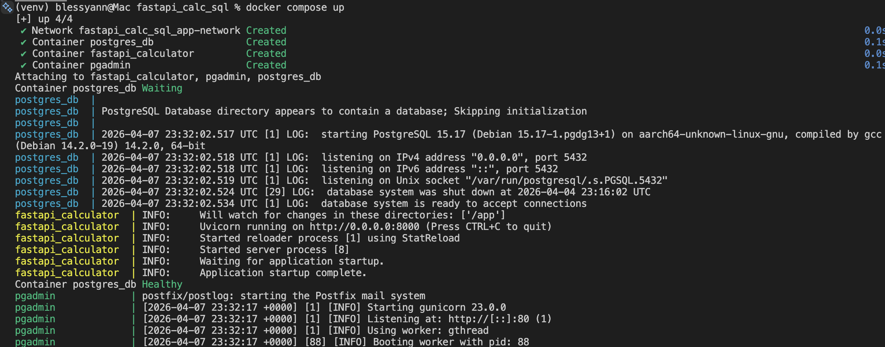
- docker ps
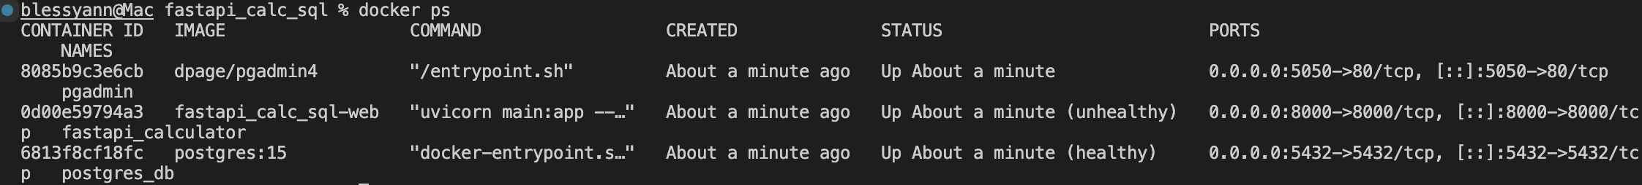

pgAdmin SQL queries:

Table creation:
- Table ‘users’ created and ‘id’ is set as primary key.
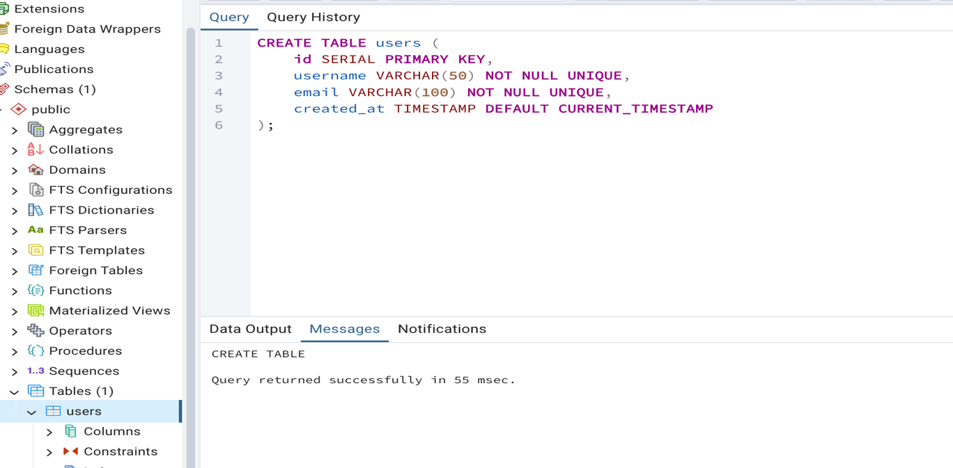

- Table ‘calculations’ created; ‘id’ is set as primary key and ‘user_id’ as foreign key referencing users(id).
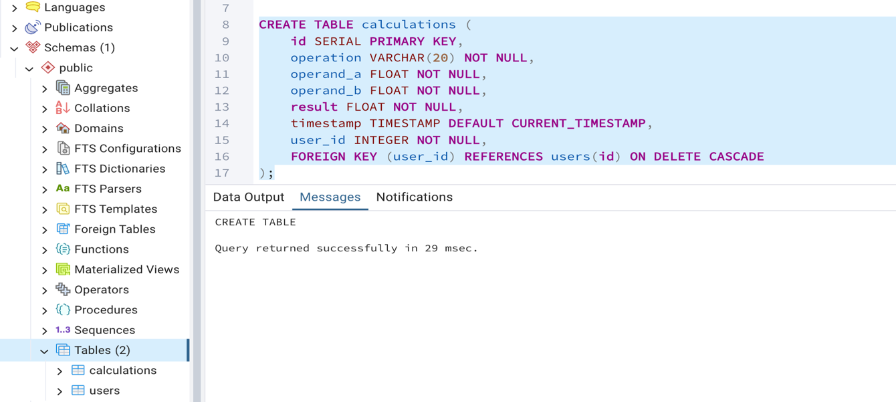

Insert Records:
- Into the ‘users’ table 2 rows are inserted with username and email.
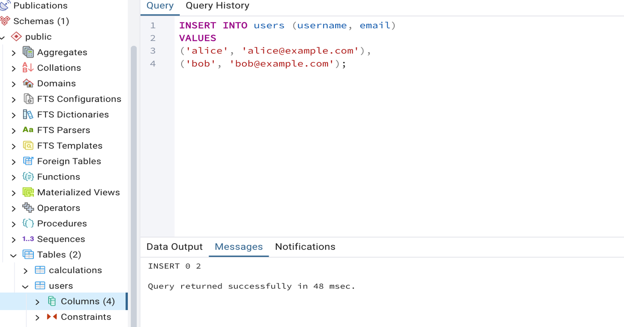

- Into ‘calculations’ table 3 rows with operation, 2 operands (a and b), result and corresponding user_id are inserted.
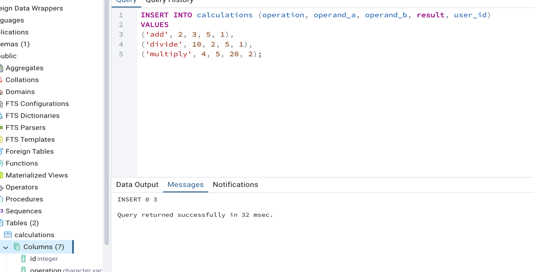

Query Data:
- Retrieve all ‘users’ table rows using the selected query
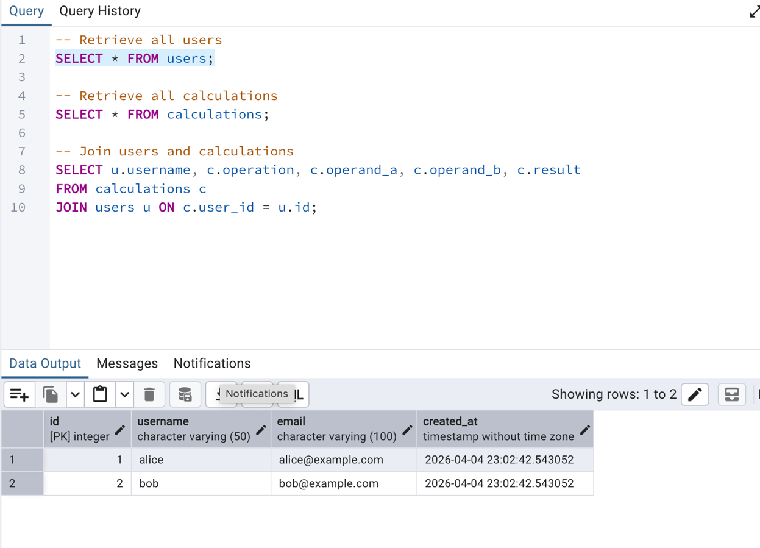

- Retrieve all ‘calculations’ table rows using the selected query
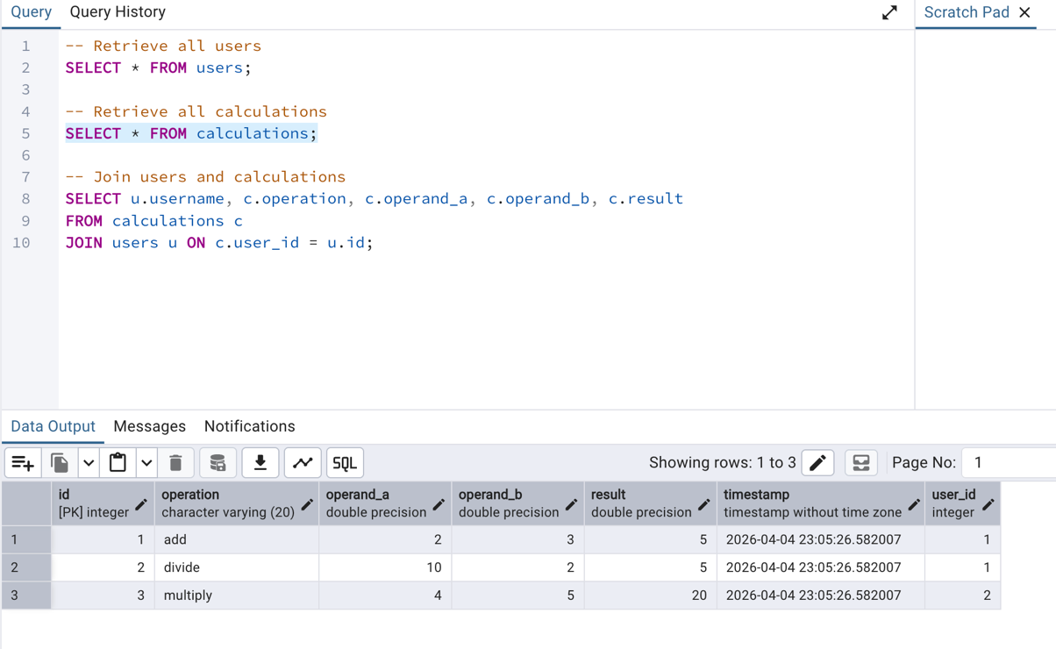
- JOIN combines data from both tables, showing which user performed each calculation 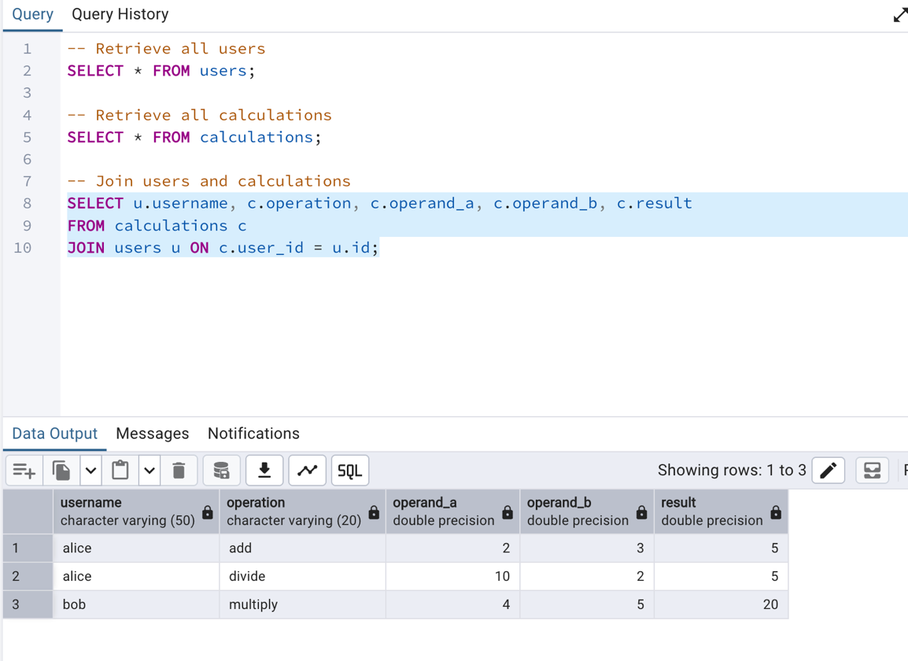

Update Record:
- Updated a calculation result, demonstrating modification of existing data.
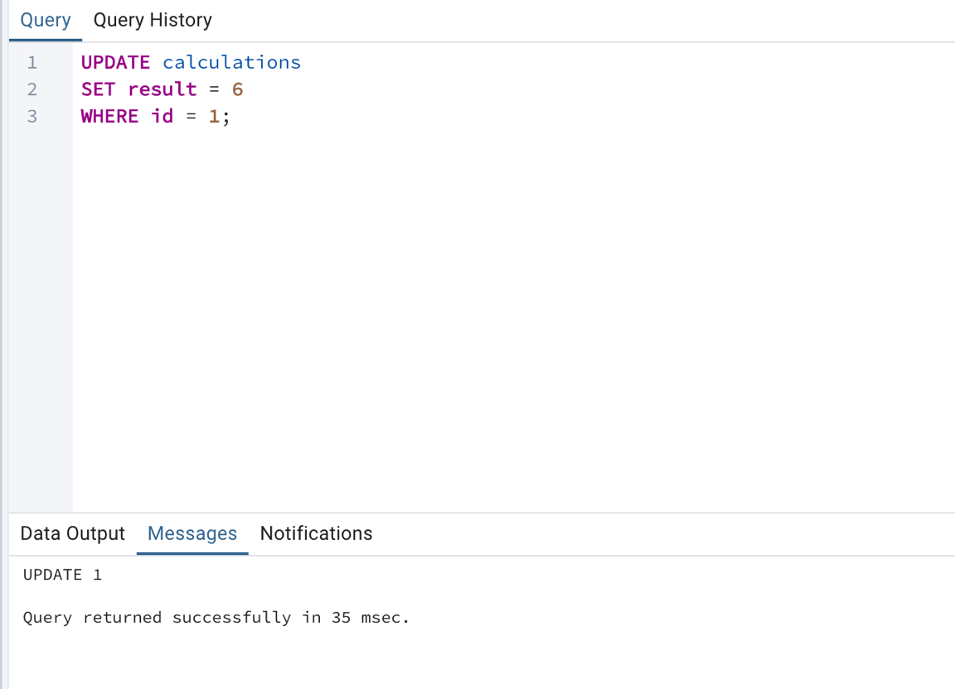

Delete Record:
- Deleted a record from the calculations table.
