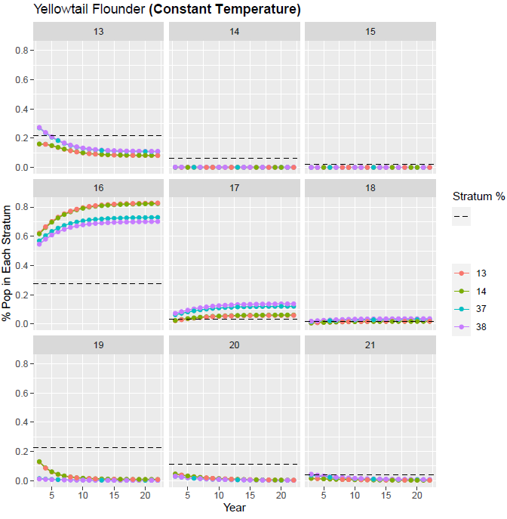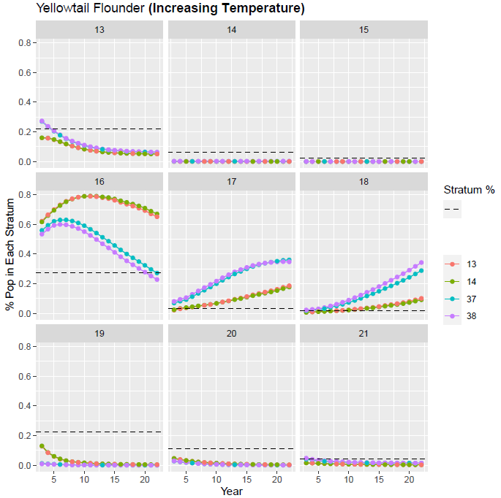

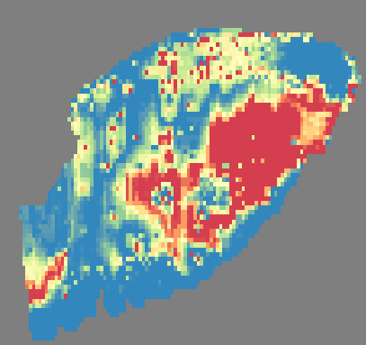

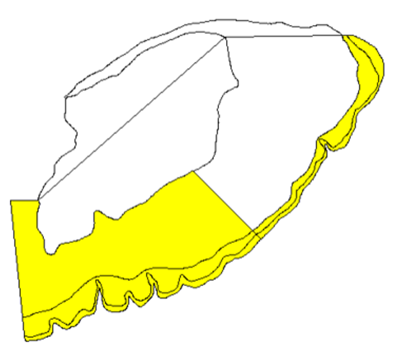

16

17 & 18

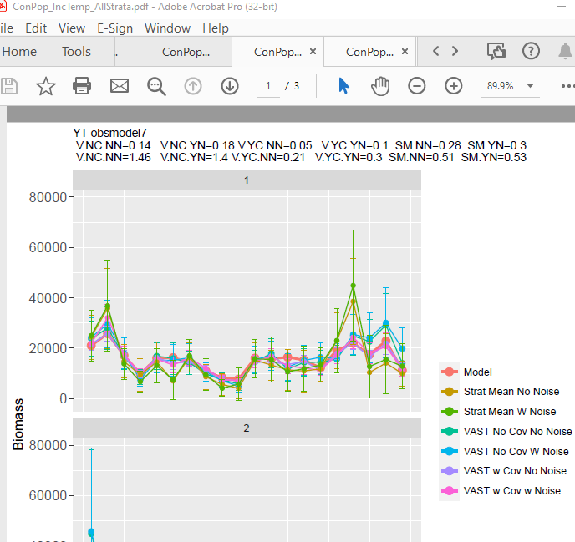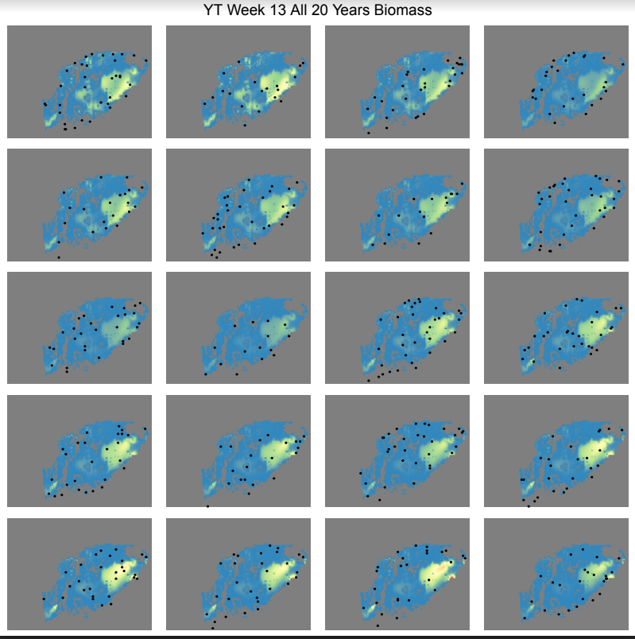

In ConPop_IncTemp Yellowtail scenario last few years, population is shifting from 16 into 17&18 (see last page). Ie out of large eastern stratum into skinny outer strata.

In the above spring estimates, all estimation methods do a nice job for most of the time series. VAST both good and SM pretty good with some big ratios.

In last 4 years, 4 years out there are 3 samples in the high population area in 17/18 )(red circle), which leads to a high SM estimate. VAST picks up the spatiotemporal shifting and adjust there without covarites, and even better with covariates. However, failing to sample the population in the last 3 years leads to low SM estimate and high VAST without covarites. With covarites corrects for this.

Excluding strata for Haddock in ConstantTemp AND IncTemp improved things without covarites, but NOT with covariates

The estimates without covariates are all well above the true value and then removing strata makes them lower than the true estimate, but also better overall in the process.

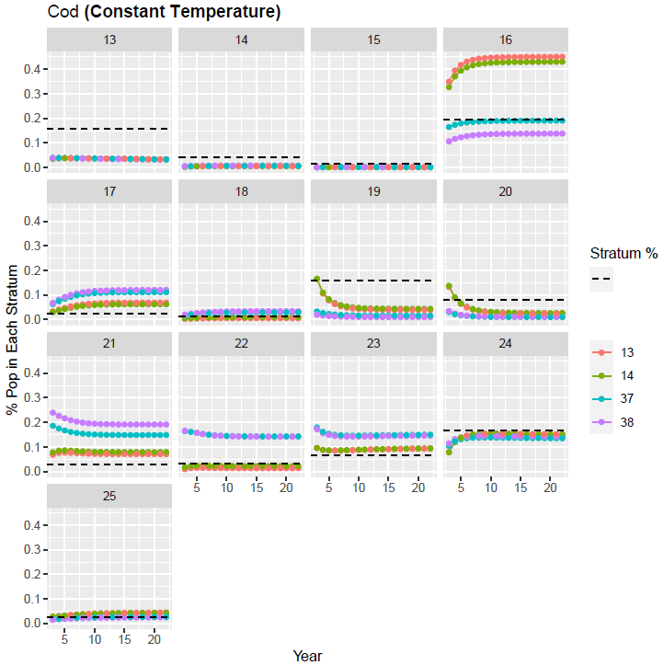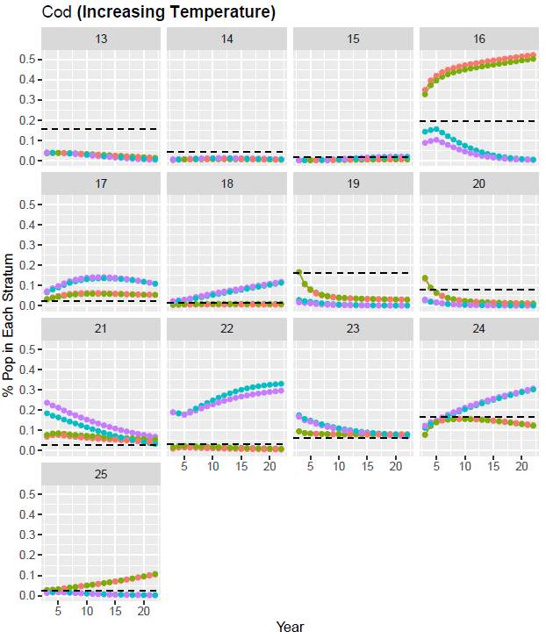

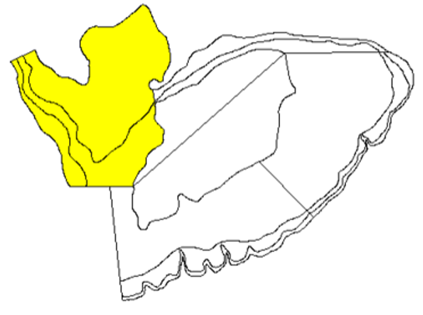

21

16

22

23

24

18

Similar dynamics in spring in both temperature scenarios (leaving 19/20 going into 16/17). In fall, leaving 16 & 21 and going to 22, 24,

Cod removing strata generally bad, but including covariates can help

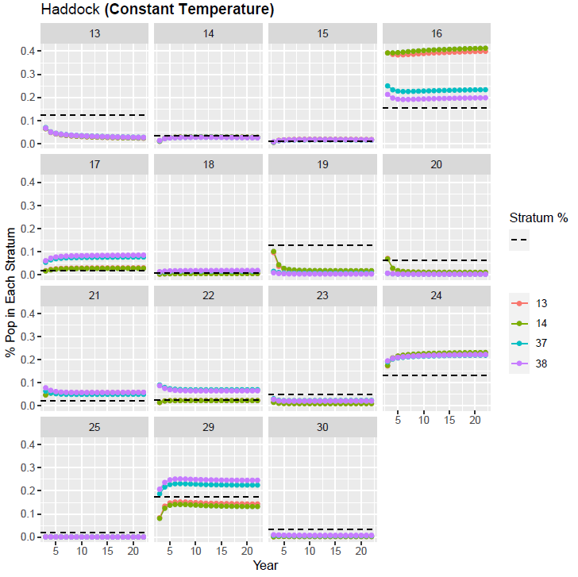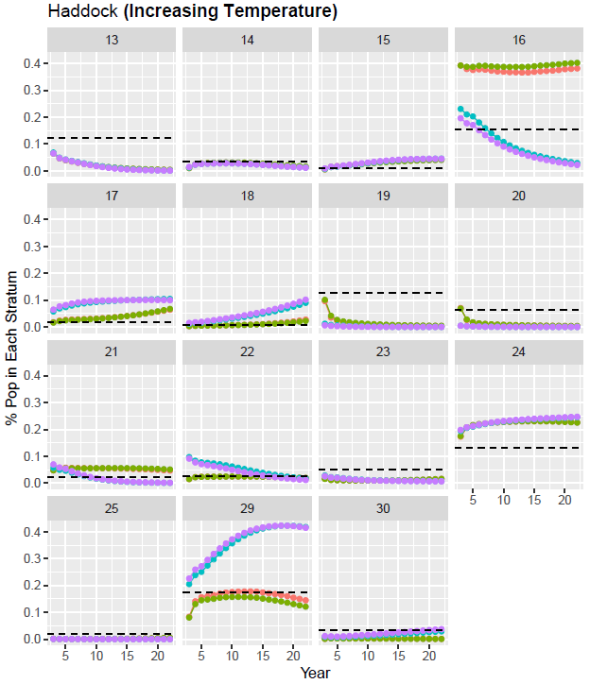

16

29

18

