Choose a title

Your Name

June 19, 2015

## Setup

To run this document you will need to install the following packages:

* [rmarkdown](http://cran.r-project.org/web/packages/rmarkdown/index.html) which allows you to write [R Markdown](http://rmarkdown.rstudio.com/) documents and transform them into HTML documents, HTML presentations or Word Document files. You can also create PDF files with it but need other dependencies.
* grid which is used for making some of the fancy plots below. Comes with your R installation.
* [plyr](http://cran.r-project.org/web/packages/plyr/index.html) which is used for the code of one of the plots.

## Run manually if you need to install these packages  
install.packages(c("plyr", "rmarkdown"))

TODO

* Install the necessary packages.
* Delete this section.

## Cafe wall illusion

All the lines are actually parallel.

library("grid")  
rs <- expand.grid(x = seq(0, 1, 1/10), y = seq(0, 1, 1/10))  
grid.rect(rs$x, rs$y, 1/10/2, 1/10/2, gp = gpar(fill = "black", col = NA))  
grid.rect(rs$x + 1/10/4, rs$y + 1/10/2, 1/10/2, 1/10/2, gp = gpar(fill = "black",   
 col = NA))  
ls <- expand.grid(x = 0:1, y = seq(0, 1, 1/20) - 1/20/2)  
grid.polyline(ls$x, ls$y, id = gl(nrow(ls)/2, 2), gp = gpar(col = "grey50",   
 lwd = 1))

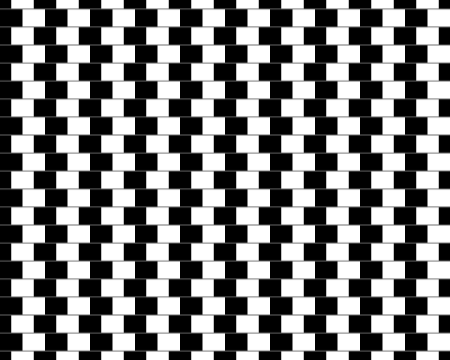

TODO

* Describe what you observe (1 sentence ideally, 2 maximum).
* Hide the code from the output.
* In your description include a link to the Wikipedia page of this illusion using Markdown syntax.

## Un-named

nx <- 6; ny <- 6; lwd <- 10; cr <- 1/100  
grid.newpage()  
grid.rect(0.5, 0.5, 1, 1, gp = gpar(fill = "black"))  
ls <- expand.grid(x = 0:1, y = seq(0, 1, 1/nx/2) - 1/nx/2/2)  
grid.polyline(ls$x, ls$y, id = gl(nrow(ls)/2, 2), gp = gpar(col = "grey", lwd = lwd))  
ls <- expand.grid(y = 0:1, x = seq(0, 1, 1/ny/2) - 1/ny/2/2)  
grid.polyline(ls$x, ls$y, id = gl(nrow(ls)/2, 2), gp = gpar(col = "grey", lwd = lwd))  
ls <- expand.grid(x = seq(0, 1, 1/nx/2) - 1/nx/2/2, y = seq(0, 1, 1/ny/2) - 1/ny/2/2)  
grid.circle(ls$x, ls$y, r= cr, gp = gpar(col = NA, fill = "white"))

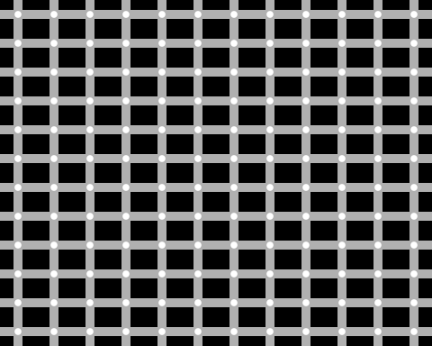

TODO

* Describe what you observe (1 sentence ideally, 2 maximum).
* Hide the code from the output.
* Choose a new name for the illusion and update the section title as well as the chunk description (remember to keep the quotes!).

## Ouchi

Move your frame of reference to see the effect.

grid.newpage()  
nx <- 10  
ny <- 30  
rs <- expand.grid(x = seq(0, 1, 1/nx/2), y = seq(0, 1, 1/ny/2))  
grid.rect(rs$x, rs$y, 1/nx/2, 1/ny/2, gp = gpar(col = NA, fill = c("black",   
 "white")))  
rs <- expand.grid(x = seq(0.25, 0.75, 1/nx/2), y = seq(0.25, 0.75, 1/ny/2))  
grid.rect(rs$y, rs$x, 1/ny/2, 1/nx/2, gp = gpar(col = NA, fill = c("black",   
 "white")))

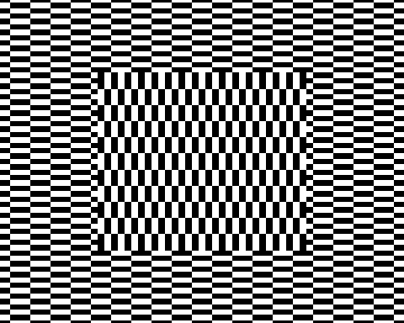

TODO

* Describe what you observe (1 sentence ideally, 2 maximum).
* Hide the code from the output.

## Fraser illusion

All the lines are actually parallel.

library("plyr")  
grid.newpage()  
n <- 10  
ny <- 8  
L <- 0.01  
c <- seq(0, 1, length = n)  
d <- 1.2 * diff(c)[1]/2  
col <- c("black", "white")  
x <- c(c - d, c, c + d, c)  
y <- rep(c(0, -d, 0, d), each = n)  
w <- c(c - d, c - d + L, c + d, c + d - L)  
z <- c(0, L, 0, -L)  
ys <- seq(0, 1, length = ny)  
grid.rect(gp = gpar(fill = gray(0.5), col = NA))  
l_ply(1:ny, function(i) {  
 n  
 if (i%%2 == 0) {  
 co <- rev(col)  
 z <- -z  
 } else {  
 co <- col  
 }  
 grid.polygon(x, y + ys[i], id = rep(1:n, 4), gp = gpar(fill = co, col = NA))  
 grid.polygon(w, rep(z, each = n) + ys[i], id = rep(1:n, 4), gp = gpar(fill = rev(co),   
 col = NA))  
})

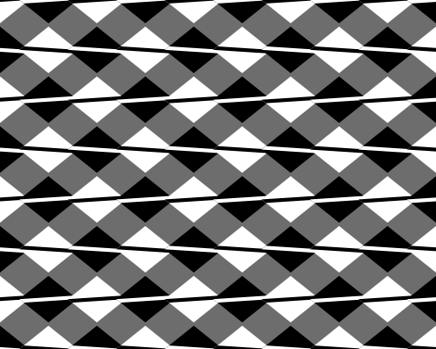

TODO

* Describe what you observe (1 sentence ideally, 2 maximum).
* Hide the code from the output.

## Fraser-Wilcox illusion

grid.newpage()  
No <- 3  
wo <- 1/3/2  
po <- seq(0, 1, by = wo)[(1:No) * 2]  
Nc <- 8  
tc <- seq(pi * 11/12, pi * 1/12, len = Nc)  
px <- c(outer(wo * cos(tc), po, `+`))  
wc <- rep(sin(tc), No)  
ag <- rep(1:No, each = Nc)  
dc <- 21  
th <- seq(0, 2 * pi, len = dc)  
grid.rect(gp = gpar(col = NA, fill = "#D2D200"))  
for (y0 in seq(0, 1, len = 10)) {  
 for (i in seq_along(px)) {  
 th <- seq(pi/2, pi/2 + 2 * pi, len = 21)  
 if (ag[i]%%2 == 0)   
 th <- rev(th)  
 x <- px[i] + 0.5 * 0.04 * cos(th) * wc[i]  
 y <- y0 + 0.04 * sin(th)  
 grid.polygon(x, y, gp = gpar(fill = "#3278FE"))  
 grid.polyline(x[1:((dc + 1)/2)], y[1:((dc + 1)/2)], gp = gpar(lineend = "butt",   
 lwd = 3, col = gray(0)))  
 grid.polyline(x[-(1:((dc - 1)/2))], y[-(1:((dc - 1)/2))], gp = gpar(lineend = "butt",   
 lwd = 3, col = gray(1)))  
 }  
}

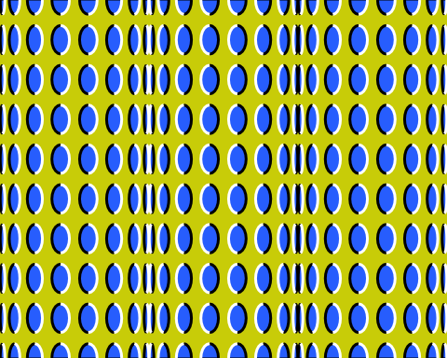

TODO

* Describe what you observe (1 sentence ideally, 2 maximum).
* Hide the code from the output.

## Parallel curves

These curves are the same offset apart for every x, even though it looks like they converge.

x = 1:100  
y = 1/log10(x)  
y2 = y + 0.2  
plot(x, y, type = "l", ylim = c(0, 1.5))  
lines(x, y2)

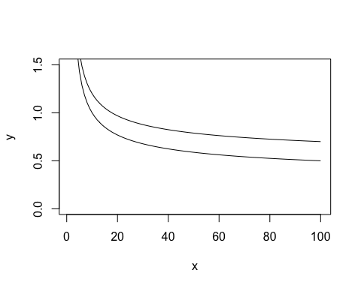

TODO

* Describe what you observe (1 sentence ideally, 2 maximum).
* Hide the code from the output.

## 蛇の回転錯視

Google translate: rotation illusion of snake

nt <- 41; nr <- 15; br <- 0.8  
col1 <- c("black", "white")  
col2 <- c("aquamarine4", "gold2")  
  
f <- function(x0, y0) {  
 r <- embed(br^(0:nr), 2)  
 t <- embed(seq(0, 2*pi, length=nt), 2)  
 i <- as.matrix(expand.grid(1:nrow(r), 1:nrow(t)))  
 ci <- 1 + (i[,2]%%2 + i[,1]%%2) %% 2  
  
 p <- t(apply(i, 1, function(x) c(r[x[1], ], t[x[2], ])))  
 x <- c(p[,1]*cos(p[,3]), p[,1]*cos(p[,4]), p[,2]*cos(p[,4]), p[,2]*cos(p[,3]))  
 y <- c(p[,1]*sin(p[,3]), p[,1]*sin(p[,4]), p[,2]*sin(p[,4]), p[,2]*sin(p[,3]))  
 grid.polygon(x0+x/2, y0+y/2, id = rep.int(1:nrow(p), 4),  
 gp = gpar(fill = col1[ci], col=NA), default.units="native")  
  
 p <- expand.grid(1:nrow(r), sign((abs(x0-y0)==1)-0.5)*seq(0, 2*pi, length=41)[-1])  
 p <- cbind(p[,2], rowMeans(r)[p[,1]], (r[,2]-r[,1])[p[,1]]/2)  
 t <- seq(0, 2*pi, length=20)[-1]  
 x <- c(apply(p, 1, function(a) a[2]*cos(a[1])+a[3]*(cos(a[1])*cos(t)-0.5*sin(a[1])*sin(t))))  
 y <- c(apply(p, 1, function(a) a[2]*sin(a[1])+a[3]*(sin(a[1])*cos(t)+0.5*cos(a[1])*sin(t))))  
 col <- if(abs(x0-y0)==1) {col2} else {rev(col2)}  
 grid.polygon(x0+x/2, y0+y/2, id = rep(1:nrow(p), each=length(t)),  
 gp = gpar(fill = col[ci], col=NA), default.units="native")  
  
}  
  
grid.newpage()  
pushViewport(viewport(xscale = c(0, 3), yscale = c(0, 3)))  
for (x0 in 0.5+0:2) for (y0 in 0.5+0:2) f(x0, y0)  
for (x0 in 1:2) for (y0 in 1:2) f(x0, y0)

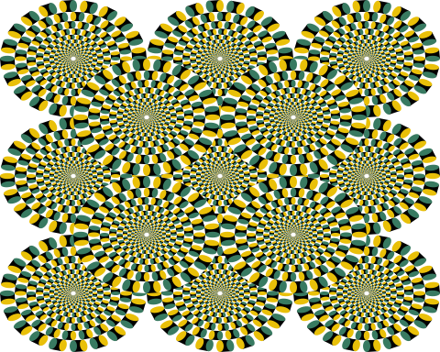

TODO

* Describe what you observe (1 sentence ideally, 2 maximum).
* Hide the code from the output.
* Translate the Japanese section title into English.

## References

Based on the [illusions knitrBootstrap vignette](http://cran.r-project.org/web/packages/knitrBootstrap/vignettes/illusions.html) which itself is based on ´[Kohske Takahashi](https://twitter.com/kohske) code at <http://rpubs.com/kohske/R-de-illusion>.

## Reproducibility

TODO

* Add an R code chunk showing the reproducibility information. Use the session_info() function from the devtools package.
* Hide the code from the output.
* Use an R inline code to show the date the report was generated. Use the Sys.time() function to get the date. Remember that R inline code is useful if you want to automatically include numbers or other results in your document.