Common illusions

Leonardo Collado-Torres

June 19, 2015

## Cafe wall illusion

All the lines are actually parallel.



This plot shows the cafe wall illusion (see [Wikipedia](https://en.wikipedia.org/wiki/Caf%C3%A9_wall_illusion)) where my brain struggles to see all the lines as parallel.

## Simple illusion

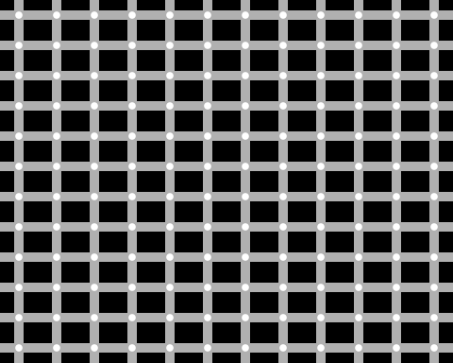

This looks like a simple illusion. If I look at the center of it, I don't perceive all the squares to be equal as some look rectangular.

## Ouchi

Move your frame of reference to see the effect.



It looks like piano keys to me that change colors fast when I scroll up and down quickly.

## Fraser illusion

All the lines are actually parallel.



I'm slighly confused by this illusion because I'm not sure which lines are the ones I should be looking at. But if I scroll up and down quickly, I start seeing sine curves.

## Fraser-Wilcox illusion

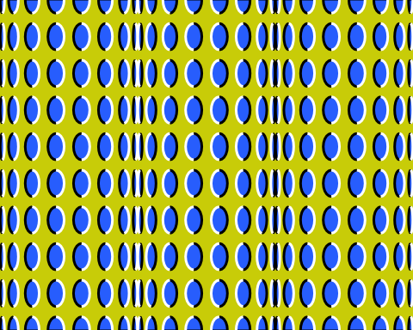

This illusion is pretty cool as I can see the cylinders moving, although they are not.

## Parallel curves

These curves are the same offset apart for every x, even though it looks like they converge.

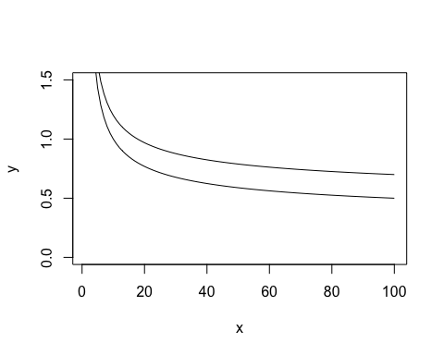

This illusion seems to be based more on the scale. Lets look at it again with a different y-axis boundary.

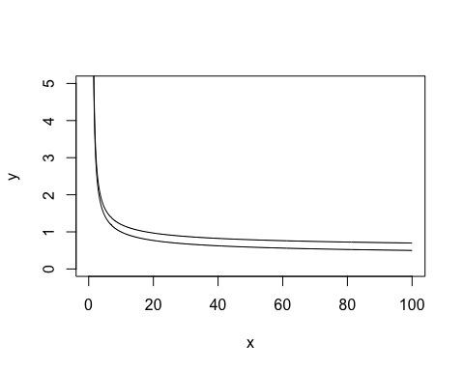

Ok, it does look like they converge.

## Rotating snake

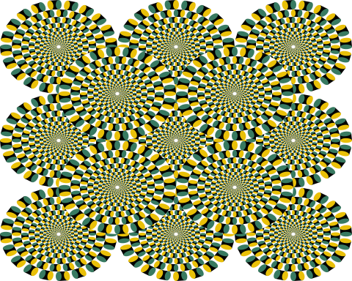

I liked this illusion quite a bit although I don't see the relation to snakes. I feel like I'm seeing at a bunch of clocks turning.

## References

Based on the [illusions knitrBootstrap vignette](http://cran.r-project.org/web/packages/knitrBootstrap/vignettes/illusions.html) which itself is based on [Kohske Takahashi](https://twitter.com/kohske)'s code at <http://rpubs.com/kohske/R-de-illusion>.

## Reproducibility

## Session info --------------------------------------------------------------

## setting value   
## version R version 3.2.0 Patched (2015-05-18 r68382)  
## system x86_64, darwin10.8.0   
## ui X11   
## language (EN)   
## collate en_US.UTF-8   
## tz America/New_York

## Packages ------------------------------------------------------------------

## package * version date source   
## curl 0.8 2015-06-06 CRAN (R 3.2.0)  
## devtools * 1.8.0 2015-05-09 CRAN (R 3.2.0)  
## digest 0.6.8 2014-12-31 CRAN (R 3.2.0)  
## evaluate 0.7 2015-04-21 CRAN (R 3.2.0)  
## formatR 1.2 2015-04-21 CRAN (R 3.2.0)  
## git2r 0.10.1 2015-05-07 CRAN (R 3.2.0)  
## htmltools 0.2.6 2014-09-08 CRAN (R 3.2.0)  
## knitr 1.10.5 2015-05-06 CRAN (R 3.2.0)  
## magrittr 1.5 2014-11-22 CRAN (R 3.2.0)  
## memoise 0.2.1 2014-04-22 CRAN (R 3.2.0)  
## plyr * 1.8.3 2015-06-12 CRAN (R 3.2.0)  
## Rcpp 0.11.6 2015-05-01 CRAN (R 3.2.0)  
## rmarkdown * 0.7 2015-06-13 CRAN (R 3.2.0)  
## rversions 1.0.1 2015-06-06 CRAN (R 3.2.0)  
## stringi 0.4-1 2014-12-14 CRAN (R 3.2.0)  
## stringr 1.0.0 2015-04-30 CRAN (R 3.2.0)  
## xml2 0.1.1 2015-06-02 CRAN (R 3.2.0)  
## yaml 2.1.13 2014-06-12 CRAN (R 3.2.0)

Date this report was generated: 2015-06-18 13:36:19.