Workout Planner

High-Level Design

User Interface

Upon starting the application, users will be presented with a simple one-click user selection screen. 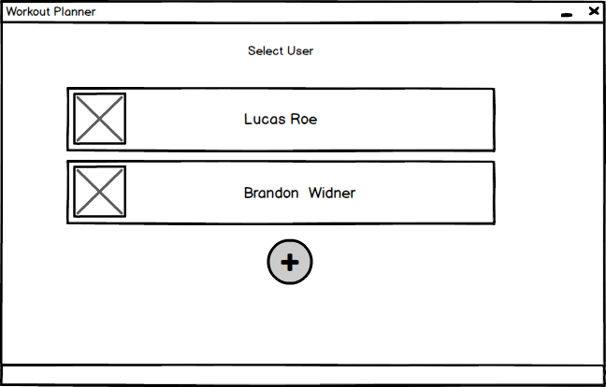

If the user has never used the application before, they can click the “plus” button which will open a screen where the user can enter their information.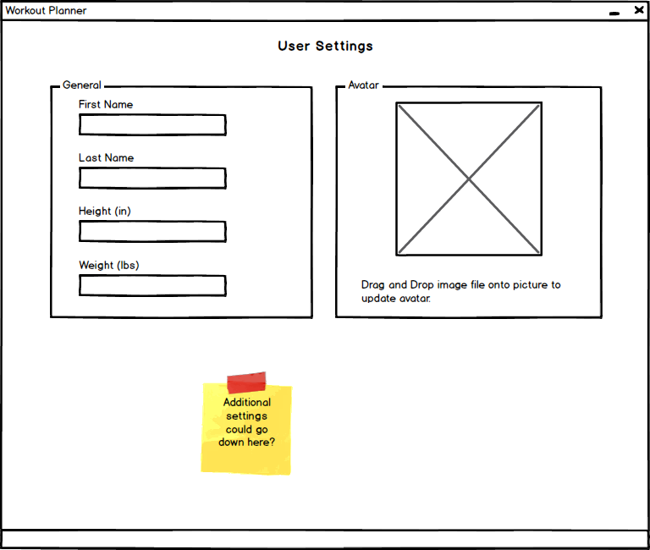

Once the user either creates an account or logs into an existing one, they will be shown the dashboard, which shows a graph of the user’s weight over time, a preview of upcoming workouts, and navigation controls.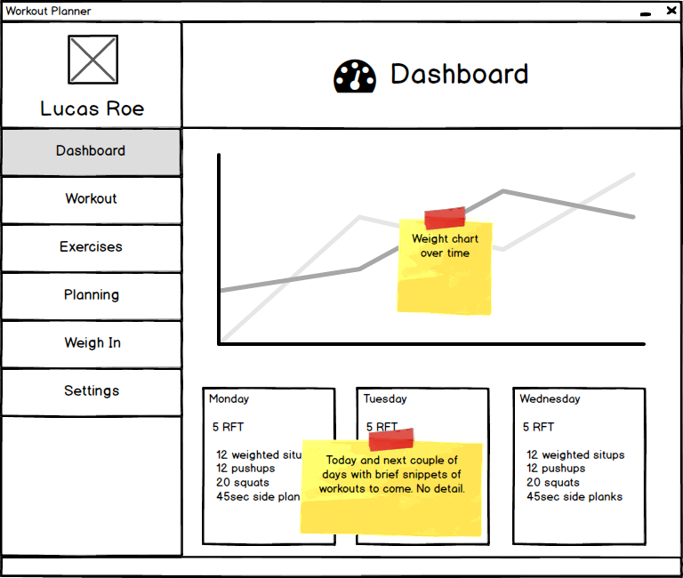

When the user navigates to the workout screen, they will see a variable number of sections telling them which exercises to do for their workout. Once the user is done, they enter how much time it took them and end the workout.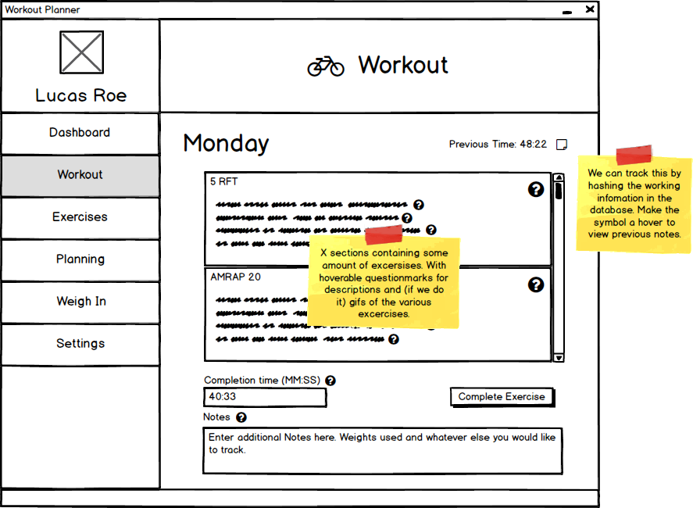

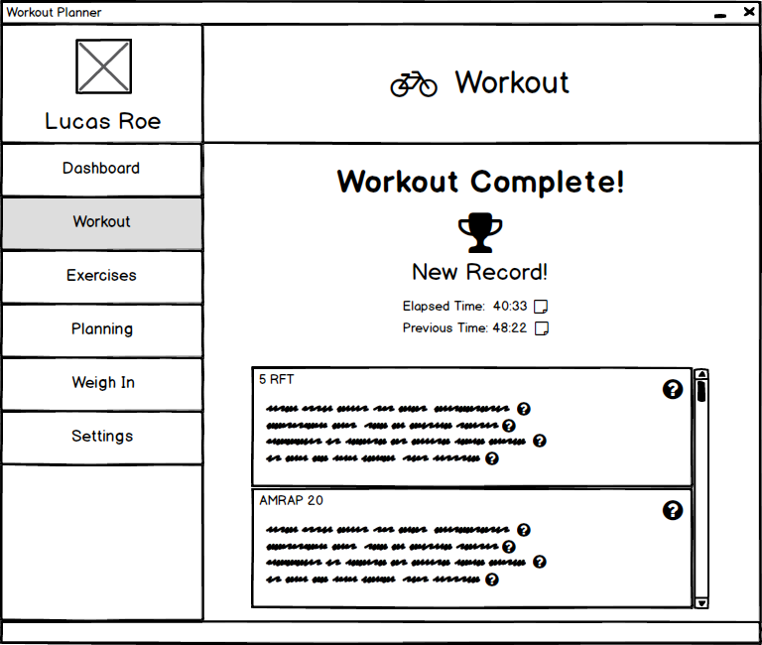

When the user navigates to the exercises screen, they will be able to view exercise information and indicate whether they want specific exercises to be available for assignment.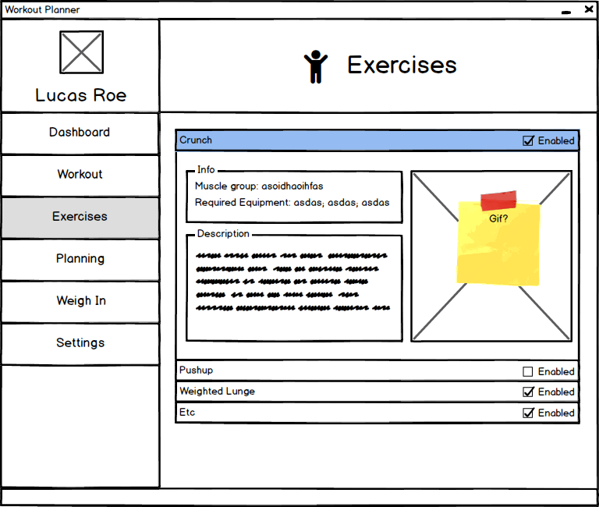

When the user navigates to the planning screen, they will see tabs for the days of the week and will be able to add/remove exercise groups and add/remove specific exercises to said group.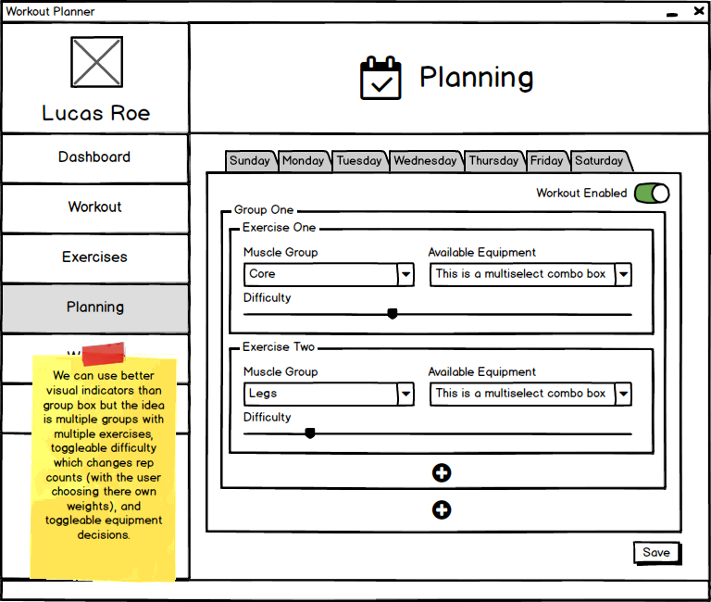

When users navigate to the weigh in screen, they will be able to enter their weight on that day.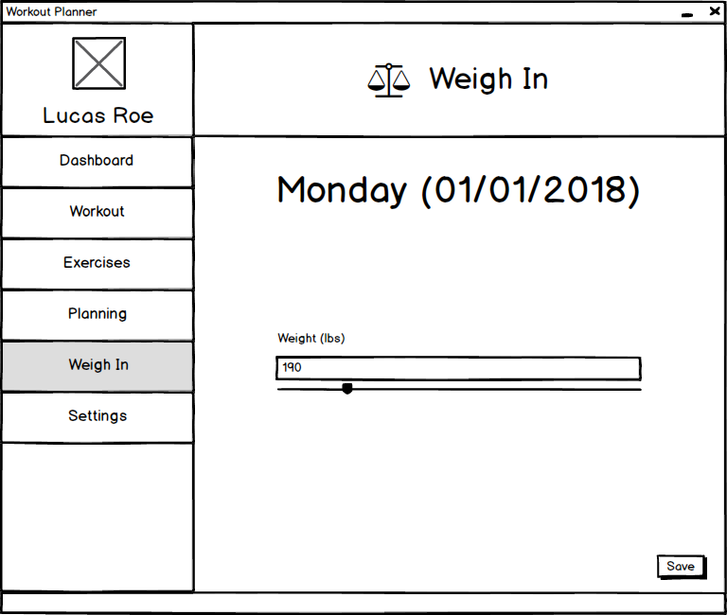

When users navigate to the settings screen, they will be able to adjust most of the settings they entered when first creating their account.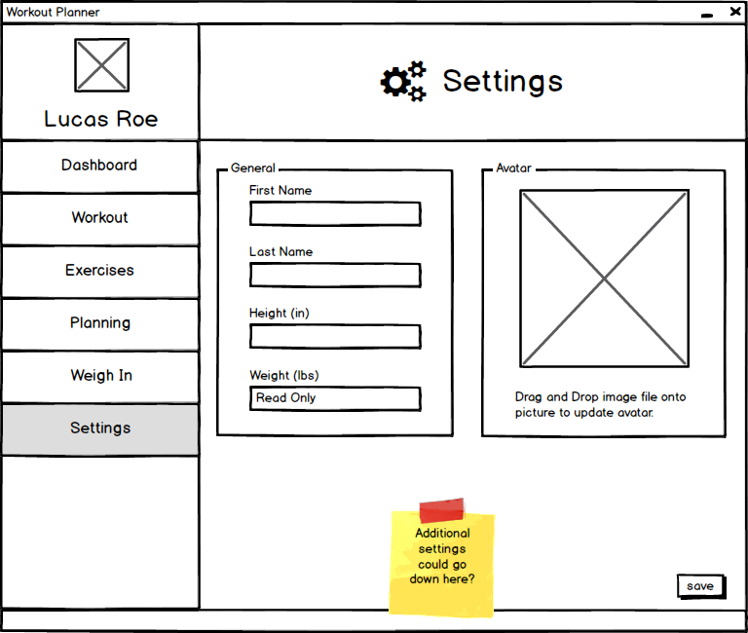

Data Model Design

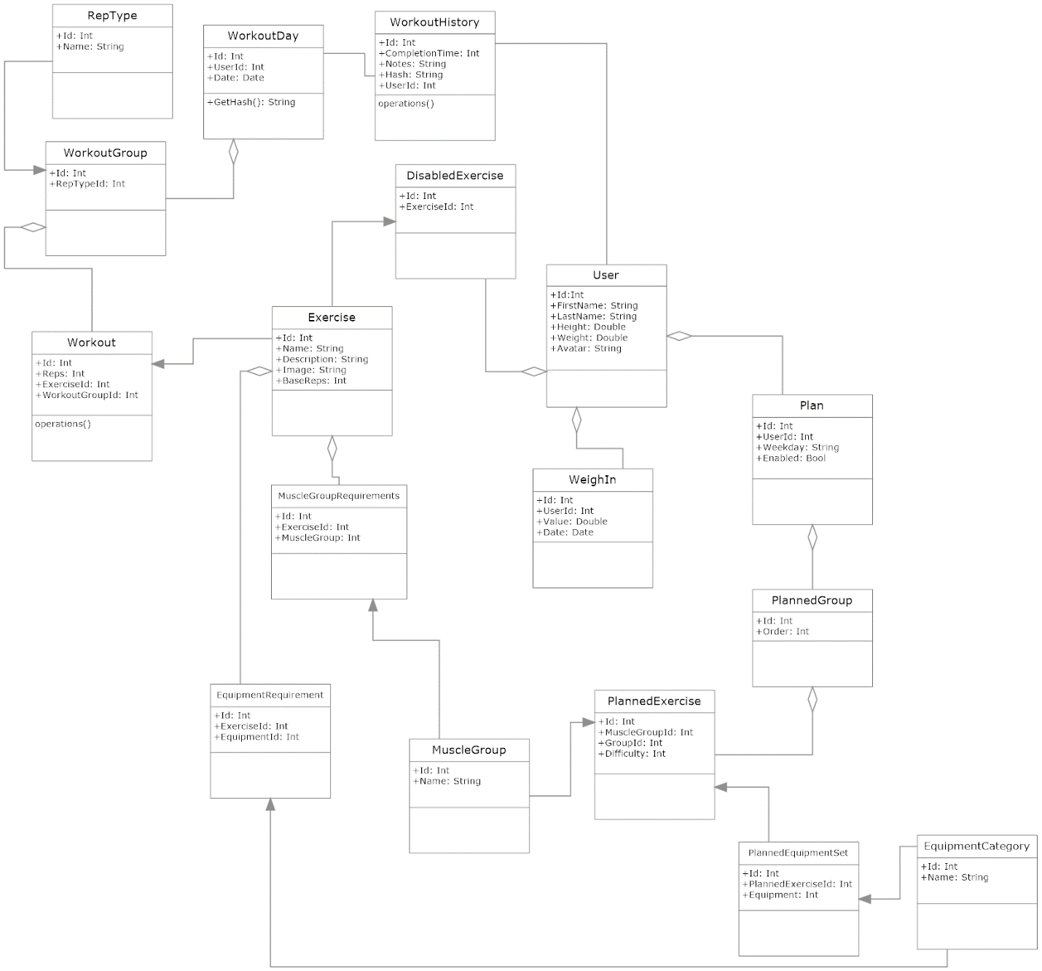

Database Interface Design

Because we will be utilizing SQLite and Linq-to-Sql, we will not be needing to do much/any database interface design.