Workout Planner Group

Requirements Gathering Document

* High-Priority Requirements – “Must/Should”
  + Functional - “Will Have”
    - Track Weight (“mass” in BMI formula).
    - Track BMI.
      * US: $BMI=703 \left(\frac{mass (lbs)}{{height}^{2} (in)}\right)$
      * Metric: $BMI=703 \left(\frac{mass (kg)}{{height}^{2} (m)}\right)$
    - Form Workout Routines
      * Users can allow the program do develop one for them or manually enter their own.
      * Type:
        + Cardio.
        + Meditation.
        + Weights.
        + Freestyle.
        + Etc.
      * Duration of workout (if applicable)
    - Allow user to determine days worked.
    - Allow user to select equipment that they have access to
      * This way, for example, a user without access to a treadmill won’t be told to run on a treadmill.
    - Allow users to assign sections of the body for a particular day.
      * Arms.
      * Legs.
      * Chest.
      * Back.
      * Etc.
  + Nonfunctional - “Will Be”
    - Thick Client Install-able Application.
    - The simplest UX experience we can create.
      * Visual in nature, using colors and images to give data rather than text where possible.
        + Royalty-free icons.
      * Touch Screen Friendly.
* Low-Priority Requirements – “Could/Won’t”
  + Functional - “Will Have”
    - Allow users to rate exercises for favorite, which will weigh the randomization of workouts.
    - Diet (For the entire day of the workout or before and after the workout).
    - Allow the user to enter a new type of workout, form, type of diet and other possible options that are not displayed in the menu.
    - Calculate the calories burn based on the type of workout and intensity.
    - Support multiple workout set types (AMRAP, RFT, 20-15-10-5, 40-30-20-10-20-30-40, etc).
    - Support multiple workout variations. Ex: Bench press(wide grip, narrow grip, rep speed…etc)
    - Support GIFs/diagrams of most workouts to aid user in correct posture and form.
      * Example of “diagram”:

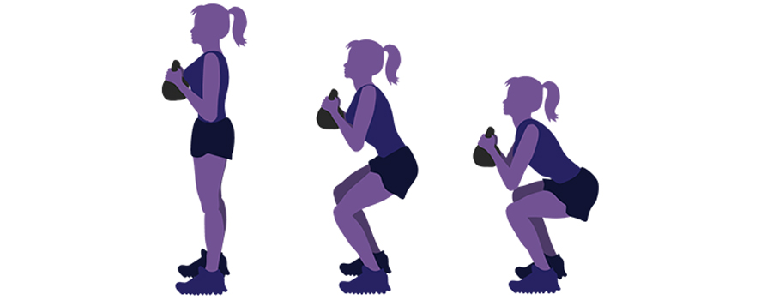

* + - Support an instructions tab to give a short explanation on how to properly perform the workout.
      * Example:
        + Preparation: Stand up straight with a dumbbell in your desired grip, while keeping your elbows close to your sides.
        + Execution: Keep your upper arms still, exhale, and curl the weights upwards, while contracting you biceps. Lower the weights to starting position and repeat.
    - Remind the user when a scheduled workout day & time has come.
      * Example:
        + If program is still running but minimized/behind other windows, play a tone.
  + Nonfunctional - “Will Be”
    - Display the type of diet icon (vegetarian, omnivore, gluten free).
    - Icon for the type of workout.
    - Create new health goals.
    - Positive affirmations (goals) for next week’s goal. (Reminds the user of a new workout, routine, or short-term goal while they display the workout calendar by week.)
    - Visual customizable emoji of user.