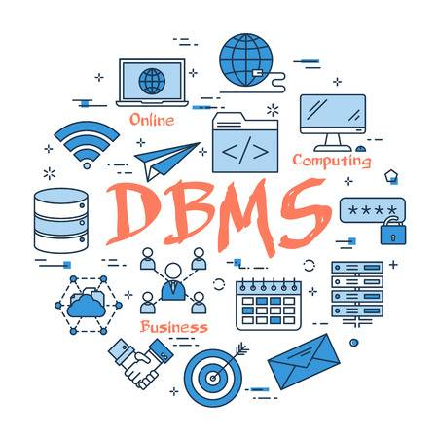

DATABASE   
MANAGEMENT SYSTEM

Project 1

Denado Rabeli | DBMS | 17/05/2020

# What needs to be done :

# CEN 202 - Database Project Submission

# 

1. Problem Description

1.a Introduction of the problem (Problem Analysis)

1.b Full description of the requirements taken into consideration

(a list of requirements, that act as a problem definition)

2. Analysis with ER Diagrams

2.a Main Entities, Relationships and Cardinalities.

2.b Full ER Diagram

3. Relational Schema Model

3.a The converted Relational Schema from ER Diagram

4. Rationale

4.a Constraints, Triggers, Functions and Procedures

4.b Authorization (User Access Definitions)

5. SQL (Only in SQL code)

5.a DDL (The applied schema with all Integrity Constraints)

5.b DML (The code that fills data in the database)

5.c Triggers, Functions and Procedures (at least 3 of each)

5.d SQL Queries (at least 10 Descriptive cross-table queries)

# Part 1

*This database is about a company that deals with sales .*

In this company we have **employees** , **employees family** , **customers** , **products** , **products category** , **invoices** , **departments** , **stock market** and **store**.

In employees we have all the employees each with a unique identification number .They also have personal info such as name , surname , gender , address , phone number and email. The employees also have a salary , department ID where they work and their position in this department (Simple , Manager ,Director) also the store ID of the place where they work.

As far as their family’s are concerned we only keep track of their name and surnames , their relatives in the company ID number , also what type of relationship they have and their gender .

In customers we store this customer’s name ,surname ,Customer ID , address , phone number , email .

In products we have an ID, Name, Category ID , price , manufacturing date and a description .

As far as product category is concerned we have a name and an ID for it.

Invoice has an invoice ID, products ID, quantity , total price , customer ID ,date , employee ID of the one who made it and also store ID from where it was printed .

Departments are 3 Sales , Finances and Management and each of them has an ID and a director .

Stock market has the quantity of stocks available and a employee ID for the employee that deals with the exchanges in this market.

Locations(Stores) has an ID and location.

# Full Description ->

This is a sales company specialized in the field of computers .

There is one headquarter that controls all the other stores part of this company.(Where all 3 directors of each department are located )The director of the management department is CEO of the company .

There are a total of 7 locations . Each location has a manager of the management department in it .

We can at most have one manager for each location.

Stock market is only controlled by employees part of the finance department.

At invoice we have only a date and the total value .

The products bought are included in another table sold ( Sold Product ) which also has the quantity sold.

This comes due to the fact that there is a M:M connection between the invoice and product.

At family of employee we can at most have 1 relative for each employee.

# Part 2

Customer – main entity , it’s relation to invoice and their cardinalities (Mandatory One – Optional Many) because a customer can get many invoices but an invoice should have at least one customer .

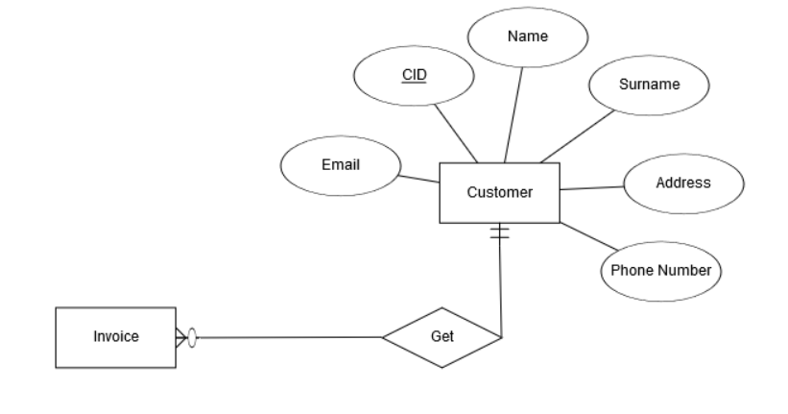

Department Only Relation is to Employee and it’s a (Mandatory 1 to Optional many) because each employee should have only one department but a department can have many employees.

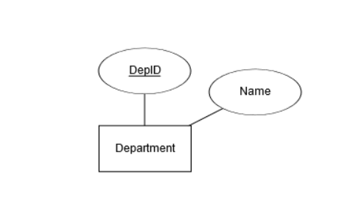

Here we have the employee entity one of the most important ones with all it’s attributes and connected as many to one with both store and department. Because employees can work in only one store and be part of only one department but each store and department can have many employees.

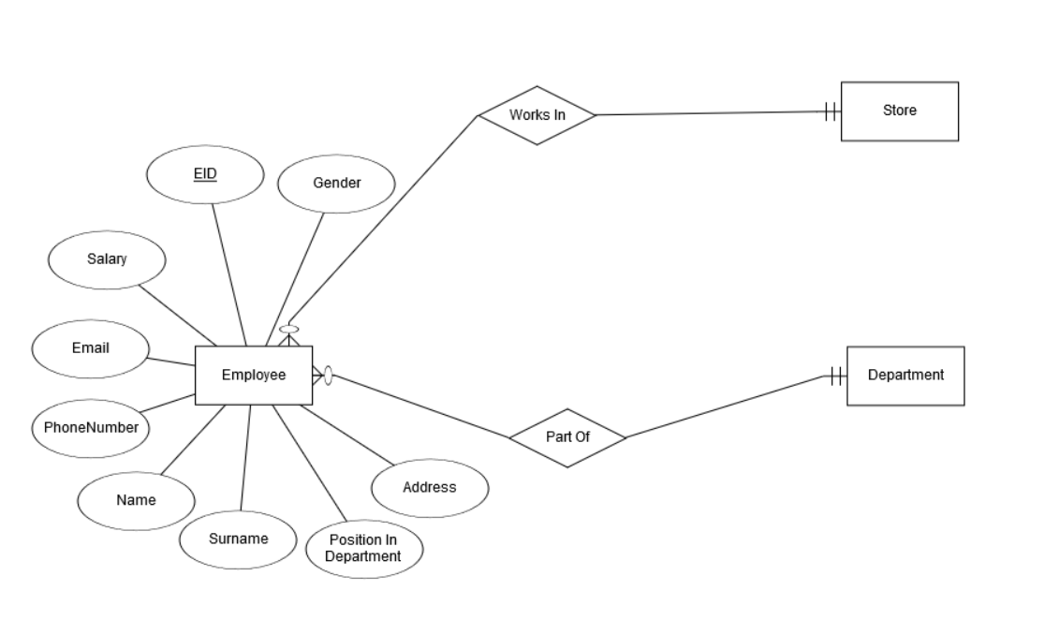

Below is the entity which represents the family members of the employees . Each employee can have at most one family member recorded in the database used to contact their family members in case the company needs information or wants to give it from/to the family members. That’s why it’s also a one to one connection but the family part is optional because some of the employees don’t want to give their information or don’t have any relatives.

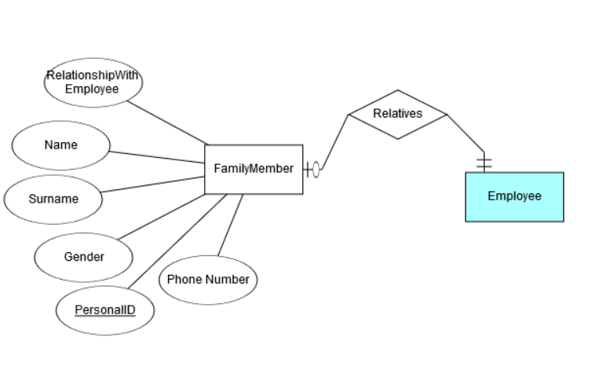

This is the invoice entity and it is connected to a single employee with a many to one so one employee can print many invoices but an invoice can be printed by only a single employee. The connection to products contained on the other hand is through sold products and part of the invoice is only the total value of all product’s bought .On the sold product on the other hand we have their quantity also the PID which refers to their product ID so that they can be identified .

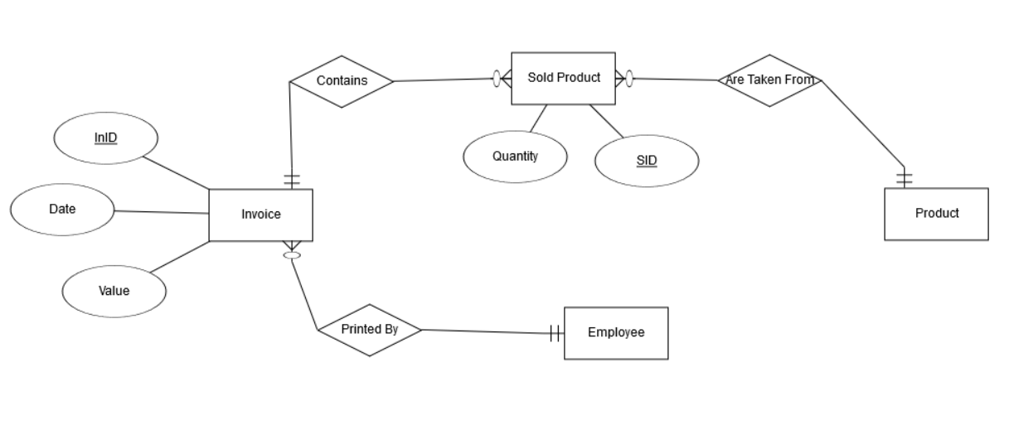

Each product has a category , but a category can have many products and that why the 1 to M relationship

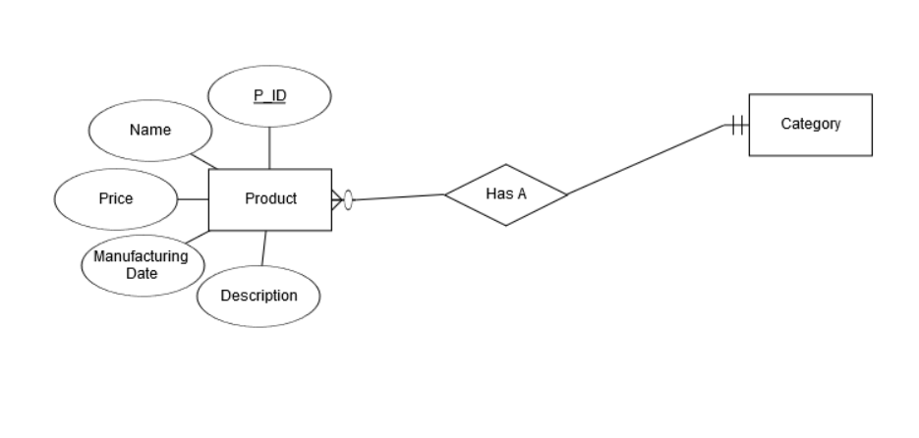

This is the category entity with it’s attributes where the ID is unique .

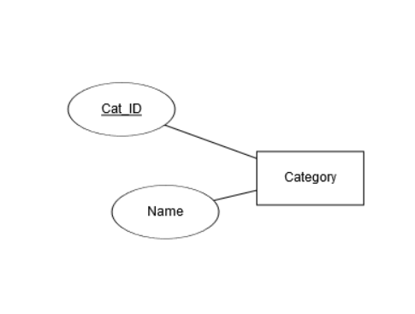

Here is the stock market entity controlled by an employee who is part of the finance department .

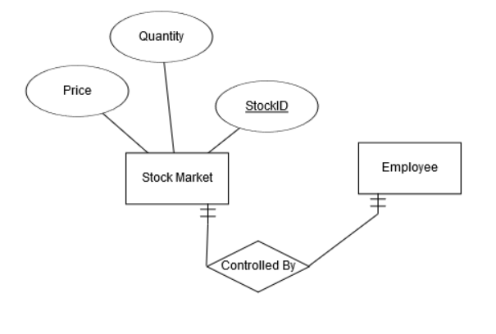

This is the store or location entity in which we have address and an ID.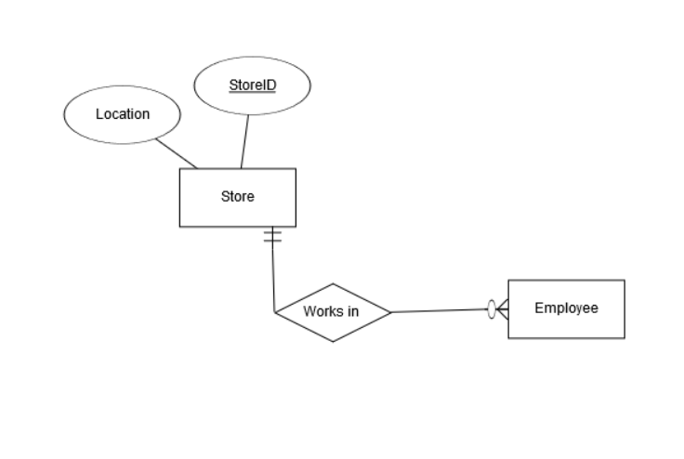

This is the outlook of the whole diagram with all of the entities, their attributes and their relationship.Followed by constraints such as 1:M and M:1 , the only M:M connection I separated using another entity called sold product .

There are also other constraints such as unique denoted on the diagram by an underline.

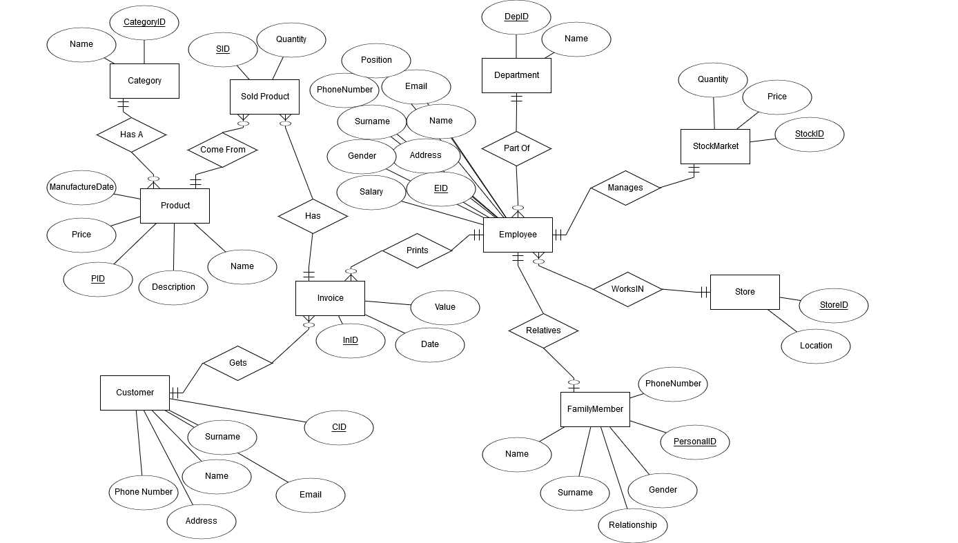

This one is the converted Relational Schema from the above Diagram with Foreign keys (FK) and primary keys(Underlined) also included .The connection 1 to M are denoted by the arrows for example the arrow points from employee to Department and that is also the connection 1 employee can have only 1 department(that is also the reason why the dep ID shows as foreign key in employee because it’s a primary key for department) , 1 department on the other hand can have many employee.

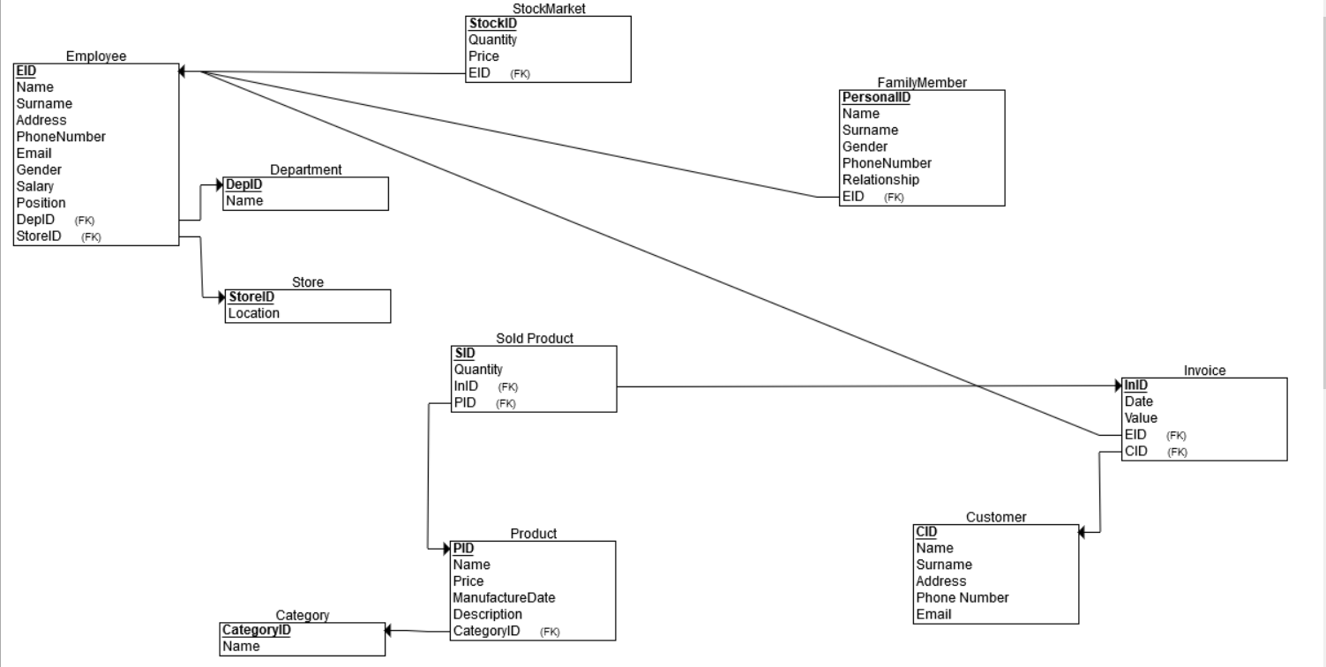

# Constraints ,Triggers, Functions and Procedures

In my database:

Each entity has it’s own primary key which is unique and can be used to find the right ID when deleting or updating.

All rows in each table cannot be null value ,also the foreign keys(also constraints) have some added constraints such as **on delete no action on update cascade** or only **on update cascade**

## Triggers ->

We will need triggers for when inserting in employee to check if the salary is smaller than 600.

Then we will need another one that doesn’t allow users to delete any invoice data.

The next trigger will then be about printing invoices , the employee ID belonging to it should be of an employee that is from the ‘Sales’ department and whose position is ‘Simple’.

Another trigger will be about the employee which controls the transactions in the stock market , his ID should be that of an employee of the ‘Finances’ department

Also the finance employees cannot be of ‘Manager’ position .

The next trigger will be to not allow the insertion of any other directors .

The last one will not allow their deletion

## Functions ->

One function will be about counting the number of male and female employees and giving an output showing if there are more females or males.

Another one will be used to find the phone number of family member of an employee in case information is needed about the employee or the family needs to be contacted .

The other function will print out the number of invoices printed by an employee when a tournament is held about the employee with most sales .

## Procedures ->

First procedure will be to inform the company about the store location of an employee given his name .

Another one will be to find all employees of a certain department .

The third procedure will be used to get all products sold in a certain invoice (quantity included)

The 4th will be about the discounts available for good customers that have bought products more than once.

The last procedure will be used to directly calculate the invoice value of a certain invoice from the products sold (I tried to use this procedure to automatically insert the values inside an invoice but couldn’t do it.)

# Authorization

Definition**:** Authorization is a security mechanism to determine access levels or user/client privileges related to system resources including files, services, computer programs, data and application features. This is the process of granting or denying access to a network resource which allows the user access to various resources based on the user's identity.

Description**:** Most security systems are based on a two-step process. The first step is authentication, which ensures about the user identity and the second stage is authorization, which allows the user to access the various resources based on the user's identity. Modern operating systems depend on effectively designed authorization processes to facilitate application deployment and management. Key factors contain user type, number and credentials, requiring verification and related actions and roles.

Access control in computer systems and networks relies on access policies and it is divided into two phases:  
  
1) Policy definition phase where access is authorized.  
  
2) Policy enforcement phase where access requests are permitted or not permitted.

Thus authorization is the function of the policy definition phase which precedes the policy enforcement phase where access requests are permitted or not permitted based on the previously defined authorizations.

Access control also uses authentication to check the identity of consumers. When a consumer attempts to access a resource, the access control process investigates that the consumer has been authorized to use that resource.

Authorization services are implemented by the Security Server which can control access at the level of individual files or programs.

## In my own database :

There will be different level of users ->

Employee users where depending on their department and position different actions will be allowed .

For example if employee is of sales department and ‘Simple’ position then he can only insert new invoices.

If otherwise he is from the finance department then he can do all actions in the stock market entity, invoices too to check total profit of company and also add new products or update old ones.

If he is a manager he can insert , update , select or delete on any of the tables.

Directors can add, delete or update new rows they can also select any query and grant access to other users.

Customers on the other hand will only be able to use select in the products table to check the products.

Administrator user will have all privileges on this database.