 | Republic of the Philippines  Province of Palawan  Municipality of Taytay  Barangay Pularaquen | 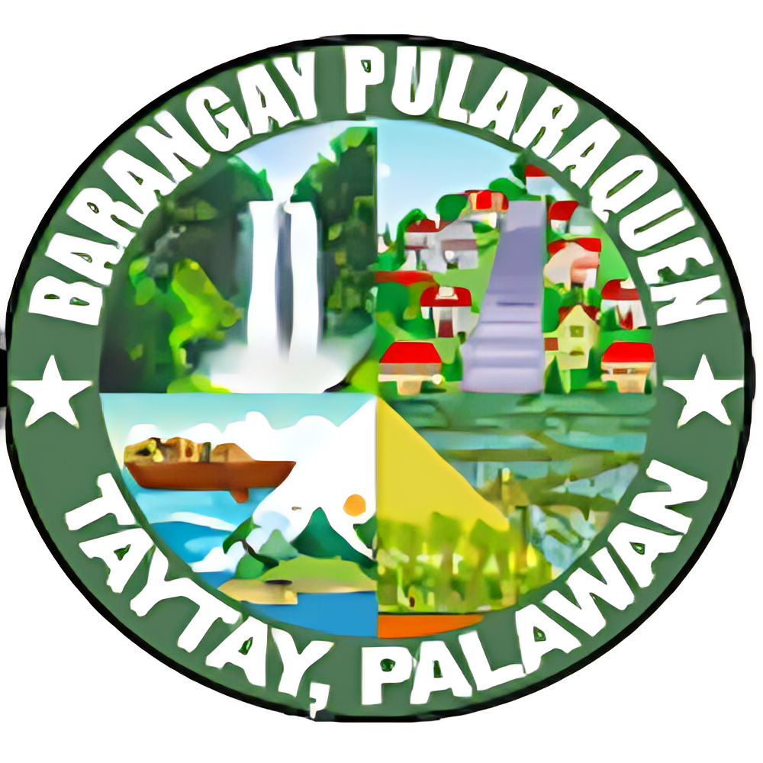

OFFICE OF THE PUNONG BARANGAY

BARANGAY CLEARANCE

TO WHOM IT MAY CONCERN:

This is to certify that {fullName}, legal age, Single/Married, a resident of Barangay Pularaquen, Taytay, Palawan, is personally known to me to be of good moral character and a law-abiding citizen in the community.
This certification is being issued upon the request of the above-named person for whatever legal purpose it may serve.

Issued this 13th day of October, 2025

ELY C. ABIS
Punong Barangay

OR No.: _____________
Amount Paid: ₱{amount}

