**Converting Image to a 3D model using pixel intensity**

Akshay RM   
Department of computer science *RV college of Engineering*

Ganvi GR   
Department of computer science *RV college of Engineering* Bharath kumar M   
Department of computer science *RV college of Engineering*

Gagana shree D   
Department of computer science *RV college of Engineering*

1. *Abstract*—Converting Image to 3D model is one of most researched topic in 3D modelling field. Due to the nature of the problem it is extremely difficult to achieve the solution completely. In this paper we will be explaining how to achieve this by using pixel intensity. Outcome of this process gives us a 3D model of object without any heavy computation and need for large datasets. This technique best works for objects which are similar to terrain and also gives a detailed 3D model.
2. Keywords—3D object, greyscale, polygons, mesh

# Introduction

Visualizing 3D objects from a single perspective is easy for human eyes, this not the case for the computer vision. Generating 3 dimensional data from 2 dimensional objects is extremely challenging. Try to solve this using deep learning techniques is extremely GPU intensive, time consuming. For the objects which have a similar shape to terrain or a square using deep learning is waste of resource. Using greyscale technique models can achieved with far less resources and quickly. Every image is 2X2 matrix which holds some RGB values. For greyscale images this RBG values is replaced by pixel intensity which ranges from 0 to 255. Values towards 0 are dark and values towards to 255 are lighter. Pixel intensity can be correlated to the height. Thus using this correlation we can achieve a 3D model with a single images. Output of this will be s STL object which can be further modified.

# Method

First we have to create a flat 2d mesh surface. This mesh is a now matrix acting as a 2d surface. Next Input should be converted to greyscale if its RBG image. Conversion be done using any method, we will be averaging R, B and G values. Now each pixel as an intensity ranging from 0-225. The 2d mesh has 3 values i.e. .X, Y, Z coordinates, to form 2d mesh Y value will be initially zero. Y is replace with the intensity.

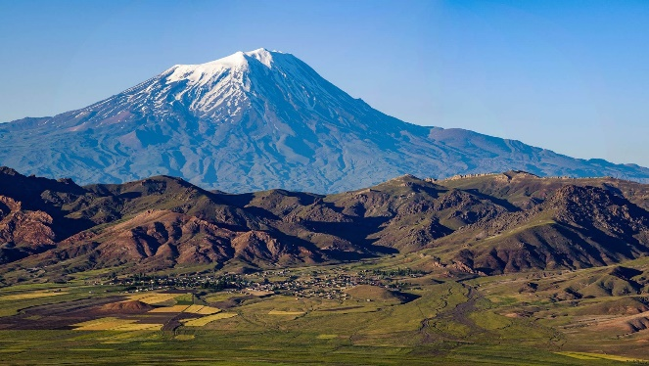

Fig.1 Input image

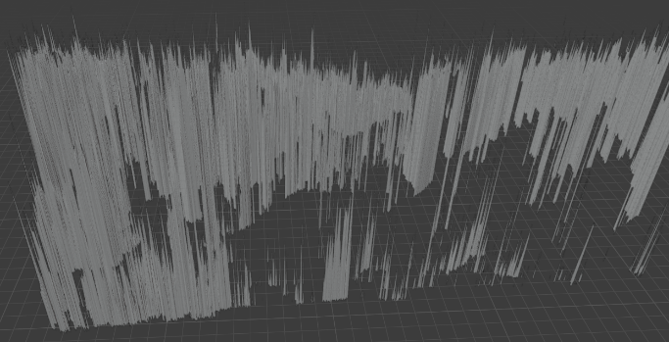

Fig. 2 Output for replacing Y coordinates with Pixel intensity

As we can see in Fig.2 output is not right. Just by simple replacing Y coordinates with pixel intensity gives spikes. To fix this we have to set a boundary values. After adding a boundary value we get the output as seen in Fig.3.

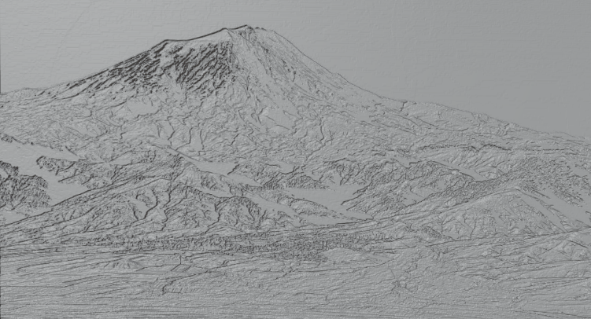

Fig.3 Output with boundary value

Output Fig.3 is lacking depth, this can be solved by varying different parameters like B/W threshold, boundary values.

# Outcome

After replacing Y coordinate with pixel intensity and setting boundary value, these information should be incorporated with 2d mesh. After this output can exported as any 3D model extension. Here are some objects converted to 3D model.

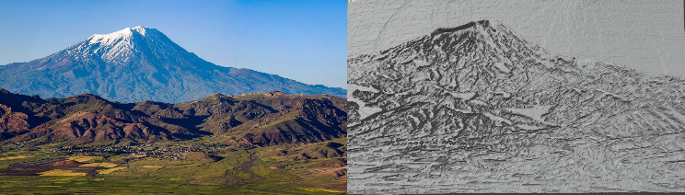

Fig.4 Final output

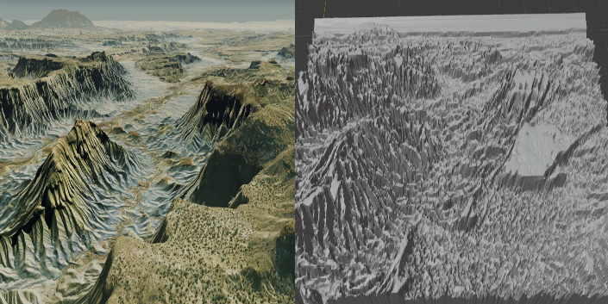

Fig.5 output

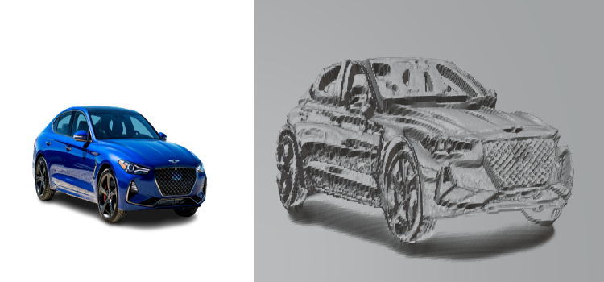

Fig.6 output

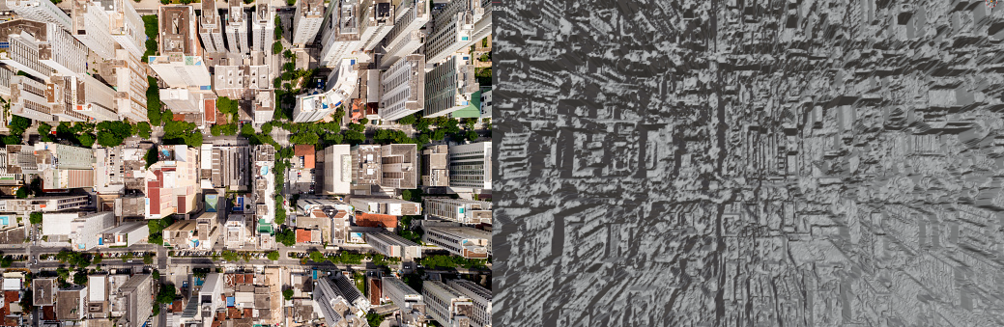

Fig.7 output

This technique gives best output when the input is a terrain based.

# Problems with greyscale technique

Greyscale technique is simple, computational friendly and doesn’t require large datasets. Major drawback of this technique is its simplicity. Because it’s simple, images with circular objects cannot be processed as circular images has parts which is not visible in 2D images. This technique is not suited for creating 3D objects for creating completed 3D objects. For this there separate solution called multi-view object reconstruction. Which much more suitable for creating entire 3D objects. Converting RBG images to greyscale has some loss to it. Depending on the method used to convert RBG to greyscale, Images loss can significantly reduce the output quality and clarity of the model.

# Conclusion

Pixel intensity method is simple and effective to convert image to 3D objects. By using Artificial intelligence and pixel intensity we can convert many more shapes, even circular objects. This can achieved by using multiple images taken from different angle. Then applying pixel value technique to all images and stitching them together by using AI. This can solve the major drawback of this image. Pixel intensity is still useful for generating objects of terrain or objects which square in shape

##### References

1. Nanyang Wang, Yinda Zhang, Zhuwen Li, Yanwei Fu, Wei Liu, Yu-Gang Jiang J: Pixel2Mesh: Generating 3D Mesh Models from Single RGB Images arXiv:1804.01654v2 [cs.CV]-3 Aug 2018
2. Christopher B. Choy, Danfei Xu, JunYoung Gwak, Kevin Chen, Silvio Savarese: “A Unified Approach for Single and Multi-view 3D Object Reconstruction” -2 Apr 2016
3. Haozhe-Xie, Hongxun-Yao, Xiaoshuai-Sun, Shangchen Zhou, Shengping Zhang K. Elissa, “Context-aware 3D Reconstruction from Single and Multi-view Images”-ICCV 2019
4. Haoqiang Fan, Hao Su, Leonidas Guibas :“A Point Set Generation Network for 3D Object Reconstruction from a Single Image”- CVPR 2017
5. Amir A. Soltani, Haibin Huang, Jiajun Wu, Tejas Kulkarni and Joshua Tenenbaum: “Synthesizing 3D Shapes via Modeling Multi-View Depth Maps and Silhouettes with Deep Generative Networks”- CVPR 2017
6. Xinchen Yan, Jimei Yang, Ersin Yumer, Yijie Guo, Honglak Lee: “ Learning Single-View 3D Object Reconstruction without 3D Supervision”- NeurIPS 2016
7. Chen-Hsuan Lin, Chen Kong, Simon Lucey: “Learning Efficient Point Cloud Generation for Dense 3D Object Reconstruction”- 21 Jun 2017
8. Bo Yang, Hongkai Wen, Sen Wang, Ronald Clark, Andrew Markham, Niki Trigoni: “3D Object Reconstruction from a Single Depth View with Adversarial Learning”- 26 Aug 2017
9. Kar, A., Tulsianni, S., Careira, J., Malik, J.: Category-specific object reconstruction from a single image. In: CVPR (2015)
10. Saxenaa, A., Sun, M., Ng, A.Y.: Make3d: Learning 3d scene structure from a single still image. IEEE Trans. Pattern Anal. Mach. Intell. 31(5), 824–840 (2009)