Homework 1
1) Research
a. What already exists that is like our application?
There are already existing smart parking applications such as SpotHero, ParkMobile, and ParkWhiz. These applications allow users to search for parking locations, compare parking prices, and pay for parking through their mobile devices. Some applications also allow users to reserve parking spaces in advance, making it easier to find parking in busy areas.
b. What makes our application different?
Unlike traditional parking applications, our Smart Parking App will focus on making the process of finding available parking spaces faster and more convenient. The application will help users locate nearby parking spaces, view parking availability, compare prices, and receive directions to their selected parking location.
Our application will also focus on providing a simple and user-friendly experience by combining parking availability, navigation, and reservations into one platform. Rather than requiring users to search multiple parking locations individually, the application will help them identify suitable parking options based on their location, preferences, and budget.
The goal is to reduce the time drivers spend searching for parking while making the overall parking experience more efficient.

2) Vision and Scope
a. Who are we and how was this project acquired?
We are ParkNav Technologies, a software company focused on developing solutions that make finding parking easier and more convenient. Our goal is to create a smart parking application that helps drivers quickly locate available parking spaces, compare parking prices, and navigate to their desired parking locations.
The ParkNav project started after recognizing that finding parking can be a frustrating and time-consuming experience, especially in busy areas such as downtown districts, shopping centers, and college campuses. We decided to develop our own smart parking application that provides drivers with a more efficient way to locate and reserve parking spaces. ParkNav will help users save time, reduce unnecessary driving, and make the overall parking experience more convenient.
b. What is the vision of the project?
The vision of ParkNav is to create a smart parking application that makes finding available parking spaces faster, easier, and more accessible to drivers. Instead of spending unnecessary time driving around searching for parking, users will be able to view nearby parking locations, check availability, and receive directions directly through the application.
We also want users to have more control over their parking experience. ParkNav will allow users to compare parking prices, select locations based on their preferences, and reserve available spaces when possible. By combining these features into one application, ParkNav aims to reduce parking-related frustration and provide drivers with a more convenient and organized parking experience.
c. What is the scope of the project?
The scope of ParkNav will include the main features expected from a smart parking application, such as creating an account, logging in, searching for nearby parking locations, viewing available parking spaces, comparing parking prices, and receiving GPS directions to selected parking locations.
The main focus of the project will be ParkNav's parking availability and navigation system. Users will be able to search for parking based on their current location, view parking information, and reserve available parking spaces at participating locations. The application will also provide reservation confirmations and notifications to help users manage their parking experience.
For the first version of ParkNav, features such as automated parking payments, physical parking sensors, license plate recognition, and integration with citywide parking management systems will not be included. Parking availability will initially be demonstrated using sample data. This will allow the project to focus primarily on parking search, navigation, and reservation functionality within the planned three-month development period.

3) Draft for SRS (Software Requirements Specification)
1. Create Account — The user can create a ParkNav account.
2. Log In — The user can log into an existing account.
3. Search Parking — The user can search for nearby parking locations based on their current location.
4. View Parking Availability — The user can see available parking spaces at participating parking locations.
5. View Parking Prices — The user can view and compare parking rates at different locations.
6. GPS Navigation — The user can receive directions to their selected parking location.
7. Reserve Parking — The user can reserve an available parking space in advance.
8. Manage Reservations — The user can view or cancel their existing parking reservations.
9. View Parking Details — The user can view information about parking locations, including addresses, prices, and availability.
10. Filter Parking Results — The user can filter parking locations based on price, distance, and availability.
11. Save Favorite Locations — The user can save frequently used parking locations for easier access.
12. View Parking History — The user can view their previous parking reservations and locations.
13. Receive Notifications — The user can receive notifications about reservation confirmations and upcoming parking expiration times.
14. Manage User Profile — The user can update their personal information and parking preferences.
15. View Parking Map — The user can view nearby parking locations displayed on an interactive map.
Next: Homework 2 – 1) Create WBS for App

Homework 2
1) Create WBS for App
1.0 ParkNav – Smart Parking Application
1.1 Project Planning
- 1.1.1 Define project vision and scope
- 1.1.2 Identify stakeholders
- 1.1.3 Define project requirements
- 1.1.4 Create project schedule
1.2 UI/UX Design
- 1.2.1 Design login/signup screens
- 1.2.2 Design home/dashboard
- 1.2.3 Design parking search and map interface
- 1.2.4 Design user profile and settings
1.3 User Account System
- 1.3.1 Implement account registration
- 1.3.2 Implement login/logout
- 1.3.3 Store user preferences
- 1.3.4 Manage favorite parking locations
1.4 Parking Database & Search
- 1.4.1 Build parking location database
- 1.4.2 Implement parking location search
- 1.4.3 Implement parking availability display
- 1.4.4 Display parking prices and location information
1.5 Parking Availability System
- 1.5.1 Collect parking availability data
- 1.5.2 Track available and occupied parking spaces
- 1.5.3 Update parking availability information
- 1.5.4 Allow users to filter available parking spaces
1.6 GPS Navigation
- 1.6.1 Integrate GPS and mapping services
- 1.6.2 Display nearby parking locations on a map
- 1.6.3 Provide directions to selected parking locations
- 1.6.4 Calculate distance to parking locations
1.7 Parking Reservation System
- 1.7.1 Allow users to reserve parking spaces
- 1.7.2 Manage and cancel reservations
- 1.7.3 Save reservation information
- 1.7.4 Send reservation confirmations and notifications
1.8 Testing
- 1.8.1 Test user accounts
- 1.8.2 Test parking search and navigation
- 1.8.3 Test parking availability and reservations
- 1.8.4 Fix identified bugs
1.9 Deployment
- 1.9.1 Prepare production build
- 1.9.2 Deploy application
- 1.9.3 Perform final system testing
- 1.9.4 Release application prototype
This WBS maintains the three-level structure required for your assignment:
- Level 1: Overall project (1.0)
- Level 2: Major project activities (1.1–1.9)
- Level 3: Individual tasks (1.1.1–1.9.4)

2) Draft Timeline
WBS | Activity | Duration | Proposed Weeks
1.1 | Project Planning | 2 weeks | 1–2
1.2 | UI/UX Design | 2 weeks | 2–3
1.3 | User Account System | 2 weeks | 3–4
1.4 | Parking Database & Search | 3 weeks | 4–6
1.5 | Parking Availability System | 4 weeks | 5–8
1.6 | GPS Navigation | 3 weeks | 6–8
1.7 | Parking Reservation System | 2 weeks | 8–9
1.8 | Testing & Bug Fixes | 3 weeks | 9–11
1.9 | Deployment & Finalization | 1 week | 12

Homework 3
1) Create Backlog for Parking App
Category | Minimum Items
Login | 5
UI for Operator and User | 15
Backend Processes for Operator and User | 15
Reporting for Operator and User | 10
Total | 45
2) Plan Sprint 1 Backlog
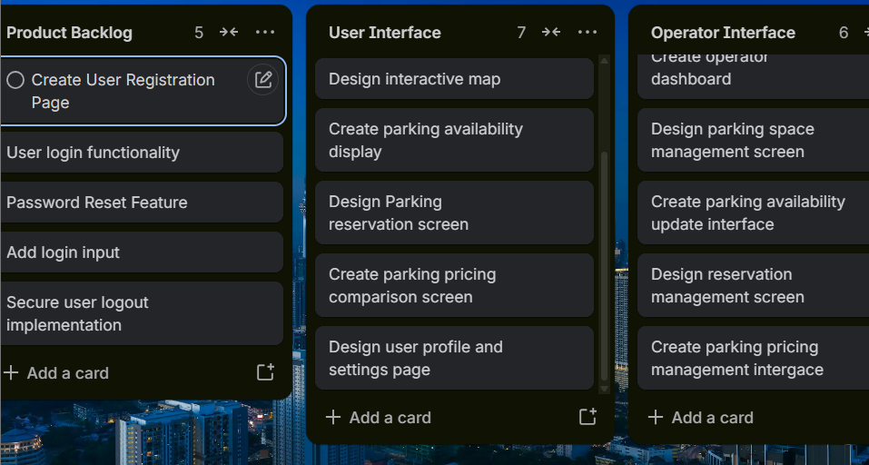

Homework 4

1) Identifying Risks

Category | Possible Risks for ParkNav
Technical | Parking availability information is inaccurate; GPS navigation or mapping API integration fails; database/server issues; user data and security vulnerabilities
Schedule | Parking availability system takes longer to develop; GPS integration delays; testing falls behind schedule; reservation features take longer than estimated
Financial | Mapping API costs exceed the project budget; cloud hosting costs increase; development tools require paid subscriptions; insufficient funding for future expansion
People | Team member becomes unavailable; poor communication between team members; uneven workload distribution; lack of experience with mapping or database technologies

Homework 4

2) Risk Register

ID | Risk Description | Probability | Impact | Owner | Response Strategy | Status / Notes
R1 | Parking availability system displays inaccurate information | Medium | High | Development Team | Test availability updates and verify parking data accuracy | Monitoring
R2 | GPS or mapping API integration experiences compatibility issues | Medium | High | Development Team | Test API integration early and research alternative mapping services | Open
R3 | Database or server problems cause application downtime | Low | High | Development Team | Use reliable hosting and regularly back up data | Monitoring
R4 | Security vulnerabilities expose user information | Low | High | Development Team | Implement secure authentication and conduct security testing | Open
R5 | Parking availability system takes longer to develop than planned | Medium | High | Project Manager | Establish development milestones and monitor progress | Open
R6 | Testing falls behind schedule | Medium | Medium | Testing Team | Begin testing early and prioritize important features | Open
R7 | Mapping API costs exceed the project budget | Medium | Medium | Project Manager | Monitor API usage and investigate lower-cost alternatives | Monitoring
R8 | Cloud hosting costs increase | Low | Medium | Project Manager | Monitor resource usage and establish spending limits | Open
R9 | Team member becomes unavailable | Medium | Medium | Project Manager | Cross-train team members and redistribute tasks | Open
R10 | Poor team communication causes delays | Medium | High | Project Manager | Hold regular meetings and use a shared communication platform | Monitoring
3) Communication Plan
Communication | Participants | Purpose | Method | Frequency | Responsible Person
Team Meeting | Project Team | Discuss progress, upcoming tasks, and problems | In-person / Microsoft Teams | Weekly | Project Manager
Development Update | Developers & Project Manager | Report progress on parking availability, GPS navigation, and reservation features | Teams / Group Chat | Weekly | Development Team
Risk Update | Project Team | Discuss new risks and changes to existing risks | Team Meeting | Weekly | Project Manager
Testing Report | Developers & Testers | Report bugs and problems found during testing | Shared Document | As needed during testing | Testing Team
Stakeholder Update | Stakeholders & Project Manager | Explain overall project progress, accomplishments, and upcoming work | Video / Presentation | Weekly | Project Manager

Homework 5

1. Roles & Resources
Fictional name | Project role | Skill level | Allocation
Alex Carter | Project Manager | Advanced | 50%
Sarah Lee | Mobile App Developer | Advanced | 100%
Michael Chen | Database Developer | Intermediate | 75%
Emily Davis | UI/UX Designer | Intermediate | 50%
James Wilson | QA Tester | Intermediate | 50%
.
2. Resource & Cost Plan
Resource | Hourly rate | Hours (12 weeks) | Total cost
Project Manager | $45 | 240 | $10,800
Mobile Developer | $40 | 480 | $19,200
Database Developer | $35 | 360 | $12,600
UI/UX Designer | $30 | 240 | $7,200
QA Tester | $25 | 240 | $6,000
Cloud hosting and software | — | — | $1,500
Total |  |  | $57,300
Monthly budgeted cash flow
Estimated Monthly Project Spending
Budgeted expenses across the three-month development period
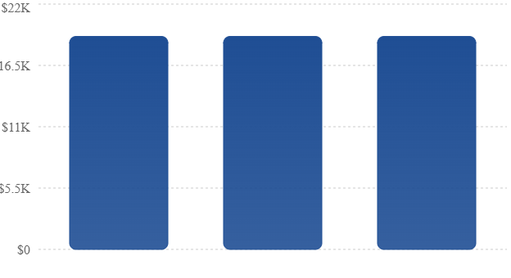

3. RACI Matrix
Project activity | PM | App Dev | DB Dev | Designer | Tester
Requirements gathering | A/R | C | C | C | I
UI/UX design | A | C | I | R | I
Parking availability system | A | R | C | I | C
Database development | A | C | R | I | I
Parking reservation feature | A | R | C | C | I
Application testing | A | C | C | I | R
Final deployment | A | R | C | I | C
Three-month project schedule
Month | Project activities
Month 1 (Weeks 1–4) | Requirements gathering, planning, interface design, database planning
Month 2 (Weeks 5–8) | Mobile app development, database integration, parking search and reservation features
Month 3 (Weeks 9–12) | Software testing, bug fixes, final deployment, stakeholder presentation

Homework 7
  - Power Interest Grid
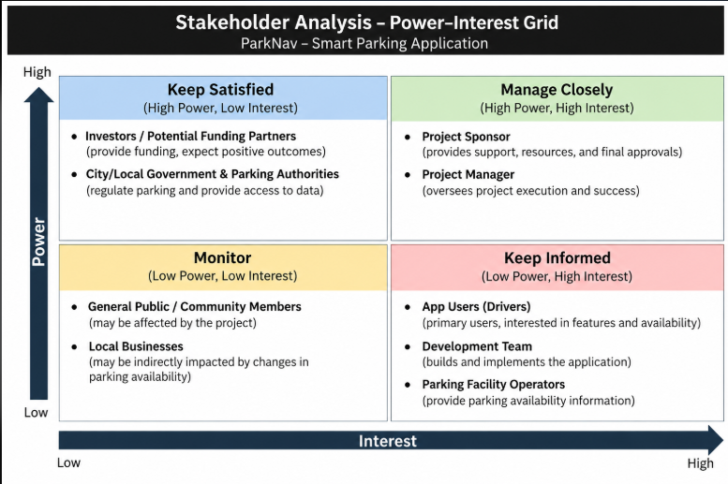

  - Project Charter & Team Charter