 | Professional Regulation Commission
 | REGISTRATION SHEET

CPD COUNCIL OF/FOR ___AGRICULTURE_______

Title of the Program: {program_title}
Date : {date} |  |  |  |  | Venue : {venue}
NO. | NAME | SIGNATURE | MOBILE PHONE NUMBER |  | E-MAIL ADDRESS | PRC LICENSE NO. | EXPIRY DATE  (DD/MM/YYYY)
{#rows}{no} | {name} |  | {mobile} |  | {email} | {license} | {expiry}{/rows}
Certified Correct by:  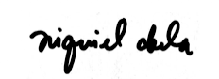  NIQUIEL ABELA________  (Signature Over Printed Name)  CPD Provider’s Authorized Representative  Date and Time: {signed_date} |  |  |  | Concurred by:  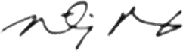  TIMOTHY PAOLO BAGUI_____  (Signature Over Printed Name)  CPD Provider’s Authorized Representative  Date and Time: {signed_date}

