 |  |  |  | Professional Regulation Commission
 |  |  |  | ATTENDANCE SHEET
CPD COUNCIL OF/FOR ___AGRICULTURE______
Title of the Program: {program_title}
Date : {date} |  |  |  |  |  |  | Venue : {venue}
Topic/s:  {#topics}  {.}  {/topics} |  |  |  |  |  |  |  | Time: {time} |  | Room: {room}
NO. |  | NAME |  |  |  | SIGNATURE |  | PRC LICENSE NO. |  | EXPIRY DATE  (DD/MM/YYYY)
{#rows}{no} |  | {name} |  |  |  |  |  | {license} |  | {expiry}{/rows}
Certified Correct by: |  |  |  |  |  |  | Concurred by:
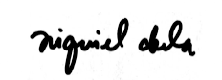  NIQUIEL ABELA________  (Signature Over Printed Name)  CPD Provider’s Authorized Representative |  |  |  |  |  |  | 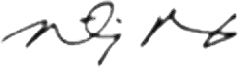  TIMOTHY PAOLO BAGUI_____  (Signature Over Printed Name)  CPD Provider’s Authorized Representative
Date and Time: {signed_date} |  |  |  |  |  |  | Date and Time: {signed_date}

