# 2. Requirements Engineering

Requirement engineering basically refers to understanding the clients’ problems so that we can plan out our objectives and goals according to their needs and the data’s that they provide. It is all about solving the problems but to solve those problems we have to know what the exact problem is because of which there has to be constant communication with the clients so that we can obtain the exact requirements as these information’s play crucial role in further development of the software which directly helps to deliver accurate results to the clients. The entire project is depended upon the requirement engineering.

# 2.1 Elicitation Activities

Elicitation activities is all about gathering major information from the stakeholders to understand their needs and expectations and is based on effective customer-developer partnership. This is quite tough as it is most error-prone and requires intensive communication skills because of which there is frequent meetings, interviews, questionnaire, brain storming sessions and so on with the stakeholders s this is a key for getting end results. There should be detailed investigations if user needs.

In this project too various elicitation process were used to extract acute problems and domains from the stakeholders. There was a detailed interview session with major stakeholders which helped a lot in bringing out important key information’s for the project.

# 2.1.1 Interview Plans

In the interview with the stakeholders, we divided group members and interviewed all the four major stakeholders. The divided group members were told to investigate the problem domain and have meaningful open-ended interview with the stakeholder and were allowed to ask context free questions to understand the problems clearly. These interview sessions are important because through these sessions we can understand the clients’ expectations from the software. After the interviews all of the group members shall have required important information’s and should clearly understand the problem domains.

**Interview Questions:**

**Stake Holder: Dr. Simone White (The computing course leader)**

**1.Gathering information’s about the record management system, student portal and corporate website:**

* Can You tell us briefly about record management system, student portal and corporate website?
* For how long would you want to test the pilot test system after its completion?
* What kind of records are stored in current system?

**2.Gathering information about problem domain:**

* Who are the key users in the system?
* What kind of problems with the current system do you want to fix with the computerized system?
* What are the differences in courses and modules?
* How are you planning to scale the software in the future?
* How are the document’s being created and accessed currently?

**3.Gathering other useful information**

* What is a diary supposed to do?
* Is diary unique with every student?
* Which user creates assignment (student or staff)?
* What are the different kinds of staff other than teachers?
* Features of module leaders and tutors?

**4.Gathering Suggestions**

* Are there any system software you recommend for us to reference?
* Are there any constraints we need to keep in mind?

**Stake Holder: Mr. Adam Blake (An experienced course administrator from the computing course program support team)**

* How are you planning to utilize the new system?
* What features are you expecting?
* How should we maintain the level of access within the users?
* Can you tell us briefly how the college courses function in general?
* What is a personal tutor? And who type of students require personal tutor?

**Stake Holder: Dr. Raj Singh (A senior lecturer, module leader and personal tutor from the computing department)**

* What features are expected for the teachers in this system?
* if you will use diary management then how will you use it?
* What kind of assignments are created?
* Will you be uploading any file through the system?
* What kind of information’s should flow between a student and teachers through the system?

**Stake Holder: Mr. Mark Williams (An existing student enrolled on the computing course)**

**1.Gathering information about the students’ difficulties:**

* Do you feel any difficulties due to the current clerical-based system in Woodlands University College (WUC)?

**2.Gathering information about comparison’s:**

* Do you know of some other colleges system where you didn’t face such difficulties?
* Not exactly
* What kind of activities should be possible in the system?

**3.Gathering Suggestions:**

* What kind of facility in the system do you expect, and could you suggest some functionality that would make you feel more comfortable?

# 2.1.2 Interview Findings

Interview findings consists of the results, information’s and the answers we were able to gather from the stakeholders from the interview session. These findings will further help us to clear out our doubts and help in delivering the required output to our clients.

Stake Holder: Dr. Simone White

Interview Duration: 30Minutes

|  |  |
| --- | --- |
| Question No | Questions and their responses |
| 1. | Can you tell us briefly about record management system, student portal and corporate website?  Answer:  So, talking about student portal at first, there are in total 10 functionalities out of which lots of functionalities are allocated for the students. So, all the privileges or the facilities provided to the students must be included at the student dashboard which includes his attendance management system, and also should have other facilities like how the assignment gradings and assignment progresses are made in the portal, these are the requirements for student’s portal. And if notification ** is required then the notification section should also be there. talking about the corporate website due to the time constraint you can exclude this part. but as the record management system is the backend part this is important. |
| 2. | Who are the key users in the system?  Answer:  Ideally there are 4 kinds of users in the system, the first one is student, the second one is tutor, the third one is module leader and the last one is the admin. |
| 3. | What are the differences between courses and modules?  Answer:  So basically, there are multiple modules within a single course. For example, if any academic programs like BSC Hons, BCA etc. are the courses then within these courses there will different kind of modules. |
| 4. | What is the sole purpose of diary management system? And what are the expectations from diary management system?  Answer:  So, diary management systems sole purpose is to remind the students and the stakeholder about upcoming events or important tasks so that they won’t be missing them. And the diary management system should provide the functionality along with the calendar, which should contain things like when the class is scheduled, when the assignments due date is or any other kind of submission due dates, all these things should be available in the calendar as a reminder so that the students or stakeholders won’t miss them. |

|  |  |
| --- | --- |
| 5. | Is diary unique with every student?  Answer:  It depends, ideally if the students are taking same courses, then they shall have similar kind of diary but if the students have different courses, then they will have different diary according to their respective courses. |
| 6. | What are the features of module leaders and tutors?  Answer:  Ideally the features for the module leaders and the tutors are almost similar. Tutors are assigned with single modules and s/he shall have access to only one module whereas in the context of module leaders if s/he is allocated for multiple modules then s/he will have access to multiple modules. |
| 7. | How often should we conduct the meetings and technical reviews of the project? And how would you track the project?  Answer:  So, regarding this it would be great if the team leaders coordinate and send updates on the weekly basis as we have very limited time frame, 5-week delivery timeline is very short for these kinds of projects so regular meetings in weekly basis may not be required. But you shall keep updating along with the roadmap that I have shown you; I have already shared roadmap for next 5 weeks so on the basis of roadmap you should write the details like whether the roadmap items are completed or not completed or are in process of completion and are to be updated next week. All these information should be updated through email. But at least written updates through the email is expected. |
| 8. | Are there any system software you recommend us to reference?  Answer:  So, for the reference you won’t have a single application which will fulfill all the requirement or the features that I have included in the requirement document but you can take some help form the apps which have the functionality. Some of them are NILE website which has a simple and intuitive login portal for both staff and students alike and I would also like to recommend Acquia which is a record management system with built in security features. |
| 9. | For how long would you want to test the pilot test system after its completion?  Answer:  The testing can be completed within a week as the pilot system has to tested by all our module teachers and some credited students who will check all the required functionality of the system. |
| 10. | What kind of records are stored in current system?  Answer:  As I’ve discussed with you, the current system is a paper-based system and all our crucial documents of staffs and students are stored manually in a storage warehouse. This has created many problems as the cost and maintenance of the sensitive documents are very difficult to track and retrieve that information. Records such as students address, age, grades, etc. and staffs phone number any various other personal information are stored. |
| 11. | What kind of problems with the current system do you want to fix with the computerized system?  Answer:  Mainly I would say the safe keeping of all the sensitive data, its efficient retrieval, editing the data of all staffs and students through a single admin page, a login portal for the teachers and especially the students. |
| 12. | How are you planning to scale the software in the future?  Answer:  Me and my team haven’t discussed about the future scaling as we are firstly only expecting the bare bones function of the system. |
| 13. | How are the document’s being created and accessed currently?  Answer:  I’ve already answered this previously. |
| 14. | What is a diary supposed to do?  Answer:  I think a student’s diary should consist of all the module activities and its information. Such as grades, upcoming assignment/projects, university events which will facilitate the students with the required resources to complete their modules. |
| 15. | Which user creates assignment (student or staff)?  Answer:  Only the respective module teachers should be able to create and publish the assignments in the website portal. |
| 16. | What are the different kinds of staff other than teachers?  Answer:  Besides the educational staffs there are administrative and security personnel, non-teaching staffs including researchers, interns, service staffs, librarians, IT staff and technicians, etc. |
| 17. | Are there any constraints we need to keep in mind?  Answer:  All the required functions and constraints are already present in brief so, as for the extra functionalities we will discuss after the pilot system has been successfully deployed. |

Stake Holder: Adam Blake

Interview Duration: 30Minutess

|  |  |
| --- | --- |
| Question NO | Questions and their responses |
| 1. | What are the problems that you are facing in this current software? And how are you planning to utilize this new system?  Answer:  We are expecting one of the great evolutions after we roll out this system because currently, we are facing many problems during the student enrollment, during the assignment allocation, its management and its publications and there are other multiple complications as well. With the new system we have in vision and the way of implementation we have in in vision, the users are definitely going to get benefitted a lot. This new software shall have centralized location for all the information and everything should be available in the system which will decrease the human errors in some extent. |
| 2. | How should we maintain the level of access within the users?  Answer:  As it is already mentioned earlier that there are 4 kind of user roles in this application i.e., students, tutor, module leader and. Admin. So these 4 kind of roles will have the access that they require. |
| 3. | Can you tell us briefly how the college courses function in general?  Answer:  The college courses will be created by the admin and the list of the courses along with their modules will be added by the admin himself, module leader will also be allocated accordingly, then the module leaders and tutors will be able to upload the learning syllabus and in some cases the syllabus can be uploaded by the admin as well, once the syllabus is available module leader is allocated for the course and then the module leader or the tutor will have the option to upload the learning materials which includes the files that may be in different formats like documentation format or spreadsheet format or pdf format or any kind of format including audio and visuals. |
| 4. | What is a personal tutor? And what type of students require personal tutor?  Answer:  Personal tutors are like personal teachers who will be helping the student in clearing their doubts in the subjects in which they are weak. If a student feels that if s/he needs additional guidance and the university is providing it to the students then |
| 5. | What features are you expecting?  Answer:  Well, as for my expectations it’s pretty simple, it’s the same features that I’ve discussed earlier about how I’ll utilize the current system. |

Stake Holder: Mr. Mark Williams

Interview Duration: 30Minutues

|  |  |
| --- | --- |
| Question No | Question and their responses |
| 1. | Do you feel any difficulties due to the current clerical-based system in woodlands university college (WUC)?  Answer:  As a student while having the clerical-based system in Woodlands, we are having difficult time. Everything here is manual and manual things takes a lot of time. And sometimes when there are human errors from the administration side. Another main defect is that there is no centralized mechanism where everything is located or stored and sometimes even information is not received in time |
| 2. | Do you know of some other colleges system where you didn’t face such difficulties?  Answer:  Not exactly |
| 3. | What kind of activities should be possible in the system?  Answer:  One centralized system would be there which you can call it as a student portal which should include all the facilities in4. an organized manner. So out of 10 functions most of them are serving for the students so these modules should be organized and delivered in student portal then it will be easy to use, and will definitely increase the user experience. |
| 4. | What kind of facility in the system do you expect, and could you suggest some functionality that would make you feel more comfortable?  Answer:  Proper record management, a teacher’s and student’s portal and a mobile view should be present in the primary system solution. As of now I don’t have any ideas about extra functionalities. So after I’ve used the upcoming system I will suggest some more functionalities. |

Stake Holder: Dr. Raj Singh

Interview Duration: 30Minutes

|  |  |
| --- | --- |
| Question NO | Questions and their responses |
| 1. | What features are expected for the teachers in this system?  Answer:  For the tutors, assignment management system should be one of the features that am expecting and beside those other systems like attendance management systems and learning management systems are also expected. |
| 2. | If you will use diary management system then how will you use it?  Answer:  Diary management system will work as a reminder for me. It will help me in reminding my class times, any due dates or to create the assignments and to assign it to the students. Tracking should be done and all other things should be visible in the calendar within the feature of diary management system then that would be good. |
| 3. | Will you be uploading any file through the system?  Answer:  Yes of course, as I have mentioned earlier tutor will upload the questions that maybe in the form of pdf file or document format file. |
| 4. | What kind of assignments are created?  Answer:  A diary management system is a place holder which will tell you what particular assignments to be made available to the students. With the help of the diary or calendar students or tutors should be able to extract details after the they enter to that particular item. For students they won’t be getting any administrative rights but they will have access to download assignment files, upload the solved assignment files and see the gradings when the tutors or module leaders will publish the results. |
| 5. | What kind of information’s should flow between a student and teachers through the system?  Answer:  The flow of information should be frequent with the students and should not have any ups and downs with the system interaction. Activities such as module grades, upcoming events, assignment and activities, online discussion classes, sharing of module materials, etc. should be regularly discussed between the students and teachers. |

# 2.1.3 Other problem domain research

The main problem domain seems to be the lack of proper functionalities. The current system is not able to meet the requirements of the users. in comparison to other systems this system is quite outdated. In the current system there is paper based system which is hard to manage and is time consuming as well so there is need of a clerical system which will make day to day work easer. There is no proper record management system because of which they had to face number of problems so to eradicate that there is a need of record management system from where the data retrieval of all the students, staff, faculty members can be retrieved easily in a systematic way. The students were also not able to access the student portal and were not able to get access to the courses and other important topics form which the students can gain benefits.

# 2.1.3.1 Comparable System software review

# 2.1.3.1.1 Record management system

# 2.1.3.1.2 Student records/Information portal

# 2.1.3.1.3 Student records/ Information applications (Mobile Format)

University of Northampton

www.norhtampton.ac.uk

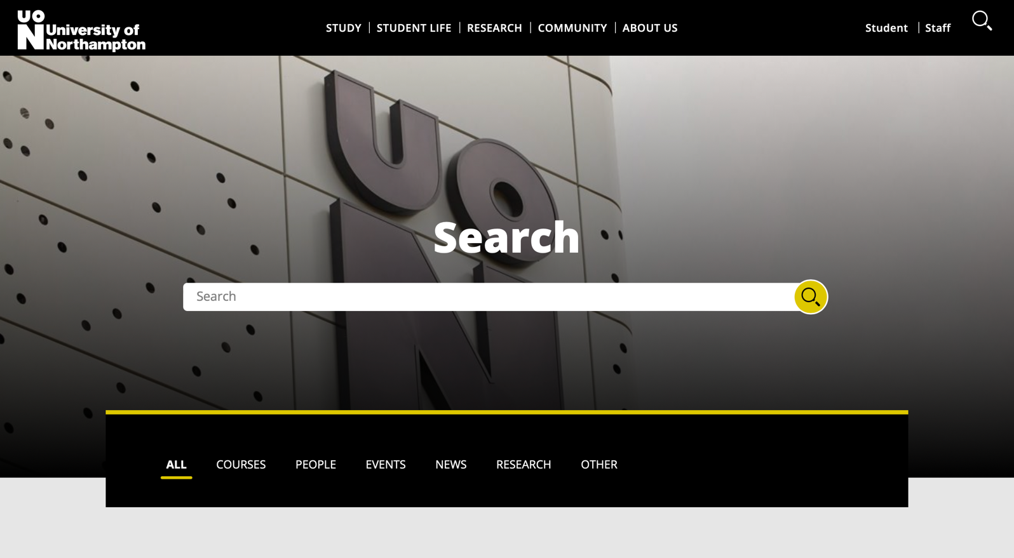

The above-mentioned website is of university of Northampton which is based in Northampton, United Kingdom. This university has been providing its facilities to more than 12000 students. The system of this university can be a role model for the new system, the system is user friendly and has all the functionalities that are required. The website can be accessed by anyone and can see through the courses, events, news, research and many other important things which will be very helpful for those who are willing to get enrolled in the university. There is detailed information about the university and about the community as well. The system is easy to use and beginner friendly. If the students and staffs are willing to enter student portal then also, they can navigate through this page. There is also a search engine from where we can search about the information’s that we want. So, this is one of the examples of modern system consisting of all the functionalities required. Though it has its own drawbacks as sometimes due to the very high number of users the system crashes and it also needs to be updated very frequently as, latest information’s and news should be made available.

[www.nile.northampton.ac.uk](http://www.nile.northampton.ac.uk)

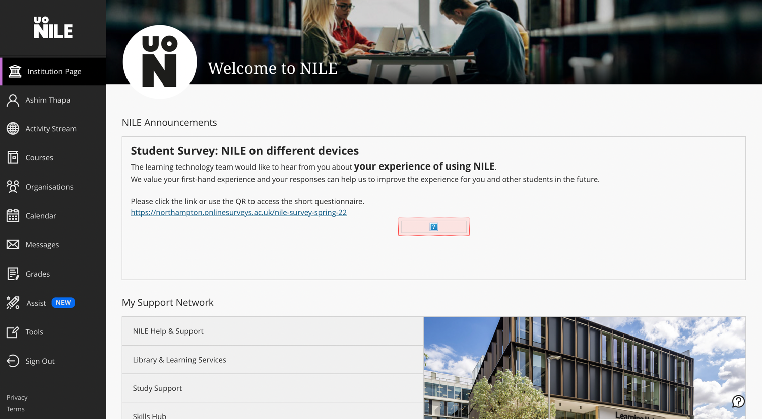

This is the student portal of university of Northampton. As you can see that the student can get lots of advantages while having the student portal. They can see the activity stream, courses, calendar, grades and so on, this will be very helpful in uplifting the quality of the education. The student portal is also very user friendly and the students will be able to check their courses and can download the reading resources from the portal and they can submit their assessment, download the assessments and view their grades as well. They can view upcoming events and will be able to give TCA (Time Constraint Assessment) which is online based exam. The same advantages can be gained by the faculty members as they can publish the assessments and grades in the portal and also provide different study materials related to the course.

MyNorthampton

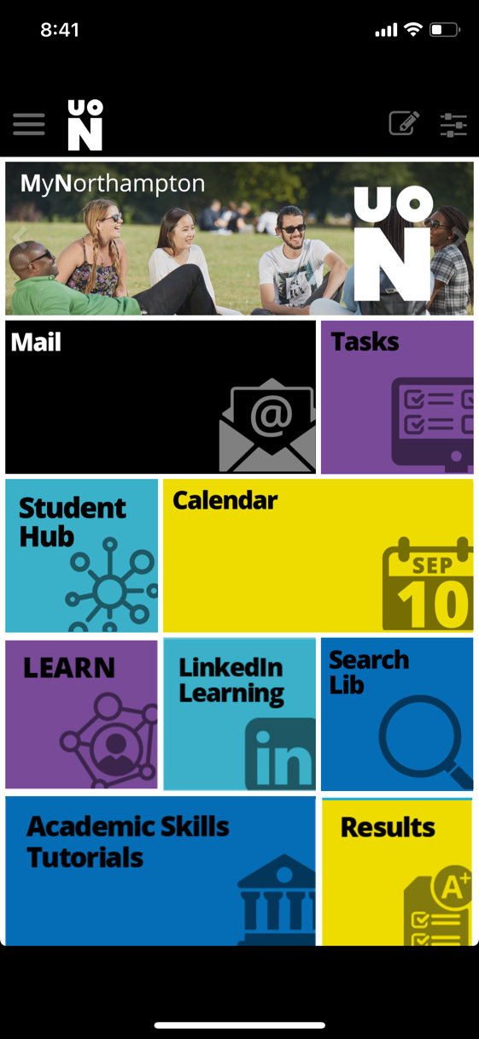

The above-mentioned figure is of the mobile app of University of Northampton. As you can see that there are almost all the features that are in the website. It will help the students when they can’t get access to their computers and laptops. You can find results, calendar, academic skills tutorial, tasks and many other features in the app. As apps usually stores data in the device but the websites store data in the web server because of which data retrieval happens swiftly in mobile apps. Rather than going to the website and checking, students and staffs can get almost all of the features through the app itself.

# 2.1.3.2 Development Relevant legislation

The development relevant legislation ensures to promote quality, and greater choices and opportunities for the students.