The automation script is built with Java and Cucumber with Junit, please do the following before running.

Pre-requisites:

1. download appium from http://appium.io/downloads.html

->Go to Appium Desktop Apps and select installer for your OS ex. for Windows (Appium-windows-1.17.1.exe)

-> Install downloaded file

2. download android studio

->Go to https://developer.android.com/studio#downloads and choose your platform ex. (android-studio-ide-193.6514223-windows.exe)

->Install downloaded file

->Install Adroid Sdk and add an Environment System Variable as “ANDROID_HOME” and set value to the Android Sdk path

->Add PATH for

1. %ANDROID_HOME%\tools

2. %ANDROID_HOME%\platform-tools

->Create your Android Emulator to be used for testing for example device “Pixel with API Level 27” or anything that is available under Android AVD Manager, take note of the device name created.

3. download IntelliJ as an IDE to be use in creating and running the Java code

->Go to https://www.jetbrains.com/idea/download/#section=windows

->Download the community version

->Install downloaded file

4. download Java JDK - version 14 currently used

->Go to https://www.oracle.com/java/technologies/javase/jdk14-archive-downloads.html

->Install downloaded file

5. download maven

->Go to <https://maven.apache.org/download.cgi>

->Download Binary Zip archive

->Extract files to your path of your choosing for example in “C:\opt\apache-maven-3.6.3”

->Add new System Environment Variable with name “MAVEN_HOME” set value to the path above

6. download gradle version for 6.3-all (currently used)

->Go to <https://services.gradle.org/distributions/>

->Download and extract the zip file to the path of your choosing for ex: (C:\gradle\6.3-all)

->Add new Environment System Variable name “GRADLE_HOME” and set value from the path given

7. download chromedriver version, make sure the version is what is used by your mobile device, see settings of Chrome then about for the version, see sample screen below:

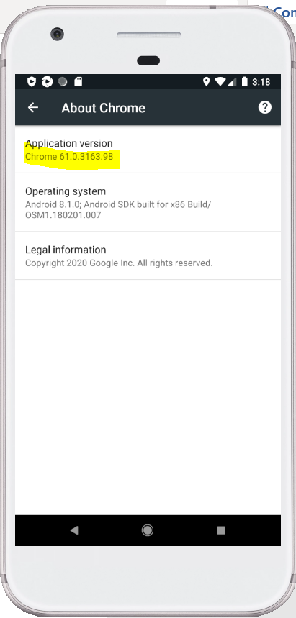

Note: I have added the chromedriver used in the source code under “/src/test/java/resources”

Running the automation from IntelliJ

1. First make sure Appium is running and set the server host to: 127.0.0.1

Select Advance mode and set the “Chromedriver Binary Path” where your chromedriver.exe is located ex: “C:\Automation_App\src\test\java\resources\chromedriver.exe”

1. Now make sure that the emulator is also running
2. Check and make sure that the values are correct in “/src/test/java/configs/TestConfig”

-> Set correct values for the following: (currently used)

1. PLATFORM_NAME = “Android”

2. PLATFORM_VERSION = “8.1”

3. DEVICE_NAME = “Pixel_O”

4. BROWSERNAME = “Chrome”

5. CHROME_DRIVER = “/resources/chromedriver.exe”

6. APPIUM_SERVER = <http://127.0.0.1:4723/wd/hub>

1. Once all data are correct we can now run the script, by right clicking the “Sample.feature” and select Run “Feature: Sample”, see screen below:

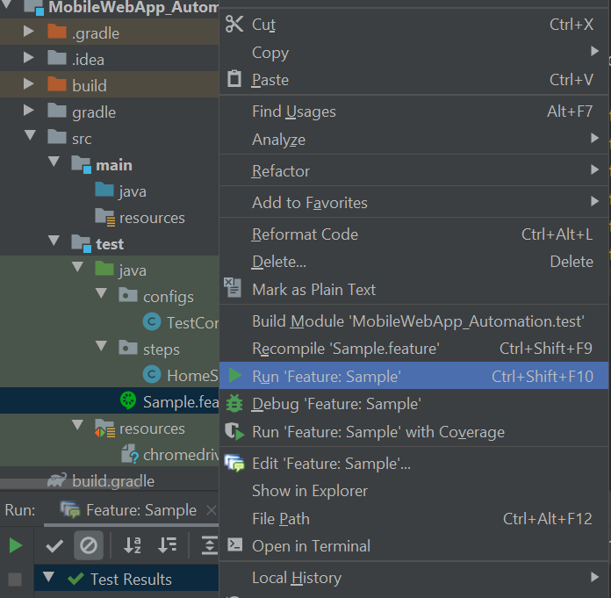

1. Once test is done you will see result from below if “Passed or Failed”, see screen below:

