Effect of Parental Alcohol Use on Parenting (Synthetic Study)

This synthetic dataset has 5,000 simulated parent observations.

# Key descriptives

None: n=2033, mean parenting=75.11, SD=10.64, adverse_rate=0.097

Moderate: n=2237, mean parenting=72.32, SD=10.48, adverse_rate=0.135

Heavy: n=730, mean parenting=64.31, SD=10.73, adverse_rate=0.232

# Statistical results

ANOVA (parenting_score by alcohol_category): F=280.028, p=0.0000

Logistic regression coefficients (child_adverse):

alcohol_category_Moderate: 0.161

alcohol_category_Heavy: 0.301

parenting_score: -0.186

ses_z: -0.053

parent_age: 0.016

# Figures

Parenting quality distribution by alcohol use

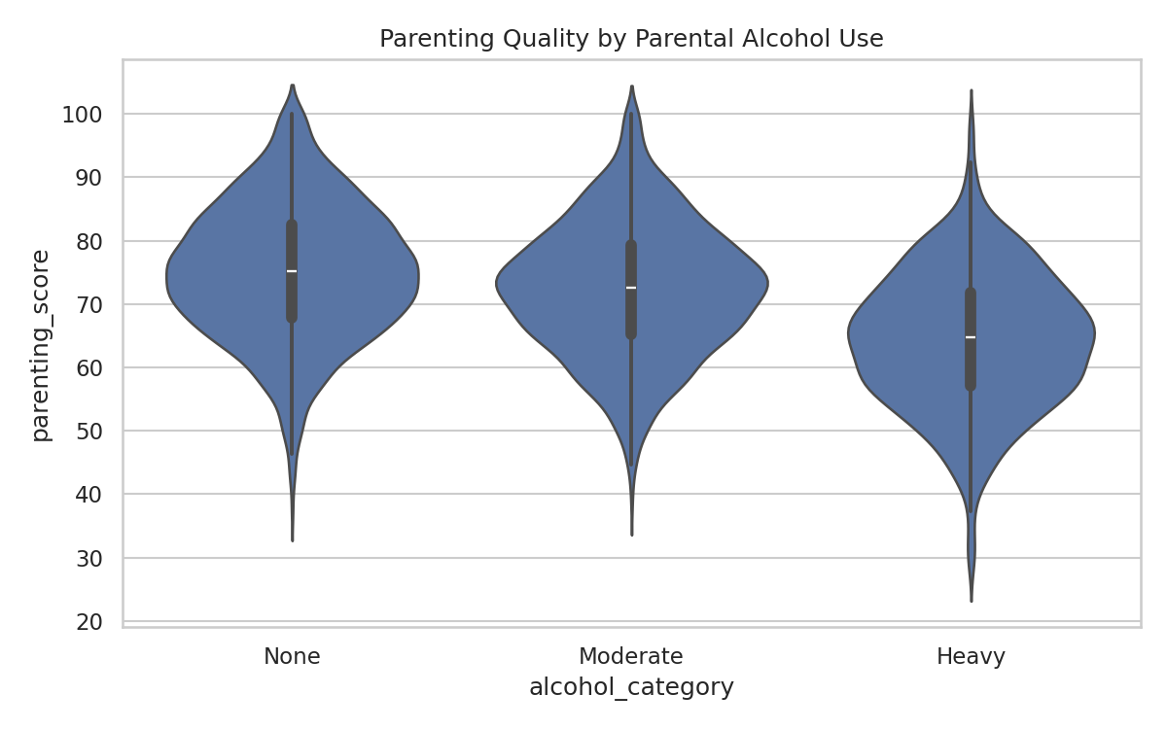

Parenting score vs child risk

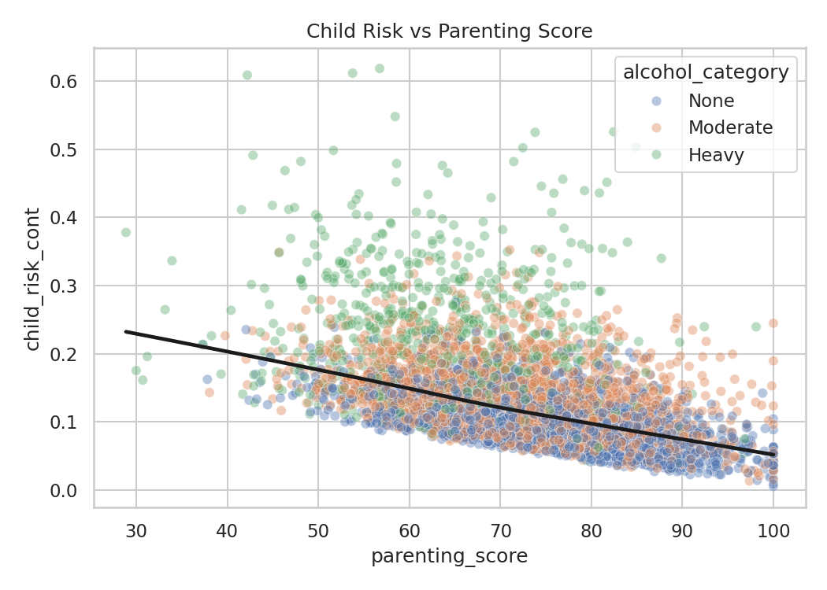

Adverse outcome rates by alcohol category

