Mobile Device Usage and Academic Performance

Correlation between mobile usage and GPA: -0.36

p-value: 0.0003

# Relationship Plot

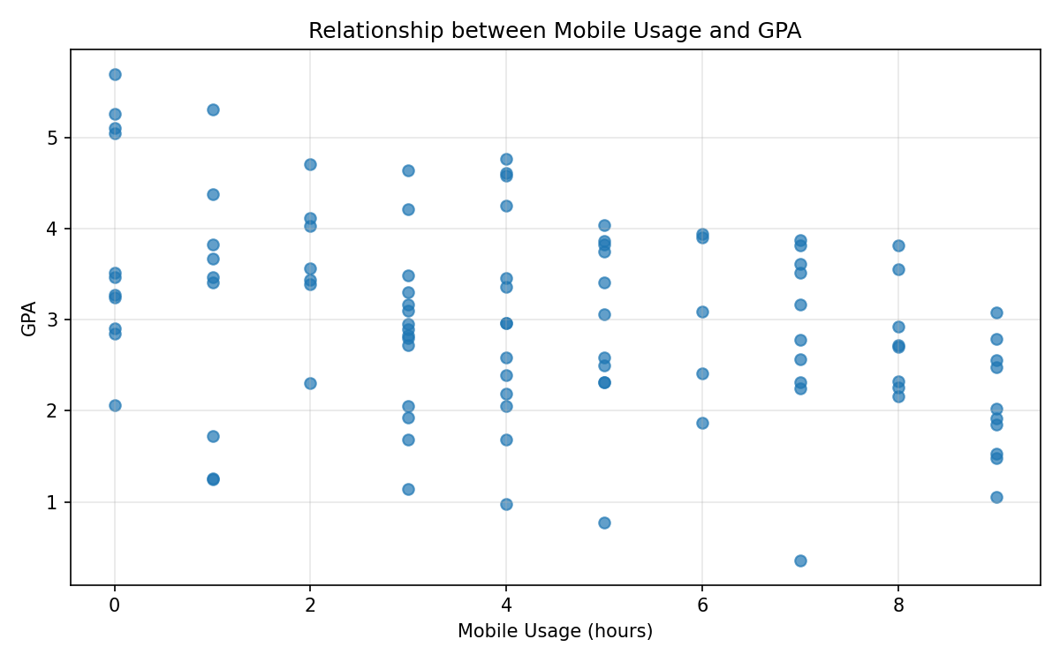

# Average GPA by Usage Category

