YouTube Top 100 Songs 2025: Statistical Analysis Report

Report Generated on: 2025-10-14 22:48:41

Data Source: youtube-top-100-songs-2025.csv

# 1. Descriptive Statistics

Summary statistics for the primary quantitative metrics, highlighting the distribution skewness.

## Table 1: Key Descriptive Statistics

|  |  |  |  |  |  |  |  |  |  |
| --- | --- | --- | --- | --- | --- | --- | --- | --- | --- |
| index | Metric | Count | Mean | Std Dev | Min | 25% | Median | 75% | Max |
| 0 | View Count | 100.0 | 105.9M | 249.1M | 1161.0 | 18.5M | 38.0M | 111.1M | 2.01B |
| 1 | Duration (sec) | 100.0 | 203.9 | 44.26059195266145 | 120.0 | 173.0 | 193.5 | 231.75 | 354.0 |
| 2 | Channel Followers | 100.0 | 16.1M | 19.8M | 1.0 | 613K | 6.3M | 27.6M | 76.2M |

The massive difference between the Mean View Count and the Median confirms the distribution is highly right-skewed, meaning a few exceptionally viral hits (outliers) heavily influence the overall average.

# 2. Correlation Analysis

The Pearson correlation coefficient between **View Count** and **Channel Follower Count** is **0.114**.

This indicates a very weak positive correlation. While channels with a larger follower base tend to have a baseline advantage, the view count of a song is only slightly related to the channel size. Viral factors, external marketing, and the inherent popularity of the song itself are likely more dominant drivers of ultra-high view counts.

# 3. Top Channel Performance

## Table 2: Top 10 Channels by Total View Count

|  |  |  |  |  |
| --- | --- | --- | --- | --- |
| channel | Total_Views | Total_Songs | Avg_Views_per_Song | Followers |
| ROSÉ | 2.24B | 3 | 746.8M | 19.2M |
| Lady Gaga | 1.56B | 3 | 520.7M | 29.6M |
| Sabrina Carpenter | 1.12B | 7 | 159.6M | 12.3M |
| Billie Eilish | 747.2M | 3 | 249.1M | 56.8M |
| Kendrick Lamar | 610.3M | 3 | 203.4M | 19.7M |
| JENNIE | 335.2M | 3 | 111.7M | 16.1M |
| LLOUD Official | 289.6M | 2 | 144.8M | 8.1M |
| Shaboozey | 288.3M | 1 | 288.3M | 955K |
| Sevdaliza | 236.5M | 1 | 236.5M | 1.2M |
| Ed Sheeran | 219.1M | 2 | 109.6M | 58.5M |

The analysis shows ROSÉ and Lady Gaga lead the chart in total views, but channels like Sabrina Carpenter demonstrate high consistency with the most songs in the Top 100. This table highlights channels that drive massive traffic through one or two super-hits versus those that consistently produce chart-worthy content.

# 4. Top Tags and Genre Insights

## Table 3: Top 10 Most Frequent YouTube Tags

|  |  |  |
| --- | --- | --- |
| index | Tag | Count |
| 0 | Pop | 24 |
| 1 | Island Records | 8 |
| 2 | Sabrina Carpenter | 7 |
| 3 | BLACKPINK | 6 |
| 4 | new music | 6 |
| 5 | 블랙핑크 | 5 |
| 6 | 2025 | 5 |
| 7 | Alternative | 5 |
| 8 | 블링크 | 4 |
| 9 | Fashion | 4 |

The overwhelming dominance of the "Pop" tag confirms the genre preference of the current Top 100 list. The consistent appearance of record labels and specific artist/fandom names in the tags indicates effective use of keywords for search engine optimization (SEO) on YouTube.

# 5. Visualizations

### Figure 1: Distribution of View Counts

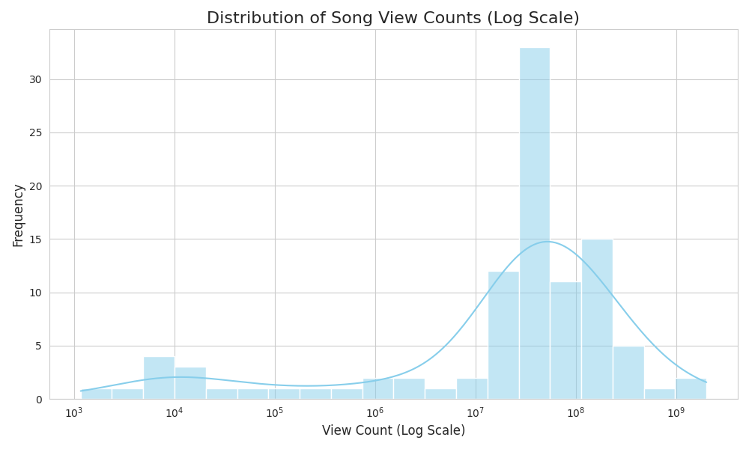

### Figure 2: View Count vs. Channel Followers

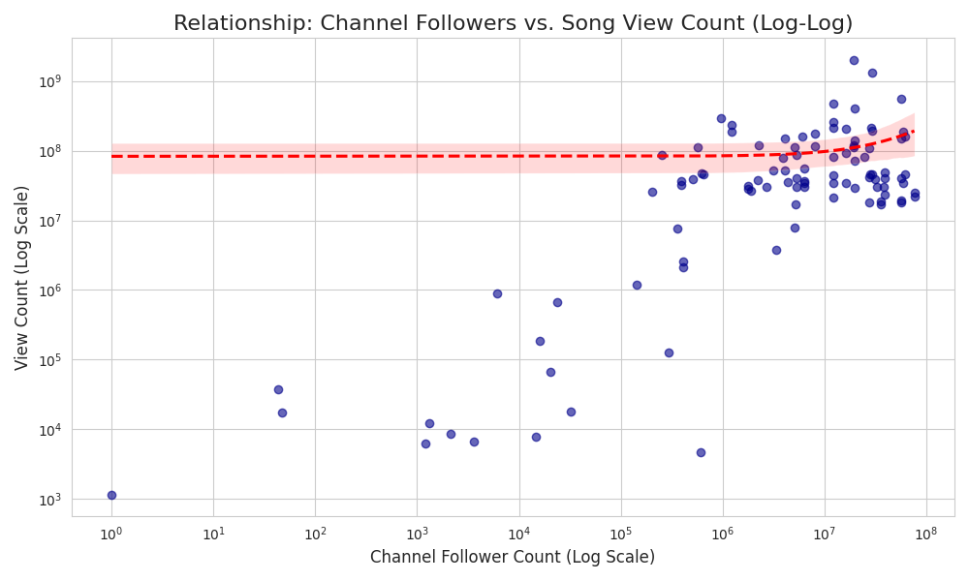

### Figure 3: Top 10 Most Frequent Tags

