# Physicochemical Analysis of Banana Sap

This document presents a physicochemical analysis of banana sap. Parameters measured include ethanol concentration, ethanol yield, pH, density, viscosity, and total acidity. Each result is visualized with plots and discussed in detail.

## Table 1: Physicochemical Parameters

|  |  |
| --- | --- |
| Parameter | Banana |
| Ethanol concentration (%) | 32.7 |
| Ethanol yield | 0.5 |
| pH | 5.4 |
| Density (g/cm³) | 0.98 |
| Viscosity (mPa·s) | 1.3 |
| Total acidity (%) | 0.5 |

## Figures

Ethanol concentration (%)

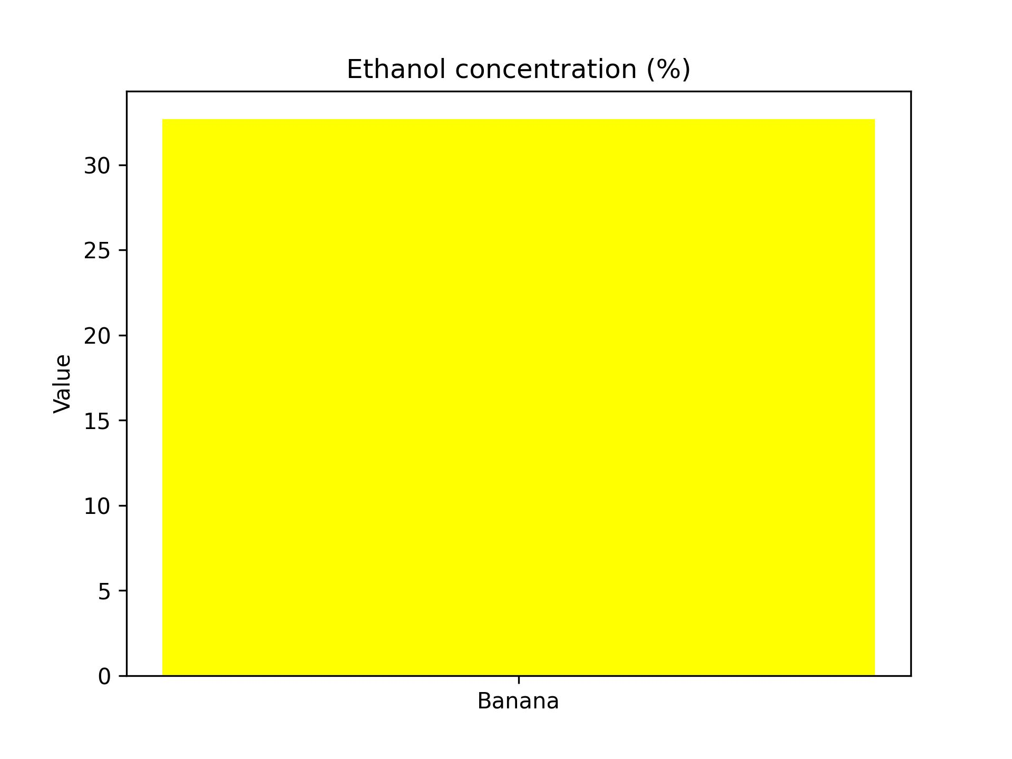

Ethanol yield

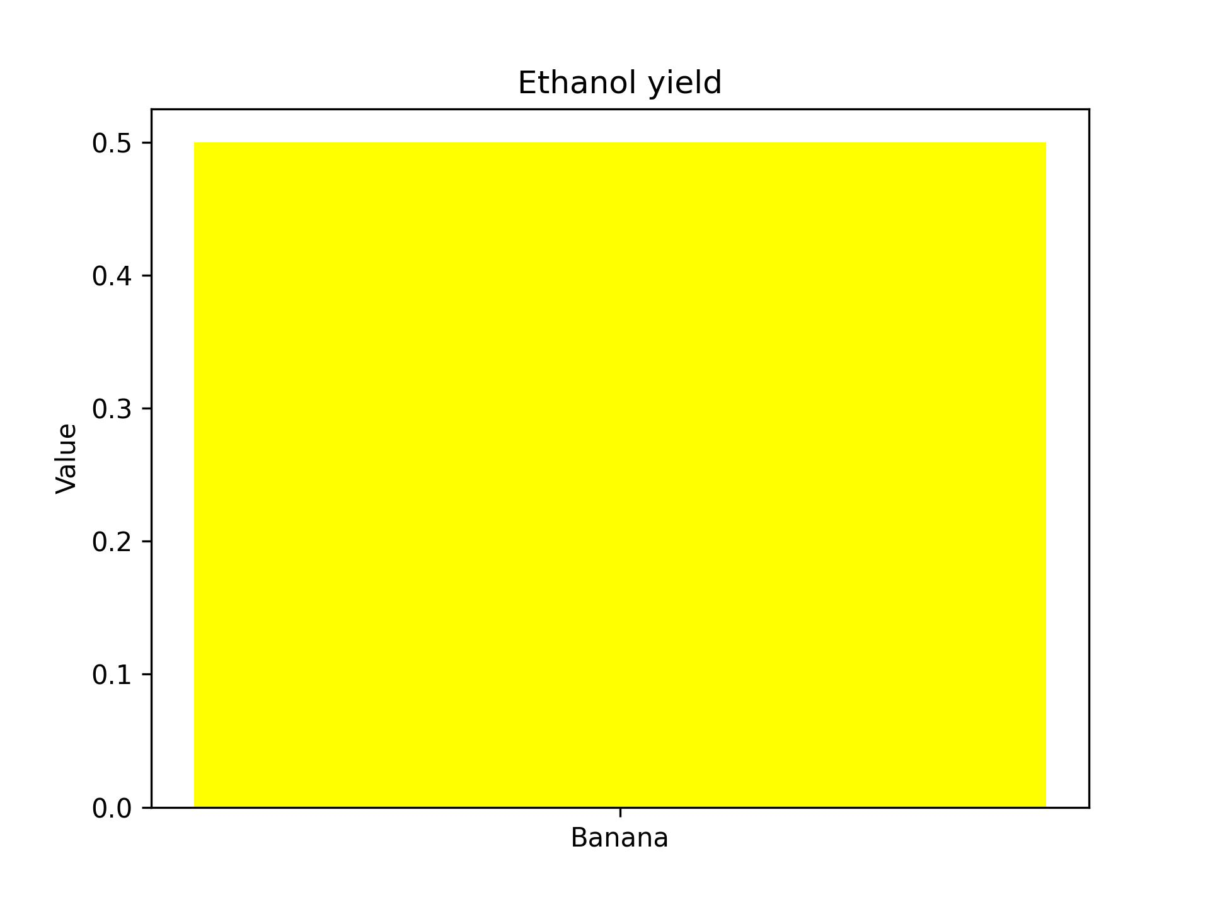

pH

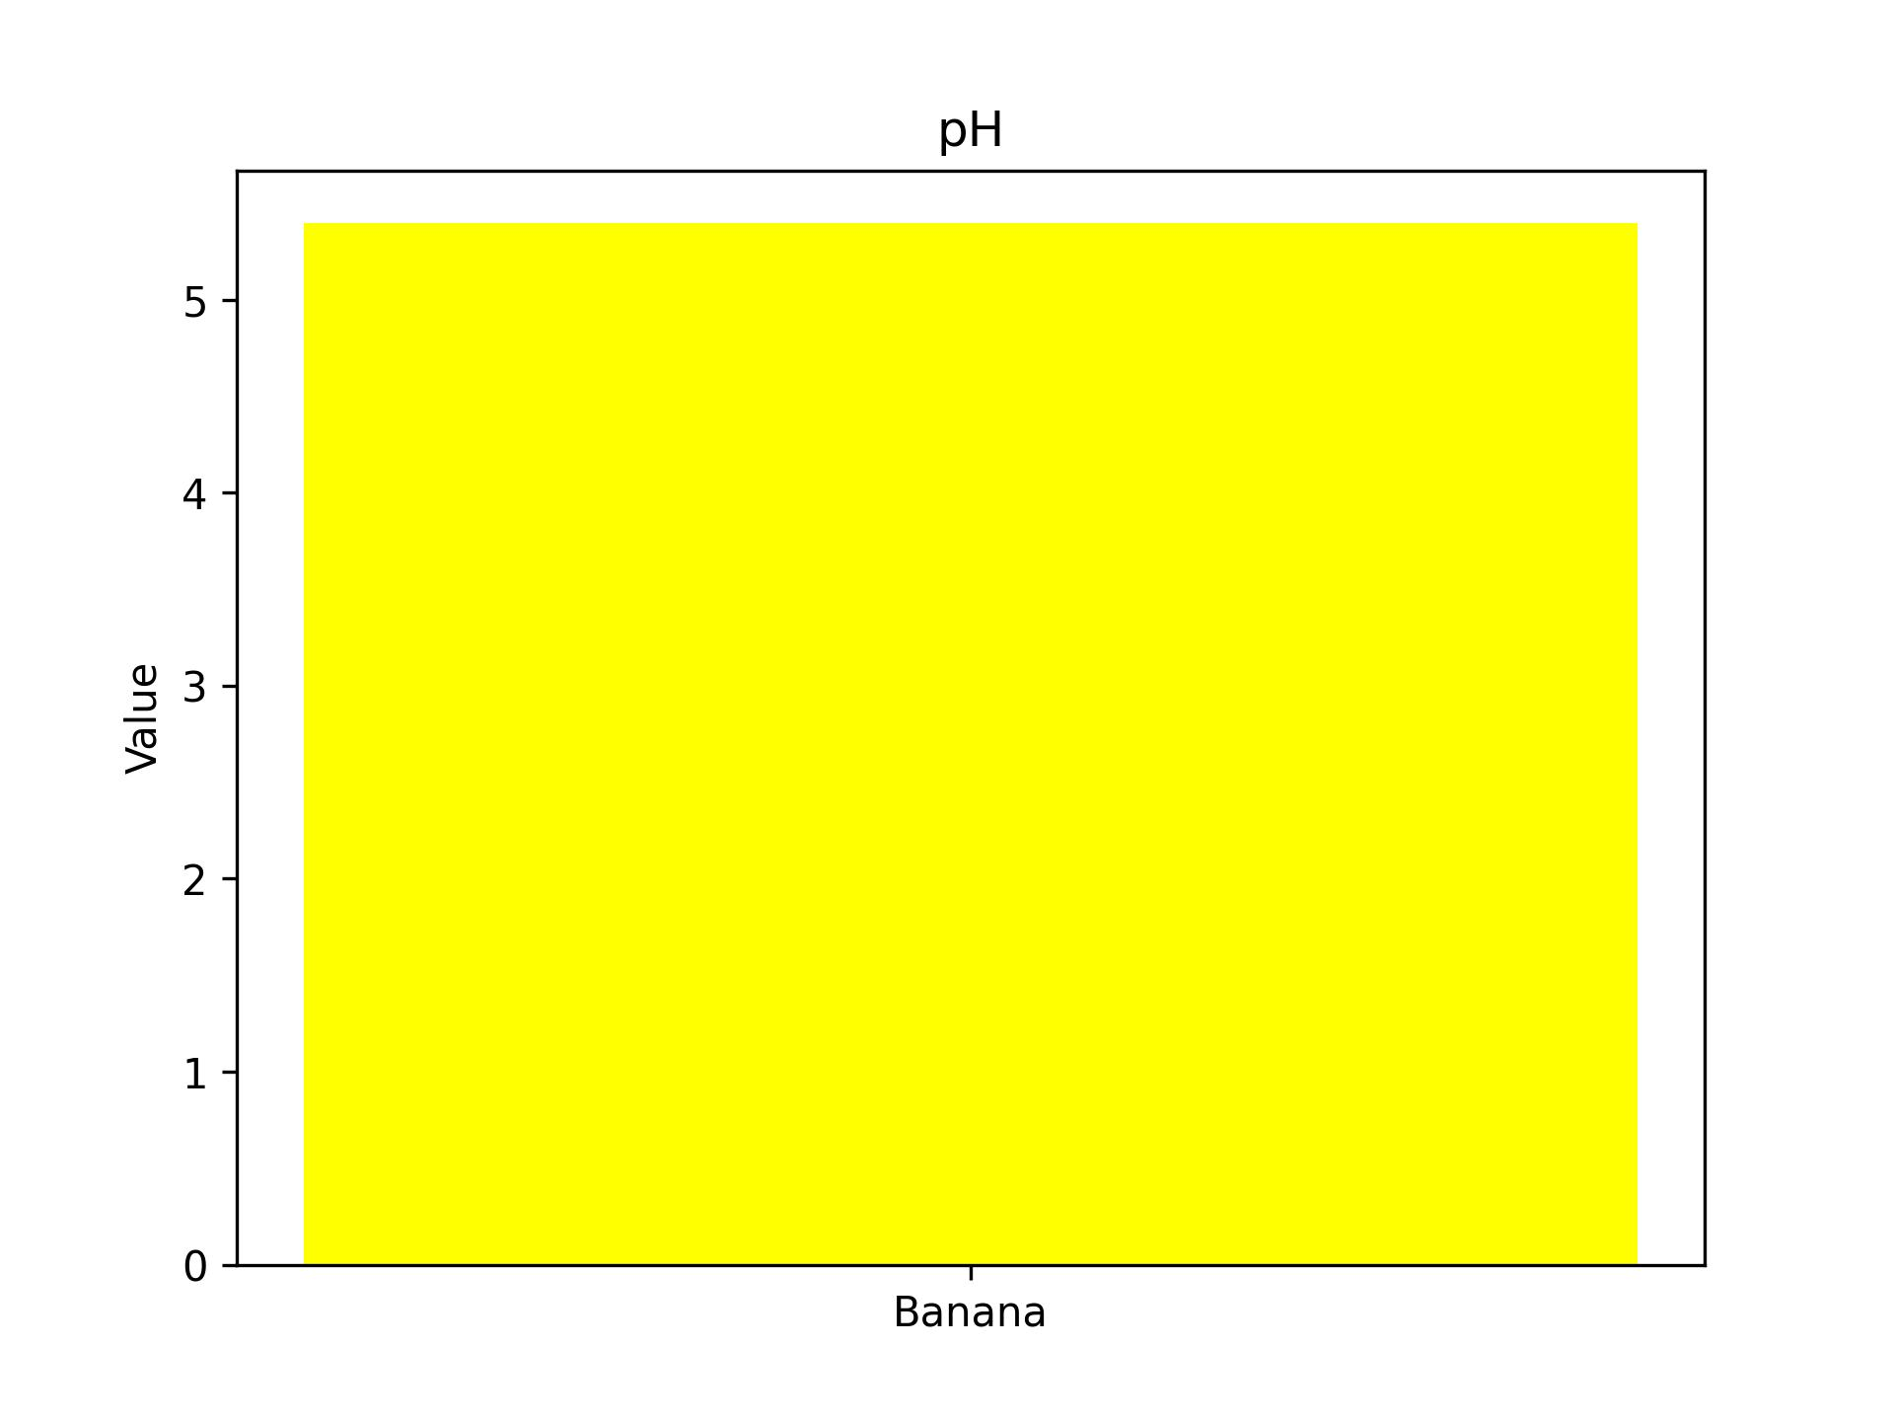

Density (g/cm³)

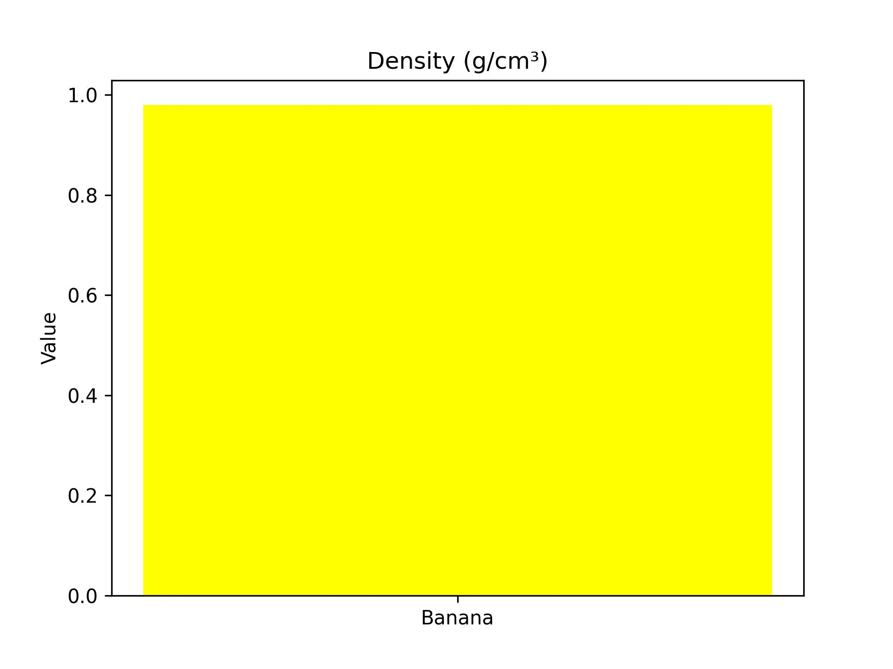

Viscosity (mPa·s)

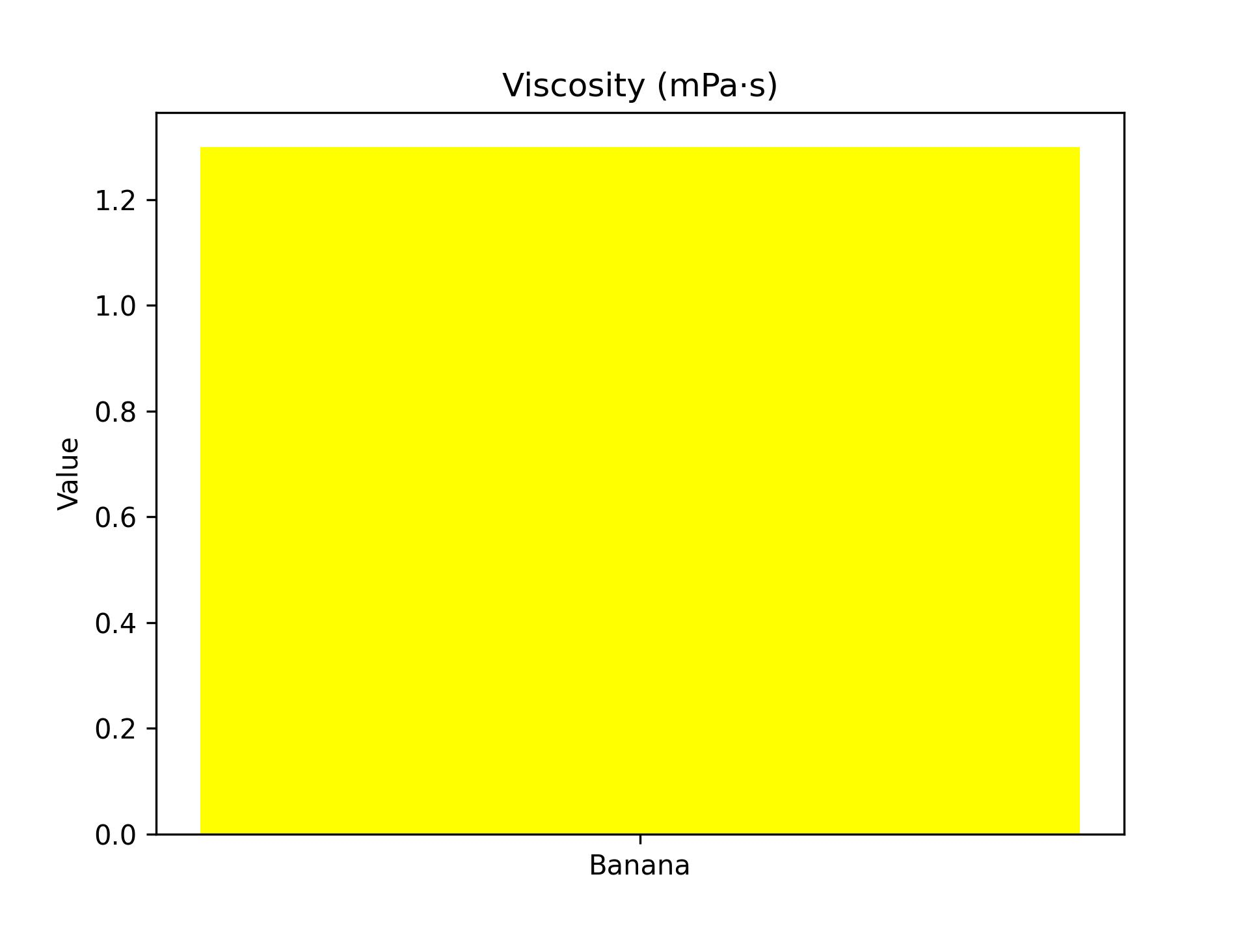

Total acidity (%)

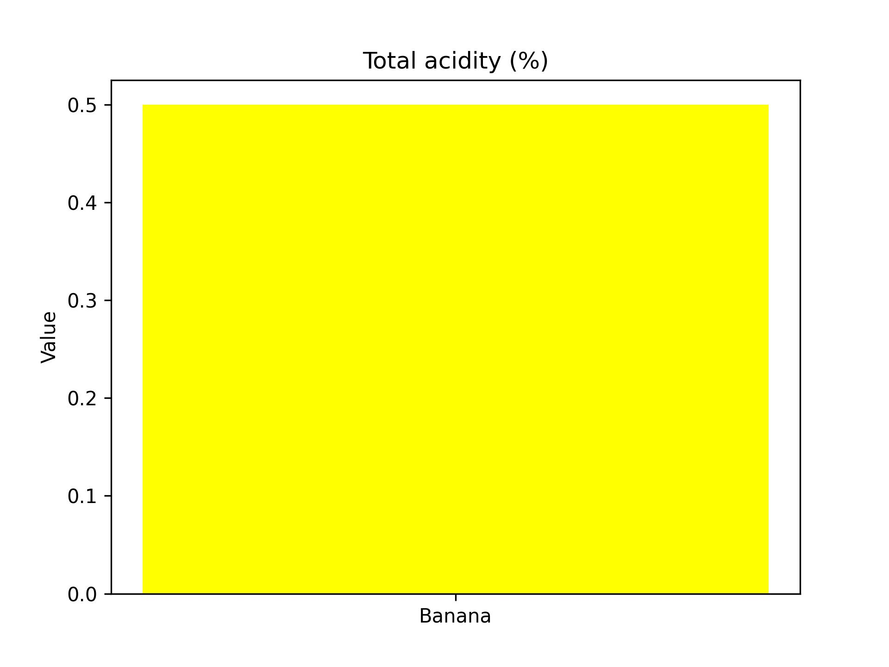

## Discussion

The physicochemical characteristics of banana sap highlight its unique biochemical   
properties and potential industrial applications. The ethanol concentration (32.70%)   
is moderate and slightly lower than that of plantain, suggesting comparatively fewer   
fermentable sugars or less efficient fermentation dynamics. Ethanol yield (0.50)   
reinforces this, indicating reduced bioethanol conversion efficiency.  
  
The sap’s pH of 5.4 falls within the acceptable fermentation range, yet it is slightly   
lower than plantain sap, reflecting higher acidity. This is further confirmed by the   
total acidity value of 0.50%, which surpasses plantain sap. Such acidity can influence   
the sensory properties of beverages, contributing to a sharper taste profile, while   
also impacting microbial activity during storage and fermentation.  
  
Banana sap’s viscosity is relatively low (1.30 mPa·s), suggesting fewer soluble solids   
and a lighter texture compared to plantain. This property can facilitate faster   
fermentation kinetics, as lower viscosity typically allows better mass transfer of   
substrates and metabolites. The density value (0.98 g/cm³) is consistent with that   
of plantain sap, indicating similar overall soluble solid concentrations.  
  
In summary, banana sap demonstrates moderate ethanol production potential but excels   
in acidity and lower viscosity. These attributes may make it more suitable for   
applications in food and beverage industries where acidity is desirable, rather than   
solely for bioethanol production. Further studies should evaluate sensory attributes,   
microbial ecology, and optimization strategies to enhance its industrial utility.