# Physicochemical Analysis of Plantain Sap

This document presents a physicochemical analysis of plantain sap. Parameters measured include ethanol concentration, ethanol yield, pH, density, viscosity, and total acidity. Each result is visualized with plots and discussed in detail.

## Table 1: Physicochemical Parameters

|  |  |
| --- | --- |
| Parameter | Plantain |
| Ethanol concentration (%) | 36.5 |
| Ethanol yield | 0.62 |
| pH | 5.6 |
| Density (g/cm³) | 0.98 |
| Viscosity (mPa·s) | 1.7 |
| Total acidity (%) | 0.4 |

## Figures

Ethanol concentration (%)

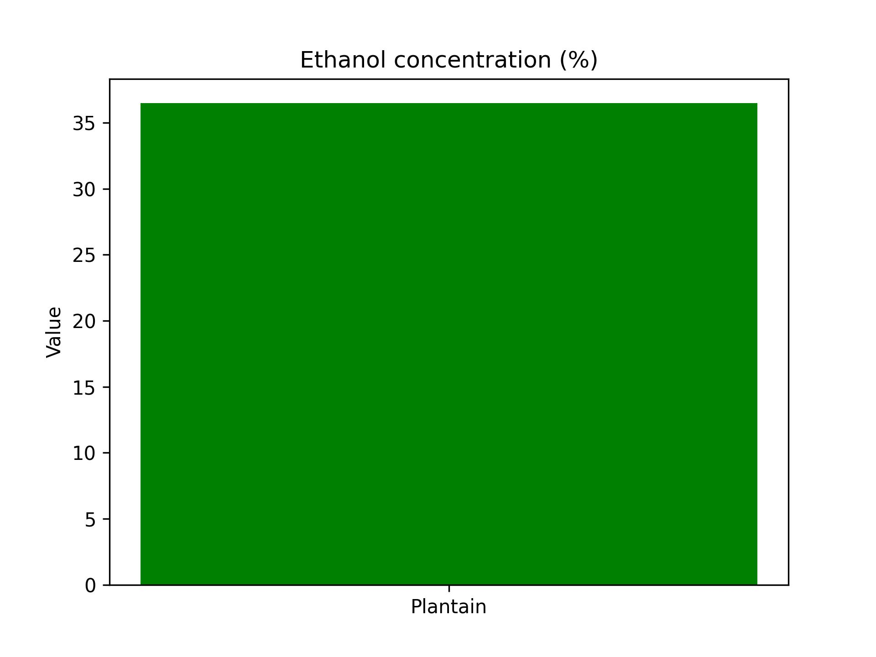

Ethanol yield

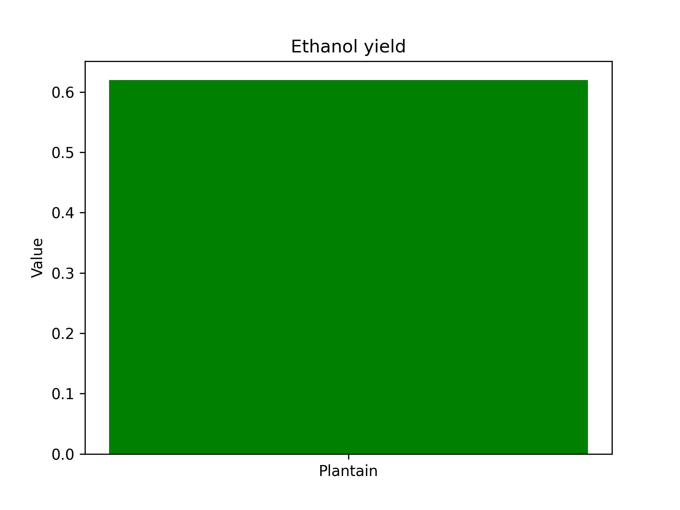

pH

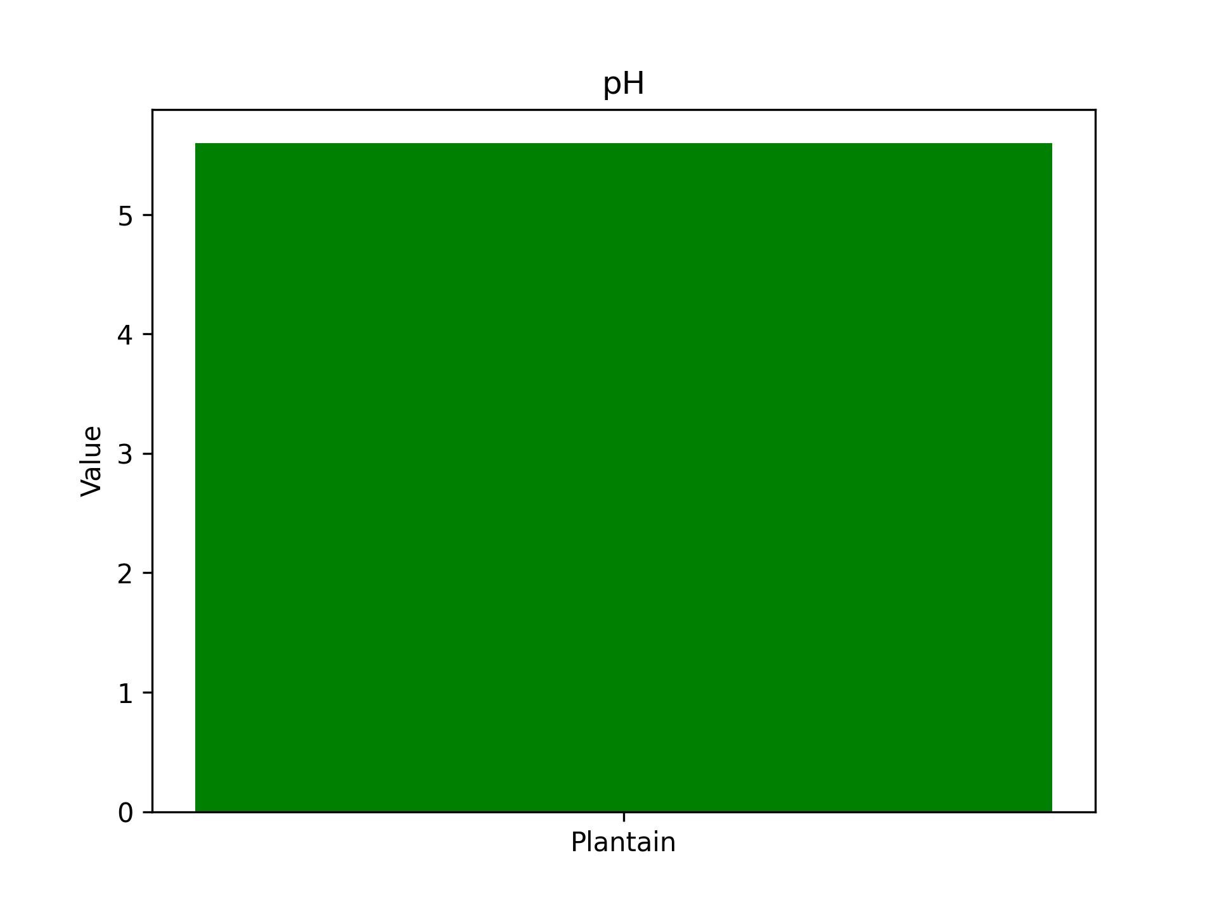

Density (g/cm³)

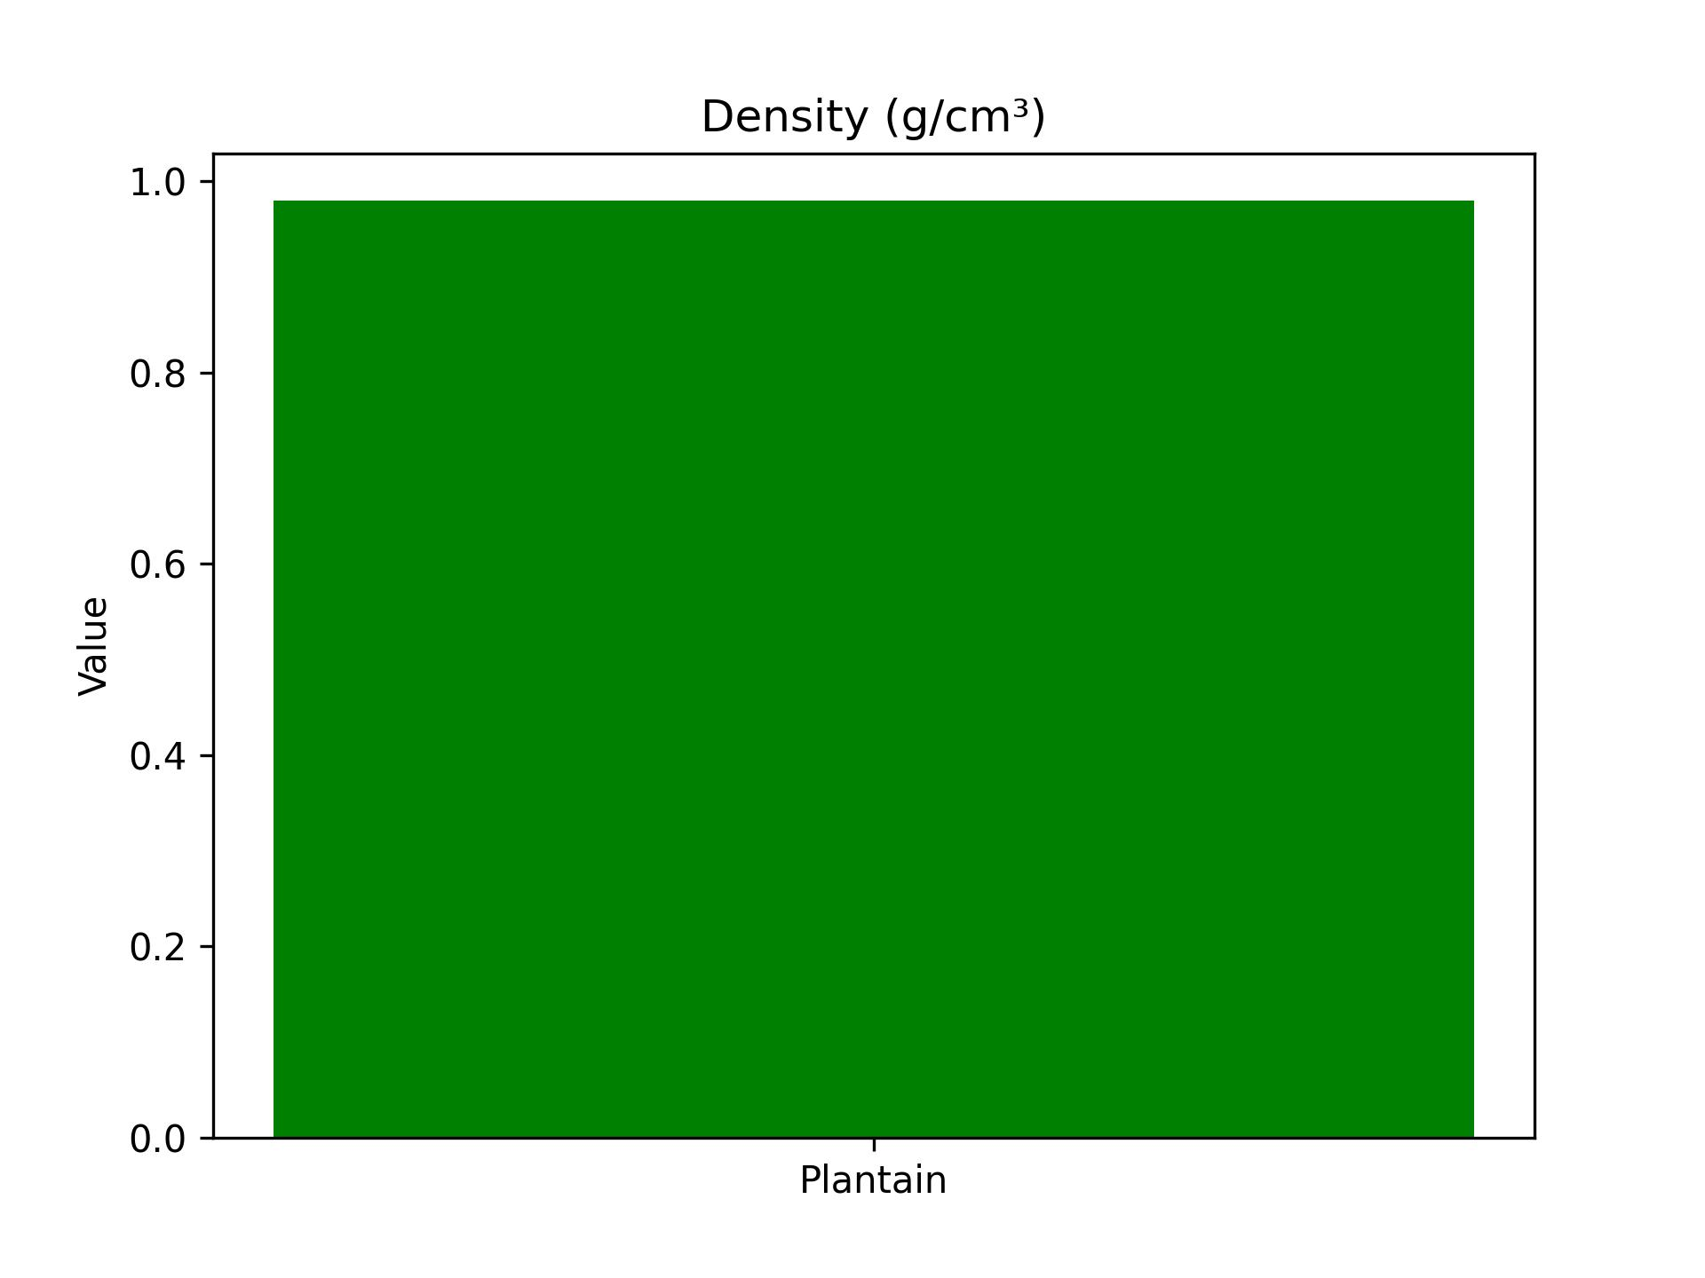

Viscosity (mPa·s)

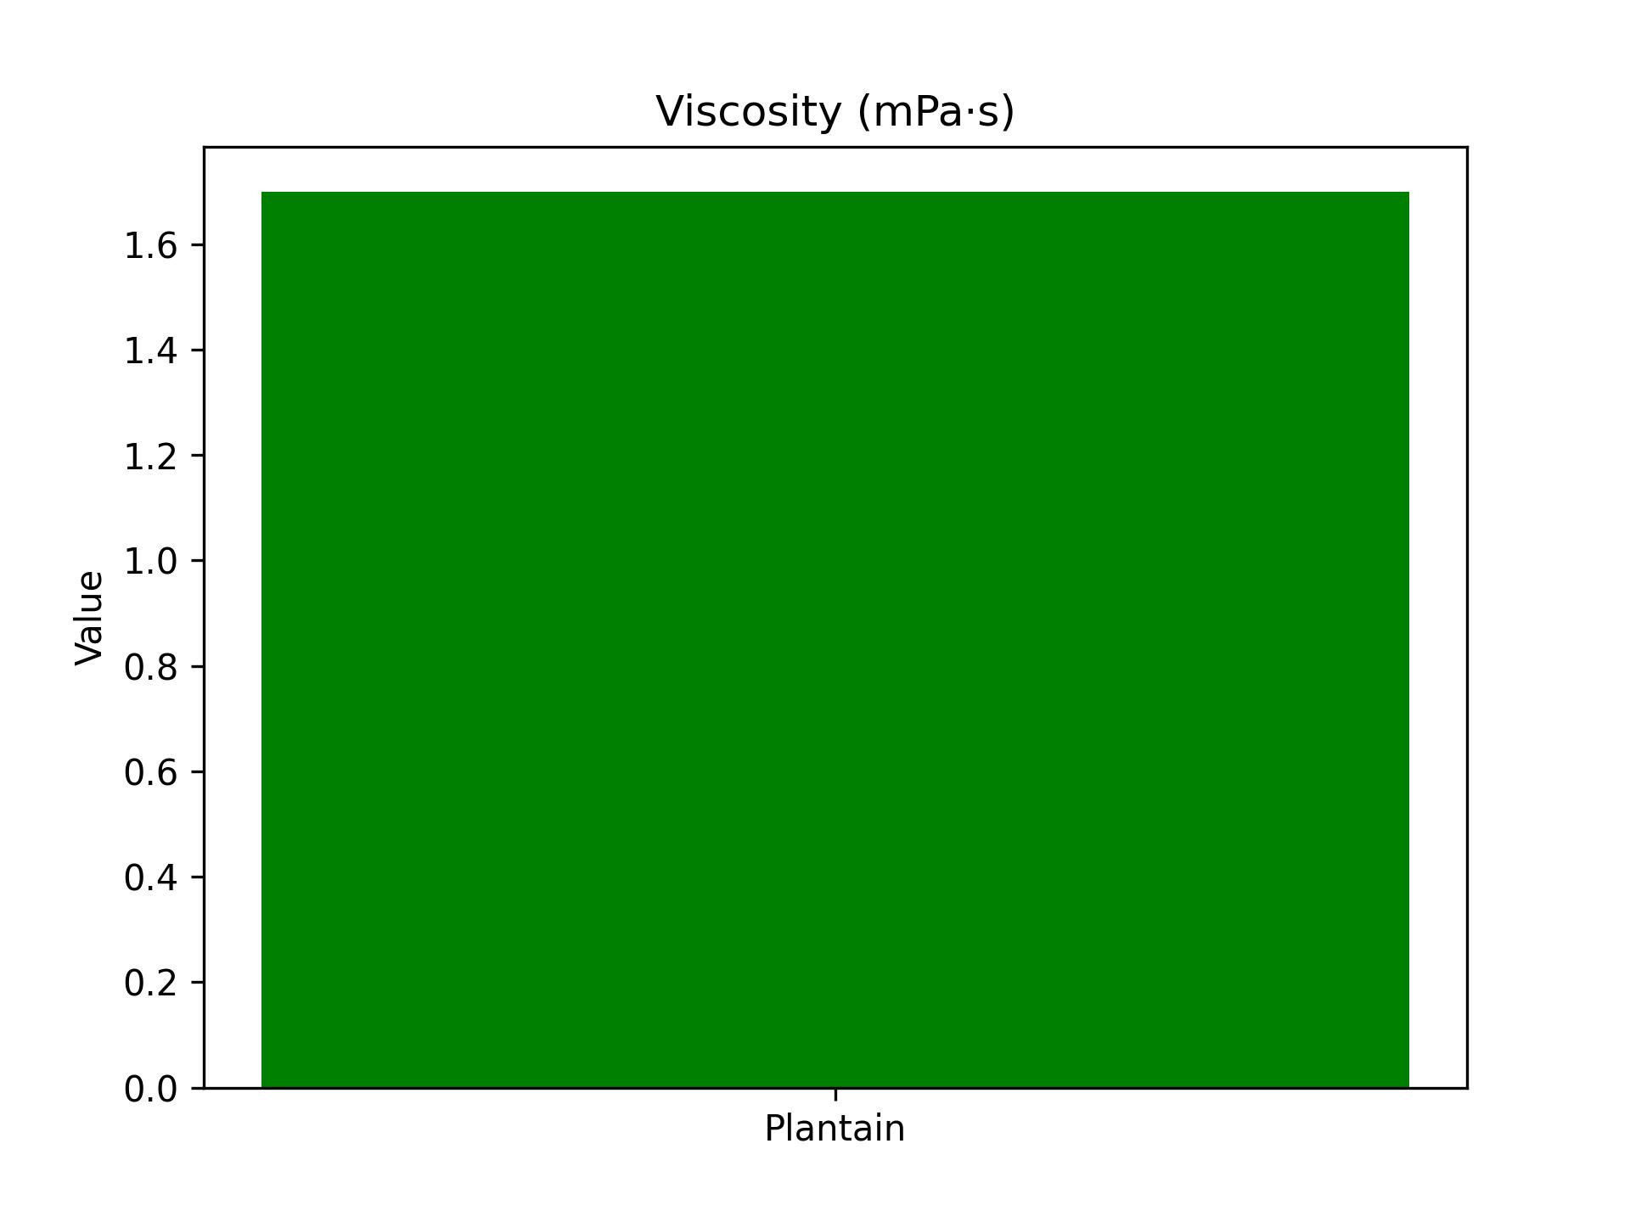

Total acidity (%)

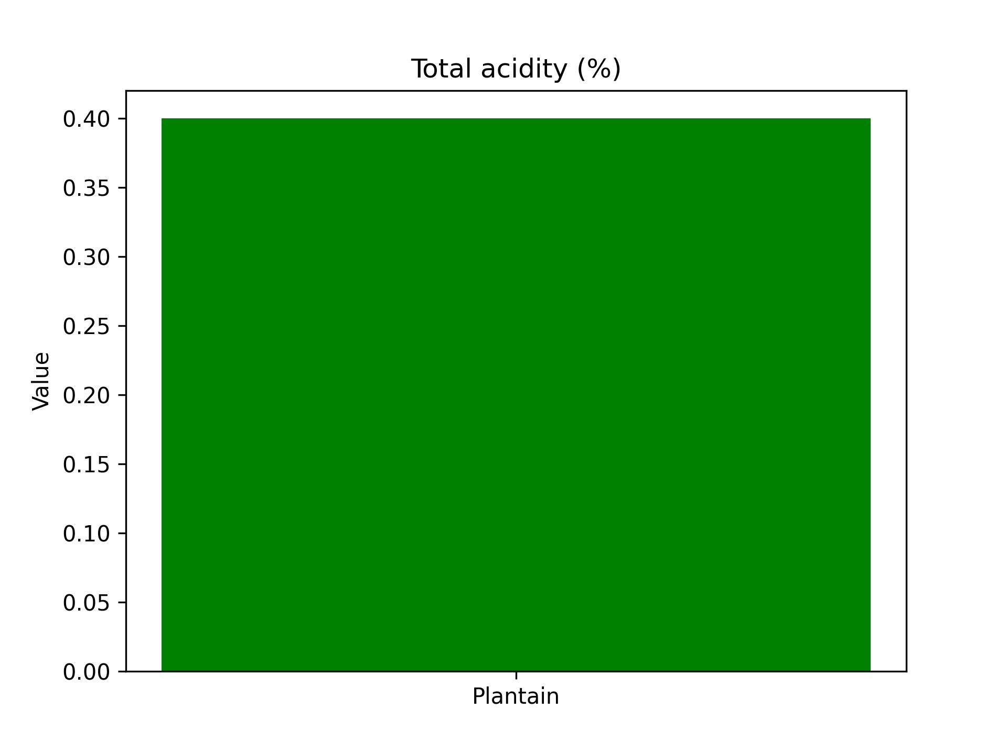

## Discussion

The physicochemical profile of plantain sap reveals a strong potential for fermentation   
and bioethanol production. The ethanol concentration (36.50%) is relatively high,   
suggesting that plantain sap possesses a rich pool of fermentable sugars. This is   
further supported by the ethanol yield of 0.62, which demonstrates favorable conversion   
efficiency. Such findings align with previous studies that report plantain cultivars   
as having higher starch and sugar reserves than bananas.  
  
The measured pH of 5.6 indicates moderate acidity, which is within the tolerance range   
for common fermenting microorganisms such as Saccharomyces cerevisiae. This makes the   
sap conducive for controlled fermentation. The total acidity value (0.40%) confirms   
that plantain sap is less acidic compared to banana sap, potentially giving it an   
advantage in maintaining microbial stability without excessive sourness.  
  
Viscosity is relatively high (1.70 mPa·s), which could be attributed to soluble fiber   
and polysaccharides. While this may slow fermentation kinetics, it also suggests   
greater nutritive density. Density (0.98 g/cm³) is comparable to most fruit juices,   
indicating balanced dissolved solids.  
  
Overall, plantain sap demonstrates significant potential as a substrate for bioethanol   
production and as a raw material in beverage formulations. Its high ethanol yield and   
moderate acidity make it a promising candidate for industrial applications. Future   
investigations should include replicates, microbial profiling, and kinetic modeling   
to optimize fermentation processes.