Statistical Analysis of Plantain Sap Fermentation

# Descriptive Statistics

Acid treatment: Mean=1.851, Std=0.125, Min=1.742, Max=1.985

Acid w/o organism: Mean=1.483, Std=0.165, Min=1.277, Max=1.623

Alkaline treatment: Mean=1.738, Std=0.137, Min=1.600, Max=1.892

Blank: Mean=0.000, Std=0.000, Min=0.000, Max=0.000

Enzyme: Mean=1.614, Std=0.075, Min=1.557, Max=1.714

Untreated: Mean=1.799, Std=0.107, Min=1.692, Max=1.943

# ANOVA Result

F-statistic: 151.724, p-value: 0.00000

# Pairwise T-Test Results

|  |  |  |  |
| --- | --- | --- | --- |
| Group 1 | Group 2 | t-statistic | p-value |
| Blank | Untreated | -33.549 | 0.0 |
| Blank | Acid treatment | -29.564 | 0.0 |
| Blank | Alkaline treatment | -25.425 | 0.0 |
| Blank | Enzyme | -43.301 | 0.0 |
| Blank | Acid w/o organism | -17.953 | 0.0 |
| Untreated | Acid treatment | -0.631 | 0.55148 |
| Untreated | Alkaline treatment | 0.711 | 0.50387 |
| Untreated | Enzyme | 2.84 | 0.02955 |
| Untreated | Acid w/o organism | 3.211 | 0.01834 |
| Acid treatment | Alkaline treatment | 1.227 | 0.2657 |
| Acid treatment | Enzyme | 3.259 | 0.01726 |
| Acid treatment | Acid w/o organism | 3.553 | 0.01203 |
| Alkaline treatment | Enzyme | 1.59 | 0.16298 |
| Alkaline treatment | Acid w/o organism | 2.374 | 0.05523 |
| Enzyme | Acid w/o organism | 1.443 | 0.19918 |

# Graphs

Line Plot:

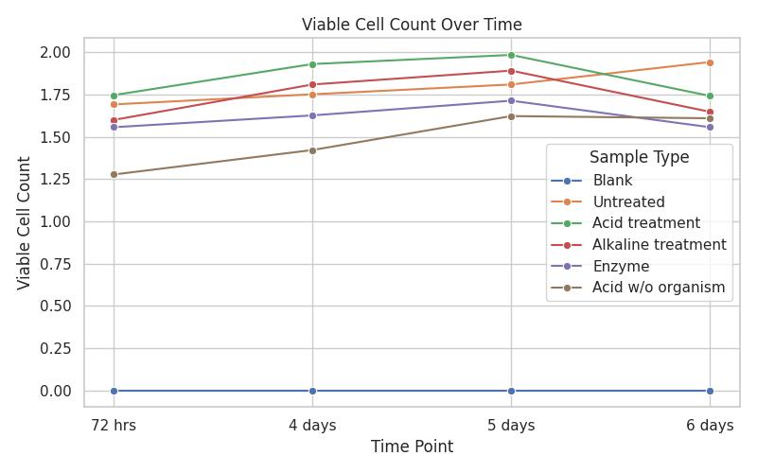

Bar Chart:

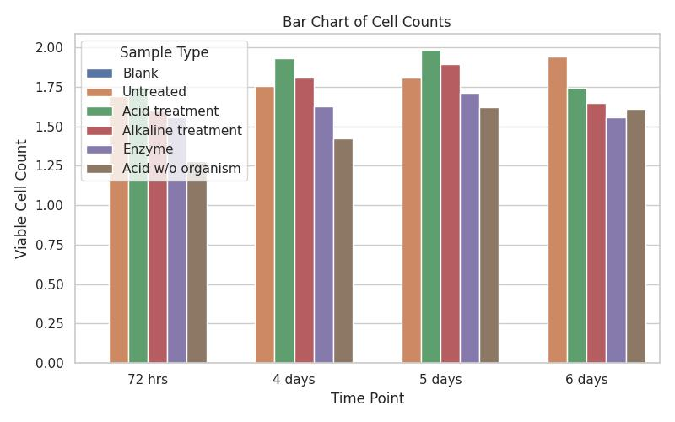

Box Plot:

