Banana Sap Composition Analysis

This document presents the proximate composition of banana sap and highlights key metrics relevant for bioethanol production.

# Proximate Composition

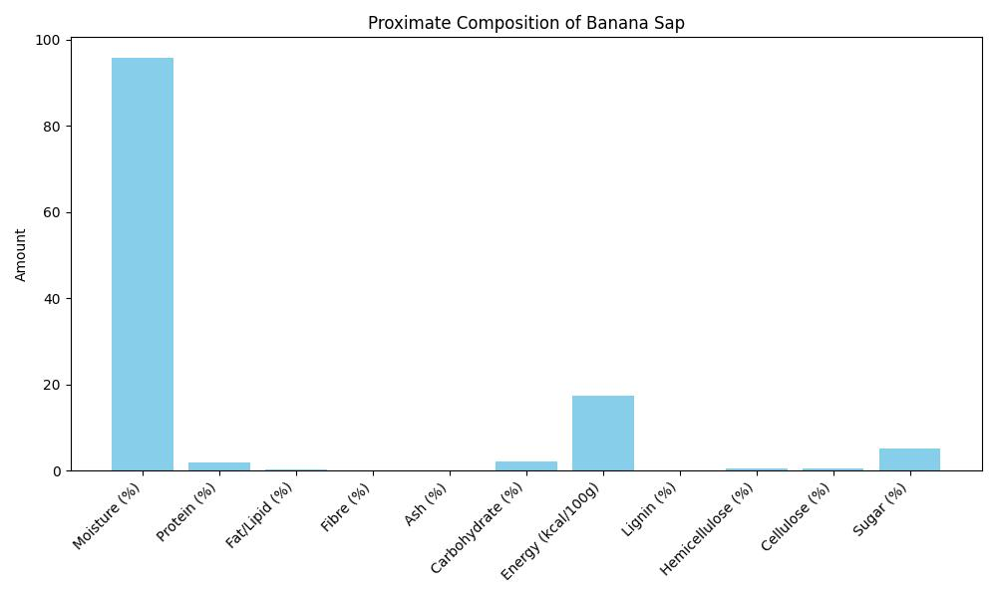

# Bioethanol-Relevant Metrics

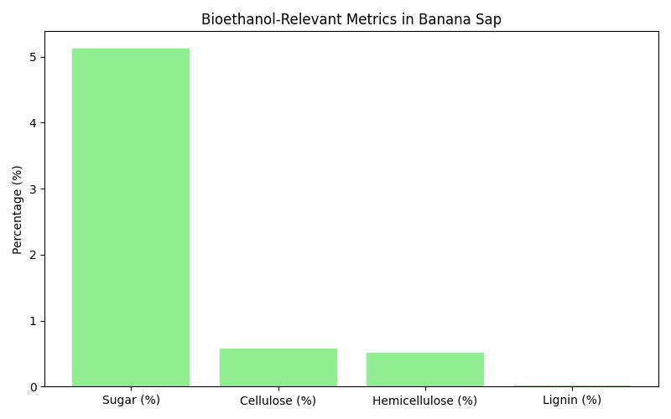

Sugar, cellulose, hemicellulose, and lignin are important components for evaluating bioethanol potential. Banana sap shows promising sugar content with moderate cellulose and hemicellulose levels.