Statistical and Bioethanol Analysis of Banana Sap

# General Composition Data

|  |  |
| --- | --- |
| Metric | Value |
| Moisture (%) | 95.81 |
| Protein (%) | 1.75 |
| Fat/Lipid (%) | 0.23 |
| Fibre (%) | 0.0 |
| Ash (%) | 0.12 |
| Carbohydrate (%) | 2.08 |
| Energy (kcal/100g) | 17.39 |
| Lignin (%) | 0.01 |
| Hemicellulose (%) | 0.51 |
| Cellulose (%) | 0.58 |
| Sugar (%) | 5.13 |

# Derived Metrics

|  |  |
| --- | --- |
| Metric | Value |
| Moisture (%) | 95.81 |
| Dry matter (%) | 4.19 |
| Sugar (g / 100 g fresh) | 5.13 |
| Energy (kcal / 100 g fresh) | 17.39 |
| Energy per sugar (kcal per g sugar) | 3.39 |
| Theoretical ethanol yield (g/100 g fresh) | 2.62 |

# Proximate Composition

The proximate composition values are presented below:

|  |  |
| --- | --- |
| Component | Percentage (%) |
| Moisture (%) | 95.81 |
| Protein (%) | 1.75 |
| Fat/Lipid (%) | 0.23 |
| Fibre (%) | 0.00 |
| Ash (%) | 0.12 |
| Carbohydrate (%) | 2.08 |

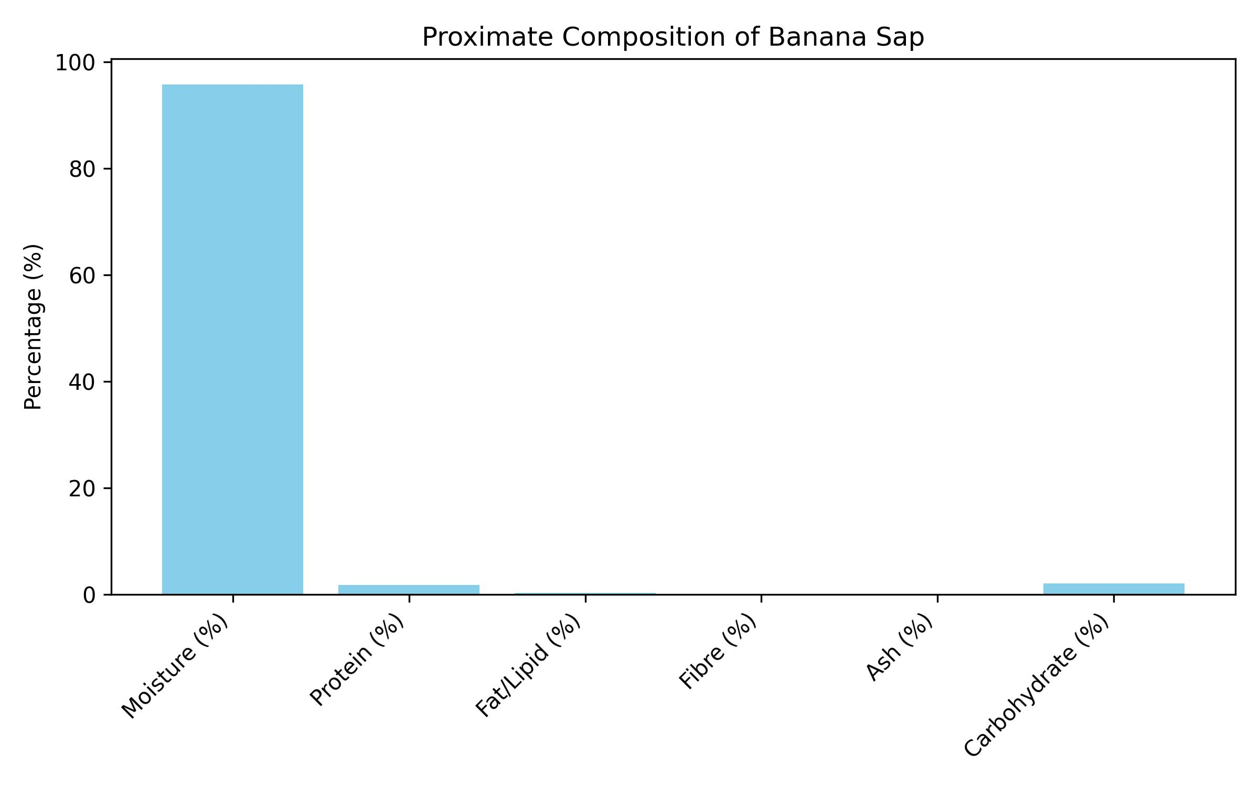

## Discussion: Proximate Composition

The proximate composition shows that banana sap is overwhelmingly composed of moisture (95.81%%), leaving only 4.19%% dry matter. Within the dry matter, protein (1.75%%), lipid (0.23%%), ash (0.12%%), and fibre are present only in trace amounts. Carbohydrates (2.08%%) constitute the main component of the solid fraction, which is important for nutritional and biochemical relevance.

# Bioethanol-Relevant Metrics

The bioethanol-relevant metrics are summarized below:

|  |  |
| --- | --- |
| Metric | Value |
| Energy (kcal/100g) | 17.39 |
| Lignin (%) | 0.01 |
| Hemicellulose (%) | 0.51 |
| Cellulose (%) | 0.58 |
| Sugar (%) | 5.13 |

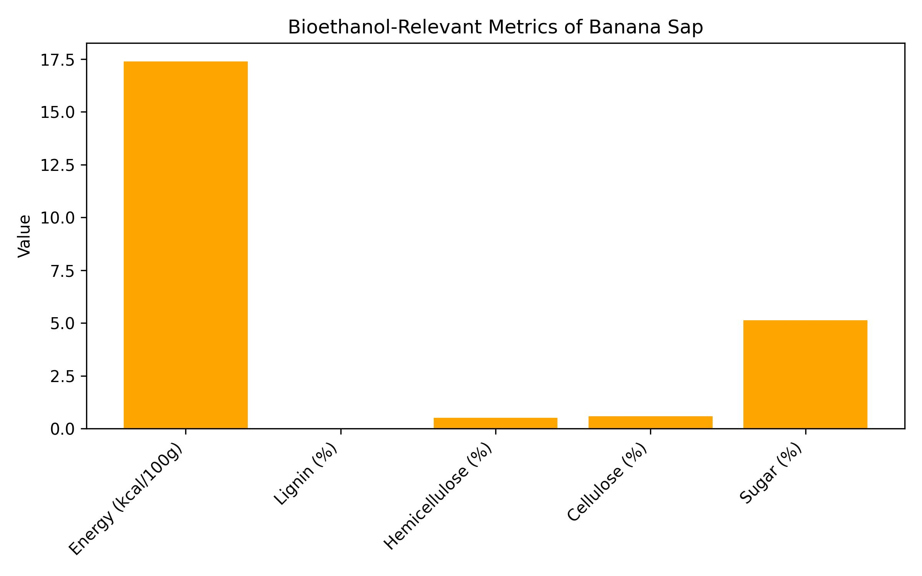

## Discussion: Bioethanol-Relevant Metrics

Among the bioethanol-relevant metrics, sugars (5.13%%) are the most significant fraction, directly contributing to fermentable substrate. The energy content (17.39 kcal/100 g) is modest but aligns with the high water fraction. Lignin (0.01%%), hemicellulose (0.51%%), and cellulose (0.58%%) are present in trace amounts, suggesting limited structural biomass but minimal inhibitory effects for fermentation. The calculated ethanol yield of 2.62 g per 100 g sap underscores its potential in bioethanol applications.

# Conclusion

In conclusion, banana sap is predominantly water but contains a fermentable sugar fraction that makes it relevant in bioethanol research. While its proximate composition indicates low nutritional value beyond hydration, the bioethanol-relevant metrics highlight a modest but usable sugar source. The low lignin and cellulose contents also suggest that fermentation can proceed with minimal pretreatment, making banana sap an interesting supplementary substrate for sustainable biofuel production.