Bioethanol Property Analysis

# Thermal Properties

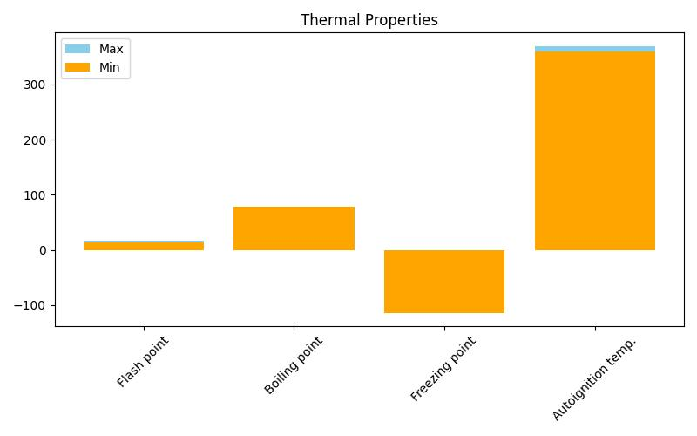

# Performance Indicators

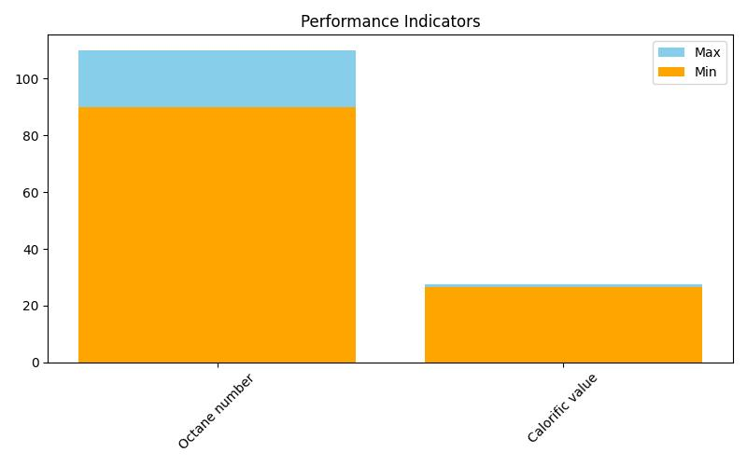

# Physical Characteristics

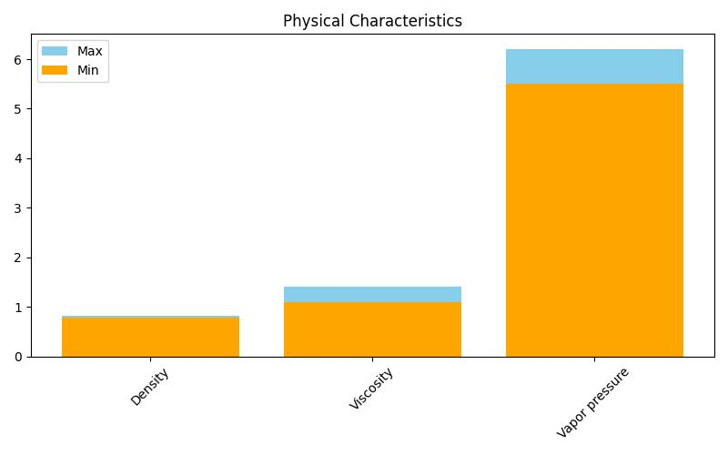

# Radar Chart Overview

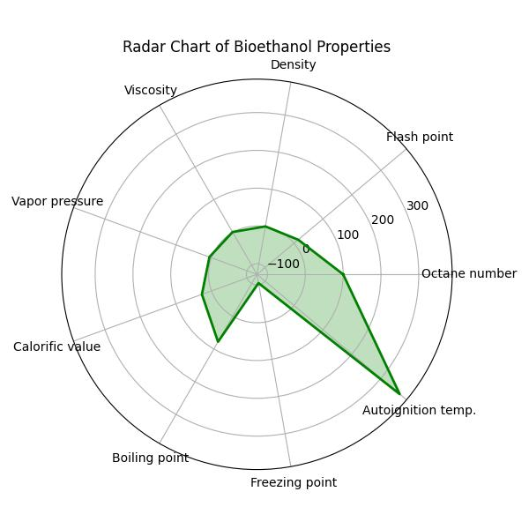

This report visualizes the key physical and chemical properties of bioethanol, highlighting its suitability as a fuel based on performance, thermal behavior, and physical traits.