Analysis of Plantain Sap Composition for Bioethanol Production

# Proximate Composition

|  |  |
| --- | --- |
| Component | Value (%) |
| Moisture | 95.62 |
| Protein | 1.63 |
| Fat/Lipid | 0.25 |
| Fibre | 0.0 |
| Ash | 0.15 |
| Carbohydrate | 2.34 |

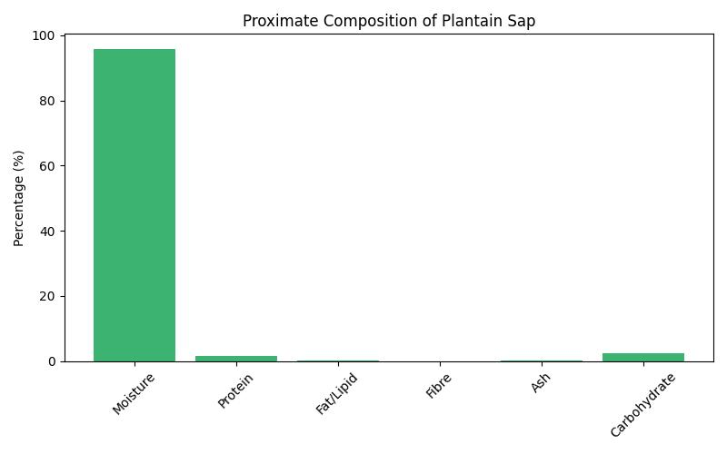

# Bioethanol-Relevant Metrics

|  |  |
| --- | --- |
| Component | Value |
| Energy | 18.13 |
| Lignin | 0.01 |
| Hemicellulose | 0.52 |
| Cellulose | 0.61 |
| Sugar | 5.13 |

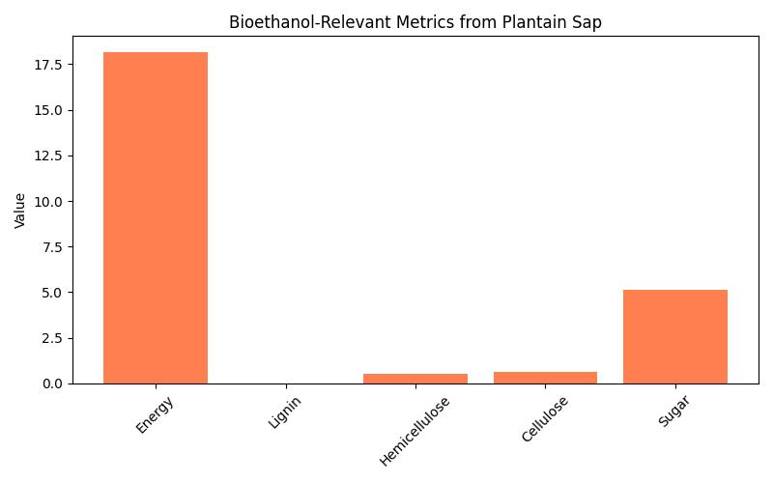

# Discussion

The proximate composition of plantain sap reveals an exceptionally high moisture content (95.62%), which may dilute fermentable substrates and affect fermentation efficiency. Protein (1.63%) and fat (0.25%) are present in low quantities, while fibre was not detected, suggesting minimal structural complexity.  
  
Carbohydrate content (2.34%) and sugar concentration (5.13 g/100g) indicate a modest potential for microbial fermentation. Bioethanol-relevant metrics such as cellulose (0.61%) and hemicellulose (0.52%) are relatively low, while lignin (0.01%) is nearly absent, which may reduce the need for pretreatment.  
  
The energy value (18.13 MJ/kg) supports its viability as a biofuel source. These findings align with observations by Rakhonde et al. (2019), who emphasized banana sap’s potential for ethanol recovery, and extend the scope to plantain sap, which shows similar but slightly more dilute characteristics.  
  
Overall, plantain sap presents a viable substrate for bioethanol production, particularly due to its low lignin content and moderate sugar levels, though its high moisture may require concentration or blending with other biomass sources.

# References

1. Rakhonde MG, Waghmare GM, Garud HS. (2019). Production of bioethanol from banana scuitched sap. International Journal of Chemical Studies, 7(1): 2369–2371. https://www.chemijournal.com/archives/2019/vol7issue1/PartAO/7-1-556-203.pdf

2. Wani S, Patil D. (2025). Nutritional and Biological Analysis of Nutrient-dense Banana Sap Water. International Journal of Environmental and Agriculture Research. https://ijoear.com/assets/articles_menuscripts/file/IJOEAR-JUL-2025-2.pdf