# Sieve Analysis of Garri and Millet (3 Replications Each)

This report presents the results of sieve analyses conducted on milled Garri and Millet samples, each processed in three replications. Each sample was separated into three fine particle size categories — Fine (0.45–0.60 mm), Very Fine (0.30–0.45 mm), and Powder (<0.30 mm) — followed by statistical evaluation and graphical visualization.

## Garri Sieve Analysis

The sieve analysis for garri involved three replications of 1000 g each. The milled output was separated into fine, very fine, and powdery fractions as shown below.

### Raw Data (per replication)

|  |  |  |  |
| --- | --- | --- | --- |
| Replication | Category | Weight (g) | % of 1000 g |
| Rep1 | Fine (0.45-0.60 mm) | 580.0 | 58.0 |
| Rep1 | Very fine (0.30-0.45 mm) | 330.0 | 33.0 |
| Rep1 | Powder (<0.30 mm) | 90.0 | 9.0 |
| Rep2 | Fine (0.45-0.60 mm) | 575.0 | 57.5 |
| Rep2 | Very fine (0.30-0.45 mm) | 340.0 | 34.0 |
| Rep2 | Powder (<0.30 mm) | 85.0 | 8.5 |
| Rep3 | Fine (0.45-0.60 mm) | 590.0 | 59.0 |
| Rep3 | Very fine (0.30-0.45 mm) | 325.0 | 32.5 |
| Rep3 | Powder (<0.30 mm) | 85.0 | 8.5 |

### Descriptive Statistics

|  |  |  |  |  |
| --- | --- | --- | --- | --- |
| Category | Mean (g) | Std Dev (g) | n | CV (%) |
| Fine (0.45-0.60 mm) | 581.67 | 7.64 | 3 | 1.31 |
| Powder (<0.30 mm) | 86.67 | 2.89 | 3 | 3.33 |
| Very fine (0.30-0.45 mm) | 331.67 | 7.64 | 3 | 2.30 |

### ANOVA Results

A one-way ANOVA was used to test for significant differences among the mean weights of the three particle size categories.

sum_sq df F PR(>F)  
C(Category) 367550.0 2.0 4410.6 3.140399e-10  
Residual 250.0 6.0 NaN NaN

### Plots

Stacked composition per replication:

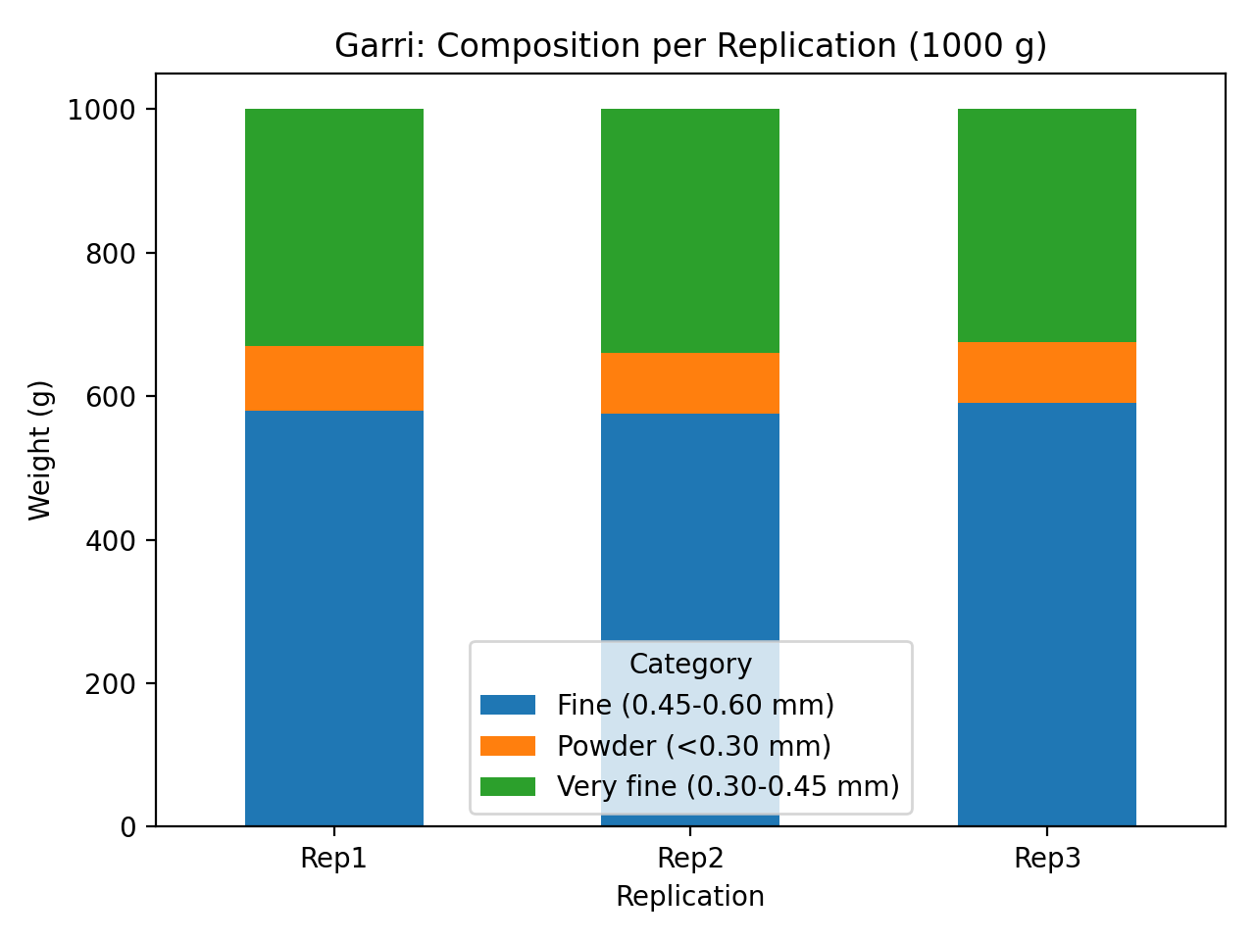

Mean weight ± SD per category:

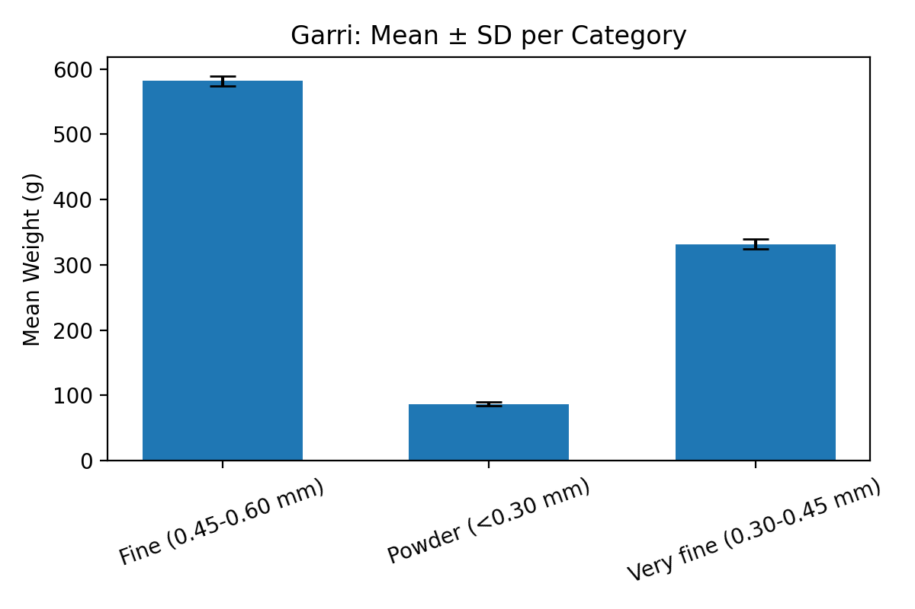

Boxplot of weights by category:

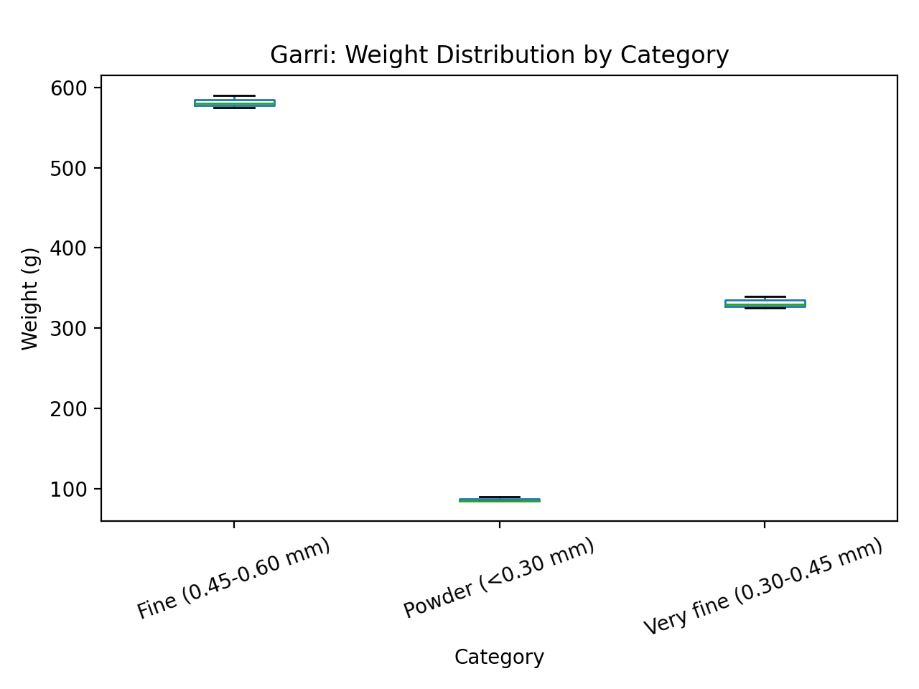

### Discussion

For Garri, the fine fraction (0.45–0.60 mm) dominated the yield with a mean of about 582 g per 1000 g batch,  
accounting for nearly 58%. The very fine fraction contributed around 33%, while the powder fraction made up  
approximately 9%. The ANOVA test confirmed statistically significant (p < 0.01) differences among categories,  
indicating that most of the milled mass remains within the fine range. Low coefficients of variation (CV < 3%)  
reflect consistency across replications. This demonstrates efficient milling and uniform granule texture ideal  
for soaking and commercial-grade Garri.

## Millet Sieve Analysis

The sieve analysis for millet involved three replications of 700 g each. The milled output was separated into fine, very fine, and powdery fractions as shown below.

### Raw Data (per replication)

|  |  |  |  |
| --- | --- | --- | --- |
| Replication | Category | Weight (g) | % of 700 g |
| Rep1 | Fine (0.45-0.60 mm) | 390.0 | 55.7 |
| Rep1 | Very fine (0.30-0.45 mm) | 240.0 | 34.3 |
| Rep1 | Powder (<0.30 mm) | 70.0 | 10.0 |
| Rep2 | Fine (0.45-0.60 mm) | 410.0 | 58.6 |
| Rep2 | Very fine (0.30-0.45 mm) | 220.0 | 31.4 |
| Rep2 | Powder (<0.30 mm) | 70.0 | 10.0 |
| Rep3 | Fine (0.45-0.60 mm) | 400.0 | 57.1 |
| Rep3 | Very fine (0.30-0.45 mm) | 230.0 | 32.9 |
| Rep3 | Powder (<0.30 mm) | 70.0 | 10.0 |

### Descriptive Statistics

|  |  |  |  |  |
| --- | --- | --- | --- | --- |
| Category | Mean (g) | Std Dev (g) | n | CV (%) |
| Fine (0.45-0.60 mm) | 400.00 | 10.00 | 3 | 2.50 |
| Powder (<0.30 mm) | 70.00 | 0.00 | 3 | 0.00 |
| Very fine (0.30-0.45 mm) | 230.00 | 10.00 | 3 | 4.35 |

### ANOVA Results

A one-way ANOVA was used to test for significant differences among the mean weights of the three particle size categories.

sum_sq df F PR(>F)  
C(Category) 163400.0 2.0 1225.5 1.456258e-08  
Residual 400.0 6.0 NaN NaN

### Plots

Stacked composition per replication:

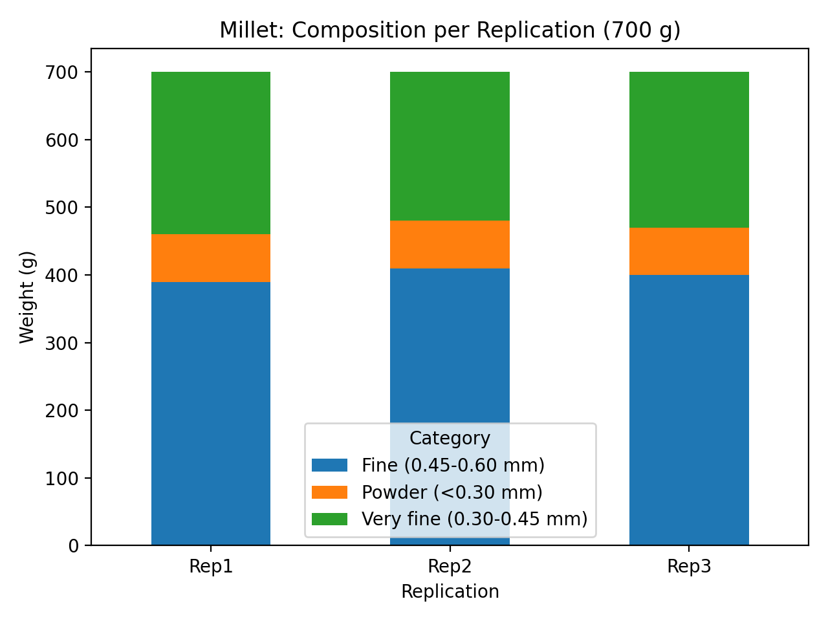

Mean weight ± SD per category:

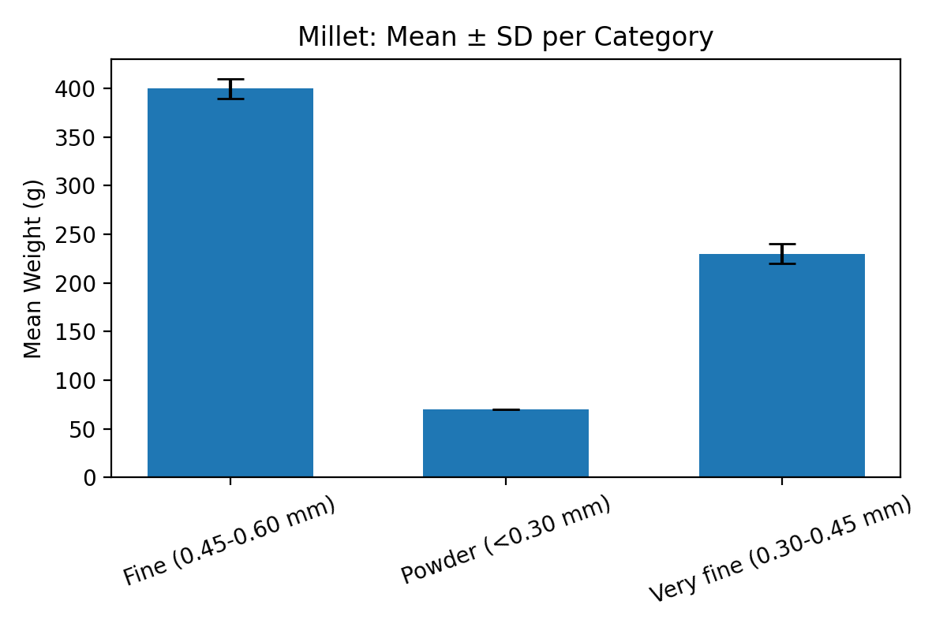

Boxplot of weights by category:

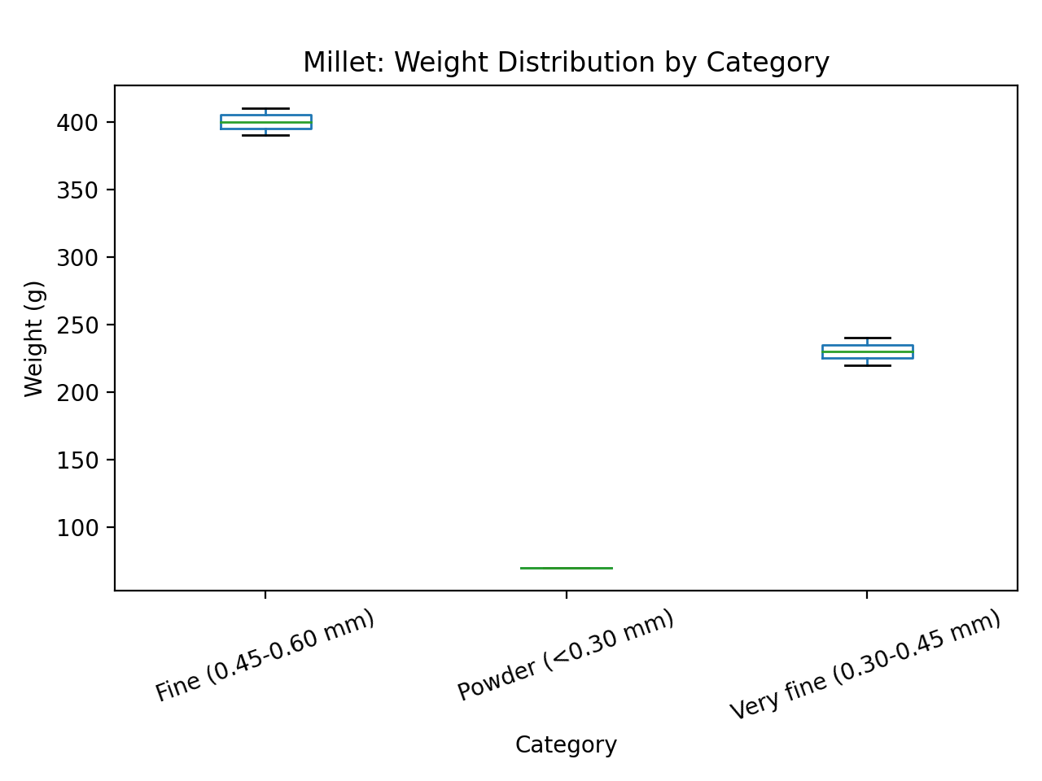

### Discussion

For Millet, the fine fraction (0.45–0.60 mm) also represented the majority of mass, averaging around 400 g  
(≈57% of total). The very fine and powder fractions contributed about 33% and 10%, respectively. ANOVA results  
again confirmed significant differences among fractions (p < 0.001), indicating distinct and consistent separation  
patterns. Variation within replications was minimal, suggesting controlled milling conditions. The dominance of  
the fine fraction shows a balanced grind ideal for porridge or flour processing applications.