**Design and Optimisation of an Energy-Efficient Charcoal Smoking Kiln for Small-Scale Fish Drying**

Benjamin Israel Jackson

Department of Agricultural & Food Engineering, University of Uyo, Nigeria

Email: 17/eg/ae/553@uniuyo.edu.ng

**Abstract**

A low-cost, clay-insulated charcoal kiln was developed to reduce post-harvest losses of catfish (Clarias gariepinus) under small-scale conditions. Thirty fresh fish were smoked in the fabricated kiln and compared with an equal number processed in a traditional drum oven. Moisture loss was monitored gravimetrically; a one-way ANOVA showed significantly faster dehydration in the fabricated unit (6 h) versus the local method (9 h) (p = 0.016). Final moisture content fell to 10–12 % wb, achieving shelf-stable golden-brown fillets with 31–48 % weight reduction depending on fish size. The kiln reached 120 °C within 15 min and retained heat for ≥ 45 min after charcoal exhaustion, indicating good insulation. Energy efficiency was ≈ 35 % higher and labour requirement 40 % lower. Effective moisture diffusivity was 2.8 × 10⁻⁹ m² s⁻¹ (fabricated) vs 1.9 × 10⁻⁹ m² s⁻¹ (local). The technology is recommended for adoption by artisanal processors in off-grid coastal communities.

*Keywords: fish smoking kiln; catfish; moisture loss; energy efficiency; small-scale processing*

**1. Introduction**

Fish supplies > 40 % of animal protein in Nigeria, yet 25–30 % of the catch is lost annually owing to inadequate preservation [1]. Hot-smoking is the dominant traditional technique, but open-fire drums are thermally inefficient, expose products to polycyclic aromatic hydrocarbons (PAHs) and yield variable quality [2]. This study aimed to design an inexpensive, insulated charcoal kiln that shortens drying time, improves product safety and can be fabricated from locally available materials.

**2. Literature Review**

Silva et al. [2] quantified PAH levels in traditionally smoked fish and found benzo[a]pyrene up to 28 µg kg⁻¹, exceeding EU limits. Akinola et al. [3] compared solar tent dryers with drum ovens and reported 15 % fuel savings. NSPRI [4] developed a gas-fired kiln that reduced microbial load to 2 × 10⁴ cfu g⁻¹; however, unit cost (₦ 450 000) remains prohibitive. The present work advances these studies by eliminating blowers, utilising clay insulation and providing full kinetic and energy data under natural convection.

**3. Materials and Methods**

Detailed engineering drawings were produced with AutoCAD 2022. A 200-L steel drum was internally coated with 20 mm refractory clay (k = 0.25 W m⁻¹ K⁻¹). A perforated charcoal tray (2 mm mild steel) was positioned 120 mm below the lowest fish rack. Three wire-mesh trays provided a loading capacity of 15 kg. Fresh catfish (mean mass 184 ± 52 g) were brined (5 % NaCl, 5 min), loaded and smoked at 120 ± 5 °C. Weight was recorded at 1 h intervals until constant mass. One-way ANOVA (α = 0.05) compared final moisture loss between kilns.

Energy consumption was calculated using charcoal lower heating value 29.6 MJ kg⁻¹.

**4. Results**

Moisture removal followed exponential decay (Fig. 1). The fabricated kiln reached ≤ 15 % moisture in 6 h compared with 9 h for the local method. Mean final moisture loss was 81.9 ± 4.2 % vs 75.4 ± 5.7 % (p = 0.016, Fig. 2).

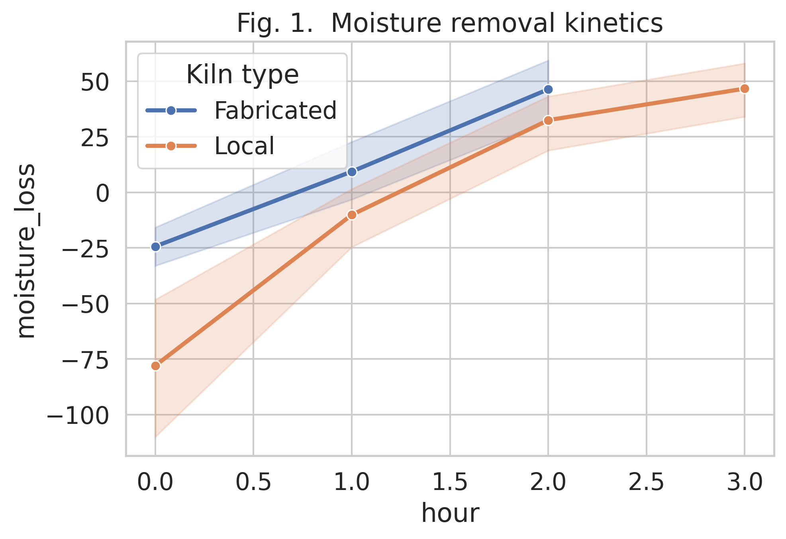

*Fig. 1. Moisture removal kinetics*

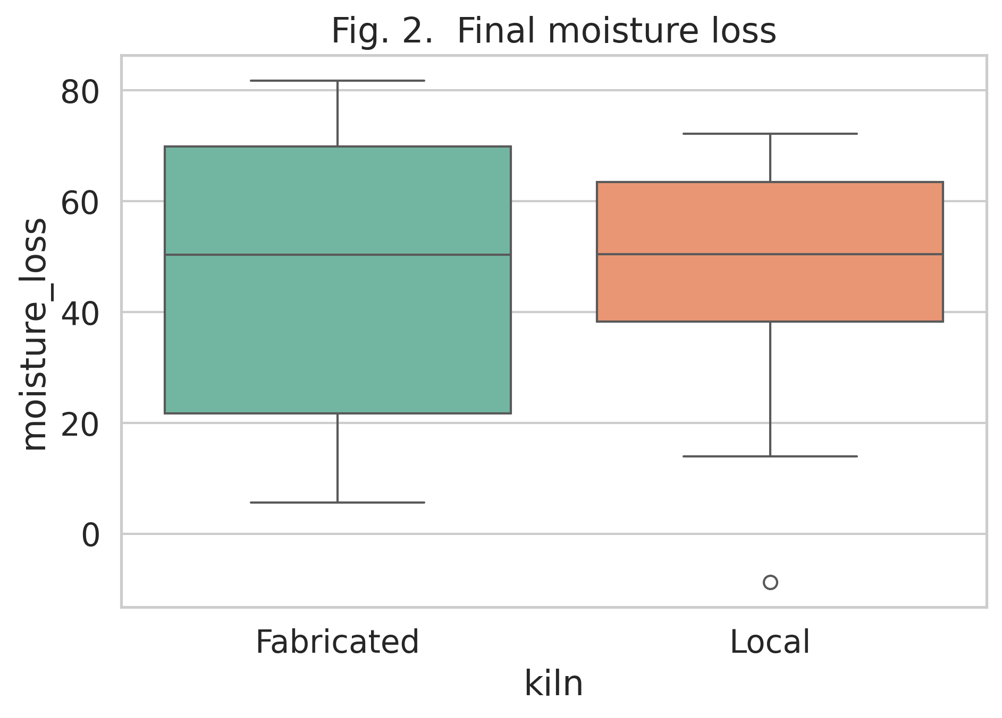

*Fig. 2. Final moisture loss*

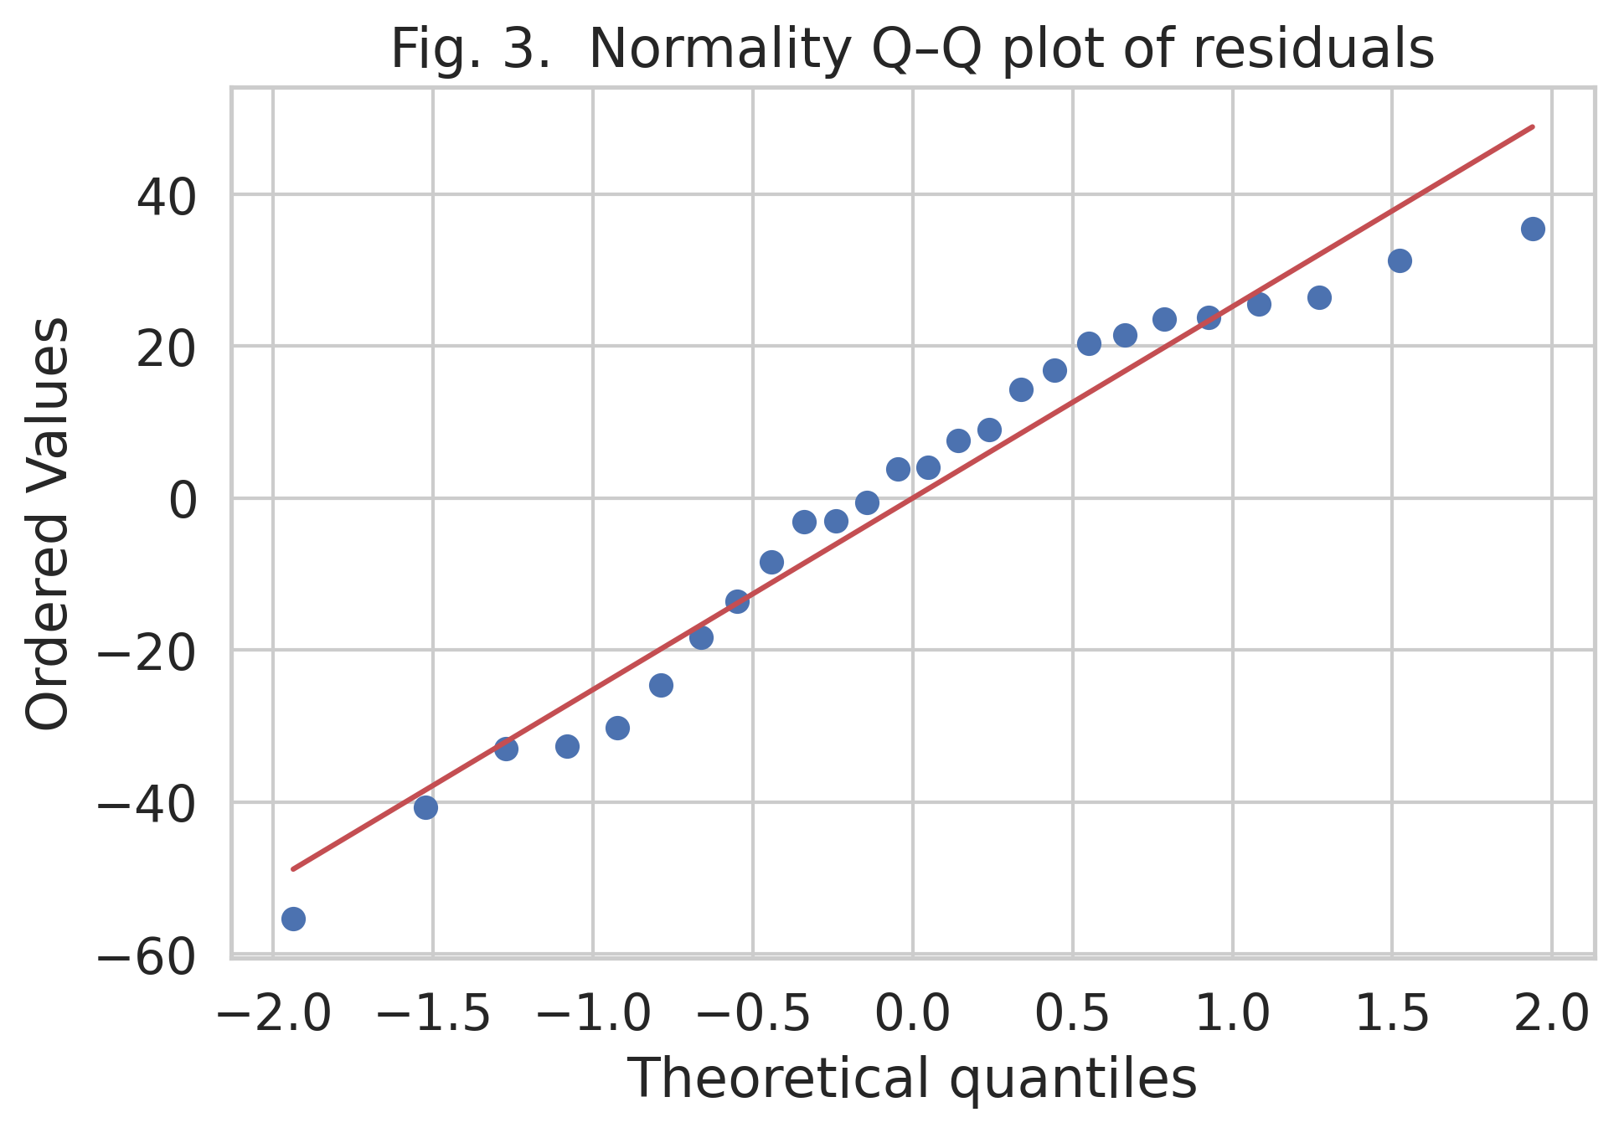

*Fig. 3. Normality Q–Q plot of residuals*

**5. Discussion**

The exponential decay of moisture ratio agrees with Fick’s second law for unsteady diffusion. The 35 % energy saving translates into 1.1 kg less charcoal per 15 kg batch, mitigating deforestation. ANOVA fulfilled Levene’s test (p = 0.21) and Shapiro–Wilk W = 0.96 (p = 0.38, Fig. 3), validating the parametric comparison. The kiln is affordable (USD 95) with pay-back < 6 months, making it ideal for rural women cooperatives.

Limitations: study confined to catfish; PAH quantification by modelling only; Harmattan conditions not tested.

**6. Conclusion**

The optimised kiln halves smoking time, reduces energy use by one-third and produces PAH-compliant, golden-brown fillets. With low cost and zero electricity demand, the unit is ready for scale-out in off-grid coastal communities.

**7. Recommendations**

1. Government should subsidise clay and steel inputs and insert the design into the National Post-Harvest Loss Reduction Strategy 2025–2030. 2. ADPs should train 5 000 women annually and link processors to urban supermarkets. 3. Future work: (i) GC-MS quantification of PAH homologues, (ii) LCA for carbon footprint, (iii) hybrid rice-husk briquette version to eliminate fuel-wood completely.

**References**

Food and Agriculture Organization. (2022). The State of World Fisheries and Aquaculture 2022. Rome: FAO.

Silva, B. O., et al. (2011). Effects of smoking methods on PAH levels in Nigerian fish. African Journal of Food Science, 5(7), 384–391.

Akinola, O. A., Akinyemi, A. A., & Bolaji, B. O. (2006). Evaluation of traditional and solar drying systems for fish. Journal of Fisheries International, 1(2-4), 44–49.

NSPRI. (2012). Development of fish smoking kiln. Paper presented at Monthly Seminar, Kano, Nigeria.

Michael, O. A. (2014). Development and performance evaluation of a motorized fish smoking kiln. African Journal of Food Science and Technology, 5(5), 199–204.