Comprehensive Soil Physicochemical Properties Report

# Sand (%)

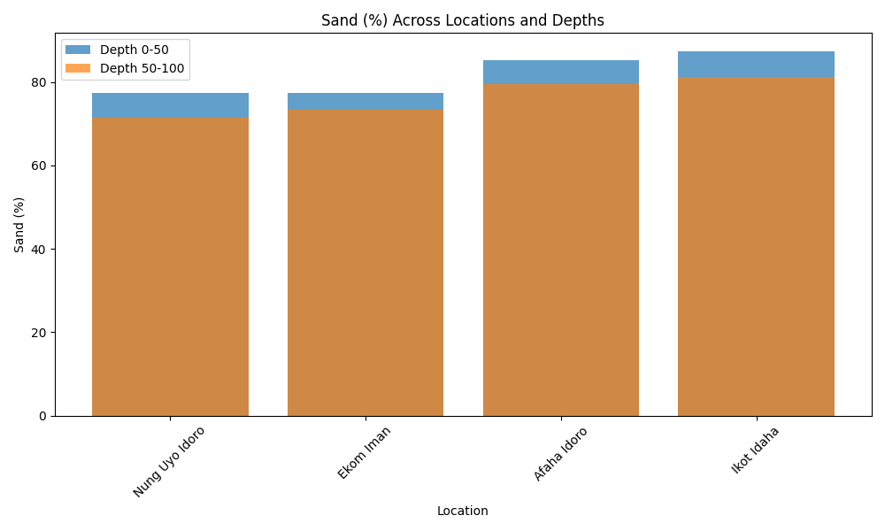

Bar chart showing Sand (%) variation across locations at depths 0–50 cm and 50–100 cm.

# Silt (%)

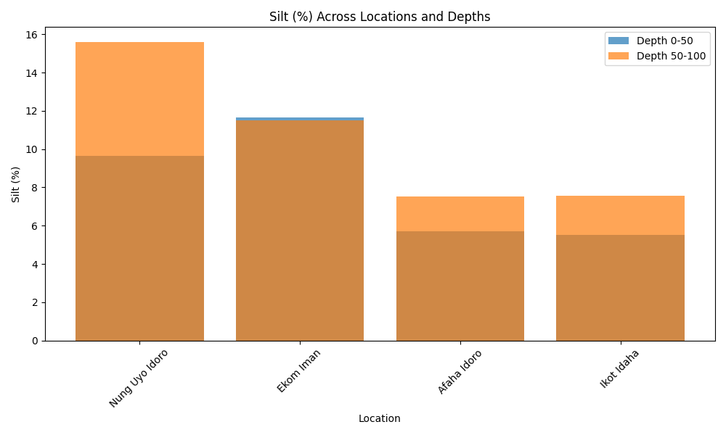

Bar chart showing Silt (%) variation across locations at depths 0–50 cm and 50–100 cm.

# Clay (%)

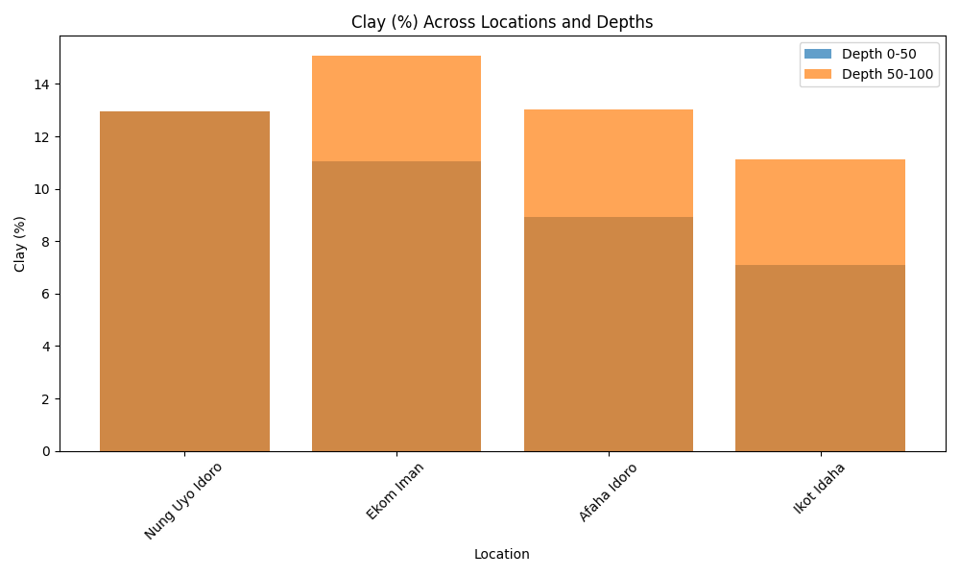

Bar chart showing Clay (%) variation across locations at depths 0–50 cm and 50–100 cm.

# TC

TC is a non-numeric parameter and is not visualized as a chart.

# pH (H₂O)

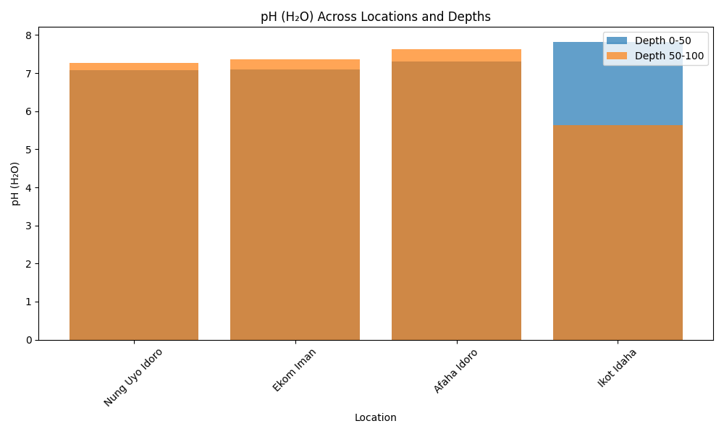

Bar chart showing pH (H₂O) variation across locations at depths 0–50 cm and 50–100 cm.

# E/C (ds/m)

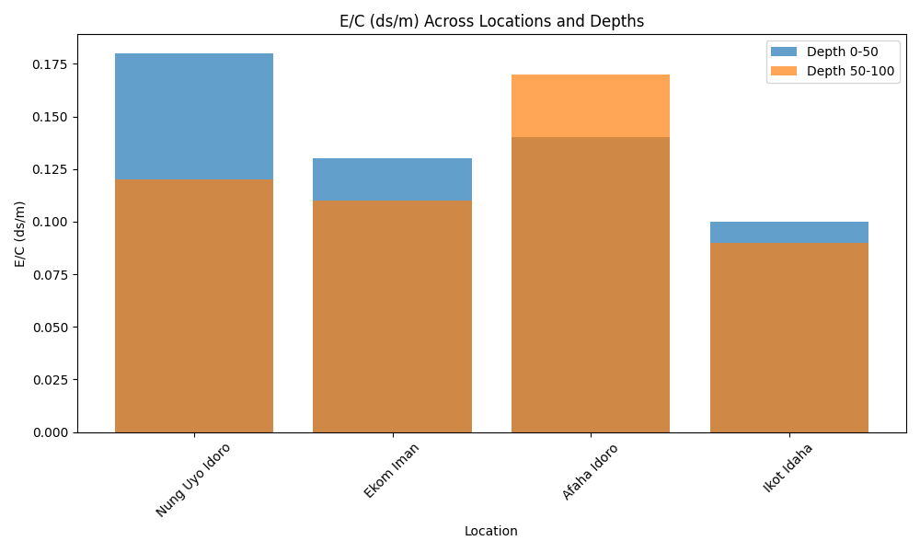

Bar chart showing E/C (ds/m) variation across locations at depths 0–50 cm and 50–100 cm.

# OC (%)

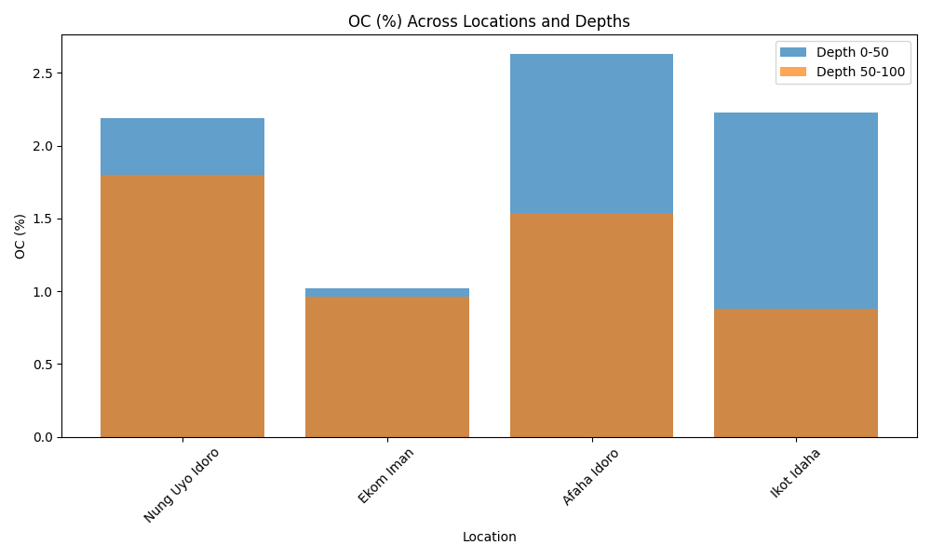

Bar chart showing OC (%) variation across locations at depths 0–50 cm and 50–100 cm.

# OM (%)

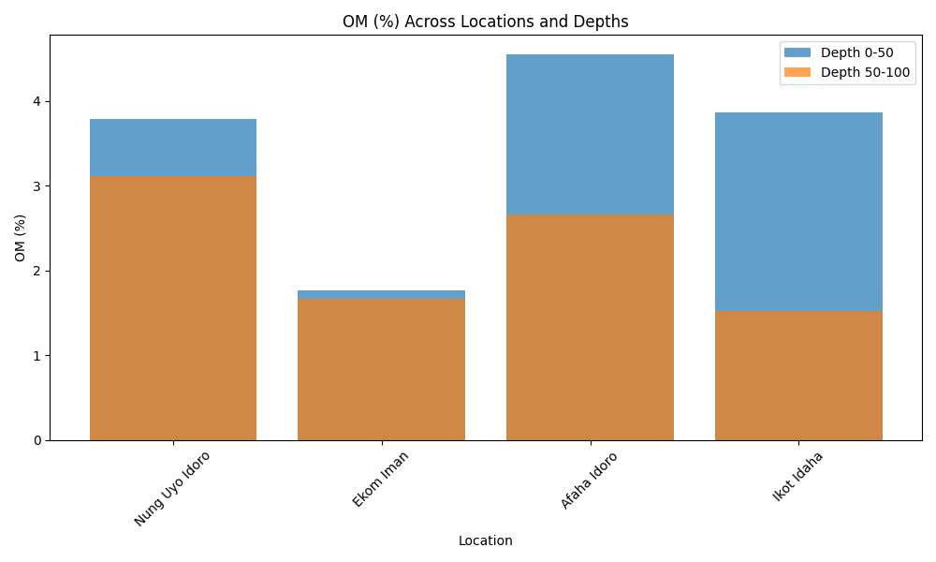

Bar chart showing OM (%) variation across locations at depths 0–50 cm and 50–100 cm.

# T/N (%)

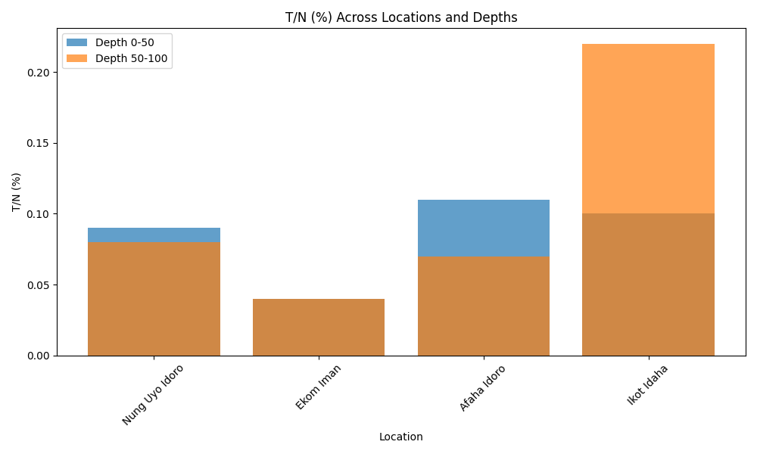

Bar chart showing T/N (%) variation across locations at depths 0–50 cm and 50–100 cm.

# CN:R

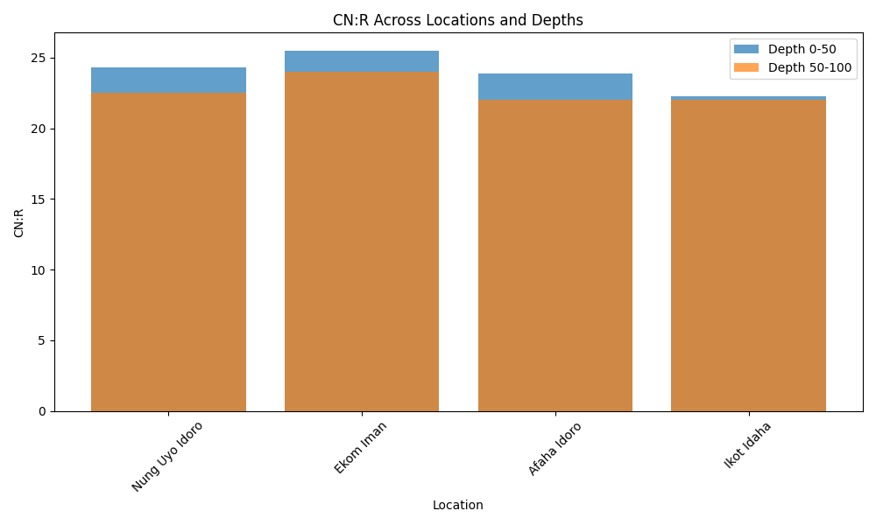

Bar chart showing CN:R variation across locations at depths 0–50 cm and 50–100 cm.

# Av.P (mg/kg)

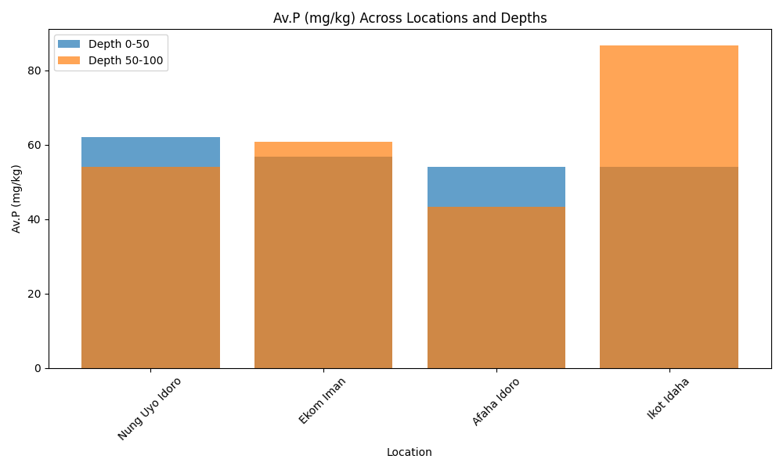

Bar chart showing Av.P (mg/kg) variation across locations at depths 0–50 cm and 50–100 cm.

# Ca Cmol/kg

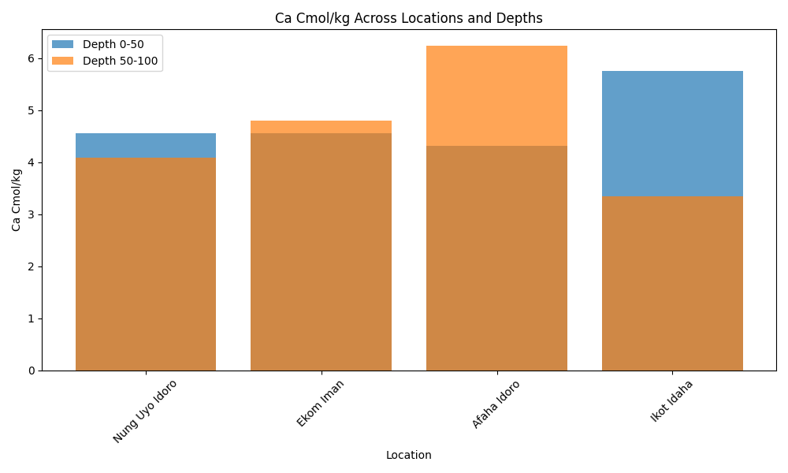

Bar chart showing Ca Cmol/kg variation across locations at depths 0–50 cm and 50–100 cm.

# Mg Cmol/kg

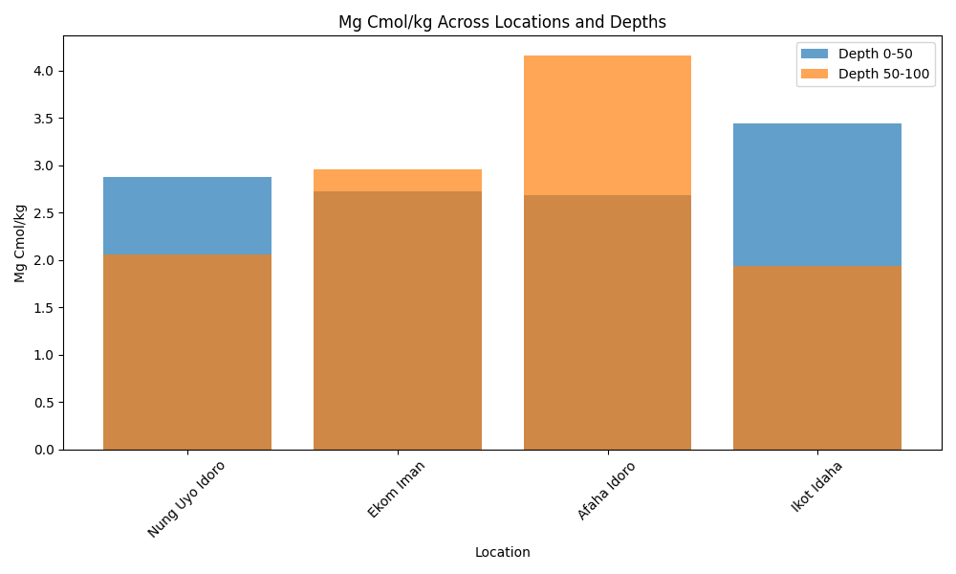

Bar chart showing Mg Cmol/kg variation across locations at depths 0–50 cm and 50–100 cm.

# K Cmol/kg

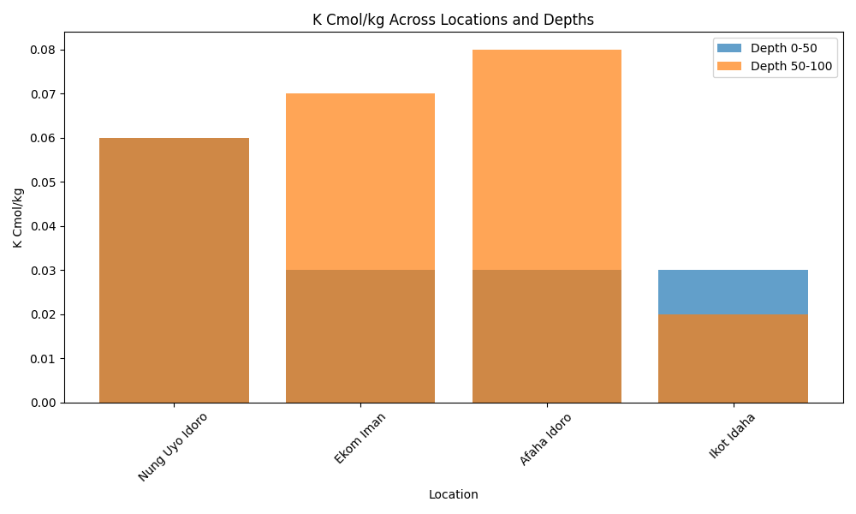

Bar chart showing K Cmol/kg variation across locations at depths 0–50 cm and 50–100 cm.

# Na Cmol/kg

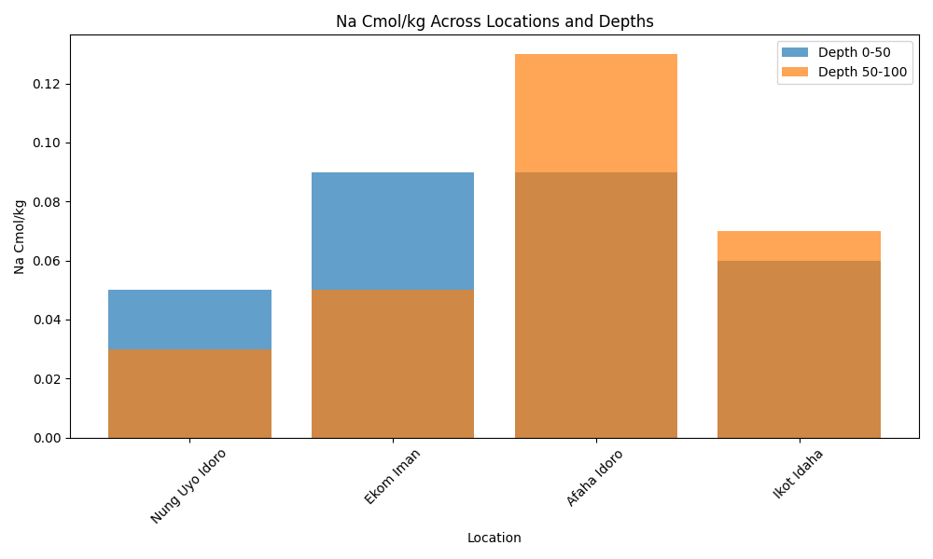

Bar chart showing Na Cmol/kg variation across locations at depths 0–50 cm and 50–100 cm.

# E/A Cmol/kg

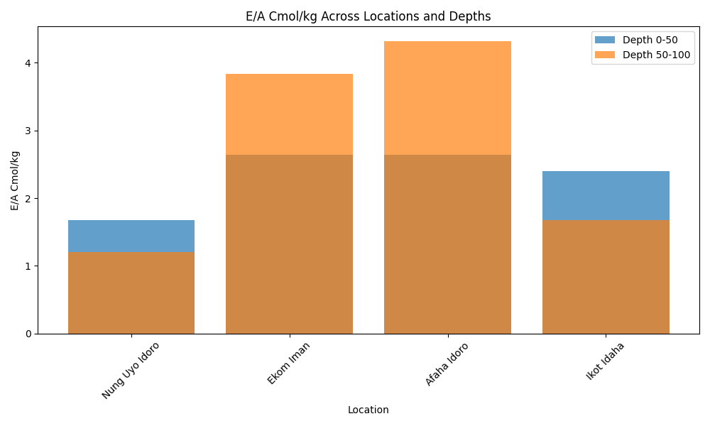

Bar chart showing E/A Cmol/kg variation across locations at depths 0–50 cm and 50–100 cm.

# AL⁺ Cmol/kg

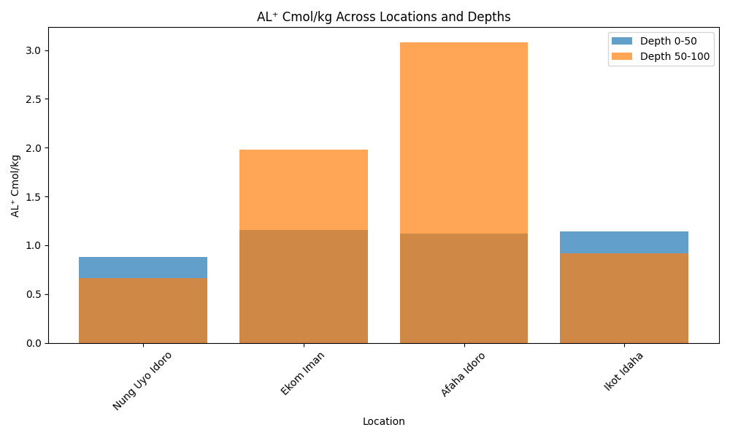

Bar chart showing AL⁺ Cmol/kg variation across locations at depths 0–50 cm and 50–100 cm.

# H⁺ Cmol/kg

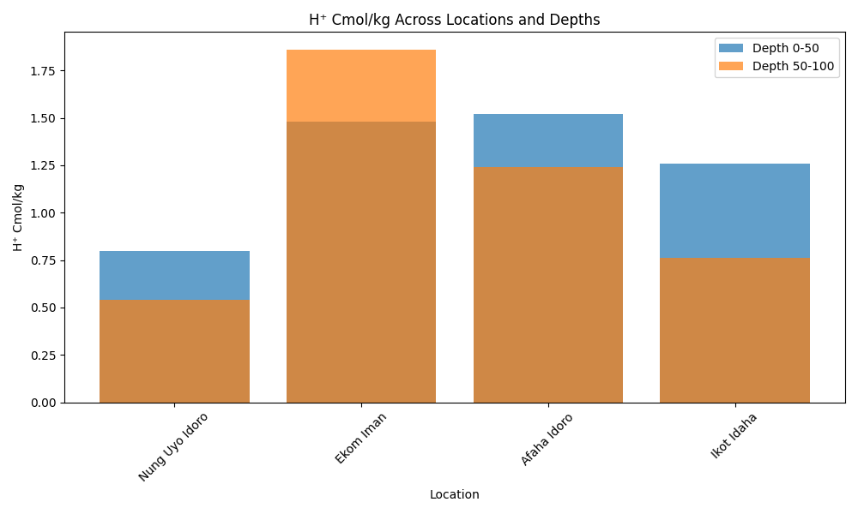

Bar chart showing H⁺ Cmol/kg variation across locations at depths 0–50 cm and 50–100 cm.

# TEB Cmol/kg

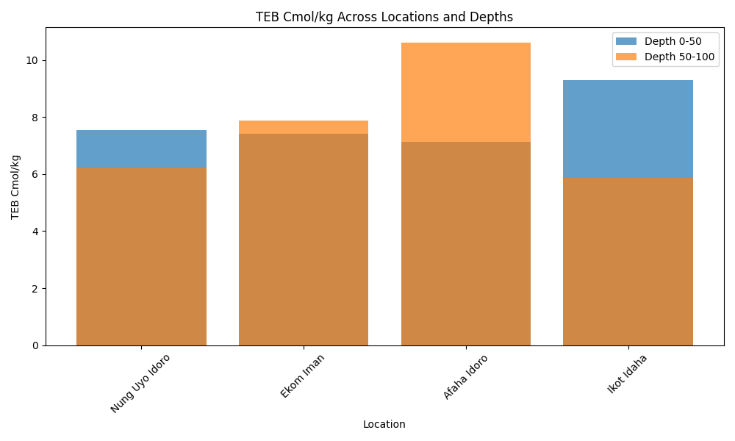

Bar chart showing TEB Cmol/kg variation across locations at depths 0–50 cm and 50–100 cm.

# ECEC Cmol/kg

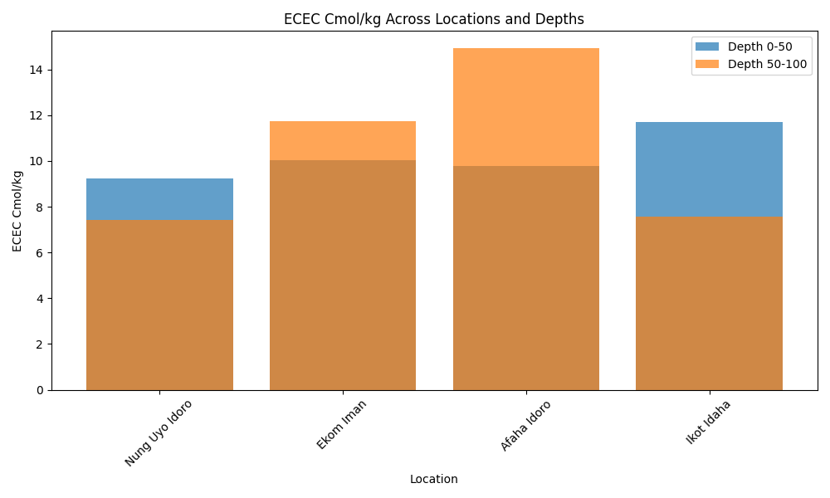

Bar chart showing ECEC Cmol/kg variation across locations at depths 0–50 cm and 50–100 cm.

# BSAT (%)

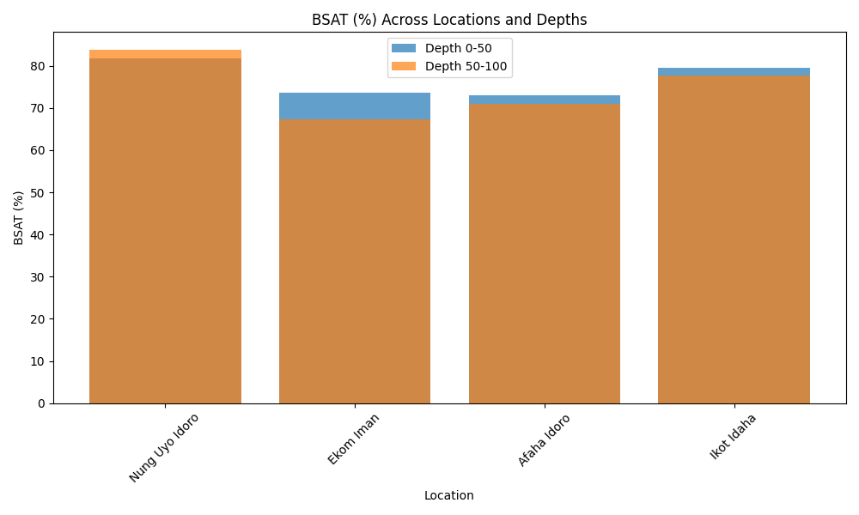

Bar chart showing BSAT (%) variation across locations at depths 0–50 cm and 50–100 cm.