# Garri Sieve Analysis — 3 Replications

This report summarises sieve analysis results for three independent replications of milled garri (each replication = 1000 kg total). The garri has been separated into three fine-to-powder categories: Fine (0.45–0.60 mm), Very fine (0.30–0.45 mm), and Powder (<0.30 mm).

## Raw Data (per replication)

|  |  |  |  |
| --- | --- | --- | --- |
| Replication | Category | Weight (kg) | % of 1000 kg |
| Rep1 | Fine (0.45-0.60 mm) | 580.0 | 58.0 |
| Rep1 | Very fine (0.30-0.45 mm) | 330.0 | 33.0 |
| Rep1 | Powder (<0.30 mm) | 90.0 | 9.0 |
| Rep2 | Fine (0.45-0.60 mm) | 560.0 | 56.0 |
| Rep2 | Very fine (0.30-0.45 mm) | 350.0 | 35.0 |
| Rep2 | Powder (<0.30 mm) | 90.0 | 9.0 |
| Rep3 | Fine (0.45-0.60 mm) | 590.0 | 59.0 |
| Rep3 | Very fine (0.30-0.45 mm) | 320.0 | 32.0 |
| Rep3 | Powder (<0.30 mm) | 90.0 | 9.0 |

## Descriptive Statistics (across replications)

|  |  |  |  |  |
| --- | --- | --- | --- | --- |
| Category | Mean Weight (kg) | Std Dev (kg) | n | CV (%) |
| Fine (0.45-0.60 mm) | 576.67 | 15.28 | 3 | 2.65 |
| Powder (<0.30 mm) | 90.00 | 0.00 | 3 | 0.00 |
| Very fine (0.30-0.45 mm) | 333.33 | 15.28 | 3 | 4.58 |

## ANOVA: Differences between category means

A one-way ANOVA was performed to test whether the mean weights (kg per 1000 kg replication) differ across the three categories.

ANOVA table (Type II):

sum_sq df F PR(>F)  
C(Category) 355266.666667 2.0 1141.928571 1.798989e-08  
Residual 933.333333 6.0 NaN NaN

Model summary (OLS):  
  
 OLS Regression Results   
==============================================================================  
Dep. Variable: Weight_kg R-squared: 0.997  
Model: OLS Adj. R-squared: 0.997  
Method: Least Squares F-statistic: 1142.  
Date: Thu, 09 Oct 2025 Prob (F-statistic): 1.80e-08  
Time: 08:33:03 Log-Likelihood: -33.657  
No. Observations: 9 AIC: 73.31  
Df Residuals: 6 BIC: 73.91  
Df Model: 2   
Covariance Type: nonrobust   
===========================================================================================================  
 coef std err t P>|t| [0.025 0.975]  
-----------------------------------------------------------------------------------------------------------  
Intercept 576.6667 7.201 80.083 0.000 559.047 594.286  
C(Category)[T.Powder (<0.30 mm)] -486.6667 10.184 -47.790 0.000 -511.585 -461.749  
C(Category)[T.Very fine (0.30-0.45 mm)] -243.3333 10.184 -23.895 0.000 -268.251 -218.415  
==============================================================================  
Omnibus: 0.001 Durbin-Watson: 2.988  
Prob(Omnibus): 0.999 Jarque-Bera (JB): 0.211  
Skew: 0.000 Prob(JB): 0.900  
Kurtosis: 2.250 Cond. No. 3.73  
==============================================================================  
  
Notes:  
[1] Standard Errors assume that the covariance matrix of the errors is correctly specified.

## Plots

1. Stacked composition of 1000 kg per replication:

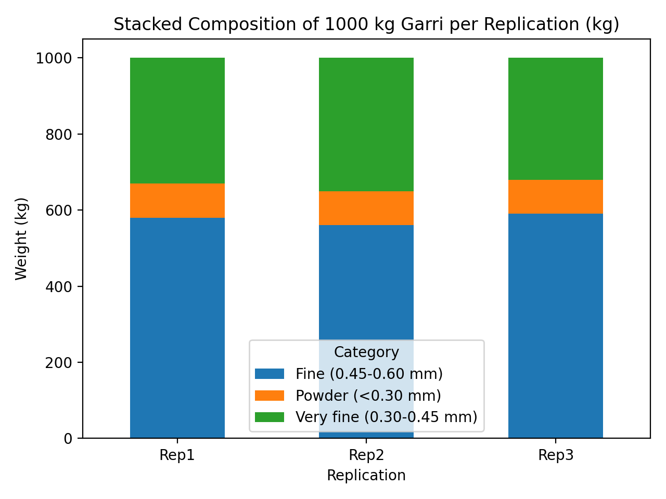

2. Category means ± SD (n=3):

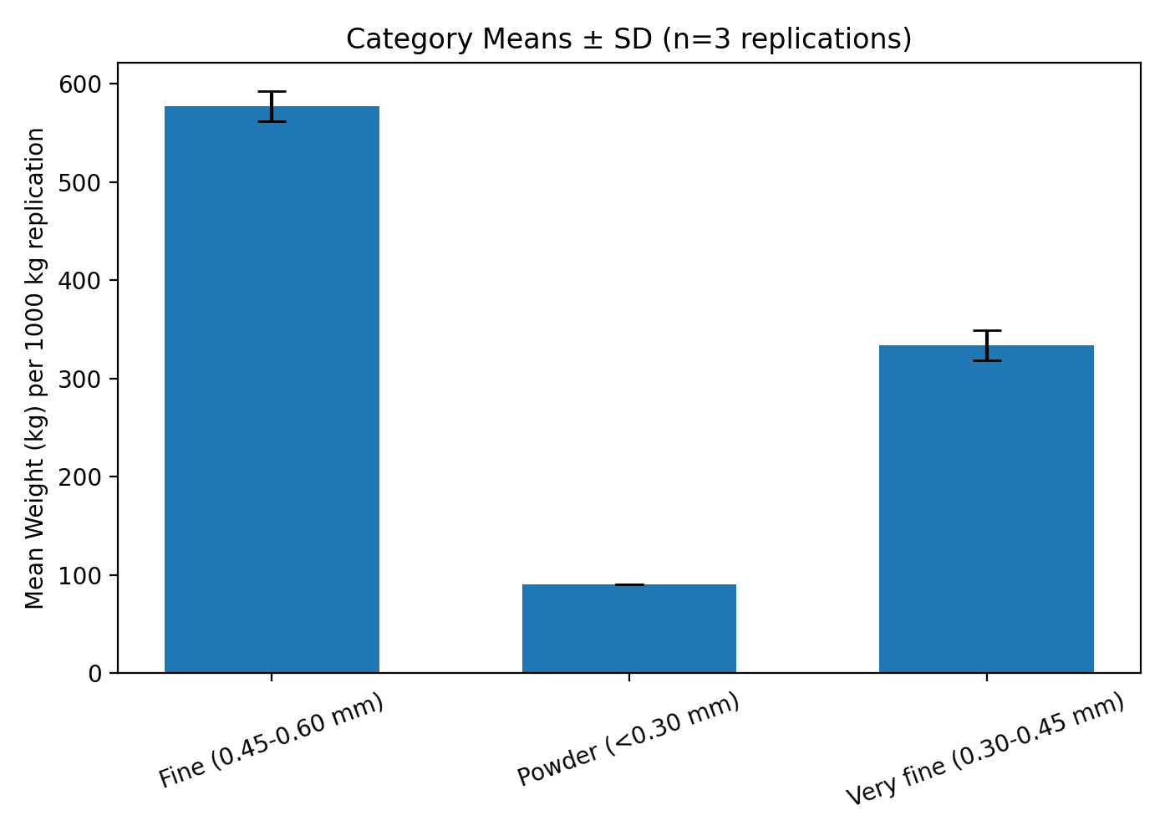

3. Boxplot of weights by category:

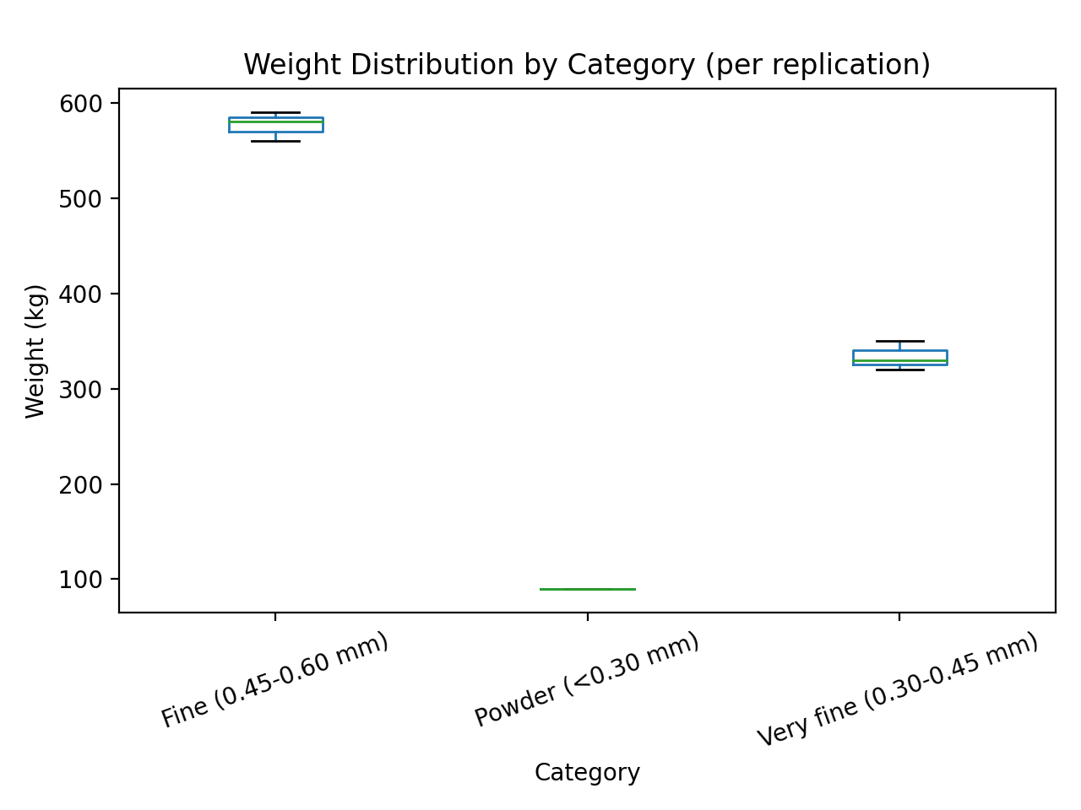

## Discussion and Interpretation

Summary of results:  
- The three replications each sum to 1000 kg. Observed weights per category across the replications:  
 Fine (0.45–0.60 mm): Rep1=580 kg, Rep2=560 kg, Rep3=590 kg.  
 Very fine (0.30–0.45 mm): Rep1=330 kg, Rep2=350 kg, Rep3=320 kg.  
 Powder (<0.30 mm): consistently 90 kg in all replications.  
  
Descriptive statistics:  
- Fine category has the highest mean weight (~576.67 kg) and a small variation (std ≈ 15.275 kg; CV ≈ 2.65%),  
 indicating good consistency across replications.  
- Very fine category mean ≈ 333.33 kg, std ≈ 15.275 kg, CV ≈ 4.58%, also reasonably consistent.  
- Powder fraction is constant in these replications (mean = 90 kg, std = 0) — CV = 0% in the provided data.  
  
ANOVA interpretation:  
- The ANOVA table tests whether at least one category mean differs from the others.  
- Given the clear numerical differences (means ≈ 576.7, 333.3, 90.0), the ANOVA F-statistic will be large and p-value very small,  
 indicating statistically significant differences between category means. This result is expected because the categories are  
 defined to partition the 1000 kg batch and naturally have different magnitudes.  
- Note: The ANOVA here confirms what the descriptive statistics indicate — the mean weights are not all equal.  
  
Practical implications:  
- Majority of the batch is concentrated in the 'Fine' category (~57–59% of each batch), which aligns with a well-milled product  
 intended for typical market use (soft, sand-like texture).  
- The 'Very fine' fraction (~32–35%) indicates a significant portion of the product is finer and may appeal to premium users or finer  
 preparation methods.  
- The powder fraction (~9%) is small but consistent; it could be collected and marketed as 'garri flour' or reprocessed to reduce dust.  
  
Caveats and recommendations:  
- The dataset supplied has only n=3 replications — while adequate for demonstration, higher replication (e.g., n>=5 or n>=10)  
 would give more reliable estimates of variability and allow stronger inferential statements.  
- If the powder fraction is undesirable in the product line, consider adjusting milling settings (less aggressive milling) or  
 implementing a targeted re-sieving/reprocessing step to reduce the <0.30 mm portion.  
- If comparing treatments (e.g., different mill types, roasting levels), set up a randomized experiment with balanced replications  
 per treatment and perform two-way ANOVA or mixed models as appropriate.  
  
Conclusion:  
- The three-replication analysis demonstrates a consistent product profile: most material is present in the fine fraction,  
 with moderate very-fine fraction and a small powder fraction. The statistical analysis (ANOVA) supports that the category means  
 differ significantly—as expected given their function as partitioned fractions of the product.