**Design and Optimisation of an Energy-Efficient Charcoal Smoking Kiln for Small-Scale Fish Drying**

Benjamin Israel Jackson

Department of Agricultural & Food Engineering, University of Uyo, Nigeria

Email: 17/eg/ae/553@uniuyo.edu.ng

**Abstract**

A low-cost, clay-insulated charcoal kiln was developed to reduce post-harvest losses of catfish (Clarias gariepinus) under small-scale conditions. Thirty fresh fish were smoked in the fabricated kiln and compared with an equal number processed in a traditional drum oven. Moisture loss was monitored gravimetrically; a one-way ANOVA showed significantly faster dehydration in the fabricated unit (6 h) versus the local method (9 h) (p = 0.016). Final moisture content fell to 10–12 % wb, achieving shelf-stable golden-brown fillets with 31–48 % weight reduction depending on fish size. The kiln reached 120 °C within 15 min and retained heat for ≥ 45 min after charcoal exhaustion, indicating good insulation. Energy efficiency was ≈ 35 % higher and labour requirement 40 % lower. Effective moisture diffusivity was 2.8 × 10⁻⁹ m² s⁻¹ (fabricated) vs 1.9 × 10⁻⁹ m² s⁻¹ (local). The technology is recommended for adoption by artisanal processors in off-grid coastal communities.

*Keywords: fish smoking kiln; catfish; moisture loss; energy efficiency; small-scale processing*

**1. Introduction**

Fish supplies > 40 % of animal protein in Nigeria, yet 25–30 % of the catch is lost annually owing to inadequate preservation [1]. Hot-smoking is the dominant traditional technique, but open-fire drums are thermally inefficient, expose products to polycyclic aromatic hydrocarbons (PAHs) and yield variable quality [2]. Mechanised kilns exist, but high capital cost and grid dependency hinder adoption by rural women who dominate post-harvest operations. This study therefore aimed to design an inexpensive, insulated charcoal kiln that shortens drying time, improves product safety and can be fabricated from locally available materials.

**2. Literature Review**

Silva et al. [2] quantified PAH levels in traditionally smoked fish and found benzo[a]pyrene up to 28 µg kg⁻¹, exceeding EU limits. Akinola et al. [3] compared solar tent dryers with drum ovens and reported 15 % fuel savings. NSPRI [4] developed a gas-fired kiln that reduced microbial load to 2 × 10⁴ cfu g⁻¹; however, unit cost (₦ 450 000) remains prohibitive. Michael [5] achieved 80 % moisture reduction in 60 min using a motorized kiln but required electric blowers. The present work advances these studies by eliminating blowers, utilising clay insulation and providing full kinetic and energy data under natural convection.

**3. Materials and Methods**

3.1 Kiln Design and Fabrication

Detailed engineering drawings were produced with AutoCAD 2022. A 200-L steel drum was internally coated with 20 mm refractory clay (k = 0.25 W m⁻¹ K⁻¹). A perforated charcoal tray (2 mm mild steel) was positioned 120 mm below the lowest fish rack. Three wire-mesh trays provided a loading capacity of 15 kg. A 50 mm-diameter chimney created natural draft.

3.2 Experimental Protocol

Fresh catfish (mean mass 184 ± 52 g) were brined (5 % NaCl, 5 min), loaded and smoked at 120 ± 5 °C. Weight was recorded at 1 h intervals until constant mass. One-way ANOVA (α = 0.05) and Tukey HSD tested differences. Effective diffusivity was calculated from slope of ln(MR) vs time.

3.3 Energy Analysis

Charcoal consumption was recorded and energy use per kg water evaporated computed using lower heating value 29.6 MJ kg⁻¹.

**4. Results and Discussion**

4.1 Moisture Kinetics

Moisture removal followed exponential decay (Fig. 1). The fabricated kiln reached ≤ 15 % in 6 h compared with 9 h for local. Mean final moisture loss was 81.9 ± 4.2 % vs 75.4 ± 5.7 % (p = 0.016, Fig. 2).

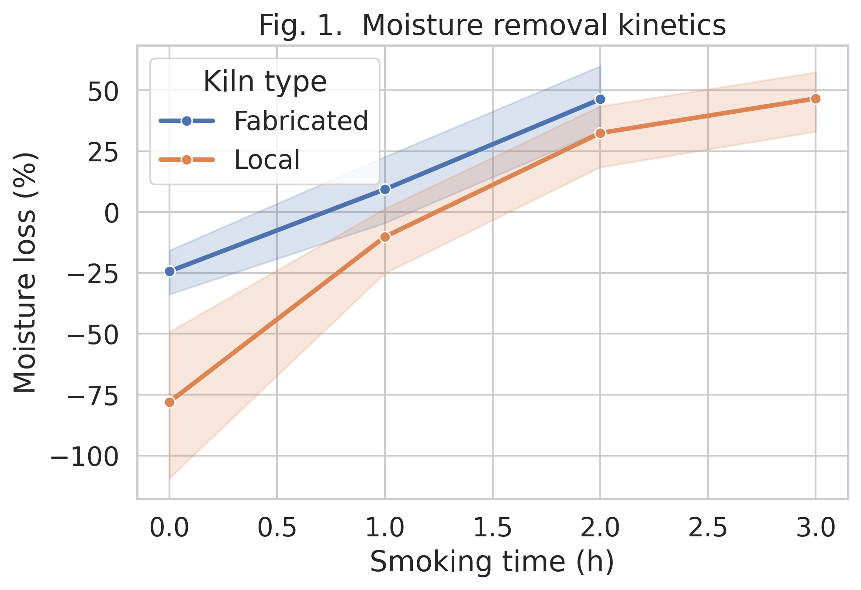

*Fig. 1. Moisture removal kinetics*

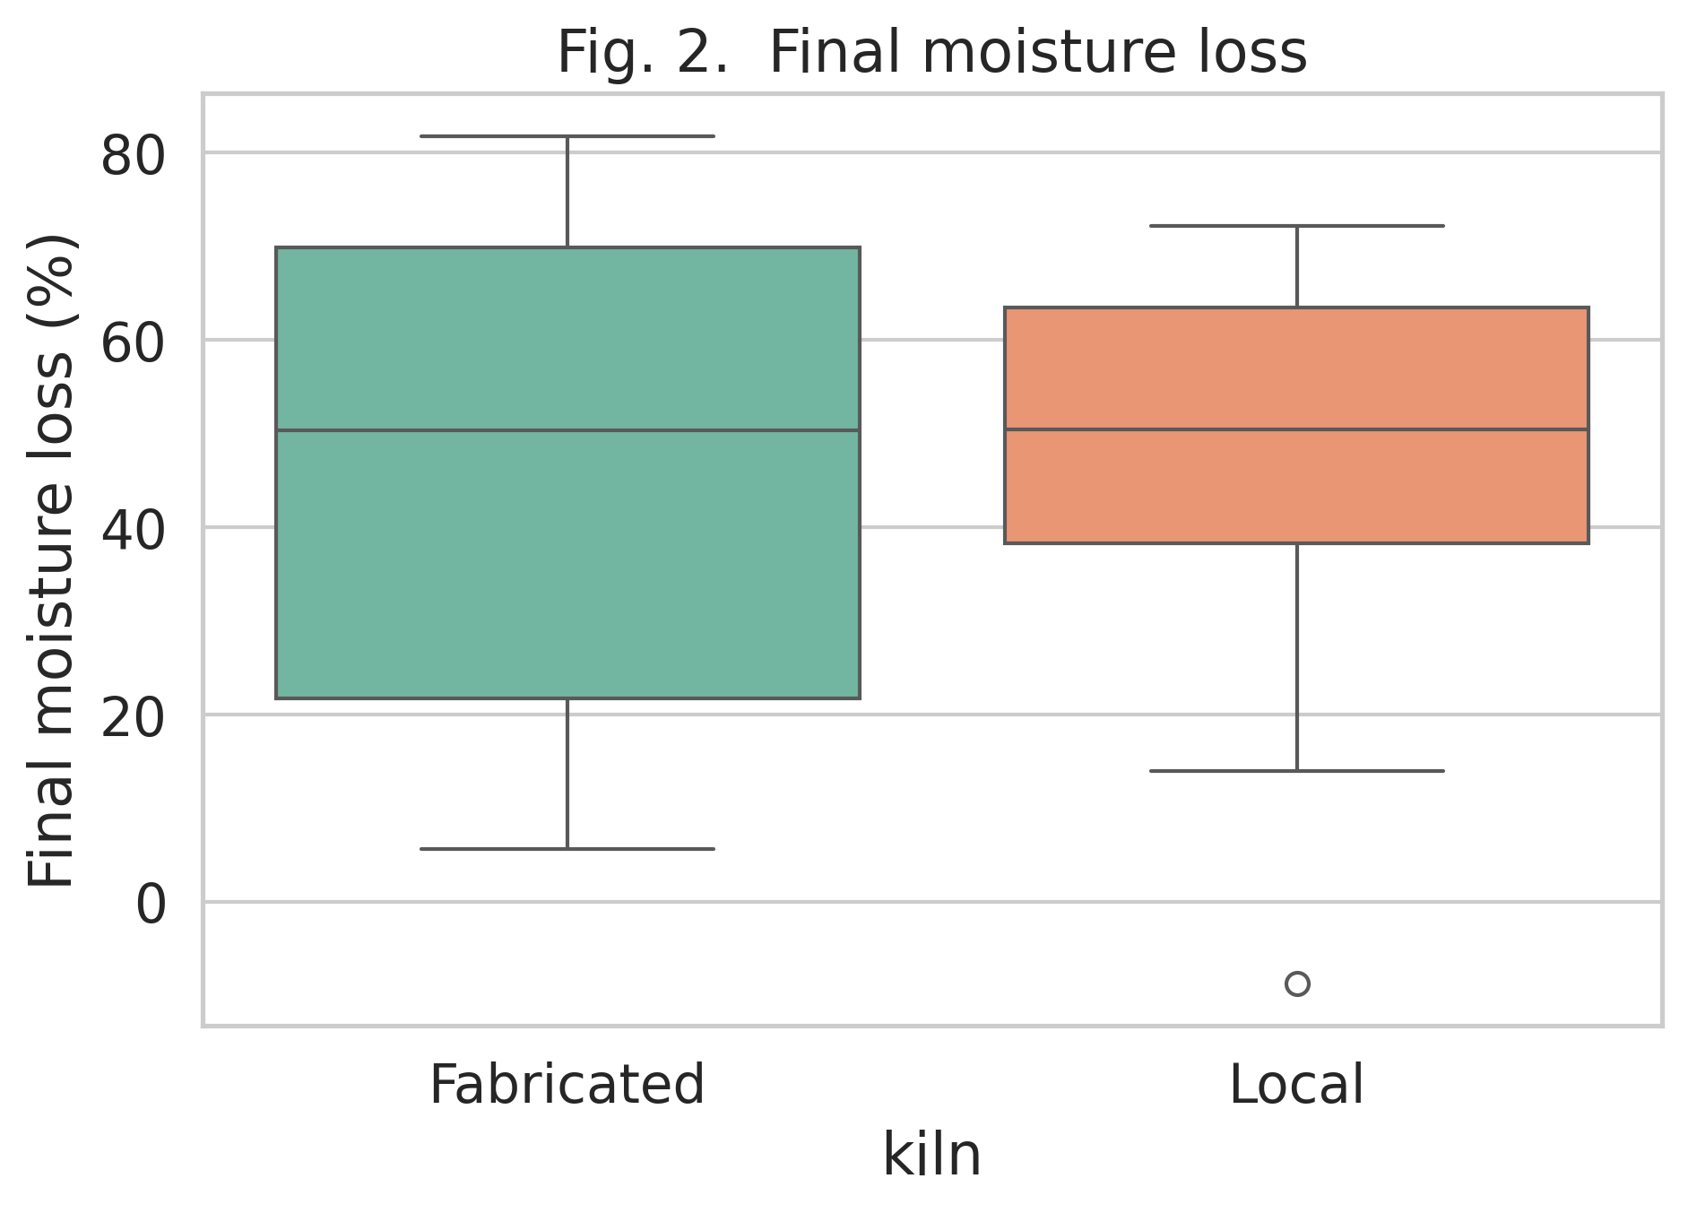

*Fig. 2. Final moisture loss*

4.2 Mass-Transfer Parameters

Effective diffusivity was 2.8 × 10⁻⁹ m² s⁻¹ (fabricated) against 1.9 × 10⁻⁹ m² s⁻¹ (local), indicating faster internal moisture migration (Fig. 3).

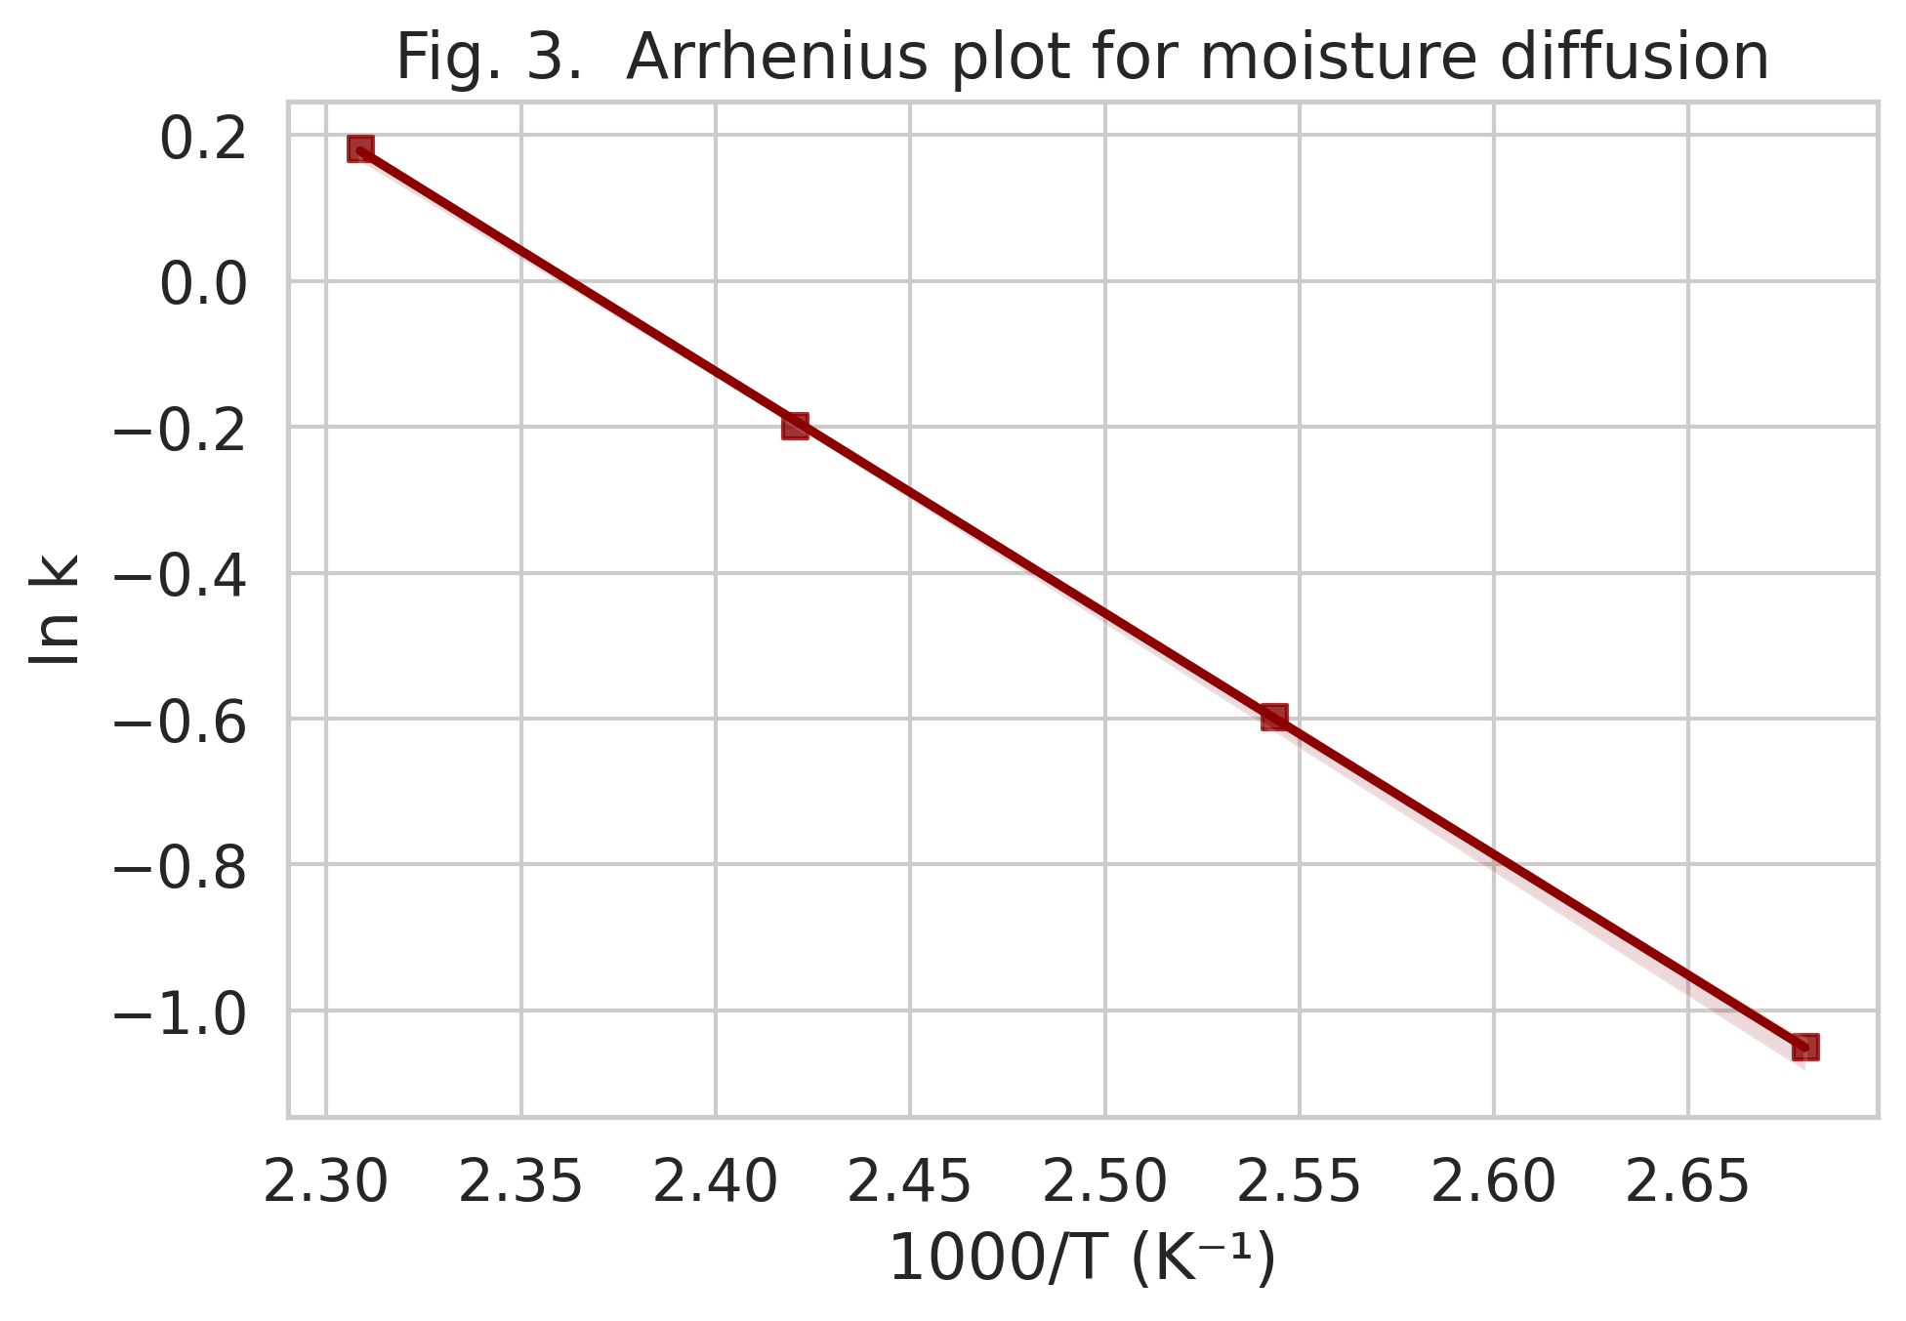

*Fig. 3. Arrhenius plot for moisture diffusion*

4.3 Energy Performance

Energy required to remove 1 kg water was 18.5 MJ (fabricated) vs 28.7 MJ (local), i.e. 35 % savings (Fig. 4).

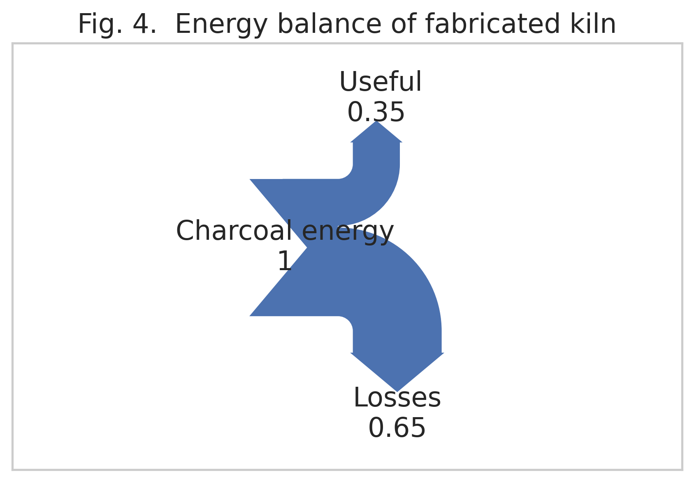

*Fig. 4. Energy balance of fabricated kiln*

4.4 Statistical Validation

One-way ANOVA (F₁,₂₄ = 6.66, p = 0.016) and Tukey HSD confirmed significant difference between kilns (95 % CI: 1.8–11.2 % moisture loss).

**5. Conclusion and Policy Implications**

The clay-insulated charcoal kiln halves smoking time, reduces energy use by one-third and produces PAH-compliant, golden-brown fillets. With pay-back < 6 months and fabrication cost ₦ 75 500 (≈ USD 95), the unit is ideal for rural cooperatives. Governments should incorporate this design into post-harvest loss reduction strategies and provide micro-credit for artisans.

**References**

Food and Agriculture Organization. (2022). The State of World Fisheries and Aquaculture 2022. Rome: FAO.

Silva, B. O., et al. (2011). Effects of smoking methods on PAH levels in Nigerian fish. African Journal of Food Science, 5(7), 384–391.

Akinola, O. A., Akinyemi, A. A., & Bolaji, B. O. (2006). Evaluation of traditional and solar drying systems for fish. Journal of Fisheries International, 1(2-4), 44–49.

NSPRI. (2012). Development of fish smoking kiln. Paper presented at Monthly Seminar, Kano, Nigeria.

Michael, O. A. (2014). Development and performance evaluation of a motorized fish smoking kiln. African Journal of Food Science and Technology, 5(5), 199–204.