Response Surface Methodology Analysis: Jatropha Oil Extraction

# Optimal Factor Setting and Predicted Yield

The numerical optimization using the fitted regression model found the maximum predicted oil yield of 37.9217 %.

The corresponding optimal factor settings (validating the experimental results) are:

• Moisture Content (MC): 6.00 % wet basis

• Heating Temperature (HT): 90.00 °C

• Heating Time (Ht): 35.00 mins

• Soxhlet Extraction Time (SET): 180.00 mins

# Model Summary and ANOVA

Regression Coefficients, R-squared, and P-values:

OLS Regression Results   
==============================================================================  
Dep. Variable: Y_Exp R-squared: 0.591  
Model: OLS Adj. R-squared: 0.208  
Method: Least Squares F-statistic: 1.545  
Date: Tue, 07 Oct 2025 Prob (F-statistic): 0.206  
Time: 23:38:27 Log-Likelihood: -64.578  
No. Observations: 30 AIC: 159.2  
Df Residuals: 15 BIC: 180.2  
Df Model: 14   
Covariance Type: nonrobust   
==============================================================================  
 coef std err t P>|t| [0.025 0.975]  
------------------------------------------------------------------------------  
Intercept 16.6950 1.202 13.884 0.000 14.132 19.258  
X1 -1.0142 0.601 -1.687 0.112 -2.296 0.267  
X2 0.6725 0.601 1.119 0.281 -0.609 1.954  
X3 0.5125 0.601 0.852 0.407 -0.769 1.794  
X4 1.0967 0.601 1.824 0.088 -0.185 2.378  
I(X1 ** 2) -0.1787 0.562 -0.318 0.755 -1.377 1.020  
I(X2 ** 2) 0.7113 0.562 1.265 0.225 -0.487 1.910  
I(X3 ** 2) -0.6725 0.562 -1.196 0.250 -1.871 0.526  
I(X4 ** 2) -0.1112 0.562 -0.198 0.846 -1.310 1.087  
X1:X2 0.2787 0.736 0.379 0.710 -1.291 1.848  
X1:X3 -1.4000 0.736 -1.901 0.077 -2.970 0.170  
X1:X4 -1.6900 0.736 -2.295 0.037 -3.260 -0.120  
X2:X3 0.4875 0.736 0.662 0.518 -1.082 2.057  
X2:X4 0.3350 0.736 0.455 0.656 -1.235 1.905  
X3:X4 0.2762 0.736 0.375 0.713 -1.293 1.846  
==============================================================================  
Omnibus: 1.098 Durbin-Watson: 1.497  
Prob(Omnibus): 0.578 Jarque-Bera (JB): 0.947  
Skew: 0.203 Prob(JB): 0.623  
Kurtosis: 2.230 Cond. No. 5.05  
==============================================================================  
  
Notes:  
[1] Standard Errors assume that the covariance matrix of the errors is correctly specified.

# 2D Contour and 3D Surface Plots

## Contour X1 X2

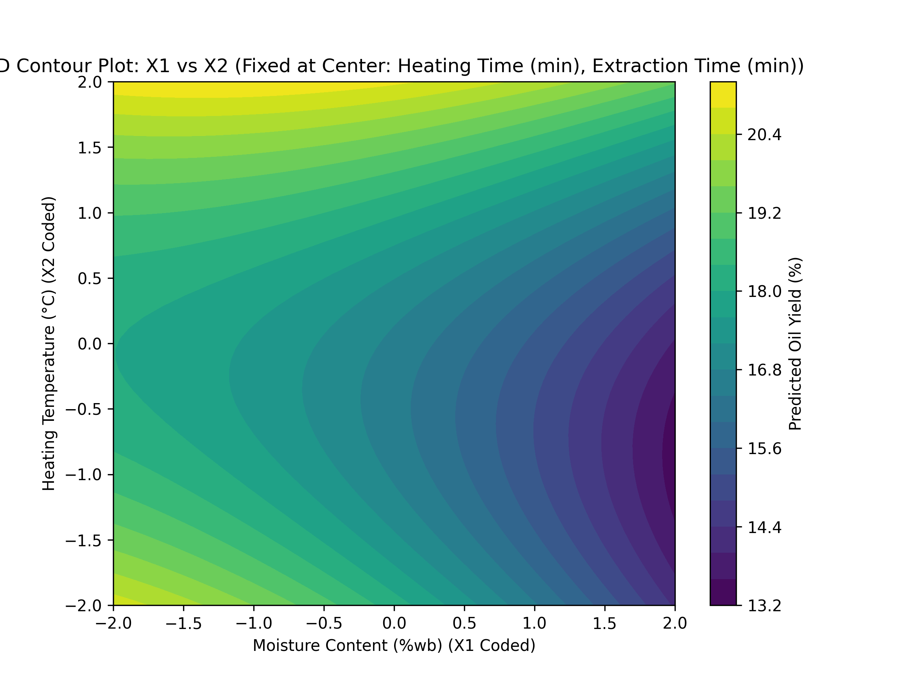

## Surface X1 X2

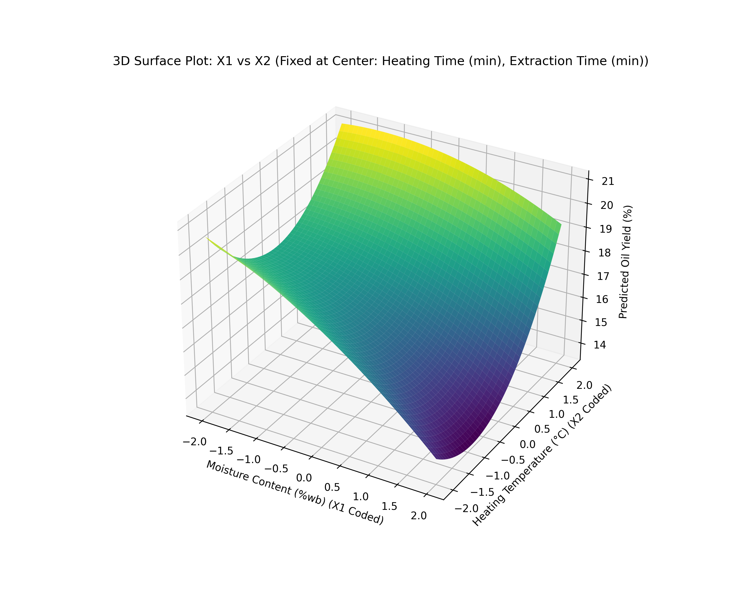

## Contour X3 X4

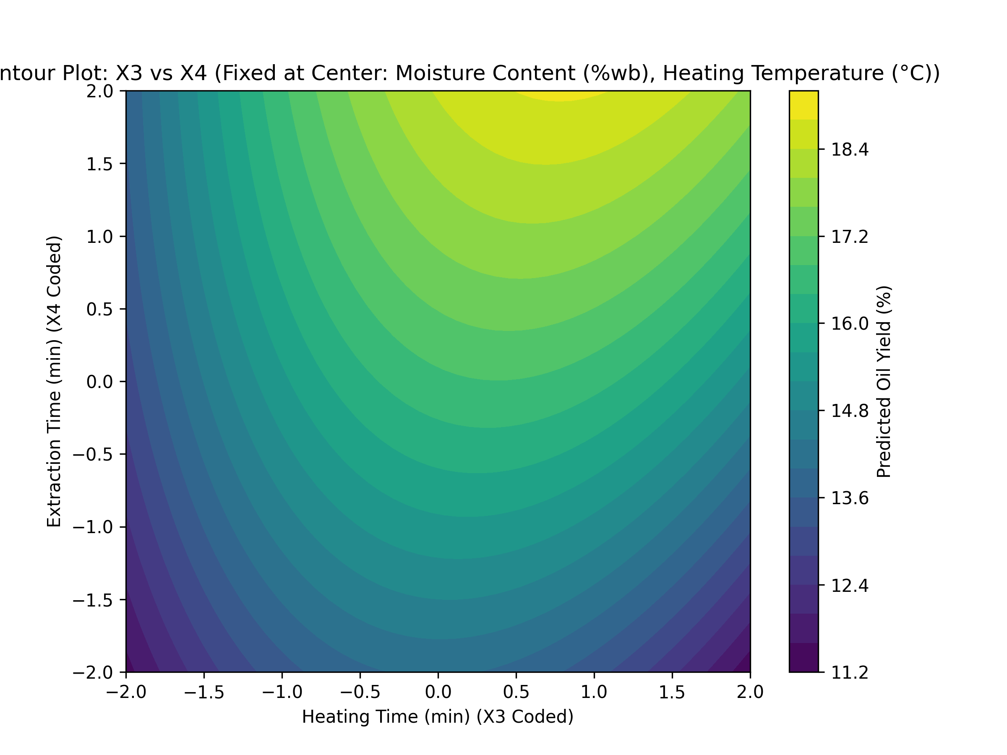

## Surface X3 X4

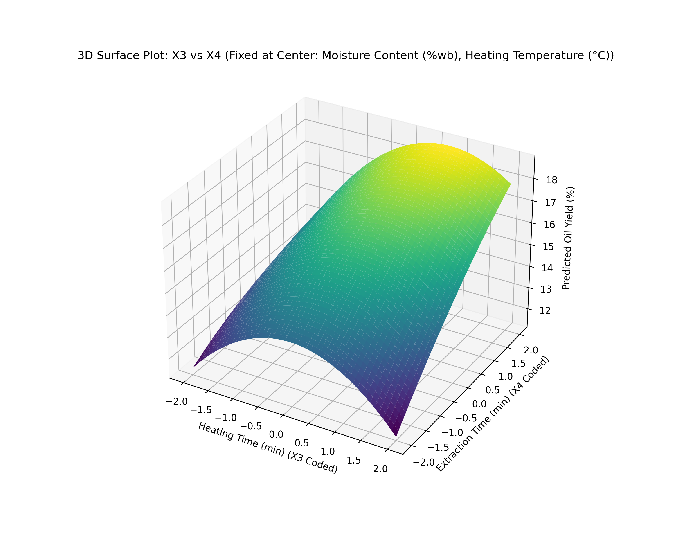

## Contour X2 X4

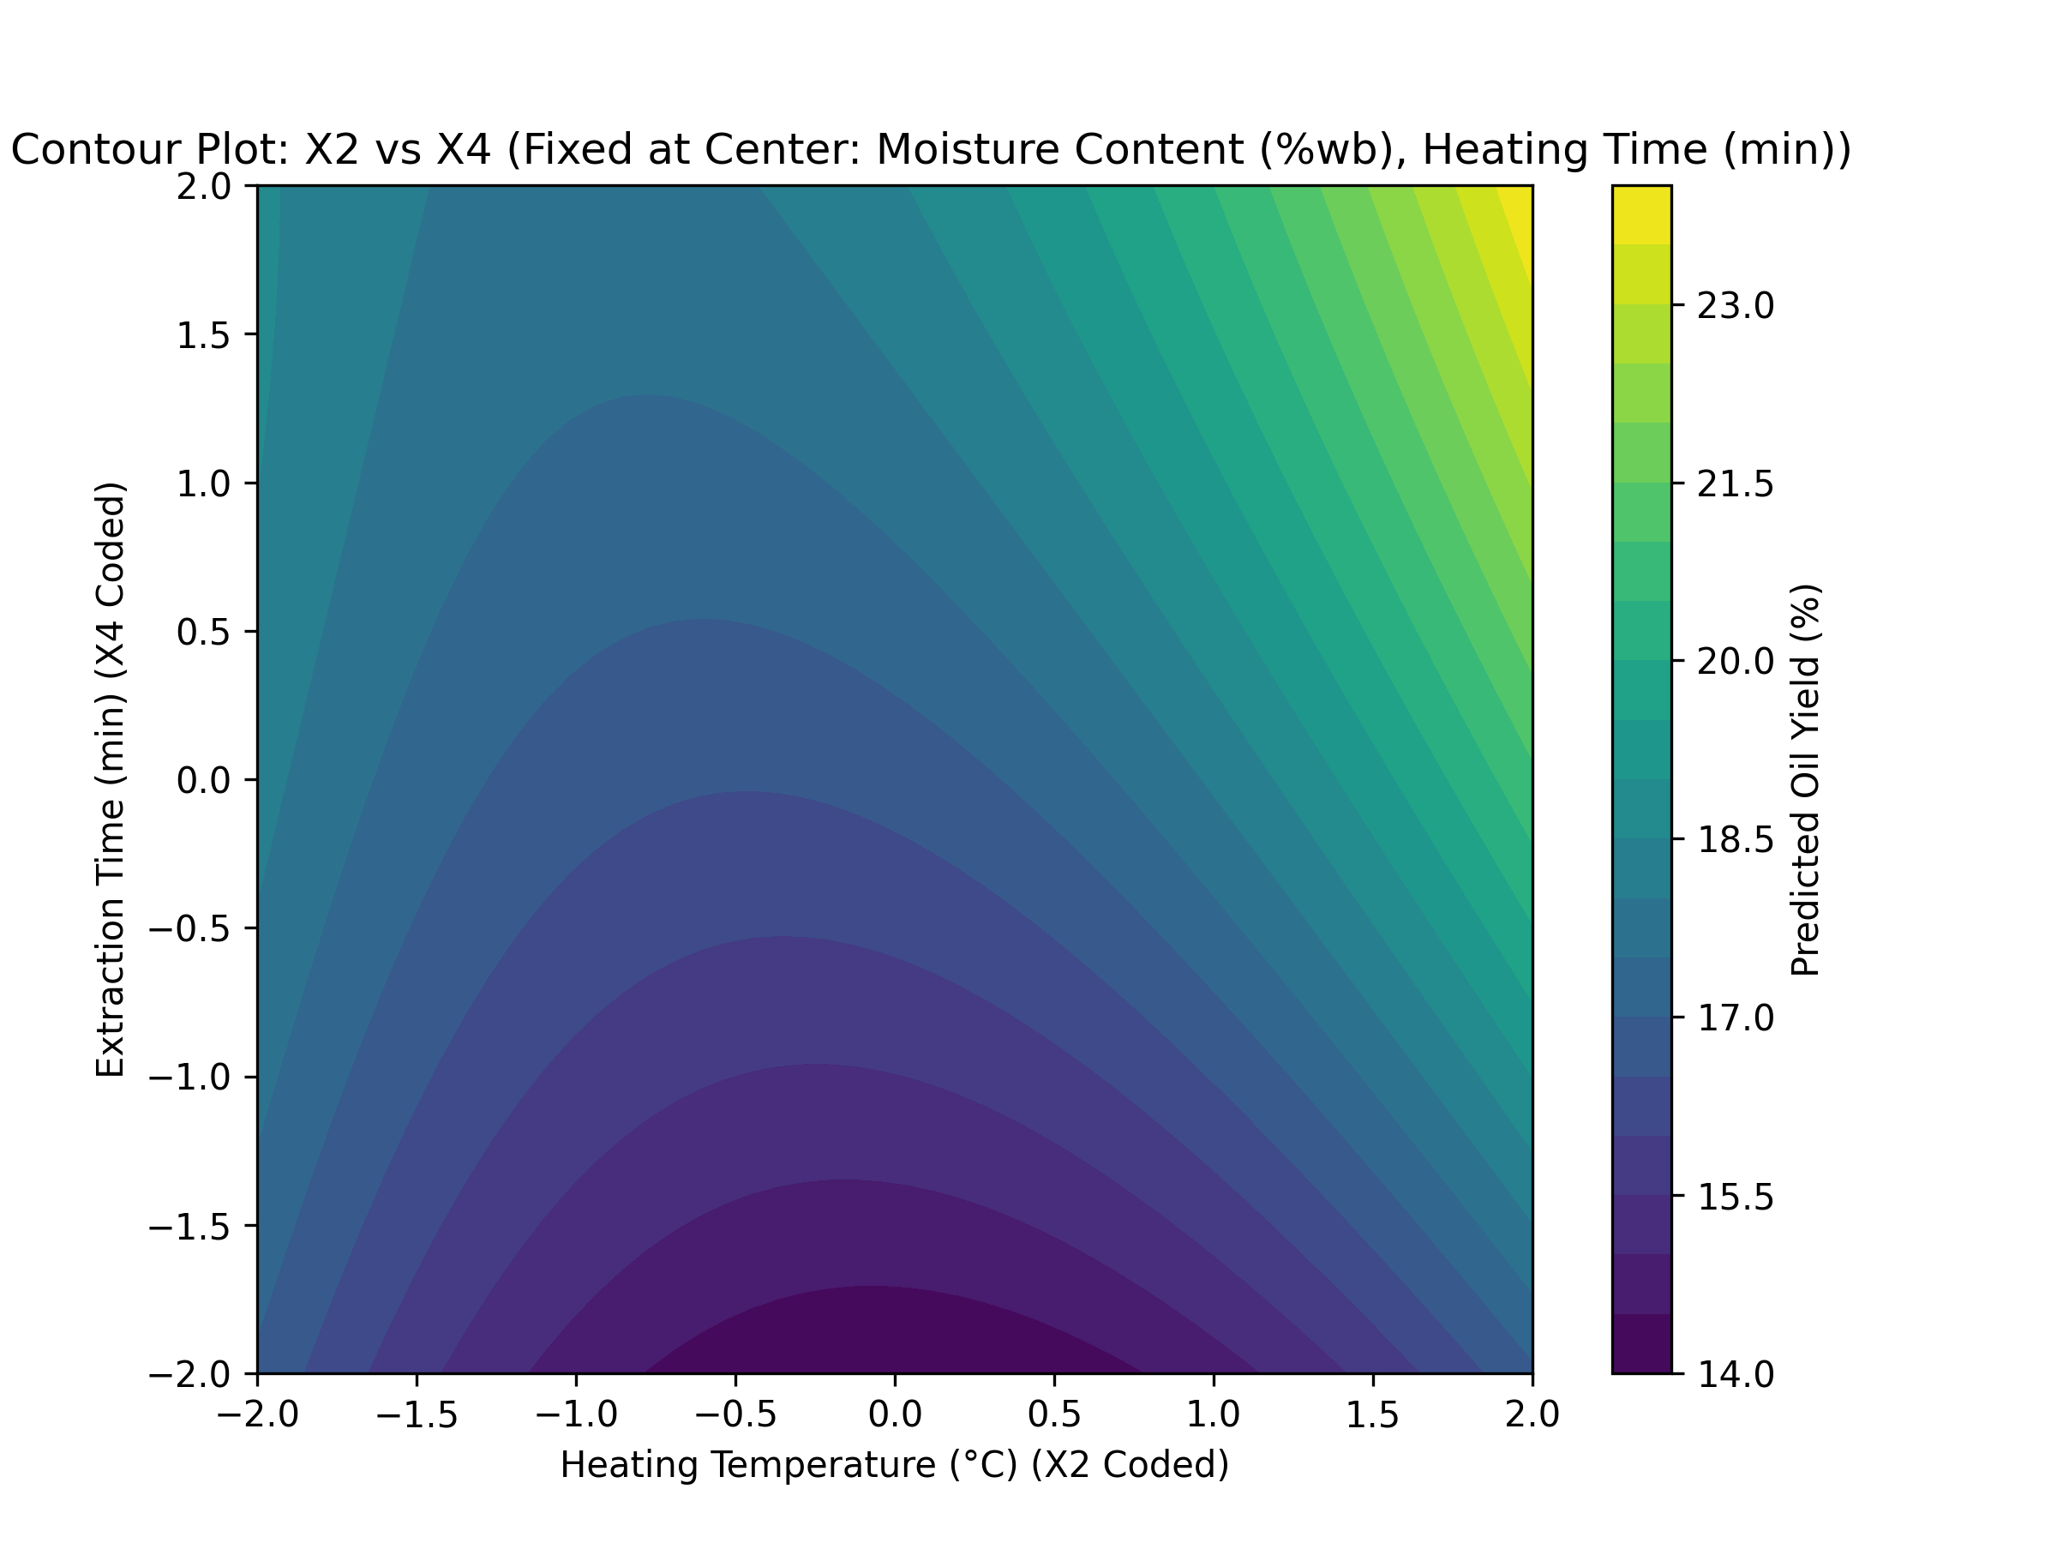

## Surface X2 X4

