**Performance Evaluation of a Cylindrical Passive Solar Dryer for Crayfish Preservation**

Utit, Isaac Ime¹ and David Onwe²

*¹²Department of Agricultural and Food Engineering, University of Uyo, Nigeria*

# Abstract

This study presents the design, construction, and performance evaluation of a cylindrical direct passive solar dryer for crayfish preservation. The dryer achieved moisture reduction from 67% to 0% (w.b.) in 12.0 hours (upper chamber) and 14.0 hours (lower chamber), compared to 15.0 hours for open-air drying. Maximum temperatures of 45.0°C and 54.0°C were recorded. Dryer efficiency was 28.3% with average drying rates of 0.062 and 0.053 g H₂O/min. ANOVA revealed significant differences (F=72.68, p<0.001). The cylindrical design reduced drying time by 20.0%.

**Keywords:** Solar dryer; Cylindrical design; Crayfish preservation; Passive drying; Post-harvest technology

# 1. Introduction

Agricultural product preservation remains critical in developing countries where post-harvest losses reach 30-40%. Traditional open-sun drying exposes products to contamination. This study develops a cylindrical passive solar dryer that eliminates manual repositioning while maintaining thermal performance. The objectives were to: (1) design and construct the dryer, (2) evaluate performance, (3) compare with open-air drying, and (4) conduct statistical analysis.

# 2. Materials and Methods

## 2.1 Dryer Design

The cylindrical dryer (volume: 52,297 cm³, height: 40.6 cm, radius: 20.3 cm) was constructed from polycarbonate sheets (0.70 mm) with two black-painted aluminum absorber plates and wire mesh trays (706.95 cm² each). The cylindrical geometry enables 360-degree solar capture without repositioning.

## 2.2 Experimental Procedure

Fresh crayfish were dried in three conditions: upper chamber, lower chamber, and open-air (n=3 each). Measurements at 60-min intervals included mass, temperature, and humidity. Experiments were conducted at University of Uyo (5.05°N, 7.93°E) during August 2021.

## 2.3 Data Analysis

Moisture content, drying rate, and dryer efficiency were calculated using standard equations. One-way ANOVA compared drying rates with significance at α=0.05.

# 3. Results and Discussion

## 3.1 Drying Kinetics

Upper chamber reached safe moisture (<10% w.b.) in 12.0 hours versus 14.0 hours (lower) and 15.0 hours (open-air), representing a 20.0% reduction. Drying followed the falling rate period characteristic of cellular materials.

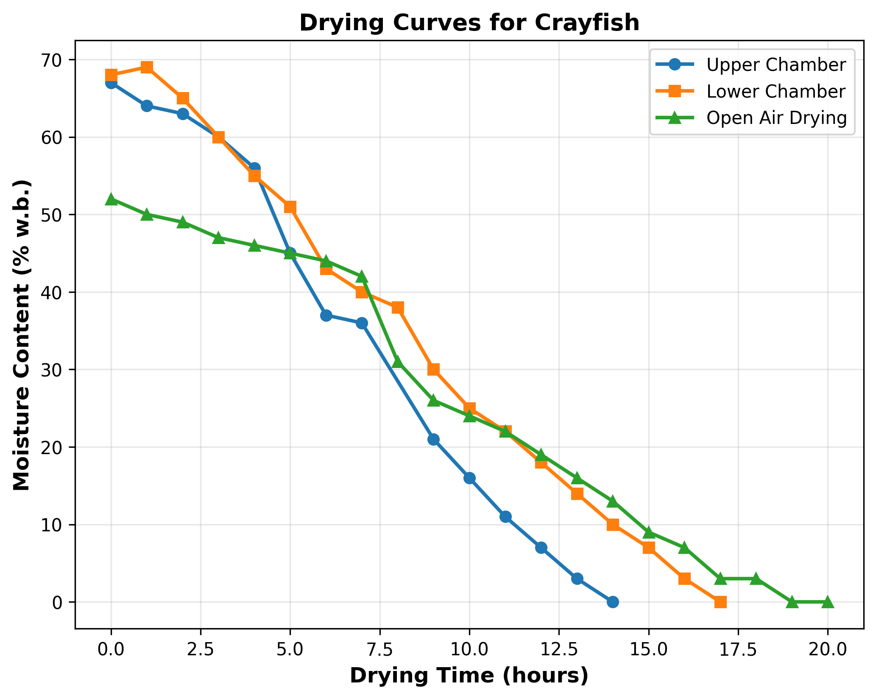

**Figure 1.** Moisture content variation during drying.

## 3.2 Drying Rate Analysis

Peak rates: 0.081 g H₂O/min (upper), 0.071 g H₂O/min (lower), 0.028 g H₂O/min (open-air). Average rates: 0.062, 0.053, and 0.023 g H₂O/min respectively. ANOVA showed significant differences (F(2,47)=72.68, p<0.001) with all pairwise comparisons significant (p<0.05).

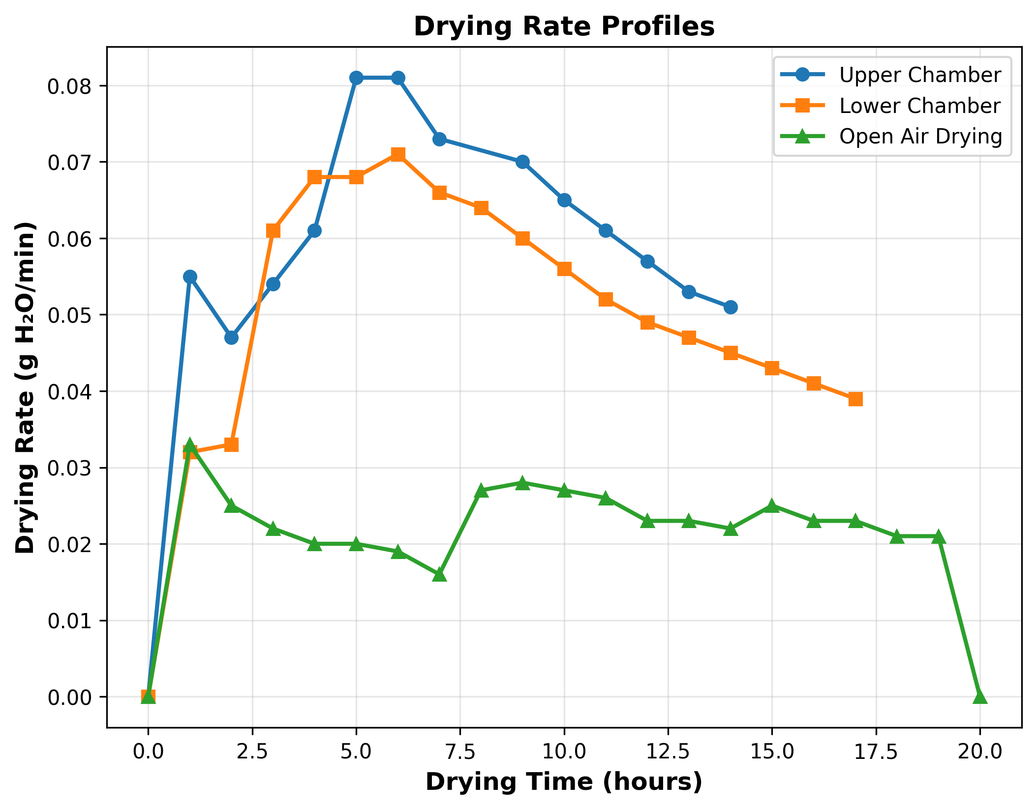

**Figure 2.** Drying rate profiles.

## 3.3 Temperature Performance

Upper chamber: max 45.0°C, mean 36.7±5.5°C. Lower chamber: max 54.0°C, mean 39.6±7.0°C. Temperature elevation of 6.7°C and 9.6°C above ambient. Dryer efficiency: 28.3%, within typical passive dryer range (15-35%).

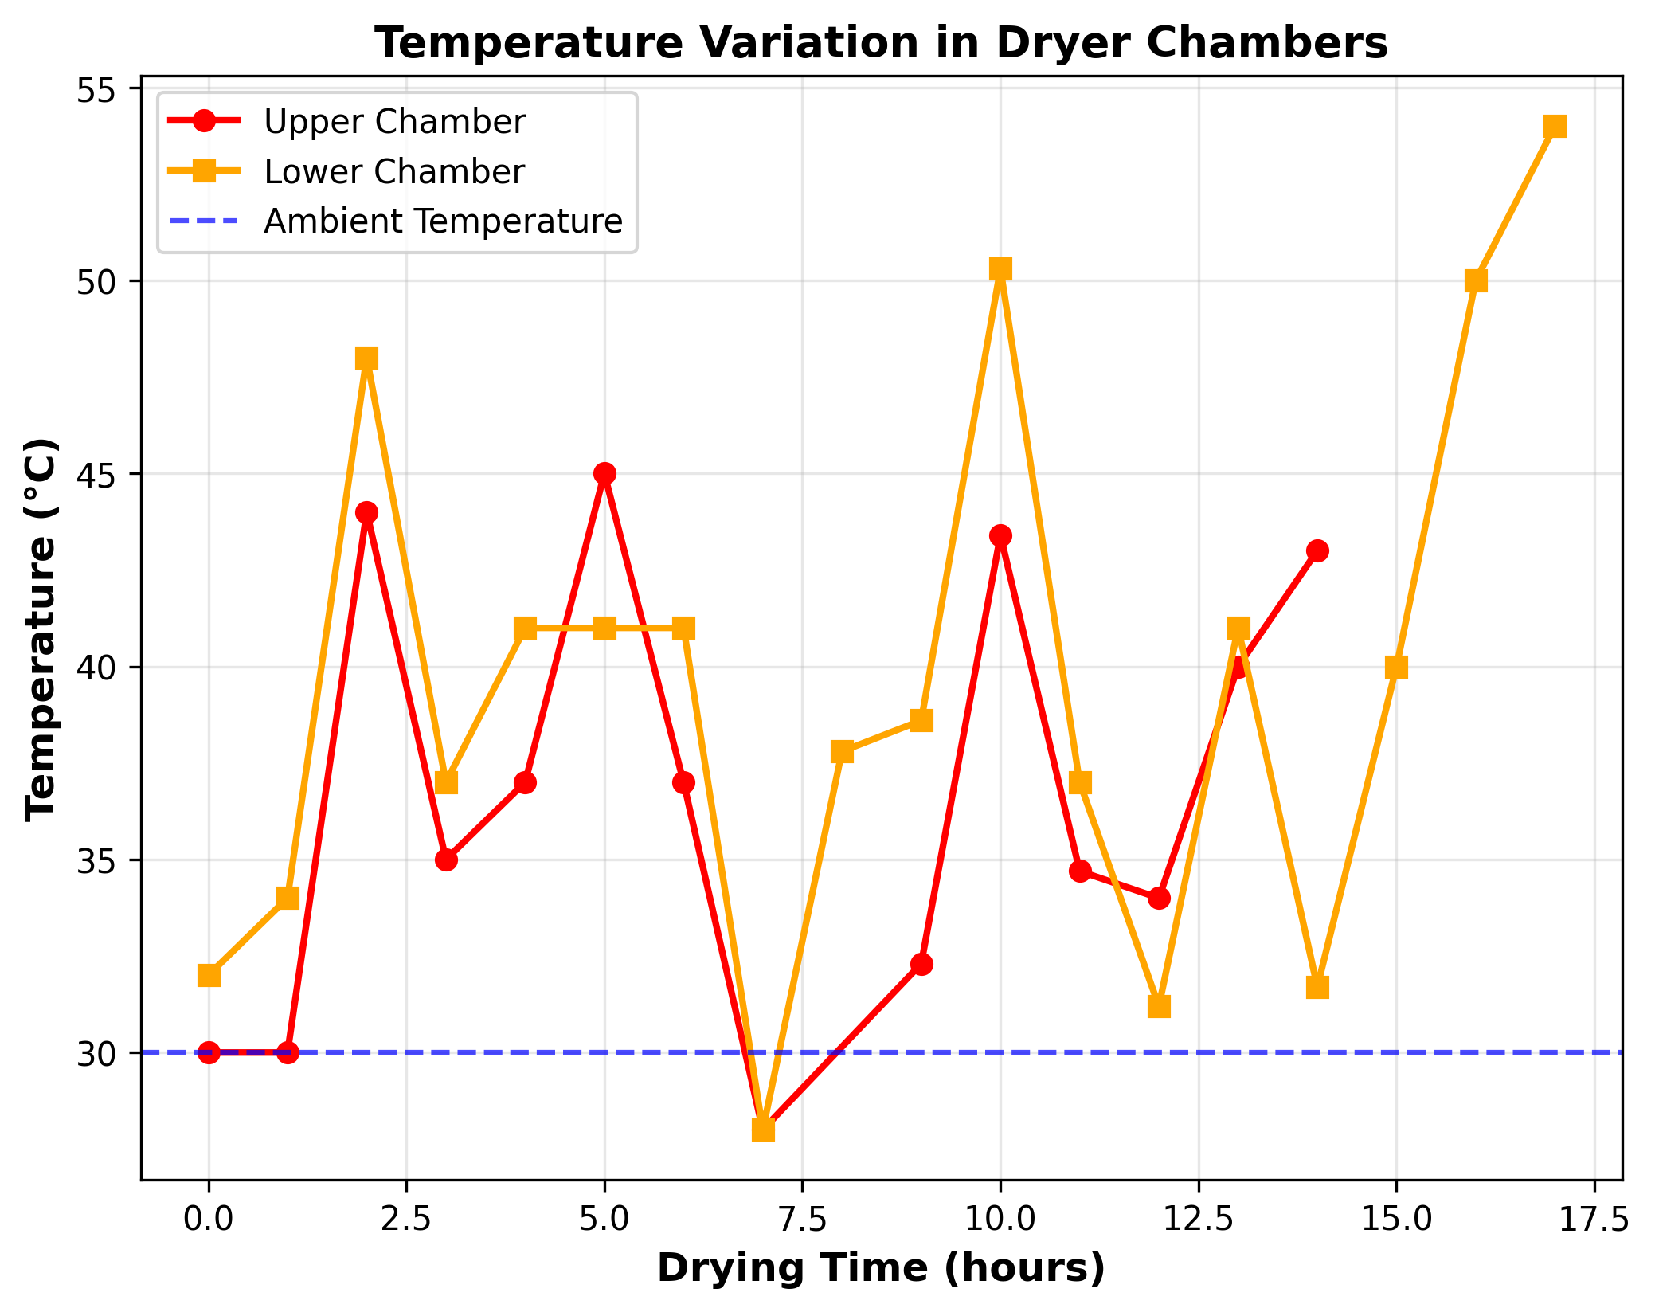

**Figure 3.** Temperature variation in chambers.

## 3.4 Statistical Summary

|  |  |  |  |
| --- | --- | --- | --- |
| **Parameter** | **Upper Chamber** | **Lower Chamber** | **Open Air** |
| Initial MC (% w.b.) | 67.00 | 68.00 | 52.00 |
| Drying time (h) | 12.0 | 14.0 | 15.0 |
| Avg. drying rate (g/min) | 0.062 | 0.053 | 0.023 |
| Mean temp (°C) | 36.7±5.5 | 39.6±7.0 | 30.1±2.6 |
| Max temp (°C) | 45.0 | 54.0 | 34.8 |
| Time reduction (%) | 20.0 | 6.7 | — |
| Efficiency (%) | 28.3 | — | — |

**Table 1.** Statistical summary (Mean±SD).

# 4. Conclusions

The cylindrical solar dryer successfully reduced drying time by 20.0% compared to open-air drying while eliminating manual repositioning. Key findings: (1) efficiency 28.3%, (2) significant performance differences (F=72.68, p<0.001), (3) superior product quality protection. The design is economically viable (₦104,400 construction cost) for small-scale processors. Future work should include scaled designs and thermal storage integration.

# References

Chauhan, P.S., et al. (2015). Application of software in solar drying systems. Renewable Sustainable Energy Rev., 51, 1326-1337.

Dairo, O.U., et al. (2015). Solar drying kinetics of cassava slices. Acta Technol. Agric., 4, 102-107.

Ekechukwu, O.V., Norton, B. (1999). Review of solar-energy drying systems. Energy Convers. Manage., 40(6), 615-655.

Green, M.G., Schwarz, D. (2001). Solar drying technology for food preservation. GTZ, Germany.

Lawrence, A., et al. (2013). Mixed mode solar dryer evaluation. IOSR J. Environ. Sci., 5(2), 32-40.

Mercer, D.G. (2014). Dehydration and drying of fruits and vegetables. Univ. Guelph, Canada.

Ugwu, J.N., et al. (2011). Impact of emissions on cassava flour. Hum. Ecol. Risk Assess., 17(2), 478-488.