Water Quality Analysis Across Four Locations

# pH

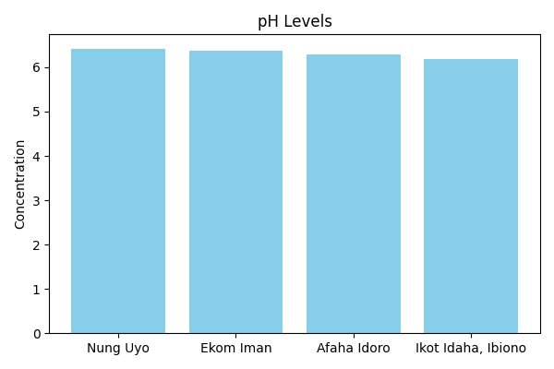

**Discussion:** The concentration of pH varies across the four sampled locations. Nung Uyo recorded a value of 6.42, Ekom Iman had 6.37, Afaha Idoro showed 6.29, and Ikot Idaha, Ibiono had 6.18. This variation may be attributed to differences in local environmental conditions, anthropogenic activities, and natural water sources. Further investigation could help determine the specific causes of these differences.

# Electrical Conductivity (EC)

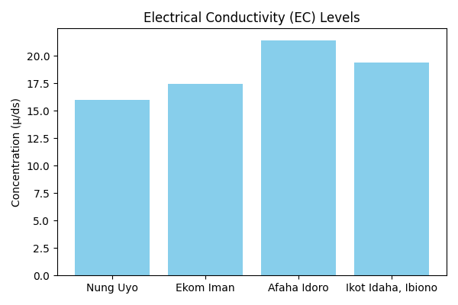

**Discussion:** The concentration of Electrical Conductivity (EC) varies across the four sampled locations. Nung Uyo recorded a value of 16.0µ/ds, Ekom Iman had 17.44µ/ds, Afaha Idoro showed 21.41µ/ds, and Ikot Idaha, Ibiono had 19.4µ/ds. This variation may be attributed to differences in local environmental conditions, anthropogenic activities, and natural water sources. Further investigation could help determine the specific causes of these differences.

# Dissolve Oxygen (DO)

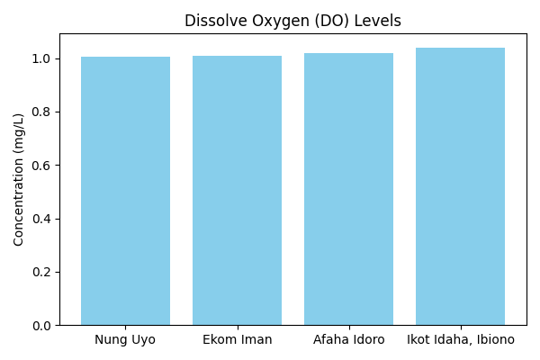

**Discussion:** The concentration of Dissolve Oxygen (DO) varies across the four sampled locations. Nung Uyo recorded a value of 1.004mg/L, Ekom Iman had 1.009mg/L, Afaha Idoro showed 1.02mg/L, and Ikot Idaha, Ibiono had 1.04mg/L. This variation may be attributed to differences in local environmental conditions, anthropogenic activities, and natural water sources. Further investigation could help determine the specific causes of these differences.

# BOD

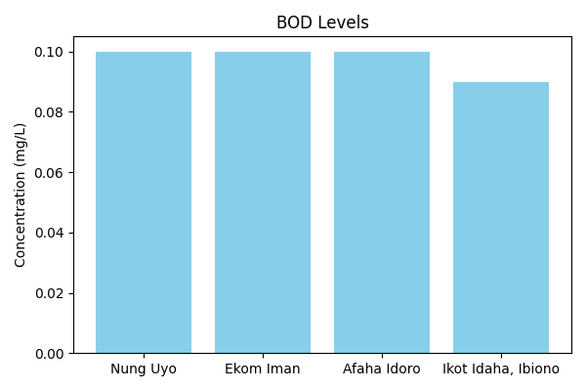

**Discussion:** The concentration of BOD varies across the four sampled locations. Nung Uyo recorded a value of 0.1mg/L, Ekom Iman had 0.1mg/L, Afaha Idoro showed 0.1mg/L, and Ikot Idaha, Ibiono had 0.09mg/L. This variation may be attributed to differences in local environmental conditions, anthropogenic activities, and natural water sources. Further investigation could help determine the specific causes of these differences.

# Turbidity

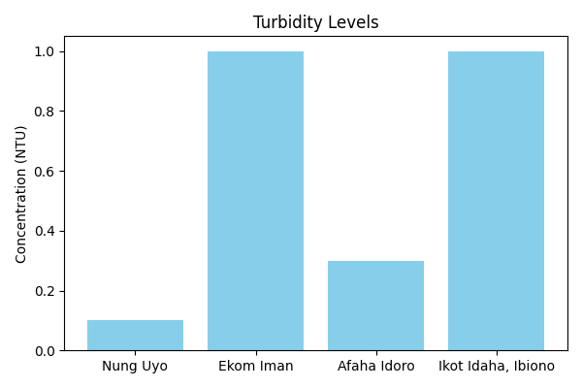

**Discussion:** The concentration of Turbidity varies across the four sampled locations. Nung Uyo recorded a value of 0.1NTU, Ekom Iman had 1.0NTU, Afaha Idoro showed 0.3NTU, and Ikot Idaha, Ibiono had 1.0NTU. This variation may be attributed to differences in local environmental conditions, anthropogenic activities, and natural water sources. Further investigation could help determine the specific causes of these differences.

# TSS

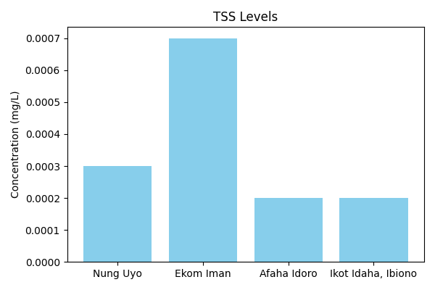

**Discussion:** The concentration of TSS varies across the four sampled locations. Nung Uyo recorded a value of 0.0003mg/L, Ekom Iman had 0.0007mg/L, Afaha Idoro showed 0.0002mg/L, and Ikot Idaha, Ibiono had 0.0002mg/L. This variation may be attributed to differences in local environmental conditions, anthropogenic activities, and natural water sources. Further investigation could help determine the specific causes of these differences.

# TDS

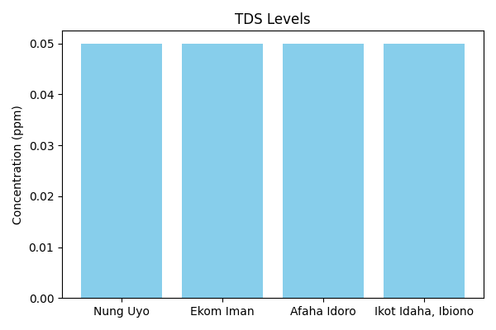

**Discussion:** The concentration of TDS varies across the four sampled locations. Nung Uyo recorded a value of 0.05ppm, Ekom Iman had 0.05ppm, Afaha Idoro showed 0.05ppm, and Ikot Idaha, Ibiono had 0.05ppm. This variation may be attributed to differences in local environmental conditions, anthropogenic activities, and natural water sources. Further investigation could help determine the specific causes of these differences.

# Phosphate

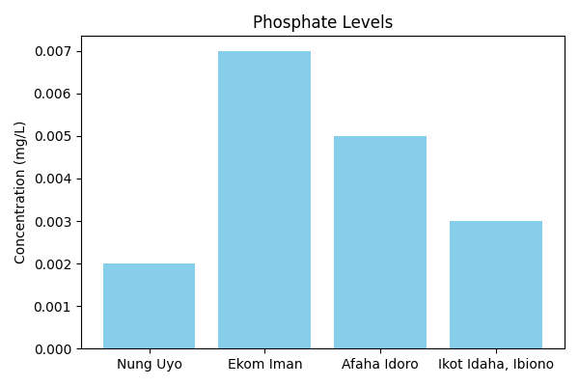

**Discussion:** The concentration of Phosphate varies across the four sampled locations. Nung Uyo recorded a value of 0.002mg/L, Ekom Iman had 0.007mg/L, Afaha Idoro showed 0.005mg/L, and Ikot Idaha, Ibiono had 0.003mg/L. This variation may be attributed to differences in local environmental conditions, anthropogenic activities, and natural water sources. Further investigation could help determine the specific causes of these differences.

# Alkalinity

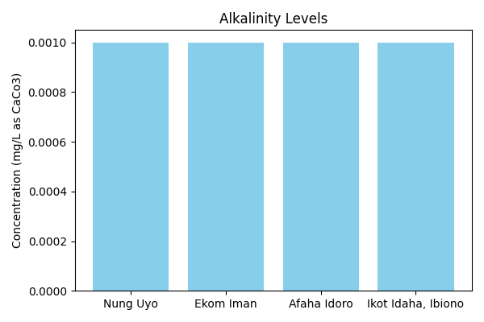

**Discussion:** The concentration of Alkalinity varies across the four sampled locations. Nung Uyo recorded a value of 0.001mg/L as CaCo3, Ekom Iman had 0.001mg/L as CaCo3, Afaha Idoro showed 0.001mg/L as CaCo3, and Ikot Idaha, Ibiono had 0.001mg/L as CaCo3. This variation may be attributed to differences in local environmental conditions, anthropogenic activities, and natural water sources. Further investigation could help determine the specific causes of these differences.

# Salinity

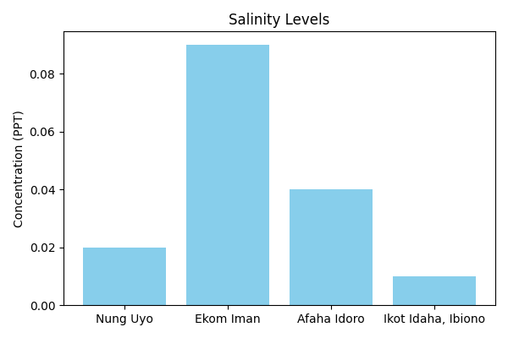

**Discussion:** The concentration of Salinity varies across the four sampled locations. Nung Uyo recorded a value of 0.02PPT, Ekom Iman had 0.09PPT, Afaha Idoro showed 0.04PPT, and Ikot Idaha, Ibiono had 0.01PPT. This variation may be attributed to differences in local environmental conditions, anthropogenic activities, and natural water sources. Further investigation could help determine the specific causes of these differences.

# Chloride

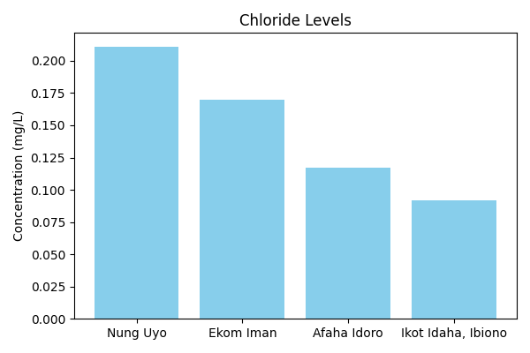

**Discussion:** The concentration of Chloride varies across the four sampled locations. Nung Uyo recorded a value of 0.211mg/L, Ekom Iman had 0.17mg/L, Afaha Idoro showed 0.117mg/L, and Ikot Idaha, Ibiono had 0.092mg/L. This variation may be attributed to differences in local environmental conditions, anthropogenic activities, and natural water sources. Further investigation could help determine the specific causes of these differences.

# Acidity

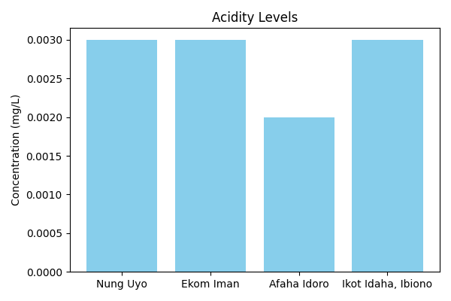

**Discussion:** The concentration of Acidity varies across the four sampled locations. Nung Uyo recorded a value of 0.003mg/L, Ekom Iman had 0.003mg/L, Afaha Idoro showed 0.002mg/L, and Ikot Idaha, Ibiono had 0.003mg/L. This variation may be attributed to differences in local environmental conditions, anthropogenic activities, and natural water sources. Further investigation could help determine the specific causes of these differences.

# Nitrate

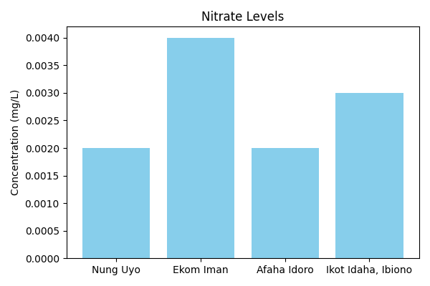

**Discussion:** The concentration of Nitrate varies across the four sampled locations. Nung Uyo recorded a value of 0.002mg/L, Ekom Iman had 0.004mg/L, Afaha Idoro showed 0.002mg/L, and Ikot Idaha, Ibiono had 0.003mg/L. This variation may be attributed to differences in local environmental conditions, anthropogenic activities, and natural water sources. Further investigation could help determine the specific causes of these differences.

# COD

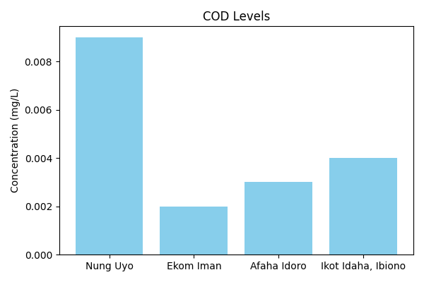

**Discussion:** The concentration of COD varies across the four sampled locations. Nung Uyo recorded a value of 0.009mg/L, Ekom Iman had 0.002mg/L, Afaha Idoro showed 0.003mg/L, and Ikot Idaha, Ibiono had 0.004mg/L. This variation may be attributed to differences in local environmental conditions, anthropogenic activities, and natural water sources. Further investigation could help determine the specific causes of these differences.

# Temperature

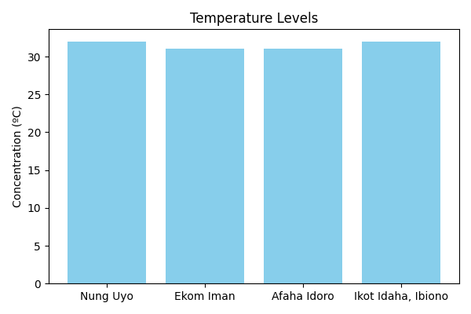

**Discussion:** The concentration of Temperature varies across the four sampled locations. Nung Uyo recorded a value of 32ºC, Ekom Iman had 31ºC, Afaha Idoro showed 31ºC, and Ikot Idaha, Ibiono had 32ºC. This variation may be attributed to differences in local environmental conditions, anthropogenic activities, and natural water sources. Further investigation could help determine the specific causes of these differences.

# Iron (Fe)

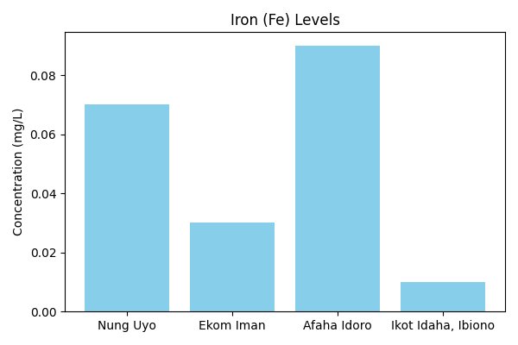

**Discussion:** The concentration of Iron (Fe) varies across the four sampled locations. Nung Uyo recorded a value of 0.07mg/L, Ekom Iman had 0.03mg/L, Afaha Idoro showed 0.09mg/L, and Ikot Idaha, Ibiono had 0.01mg/L. This variation may be attributed to differences in local environmental conditions, anthropogenic activities, and natural water sources. Further investigation could help determine the specific causes of these differences.

# Zinc (Zn)

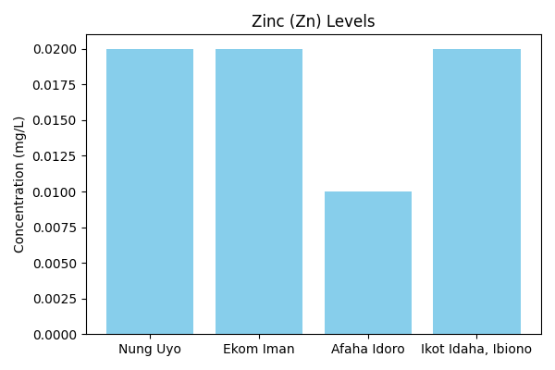

**Discussion:** The concentration of Zinc (Zn) varies across the four sampled locations. Nung Uyo recorded a value of 0.02mg/L, Ekom Iman had 0.02mg/L, Afaha Idoro showed 0.01mg/L, and Ikot Idaha, Ibiono had 0.02mg/L. This variation may be attributed to differences in local environmental conditions, anthropogenic activities, and natural water sources. Further investigation could help determine the specific causes of these differences.

# Copper (Cu)

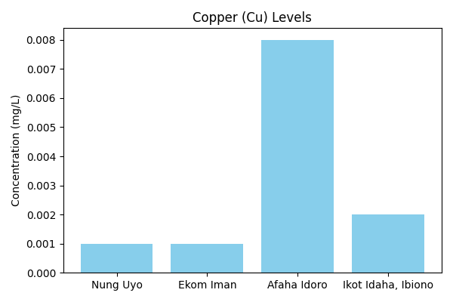

**Discussion:** The concentration of Copper (Cu) varies across the four sampled locations. Nung Uyo recorded a value of 0.001mg/L, Ekom Iman had 0.001mg/L, Afaha Idoro showed 0.008mg/L, and Ikot Idaha, Ibiono had 0.002mg/L. This variation may be attributed to differences in local environmental conditions, anthropogenic activities, and natural water sources. Further investigation could help determine the specific causes of these differences.