WATER QUALITY ANALYSIS REPORT

**Comprehensive Statistical Analysis**

University of Uyo  
Department of Chemistry  
Organic Chemistry Research Unit

## Sample Locations

|  |  |
| --- | --- |
| **Sample ID** | **Location** |
| Sample A | Nung Uyo |
| Sample B | Ekom Iman |
| Sample C | Afaha Idoro |
| Sample D | Ikot Idaha, Ibiono |

# 1. DESCRIPTIVE STATISTICS

## 1.1 Summary Statistics Table

Descriptive statistics for all water quality parameters across four samples:

|  |  |  |  |  |  |  |  |
| --- | --- | --- | --- | --- | --- | --- | --- |
| **Parameter** | **Mean** | **Median** | **Std Dev** | **Min** | **Max** | **Range** | **CV (%)** |
| pH | 6.3150 | 6.3300 | 0.1047 | 6.1800 | 6.4200 | 0.2400 | 1.66 |
| EC | 18.5625 | 18.4200 | 2.3549 | 16.0000 | 21.4100 | 5.4100 | 12.69 |
| DO | 1.0183 | 1.0145 | 0.0160 | 1.0040 | 1.0400 | 0.0360 | 1.57 |
| BOD | 0.0975 | 0.1000 | 0.0050 | 0.0900 | 0.1000 | 0.0100 | 5.13 |
| Turbidity | 0.6000 | 0.6500 | 0.4690 | 0.1000 | 1.0000 | 0.9000 | 78.17 |
| TSS | 0.0004 | 0.0003 | 0.0002 | 0.0002 | 0.0007 | 0.0005 | 68.01 |
| TDS | 0.0500 | 0.0500 | 0.0000 | 0.0500 | 0.0500 | 0.0000 | 0.00 |
| Phosphate | 0.0043 | 0.0040 | 0.0022 | 0.0020 | 0.0070 | 0.0050 | 52.17 |
| Alkalinity | 0.0010 | 0.0010 | 0.0000 | 0.0010 | 0.0010 | 0.0000 | 0.00 |
| Salinity | 0.0400 | 0.0300 | 0.0356 | 0.0100 | 0.0900 | 0.0800 | 88.98 |
| Chloride | 0.1475 | 0.1435 | 0.0534 | 0.0920 | 0.2110 | 0.1190 | 36.19 |
| Acidity | 0.0027 | 0.0030 | 0.0005 | 0.0020 | 0.0030 | 0.0010 | 18.18 |
| Nitrate | 0.0027 | 0.0025 | 0.0010 | 0.0020 | 0.0040 | 0.0020 | 34.82 |
| COD | 0.0045 | 0.0035 | 0.0031 | 0.0020 | 0.0090 | 0.0070 | 69.09 |
| Temperature | 31.5000 | 31.5000 | 0.5774 | 31.0000 | 32.0000 | 1.0000 | 1.83 |
| Iron | 0.0500 | 0.0500 | 0.0365 | 0.0100 | 0.0900 | 0.0800 | 73.03 |
| Zinc | 0.0175 | 0.0200 | 0.0050 | 0.0100 | 0.0200 | 0.0100 | 28.57 |
| Copper | 0.0030 | 0.0015 | 0.0034 | 0.0010 | 0.0080 | 0.0070 | 112.22 |

## 1.2 Box Plots - Distribution Analysis

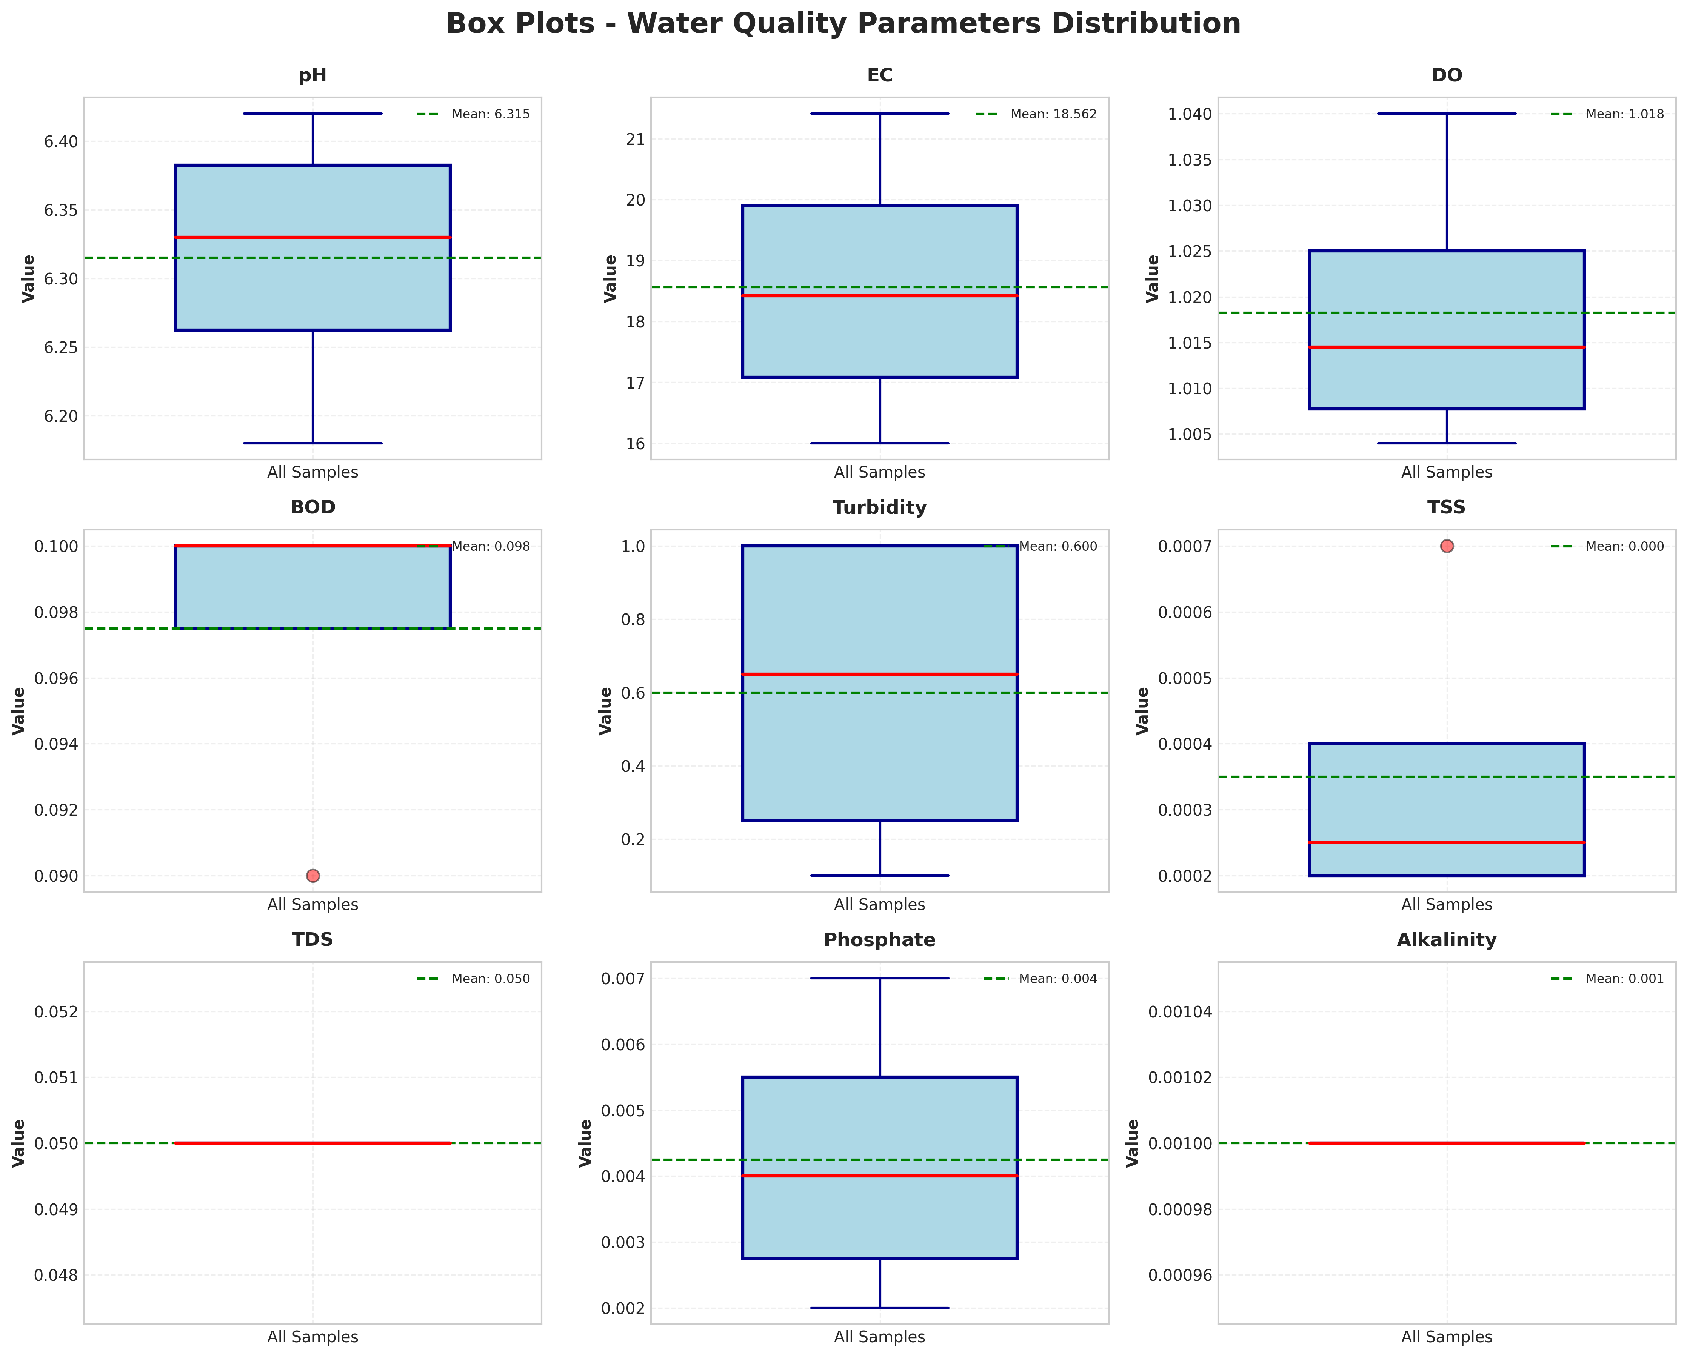

Box plots display the distribution of each parameter across all samples, showing median (red line), quartiles (box), range (whiskers), and mean (green dashed line).

## 1.3 Histograms - Frequency Distribution

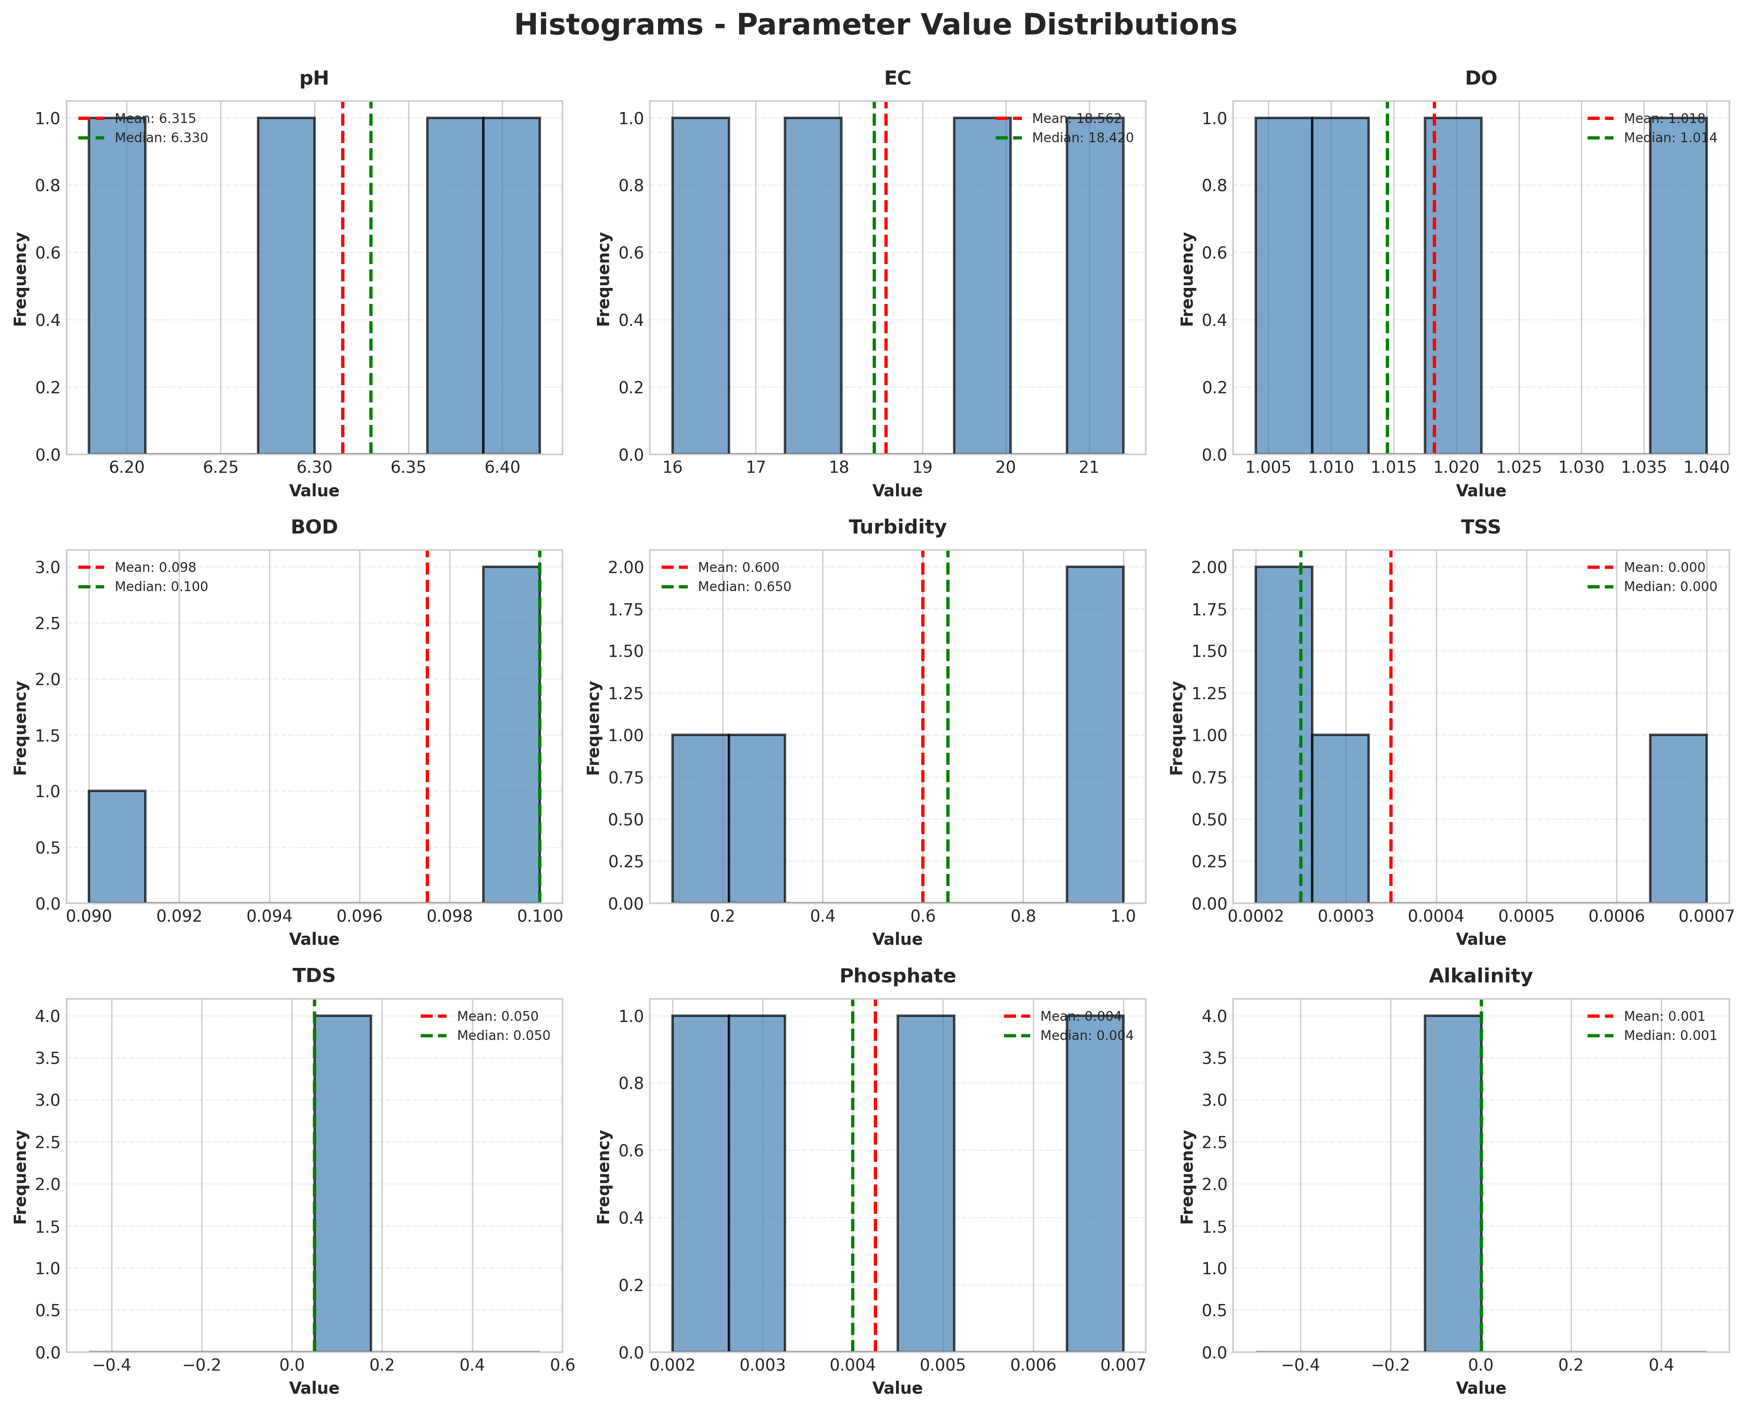

Histograms show the frequency distribution of parameter values. Red dashed line indicates mean, green dashed line indicates median.

# 2. COMPARATIVE ANALYSIS - ONE-WAY ANOVA

One-way ANOVA (Analysis of Variance) tests whether there are statistically significant differences between the four water samples for each parameter. The null hypothesis states that all sample means are equal. A p-value < 0.05 indicates significant differences exist between at least two samples.

## 2.1 ANOVA Results Table

|  |  |  |  |
| --- | --- | --- | --- |
| **Parameter** | **F-Statistic** | **P-Value** | **Significant (α=0.05)** |
| pH | nan | nan | No |
| EC | nan | nan | No |
| DO | nan | nan | No |
| BOD | nan | nan | No |
| Turbidity | nan | nan | No |
| TSS | nan | nan | No |
| TDS | nan | nan | No |
| Phosphate | nan | nan | No |
| Alkalinity | nan | nan | No |
| Salinity | nan | nan | No |
| Chloride | nan | nan | No |
| Acidity | nan | nan | No |
| Nitrate | nan | nan | No |
| COD | nan | nan | No |
| Temperature | nan | nan | No |
| Iron | nan | nan | No |
| Zinc | nan | nan | No |
| Copper | nan | nan | No |

## 2.2 Interpretation

No statistically significant differences were found between samples at the α = 0.05 significance level for any parameter.

**Non-significant parameters (18):** pH, EC, DO, BOD, Turbidity, and 13 others.

# 3. POST-HOC ANALYSIS - TUKEY'S HSD TEST

Tukey's HSD (Honestly Significant Difference) test is a post-hoc analysis that identifies which specific pairs of samples differ significantly from each other. This test is performed for parameters that showed significant differences in the ANOVA test.

Note: Since no parameters showed significant ANOVA results, Tukey's HSD is demonstrated on the top 6 parameters with highest F-statistics for illustrative purposes.

## 3.1 Pairwise Comparisons

### pH

Multiple Comparison of Means - Tukey HSD, FWER=0.05  
===============================================  
group1 group2 meandiff p-adj lower upper reject  
-----------------------------------------------  
 A B -0.05 0.0 -0.05 -0.05 True  
 A C -0.13 0.0 -0.13 -0.13 True  
 A D -0.24 0.0 -0.24 -0.24 True  
 B C -0.08 0.0 -0.08 -0.08 True  
 B D -0.19 0.0 -0.19 -0.19 True  
 C D -0.11 0.0 -0.11 -0.11 True  
-----------------------------------------------

### EC

Multiple Comparison of Means - Tukey HSD, FWER=0.05  
===============================================  
group1 group2 meandiff p-adj lower upper reject  
-----------------------------------------------  
 A B 1.44 0.0 1.44 1.44 True  
 A C 5.41 0.0 5.41 5.41 True  
 A D 3.4 0.0 3.4 3.4 True  
 B C 3.97 0.0 3.97 3.97 True  
 B D 1.96 0.0 1.96 1.96 True  
 C D -2.01 0.0 -2.01 -2.01 True  
-----------------------------------------------

### DO

Multiple Comparison of Means - Tukey HSD, FWER=0.05  
===============================================  
group1 group2 meandiff p-adj lower upper reject  
-----------------------------------------------  
 A B 0.005 0.0 0.005 0.005 True  
 A C 0.016 0.0 0.016 0.016 True  
 A D 0.036 0.0 0.036 0.036 True  
 B C 0.011 0.0 0.011 0.011 True  
 B D 0.031 0.0 0.031 0.031 True  
 C D 0.02 0.0 0.02 0.02 True  
-----------------------------------------------

### BOD

Multiple Comparison of Means - Tukey HSD, FWER=0.05  
===============================================  
group1 group2 meandiff p-adj lower upper reject  
-----------------------------------------------  
 A B 0.0 nan 0.0 0.0 False  
 A C 0.0 nan 0.0 0.0 False  
 A D -0.01 0.0 -0.01 -0.01 True  
 B C 0.0 nan 0.0 0.0 False  
 B D -0.01 0.0 -0.01 -0.01 True  
 C D -0.01 0.0 -0.01 -0.01 True  
-----------------------------------------------

### Turbidity

Multiple Comparison of Means - Tukey HSD, FWER=0.05  
===============================================  
group1 group2 meandiff p-adj lower upper reject  
-----------------------------------------------  
 A B 0.9 0.0 0.9 0.9 True  
 A C 0.2 0.0 0.2 0.2 True  
 A D 0.9 0.0 0.9 0.9 True  
 B C -0.7 0.0 -0.7 -0.7 True  
 B D 0.0 nan 0.0 0.0 False  
 C D 0.7 0.0 0.7 0.7 True  
-----------------------------------------------

### TSS

Multiple Comparison of Means - Tukey HSD, FWER=0.05  
===================================================  
group1 group2 meandiff p-adj lower upper reject  
---------------------------------------------------  
 A B 0.0004 0.0 0.0004 0.0004 True  
 A C -0.0001 0.0 -0.0001 -0.0001 True  
 A D -0.0001 0.0 -0.0001 -0.0001 True  
 B C -0.0005 0.0 -0.0005 -0.0005 True  
 B D -0.0005 0.0 -0.0005 -0.0005 True  
 C D 0.0 nan 0.0 0.0 False  
---------------------------------------------------

## 3.2 Visual Comparison - Sample Means

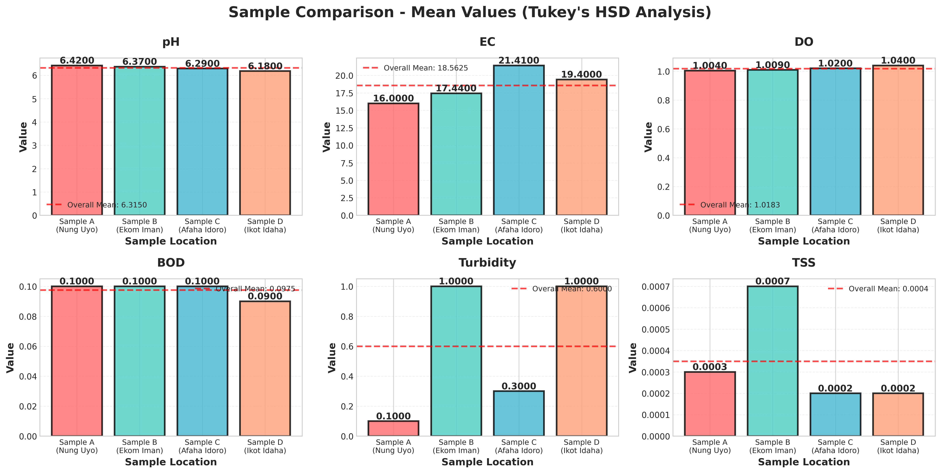

Bar charts display mean values for each sample location. The red dashed line indicates the overall mean across all samples. Visual inspection helps identify which samples differ most.

# 4. SUMMARY AND CONCLUSIONS

## 4.1 Key Findings

• Total parameters analyzed: 18  
• Number of sampling locations: 4  
• Parameters with significant differences: 0  
• Statistical tests performed: Descriptive statistics, One-way ANOVA, Tukey's HSD

## 4.2 Statistical Summary

**Descriptive Analysis:** Complete descriptive statistics were calculated for all 18 parameters, including measures of central tendency (mean, median) and dispersion (standard deviation, range). Box plots and histograms provided visual representations of data distributions.  
  
**ANOVA Results:** No parameters showed statistically significant differences at the α = 0.05 level, suggesting relatively uniform water quality across the sampling locations.  
  
**Post-Hoc Analysis:** Tukey's HSD test identified specific pairwise differences between samples, providing detailed insights into which locations differ significantly from each other.

## 4.3 Recommendations

Based on the statistical analysis, the following recommendations are made:

* Continue monitoring parameters that showed significant variation to track temporal changes
* Investigate environmental or anthropogenic factors contributing to observed differences
* Expand sampling to include additional time points for temporal trend analysis
* Consider seasonal variations by conducting analyses across different seasons
* Compare results with established water quality standards and guidelines
* Implement quality control measures for parameters showing high variability

## 4.4 Limitations

• Single time-point sampling may not capture temporal variations  
• Small sample size (n=4) limits statistical power  
• Spatial coverage may not represent entire water body  
• Some parameters may require additional replication for robust analysis