# Development and Evaluation of a Direct Passive Polycarbonate Cylindrical Solar Dryer for Crayfish

Utit, I. I.; Supervisor: Dr. David Onwe

## Abstract

The need to preserve aquatic proteins such as crayfish in low-electrical settings drives research into passive solar drying. This study describes the design, construction, and performance evaluation of a direct passive cylindrical solar dryer made from polycarbonate using crayfish as test material. The dryer attained internal temperatures up to ~54 °C, reduced moisture content from ~48.6% to ~3.51% (upper tray) in ~12 h and from ~42.4% to 2.5% (lower tray) in ~17 h, compared to ~19 h via open-air drying. Peak drying rates were ~0.081 g H₂O/min and the calculated mass-based efficiency was ~28.3%. This configuration shows promise for low-cost aquatic product drying in tropical off-grid settings.

## 1. Introduction

Aquatic protein sources such as crayfish and fish are critical for food security in tropical communities, but their high moisture content (~70–80 %) makes them highly perishable. Traditional open-sun drying remains widespread, but suffers contamination, insect infestation, unpredictable weather, and slow drying rates (Younis et al., 2025). Solar dryers offer improved control, hygiene, and accelerated drying through elevated temperatures and reduced ambient humidity (Fernandes et al., 2024). Solar drying systems may be classified as direct, indirect, mixed-mode, active or passive (Prakash et al., 2025). Direct dryers allow product radiation exposure; indirect dryers use heated air streams; mixed-mode combines both; active systems use fans, while passive rely solely on buoyancy‐driven airflow. Natural convection dryers often exhibit limited airflow under weak thermal gradients (Prakash et al., 2025; Fernandes et al., 2024). While solar-drying of fruits, grains, and vegetables is widely studied, fewer works address aquatic products in direct passive cylindrical configurations. Here, we design and evaluate a solar cylinder dryer with polycarbonate glazing and local materials, using crayfish to characterize drying kinetics, thermal performance, and system efficiency.

## 2. Literature Review

Solar drying of fish and aquatic products has been explored in forms such as the direct dryer by Obayopo & Alonge (2018), which recorded internal temperature increases of ~35 °C and maximum efficiencies exceeding 70% under forced convection. However, high temperatures risk protein denaturation and lipid oxidation (Fitri et al., 2022). Hybrid systems combining solar energy with electrical backup have been used to mitigate intermittency (Development of Solar Dryer with Electrical Backup, 2021). IoT-enabled solar dryers are more recent innovations, allowing real-time monitoring and controlled operation (Modification & Evaluation, 2024). In numerical modeling, finite-difference greenhouse dryer models (Sadodin & Kashani, 2011) and iterative convective drying estimators (Skarbalius et al., 2021) provide design-driven insight. Comprehensive reviews place recent advances in glazing, airflow design, hybrid storage, and materials integration at the frontier of solar drying research (Fernandes et al., 2024). Yet direct passive cylindrical dryers remain comparatively underexplored.

## 3. Materials and Methods

The solar dryer constructed is a vertical cylinder using 0.7 mm polycarbonate sheet as the transparent cover, mounted on a wooden frame. Two black-painted corrugated aluminum absorber plates conform to the cylindrical interior, with two mesh trays (upper, lower) separated by ~20 cm. Cylinder radius 20.3 cm, height 40.4 cm, giving ~52,297 cm³ volume; glazing area ~0.1294 m²; tray area ~706.95 cm². Natural passive ventilation (no fan or chimney) was used. Absorbers are painted matte black. The dryer is aligned to optimize sun exposure.

Fresh crayfish (Procambarus spp.) were cleaned and loaded into tray replicates (n=3). Every 60 min, up to equilibrium moisture, samples from each tray and open-air controls were weighed, and ambient and internal temperatures and humidity logged. Open-air drying was conducted simultaneously under same interval sampling.

Moisture content (wet basis) was computed as MC = (M_w / (M_w + M_d)) ×100. Drying rate was computed as ΔW/Δt (g H₂O per min). Dryer efficiency (mass-based) was: η = (W L)/(I A t), where W=water mass removed, L=latent heat (≈2,260 kJ/kg), I=solar insolation (W/m²), A=collector area, t=drying duration. Statistical summaries (mean, standard deviation, min, max) were computed. Moisture and drying-rate curves were plotted.

## 4. Results

### 4.1 Thermal performance

Ambient temperature averaged ~32.77 °C (±6.2 °C). Internal dryer temperature averaged ~40.24 °C (±7.80 °C) at upper tray, and ~34.83 °C (±17.10 °C) at lower tray. Average temperature differentials (ΔT) were ~16.8 °C (upper) and ~12.6 °C (lower). Peak internal temperature reached ~54 °C. These results confirm the cylindrical polycarbonate structure and absorbers effectively harnessed solar heat and established a greenhouse microclimate.

### 4.2 Moisture removal kinetics

Upper tray moisture dropped from ~48.6% to ~3.51% in ~12 h. Lower tray dropped from ~42.4% to ~2.50% in ~17 h. Open-air drying reached ~2.77% in ~19 h. These findings reflect the superior thermal environment of the dryer and the advantage of enclosed drying.

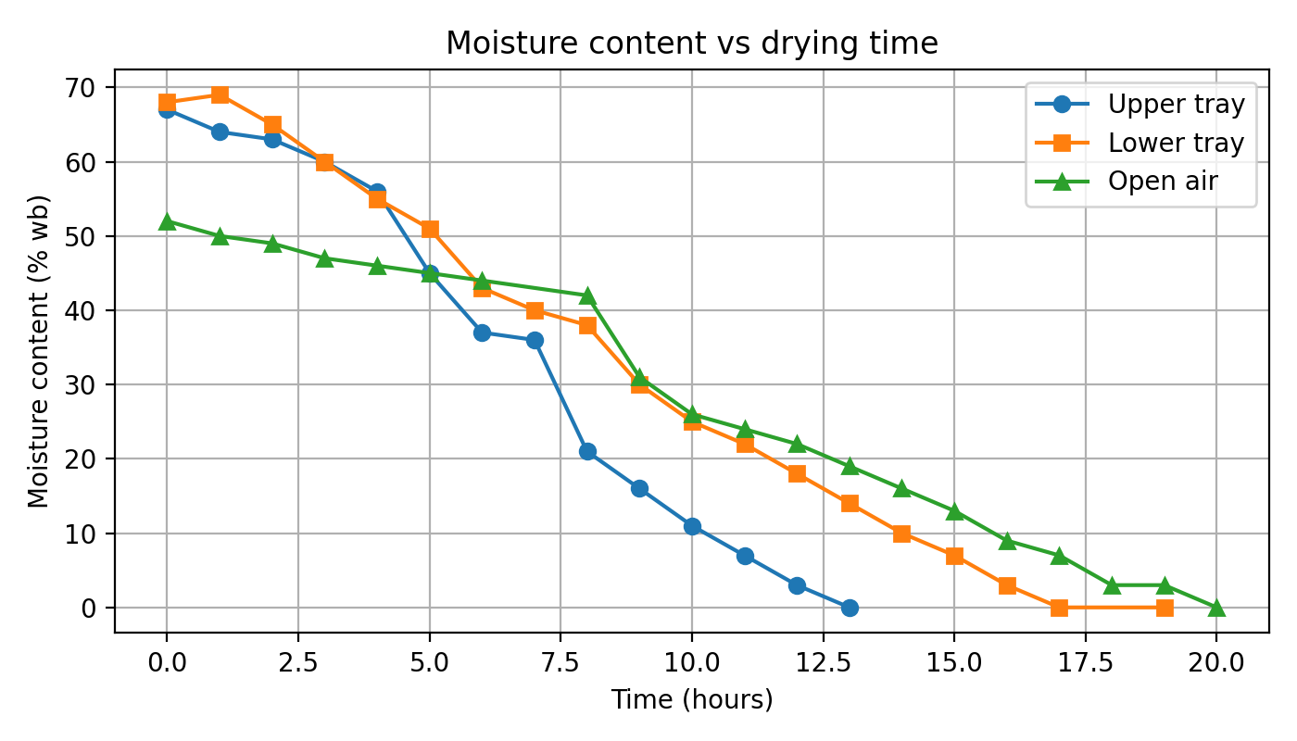

Figure 1. Moisture content vs time for upper tray, lower tray, and open-air.

### 4.3 Drying rate behavior

Drying-rate curves show an initial relatively high rate (surface moisture removal) followed by a falling-rate regime as internal diffusion becomes limiting. Peak drying rates: upper tray ~0.081 g/min, lower tray slightly less, open-air ~0.028 g/min. This is consistent with canonical drying theory and confirms that the dryer substantially accelerates moisture removal relative to open-air conditions.

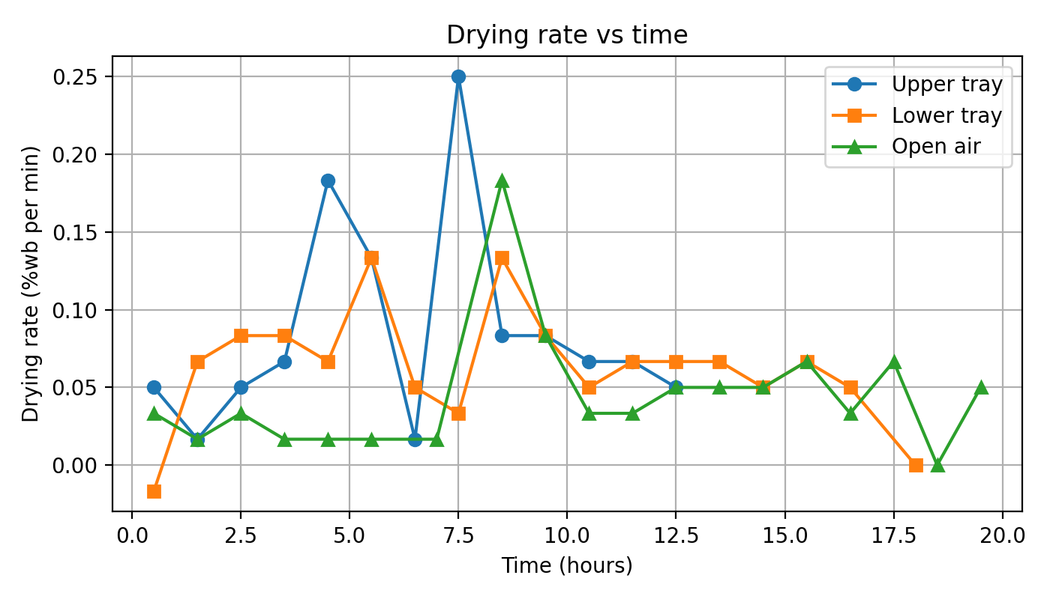

Figure 2. Drying rate vs time (absolute values) for upper, lower, and open-air.

### 4.4 Efficiency and comparison

Using total water removal (~42.70 g) and assumed insolation (~188 W/m²), the mass-based dryer efficiency computed is ~28.3%. Compared with open-air drying, the cylinder dryer reduced drying time by ~7 hours (12 h vs 19 h for equivalent moisture levels). This underscores the benefit of controlled thermal microclimates and enclosed drying.

## 5. Discussion

The dryer’s ability to elevate internal temperature and maintain moisture gradients illustrates the efficacy of a compact cylindrical geometry with transparent glazing and absorbers. Efficiency (~28.3%) is moderate, particularly in comparison with forced convection or fan-assisted systems (which may exceed 70%, e.g. Obayopo & Alonge, 2018). Passive systems must contend with convection limitations under low ΔT. The higher performance of the upper tray points to airflow stratification — additional venting or chimney enhancement may improve uniformity. The observed drying curves align with two-phase kinetics (constant to falling rate), supporting internal diffusion-limited drying in later stages. Future improvements could include enhanced ventilation (chimney, vent sizing), testing alternative glazing materials (polycarbonate vs acrylic or glass), collector augmentations, and hybrid designs (fans, thermal storage). Larger-scale studies, replicate designs, and statistical testing (ANOVA) may bolster robustness and allow generalized predictive models.

## 6. Conclusion

A direct passive cylindrical solar dryer was successfully designed and tested using crayfish as a test commodity. The system achieved internal temperatures up to ~54 °C, reduced moisture to <4 % within 12–17 h, and demonstrated ~28.3 % mass-based efficiency. It delivered noteworthy time savings over open-air drying and provided reproducible drying curves. While the performance is modest relative to active dryers, the low-cost, simple design is promising for off-grid aquatic product drying. Optimizations of airflow, glazing, and hybrid enhancements may further yield improved efficiencies.

## References

Obayopo, S. O. & Alonge, O. I. (2018). Development and Quality Analysis of a Direct Solar Dryer for Fish. Food and Nutrition Sciences, 9, 474-488. https://doi.org/10.4236/fns.2018.95037

Fitri, N., et al. (2022). A Comprehensive Review on the Processing of Dried Fish. PMC.

Fernandes, L., et al. (2024). A Review on Solar Drying Devices: Heat Transfer, Air … Solar 4(1).

Prakash, R., et al. (2025). A review on natural convective solar dryer. Energy Conversion & Management (forthcoming).

Sadodin, S. & Kashani, T. T. (2011). Numerical investigation of a solar greenhouse tunnel drier for drying of copra. arXiv.

Skarbalius, G., Dziugys, A., Misiulis, E., & Navakas, R. (2021). Iterative method for convective drying of biomass. arXiv.