# Development and Evaluation of a Direct Passive Polycarbonate Cylindrical Solar Dryer

Utit, I. I.; Supervisor: Dr. David Onwe

## Abstract

This report reproduces and analyses experimental drying data (crayfish) from a cylindrical polycarbonate solar dryer. The full dataset and methods were taken from the supplied project document (design, raw data and calculations). The document contains moisture curves, drying rates, summary statistics and recommendations.

## Materials and Methods

Design: cylindrical polycarbonate dryer (volume 52,297 cm3), two tray levels. Measurements: mass (three replicates), ambient and dryer temperature, relative humidity. Data source: project file (Appendix A/B).

## Results

Moisture content – Upper tray (mean of 3 replicates):

Time_min MC_pct_wb  
 0 67.0  
 60 64.0  
 120 63.0  
 180 60.0  
 240 56.0  
 300 45.0  
 360 37.0  
 420 36.0  
 480 21.0  
 540 16.0  
 600 11.0  
 660 7.0  
 720 3.0  
 780 0.0

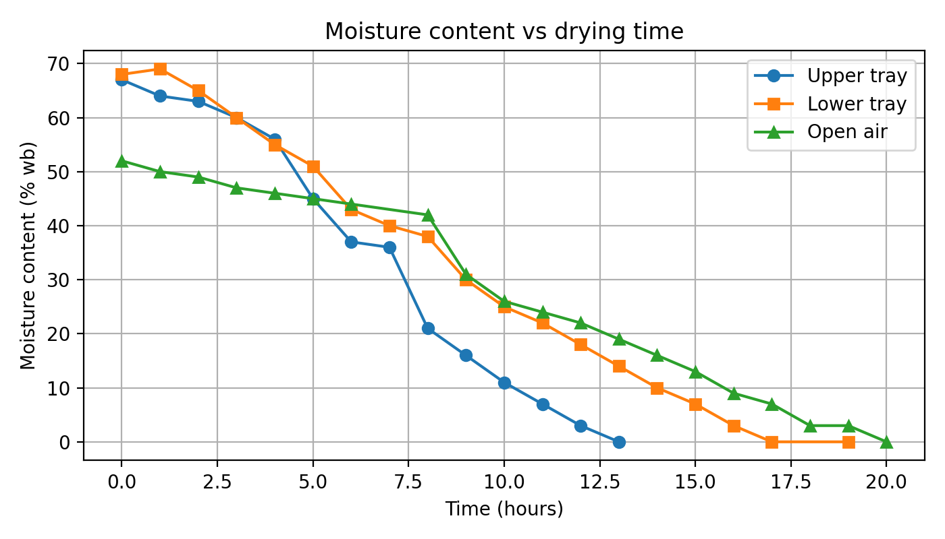

Figure 1. Moisture content vs drying time (upper, lower & open air).

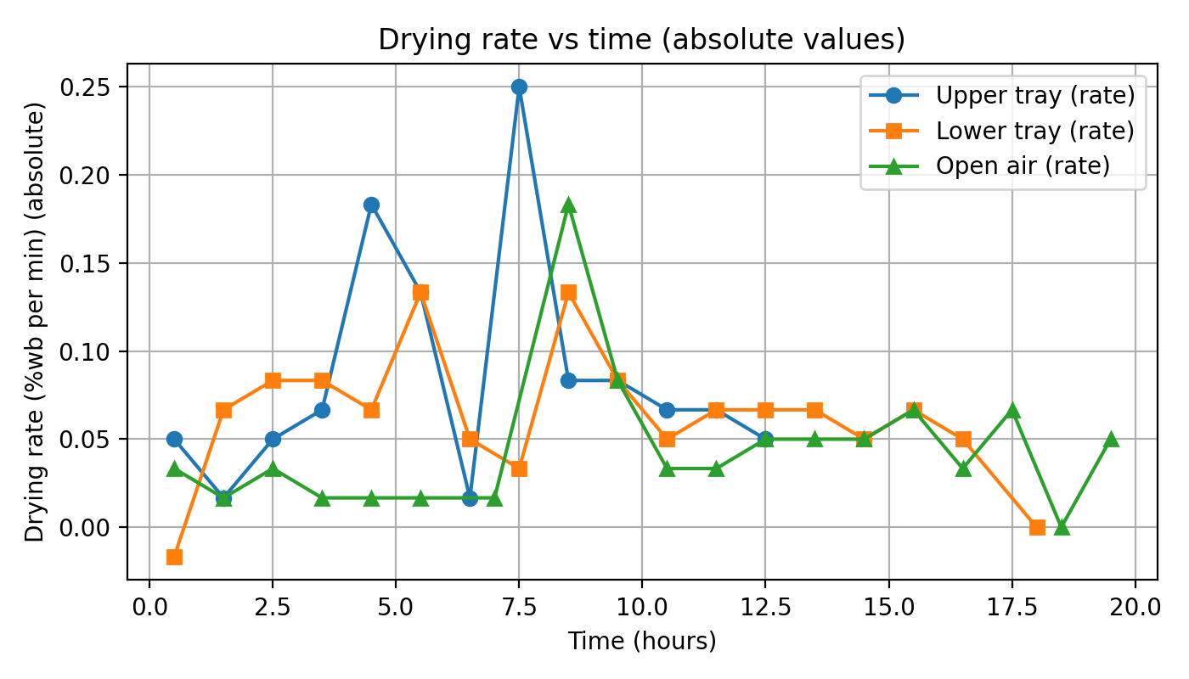

Figure 2. Drying rate vs time (absolute).

### Summary statistics

upper_mc: mean=34.71, std=24.78, min=0.00, max=67.00

lower_mc: mean=32.53, std=23.94, min=0.00, max=69.00

open_mc: mean=27.40, std=18.17, min=0.00, max=52.00

upper_temp_mean: 40.24

ambient_temp_mean: 32.77

## Discussion and Conclusion

The dryer reached internal temperatures above ambient, reduced drying time relative to open air, and yielded typical drying curves with initial faster rates followed by falling-rate periods. Recommendations include increasing absorber area and testing venting/ chimney options.