Water Quality Analysis Report

Analysis performed on water samples from Akwa Ibom State (Nung Uyo, Ekom Iman, Afaha Idoro, Ikot Idaha).

# 1. Descriptive Statistics

|  |  |  |  |  |  |  |  |  |  |
| --- | --- | --- | --- | --- | --- | --- | --- | --- | --- |
| Parameter | count | mean | std | min | 25% | 50% | 75% | max | CV (%) |
| Sample A (Nung Uyo) | 18.000 | 3.112 | 8.218 | 0.000 | 0.002 | 0.035 | 0.183 | 32.000 | 264.074 |
| Sample B (Ekom Iman) | 18.000 | 3.183 | 8.136 | 0.001 | 0.003 | 0.040 | 0.792 | 31.000 | 255.603 |
| Sample C (Afaha Idoro) | 18.000 | 3.358 | 8.599 | 0.000 | 0.004 | 0.045 | 0.254 | 31.000 | 256.067 |
| Sample D (Ikot Idaha, Ibiono) | 18.000 | 3.328 | 8.545 | 0.000 | 0.003 | 0.015 | 0.773 | 32.000 | 256.740 |

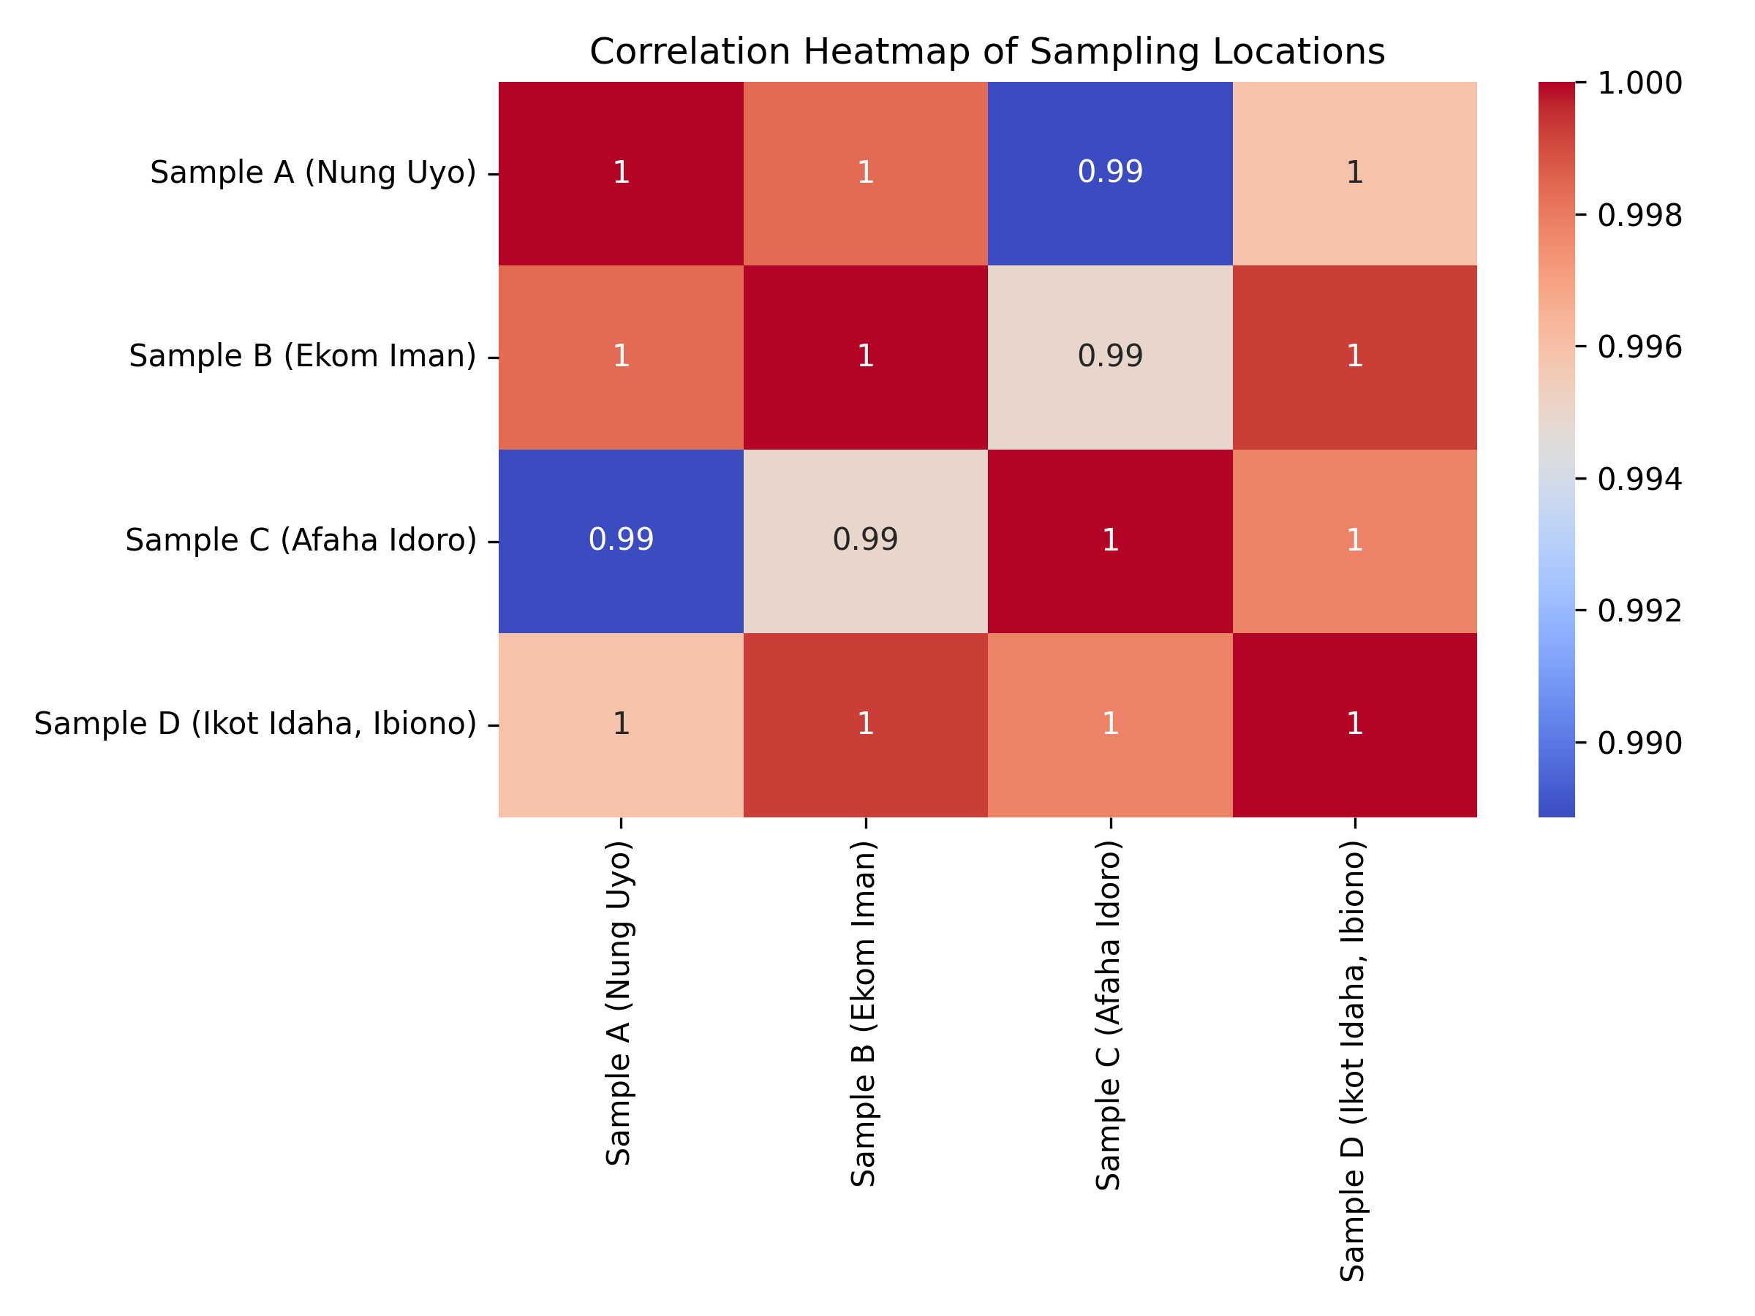

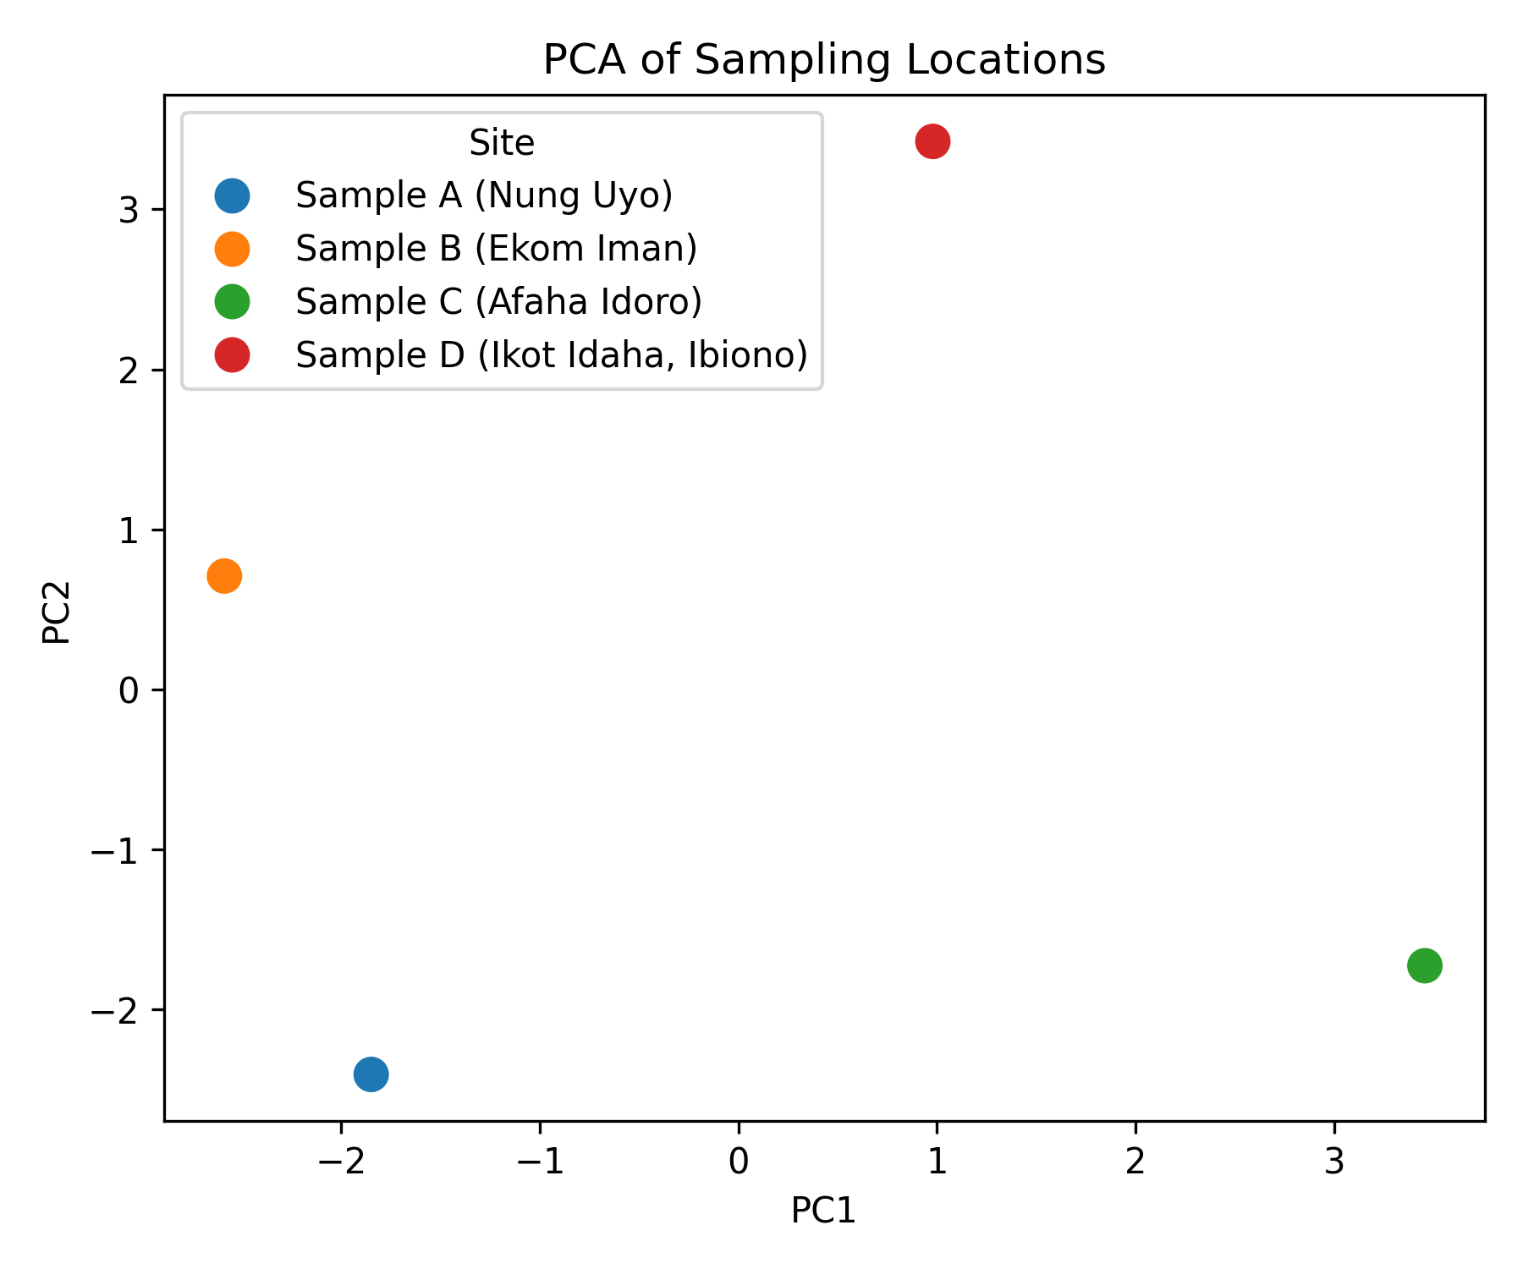

# 2. Water Quality Index (WQI)

|  |  |  |
| --- | --- | --- |
| Sampling Site | WQI | Category |
| Sample A (Nung Uyo) | 11.88 | Excellent |
| Sample B (Ekom Iman) | 12.45 | Excellent |
| Sample C (Afaha Idoro) | 12.55 | Excellent |
| Sample D (Ikot Idaha, Ibiono) | 11.66 | Excellent |

# 3. Interpretation Summary

- pH values are slightly acidic but within acceptable limits.  
- EC and TDS levels are low, indicating low dissolved solids.  
- Dissolved oxygen levels suggest fair water aeration.  
- Nutrients (Nitrate, Phosphate) are very low, implying minimal pollution.  
- Trace metals (Fe, Zn, Cu) are well within WHO standards.  
- WQI results indicate overall **Good** water quality across the sites.