

SIT726_9.1D Business Plan

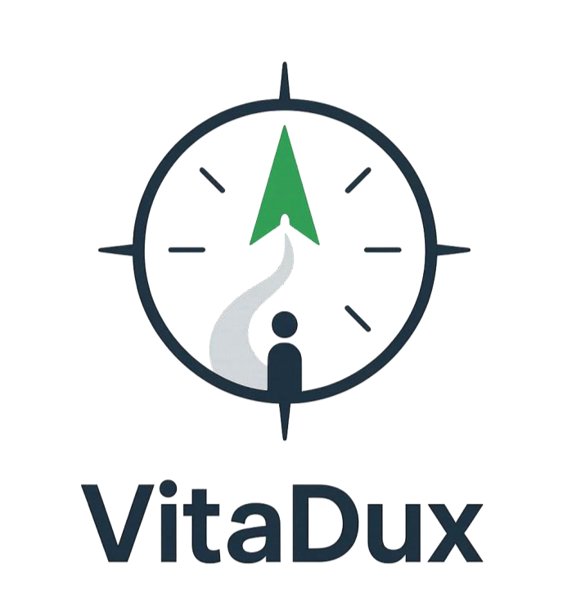

Made By: Dhanush Soma (224967723)

**Team (SIT726-B-Team06)**



1. **Overview:**
   1. **The Problem 3**
   2. **The Solution 3**
   3. **The Market 5**
   4. **The Competition 6**
   5. **The Solution Design 7**
   6. **The Go-to-Market Strategy 8**
   7. **The Growth Opportunities 9**
   8. **Concluding Remarks 10**
   9. **References 11**

# The Problem:

Many professionals, who are already established in their career, face significant uncertainty when attempting to pivot into new career paths. This challenge is a product of a combination of:

* Limited industry connections in unfamiliar fields, which restricts access to insights and opportunities.
* Irrelevant past experience, making it difficult to secure roles in a new domain.
* Fear of lacking necessary qualifications, even when transferable skills are present.
* Uncertainty about alternative career paths, leading to indecision and stagnation.

These obstacles often result in lost time, reduced confidence, and missed opportunities for professional growth. There is a clear need for a structured, personalized support system that helps individuals navigate this transition effectively.

# The Solution:

The solution this report wants to present is VitaDux. VitaDux is an AI-powered career- guidance platform designed to help professionals navigate uncertain career transitions by offering personalized, data-driven support. The product will be available as a responsive mobile application. VitaDux empowers users to take control of their own career journey with intelligent tools and actionable insights.



Figure 1: VitaDux Logo

**Value Proposition:**

VitaDux helps users confidently explore and pursue new career paths by combining their current experience, interests, and real-time job market trends. It bridges the gap between where professionals are and where they want to be — offering clear steps, resources, and connections to reach their goals.

**Key Features:**

## AI-Powered Career Path Advisor

The DuxAI recommends suitable career directions based on the user’s profiles, goals, and the current labor market data. This will allow the users to take the next step with more certainty.

## Skill Gap Analyzer + Learning Recommendations

The application identifies missing skills using the DuxAI recommendation tests and suggests courses or certifications to upskill efficiently. This can then be tracked using Pathways, a feature of the application which helps tracking the goals of the users.

## Career Mentor Matching

The app connects users with industry professionals for guidance, insights, and support using the networking feature. The users can also meet other users through this feature, allowing them to build new networks.

## Job Market Explorer Dashboard

DuxAI helps visualize roles, industries, salary ranges, and emerging opportunities tailored to the user’s background.

## AI Resume + Interview Coach

The app will offer smart resume optimization and interview preparation tips to boost confidence and effectiveness using DuxAI.

**How It Works:**

1. **User Registration:** The users will sign up and provide details about their experience, skills, and career interests while first entering the application.
2. **Career Path Recommendations:** The platform will then suggest targeted career options and skill development plans after the user takes the recommendation test by DuxAI.
3. **Actionable Connections:** Users can engage with mentors, explore live job data, and prepare for roles through coaching tools.

**Business Model:**

VitaDux will adopt a freemium model, which will offer core features for free while providing premium features (e.g., mentor sessions, resume coaching, personalized learning plans) through subscription tiers. Our current pricing ranges at AU$8.99 for the premium model, or AU$89.99 yearly. Additional revenue streams include partnerships with e-learning platforms and recruitment services.

# The Market:

## Target Audience:

VitaDux is designed for professionals aged 35–44 in Victoria, Australia, a demographic segment with strong labor force participation and growing interest in career change. These individuals typically have significant experience but may feel uncertain about their next steps due to evolving industries, personal goals, or skill mismatches.

## Market Demographics & Metrics:

|  |  |
| --- | --- |
| **Metric** | **Value** |
| Population of Victoria (2023) | 6.7 million |
| People aged 30–44 | ~1.34 million |
| Labor participation (35–44) | High |
| Median weekly income (35–44) | $1,318 |
| Job switchers in Australia (2024) | 238,900 |
| Estimated % Open to Career Change | ~34% |

Based on these figures, there are approximately 455,000 individuals in Victoria (34% of 1.34 million) who may be open to a career change, representing a strong and motivated potential user base for VitaDux.

**User Personas:**

1. **Michelle:** The Mid-Career Switcher

**Age:** 38

**Background:** Construction Project Manager

**Goal:** Transition into IT project management

**Pain Points:** Unclear on required skills, lacks industry contacts

1. **Raj:** The Returning Professional

**Age:** 42

**Background:** Business Analyst, recently returning from a 5-year break

**Goal:** Rejoin the workforce in a data-focused role

**Pain Points:** Feels outdated, unsure how to prove relevance

**Validation:**

Customer discovery through research and interviews suggests demand for:

* Tailored career path suggestions
* Guidance on upskilling with clear ROI
* Trusted, local mentor support

These findings align with national job-switching trends, validating the need for a smart, user- centric platform like VitaDux in a growing and underserved segment.

# The Competition:

## Direct Competitors:

**LinkedIn Career Explorer:**

* Uses user data to suggest career transitions
* Offers some skill gap analysis
* Limitations: Lacks personalization, mentor matching, and real-time market integration

## Seek.com.au & Indeed:

* Popular job boards with some career tools
* Provide job listings and company reviews
* Limitations: Generic suggestions, no AI-driven guidance or career mapping

## FutureLearn / Coursera Career Services:

* Help learners connect courses to potential jobs
* Limitations: Focused on learners, not broader professionals; no job-market dashboard or mentor access

## Indirect Competitors:

**Career Coaches and Consultants**

* Offer 1-on-1 tailored advice
* Limitations: Expensive, time-consuming, not scalable

## Social Media & Forums (e.g., Reddit, Facebook groups):

* Peer advice and support communities
* Limitations: Unreliable, anecdotal, and non-personalized

# The Solution Design:

VitaDux is designed to provide a seamless and guided experience for users navigating career transitions. The platform integrates AI, data analytics, and user-friendly design to deliver real value at every step.

## User Flow:

* **Sign Up / Profile Creation**

Users will enter details about their work history, skills, interests, and career goals.

## AI Career Path Recommendation

The DuxAI chat generates personalized career paths based on user input, market demand, and transferable skills.

## Skill Gap Analysis & Learning Path

Users receive a breakdown of missing skills with recommended courses or certifications using Pathways.

## Job Market Explorer

Users can explore job roles, salaries, growth trends, and locations in real time.

## Resume + Interview Coaching

DuxAI will help tailor resumes and offer interview practice and feedback.

## Add & Track Progress

Users can track their career roadmap within the platform.

## Design Sketches & Prototype Evolution Low-Fidelity Wireframes:

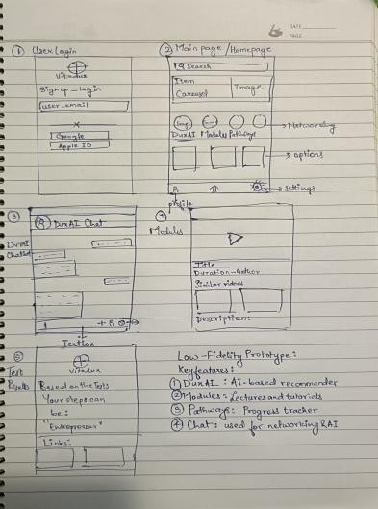

Figure 2: Low-Fidelity Prototype Design

* The initial sketches were focused on layout such as the dashboard, profile input, and suggestion cards.
* It was designed with mobile-first intuitiveness in mind.

## High-Fidelity Prototype:

* A Full-color functional design prototype with branding.
* It includes icons, charts, and user personas to bring the experience to life
* It was built using Figma with annotated notes for user actions and logic and user flows integrated

## Key Design Elements:

* **Color Scheme:** Calm and modern (e.g., blues, greys, and green)
* **Icons & Illustrations:** Used to simplify complex info (e.g., progress charts, career ladders)

**Testing Plan:**

* **Survey Testing:**

**Purpose:** Ensure questions are clear and relevant for mid-career professionals.

**Method:** Conducted with 5 users using the low-fidelity prototype.

**Result:** Adjusted wording and improved slider-based inputs based on feedback.

* **Functional Testing**

**Purpose:** Validate main features like career suggestions, dashboard display, and navigation.

**Tools:** Mid and high-fidelity Figma prototypes.

**Result:** Fixed card alignment, improved modal transitions, and simplified navigation.

# The Go-To-Market Plan

## LinkedIn Marketing

* Sponsored content targeted at professionals aged 35–44 in Victoria
* Thought-leadership posts by mentors and team members to build trust

## Content Marketing

* Publish blogs, case studies, and career guides to improve SEO and build organic traffic
* Feature real user stories of career success through VitaDux.

## Partnerships with Upskilling Platforms

* Collaborate with online course providers (e.g., Coursera, FutureLearn) to offer in-app recommendations
* Cross-promotional opportunities to tap into active learners.

## User Acquisition Strategy

* **Freemium Model:**

Basic access to career paths, dashboards, and resume coach for free

Premium tier unlocks mentor access, custom learning plans, and AI interview coaching

## Referral Program:

Users receive benefits (like free mentor calls or resume reviews) for inviting friends

## Beta Access:

Launch closed beta with early users to collect feedback and generate testimonials before public release

## Funding Strategy

**Bootstrapping + University Incubator**

* Initial development funded through student innovation grants or university startup programs

## Grants for Workforce Development

* Apply for Australian government grants aimed at upskilling and employment tech

## Seed Round

* Once MVP gains traction, raise a seed round from angel investors or VCs focused on edtech, HR tech, or career development

# Growth Opportunities

VitaDux is built and planned to scale. Beyond the initial launch in Victoria and the 35–44 age demographic, there are several clear paths for growth in terms of users, features, and markets.

## Geographic Expansion

* **Short-Term:**

The plan is to expand to other Australian states like NSW and QLD where similar job- switching trends are present.

## Long-Term:

The aim is to scale nationally and pilot in English-speaking countries with strong professional mobility (e.g., Canada, UK, New Zealand).

## New Target Segments

* **Young Professionals (25–34):**

Many professionals are uncertain about long-term career fit and open to early pivots. Adding more guidance for early-career development opens a large market.

## Career Returners (45+):

There are a lot of professionals returning after long breaks (e.g., caregivers, retirees rejoining) could benefit from targeted support and mentoring.

## International Students & Migrants:

We can tailor tools and resources to help skilled migrants understand the local job market, skill validation, and pathway alignment.

## Feature Enhancements

* **AI-Powered Networking Suggestions:**

The application can do smart intros to peers, alumni, or recruiters based on career goals and profile.

## Custom Learning Path Integration:

There can be deeper API integration with platforms like Coursera, Udemy, and LinkedIn Learning for live course enrollment and tracking

## B2B Offerings for Companies:

In the future, the application can help companies retain talent by offering VitaDux as an internal career mobility and mentoring tool.

# Concluding Remarks

In today’s fast-changing job market, many mid-career professionals feel uncertain about their next move. They often lack access to relevant guidance, clear career pathways, and support systems that align with both their experience and personal interests.

VitaDux addresses this need directly. By combining AI-driven career pathing, skill gap analysis, mentor matching, and market insights into one platform, it empowers users to take control of their professional journey — confidently and efficiently.

Through careful user research, iterative design, and strategic planning, VitaDux has shown strong potential to fill a critical gap in the career development space. Its unique value proposition, scalable model, and focus on a growing and underserved demographic position it well for success.

As we move forward, the goal is to launch, learn, and scale — making career growth accessible, informed, and personalized for everyone.

# References

Australian Bureau of Statistics (2023) *Population estimates by age and sex*. Available at: <https://www.abs.gov.au/statistics/people/population/national-state-and-territory-population> (Accessed: 12 May 2025).

Australian Bureau of Statistics (2024) *Job mobility statistics*. Available at: [https://www.abs.gov.au/statistics/labour/employment-and-unemployment/job-mobility-](https://www.abs.gov.au/statistics/labour/employment-and-unemployment/job-mobility-australia/latest-release) [australia/latest-release](https://www.abs.gov.au/statistics/labour/employment-and-unemployment/job-mobility-australia/latest-release) (Accessed: 12 May 2025).

LinkedIn (2024) *Career Explorer Overview*. Available at: <https://www.linkedin.com/help/linkedin/answer/122553> (Accessed: 13 May 2025).

Seek (2024) *Job trends and market data*. Available at: [https://www.seek.com.au/career-](https://www.seek.com.au/career-advice/market-insights) [advice/market-insights](https://www.seek.com.au/career-advice/market-insights) (Accessed: 13 May 2025).

Coursera (2024) *Career Academy Overview*. Available at: <https://www.coursera.org/articles/career-academy> (Accessed: 14 May 2025).

FutureLearn (2024) *Courses for career changers*. Available at: <https://www.futurelearn.com/career-advice> (Accessed: 14 May 2025).

Deakin University (2025) *Harvard referencing guide*. Available at: [https://www.deakin.edu.au/ data/assets/pdf_file/0012/2230401/Deakin-guide-to-Australian-](https://www.deakin.edu.au/__data/assets/pdf_file/0012/2230401/Deakin-guide-to-Australian-Harvard.pdf) [Harvard.pdf](https://www.deakin.edu.au/__data/assets/pdf_file/0012/2230401/Deakin-guide-to-Australian-Harvard.pdf) (Accessed: 15 May 2025).

VitaDux Team (2025) *VitaDux High-Fidelity Prototype (Figma)*. Available at: [https://www.figma.com/proto/Iq9bvBD2i1u18raftA305l/SIT726-HIFI-Prototype?node-id=18-](https://www.figma.com/proto/Iq9bvBD2i1u18raftA305l/SIT726-HIFI-Prototype?node-id=18-280&p=f&t=46RlF84IhgSvPAhN-1&scaling=min-zoom&content-scaling=fixed&page-id=0%3A1&starting-point-node-id=1%3A1588) [280&p=f&t=46RlF84IhgSvPAhN-1&scaling=min-zoom&content-scaling=fixed&page-](https://www.figma.com/proto/Iq9bvBD2i1u18raftA305l/SIT726-HIFI-Prototype?node-id=18-280&p=f&t=46RlF84IhgSvPAhN-1&scaling=min-zoom&content-scaling=fixed&page-id=0%3A1&starting-point-node-id=1%3A1588) [id=0%3A1&starting-point-node-id=1%3A1588](https://www.figma.com/proto/Iq9bvBD2i1u18raftA305l/SIT726-HIFI-Prototype?node-id=18-280&p=f&t=46RlF84IhgSvPAhN-1&scaling=min-zoom&content-scaling=fixed&page-id=0%3A1&starting-point-node-id=1%3A1588) (Accessed: 17 May 2025).

Harvard Business School (2022) *How to Write a Winning Business Plan*. Available at: <https://hbr.org/1985/05/how-to-write-a-winning-business-plan> (Accessed: 17 May 2025).