**EXPT:** **STACK 1**

**DATE:**

**CODE:**

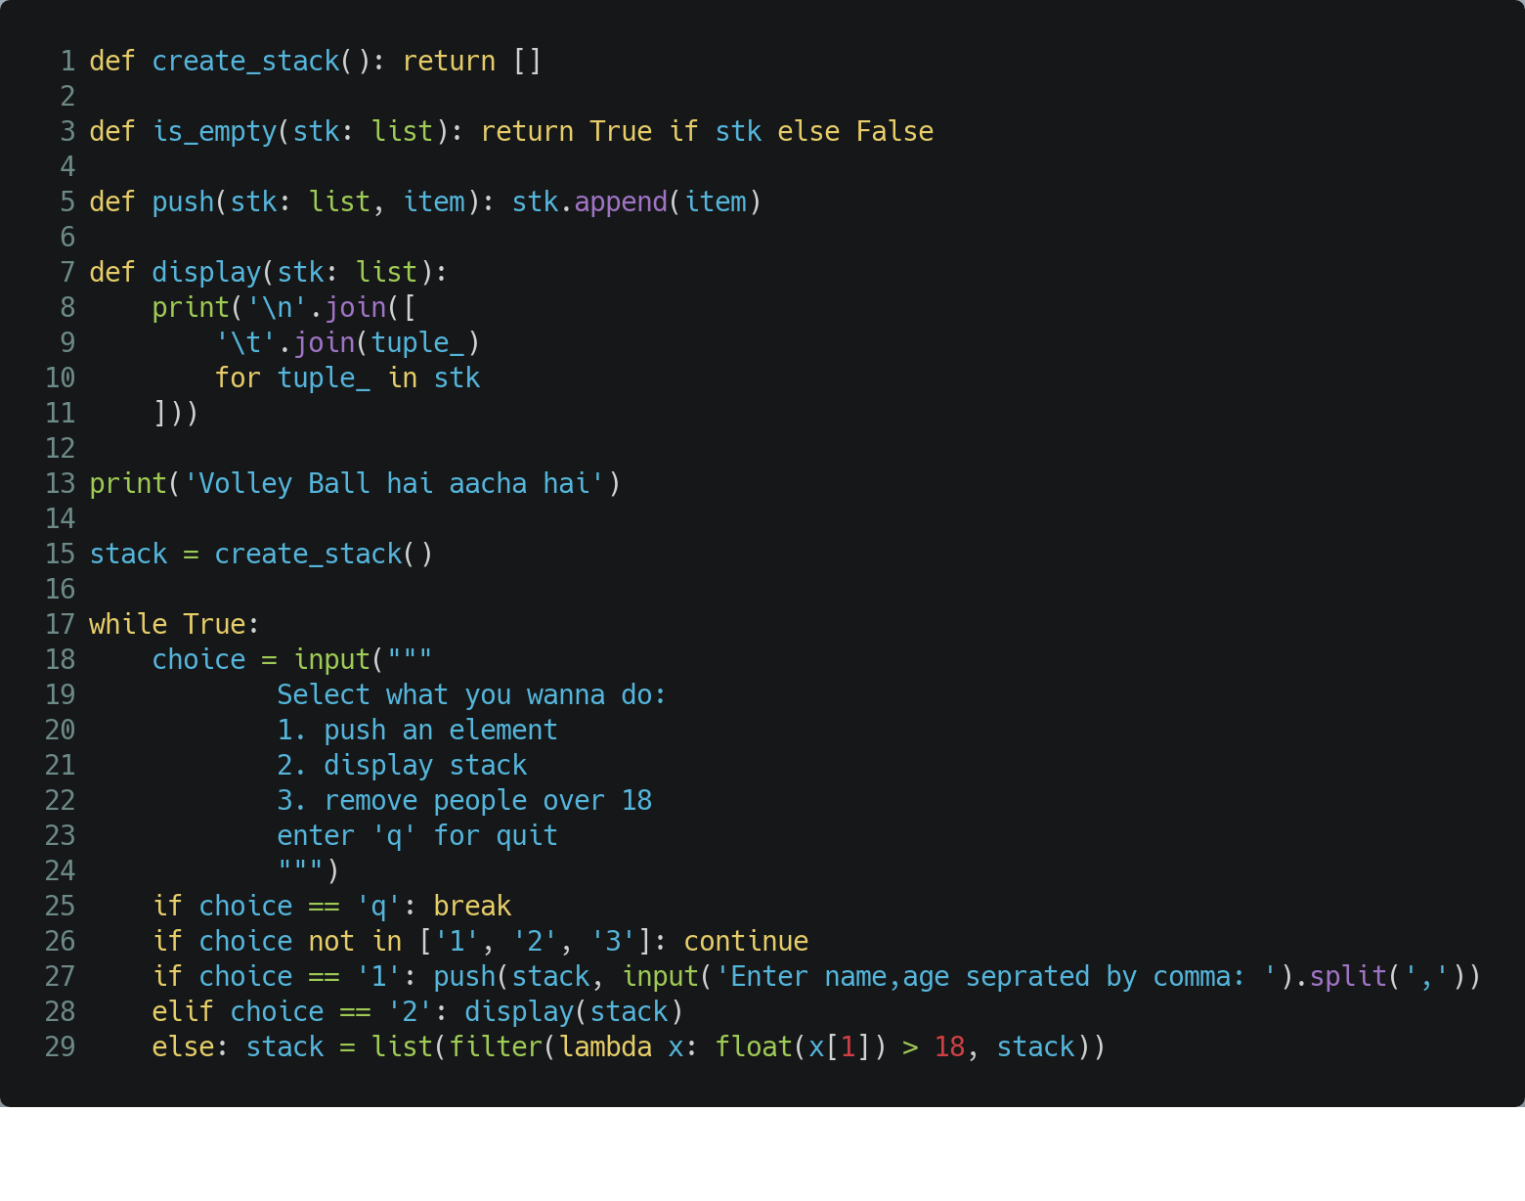

OUTPUT:

