

Practices for Secure Software Report

Table of Contents
Document Revision History 3
Client 3
Instructions 3
Developer 4
1. Algorithm Cipher 4
2. Certificate Generation 4
3. Deploy Cipher 4
4. Secure Communications 4
5. Secondary Testing 4
6. Functional Testing 4
7. Summary 4
8. Industry Standard Best Practices 4

Document Revision History

Version | Date | Author | Comments
1.0 | October 18, 2026 | Eddie Loya | Completed Project Two secure-software refactor and verification

Client



Instructions

Submit this completed practices for secure software report. Replace the bracketed text with the relevant information. You must document your process for writing secure communications and refactoring code that complies with software security testing protocols.

- Respond to the steps outlined below and include your findings.
- Respond using your own words. You may also choose to include images or supporting materials. If you include them, make certain to insert them in all the relevant locations in the document.
- Refer to the Project Two Guidelines and Rubric for more detailed instructions about each section of the template.

Developer
Eddie Loya

Algorithm Cipher

Artemis Financial should use SHA-256 for the file-verification checksum required by this project and AES-256-GCM when stored files also require confidentiality. The refactored application deploys SHA-256 because a checksum must provide a stable, one-way integrity value. Encryption and hashing solve different problems: encryption can be reversed with an authorized key, while a cryptographic hash is designed to make recovery of the original message impractical.
SHA-256 is part of the SHA-2 family and processes input in 512-bit blocks to produce a 256-bit message digest. Its 256-bit output provides approximately 128 bits of collision resistance and 256 bits of preimage resistance under the expected brute-force model. A collision occurs when two different inputs produce the same digest. Strong collision resistance makes an unnoticed file substitution impractical. The code requests the standard Java name SHA-256 through MessageDigest, converts the unique string to UTF-8 bytes, and renders the 32 digest bytes as 64 lowercase hexadecimal characters (National Institute of Standards and Technology [NIST], 2015; Oracle, 2017).
SHA-256 does not use a key, initialization vector, or random number, so those values are not needed for this checksum. When Artemis encrypts archived files, AES-256-GCM is the appropriate symmetric cipher because it efficiently protects bulk data and authenticates the ciphertext. Java SecureRandom should generate a fresh 256-bit data key and a unique 96-bit GCM initialization vector for each encryption operation. A managed key service can protect that data key with asymmetric or key-encryption controls. The RSA key pair in this project serves a different role: the private key supports the server certificate, and the public certificate allows a client to authenticate the TLS endpoint.
The history of these algorithms supports this choice. MD5 and SHA-1 remain available in some platforms for compatibility, but their collision weaknesses make them unsuitable for new integrity designs. NIST standardized SHA-2 in the Secure Hash Standard, and SHA-256 remains a widely supported choice for file verification. NIST selected Rijndael as the Advanced Encryption Standard in 2001 and reaffirmed AES in 2023. GCM adds authenticated encryption, avoiding the need to combine an older confidentiality-only mode with a separately designed message-authentication scheme (Dworkin, 2007; NIST, 2023).
For this application, the checksum provides evidence that the transmitted string has not changed; it does not hide the string and does not authenticate the user. HTTPS protects the checksum and content while they travel between client and server. A production service would add authentication and authorization to sensitive REST endpoints because encryption alone does not determine who may access financial data.

Certificate Generation
Insert a screenshot below of the CER file.

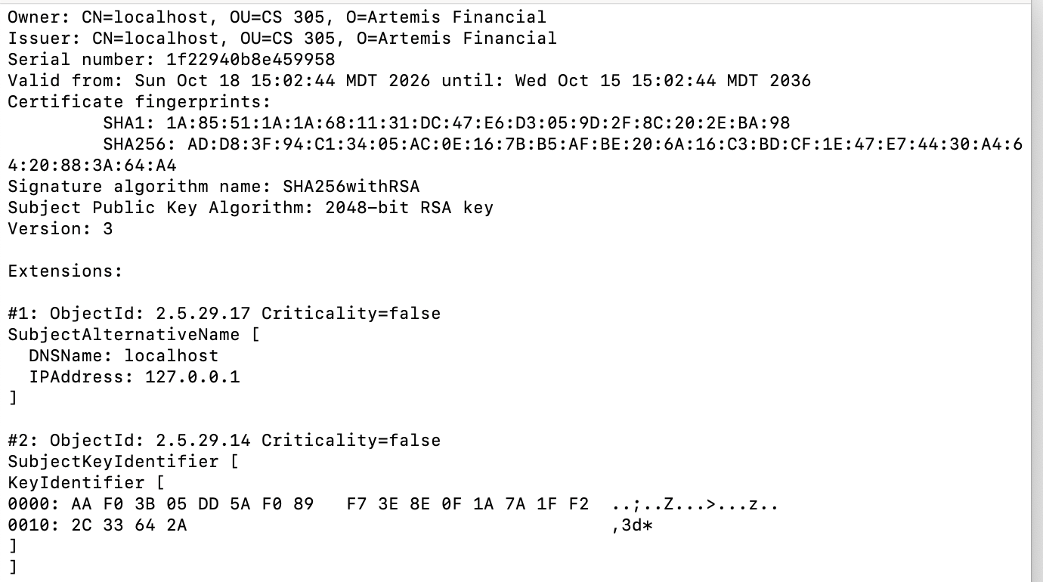
Figure 1. Exported CER certificate printed with Java keytool.
I generated a PKCS12 keystore with a 2048-bit RSA key pair and a self-signed X.509 version 3 certificate signed with SHA256withRSA. The certificate identifies localhost and includes Subject Alternative Name entries for localhost and 127.0.0.1. I exported the public certificate as artemis-financial.cer and verified its owner, issuer, validity dates, fingerprints, public-key algorithm, and SAN extension. The self-signed certificate is suitable for this development exercise; Artemis should use a certificate issued by a trusted certificate authority for a public financial application.

Deploy Cipher
Insert a screenshot below of the checksum verification.

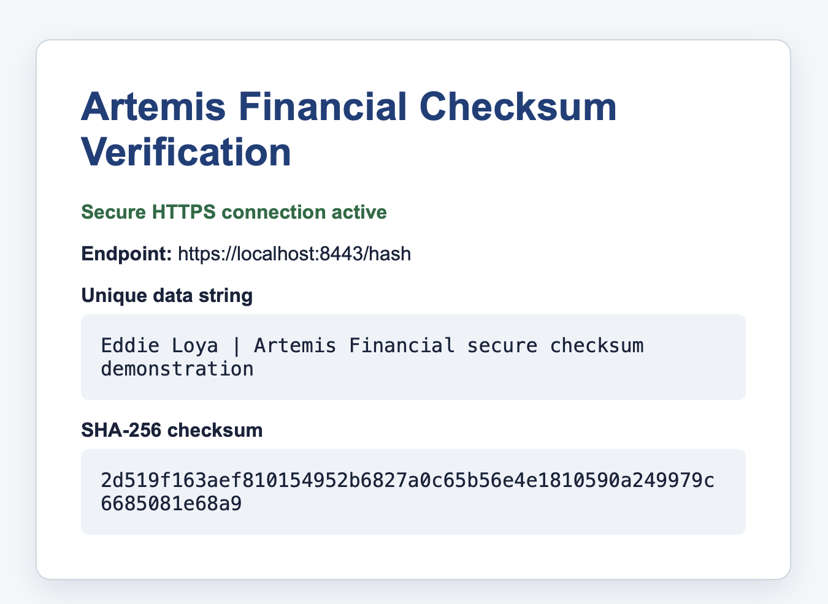
Figure 2. Personalized SHA-256 checksum verification at the hash endpoint.
ChecksumService.java uses MessageDigest.getInstance("SHA-256") and StandardCharsets.UTF_8. ChecksumController.java supplies the unique string "Eddie Loya | Artemis Financial secure checksum demonstration" and returns the resulting 64-character digest. Keeping the checksum operation in a service separates cryptographic processing from HTTP response construction and makes the algorithm independently testable.

Secure Communications
Insert a screenshot below of the web browser that shows a secure webpage.

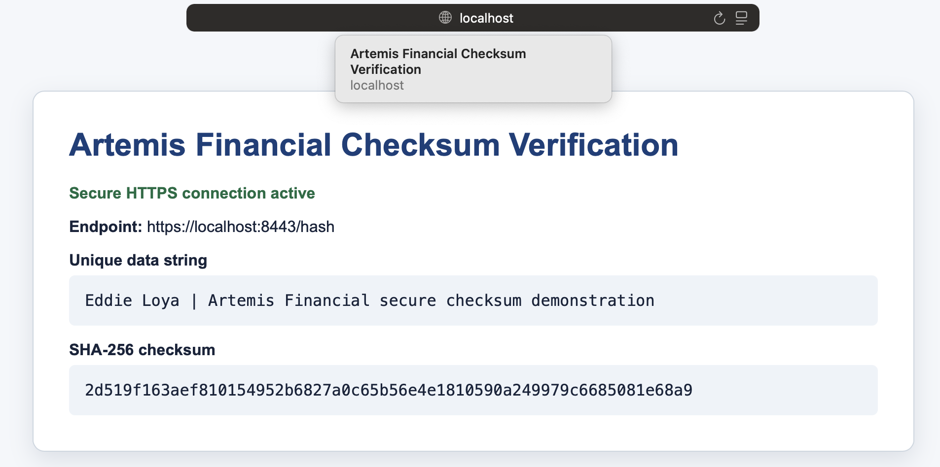
Figure 3. The checksum page delivered through https://localhost:8443/hash.
application.properties enables SSL on port 8443, loads artemis-financial.p12 from the classpath, selects the artemis alias, and uses the PKCS12 keystore type. The password can be supplied through the SSL_KEY_STORE_PASSWORD environment variable; the development fallback exists so the submitted demonstration runs as packaged. The endpoint confirms request.isSecure(), and the response disables caching, prevents MIME sniffing, and applies a restrictive Content Security Policy. Because the certificate is self-signed, a browser will label it as a development certificate until the certificate is trusted locally. Encryption is active, but a public deployment still requires a CA-signed certificate and protected secret storage.

Secondary Testing
Insert screenshots of the successful test run and Dependency-Check report below.

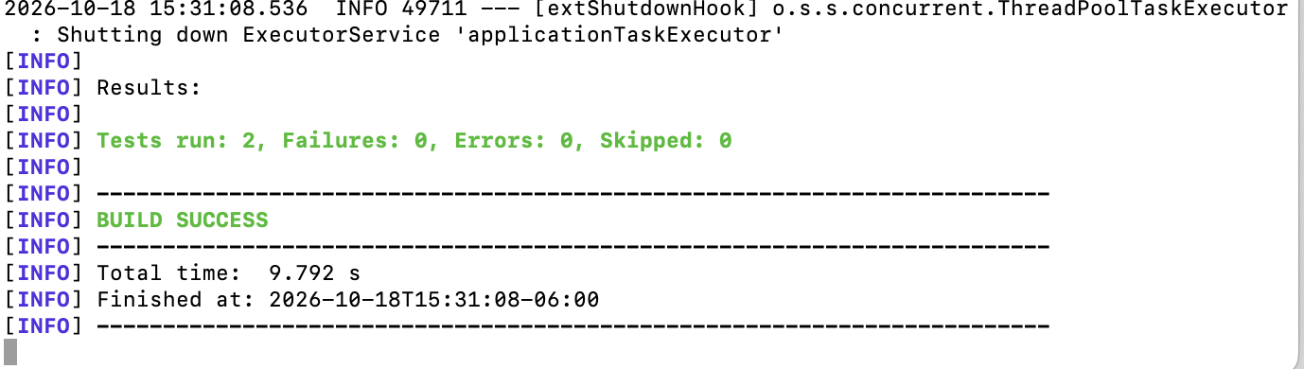
Figure 4. Refactored code compiled and completed both tests without failures or errors.
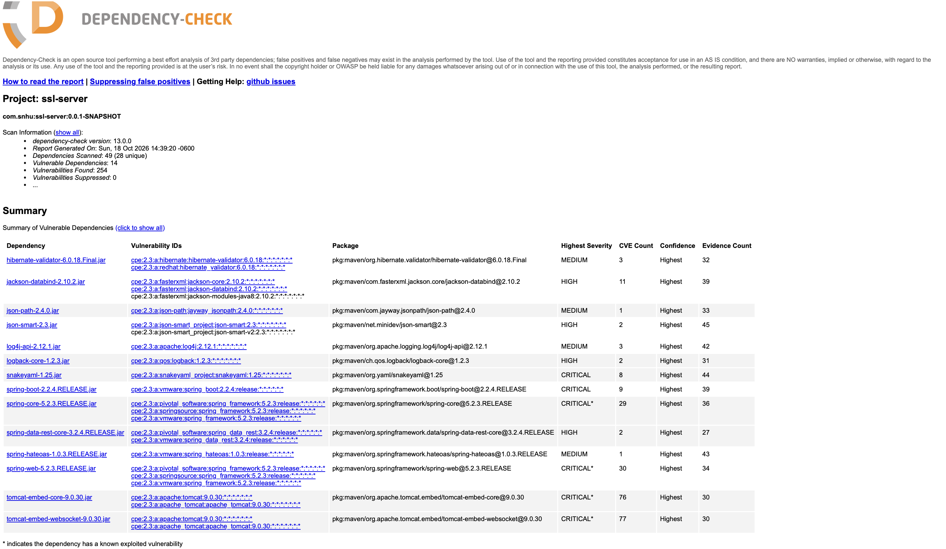
Figure 5. OWASP Dependency-Check 13.0.0 secondary static-analysis results.
I ran OWASP Dependency-Check Maven 13.0.0 after the refactor. The HTML report was generated on October 18, 2026. It scanned 49 resolved artifacts representing 28 unique dependencies, marked 14 dependencies as vulnerable, reported 254 dependency-to-CVE matches, and suppressed none. A reported match is a review lead rather than proof that every CVE is reachable in this application.
The findings come from the supplied Spring Boot 2.2.4 dependency baseline. The refactor adds no third-party runtime library: SHA-256, UTF-8 encoding, certificate handling, and HTTPS configuration use Java and Spring classes already present in the project. Therefore, the changes introduced no new dependency findings. The inherited framework, Jackson, validation, logging, SnakeYAML, Spring, and Tomcat findings remain release risks. Before production use, Artemis should migrate to supported Java and Spring versions, update aligned transitive dependencies, remove unused starters, rerun the scan, and document any verified false-positive suppression narrowly. This conclusion is consistent with the earlier Project One assessment and Module Six dependency-check work.

Functional Testing
Insert a screenshot below of the refactored code executed without errors.

Figure 6. Functional test run with two tests, zero failures, and zero errors.
I reviewed the refactored source for syntactical, logical, and security problems, then compiled and tested it with Maven. ChecksumServiceTests verifies the exact expected SHA-256 value for the personalized input. SslServerApplicationTests verifies that Spring can construct the application context with the keystore and HTTPS configuration. Both tests passed.
The manual review confirmed that the controller has one read-only route, accepts no untrusted parameters, uses a fixed UTF-8 encoding, and returns controlled response headers. The checksum service handles the unlikely absence of SHA-256 by throwing a defined IllegalStateException instead of silently returning an invalid value. The certificate matches localhost through SAN values, the private key remains inside the PKCS12 keystore, and stack traces are excluded from HTTP error responses. The review also identified a residual security limitation: this demonstration does not add user authentication or record-level authorization because it exposes only a static verification string. Those controls are required before financial or customer data is added.

Summary

I followed the vulnerability-assessment process by reviewing the application architecture, running static analysis, selecting the manual review areas indicated by those results, refactoring the code, and retesting the application. The completed application adds multiple security layers: SHA-256 integrity verification, an RSA-backed X.509 development certificate, HTTPS transport on port 8443, reduced error disclosure, defensive response headers, and repeatable functional and dependency testing.
The architecture review showed a client/server boundary at the /hash REST endpoint and a cryptographic boundary around the keystore. I addressed Cryptography by using standard Java SHA-256 and certificate algorithms instead of custom cryptography. I addressed Client/Server security by replacing plaintext HTTP with HTTPS. I addressed APIs by limiting the added route to a read-only fixed response and adding restrictive headers. I addressed Code Error by returning a defined failure if SHA-256 is unavailable and by excluding stack traces from web errors. I addressed Code Quality by separating the controller and checksum service and by adding a deterministic unit test. I addressed Input Validation by avoiding user-controlled input in the demonstration endpoint. Encapsulation is improved because checksum creation is contained in one service rather than scattered through the web layer.
Static testing then identified the legacy dependency backlog. I compared that output with the code changes and confirmed that the refactor introduced no new external library. Functional testing verified both the checksum result and application startup. This layered process reduces the chance that one control will be treated as sufficient by itself. The application now demonstrates confidentiality in transit and integrity verification, while the report records the remaining work needed for production: framework updates, trusted certificate issuance, managed secrets, authentication, authorization, logging, and continuous dependency monitoring.

Industry Standard Best Practices

I applied established secure-coding practices by using Java Cryptography Architecture standard algorithm names, deterministic UTF-8 encoding, a modern SHA-2 digest, an RSA certificate with localhost SAN entries, and the PKCS12 keystore format. I did not design a proprietary cipher or add an unnecessary cryptographic provider. The code separates HTTP handling from checksum generation, uses constructor injection, returns no user-supplied markup, disables caching for the verification response, adds nosniff and Content Security Policy headers, and prevents stack traces from being included in HTTP errors.
The keystore password can be supplied at runtime instead of being permanently fixed in source. For this course demonstration, a documented fallback keeps the package runnable; production deployment should require a secret manager or protected environment variable with no default. A trusted CA should replace the self-signed certificate, renewal should be automated, private-key access should follow least privilege, and HTTPS should be enforced at every public entry point. Authentication and record-level authorization should be added before the API processes client financial information.
Dependency-Check provides a repeatable secondary control, but its findings require human review. I preserved the complete report, avoided broad suppressions, and separated inherited dependency risk from changes introduced by the refactor. Integrating the scanner and tests into the build would detect newly disclosed vulnerabilities and regressions earlier. Applying these practices protects confidentiality, integrity, and availability; reduces the cost of emergency fixes; supports customer trust; and gives Artemis Financial evidence that security decisions were reviewed rather than assumed.

References
Dworkin, M. (2007). Recommendation for block cipher modes of operation: GCM and GMAC (NIST Special Publication 800-38D). National Institute of Standards and Technology. https://doi.org/10.6028/NIST.SP.800-38D
National Institute of Standards and Technology. (2015). Secure Hash Standard (FIPS PUB 180-4). https://doi.org/10.6028/NIST.FIPS.180-4
National Institute of Standards and Technology. (2023). Advanced Encryption Standard (FIPS 197, Update 1). https://doi.org/10.6028/NIST.FIPS.197-upd1
Oracle. (2017). Java security standard algorithm names. https://docs.oracle.com/javase/9/docs/specs/security/standard-names.html
OWASP Foundation. (2026). Dependency-Check Maven usage. https://dependency-check.github.io/DependencyCheck/dependency-check-maven/
Southern New Hampshire University. (n.d.). CS 305 vulnerability assessment process flow diagram. Course material.

Appendix A Refactored Code File Details
The submitted ZIP contains the complete project. The following files contain the security-related changes and evidence discussed in this report.
File | Purpose
ChecksumService.java | Generates SHA-256 digests from UTF-8 input and converts the result to lowercase hexadecimal.
ChecksumController.java | Exposes the read-only /hash endpoint, supplies the personalized data string, confirms secure requests, and sets defensive response headers.
SslServerApplication.java | Starts the Spring Boot application; the starter FIXME was removed after the route was implemented in a dedicated controller.
application.properties | Enables HTTPS on port 8443, selects the artemis key alias and PKCS12 keystore, reads the password from the environment when supplied, and limits error disclosure.
artemis-financial.p12 | Stores the private RSA key and self-signed X.509 development certificate used by the HTTPS server.
artemis-financial.cer | Contains the exported public certificate for independent inspection and submission evidence.
ChecksumServiceTests.java | Checks the exact SHA-256 output for the unique Eddie Loya data string.
SslServerApplicationTests.java | Verifies that the refactored Spring application context loads successfully.
pom.xml | Configures the Spring Boot build and OWASP Dependency-Check Maven 13.0.0 HTML report.
target/dependency-check-report.html | Preserves the generated secondary static-analysis report included in the project ZIP.

