CS 255 Project One
Business Requirements Document
DriverPass System
Eddie Loya
Southern New Hampshire University
CS 255: System Analysis and Design

System Components and Design

Purpose
- The purpose of this project is to design a web-based system for DriverPass, a driver-training company that wants to improve student preparation for state driving examinations.
- The system will provide online classes, practice tests, and scheduling for two-hour on-the-road driving lessons.
- The design will support customers, the owner, the IT officer, the secretary, and drivers while giving each role only the functions and data needed for its work.

System Background
- DriverPass identified a market need because many students fail driving tests after relying only on previous test questions instead of receiving complete preparation.
- The proposed system will combine online learning, practice testing, customer registration, package selection, appointment scheduling, driver notes, reports, and account administration.
- The system will operate through a cloud-hosted website that can be accessed from computers and mobile devices. Current data may be viewed online, and reports may be downloaded for offline analysis.
- The main components will include a browser-based user interface, application and business-logic services, a centralized database, role-based authentication, reporting tools, scheduling functions, and an interface for receiving DMV updates.

Objectives and Goals
- The system shall allow students to register, select a training package, complete online lessons and practice tests, and track test progress.
- The system shall allow students or the secretary to create, modify, and cancel driving lesson reservations.
- The scheduling process shall match each two-hour lesson with an available student, driver, vehicle, date, time, pickup location, and drop-off location.
- The system shall maintain an auditable history showing who created, changed, or canceled reservations and other important records.
- The system shall present accurate reports that Liam can download and use in applications such as Microsoft Excel.
- The system shall receive notifications when the DMV publishes updated rules, policies, or sample questions so DriverPass content can remain current.
- The project shall follow the approved schedule and conclude with testing, delivery, and formal customer sign-off.

Requirements

Nonfunctional Requirements

Performance Requirements
- The web application should provide responsive performance on common desktop and mobile browsers under normal business usage.
- Pages, schedules, test results, and account information should normally load within a few seconds when a stable internet connection is available.
- The centralized database should update reservations, test progress, package status, and user records immediately after a successful transaction to avoid duplicate or conflicting information.
- The cloud environment should support routine backups, recovery, monitoring, and security updates with minimal interruption to DriverPass operations.
- DMV content updates should generate a timely notification to authorized staff so practice materials can be reviewed and updated.

Platform Constraints
- The system will be web-based and preferably hosted in a managed cloud environment.
- Users will access the system through supported web browsers on computers, tablets, and smartphones rather than through a separately installed desktop application.
- A centralized database is required to store customer, employee, appointment, package, payment, test, driver, vehicle, and audit information.
- Users must be online to create or modify records. Downloaded reports may be used offline, but offline changes will not update the production database.
- The system must integrate with external DMV information sources when an approved connection or update mechanism is available.

Accuracy and Precision
- Every user shall be identified by a unique account, and permissions shall be based on assigned roles such as customer, secretary, driver, owner, and IT administrator.
- The system shall validate required customer fields, including name, address, phone number, state, pickup location, and payment information, before registration is completed.
- Driving lessons shall be scheduled in two-hour blocks and shall not exceed the hours included in the customer’s selected package.
- The system shall prevent double-booking of a driver, vehicle, or student for overlapping lesson times.
- Online test records shall accurately display the test name, time taken, score, and status as not taken, in progress, failed, or passed.
- Administrators shall be notified of failed integrations, repeated authentication failures, scheduling conflicts, and other errors requiring attention.

Adaptability
- Authorized administrators shall be able to add, disable, unlock, and modify user accounts without changing application code.
- The owner shall be able to disable an existing training package so new customers cannot select it.
- The design should separate interface, business logic, and data components so future developers can add or remove packages and modules with limited impact on the rest of the system.
- The system should remain compatible with routine browser, operating-system, database, and cloud-platform updates.
- The IT officer shall have administrative access for account maintenance, permission management, system monitoring, and troubleshooting.

Security
- The system shall require a unique username and password and shall apply role-based access controls after authentication.
- Customer payment information and all data exchanged between browsers, servers, the database, and external services shall be encrypted in transit and protected at rest.
- The system shall lock or temporarily suspend accounts after repeated failed login attempts and shall record the attempts for administrator review.
- Customers shall be able to request a secure password reset, while the IT officer shall be able to reset or block employee accounts when necessary.
- The system shall maintain an audit trail identifying who created, modified, or canceled important records and when each action occurred.
- Sessions shall expire after a period of inactivity, and users shall be able to sign out securely.
- Only authorized roles shall be able to view payment details, driver notes, administrative reports, or system settings.

Functional Requirements
- The system shall allow customers to create and maintain an account.
- The system shall authenticate users and display functions based on their assigned role.
- The system shall allow the IT officer to create, modify, reset, disable, and restore user accounts.
- The system shall allow customers or the secretary to enter and update customer information.
- The system shall allow customers to select from available training packages.
- The system shall allow the owner to disable a package so it is unavailable for new enrollment.
- The system shall provide access to online course content for eligible customers.
- The system shall administer practice tests and record the test name, elapsed time, score, and completion status.
- The system shall allow customers and the secretary to schedule, modify, and cancel two-hour driving lessons.
- The system shall match each lesson with an available driver and vehicle.
- The system shall store the customer’s pickup and drop-off locations and require them to match unless DriverPass changes the rule.
- The system shall allow drivers to enter lesson start time, end time, and comments.
- The system shall allow authorized users to view customer progress, appointments, package details, and driver notes.
- The system shall record the identity and time of users who create, modify, or cancel reservations.
- The system shall generate and print or download activity and business reports.
- The system shall provide a contact page and a method for authorized staff to contact students.
- The system shall notify authorized staff when DMV rules, policies, or sample questions are updated.
- The system shall store customer payment information and process payments through a secure payment service.

User Interface
- The interface shall use a responsive web design that is readable and usable on desktop and mobile screens.
- The customer dashboard shall show profile information, package information, lesson reservations, online class access, practice test progress, and password-reset options.
- The practice-test area shall clearly display test name, time taken, score, and status.
- The appointment interface shall show available dates and times and allow authorized users to create, change, or cancel a reservation.
- The secretary interface shall support customer registration, appointment management, and customer communication.
- The driver interface shall show assigned lessons and provide fields for start time, end time, and driver comments.
- The owner and IT dashboards shall provide reports and administrative functions appropriate to their roles.
- Forms shall use clear labels, required-field indicators, validation messages, and confirmation messages. Navigation and controls should be consistent across pages.
- The interface should follow common accessibility practices, including keyboard navigation, sufficient contrast, descriptive labels, and compatibility with assistive technologies.

Assumptions
- Users have access to a supported browser, a reliable internet connection, and a device capable of displaying the website.
- DriverPass will provide accurate employee, vehicle, driver, package, and training-content information before production use.
- DriverPass will use a compliant third-party payment processor rather than storing sensitive card security codes in the application database.
- The DMV will provide an approved method for DriverPass to receive or check updates.
- Each DriverPass vehicle is normally assigned to a driver, but the database design will allow assignments to be updated.
- The owner or another authorized employee will review DMV updates before publishing changes to student content.
- Cloud hosting, backups, certificates, and monitoring will be available within the approved project budget.

Limitations
- The first release will allow packages to be disabled, but adding or removing entire software modules will require future development work.
- The system cannot update central records while a user is offline.
- System availability depends on internet connectivity, cloud services, and any external DMV or payment services.
- The schedule assumes customer approval on March 10 and 11 without major revisions. Significant scope changes could delay later tasks.
- The initial design supports DriverPass’s current fleet, packages, and workflows; major growth or new business locations may require additional scaling and configuration.
- The system can help DriverPass deliver training, but it cannot guarantee that a student will pass a DMV examination.

Gantt Chart
The following chart reflects the task dates, overlaps, and dependencies stated in the DriverPass interview.
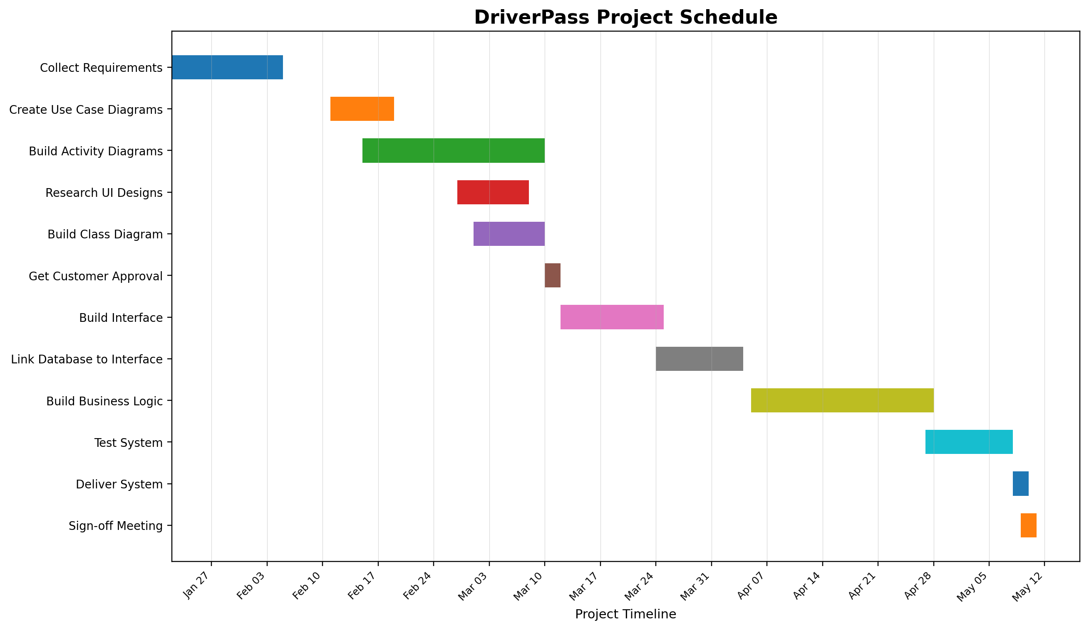
Figure 1. DriverPass project schedule based on the interview planning table.

