CS 255 Project Two: System Design Document
DriverPass System
Eddie Loya

UML Use Case Diagram
The use case diagram identifies the people and outside systems that interact with DriverPass. It shows that customers need to register, choose packages, access online training, take practice tests, and manage driving lesson reservations. It also shows how DriverPass staff support scheduling, reports, driver notes, account access, and DMV content updates.
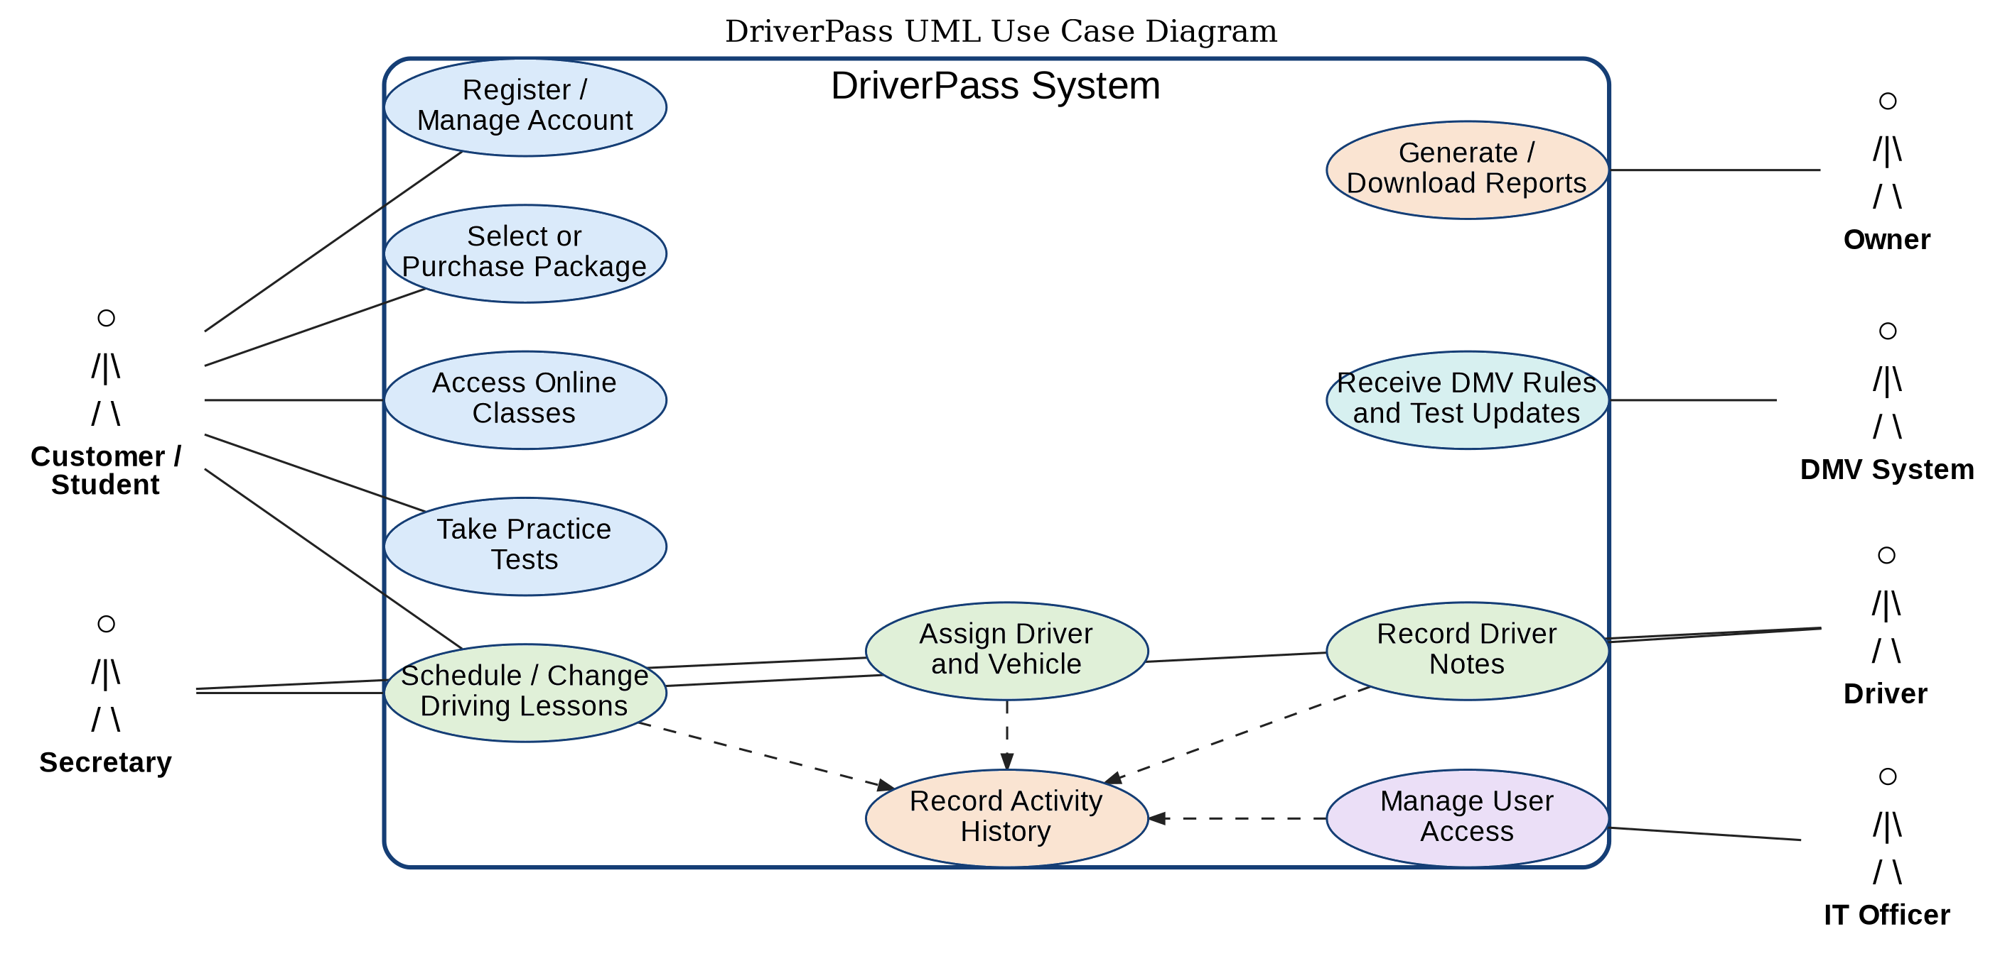
Figure 1. DriverPass UML Use Case Diagram

Activity Diagram 1: Schedule a Driving Lesson
This activity diagram breaks down the scheduling process. The design checks lesson availability before confirming a reservation, records the activity history, and sends confirmation so the student and DriverPass staff have a clear record of the lesson.
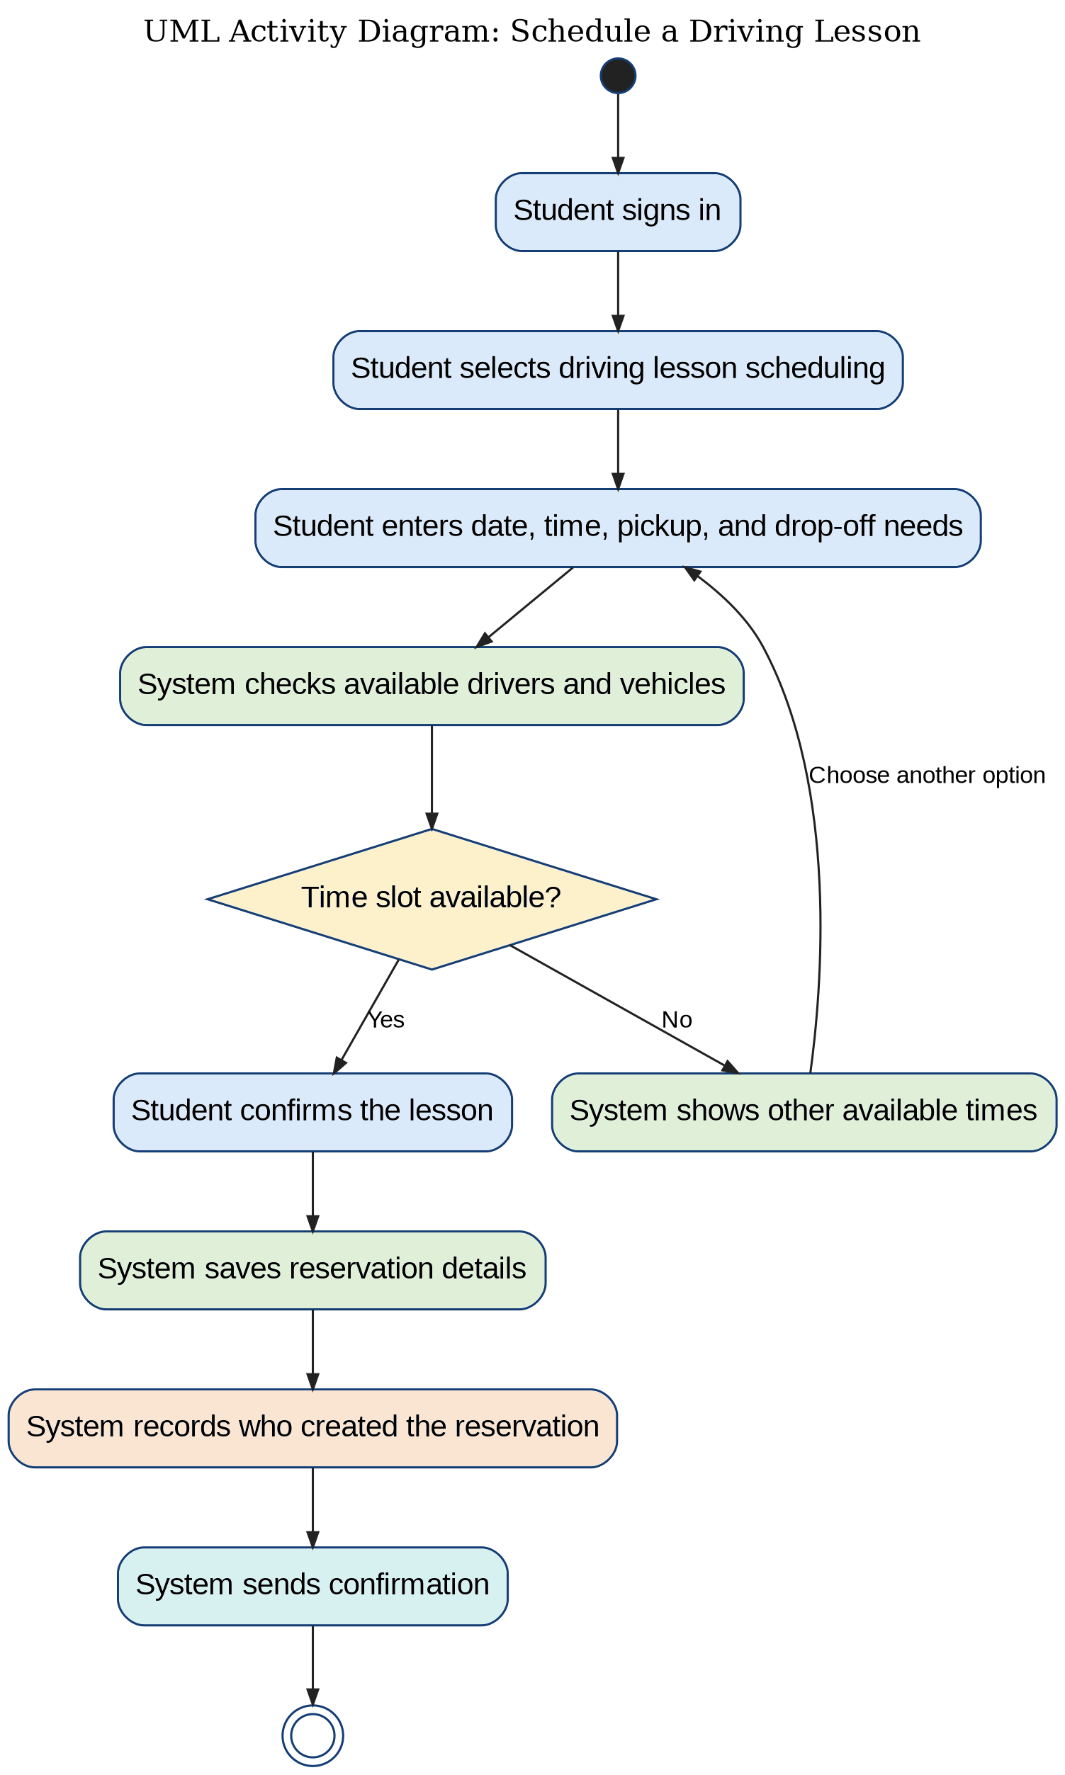
Figure 2. Schedule a Driving Lesson Activity Diagram

Activity Diagram 2: Take a Practice Test
This activity diagram shows how a student completes a practice test. The system loads current test content, scores the test, saves the result, and shows feedback so students can track progress and focus on areas that need improvement.
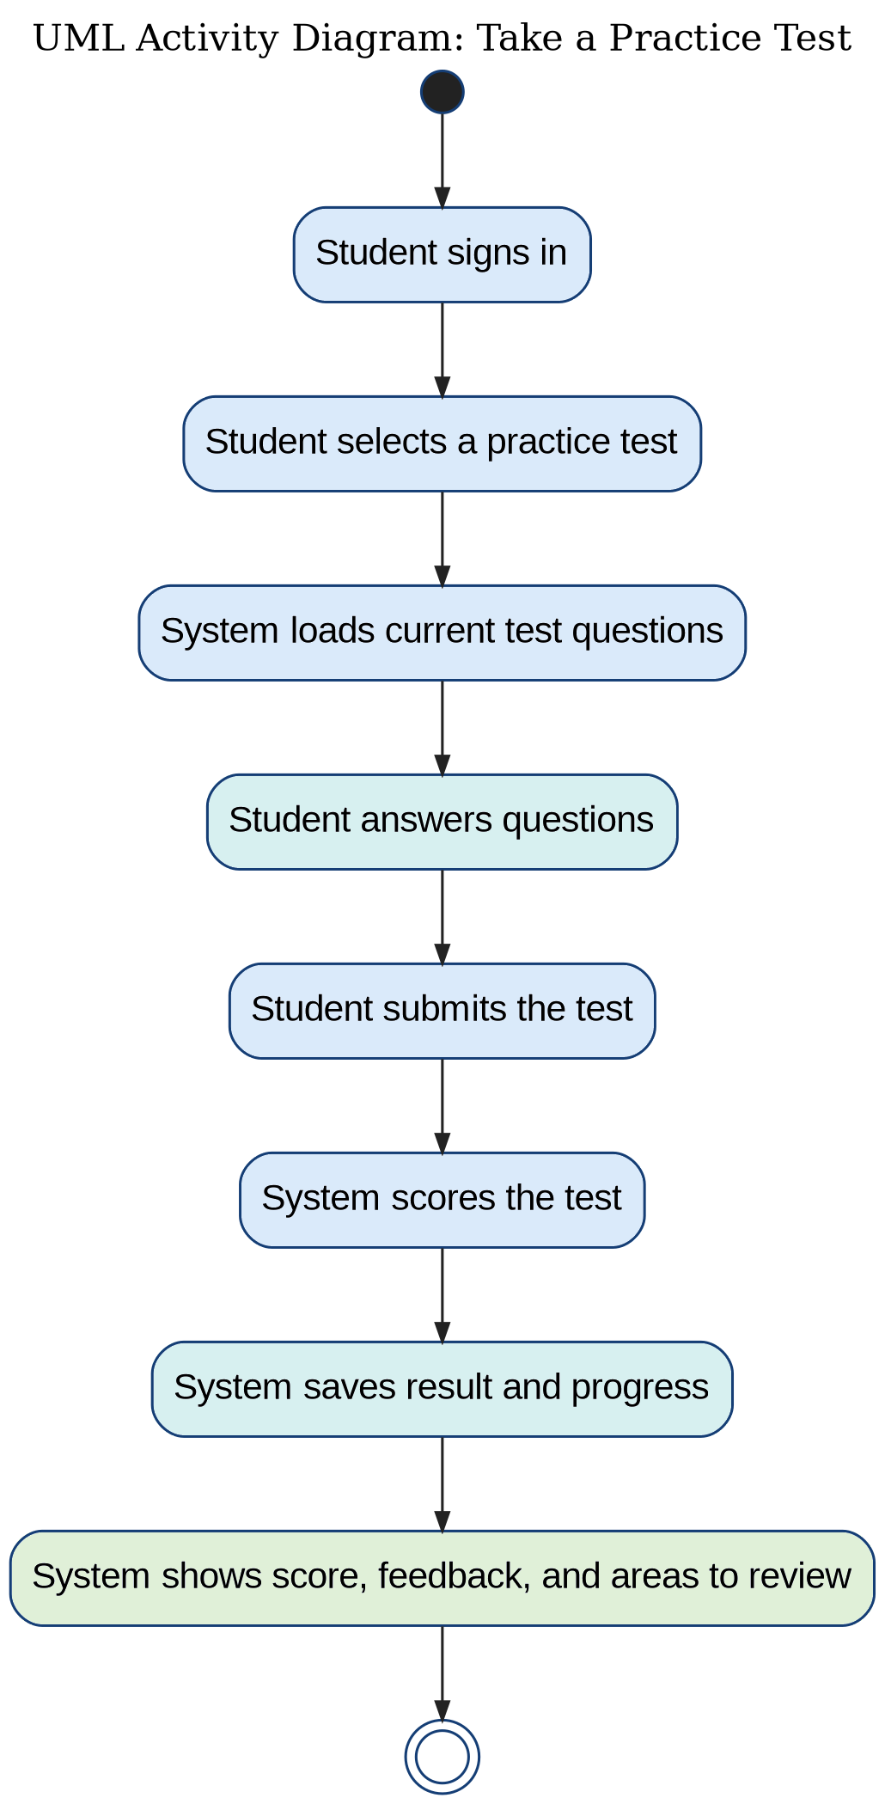
Figure 3. Take a Practice Test Activity Diagram

UML Sequence Diagram
The sequence diagram shows the order of communication when a student schedules a driving lesson. It illustrates how the web portal, scheduling service, database, and notification service work together to check availability, save the reservation, and confirm the appointment.
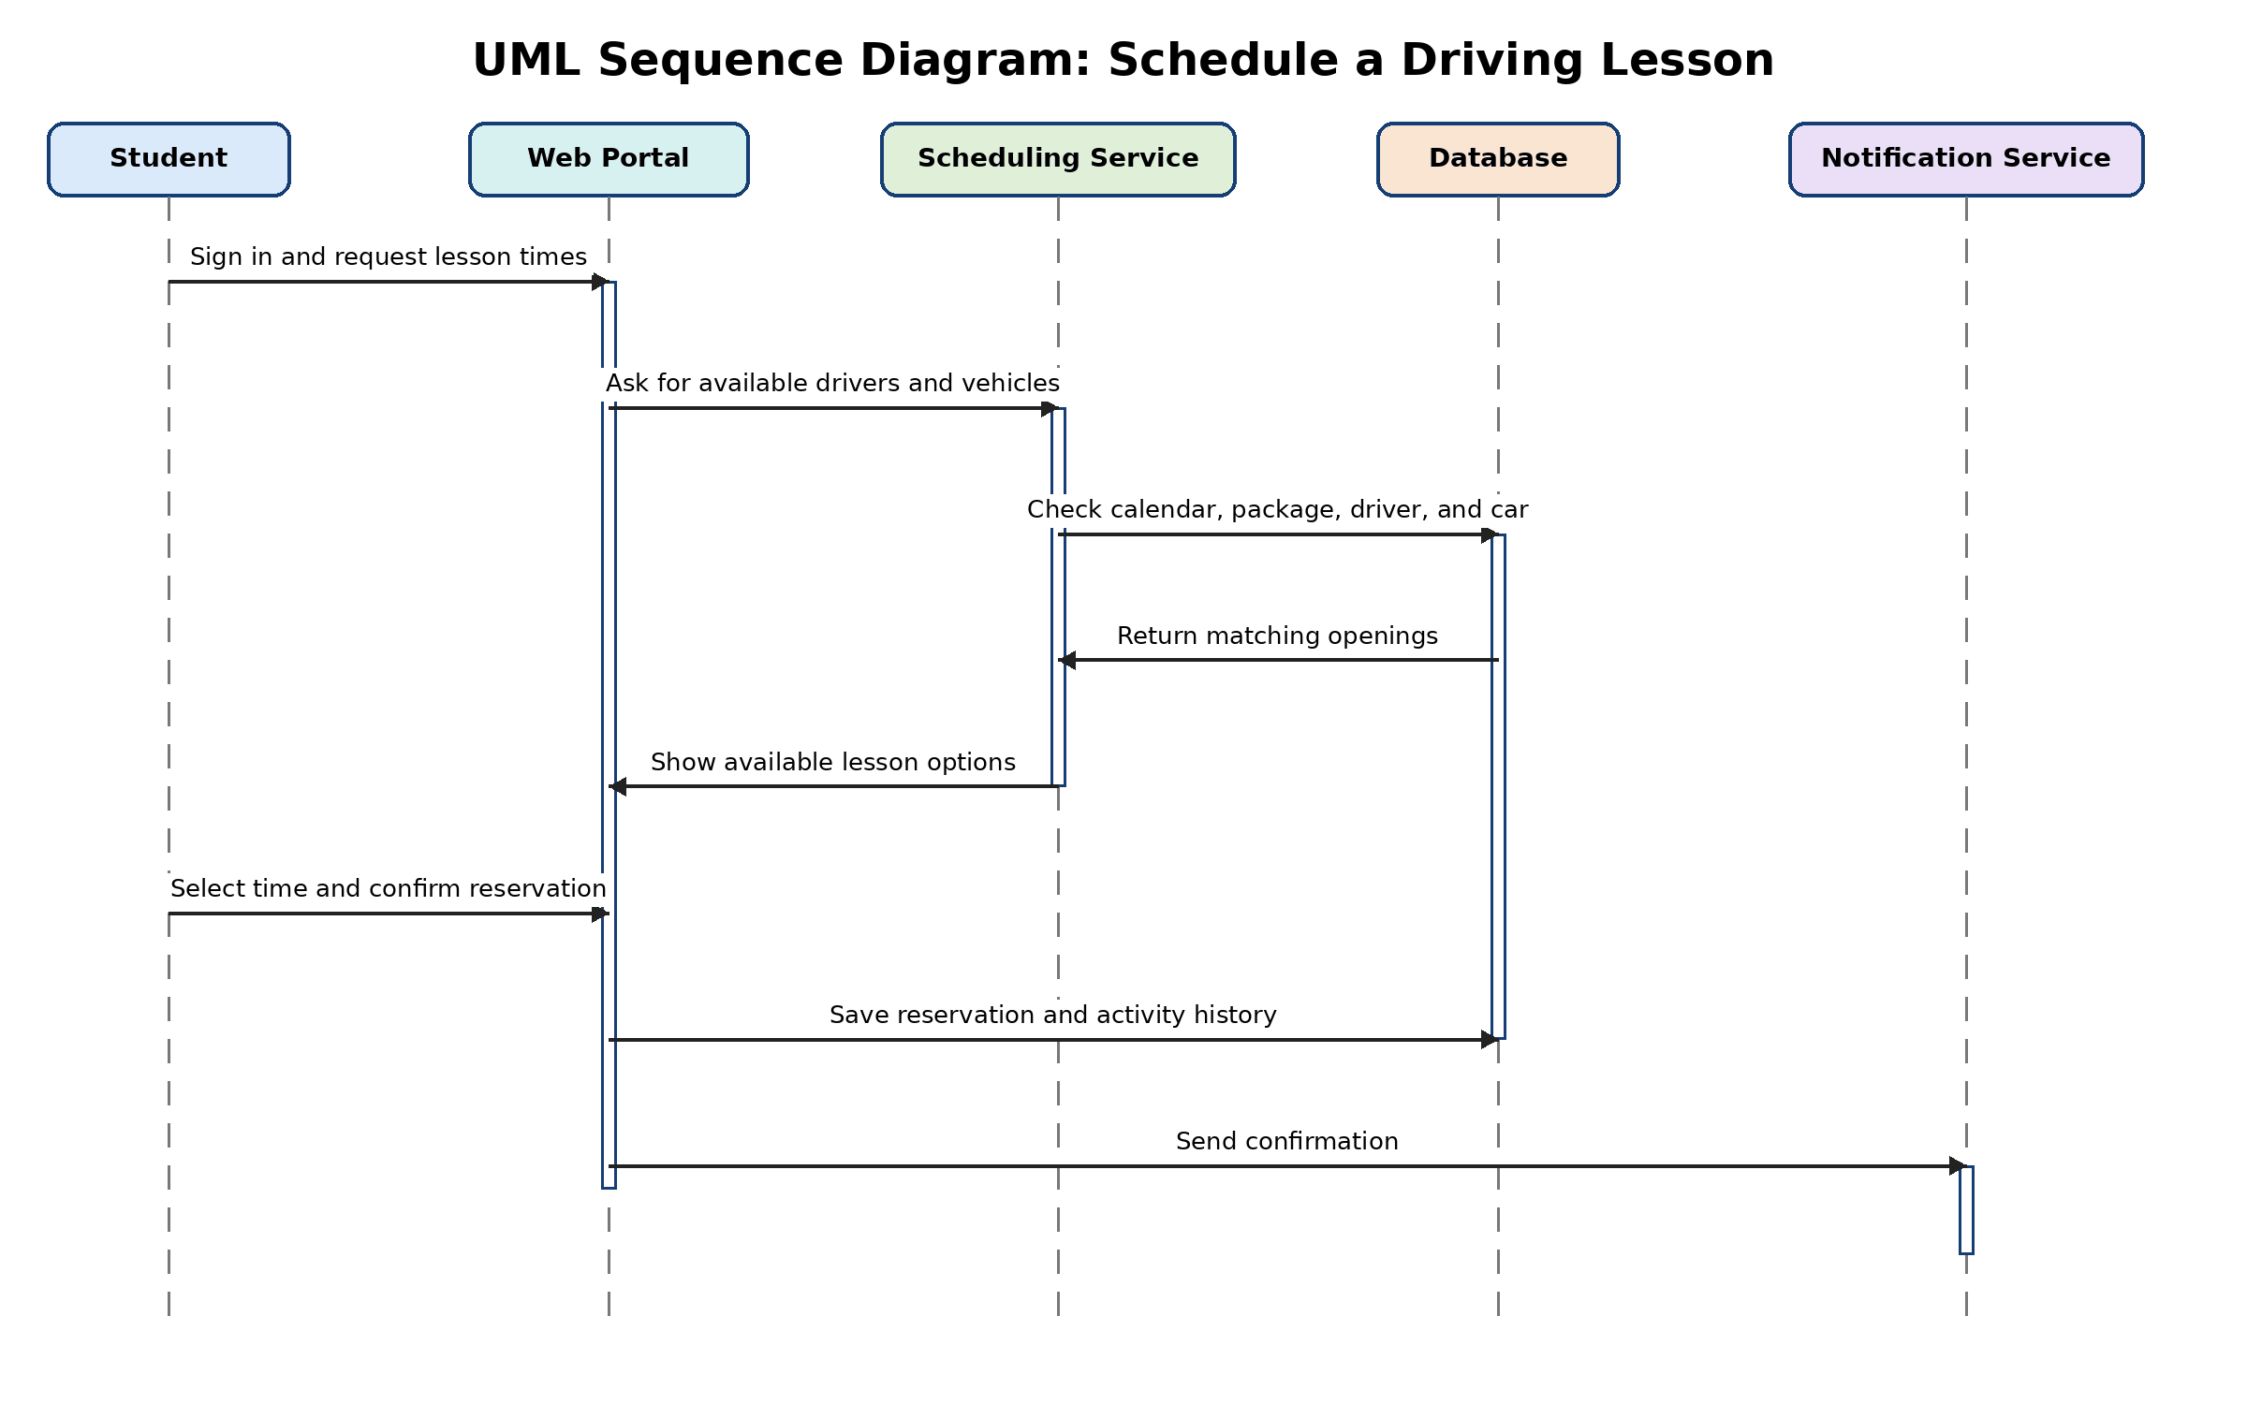
Figure 4. Schedule a Driving Lesson Sequence Diagram

UML Class Diagram
The class diagram organizes the main information the DriverPass system needs to store. The design includes user accounts, customer records, employees, packages, reservations, vehicles, practice tests, test results, DMV updates, audit history, and reports.
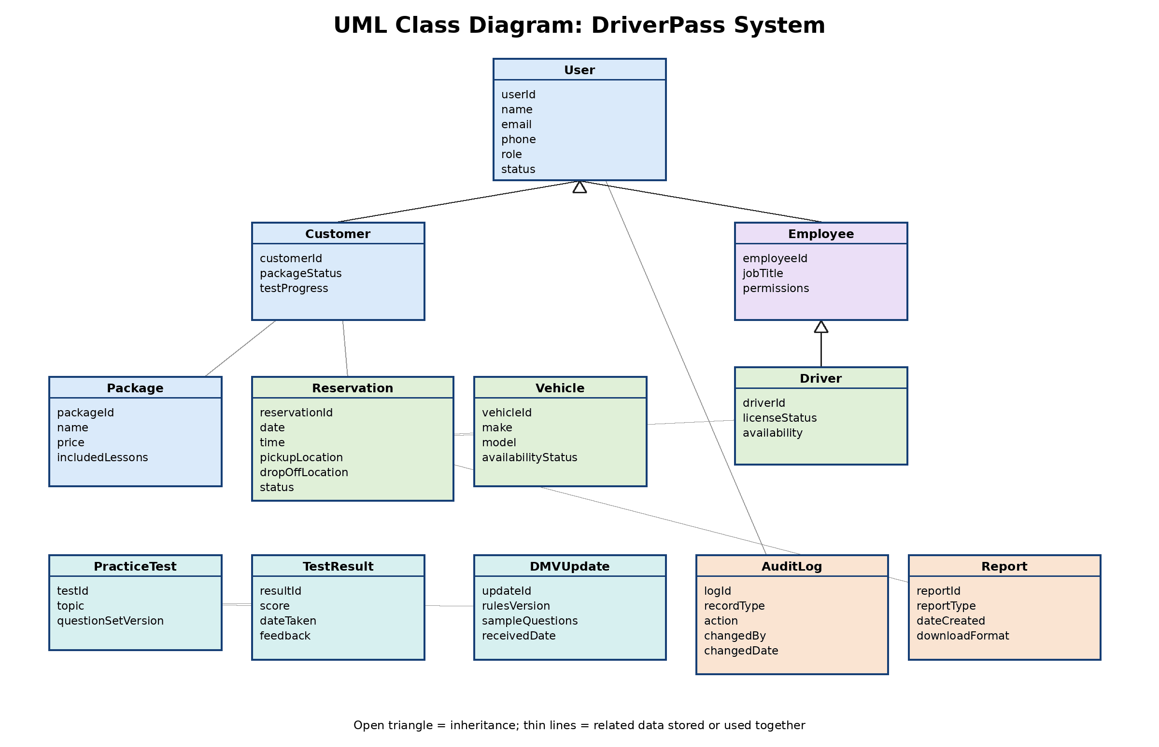
Figure 5. DriverPass UML Class Diagram

Technical Requirements
The proposed DriverPass system is a browser-based, cloud-hosted application with a centralized database. The technical requirements below support the system functions shown in the diagrams and help DriverPass provide online training, practice tests, lesson scheduling, reports, account management, and DMV content updates.

Hardware Requirements
• Students, employees, drivers, the owner, and the IT officer need access to a computer, tablet, or smartphone with a supported web browser.
• DriverPass office staff should have reliable workstations for scheduling, customer service, reports, and account administration.
• The system should use cloud-hosted application servers and database storage instead of relying on one local office computer.
• Optional office printers may be used for reports, schedules, and customer documentation when paper copies are needed.

Software Requirements
• The system should run as a responsive web application that works on common desktop and mobile browsers.
• A centralized database is required to store accounts, packages, reservations, test results, vehicles, drivers, reports, DMV updates, and activity history.
• The application needs secure sign-in, role-based access, password reset support, and tools for enabling or disabling user accounts.
• Reporting software should allow Liam and authorized staff to view and download reports in an Excel-compatible format.
• The system needs a content update process so DMV rule changes and sample question updates can be reviewed and added to DriverPass materials.

Development and Design Tools
• Lucidchart or a similar CASE tool should be used to maintain UML diagrams and communicate system structure and workflows.
• A version control system should be used to manage source code changes and support collaboration among developers.
• Database management tools should be used to create, test, back up, and maintain the centralized DriverPass database.
• Testing tools should verify account access, scheduling rules, practice test scoring, reports, security permissions, and common browser behavior.
• Monitoring tools should track application health, system errors, backups, and suspicious access attempts.

Infrastructure Requirements
• The application should be hosted in a managed cloud environment that supports growth as DriverPass adds more customers and lessons.
• All current system changes should occur online so the central database stays accurate and avoids duplicate or conflicting records.
• The system should use encrypted web access, routine backups, recovery procedures, and controlled administrative access.
• The database should maintain an activity history that records important changes such as reservations, cancellations, driver notes, and account changes.
• The design should support a secure connection or update process for DMV information when an approved source is available.
Overall, these requirements support DriverPass by making the system accessible from common devices, keeping data centralized, protecting user information, and giving staff the tools needed to manage customers, lessons, tests, reports, and account access.

