**清结算系统-软件测试文档**

目录

1.简介 1

1.1目的 1

1.2背景 1

1.3范围 1

1.4术语定义 1

1.5参考资料 2

1.6相关文档 2

1.7版本更新信息 2

2.测试需求 3

3.测试环境 3

4.单元测试 4

4.1测试描述 4

4.2测试用例 4

4.3测试结果 19

4.3.1测试结果 19

1.充值 19

2.提现 21

3.转账 23

4.查询记录 25

5.下载 31

6.清分 34

4.2截图 35

5 数据和数据库完整性测试 37

5.1测试描述 37

5.2测试结果 37

6.测试结论 38

# 1.简介

## 1.1目的

清结算系统的这一“测试计划”文档有助于实现以下目标：

• 确定现有项目的功能能够正常运行。

• 保证项目对异常状态的处理。

## 1.2背景

测试对象为清结算系统，主要进行单元测试，对其基本功能进行测试。

测试人员：刘梓雄

测试框架：IDEA Junit4

## 1.3范围

本测试计划着重于单元测试，主要针对功能测试。将对充值（Recharge）、提现（Withdraw）、交易（Trade）、数据库记录（QueryRecord）、下载文件（DownloadFile）、清分几个功能进行测试。

测试方法：黑盒测试。

## 1.4术语定义

清算：指结算之前对支付指令进行发送、对账、确认的处理，还可能包含指令的轧差。

轧差：轧差是指利用抵销、合同更新等法律制度，最终取得一方对另一方的一个数额的净债权或净债务，如市场交易者之间，可能互有内容相同，方向相反的多笔交易，在结算或结束交易时，可以将各方债权在相等数额内抵销，仅支付余额。

结算：指双方或多方对支付交易相关债务的清偿。严格意义上，清算与结算是不同的过程，清算的目的是结算。

## 1.5参考资料

[1]吕云翔，软件工程实用教程，清华大学出版社，2015

[2]吕云翔，刘瀚诚，刘天毅，软件工程项目实训教程，清华大学出版社，2016

[3]Roger S. Pressman，Bruce R. Maxim 著，软件工程：实践者的研究方法（原书第8版），郑人杰等译，机械工业出版社，2016

[4]Ian Sommerville著，软件工程（原书第10版），彭鑫等译，机械工业出版社，2018

[5]张海藩，吕云翔，软件工程（第4版），人民邮电出版社，2013

## 1.6相关文档

“清结算系统”的《软件开发计划书》；“清结算系统”的《需求规格说明书》；“清结算系统”的《软件设计说明书》。

## 1.7版本更新信息

版本更新信息如表1.1所示。

**表1.1 版本更新信息**

|  |  |  |  |  |
| --- | --- | --- | --- | --- |
| **版本号** | **创建者** | **创建日期** | **维护者** | **维护日期** |
| V1.0 | 赵志浩 | 2018/6/11 | 徐家兴 | 2018/6/11 |
| V2.0 | 赵志浩 | 2018/6/15 | 徐家兴 | 2018/6/15 |

# 2.测试需求

下面列出了那些已被确定为测试对象的项目（用例、功能性需求和非功能性需求）。此列表说明了测试的对象。

|  |  |
| --- | --- |
| 待测用例（方法） | 名称 |
| 1 | 充值 |
| 2 | 提现 |
| 3 | 交易 |
| 4 | 数据库记录 |
| 5 | 下载文件 |
| 6 | 清分 |

# 3.测试环境

* java
* jdk 1.8
* 核心框架：Spring Framework 5.0.5 RELEASE + Dubbo 2.6.1 + Zookeeper 3.4.10
* 开发工具：Intellij IDEA
* 日志管理：SLF4J、Log4j2
* 数据库：MySQL 8.0.11.0
* 数据库连接池：Alibaba Druid 1.0

# 4.单元测试

## 4.1测试描述

测试基于黑盒测试，即通过应用程序交互分析输出结果来验证应用程序及其内部进程。

|  |  |
| --- | --- |
| 测试目标： | 确保测试对象的功能正常，主要包括数据输入及处理。 |
| 方法： | 利用有效的和无效的数据来执行各个用例、用例流或功能，以核实以下内容：  • 在使用有效数据时得到预期的结果。  • 在使用无效数据时显示相应的错误消息或异常警告消息。 |
| 完成标准： | • 所计划的测试已全部执行。  • 所发现的缺陷已全部解决。 |
| 需考虑的特殊事项： | 无 |

## 4.2测试用例

1. 充值

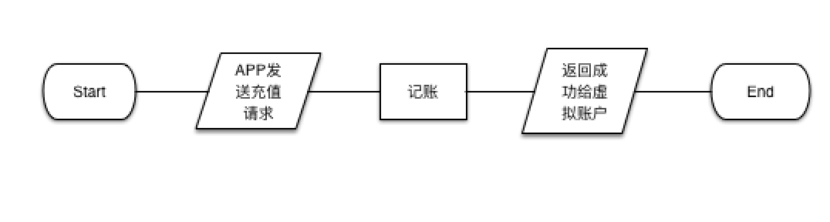

图1 充值流程图

|  |  |  |  |  |
| --- | --- | --- | --- | --- |
| 输入及外部条件 | 有效等价类 | 等价类编号 | 无效等价类 | 等价类编号 |
| requestID | 不为空且为数字 | 1 | null | 13 |
|  |  |  | 不为空但不为数字 | 14 |
| userID | 不为空且为数字 | 2 | null | 15 |
|  |  |  | 不为空但不为数字 | 16 |
| amount | amount>=0 | 3 | <0 | 17 |
| 请求时间requestTime | 不为空且格式正确 | 4 | null | 18 |
|  |  |  | 格式错误 | 35 |
| 月MM | 1<=MM<=12 | 5 | MM<1 | 19 |
|  |  |  | MM>12 | 20 |
| 日DD |  |  |  |  |
| MM{1,3,5,7,8,10,12} | 1<=DD<=31 | 6 | DD<1 | 21 |
|  |  |  | DD>31 | 22 |
| MM{4,6,9,11} | 1<=DD<=30 | 7 | DD<1 | 23 |
|  |  |  | DD>30 | 24 |
| 非闰年2月 | 1<=DD<=28 | 8 | DD<1 | 25 |
|  |  |  | DD>28 | 26 |
| 闰年2月 | 1<=DD<=29 | 9 | DD<1 | 27 |
|  |  |  | DD>29 | 28 |
| 时h | 0<=h<24 | 10 | h<0 | 29 |
|  |  |  | h>=24 | 30 |
| 分m | 0<=m<60 | 11 | m<0 | 31 |
|  |  |  | m>=60 | 32 |
| 秒s | 0<=s<60 | 12 | s<0 | 33 |
|  |  |  | s>=60 | 34 |

测试用例：

|  |  |  |
| --- | --- | --- |
| 序号 | 输入 | 覆盖等价类 |
| 1 | requestID=”” | 13 |
| 2 | requestID=”abc” | 14 |
| 3 | userID=”” | 15 |
| 4 | userID=”abc” | 16 |
| 5 | account = -100 | 17 |
| 6 | requestTime = “” | 18 |
| 7 | requestTime = “2018-00-01 03:03:03” | 4,10,12,19 |
| 8 | requestTime = “2018-13-01 03:03:03” | 4,10,12,20 |
| 9 | requestTime = “2018-03-00 03:03:03” | 4,5,10,12,21 |
| 10 | requestTime = “2018-03-33 03:03:03” | 4,5,10,12,22 |
| 11 | requestTime = “2018-04-00 03:03:03” | 4,5,10,12,23 |
| 12 | requestTime = “2018-04-31 03:03:03” | 4,5,10,12,24 |
| 13 | requestTime = “2018-02-00 03:03:03” | 4,5,10,12,25 |
| 14 | requestTime = “2018-02-29 03:03:03” | 4,5,10,12,26 |
| 15 | requestTime = “2008-02-00 03:03:03” | 4,5,10,12,27 |
| 16 | requestTime = “2008-02-30 03:03:03” | 4,5,10,12,28 |
| 17 | requestTime = “2018-06-01 -1:03:03” | 4,5,7,11,12,29 |
| 18 | requestTime = “2018-06-01 25:03:03” | 4,5,7,11,12,30 |
| 19 | requestTime = “2018-06-01 12:-3:03” | 4,5,7,10,12,31 |
| 20 | requestTime = “2018-06-01 12:61:03” | 4,5,7,10,12,32 |
| 21 | requestTime = “2018-06-01 12:03:-3” | 4,5,7,10,11,33 |
| 22 | requestTime = “2018-06-01 12:03:63” | 4,5,7,10,11,34 |
| 23 | requestTime = “asdfghjkl” | 35 |
| 24 | requestID = “1001” userID = “1621” amount = 21 method = true requestTime = "2018-06-30 00:00:30" | 1,2,3,5,7,10,11,12 |
| 25 | requestID = “1002” userID = “1621” amount = 21 method = true requestTime = "2018-05-31 15:59:30" | 1,2,3,4,5,6,10,11,12 |
| 26 | requestID = “1003” userID = “1621” amount = 21 method = true requestTime = "2018-02-28 20:00:00" | 1,2,3,4,5,8,10,11,12 |
| 27 | requestID = “1004” userID = “1621” amount = 21 method = true requestTime = "2008-02-29 12:00:00" | 1,2,3,4,5,9,10,11,12 |

1. 提现

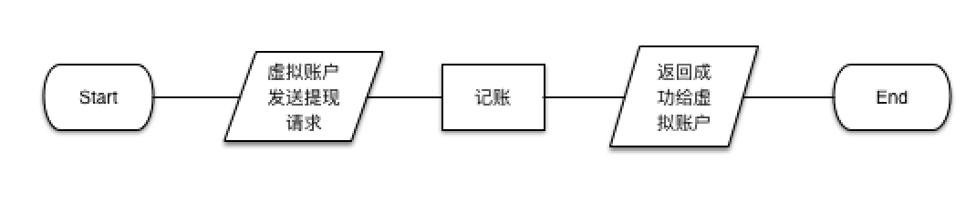

图2 提现流程图

|  |  |  |  |  |
| --- | --- | --- | --- | --- |
| 输入及外部条件 | 有效等价类 | 等价类编号 | 无效等价类 | 等价类编号 |
| requestID | 不为空且为数字 | 1 | null | 13 |
|  |  |  | 不为空但不为数字 | 14 |
| userID | 不为空且为数字 | 2 | null | 15 |
|  |  |  | 不为空但不为数字 | 16 |
| amount | amount>=0 | 3 | <0 | 17 |
| 请求时间requestTime | 不为空且格式正确 | 4 | null | 18 |
|  |  |  | 格式错误 | 35 |
| 月MM | 1<=MM<=12 | 5 | MM<1 | 19 |
|  |  |  | MM>12 | 20 |
| 日DD |  |  |  |  |
| MM{1,3,5,7,8,10,12} | 1<=DD<=31 | 6 | DD<1 | 21 |
|  |  |  | DD>31 | 22 |
| MM{4,6,9,11} | 1<=DD<=30 | 7 | DD<1 | 23 |
|  |  |  | DD>30 | 24 |
| 非闰年2月 | 1<=DD<=28 | 8 | DD<1 | 25 |
|  |  |  | DD>28 | 26 |
| 闰年2月 | 1<=DD<=29 | 9 | DD<1 | 27 |
|  |  |  | DD>29 | 28 |
| 时h | 0<=h<24 | 10 | h<0 | 29 |
|  |  |  | h>=24 | 30 |
| 分m | 0<=m<60 | 11 | m<0 | 31 |
|  |  |  | m>=60 | 32 |
| 秒s | 0<=s<60 | 12 | s<0 | 33 |
|  |  |  | s>=60 | 34 |

测试用例：

|  |  |  |
| --- | --- | --- |
| 序号 | 输入 | 覆盖等价类 |
| 1 | requestID=”” | 13 |
| 2 | requestID=”abc” | 14 |
| 3 | userID=”” | 15 |
| 4 | userID=”abc” | 16 |
| 5 | account = -100 | 17 |
| 6 | requestTime = “” | 18 |
| 7 | requestTime = “2018-00-01 03:03:03” | 4,10,12,19 |
| 8 | requestTime = “2018-13-01 03:03:03” | 4,10,12,20 |
| 9 | requestTime = “2018-03-00 03:03:03” | 4,5,10,12,21 |
| 10 | requestTime = “2018-03-33 03:03:03” | 4,5,10,12,22 |
| 11 | requestTime = “2018-04-00 03:03:03” | 4,5,10,12,23 |
| 12 | requestTime = “2018-04-31 03:03:03” | 4,5,10,12,24 |
| 13 | requestTime = “2018-02-00 03:03:03” | 4,5,10,12,25 |
| 14 | requestTime = “2018-02-29 03:03:03” | 4,5,10,12,26 |
| 15 | requestTime = “2008-02-00 03:03:03” | 4,5,10,12,27 |
| 16 | requestTime = “2008-02-30 03:03:03” | 4,5,10,12,28 |
| 17 | requestTime = “2018-06-01 -1:03:03” | 4,5,7,11,12,29 |
| 18 | requestTime = “2018-06-01 25:03:03” | 4,5,7,11,12,30 |
| 19 | requestTime = “2018-06-01 12:-3:03” | 4,5,7,10,12,31 |
| 20 | requestTime = “2018-06-01 12:61:03” | 4,5,7,10,12,32 |
| 21 | requestTime = “2018-06-01 12:03:-3” | 4,5,7,10,11,33 |
| 22 | requestTime = “2018-06-01 12:03:63” | 4,5,7,10,11,34 |
| 23 | requestTime = “asdfghjkl” | 35 |
| 24 | requestID = “1001” userID = “1621” amount = 21 method = true requestTime = "2018-06-30 00:00:30" | 1,2,3,5,7,10,11,12 |
| 25 | requestID = “1002” userID = “1621” amount = 21 method = true requestTime = "2018-05-31 15:59:30" | 1,2,3,4,5,6,10,11,12 |
| 26 | requestID = “1003” userID = “1621” amount = 21 method = true requestTime = "2018-02-28 20:00:00" | 1,2,3,4,5,8,10,11,12 |
| 27 | requestID = “1004” userID = “1621” amount = 21 method = true requestTime = "2008-02-29 12:00:00" | 1,2,3,4,5,9,10,11,12 |

1. 交易

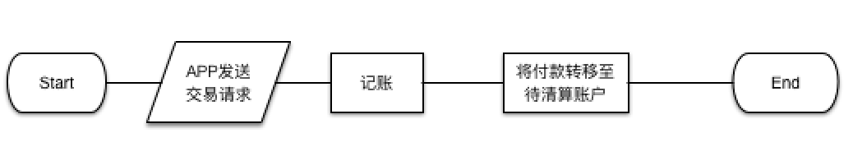

图3 交易流程图

|  |  |  |  |  |
| --- | --- | --- | --- | --- |
| 输入及外部条件 | 有效等价类 | 等价类编号 | 无效等价类 | 等价类编号 |
| requestID | 不为空且为数字 | 1 | null | 13 |
|  |  |  | 不为空但不为数字 | 14 |
| userID | 不为空且为数字 | 2 | null | 15 |
|  |  |  | 不为空但不为数字 | 16 |
| amount | amount>=0 | 3 | <0 | 17 |
| 请求时间requestTime | 不为空且格式正确 | 4 | null | 18 |
|  |  |  | 格式错误 | 38 |
| 月MM | 1<=MM<=12 | 5 | MM<1 | 19 |
|  |  |  | MM>12 | 20 |
| 日DD |  |  |  |  |
| MM{1,3,5,7,8,10,12} | 1<=DD<=31 | 6 | DD<1 | 21 |
|  |  |  | DD>31 | 22 |
| MM{4,6,9,11} | 1<=DD<=30 | 7 | DD<1 | 23 |
|  |  |  | DD>30 | 24 |
| 非闰年2月 | 1<=DD<=28 | 8 | DD<1 | 25 |
|  |  |  | DD>28 | 26 |
| 闰年2月 | 1<=DD<=29 | 9 | h<1 | 27 |
|  |  |  | DD>29 | 28 |
| 时h | 0<=h<24 | 10 | h<0 | 29 |
|  |  |  | h>=24 | 30 |
| 分m | 0<=m<60 | 11 | m<0 | 31 |
|  |  |  | m>=60 | 32 |
| 秒s | 0<=s<60 | 12 | s<0 | 33 |
|  |  |  | s>=60 | 34 |
| merchantID | 不为空且为数字 | 35 | null | 36 |
|  |  |  | 不为空但不为数字 | 37 |

测试用例：

|  |  |  |
| --- | --- | --- |
| 序号 | 输入 | 覆盖等价类 |
| 1 | requestID=”” | 13 |
| 2 | requestID=”abc” | 14 |
| 3 | userID=”” | 15 |
| 4 | userID=”abc” | 16 |
| 5 | account = -100 | 17 |
| 6 | requestTime = “” | 18 |
| 7 | requestTime = “2018-00-01 03:03:03” | 4,5,10,12,19 |
| 8 | requestTime = “2018-13-01 03:03:03” | 4,5,10,12,20 |
| 9 | requestTime = “2018-03-00 03:03:03” | 4,5,10,12,21 |
| 10 | requestTime = “2018-03-33 03:03:03” | 4,5,10,12,22 |
| 11 | requestTime = “2018-04-00 03:03:03” | 4,5,10,12,23 |
| 12 | requestTime = “2018-04-31 03:03:03” | 4,5,10,12,24 |
| 13 | requestTime = “2018-02-00 03:03:03” | 4,5,10,12,25 |
| 14 | requestTime = “2018-02-29 03:03:03” | 4,5,10,12,26 |
| 15 | requestTime = “2008-02-00 03:03:03” | 4,5,10,12,27 |
| 16 | requestTime = “2008-02-30 03:03:03” | 4,5,10,12,28 |
| 17 | requestTime = “2018-06-01 -1:03:03” | 4,5,7,11,12,29 |
| 18 | requestTime = “2018-06-01 25:03:03” | 4,5,7,11,12,30 |
| 19 | requestTime = “2018-06-01 12:-3:03” | 4,5,7,10,12,31 |
| 20 | requestTime = “2018-06-01 12:61:03” | 4,5,7,10,12,32 |
| 21 | requestTime = “2018-06-01 12:03:-3” | 4,5,7,10,11,33 |
| 22 | requestTime = “2018-06-01 12:03:63” | 4,5,7,10,11,34 |
| 23 | merchantID = “” | 36 |
| 24 | merchantID = “abc” | 37 |
| 25 | requestID = “1001” userID = “1621” merchantID = “2333” amount = 21 method = true requestTime = "2018-03-31 12:59:59" | 1,2,3,4,5,6,10,11,12,35 |
| 26 | requestID = “1002” userID = “1621” merchantID = “2333” amount = 99.8 method = true requestTime = "2018-06-30 00:00:00" | 1,2,3,4,5,7,10,11,12,35 |
| 27 | requestID = “1003” userID = “1621” merchantID = “2333” amount = 66.6 method = true requestTime = "2018-02-28 12:03:30" | 1,2,3,4,5,8,10,11,12,35 |
| 28 | requestID = “1004” userID = “1621” merchantID = “2333” amount = 666 method = true requestTime = "2008-02-29 16:00:00" | 1,2,3,4,5,9,10,11,12,35 |

1. 查询

|  |  |  |  |  |
| --- | --- | --- | --- | --- |
| 输入及外部条件 | 有效等价类 | 等价类编号 | 无效等价类 | 等价类编号 |
| 开始时间startTime | 不为空 | 1 | 格式非法 | 32 |
|  | null | 11 |  |  |
| 结束时间startTime | 不为空 | 2 | 格式非法 | 34 |
|  | null | 12 | 早于开始时间 | 29 |
| 时间格式 | | | | |
| 月MM | 1<=MM<=12 | 3 | MM<1 | 13 |
|  |  |  | MM>12 | 14 |
| 日DD |  |  |  |  |
| MM{1,3,5,7,8,10,12} | 1<=DD<=31 | 4 | DD<1 | 15 |
|  |  |  | DD>31 | 16 |
| MM{4,6,9,11} | 1<=DD<=30 | 5 | DD<1 | 17 |
|  |  |  | DD>30 | 18 |
| 非闰年2月 | 1<=DD<=28 | 6 | DD<1 | 19 |
|  |  |  | DD>28 | 20 |
| 闰年2月 | 1<=DD<=29 | 7 | h<1 | 21 |
|  |  |  | DD>29 | 22 |
| 时h | 0<=h<24 | 8 | h<0 | 23 |
|  |  |  | h>=24 | 24 |
| 分m | 0<=m<60 | 9 | m<0 | 25 |
|  |  |  | m>=60 | 26 |
| 秒s | 0<=s<60 | 10 | s<0 | 27 |
|  |  |  | s>=60 | 28 |
| operatorID | {0,1,2} | 30 | 其他 | 31 |
| 时间 |  |  | 超出15天 | 33 |

测试用例：

|  |  |  |
| --- | --- | --- |
| 序号 | 输入 | 覆盖等价类 |
| 1 | startTime = “” | 11 |
| 2 | startTime = “2018-00-01 03:03:03” | 13 |
| 3 | startTime = “2018-13-01 03:03:03” | 14 |
| 4 | startTime = “2018-03-00 03:03:03” | 15 |
| 5 | startTime = “2018-03-33 03:03:03” | 16 |
| 6 | startTime = “2018-04-00 03:03:03” | 17 |
| 7 | startTime = “2018-04-31 03:03:03” | 18 |
| 8 | startTime = “2018-02-00 03:03:03” | 19 |
| 9 | startTime = “2018-02-29 03:03:03” | 20 |
| 10 | startTime = “2008-02-00 03:03:03” | 21 |
| 11 | startTime = “2008-02-30 03:03:03” | 22 |
| 12 | startTime = “2018-06-01 -1:03:03” | 23 |
| 13 | startTime = “2018-06-01 25:03:03” | 24 |
| 14 | startTime = “2018-06-01 12:-3:03” | 25 |
| 15 | startTime = “2018-06-01 12:61:03” | 26 |
| 16 | startTime = “2018-06-01 12:03:-3” | 27 |
| 17 | startTime = “2018-06-01 12:03:63” | 28 |
| 18 | startTime = “2018-06-01 12:00:00”  endTime = “” | 12 |
| 19 | startTime = “2018-06-01 12:00:00”  endTime = “2018-05-01 12:00:00” | 29 |
| 20 | operateID = 123 | 31 |
| 21 | startTime = “asdfg” | 32 |
| 22 | startTime = “2008-06-01 00:00:00”  endTime = “2008-06-08 00:00:00”  operateID = 0 | 33 |
| 23 | startTime = “2018-06-01 00:00:00”  endTime = “2018-06-08 00:00:00”  operateID = 0 | 1,2,30 |

1. 下载

|  |  |  |  |  |
| --- | --- | --- | --- | --- |
| 输入及外部条件 | 有效等价类 | 等价类编号 | 无效等价类 | 等价类编号 |
| requestTime | 不为空 | 1 | null | 10 |
|  |  |  | 格式非法 | 27 |
|  |  |  | 不在15天内 | 28 |
| 时间格式 | | | | |
| 月MM | 1<=MM<=12 | 2 | MM<1 | 11 |
|  |  |  | MM>12 | 12 |
| 日DD |  |  |  |  |
| MM{1,3,5,7,8,10,12} | 1<=DD<=31 | 3 | DD<1 | 13 |
|  |  |  | DD>31 | 14 |
| MM{4,6,9,11} | 1<=DD<=30 | 4 | DD<1 | 15 |
|  |  |  | DD>30 | 16 |
| 非闰年2月 | 1<=DD<=28 | 5 | DD<1 | 17 |
|  |  |  | DD>28 | 18 |
| 闰年2月 | 1<=DD<=29 | 6 | h<1 | 19 |
|  |  |  | DD>29 | 20 |
| 时h | 0<=h<24 | 7 | h<0 | 21 |
|  |  |  | h>=24 | 22 |
| 分m | 0<=m<60 | 8 | m<0 | 23 |
|  |  |  | m>=60 | 24 |
| 秒s | 0<=s<60 | 9 | s<0 | 25 |
|  |  |  | s>=60 | 26 |

测试用例：

|  |  |  |
| --- | --- | --- |
| 序号 | 输入 | 覆盖等价类 |
| 1 | requestTime = “” | 10 |
| 2 | requestTime = “2018-00-01 03:03:03” | 11 |
| 3 | requestTime = “2018-13-01 03:03:03” | 12 |
| 4 | requestTime = “2018-03-00 03:03:03” | 13 |
| 5 | requestTime = “2018-03-33 03:03:03” | 14 |
| 6 | requestTime = “2018-04-00 03:03:03” | 15 |
| 7 | requestTime = “2018-04-31 03:03:03” | 16 |
| 8 | requestTime = “2018-02-00 03:03:03” | 17 |
| 9 | requestTime = “2018-02-29 03:03:03” | 18 |
| 10 | requestTime = “2008-02-00 03:03:03” | 19 |
| 11 | requestTime = “2008-02-30 03:03:03” | 20 |
| 12 | requestTime = “2018-06-01 -1:03:03” | 21 |
| 13 | requestTime = “2018-06-01 25:03:03” | 22 |
| 14 | requestTime = “2018-06-01 12:-3:03” | 23 |
| 15 | requestTime = “2018-06-01 12:61:03” | 24 |
| 16 | requestTime = “2018-06-01 12:03:-3” | 25 |
| 17 | requestTime = “2018-06-01 12:03:63” | 26 |
| 18 | requestTime = “-2131-12-01 00:wq:1w” | 27 |
| 19 | requestTime = “2000-01-01 00:00:00” | 28 |
| 20 | requestTime = “2018-06-06 20:00:30” | 1,2,4,7,8,9 |

1. 清分

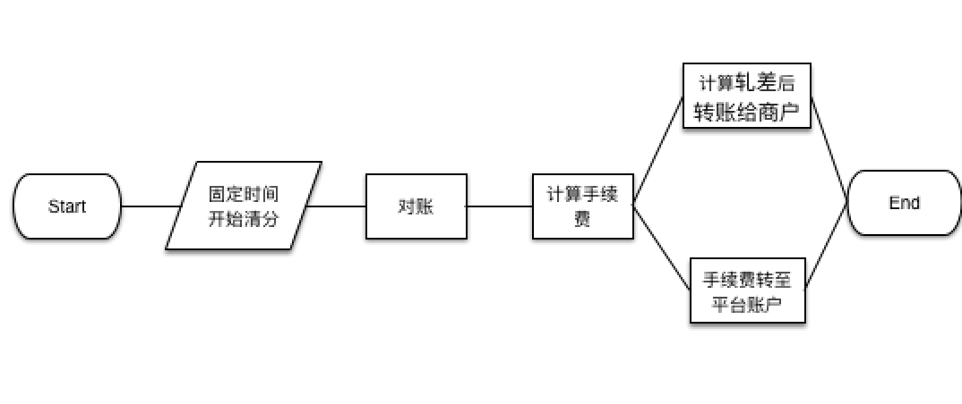

图4 清分流程图

|  |  |  |  |  |
| --- | --- | --- | --- | --- |
| 输入及外部条件 | 有效等价类 | 等价类编号 | 无效等价类 | 等价类编号 |
| 数据库内容 | 没有需要清分的纪录 | 2 | 无 |  |
|  | 有需要清分的纪录 | 3 |  |

测试用例：

|  |  |  |  |  |  |  |
| --- | --- | --- | --- | --- | --- | --- |
| 序号 | 数据库内容 | | | | | 覆盖等价类 |
| requestID | userID | merchantID | amount | requestTime |
| 1 | 无 | | | | | 1 |
| 2 | "4" | “20” | “21” | “2000” | ,"2018-06-16 12:00:00" | 2 |
| "5" | “20” | “21” | “200” | ,"2018-06-16 12:01:00" |
| "6" | “20” | “21” | “1000” | ,"2018-06-16 12:02:00" |
| "7" | “40” | “23” | “2000” | ,"2018-06-16 12:03:00" |
| 3 | "8" | “41” | “23” | “200” | ,"2018-06-16 12:04:00" | 2 |
| "9" | “42” | “24” | “1000000” | ,"2018-06-16 12:05:00" |

## 4.3测试结果

### 4.3.1测试结果

1.充值

|  |  |  |  |
| --- | --- | --- | --- |
| 序号 | 输入 | 预期输出 | 实际输出 |
| 1 | requestID=”” | RequestException | RequestException |
| 2 | requestID=”abc” | RequestException | RequestException |
| 3 | userID=”” | RequestException | RequestException |
| 4 | userID=”abc” | RequestException | RequestException |
| 5 | account = -100 | RequestException | RequestException |
| 6 | requestTime = “” | RequestException | RequestException |
| 7 | requestTime = “2018-00-01 03:03:03” | RequestException | RequestException |
| 8 | requestTime = “2018-13-01 03:03:03” | RequestException | RequestException |
| 9 | requestTime = “2018-03-00 03:03:03” | RequestException | RequestException |
| 10 | requestTime = “2018-03-33 03:03:03” | RequestException | RequestException |
| 11 | requestTime = “2018-04-00 03:03:03” | RequestException | RequestException |
| 12 | requestTime = “2018-04-31 03:03:03” | RequestException | RequestException |
| 13 | requestTime = “2018-02-00 03:03:03” | RequestException | RequestException |
| 14 | requestTime = “2018-02-29 03:03:03” | RequestException | RequestException |
| 15 | requestTime = “2008-02-00 03:03:03” | RequestException | RequestException |
| 16 | requestTime = “2008-02-30 03:03:03” | RequestException | RequestException |
| 17 | requestTime = “2018-06-01 -1:03:03” | RequestException | RequestException |
| 18 | requestTime = “2018-06-01 25:03:03” | RequestException | RequestException |
| 19 | requestTime = “2018-06-01 12:-3:03” | RequestException | RequestException |
| 20 | requestTime = “2018-06-01 12:61:03” | RequestException | RequestException |
| 21 | requestTime = “2018-06-01 12:03:-3” | RequestException | RequestException |
| 22 | requestTime = “2018-06-01 12:03:63” | RequestException | RequestException |
| 23 | requestTime = “asdfghjkl” | RequestException | RequestException |
| 24 | requestID = “1001” userID = “1621” amount = 21 method = true requestTime = "2018-06-30 00:00:30" | 1001 | 1001 |
| 25 | requestID = “1002” userID = “1621” amount = 21 method = true requestTime = "2018-05-31 15:59:30" | 1002 | 1002 |
| 26 | requestID = “1003” userID = “1621” amount = 21 method = true requestTime = "2018-02-28 20:00:00" | 1003 | 1003 |
| 27 | requestID = “1004” userID = “1621” amount = 21 method = true requestTime = "2008-02-29 12:00:00" | 1004 | 1004 |

2.提现

|  |  |  |  |
| --- | --- | --- | --- |
| 序号 | 输入 | 预期输出 | 实际输出 |
| 1 | requestID=”” | RequestException | RequestException |
| 2 | requestID=”abc” | RequestException | RequestException |
| 3 | userID=”” | RequestException | RequestException |
| 4 | userID=”abc” | RequestException | RequestException |
| 5 | account = -100 | RequestException | RequestException |
| 6 | requestTime = “” | RequestException | RequestException |
| 7 | requestTime = “2018-00-01 03:03:03” | RequestException | RequestException |
| 8 | requestTime = “2018-13-01 03:03:03” | RequestException | RequestException |
| 9 | requestTime = “2018-03-00 03:03:03” | RequestException | RequestException |
| 10 | requestTime = “2018-03-33 03:03:03” | RequestException | RequestException |
| 11 | requestTime = “2018-04-00 03:03:03” | RequestException | RequestException |
| 12 | requestTime = “2018-04-31 03:03:03” | RequestException | RequestException |
| 13 | requestTime = “2018-02-00 03:03:03” | RequestException | RequestException |
| 14 | requestTime = “2018-02-29 03:03:03” | RequestException | RequestException |
| 15 | requestTime = “2008-02-00 03:03:03” | RequestException | RequestException |
| 16 | requestTime = “2008-02-30 03:03:03” | RequestException | RequestException |
| 17 | requestTime = “2018-06-01 -1:03:03” | RequestException | RequestException |
| 18 | requestTime = “2018-06-01 25:03:03” | RequestException | RequestException |
| 19 | requestTime = “2018-06-01 12:-3:03” | RequestException | RequestException |
| 20 | requestTime = “2018-06-01 12:61:03” | RequestException | RequestException |
| 21 | requestTime = “2018-06-01 12:03:-3” | RequestException | RequestException |
| 22 | requestTime = “2018-06-01 12:03:63” | RequestException | RequestException |
| 23 | requestTime = “asdfghjkl” | RequestException | RequestException |
| 24 | requestID = “1001” userID = “1621” amount = 21 method = true requestTime = "2018-06-30 00:00:30" | 1001 | 1001 |
| 25 | requestID = “1002” userID = “1621” amount = 21 method = true requestTime = "2018-05-31 15:59:30" | 1002 | 1002 |
| 26 | requestID = “1003” userID = “1621” amount = 21 method = true requestTime = "2018-02-28 20:00:00" | 1003 | 1003 |
| 27 | requestID = “1004” userID = “1621” amount = 21 method = true requestTime = "2008-02-29 12:00:00" | 1004 | 1004 |

3.转账

|  |  |  |  |
| --- | --- | --- | --- |
| 序号 | 输入 | 预期输出 | 实际输出 |
| 1 | requestID=”” | RequestException | RequestException |
| 2 | requestID=”abc” | RequestException | RequestException |
| 3 | userID=”” | RequestException | RequestException |
| 4 | userID=”abc” | RequestException | RequestException |
| 5 | account = -100 | RequestException | RequestException |
| 6 | requestTime = “” | RequestException | RequestException |
| 7 | requestTime = “2018-00-01 03:03:03” | RequestException | RequestException |
| 8 | requestTime = “2018-13-01 03:03:03” | RequestException | RequestException |
| 9 | requestTime = “2018-03-00 03:03:03” | RequestException | RequestException |
| 10 | requestTime = “2018-03-33 03:03:03” | RequestException | RequestException |
| 11 | requestTime = “2018-04-00 03:03:03” | RequestException | RequestException |
| 12 | requestTime = “2018-04-31 03:03:03” | RequestException | RequestException |
| 13 | requestTime = “2018-02-00 03:03:03” | RequestException | RequestException |
| 14 | requestTime = “2018-02-29 03:03:03” | RequestException | RequestException |
| 15 | requestTime = “2008-02-00 03:03:03” | RequestException | RequestException |
| 16 | requestTime = “2008-02-30 03:03:03” | RequestException | RequestException |
| 17 | requestTime = “2018-06-01 -1:03:03” | RequestException | RequestException |
| 18 | requestTime = “2018-06-01 25:03:03” | RequestException | RequestException |
| 19 | requestTime = “2018-06-01 12:-3:03” | RequestException | RequestException |
| 20 | requestTime = “2018-06-01 12:61:03” | RequestException | RequestException |
| 21 | requestTime = “2018-06-01 12:03:-3” | RequestException | RequestException |
| 22 | requestTime = “2018-06-01 12:03:63” | RequestException | RequestException |
| 23 | merchantID = “” | RequestException | RequestException |
| 24 | merchantID = “abc” | RequestException | RequestException |
| 25 | requestID = “1001” userID = “1621” merchantID = “2333” amount = 21 method = true requestTime = "2018-03-31 12:59:59" | 1001 | 1001 |
| 26 | requestID = “1002” userID = “1621” merchantID = “2333” amount = 99.8 method = true requestTime = "2018-06-30 00:00:00" | 1002 | 1002 |
| 27 | requestID = “1003” userID = “1621” merchantID = “2333” amount = 66.6 method = true requestTime = "2018-02-28 12:03:30" | 1003 | 1003 |
| 28 | requestID = “1004” userID = “1621” merchantID = “2333” amount = 666 method = true requestTime = "2008-02-29 16:00:00" | 1004 | 1004 |

4.查询记录

|  |  |  |  |
| --- | --- | --- | --- |
| 序号 | 输入 | 预期输出 | 实际输出 |
| 1 | startTime = “” | [{"requestTime":"2018-06-06 00:00:00","amount":66.6,"operateStatus":0,"merchantID":"2333","requestID":"1001","userID":"1621"},{"requestTime":"2018-06-06 00:00:00","amount":99.8,"operateStatus":0,"merchantID":"2333","requestID":"1002","userID":"1621"},{"requestTime":"2018-06-06 00:00:00","amount":66.6,"operateStatus":0,"merchantID":"2333","requestID":"1003","userID":"1621"},{"requestTime":"2018-06-06 00:00:00","amount":66.6,"operateStatus":0,"merchantID":"2333","requestID":"1004","userID":"1621"}] | [{"requestTime":"2018-06-06 00:00:00","amount":66.6,"operateStatus":0,"merchantID":"2333","requestID":"1001","userID":"1621"},{"requestTime":"2018-06-06 00:00:00","amount":99.8,"operateStatus":0,"merchantID":"2333","requestID":"1002","userID":"1621"},{"requestTime":"2018-06-06 00:00:00","amount":66.6,"operateStatus":0,"merchantID":"2333","requestID":"1003","userID":"1621"},{"requestTime":"2018-06-06 00:00:00","amount":66.6,"operateStatus":0,"merchantID":"2333","requestID":"1004","userID":"1621"}] |
| 2 | startTime = “2018-00-01 03:03:03” | TimeOutOfRangeException | TimeOutOfRangeException |
| 3 | startTime = “2018-13-01 03:03:03” | TimeOutOfRangeException | TimeOutOfRangeException |
| 4 | startTime = “2018-03-00 03:03:03” | TimeOutOfRangeException | TimeOutOfRangeException |
| 5 | startTime = “2018-03-33 03:03:03” | TimeOutOfRangeException | TimeOutOfRangeException |
| 6 | startTime = “2018-04-00 03:03:03” | TimeOutOfRangeException | TimeOutOfRangeException |
| 7 | startTime = “2018-04-31 03:03:03” | TimeOutOfRangeException | TimeOutOfRangeException |
| 8 | startTime = “2018-02-00 03:03:03” | TimeOutOfRangeException | TimeOutOfRangeException |
| 9 | startTime = “2018-02-29 03:03:03” | TimeOutOfRangeException | TimeOutOfRangeException |
| 10 | startTime = “2008-02-00 03:03:03” | TimeOutOfRangeException | TimeOutOfRangeException |
| 11 | startTime = “2008-02-30 03:03:03” | TimeOutOfRangeException | TimeOutOfRangeException |
| 12 | startTime = “2018-06-01 -1:03:03” | TimeOutOfRangeException | TimeOutOfRangeException |
| 13 | startTime = “2018-06-01 25:03:03” | TimeOutOfRangeException | TimeOutOfRangeException |
| 14 | startTime = “2018-06-01 12:-3:03” | TimeOutOfRangeException | TimeOutOfRangeException |
| 15 | startTime = “2018-06-01 12:61:03” | TimeOutOfRangeException | TimeOutOfRangeException |
| 16 | startTime = “2018-06-01 12:03:-3” | TimeOutOfRangeException | TimeOutOfRangeException |
| 17 | startTime = “2018-06-01 12:03:63” | TimeOutOfRangeException | TimeOutOfRangeException |
| 18 | startTime = “2018-06-01 12:00:00”  endTime = “” | [{"requestTime":"2018-06-06 00:00:00","amount":66.6,"operateStatus":0,"merchantID":"2333","requestID":"1001","userID":"1621"},{"requestTime":"2018-06-06 00:00:00","amount":99.8,"operateStatus":0,"merchantID":"2333","requestID":"1002","userID":"1621"},{"requestTime":"2018-06-06 00:00:00","amount":66.6,"operateStatus":0,"merchantID":"2333","requestID":"1003","userID":"1621"},{"requestTime":"2018-06-06 00:00:00","amount":66.6,"operateStatus":0,"merchantID":"2333","requestID":"1004","userID":"1621"}] | [{"requestTime":"2018-06-06 00:00:00","amount":66.6,"operateStatus":0,"merchantID":"2333","requestID":"1001","userID":"1621"},{"requestTime":"2018-06-06 00:00:00","amount":99.8,"operateStatus":0,"merchantID":"2333","requestID":"1002","userID":"1621"},{"requestTime":"2018-06-06 00:00:00","amount":66.6,"operateStatus":0,"merchantID":"2333","requestID":"1003","userID":"1621"},{"requestTime":"2018-06-06 00:00:00","amount":66.6,"operateStatus":0,"merchantID":"2333","requestID":"1004","userID":"1621"}] |
| 19 | startTime = “2018-06-01 12:00:00”  endTime = “2018-05-01 12:00:00” | TimeOutOfRangeException | TimeOutOfRangeException |
| 20 | operateID = 123 | TimeOutOfRangeException | TimeOutOfRangeException |
| 21 | startTime = “asdfg” | TimeOutOfRangeException | TimeOutOfRangeException |
| 22 | startTime = “2008-06-01 00:00:00”  endTime = “2008-06-08 00:00:00”  operateID = 0 | TimeOutOfRangeException | TimeOutOfRangeException |
| 23 | startTime = “2018-06-02 00:00:00”  endTime = “2018-06-08 00:00:00”  operateID = 2 | [{"requestTime":"2018-06-06 00:00:00","amount":66.6,"operateStatus":0,"merchantID":"2333","requestID":"1001","userID":"1621"},{"requestTime":"2018-06-06 00:00:00","amount":99.8,"operateStatus":0,"merchantID":"2333","requestID":"1002","userID":"1621"},{"requestTime":"2018-06-06 00:00:00","amount":66.6,"operateStatus":0,"merchantID":"2333","requestID":"1003","userID":"1621"},{"requestTime":"2018-06-06 00:00:00","amount":66.6,"operateStatus":0,"merchantID":"2333","requestID":"1004","userID":"1621"}] | [{"requestTime":"2018-06-06 00:00:00","amount":66.6,"operateStatus":0,"merchantID":"2333","requestID":"1001","userID":"1621"},{"requestTime":"2018-06-06 00:00:00","amount":99.8,"operateStatus":0,"merchantID":"2333","requestID":"1002","userID":"1621"},{"requestTime":"2018-06-06 00:00:00","amount":66.6,"operateStatus":0,"merchantID":"2333","requestID":"1003","userID":"1621"},{"requestTime":"2018-06-06 00:00:00","amount":66.6,"operateStatus":0,"merchantID":"2333","requestID":"1004","userID":"1621"}] |
| 24 | startTime = “”  endTime = ””  operateID = 2 | [{"requestTime":"2018-06-06 00:00:00","amount":66.6,"operateStatus":0,"merchantID":"2333","requestID":"1001","userID":"1621"},{"requestTime":"2018-06-06 00:00:00","amount":99.8,"operateStatus":0,"merchantID":"2333","requestID":"1002","userID":"1621"},{"requestTime":"2018-06-06 00:00:00","amount":66.6,"operateStatus":0,"merchantID":"2333","requestID":"1003","userID":"1621"},{"requestTime":"2018-06-06 00:00:00","amount":66.6,"operateStatus":0,"merchantID":"2333","requestID":"1004","userID":"1621"}] | [{"requestTime":"2018-06-06 00:00:00","amount":66.6,"operateStatus":0,"merchantID":"2333","requestID":"1001","userID":"1621"},{"requestTime":"2018-06-06 00:00:00","amount":99.8,"operateStatus":0,"merchantID":"2333","requestID":"1002","userID":"1621"},{"requestTime":"2018-06-06 00:00:00","amount":66.6,"operateStatus":0,"merchantID":"2333","requestID":"1003","userID":"1621"},{"requestTime":"2018-06-06 00:00:00","amount":66.6,"operateStatus":0,"merchantID":"2333","requestID":"1004","userID":"1621"}] |

5.下载

|  |  |  |  |
| --- | --- | --- | --- |
| 序号 | 输入 | 预期输出 | 实际输出 |
| 1 | requestTime = “” | TimeOutOfRangeException | TimeOutOfRangeException |
| 2 | requestTime = “2018-00-01 03:03:03” | TimeOutOfRangeException | TimeOutOfRangeException |
| 3 | requestTime = “2018-13-01 03:03:03” | TimeOutOfRangeException | TimeOutOfRangeException |
| 4 | requestTime = “2018-03-00 03:03:03” | TimeOutOfRangeException | TimeOutOfRangeException |
| 5 | requestTime = “2018-03-33 03:03:03” | TimeOutOfRangeException | TimeOutOfRangeException |
| 6 | requestTime = “2018-04-00 03:03:03” | TimeOutOfRangeException | TimeOutOfRangeException |
| 7 | requestTime = “2018-04-31 03:03:03” | TimeOutOfRangeException | TimeOutOfRangeException |
| 8 | requestTime = “2018-02-00 03:03:03” | TimeOutOfRangeException | TimeOutOfRangeException |
| 9 | requestTime = “2018-02-29 03:03:03” | TimeOutOfRangeException | TimeOutOfRangeException |
| 10 | requestTime = “2008-02-00 03:03:03” | TimeOutOfRangeException | TimeOutOfRangeException |
| 11 | requestTime = “2008-02-30 03:03:03” | TimeOutOfRangeException | TimeOutOfRangeException |
| 12 | requestTime = “2018-06-01 -1:03:03” | TimeOutOfRangeException | TimeOutOfRangeException |
| 13 | requestTime = “2018-06-01 25:03:03” | TimeOutOfRangeException | TimeOutOfRangeException |
| 14 | requestTime = “2018-06-01 12:-3:03” | TimeOutOfRangeException | TimeOutOfRangeException |
| 15 | requestTime = “2018-06-01 12:61:03” | TimeOutOfRangeException | TimeOutOfRangeException |
| 16 | requestTime = “2018-06-01 12:03:-3” | TimeOutOfRangeException | TimeOutOfRangeException |
| 17 | requestTime = “2018-06-01 12:03:63” | TimeOutOfRangeException | TimeOutOfRangeException |
| 18 | requestTime = “2018-05-30 20:00:30” | TimeOutOfRangeException | TimeOutOfRangeException |
| 19 | requestTime = “2018-06-06 00:00:00” | [{"Address":"http://buaa-jj.cn/account/2018-06-06.json","Name":"2018-06-06.json"}, {"Address":"http://buaa-jj.cn/account/2018-06-07.json","Name":"2018-06-07.json"}, {"Address":"http://buaa-jj.cn/account/2018-06-08.json","Name":"2018-06-08.json"}, {"Address":"http://buaa-jj.cn/account/2018-06-09.json","Name":"2018-06-09.json"}, {"Address":"http://buaa-jj.cn/account/2018-06-10.json","Name":"2018-06-10.json"}, {"Address":"http://buaa-jj.cn/account/2018-06-11.json","Name":"2018-06-11.json"}, {"Address":"http://buaa-jj.cn/account/2018-06-12.json","Name":"2018-06-12.json"}, {"Address":"http://buaa-jj.cn/account/2018-06-13.json","Name":"2018-06-13.json"}, {"Address":"http://buaa-jj.cn/account/2018-06-14.json","Name":"2018-06-14.json"}, {"Address":"http://buaa-jj.cn/account/2018-06-15.json","Name":"2018-06-15.json"}] | [{"Address":"http://buaa-jj.cn/account/2018-06-06.json","Name":"2018-06-06.json"}, {"Address":"http://buaa-jj.cn/account/2018-06-07.json","Name":"2018-06-07.json"}, {"Address":"http://buaa-jj.cn/account/2018-06-08.json","Name":"2018-06-08.json"}, {"Address":"http://buaa-jj.cn/account/2018-06-09.json","Name":"2018-06-09.json"}, {"Address":"http://buaa-jj.cn/account/2018-06-10.json","Name":"2018-06-10.json"}, {"Address":"http://buaa-jj.cn/account/2018-06-11.json","Name":"2018-06-11.json"}, {"Address":"http://buaa-jj.cn/account/2018-06-12.json","Name":"2018-06-12.json"}, {"Address":"http://buaa-jj.cn/account/2018-06-13.json","Name":"2018-06-13.json"}, {"Address":"http://buaa-jj.cn/account/2018-06-14.json","Name":"2018-06-14.json"}, {"Address":"http://buaa-jj.cn/account/2018-06-15.json","Name":"2018-06-15.json"}] |

6.清分

|  |  |  |  |  |  |  |  |
| --- | --- | --- | --- | --- | --- | --- | --- |
| 序号 | 数据库内容 | | | | | 预期输出 | 实际输出 |
| requestID | userID | merchantID | amount | requestTime |
| 1 | 无 | | | | | 0.00 | 0.00 |
| 2 | "4" | “20” | “21” | “2000” | ,"2018-06-16 12:00:00" | 520.00 | 520.00 |
| "5" | “20” | “21” | “200” | ,"2018-06-16 12:01:00" |
| "6" | “20” | “21” | “1000” | ,"2018-06-16 12:02:00" |
| "7" | “40” | “23” | “2000” | ,"2018-06-16 12:03:00" |
| 3 | "8" | “41” | “23” | “200” | ,"2018-06-16 12:04:00" | 100540.00 | 100540.00 |
| "9" | “42” | “24” | “1000000” | ,"2018-06-16 12:05:00" |

### 4.2截图

1.充值（测试通过）

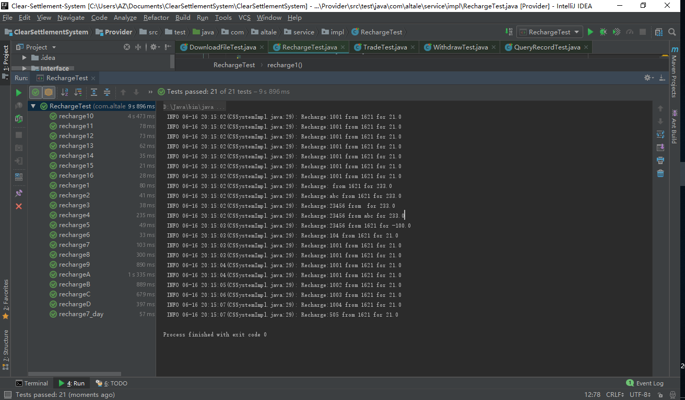

2.提现（测试通过）

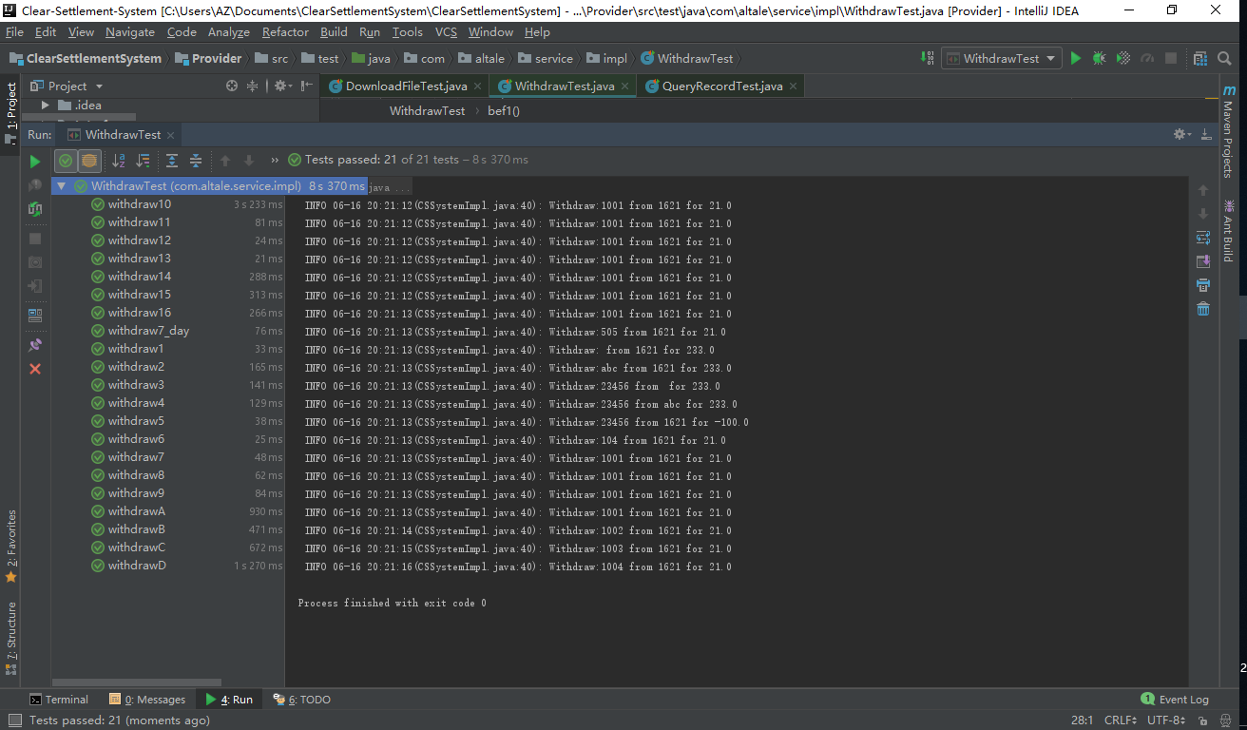

3.交易（测试通过）

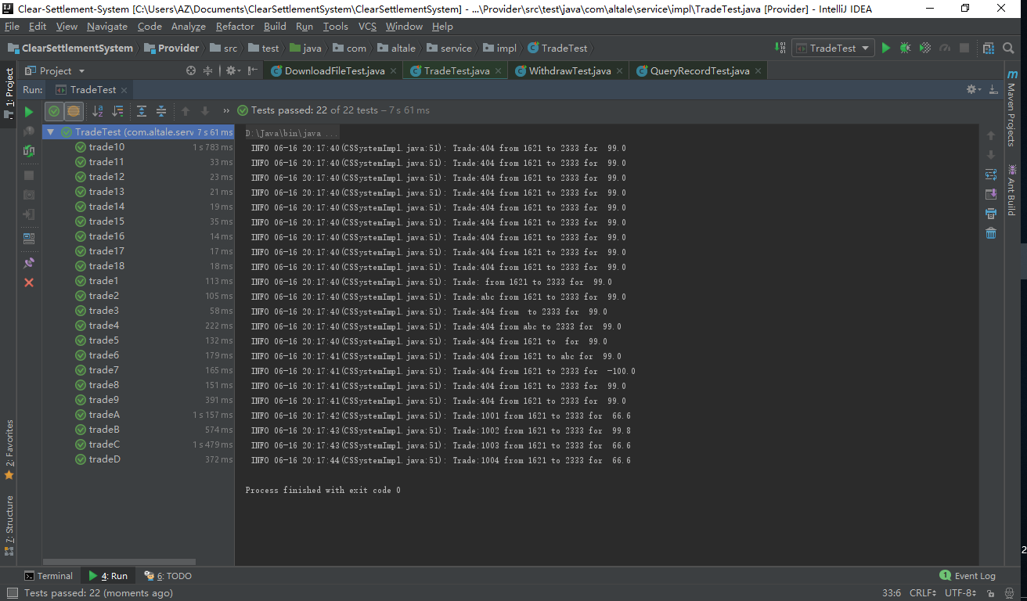

4.查询（测试通过）

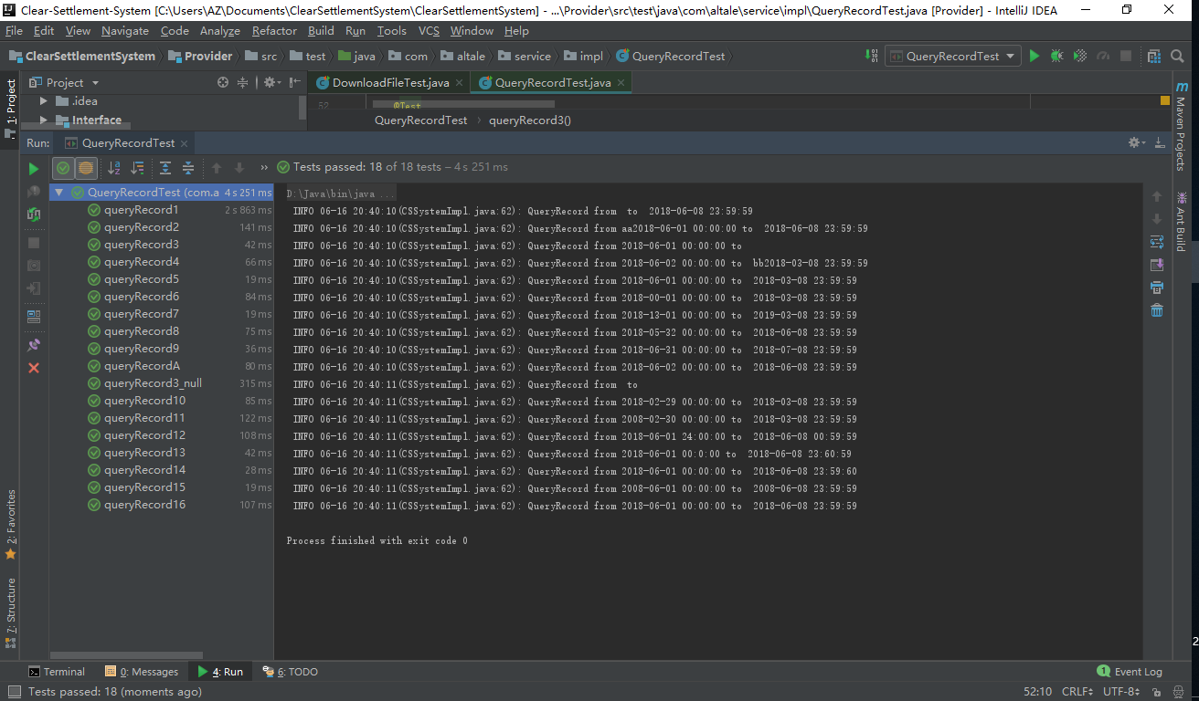

5.下载（测试通过）

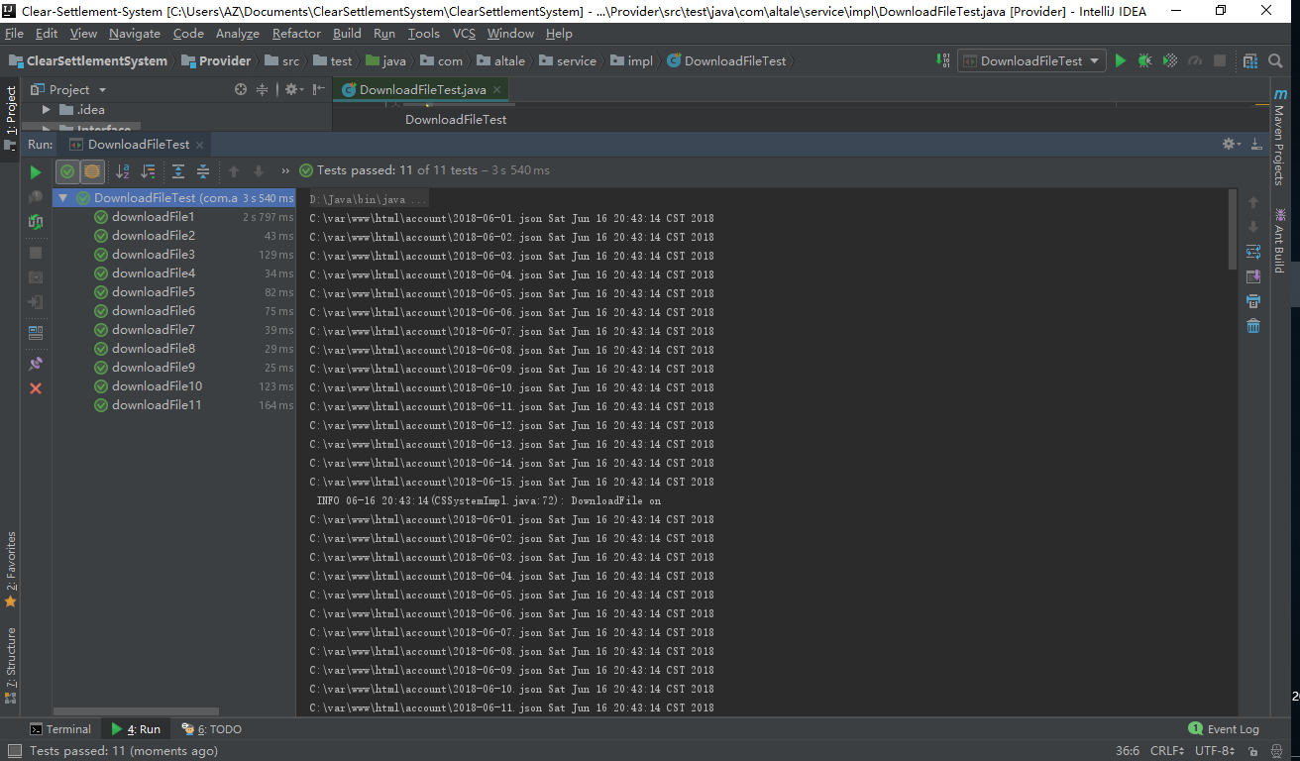

6.清分（测试通过）

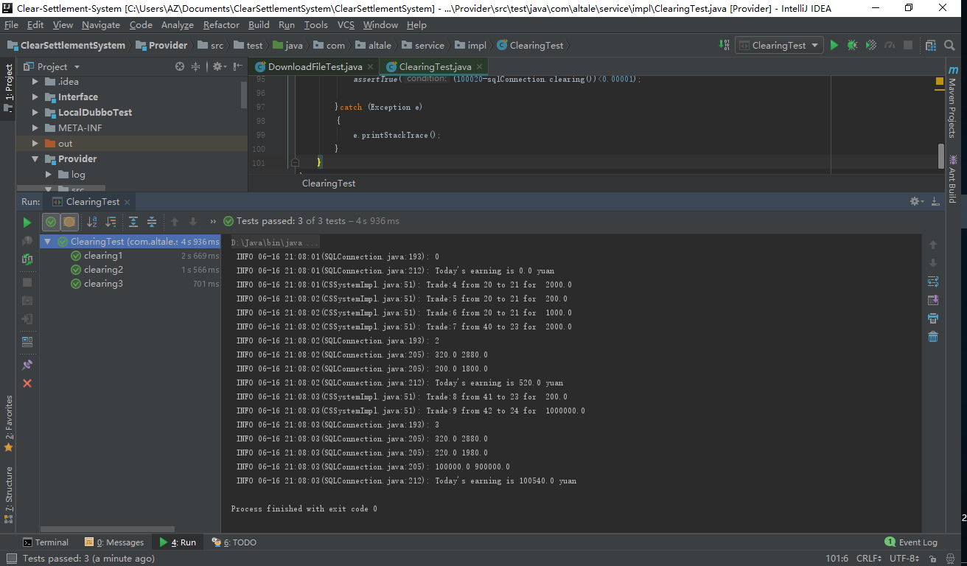

# 5 数据和数据库完整性测试

## 5.1测试描述

数据库和数据库进程应作为清结算系统中的子系统来进行测试。

|  |  |
| --- | --- |
| 测试目标： | 确保数据库访问方法和进程正常运行，数据不会遭到损坏。 |
| 方法： | • 调用各个数据库访问方法和进程，并在其中填充有效的和无效的数据或对数据的请求。  • 检查数据库，确保数据已按预期的方式填充，并且所有数据库事件都按正常方式出现；或者检查所返回的数据，确保为正当的检索到了正确的数据 |
| 完成标准： | 所有的数据库访问方法和进程都按照设计的方式运行，数据没有遭到损坏。 |
| 需考虑的特殊事项： | 进程以手工方式调用。 |

## 5.2测试结果

系统能够防止恶意或者意外访问、使用、修改等带来的不良影响：

①敏感信息加密存储；

②保留需要的日志文件；

③对关键数据检查其完整性和合法性；

④消除安全漏洞，防止包括SQL 注入、XSS 攻击等在内的恶意行为

# 6.测试结论

测试完成日期：2018-6-15

测试环境：普通家用环境

系统的强项：功能划分清晰，可靠性强

系统的弱项：功能比较简单

不符合项的统计结果：无